Supplemental Material

Changes in opioid prescribing after implementation of mandatory registration and proactive reports within California’s prescription drug monitoring program

Alvaro Castillo-Carniglia^{1,2,3} Andrés González-Santa Cruz¹ Magdalena Cerdá³ Chris Delcher⁴ Aaron B. Shev⁵ Garen J. Wintemute⁵, and Stephen G. Henry^{6,7}

1. Society and Health Research Center, Universidad Mayor, Chile.
2. School of Public Health, Universidad Mayor, Chile.
3. Department of Population Health, New York University, United States.
4. Department of Pharmacy Practice and Science, University of Kentucky, United States.
5. Violence Prevention Research Program, University of California, Davis, United States.
6. Department of Internal Medicine, University of California, Davis, United States.
7. Center for Healthcare Policy and Research, University of California, Davis, United States.

1. Generalized Synthetic Control Method
The synthetic control approach does not assume either homogenous intervention effects or parallel trends between control and treated units (Xu, 2015). It estimates an unobservable counterfactual of each exposed unit, that is, what would be the expected trend of an outcome if the exposed county was not under intervention, transforming the task of causal inference into a problem of the imputation of missing data, from a combination of non-treated counties (Abadie et al., 2010).
The generalized synthetic control method uses interactive fixed effects to account for individual time-fixed and time-varying differences in panel data. It combines a standard fixed-effects panel model with the synthetic control framework and a factor model for interactive effects, as proposed by Bai (Bai, 2009). It also considers common multidimensional “shocks” (factors conceived as principal components) or high-dimensional confounders, and unit responses (factor loadings), while controlling for the fixed effect of time, units, and for the interaction between them, permitting to relax the assumption of parallel trends, because different units can show different patterns over time (McNamee and Zhang, 2019). In other words, time is a source of variability on unit response to these factors by explicitly modeling time-varying heterogeneity without sacrificing many degrees of freedom(Gobillon and Magnac, 2016). Differently put, these estimators utilize information of observations that were not exposed to intervention prior to the intervention taking place and obtains a fixed number of time-varying coefficients (latent-factors) (Athey et al., 2018). It then estimates county-specific intercepts (factor loadings) for each treated county by linearly projecting pre-intervention outcomes for treated counties onto space spanned by the factors. The method allows for the construction of an artificial control unit, the control group (also called as the synthetic control), which serves as the counterfactual and whose pre-intervention dynamics are virtually the same as for the exposed group (Garner et al., 2019).
Further, we examine the potential for “interpolation bias” after a convex combination of similar control units that could resemble the characteristics of the treated units, to avoid producing inaccurate estimations of the counterfactuals by predicting unknown values of very different data (Abadie et al., 2014), based on factors that share very few characteristics in terms of outcomes and covariates (King and Zeng, 2006). We also plotted factor loadings and estimated factors of both treated and control units to check whether the estimated factor loadings of the treated counties lie primarily within the convex hull of those of the control units (Pierzgalski et al., 2019) (See Section 2).
The model takes the functional form of:

𝑌_{𝑖𝑡} = 𝛿 _{𝑖𝑡} 𝐷 _{𝑖𝑡} + 𝑥 _{𝑖𝑡} 𝛽 + 𝜆_{𝑖}𝑓_{𝑡} + 𝜀_{𝑖𝑡}

where Y_{it} is the outcome of interest for county i, D_{it} is the dummy for the treatment indicator, traduced in the year and quarter of implementation of the PDMP features (i.e., 𝐷_{𝑖𝑡} = 1 if county i was exposed to the treatment at time t), 𝛿_{𝑖𝑡} is the treatment effect to be estimated and traduced in average differences; 𝑥_{𝑖𝑡} is the vector of covariates and 𝛽 their corresponding coefficients, 𝑓_{𝑡} is the vector of latent factors, 𝜆_{i} are unknown factor loadings, and finally 𝜀_{it} are the idiosyncratic error terms (Brůha and Tonner, 2018).
The mechanism used is the process of validation through treated observations in pre-intervention periods until finding the number of factors that minimizes the Mean Squared Prediction Error (MSPE)(Xu, 2017).

2. Figure S1. Average differences in prescribing trends between California counties and control counties

3. Sensitivity analysis

We repeated the analysis using a fixed-effects difference-in-difference regression model. These models assume that unobserved confounding is time-invariant and additive, which require parallelism in pre-intervention trends between exposed and unexposed counties (O’Neill et al., 2016). This was checked by plotting the aggregated standardized difference for each outcome between counties in California and the control states (WA and FL) in the pre intervention period (Figure S2).

Figure S2. Pre-intervention standardized difference between California and control states for seven prescribing measures
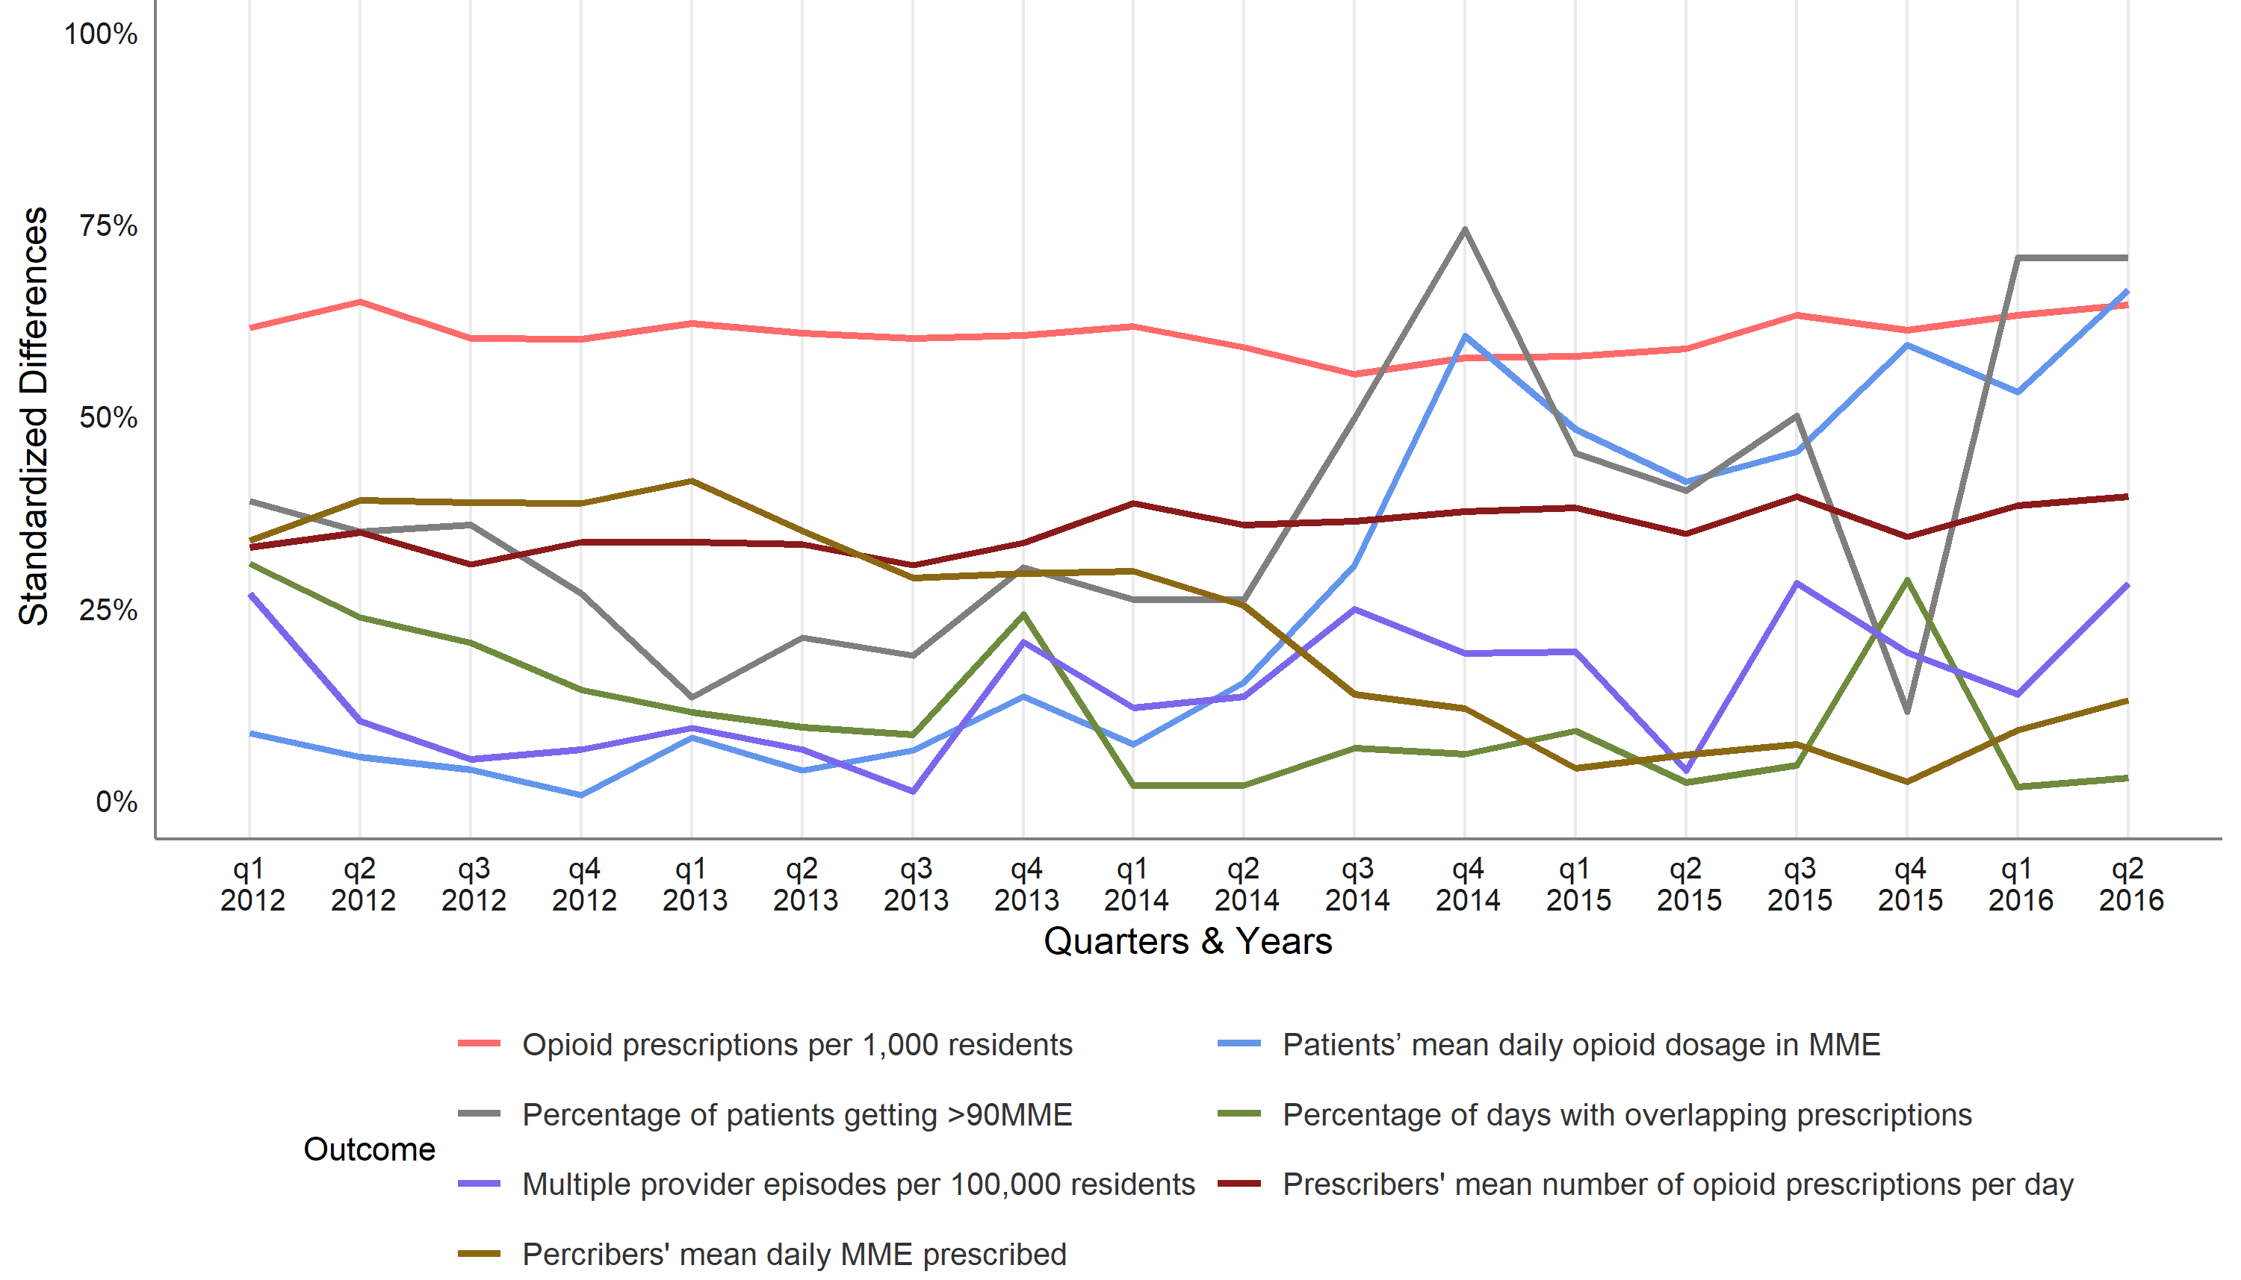
Note: Controls states: Washington and Florida

We visually checked the parallel trends assumption by inspecting graphs of aggregated trends for each outcome; this assumption was reasonably met for 4 out of 7 outcomes.

Results from fixed-effects difference-in-difference models were similar to those estimated through the generalized synthetic control method. However, the joint PDMP’s mandatory registration and proactive reports were associated with a significant decrease in the number of opioid prescriptions per 1,000 residents; this decrease was not statistically significant in our primary analysis (Table 1).
Table S1. Estimated effect of the implementation of mandatory PDMP registration and proactive reports in California, from fixed effects difference-in-difference modelsª
Variable | Coef. | CI95%  Lower | CI95%  Upper | t | p-value | N Obs.  (Clusters)
Opioid prescriptions per 1,000 residents | -7.16 | -13.09 | -1.24 | -2.50 | 0.0199 | 3936  (164)
Patients’ mean daily opioid dosage in MME | -9.87 | -13.64 | -6.10 | -5.41 | <0.001 | 3936  (164)
Percentage of patients getting >90MME | -1.87 | -2.39 | -1.34 | -7.37 | <0.001 | 3936  (164)
Percentage of days with overlapping prescriptions for opioid and benzodiazepines | -0.07 | -0.50 | 0.36 | -0.34 | 0.7339 | 3936  (164)
Multiple provider episodes per 100,000 residents | -0.37 | -1.15 | 0.41 | -0.99 | 0.3336 | 3936  (164)
Prescribers’ mean number of opioid prescriptions per day | -0.04 | -0.08 | 0.00 | -2.02 | 0.0553 | 3924  (164)
Prescribers’ mean daily MME prescribed | -8.93 | -12.37 | -5.49 | -5.37 | <0.001 | 3924  (164)
ª Each model included dummy variables for each quarter and a fixed effect for counties. Models also included the following time-varying covariates: Percentage of the total population identifying as White; Median household income (US$); Percentage of rented occupied housing units; Percentage of US citizens; Percentage of Poverty (all ages); GINI index; Median gross rent (US$); Per capita income (US$); and Percentage of people not graduated from high school.

Two main issues may explain the discrepancy in the significance of the results in opioid prescriptions per 1,000 residents between the two methods. First, the difference-in-difference model does not capture heterogeneity at the county level (Gobillon and Magnac, 2016) and does not account for potential unobserved confounders over time (Xu, 2017). Second, the generalized synthetic control method can capture more complexities than the difference-in-difference approach. Therefore, it uses more stringent criteria to qualify a coefficient as a statistically significant change in the opioid prescriptions per 1,000 residents.
Table S2. Estimated average difference in Morphine milligram equivalents from Buprenorphine, Hydrocodone and Oxycodone between California and its control group, after the implementation of mandatory PDMP registration and proactive reportsª
Prescribing practices | AD | (95% CI) | Relative Difference | (95% CI)
Patients’ mean daily opioid dosage in MME for Buprenorphine | -38.4 | -66.5, 26.1 | -9% | -16%, 6%
Patients’ mean daily opioid dosage in MME for Hydrocodone | -0.5 | -1.0, -0.2 | -1% | -3%, -0.5%
Patients’ mean daily opioid dosage in MME for Oxycodone | -18.6 | -27.9, -3.7 | -11% | -16%, -2%
ª Each model included dummy variables for each quarter and a fixed effect for counties. Models also included the following time-varying covariates: Percentage of the total population identifying as White; Median household income (US$); Percentage of rented occupied housing units; Percentage of US citizens; Percentage of Poverty (all ages); GINI index; Median gross rent (US$); Per capita income (US$); and Percentage of people not graduated from high school. MME = Morphine milligram equivalents. AD = average difference.

References

Abadie, A., Diamond, A., Hainmueller, J., 2010. Synthetic Control Methods for Comparative Case Studies: Estimating the Effect of California’s Tobacco Control Program. Journal of the American Statistical Association. 105, 493-505. doi: 10.1198/jasa.2009.ap08746.
Abadie, A., Diamond, A., Hainmueller, J., 2014. Comparative Politics and the Synthetic Control Method. American Journal of Political Science. 59, 495-510. doi: 10.1111/ajps.12116.
Athey, S., Bayati, M., Doudchenko, N., Imbens, G., Khosravi, K., 2018. Matrix Completion Methods for Causal Panel Data Models. National Bureau of Economic Research.
Bai, J., 2009. Panel Data Models With Interactive Fixed Effects. Econometrica. 77, 1229-1279. doi: 10.3982/ecta6135.
Brůha, J., Tonner, J., 2018. An Exchange Rate Floor as an Instrument of Monetary Policy: An Ex-Post Assessment of the Czech Experience. Czech National Bank, Working paper series. 68, 537-549.
Garner, M., Harvey, A., Johnson, H., 2019. Estimating Effects of Affirmative Action in Policing: A Replication and Extension of Previous Research.
Gobillon, L., Magnac, T., 2016. Regional Policy Evaluation: Interactive Fixed Effects and Synthetic Controls. Review of Economics and Statistics. 98, 535-551. doi: 10.1162/rest_a_00537.
King, G., Zeng, L., 2006. The Dangers of Extreme Counterfactuals. Political Analysis. 14, 131-159. doi: 10.1093/pan/mpj004.
McNamee, L., Zhang, A., 2019. Demographic Engineering and International Conflict: Evidence from China and the Former USSR. International Organization. 73, 291-327. doi: 10.1017/s0020818319000067.
O’Neill, S., Kreif, N., Grieve, R., Sutton, M., Sekhon, J.S., 2016. Estimating causal effects: considering three alternatives to difference-in-differences estimation. Health Services and Outcomes Research Methodology. 16, 1-21. doi: 10.1007/s10742-016-0146-8.
Pierzgalski, M., Górecki, M., Stępień, P., 2019. Ballot Paper Design and Vote Spoiling at Polish Local Elections of 2014: Establishing a Causal Link. East European Politics and Societies And Cultures. 1-26. doi: 10.1177/0888325419874427.
Xu, Y., 2015. 17.802: Lecture: Synthetic Control Methods [PowerPoint slides]. 17.802 Quantitative Research Methods II Spring 2015 - MIT, MIT.
Xu, Y., 2017. Generalized Synthetic Control Method: Causal Inference with Interactive Fixed Effects Models. Political Analysis. 25, 57-76. doi: 10.1017/pan.2016.2.

