Supporting Information

Polarization and T₁ measurement
Liquid polarization level and longitudinal relaxation time (T₁) of hyperpolarized [1-¹³C]-L-lactate were calculated from independent in vitro measurements. 90-μL [1-¹³C]lactate samples (n = 4) were polarized with the SPINlab for 5 hours, dissolved, collected in a 6-mL syringe, rapidly transported to the 3T MR scanner, positioned at the center of an ¹³C/¹H dual-tuned birdcage rat RF coil (GE Healthcare, Ø_{inner} = 80 mm), and scanned using a non-selective pulse-and-acquire MRS sequence (TR = 3 sec, 5.625º hard pulse, pulse width = 24 μsec, scan time = 4 min). One sample was mixed with a gadolinium complex (Magnevist, 1 mM) to demonstrate the effect of Gd(III) on the ¹³C T₁. A gadolinium-doped 2-M [1-¹³C]-L-lactate syringe phantom was used for RF calibration. The RF transmit gain was first calibrated for 180º non-selective excitation that nulls ¹³C signal in absorption mode, then adjusted by calculation for a 5.624º pulse. To calculate the T₁, the lactate resonance was integrated from the spectrum at each time point, and the signal loss due to RF excitation was corrected before fitting the lactate decay to a mono-exponentially decaying function. To estimate the polarization level, the thermal MR signal was measured by averaging 600 scans of the sample with a 90º hard pulse (TR = 6 sec) after adding gadolinium (Magnevist, 5 mM) in the sample. The dissolution-to-scan time was 30 – 40 seconds.

Data reconstruction and kinetic analysis
The obtained time-course data were fit using the following multi-site exchange model, which is extended from previously presented two-site exchange model to estimate apparent conversion rate constants (k’s) and apparent T₁’s(1, 2). The measured lactate signal (lac_{measured}) at the n^{th} timepoint was first corrected for the excitation flip angle and RF sampling losses using (eq.1):

${lac}_{RFcor,n}=\frac{{lac}_{measured,n}}{\sin{θ}}C_{n}$ – (eq.1)

, where C_{n} is a correction factor for prior RF sampling losses. Pyruvate, alanine, bicarbonate (HCO₃–), and aspartate produced within the n^{th} pulse repetition time (TR) were calculated from the RF-corrected lactate signal (lac_{RFcor}) with k_{Lac→Pyr}, k_{Pyr→Ala}, k_{Pyr→Bic}, and k_{Pyr→Asp} (eq.2-5).

$TR∙k_{LacPyr}=\frac{{pyr}_{n}+{ala}_{n}+{bic}_{n}+{asp}_{n}}{{pyr}_{n}+{ala}_{n}+{bic}_{n}+{asp}_{n}+{(lac}_{RFcor,n}+{lac}_{RFcor,n-1})/2}$ – (eq.2)
$TR∙k_{PyrAla}=\frac{{ala}_{n}}{{pyr}_{n}+{ala}_{n}}$ – (eq.3)
$TR∙k_{PyrBic}=\frac{{bic}_{n}}{{pyr}_{n}+{bic}_{n}}$ – (eq.4)
$TR∙k_{PyrAsp}=\frac{{asp}_{n}}{{pyr}_{n}+{asp}_{n}}$ – (eq.5)

Then, accumulated products during TR were calculated (eq.6-9) with the apparent T₁ decay and RF sampling losses.

$${pyr}_{acm,n}={pyr}_{n}+{pyr}_{n-1}⋅e^{-\frac{TR}{T_{1,pyr}}}⋅\cos{θ}+{pyr}_{n-2}⋅e^{-\frac{2TR}{T_{1,pyr}}}⋅\cos^{2}{θ}+…$$
$= \sum_{k=1}^{n}{({pyr}_{k}⋅e^{-\frac{(n-k)⋅TR}{T_{1,pyr}}}⋅\cos^{n-k}{θ})}$ – (eq.6)
${ala}_{acm,n}= \sum_{k=1}^{n}{({ala}_{k}⋅e^{-\frac{(n-k)⋅TR}{T_{1,ala}}}⋅\cos^{n-k}{θ})}$ – (eq.7)
${bic}_{acm,n}= \sum_{k=1}^{n}{({bic}_{k}⋅e^{-\frac{(n-k)⋅TR}{T_{1,bic}}}⋅\cos^{n-k}{θ})}$ – (eq.8)
${asp}_{acm,n}= \sum_{k=1}^{n}{({asp}_{k}⋅e^{-\frac{(n-k)⋅TR}{T_{1,asp}}}⋅\cos^{n-k}{θ})}$ – (eq.9)

Finally, the best combination of the apparent T₁’s and the apparent conversion rate constants were estimated by minimizing the χ²-error between the measured products with the calculated products (pyr_{acm}, ala_{acm}, bic_{acm}, and asp_{acm}).

Supporting Figures
Figure S1. Time curves of hepatic products from 60-mM or 30-mM hyperpolarized [1-¹³C]-L-lactate in a fasted rat (A, B) and a fed rat (C, D).

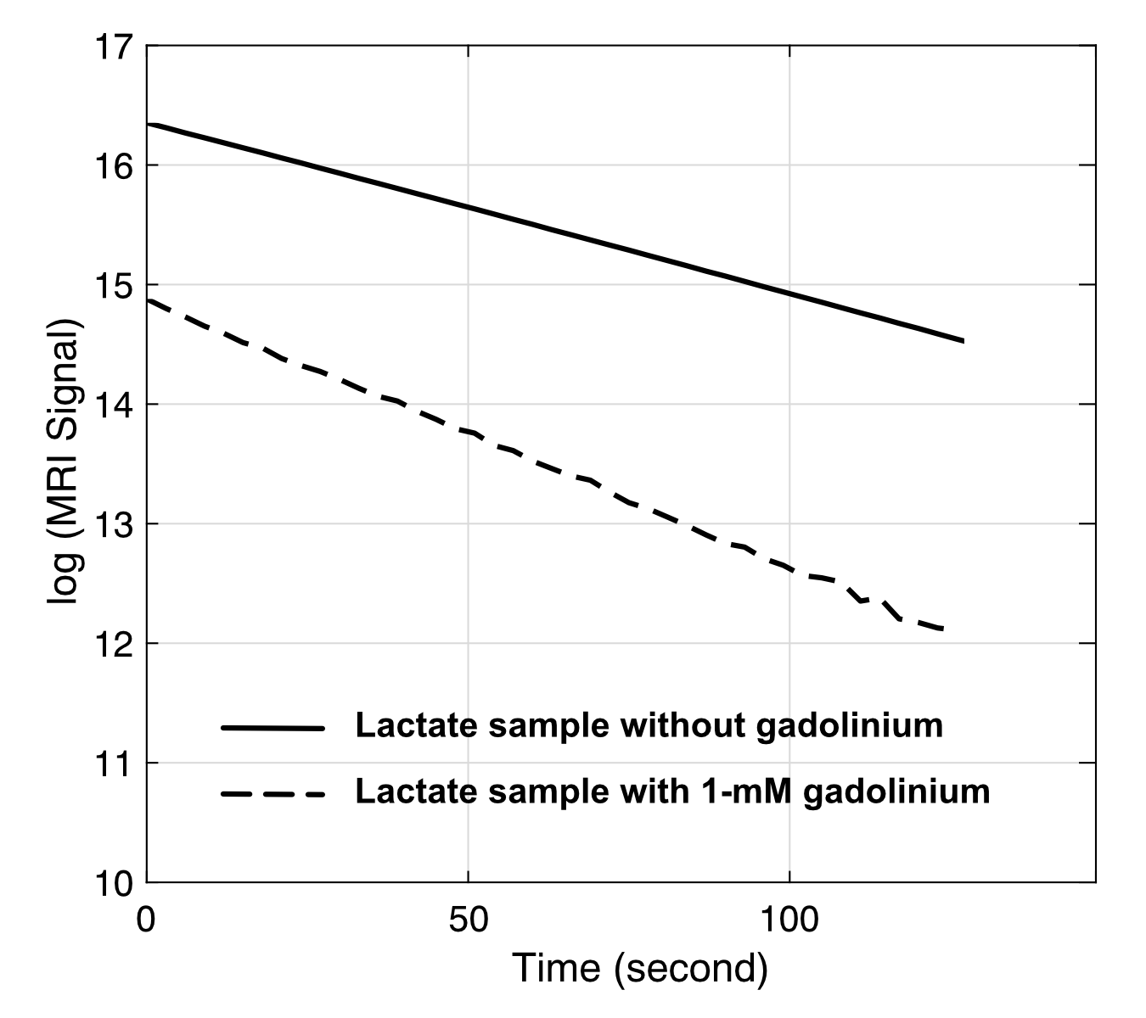
Figure S2. T₁ decay of 30-mM hyperpolarized [1-¹³C]-L-lactate with (dotted line) and without (solid line) 1-mM gadolinium (Magnevist) in the sample.

 | HCO₃⁻/tC* | Pyruvate/tC | Alanine/tC | Aspartate/tC* | Lactate/tC | Aspartate/HCO₃⁻*
Fasted (n = 6) | 0.0011 ± 0.0005 | 0.025 ± 0.002 | 0.085 ± 0.009 | 0.0047 ± 0.0011 | 0.88 ± 0.01 | 2.65 ± 0.77
Fed (n = 5) | 0.0117 ± 0.0010 | 0.022 ± 0.001 | 0.076 ± 0.006 | 0.0005 ± 0.0001 | 0.86 ± 0.01 | 0.069 ± 0.039
Table S1. Summary of metabolite ratios in fasted and fed rat liver (mean ± standard error). tC: total ¹³C signal. * indicates statistical significance (P < 0.01).

 | Apparent conversion rate constants (sec⁻¹) |  |  |  | T₁ relaxation times (sec)
 | k_{Lac→Pyr} | k_{Pyr→Ala} | k_{Pyr→Bic}* | k_{Pyr→Asp}* | T_{1,Pyr} | T_{1,Ala} | T_{1,Bic} | T_{1,Asp}
Fasted (n = 6) | 0.0075 ± 0.0008 | 0.45 ± 0.04 | 0.0034 ± 0.0017 | 0.065 ± 0.007 | 10.6 ± 0.3 | 22.8 ± 0.5 | 7.0 ± 0.2 | 17.5 ± 0.4
Fed (n = 5) | 0.0099 ± 0.0009 | 0.48 ± 0.05 | 0.18 ± 0.03 | 0.0013 ± 0.0002 | 9.6 ± 0.6 | 22.1 ± 0.3 | 6.8 ± 0.2 | 17.9 ± 0.2
Table S2. Summary of kinetic parameters in fasted and fed rat liver (mean ± standard error). * indicates statistical significance (P < 0.001).

References for Supporting Information
1. Park JM, Josan S, Jang T, Merchant M, Yen YF, Hurd RE, et al. Metabolite kinetics in C6 rat glioma model using magnetic resonance spectroscopic imaging of hyperpolarized [1-(13)C]pyruvate. Magn Reson Med. 2012;68(6):1886-93.
2. Josan S, Hurd RE, Kerr AB, Yen YF, Larson PE, Pfefferbaum A, et al. Effects of RF excitation scheme on signal-to-noise ratio and apparent rate constant estimation in dynamic volumetric imaging of hyperpolarized [1–13C] pyruvate. Annual Meeting of ISMRM2011.

