Supplemental Digital Content (SDC)

SDC Section 1: Imputation of deductible amounts
Our algorithm for imputing employer-mandated membership in high deductible health plans has been described in detail previously.^{1–3} We summarize these methods briefly below.
To determine deductible levels in smaller employers (~100 or fewer employees), we used an available benefit variable that specified exact in-network deductible amounts. For larger employers where such data were unavailable, we based our imputation on total in-network individual deductible amounts paid by members who utilized health services. For members who meet their annual deductible, yearly deductible payments add to an exact amount (e.g., $500.00, $1000.00, $2000.00, etc.). Having several members with the same exact amount provides evidence that the employer offered that annual deductible level; when multiple members have exact deductibles at two or more levels, there is evidence that the employer offered multiple deductible plan options.
For employer accounts with 10 or more members, we summed each member’s in-network individual deductible payments over the benefit year. Then, using a random half of our available employer account data, we used a multinomial logistic model to predict whether the employers offered individual-level deductible amounts at three levels (≤$500 / $500-$999 / ≥$1000). Predictors included multiple employer characteristics (median yearly deductible amount, common whole number deductible values, % of employees with HSAs, % of members using services, employer account size, and the % of enrollees with yearly annual deductible amounts ≤$500 / >$500 to <$1000 / ≥$1000 and above). We first assigned the employer to the level that had the highest probability. If employers had members with whole number deductible levels both above and below $500 (e.g. $250.00 and $1500.00), we changed the employers' assignment to "choice." We further differentiated high deductible plans into those with deductibles $1000-$2499, ≥$2500, or ≥$1000 level undetermined. If at least 98% of employees had Health Savings Accounts or Health Reimbursement Arrangements, we assigned the employer as a high-deductible employer. If no employee ever exceeded a $500 deductible, we assigned the account to low-deductible status. Finally, for any employer that had gold standard deductible level information in our benefits file, we overwrote any imputed deductible level.
To validate our imputation algorithm, we took advantage of the fact that we have exact deductible amounts for some larger employers. Using the other half of the split sample, we tested the sensitivity and specificity of our imputation. For employers with 75-100 enrollees, we found sensitivity and specificity of 96%; sensitivity and specificity increased with larger levels of employer size.

SDC Section 2: Imputation of Preventive Drug Lists
We do not have access to a variable indicating which employers offered PDL coverage, so we used pharmacy claims to impute the presence of a PDL. Larger employers are more likely to offer an extended pharmacy benefit that includes a PDL, and they are also more likely to have enough pharmacy claims experience to impute the PDL benefit reliably. We restricted inclusion in the study to employers with at least 100 members (employees and family members) per month (n=78,702); this study focuses on the subset of these accounts (n=5030) that are HSA-linked HDHPs in which all medicines would normally be included under the deductible. We linked all contracts of any size for these employers, and as part of the deductible imputation process (see above), we determined whether members had choice between plans by examining the number of members transitioning between contracts, especially during annual open enrollment. In this study, we required that eligible members in HSA-HDHP plans have no choice between plans with and without a PDL.
The national insurer represented in our data markets two standard types of preventive drug lists (PDL): a core PDL and an expanded PDL. This insurer’s core PDL contains medications in several therapeutic categories (i.e., for hypertension, high cholesterol, breast cancer prevention, blood clotting/platelet therapy, organ rejection, osteoporosis, prenatal vitamins) that employers can choose to offer members as a pharmacy benefit enhancement; the expanded PDL contains additional therapeutic categories (i.e., for diabetes, asthma, HIV/AIDS, multiple sclerosis, psychosis) that can be optionally added to the core list. Although the lists are standardized, employers have some discretion over the actual composition of the PDLs they offer. The numbers of products listed by category on the insurer’s 2014 PDLs are shown in SDC Table 1 and the names of the actual products listed are in SDC Table 2. For our imputation, we included all products (brand or generic) that were chemically equivalent to medications listed on the core or expanded PDL using equivalency data from the First DataBank National Drug Data File PlusTM (First DataBank, Inc., San Bruno, CA). We had access to the insurer’s annual core and expanded PDL lists for the years 2008-2014 and varied the products included accordingly; we used the 2008 list for earlier years.
Employers offering HSA-HDHPs linked to PDLs can choose different copayment arrangements for covered products. One common element is that the covered medications are exempt from deductibles throughout the benefit year, although they may be subject to copays either before or after the annual deductible obligation is met. Since the percentage of members satisfying annual deductibles increases during the benefit year, it is harder later in the benefit year to determine whether no deductible payment on a claim means that the drug is covered under a PDL or that the annual deductible obligation has been met. We thus used only the first 6 months of the benefit year to separately impute the presence of a core or an expanded PDL. To be counted as a possible PDL month, we required that ≤10% of fills in the month for the products on the list in question be charged a deductible and that >10% of claims for unlisted products have a deductible charge. To be counted as a PDL year, at least 5 of the first 6 months in the benefit year (or 4/5 if one month had no pharmacy claims) had to meet the monthly rule, the benefit year had to contain a full 12 months, and <10% of total pharmacy claims for PDL listed products during the entire benefit year had to have a deductible charge. Benefit years with a full 12 months of coverage in which deductibles were charged for >10% of listed medications were identified as non-PDL years.
We used the imputed annual PDL/non-PDL status to identify situations in which an employer had fully replaced a full year of coverage in an HSA-HDHP plan without a PDL with a full year of coverage in an HSA-HDHP plan with expanded PDL coverage (i.e., exempting diabetes medication from deductibles); the first day of the month of the coverage switch was defined as the index date. Using a common industry definition, full replacement was defined as at least 85% of members in all contracts linked to an employer in the prior month being switched together to the new coverage. We also identified all situations in which employers had continued all employees in HSA-HDHP coverage without a PDL for a two-year period; if employers had more than one such two-year period, one was randomly selected to be included in the control pool, with the first day of the second year of coverage defined as the index date.
We next identified all members with diabetes between ages 12 and 64 (see below for definition) insured by the employers included in the sample at the index date who were enrolled for 12 months before and after the index date; we linked the monthly PDL status of their employers in the 12 baseline and 12 follow-up months. Members could switch employers but had to remain in the correct type of HSA-HDHP-PDL coverage.

SDC Section 3: Identifying patients with diabetes
We identified all patients age 12 to 64 diagnosed with diabetes during the baseline period. Patients with diabetes were those who had diagnosis codes indicating diabetes (SDC Table 3) in medical service claims (1 inpatient claim or 2 outpatient claims within one year), or who had pharmacy claims for insulin or an oral hypoglycemic medication other than metformin alone (excluded because it can also be used to treat prediabetes or polycystic ovary syndrome). The date of first diabetes diagnosis or diabetes medication dispensing was required to precede the index month.

SDC Section 4: Propensity matching
We used propensity score matching (PSM) to generate a control group of diabetes patients with a similar likelihood of being exposed to a PDL as our identified group of PDL switchers based on measured characteristics. PSM is a commonly used approach to achieve baseline sample balance when individuals have not been randomly assigned to study groups.^{4,5} After identifying all periods in which employers remained in an HSA-HDHP for two consecutive benefit years (based on their contract anniversary date), we used our PDL imputation algorithm (above) to identify the month (index month) of the first full replacement switch from non-PDL to PDL status. We also identified two-year periods in which an employer’s workforce remained entirely in a non-PDL HSA-HDHP and randomly selected one to be included in the potential control pool, with the anniversary date of the second year defined as the index month. We then identified all members with diabetes between the ages of 13 and 65 insured by these employers in the index month who were consistently in a non-PDL HSA-HDHP during the baseline year, and who remained in a PDL HSA-HDHP for a full follow-up year.
We included both employer-level and member-level variables in our PSM logistic model predicting the likelihood of having PDL coverage added to an HSA-HDHP by the employer. Matching variables (defined in SDC-5) were: calendar month of employer index month; employer size; baseline employer high deductible category; member baseline out-of-pocket pharmacy cost; member gender; member age stratum; member month of first diabetes diagnosis; member region of residence; member baseline ACG score; member neighborhood poverty category; member race/ethnic group; and number of baseline 30-day dispensings in four key diabetes-related therapeutic categories (oral antidiabetics, insulin, lipid-powering medications, antihypertensives). We employed 1:2 caliper matching without replacement, using a caliper width equal to 0.2 of the logit of the pooled standard deviation of the propensity score, which has been found to eliminate the majority of bias due to measured confounding variables.^{6,7}
We conducted the matching separately in the overall sample and among patients in our eight analytic subgroups: higher income, lower income, ACG<3, ACG≥3, non-severe diabetes, severe diabetes, living in predominantly white neighborhoods, and not living in predominantly white neighborhoods.

SDC Section 5: Definitions of covariates
We identified key demographic and clinical covariates that we used for propensity matching, for stratifying analyses, and as variables to adjust difference-in-difference and survival models.
Individual demographic covariates included gender, age category (12-44, 45-64 years), and US region (Northeast, South, Midwest, West). Our dataset contains limited and incomplete individual-level socioeconomic variables; to derive proxy measures,⁸ our data vendor converted members’ most recent residential street addresses to geocodes which can be linked to publicly available geographically-derived socioeconomic measures. Geographic measures of socioeconomic status have been validated^{9–11} and used in multiple studies by ourselves^{3,12,13} and others^{14,15} to examine the differential impact of changes in cost-sharing within population subgroups. We linked to census tract-level data from the 2008-2012 American Community Survey (ACS)^{16 ,17} to create measures of neighborhood poverty, defined as <5%, 5.0-9.9%, 10.0-24.9%, ≥25.0% of households living below the US Department of Health and Human Services federal poverty threshold,¹⁸ which we stratified for subgroup analysis as lower income (<10.0%) vs. higher income (≥10.0%). We also used ACS data to classify members as living in predominantly (≥75% of residents) white, black, or Hispanic neighborhoods; using data provided by our vendor from the Ethnic Technologies E-Tech system,¹⁹ we superseded the neighborhood classification if a member’s surname was identifiable as Hispanic or Asian. A member not meeting criteria for either approach was classified as living in a mixed neighborhood. This validated approach of combining census data and surname attribution has positive and negative predictive values of approximately 80 and 90 percent, respectively.^{20,21} We grouped patients classified as living in predominantly white neighborhoods vs. all others (nonwhite) for subgroup analyses.
We used version 10 of the Johns Hopkins Adjusted Clinical Group® (ACG®) System^{22–24} and baseline claims data to calculate members’ morbidity score. The extensively validated^{25–27,24} ACG algorithm uses age, gender, and International Classification of Diseases, 9th Revision, Clinical Modification (ICD-9-CM) codes to calculate a morbidity score; we grouped our population as having ACG scores <3.0 or ≥3.0 for matching and subgroup analysis.
We defined patients with severe diabetes as those who had any insulin dispensing and/or who used 3 or more separate classes of antidiabetic medications during the baseline year.
All study group members were covered by HSA-HDHPs at baseline and follow-up, but deductible categories (i.e., $1000-$2499, ≥$2500, or ≥$1000 level undetermined) may have changed. We thus adjusted all statistical analyses by variables indicating the type of change experienced (e.g., $1000-$2499 to $1000-$2499 or $1000-$2499 to ≥$2500, etc.).

SDC Table 1. Number of medications listed on the 2014 Core PDL and Expanded PDL by therapeutic category
 | Core List |  | Expanded List
Therapeutic Category | Generic | Brand | Generic | Brand
Anti-infectives – HIV/AIDS | . | . | 8 | 34
Breast cancer prevention | 4 | 5 | 4 | 5
CVD – Blood clot, platelet | 9 | 13 | 9 | 13
CVD – Blood pressure | 92 | 102 | 92 | 102
CVD – Cholesterol | 16 | 31 | 16 | 31
CNS – Multiple sclerosis | . | . | 0 | 8
CNS – Psychosis | . | . | 13 | 14
Diabetes – Supplies | . | . | 4 | 0
Diabetes – Insulin | . | . | 0 | 15
Diabetes – Non-insulin | . | . | 16 | 40
Immunosuppressant – Rejection | 8 | 10 | 8 | 10
Musculoskeletal – Osteoporosis | 4 | 11 | 4 | 11
Respiratory – Asthma | . | . | 14 | 38
Vitamins | 2 | 0 | 2 | 0
Total | 135 | 172 | 190 | 321

SDC Table 2.3 Medications on the 2014 Expanded Preventive Drug List by therapeutic category and whether also listed on the Core PDL
Drug * | Category | Core PDL
abacavir | HIV/AIDS | 0
abacavir-lamivudine-zidovudine | HIV/AIDS | 0
Abilify | Psychosis | 0
acarbose | Diabetes – Oral | 0
Accolate | Asthma/COPD | 0
Accuneb | Asthma/COPD | 0
Accupril | Hypertension | 1
Accuretic | Hypertension | 1
acebutolol | Hypertension | 1
Aceon | Hypertension | 1
Actonel | Osteoporosis | 1
ACTOplus Met | Diabetes – Oral | 0
ACTOplus Met XR | Diabetes – Oral | 0
Actos ** | Diabetes – Oral | 0
Adalat CC | Hypertension | 1
Advair Diskus | Asthma/COPD | 0
Advair HFA | Asthma/COPD | 0
Advicor | High cholesterol | 1
Afeditab | Hypertension | 1
Aggrenox | Blood clot/platelet | 1
albuterol nebulized solution | Asthma/COPD | 0
albuterol oral tablet | Asthma/COPD | 0
Aldactazide | Hypertension | 1
Aldactone | Hypertension | 1
alendronate | Osteoporosis | 1
Altace | Hypertension | 1
Altoprev ** | High cholesterol | 1
Alvesco | Asthma/COPD | 0
Amaryl | Diabetes – Oral | 0
amiloride | Hypertension | 1
amiloride-hydrochlorothiazide | Hypertension | 1
aminophylline | Asthma/COPD | 0
amlodipine | Hypertension | 1
amlodipine-benazepril | Hypertension | 1
Amturnide ** | Hypertension | 1
anastrozole | Breast cancer | 1
Anoro Ellipta | Asthma/COPD | 0
Antara | High cholesterol | 1
Apidra | Diabetes – Insulin | 0
Aptivus | HIV/AIDS | 0
Arcapta Neohaler | Asthma/COPD | 0
Arimidex ** | Breast cancer | 1
Arixtra | Blood clot/platelet | 1
Aromasin | Breast cancer | 1
Asmanex Twisthaler | Asthma/COPD | 0
Astagraf XL ** | Organ rejection | 1
Atacand | Hypertension | 1
Atacand HCT | Hypertension | 1
Atelvia ** | Osteoporosis | 1
atenolol | Hypertension | 1
atenolol-chlorthalidone | Hypertension | 1
atorvastatin | High cholesterol | 1
Atripla | HIV/AIDS | 0
Atrovent HFA | Asthma/COPD | 0
Aubagio | CNS – MS | 0
Avalide | Hypertension | 1
Avandamet | Diabetes – Oral | 0
Avandaryl | Diabetes – Oral | 0
Avandia | Diabetes – Oral | 0
Avapro | Hypertension | 1
Avonex | CNS – MS | 0
Azasan | Organ rejection | 1
azathioprine | Organ rejection | 1
Azor ** | Hypertension | 1
benazepril | Hypertension | 1
benazepril-hydrochlorothiazide | Hypertension | 1
Benicar | Hypertension | 1
Benicar HCT | Hypertension | 1
Betaseron | CNS – MS | 0
betaxolol** | Hypertension | 1
Bidil | Hypertension | 1
Binosto ** | Osteoporosis | 1
bisoprolol | Hypertension | 1
bisoprolol-hydrochlorothiazide | Hypertension | 1
Boniva | Osteoporosis | 1
Breo Ellipta | Asthma/COPD | 0
Brilinta | Blood clot/platelet | 1
Brovana | Asthma/COPD | 0
budesonide | Asthma/COPD | 0
bumetanide | Hypertension | 1
Bydureon | Diabetes – Oral | 0
Byetta | Diabetes – Oral | 0
Bystolic | Hypertension | 1
Calan | Hypertension | 1
Calan SR | Hypertension | 1
calcitonin (salmon) | Osteoporosis | 1
candesartan | Hypertension | 1
candesartan-hydrochlorothiazide | Hypertension | 1
captopril | Hypertension | 1
captopril-hydrochlorothiazide | Hypertension | 1
Cardene SR | Hypertension | 1
Cardizem CD | Hypertension | 1
Cardizem | Hypertension | 1
Cardizem LA E | Hypertension | 1
Cardura | Hypertension | 1
Cardura XL | Hypertension | 1
Cartia XT | Hypertension | 1
carvedilol | Hypertension | 1
Catapres | Hypertension | 1
Catapres TTS | Hypertension | 1
Cellcept | Organ rejection | 1
chlorothiazide | Hypertension | 1
chlorpromazine | Psychosis | 0
cholestyramine | High cholesterol | 1
cholestyramine light | High cholesterol | 1
choline fenofibrate E | High cholesterol | 1
cilostazol | Blood clot/platelet | 1
clonidine | Hypertension | 1
clonidine patch | Hypertension | 1
clopidogrel | Blood clot/platelet | 1
Clorpres | Hypertension | 1
clozapine | Psychosis | 0
Clozaril | Psychosis | 0
Colestid | High cholesterol | 1
colestipol | High cholesterol | 1
Combivent Respimat | Asthma/COPD | 0
Combivir | HIV/AIDS | 0
Complera | HIV/AIDS | 0
Copaxone | CNS – MS | 0
Coreg | Hypertension | 1
Coreg CR E | Hypertension | 1
Corgard | Hypertension | 1
Corzide | Hypertension | 1
Coumadin | Blood clot/platelet | 1
Covera HS | Hypertension | 1
Cozaar | Hypertension | 1
Crestor E | High cholesterol | 1
Crixivan | HIV/AIDS | 0
cromolyn | Asthma/COPD | 0
Cycloset | Diabetes – Oral | 0
cyclosporine | Organ rejection | 1
Daliresp | Asthma/COPD | 0
Demadex | Hypertension | 1
Diabeta | Diabetes – Oral | 0
diabetic meters, solutions | Diabetes – Supplies | 0
diabetic test strips | Diabetes – Supplies | 0
diabetic lancets | Diabetes – Supplies | 0
didanosine | HIV/AIDS | 0
Didronel | Osteoporosis | 1
Dilacor XR | Hypertension | 1
Dilt CD | Hypertension | 1
Dilt XR | Hypertension | 1
Diltia XT | Hypertension | 1
diltiazem | Hypertension | 1
diltiazem ER | Hypertension | 1
Diltzac ER | Hypertension | 1
Diovan E | Hypertension | 1
Diovan HCT E | Hypertension | 1
dipyridamole | Blood clot/platelet | 1
Diuril | Hypertension | 1
doxazosin | Hypertension | 1
Duetact | Diabetes – Oral | 0
Dulera | Asthma/COPD | 0
Duoneb | Asthma/COPD | 0
Dutoprol | Hypertension | 1
Dyazide | Hypertension | 1
Dynacirc CR | Hypertension | 1
Dyrenium | Hypertension | 1
Edarbi | Hypertension | 1
Edarbyclor | Hypertension | 1
Edecrin | Hypertension | 1
Edurant | HIV/AIDS | 0
Effient | Blood clot/platelet | 1
Eliquis | Blood clot/platelet | 1
Elixophyllin | Asthma/COPD | 0
Emtriva | HIV/AIDS | 0
enalapril | Hypertension | 1
enalapril-hydrochlorothiazide | Hypertension | 1
enoxaparin | Blood clot/platelet | 1
Epaned E | Hypertension | 1
Epivir | HIV/AIDS | 0
eplerenone | Hypertension | 1
eprosartan | Hypertension | 1
Epzicom | HIV/AIDS | 0
etidronate | Osteoporosis | 1
Evista | Osteoporosis | 1
exemestane | Breast cancer | 1
Exforge ** | Hypertension | 1
Exforge HCT ** | Hypertension | 1
Extavia E | CNS – MS | 0
Fanapt | Psychosis | 0
Fareston | Breast cancer | 1
Farxiga | Diabetes – Oral | 0
FazaClo | Psychosis | 0
felodipine ER | Hypertension | 1
Femara ** | Breast cancer | 1
fenofibrate ** | High cholesterol | 1
fenofibric acid | High cholesterol | 1
Fenoglide | High cholesterol | 1
Fibricor | High cholesterol | 1
Flovent Diskus | Asthma/COPD | 0
Flovent HFA | Asthma/COPD | 0
fluphenazine | Psychosis | 0
fluvastatin | High cholesterol | 1
fondaparinux | Blood clot/platelet | 1
Foradil | Asthma/COPD | 0
Fortamet | Diabetes – Oral | 0
Forteo | Osteoporosis | 1
Fortical | Osteoporosis | 1
Fosamax | Osteoporosis | 1
Fosamax plus D | Osteoporosis | 1
fosinopril | Hypertension | 1
fosinopril-hydrochlorothiazide | Hypertension | 1
Fragmin | Blood clot/platelet | 1
furosemide | Hypertension | 1
Fuzeon | HIV/AIDS | 0
Gastrocrom | Asthma/COPD | 0
gemfibrozil | High cholesterol | 1
Gengraf | Organ rejection | 1
Geodon ** | Psychosis | 0
Gilenya | CNS – MS | 0
glimepiride | Diabetes – Oral | 0
glipizide | Diabetes – Oral | 0
glipizide ER | Diabetes – Oral | 0
glipizide-metformin | Diabetes – Oral | 0
Glucophage | Diabetes – Oral | 0
Glucophage XR | Diabetes – Oral | 0
Glucotrol | Diabetes – Oral | 0
Glucotrol XL | Diabetes – Oral | 0
Glucovance | Diabetes – Oral | 0
Glumetza | Diabetes – Oral | 0
glyburide | Diabetes – Oral | 0
glyburide micronized | Diabetes – Oral | 0
glyburide-metformin | Diabetes – Oral | 0
Glynase | Diabetes – Oral | 0
Glyset | Diabetes – Oral | 0
guanfacine | Hypertension | 1
haloperidol | Psychosis | 0
Hecoria | Organ rejection | 1
heparin | Blood clot/platelet | 1
Humalog | Diabetes – Insulin | 0
Humalog Mix 50/50 | Diabetes – Insulin | 0
Humalog Mix 75/25 | Diabetes – Insulin | 0
Humulin 50/50 | Diabetes – Insulin | 0
Humulin 70/30 | Diabetes – Insulin | 0
Humulin N | Diabetes – Insulin | 0
Humulin R | Diabetes – Insulin | 0
hydralazine | Hypertension | 1
hydrochlorothiazide | Hypertension | 1
Hyzaar | Hypertension | 1
ibandronate | Osteoporosis | 1
Imuran | Organ rejection | 1
indapamide | Hypertension | 1
Inderal | Hypertension | 1
Inderal LA | Hypertension | 1
Innopran XL | Hypertension | 1
Inspra | Hypertension | 1
insulin needles/syringes | Diabetes – Supplies | 0
Intelence | HIV/AIDS | 0
Invega | Psychosis | 0
Invirase | HIV/AIDS | 0
Invokana | Diabetes – Oral | 0
ipratropium | Asthma/COPD | 0
ipratropium/albuterol | Asthma/COPD | 0
irbesartan | Hypertension | 1
irbesartan – hydrochlorothiazide | Hypertension | 1
Isentress | HIV/AIDS | 0
Isoptin SR | Hypertension | 1
isradipine | Hypertension | 1
Jantoven | Blood clot/platelet | 1
Janumet | Diabetes – Oral | 0
Janumet XR | Diabetes – Oral | 0
Januvia | Diabetes – Oral | 0
Jentadueto | Diabetes – Oral | 0
Kaletra | HIV/AIDS | 0
Kazano | Diabetes – Oral | 0
Kombiglyze XR | Diabetes – Oral | 0
labetalol | Hypertension | 1
lamivudine | HIV/AIDS | 0
lamivudine-zidovudine | HIV/AIDS | 0
Lantus | Diabetes – Insulin | 0
Lasix | Hypertension | 1
Latuda | Psychosis | 0
Lescol | High cholesterol | 1
Lescol XL | High cholesterol | 1
letrozole | Breast cancer | 1
levalbuterol nebulized solution ** | Asthma/COPD | 0
Levatol | Hypertension | 1
Levemir | Diabetes – Insulin | 0
Lexiva | HIV/AIDS | 0
Lipitor ** | High cholesterol | 1
Lipofen | High cholesterol | 1
Liptruzet ** | High cholesterol | 1
lisinopril | Hypertension | 1
lisinopril-hydrochlorothiazide | Hypertension | 1
Livalo | High cholesterol | 1
Lofibra | High cholesterol | 1
Lopid | High cholesterol | 1
Lopressor | Hypertension | 1
Lopressor HCT | Hypertension | 1
losartan | Hypertension | 1
losartan hydrochlorothiazide | Hypertension | 1
Lotensin | Hypertension | 1
Lotensin HCT | Hypertension | 1
Lotrel | Hypertension | 1
lovastatin | High cholesterol | 1
Lovaza | High cholesterol | 1
Lovenox | Blood clot/platelet | 1
loxapine | Psychosis | 0
Lufyllin | Asthma/COPD | 0
Matzim LA | Hypertension | 1
Mavik | Hypertension | 1
Maxzide | Hypertension | 1
metaproterenol | Asthma/COPD | 0
metformin | Diabetes – Oral | 0
metformin ER | Diabetes – Oral | 0
methyclothiazide | Hypertension | 1
methyldopa | Hypertension | 1
methyldopa-hydrochlorothiazide | Hypertension | 1
metolazone | Hypertension | 1
metoprolol succinate | Hypertension | 1
metoprolol tartrate | Hypertension | 1
metoprolol-hydrochlorothiazide | Hypertension | 1
Mevacor | High cholesterol | 1
Miacalcin | Osteoporosis | 1
Micardis | Hypertension | 1
Micardis HCT | Hypertension | 1
Microzide | Hypertension | 1
Midamor | Hypertension | 1
Minipress | Hypertension | 1
minoxidil | Hypertension | 1
Moban | Psychosis | 0
moexipril | Hypertension | 1
moexipril-hydrochlorothiazide | Hypertension | 1
montelukast | Asthma/COPD | 0
mycophenolate | Organ rejection | 1
mycophenolic acid | Organ rejection | 1
Myfortic | Organ rejection | 1
nadolol | Hypertension | 1
nadolol bendroflumethazide | Hypertension | 1
nateglinide | Diabetes – Oral | 0
Neoral | Organ rejection | 1
Nesina | Diabetes – Oral | 0
nevirapine | HIV/AIDS | 0
Nexiclon XR ** | Hypertension | 1
niacin Extended-Release | High cholesterol | 1
Niacor | High cholesterol | 1
Niaspan | High cholesterol | 1
nicardipine | Hypertension | 1
nifedipine | Hypertension | 1
nifedipine ER | Hypertension | 1
nimodipine | Hypertension | 1
nisoldipine | Hypertension | 1
Norvasc | Hypertension | 1
Norvir | HIV/AIDS | 0
Novolin 70/30 | Diabetes – Insulin | 0
Novolin N | Diabetes – Insulin | 0
Novolin R | Diabetes – Insulin | 0
Novolog | Diabetes – Insulin | 0
Novolog Mix 70/30 | Diabetes – Insulin | 0
olanzapine | Psychosis | 0
Onglyza | Diabetes – Oral | 0
Oseni | Diabetes – Oral | 0
pediatric fluoride preparations | Pediatric Flouride | 1
Perforomist | Asthma/COPD | 0
perindopril | Hypertension | 1
perphenazine | Psychosis | 0
Persantine | Blood clot/platelet | 1
pindolol | Hypertension | 1
pioglitazone | Diabetes – Oral | 0
pioglitazone-glimepiride | Diabetes – Oral | 0
pioglitazone-metformin | Diabetes – Oral | 0
Plavix ** | Blood clot/platelet | 1
Pletal | Blood clot/platelet | 1
Pradaxa | Blood clot/platelet | 1
PrandiMet | Diabetes – Oral | 0
Prandin | Diabetes – Oral | 0
Pravachol | High cholesterol | 1
pravastatin | High cholesterol | 1
prazosin | Hypertension | 1
Precose | Diabetes – Oral | 0
prenatal vitamins | Prenatal Care | 1
Prevalite | High cholesterol | 1
Prezista | HIV/AIDS | 0
Prinivil | Hypertension | 1
Proair HFA | Asthma/COPD | 0
Procardia | Hypertension | 1
Procardia XL | Hypertension | 1
Prograf | Organ rejection | 1
propranolol | Hypertension | 1
propranolol hydrochlorothiazide | Hypertension | 1
Proventil HFA | Asthma/COPD | 0
Pulmicort | Asthma/COPD | 0
Pulmicort Flexhaler | Asthma/COPD | 0
Questran | High cholesterol | 1
Questran Light | High cholesterol | 1
quetiapine | Psychosis | 0
quinapril | Hypertension | 1
quinapril-hydrochlorothiazide | Hypertension | 1
QVAR | Asthma/COPD | 0
ramipril | Hypertension | 1
Rapamune | Organ rejection | 1
Rebif | CNS – MS | 0
repaglinide | Diabetes – Oral | 0
Rescriptor | HIV/AIDS | 0
reserpine | Hypertension | 1
Retrovir | HIV/AIDS | 0
Reyataz | HIV/AIDS | 0
Riomet | Diabetes – Oral | 0
Risperdal ** | Psychosis | 0
risperidone | Psychosis | 0
Sandimmune | Organ rejection | 1
Saphris | Psychosis | 0
Sectral | Hypertension | 1
Selzentry | HIV/AIDS | 0
Serevent Diskus | Asthma/COPD | 0
Seroquel ** | Psychosis | 0
Seroquel XR | Psychosis | 0
Simcor | High cholesterol | 1
simvastatin | High cholesterol | 1
Singulair ** | Asthma/COPD | 0
sirolimus | Organ rejection | 1
Soltamox ** | Breast cancer | 1
spironolactone | Hypertension | 1
Spironolactone/HCTZ | Hypertension | 1
Starlix | Diabetes – Oral | 0
stavudine | HIV/AIDS | 0
Stribild | HIV/AIDS | 0
Sular | Hypertension | 1
Sustiva | HIV/AIDS | 0
Symbicort ** | Asthma/COPD | 0
SymlinPen | Diabetes – Oral | 0
tacrolimus | Organ rejection | 1
tamoxifen | Breast cancer | 1
Tarka | Hypertension | 1
Taztia XT | Hypertension | 1
Tecfidera | CNS – MS | 0
Tekamlo ** | Hypertension | 1
Tekturna | Hypertension | 1
Tekturna HCT | Hypertension | 1
telmisartan | Hypertension | 1
telmisartan- hydrochlorothiazide | Hypertension | 1
telmisartan-amlodipine ** | Hypertension | 1
Tenex | Hypertension | 1
Tenoretic | Hypertension | 1
Tenormin | Hypertension | 1
terazosin | Hypertension | 1
terbutaline | Asthma/COPD | 0
Teveten | Hypertension | 1
Teveten HCT | Hypertension | 1
Thalitone | Hypertension | 1
Theo-24 | Asthma/COPD | 0
Theochron | Asthma/COPD | 0
theophylline | Asthma/COPD | 0
theophylline/guaifenesin | Asthma/COPD | 0
thioridazine | Psychosis | 0
thiothixene | Psychosis | 0
Tiazac | Hypertension | 1
ticlopidine | Blood clot/platelet | 1
timolol | Hypertension | 1
Tivicay | HIV/AIDS | 0
tolbutamide | Diabetes – Oral | 0
Toprol XL | Hypertension | 1
torsemide | Hypertension | 1
Tradjenta | Diabetes – Oral | 0
Trandate | Hypertension | 1
trandolapril | Hypertension | 1
trandolapril-verapamil | Hypertension | 1
triamterene – HCTZ | Hypertension | 1
Tribenzor ** | Hypertension | 1
Tricor ** | High cholesterol | 1
trifluoperazine | Psychosis | 0
Triglide | High cholesterol | 1
Trilipix ** | High cholesterol | 1
Trizivir | HIV/AIDS | 0
Truvada | HIV/AIDS | 0
Tudorza Pressair | Asthma/COPD | 0
Twynsta ** | Hypertension | 1
Uniretic | Hypertension | 1
Univasc | Hypertension | 1
valsartan- hydrochlorothiazide | Hypertension | 1
Vascepa | High cholesterol | 1
Vaseretic | Hypertension | 1
Vasotec | Hypertension | 1
Ventolin HFA | Asthma/COPD | 0
verapamil | Hypertension | 1
verapamil ER | Hypertension | 1
Verelan | Hypertension | 1
Verelan PM | Hypertension | 1
Versacloz | Psychosis | 0
Victoza | Diabetes – Oral | 0
Videx | HIV/AIDS | 0
Videx EC | HIV/AIDS | 0
Viracept | HIV/AIDS | 0
Viramune | HIV/AIDS | 0
Viramune XR | HIV/AIDS | 0
Viread | HIV/AIDS | 0
VoSpire ER | Asthma/COPD | 0
Vytorin | High cholesterol | 1
warfarin | Blood clot/platelet | 1
Welchol | High cholesterol | 1
Xarelto | Blood clot/platelet | 1
Xopenex HFA | Asthma/COPD | 0
Xopenex Nebulized Solution ** | Asthma/COPD | 0
zafirlukast | Asthma/COPD | 0
Zaroxolyn | Hypertension | 1
Zebeta | Hypertension | 1
Zerit | HIV/AIDS | 0
Zestoretic | Hypertension | 1
Zestril | Hypertension | 1
Zetia | High cholesterol | 1
Ziac | Hypertension | 1
Ziagen | HIV/AIDS | 0
zidovudine | HIV/AIDS | 0
ziprasidone | Psychosis | 0
Zocor | High cholesterol | 1
Zortress | Organ rejection | 1
Zyflo | Asthma/COPD | 0
Zyflo CR | Asthma/COPD | 0
Zyprexa ** | Psychosis | 0

* Capitalized medications listed by brand name, others by generic name; ** Can be excluded from the PDL by an employer
SDC Table 3. Diagnosis and medication codes used to define diabetes patients
Code Description | ICD-9-CM, DRG, or AHFS Code
Include if:
Diabetes diagnosis | 250.0-250.93
Polyneuropathy in diabetes | 357.2
Diabetic retinopathy | 362.0
Diabetic cataract | 366.41
Diabetes mellitus complicating pregnancy | 648.03, 648.04
Uncomplicated diabetes, age over 35¹ | 294
Uncomplicated diabetes, age 35 and under¹ | 295
Diabetes with MCC² | 637
Diabetes with CC² | 638
Diabetes without CC/MCC² | 639
Oral antidiabetic medications³ | 68200200, 68200300, 68200500, 68200600,  68201600, 68201800, 68202000, 68202800,  68209200
Insulins | 682008xx
Exclude if:
Polycystic ovary syndrome | 256.4
Other specified disorders of pancreatic internal secretion | 251.8
Poisoning by adrenal cortical steroid | 962.0
¹Used before 10/1/2007; ²Used on or after 10/1/2007 ³68200400 (biguanides) alone not sufficient for diagnosis
Abbreviations: ICD-9-CM, International Classification of Diseases, 9th Revision, Clinical Modification; DRG, Diagnosis Related Group; AHFS, American Hospital Formulary Service; MCC, major complications and comorbid conditions; CC, complications and comorbid conditions

SDC Table 4. Individual medication classes included in study, relevant AHFS categories, and whether listed on core or expanded PDL

Therapeutic class | AHFS categories | PDL list
Oral antidiabetics | 68200200, 68200300, 68200400, 68200500, 68200600, 68201600, 68201800, 68202000, 68202800, 68209200 | Expanded
Insulin | 68200800, 68200804, 68200808, 68200812, 68200816 | Expanded
Diabetes test strips and supplies | 36260000, 94000000 | Expanded
Antihypertensives | 12160412, 24081600, 24082000, 24083200, 24089200, 24200000, 24240000, 24280800, 24289200, 24320400, 24320800, 24322000, 24324000, 40280800, 40281200, 40281600, 40282000, 40282400, 40282800, 40289200 | Core
Antihyperlipidemics | 24060400, 24060500, 24060600, 24060800, 24062400, 24069200 | Core
Other cardiovascular medications | 12120804, 12120808, 20120408, 20120412, 20120414, 20120416, 20120492, 20121400, 20121800, 20122000, 20129200, 24040400, 24040404, 24040408, 24040412, 24040420, 24040424, 24040800, 24049200, 24120800, 24129200 | Unlisted
Antiasthmatics | 12080800, 12120804, 12120812, 48100808, 48102000, 48102400, 48103200, 48240000, 48920000, 68040000, 86160000 | Expanded
Antidepressants | 28160412, 28160416, 28160420, 28160424, 28160428, 28160492 | Unlisted
Antiulcer medications | 56281200, 56282800, 56283200, 56283600 | Unlisted

Abbreviations: PDL, preventive drug list; AHFS, American Hospital Formulary Service. Note: AHFS categories exclude products that do not have a primary indication for the condition of interest

SDC Table 5a. Baseline characteristics of PDL and control patients living in neighborhoods with <10% below poverty (higher income), before and after the propensity score match

 |  | Before Propensity Matching |  |  |  |  | After Propensity Matching
 |  | PDL Group |  | Control Group |  | Std. | PDL Group |  | Control Group |  | Std.
 | Sample Size | (N=953) |  | (N=17487) |  | Diff. * | (N=1858) |  | (N=3490) |  | Diff. *
Female gender, No. (%) |  | 390 | (40.9) | 7502 | (42.9) | -0.04 | 758 | (81.6) | 1424 | (81.6) | 0.00
Age on index date, Mean (SD) |  | 52 | (10.2) | 52 | (10.7) | 0.01 | 103 | (20.4) | 104 | (21.8) | -0.10
Age > 45 on index date, No. (%) |  | 768 | (80.6) | 13801 | (78.9) | 0.04 | 1494 | (160.8) | 2810 | (161.0) | -0.01
Neighborhood below-poverty level, No. % |  |  |  |  |  | 0.08 |  |  |  |  | 0.18
 | <5%¹ | 484 | (50.8) | 8228 | (47.1) |  | 942 | (101.4) | 1610 | (92.3)
 | 5%-9.9%¹ | 469 | (49.2) | 9259 | (52.9) |  | 916 | (98.6) | 1880 | (107.7)
 | 10%-19.9%² | 0 | (0.0) | 0 | (0.0) |  | 0 | (0.0) | 0 | (0.0)
 | >=20%² | 0 | (0.0) | 0 | (0.0) |  | 0 | (0.0) | 0 | (0.0)
Race/ethnicity, No. (%)⁵ |  |  |  |  |  | 0.17 |  |  |  |  | 0.19
 | Hispanic | 58 | (6.1) | 909 | (5.2) |  | 110 | (11.8) | 238 | (13.6)
 | Asian | 50 | (5.2) | 736 | (4.2) |  | 94 | (10.1) | 194 | (11.1)
 | Black neighborhood | 4 | (0.4) | 83 | (0.5) |  | 8 | (0.9) | 16 | (0.9)
 | Mixed neighborhood | 162 | (17.0) | 2060 | (11.8) |  | 310 | (33.4) | 472 | (27.0)
 | White neighborhood | 679 | (71.2) | 13699 | (78.3) |  | 1336 | (143.8) | 2570 | (147.3)
Region, No. (%) |  |  |  |  |  | 0.29 |  |  |  |  | 0.10
 | West | 221 | (23.2) | 2453 | (14.0) |  | 414 | (44.6) | 764 | (43.8)
 | Midwest | 293 | (30.7) | 7162 | (41.0) |  | 586 | (63.1) | 1194 | (68.4)
 | South | 330 | (34.6) | 6476 | (37.0) |  | 650 | (70.0) | 1188 | (68.1)
 | Northeast | 109 | (11.4) | 1396 | (8.0) |  | 208 | (22.4) | 344 | (19.7)
ACG score, Mean (SD) ** |  | 2.0 | (3.0) | 1.9 | (2.9) | 0.02 | 4.0 | (6.1) | 4.1 | (6.1) | -0.02
ACG score ≥ 3.0, No. (%) |  | 192 | (20.1) | 3271 | (18.7) | 0.04 | 376 | (40.5) | 714 | (40.9) | -0.01
Baseline OOP on medicines, Mean $ (SD) |  | 870 | (946) | 1034 | (1093) | -0.16 | 1749 | (1885) | 1788 | (1919) | -0.04
Any baseline use, No. (%)
 | Any oral antidiabetic use | 569 | (59.7) | 9858 | (56.4) | 0.07 | 1110 | (119.5) | 2054 | (117.7) | 0.00
 | Any insulin use | 232 | (24.3) | 3516 | (20.1) | 0.10 | 452 | (48.7) | 786 | (45.0) | 0.00
 | Any antihypertensive use | 579 | (60.8) | 10368 | (59.3) | 0.03 | 1128 | (121.4) | 2110 | (120.9) | 0.01
 | Any antihyperlipidemic use | 547 | (57.4) | 9211 | (52.7) | 0.10 | 1060 | (114.1) | 1932 | (110.7) | 0.07
Baseline medication fills, Mean (SD)
 | Mean oral antidiabetic 30-day fills | 7.6 | (9.4) | 6.3 | (8.3) | 0.15 | 15.0 | (18.3) | 15.3 | (18.9) | -0.03
 | Mean insulin 30-day fills | 2.5 | (5.4) | 1.9 | (4.7) | 0.12 | 4.9 | (10.6) | 4.8 | (10.9) | 0.02
 | Mean antihypertensive 30-day fills | 9.3 | (11.6) | 8.7 | (10.9) | 0.05 | 18.3 | (22.9) | 18.8 | (23.2) | -0.05
 | Mean antihyperlipidemic 30-day fills | 5.9 | (6.8) | 5.3 | (6.9) | 0.09 | 11.7 | (13.7) | 11.6 | (14.4) | 0.01
Calendar year of index date, No. (%) |  |  |  |  |  | 0.72 |  |  |  |  | 0.35
 | 2006-2008 | 49 | (5.1) | 2506 | (14.3) |  | 98 | (10.5) | 110 | (6.3)
 | 2009-2011 | 91 | (9.5) | 5627 | (32.2) |  | 182 | (19.6) | 530 | (30.4)
 | 2012-2014 | 813 | (85.3) | 9351 | (53.5) |  | 1578 | (169.9) | 2850 | (163.3)
Baseline deductible amount, No (%) |  | - |  |  |  | 0.44 |  |  |  |  | 0.10
 | $1000-$2499 | 232 | (24.3) | 6927 | (39.6) |  | 464 | (49.9) | 958 | (54.9)
 | $2500+ | 236 | (24.8) | 5045 | (28.9) |  | 470 | (50.6) | 860 | (49.3)
 | $1000+ (level uncertain) | 485 | (50.9) | 5515 | (31.5) |  | 924 | (99.5) | 1672 | (95.8)
Employer size, (No. %) |  |  |  |  |  | 0.79 |  |  |  |  | 0.16
 | Less than 100 Employees | 213 | (22.4) | 7420 | (42.4) |  | 426 | (45.9) | 850 | (48.7)
 | 101-500 Employees | 100 | (10.5) | 4617 | (26.4) |  | 200 | (21.5) | 442 | (25.3)
 | 501-2500 Employees | 246 | (25.8) | 2706 | (15.5) |  | 490 | (52.7) | 898 | (51.5)
 | 2500+ Employees | 394 | (41.3) | 2744 | (15.7) |  | 742 | (79.9) | 1300 | (74.5)
Abbreviations: ACG, Adjusted Clinical Group; PDL, Preventive Drug List; OOP, out of pocket. ¹ Defined as high-income. ² Defined as lower income. ³ See manuscript for definition of race/ethnicity categories. * Lower standardized differences indicate greater similarity. ** An ACG Score of 1.0 represents the mean score of the reference population

SDC Table 5b. Baseline characteristics of PDL and control patients living in neighborhoods with ≥10% below poverty (lower income), before and after the propensity score match

 |  | Before Propensity Matching |  |  |  |  | After Propensity Matching
 |  | PDL Group |  | Control Group |  | Std. | PDL Group |  | Control Group |  | Std.
 | Sample Size | (N=807) |  | (N=15317) |  | Diff. * | (N=801) |  | (N=1577) |  | Diff. *
Female gender, No. (%) |  | 355 | (44.0) | 7181 | (46.9) | -0.06 | 352 | (43.9) | 713 | (45.2) | -0.03
Age on index date, Mean (SD) |  | 51 | (9.7) | 51 | (10.1) | -0.04 | 51 | (9.6) | 51 | (10.2) | -0.04
Age > 45 on index date, No. (%) |  | 622 | (77.1) | 11872 | (77.5) | -0.01 | 618 | (77.2) | 1215 | (77.0) | 0.00
Neighborhood below-poverty level, No. % |  |  |  |  |  | 0.00 |  |  |  |  | 0.00
 | <5%¹ | 0 | (0.0) | 0 | (0.0) |  | 0 | (0.0) | 0 | (0.0)
 | 5%-9.9%¹ | 0 | (0.0) | 0 | (0.0) |  | 0 | (0.0) | 0 | (0.0)
 | 10%-19.9%² | 527 | (65.3) | 9993 | (65.2) |  | 521 | (65.0) | 970 | (61.5)
 | >=20%² | 280 | (34.7) | 5324 | (34.8) |  | 280 | (35.0) | 607 | (38.5)
Race/ethnicity, No. (%)⁵ |  |  |  |  |  | 0.22 |  |  |  |  | 0.04
 | Hispanic | 116 | (14.4) | 1630 | (10.6) |  | 115 | (14.4) | 208 | (13.2)
 | Asian | 23 | (2.9) | 367 | (2.4) |  | 22 | (2.7) | 55 | (3.5)
 | Black neighborhood | 41 | (5.1) | 476 | (3.1) |  | 41 | (5.1) | 84 | (5.3)
 | Mixed neighborhood | 244 | (30.2) | 3975 | (26.0) |  | 240 | (30.0) | 464 | (29.4)
 | White neighborhood | 383 | (47.5) | 8869 | (57.9) |  | 383 | (47.8) | 766 | (48.6)
Region, No. (%) |  |  |  |  |  | 0.20 |  |  |  |  | 0.06
 | West | 131 | (16.2) | 1855 | (12.1) |  | 130 | (16.2) | 232 | (14.7)
 | Midwest | 235 | (29.1) | 5605 | (36.6) |  | 235 | (29.3) | 490 | (31.1)
 | South | 394 | (48.8) | 7172 | (46.8) |  | 390 | (48.7) | 767 | (48.6)
 | Northeast | 47 | (5.8) | 685 | (4.5) |  | 46 | (5.7) | 88 | (5.6)
ACG score, Mean (SD) ** |  | 2.0 | (3.1) | 1.9 | (2.9) | 0.05 | 2.1 | (3.1) | 2.0 | (3.1) | 0.02
ACG score ≥ 3.0, No. (%) |  | 160 | (19.8) | 2832 | (18.5) | 0.03 | 160 | (20.0) | 306 | (19.4) | 0.01
Baseline OOP on medicines, Mean $ (SD) |  | 718 | (851) | 848 | (989) | -0.14 | 721 | (853) | 701 | (849) | 0.02
Any baseline use, No. (%)
 | Any oral antidiabetic use | 481 | (59.6) | 8920 | (58.2) | 0.03 | 478 | (59.7) | 898 | (56.9) | 0.00
 | Any insulin use | 203 | (25.2) | 2727 | (17.8) | 0.18 | 199 | (24.8) | 329 | (20.9) | 0.00
 | Any antihypertensive use | 506 | (62.7) | 9347 | (61.0) | 0.04 | 504 | (62.9) | 984 | (62.4) | 0.01
 | Any antihyperlipidemic use | 424 | (52.5) | 7512 | (49.0) | 0.07 | 419 | (52.3) | 774 | (49.1) | 0.07
Baseline medication fills, Mean (SD)
 | Mean oral antidiabetic 30-day fills | 6.7 | (8.3) | 6.0 | (7.9) | 0.08 | 6.7 | (8.3) | 6.4 | (8.2) | 0.03
 | Mean insulin 30-day fills | 2.4 | (5.2) | 1.5 | (4.1) | 0.19 | 2.3 | (5.0) | 2.1 | (5.2) | 0.05
 | Mean antihypertensive 30-day fills | 9.2 | (11.9) | 8.5 | (10.7) | 0.06 | 9.2 | (11.9) | 9.2 | (11.3) | 0.00
 | Mean antihyperlipidemic 30-day fills | 4.8 | (6.3) | 4.4 | (6.2) | 0.07 | 4.8 | (6.3) | 4.6 | (6.5) | 0.03
Calendar year of index date, No. (%) |  |  |  |  |  | 0.66 |  |  |  |  | 0.17
 | 2006-2008 | 59 | (7.3) | 2406 | (15.7) |  | 59 | (7.4) | 69 | (4.4)
 | 2009-2011 | 105 | (13.0) | 5215 | (34.1) |  | 105 | (13.1) | 275 | (17.4)
 | 2012-2014 | 643 | (79.7) | 7688 | (50.2) |  | 637 | (79.5) | 1233 | (78.2)
Baseline deductible amount, No (%) |  | - |  |  |  | 0.23 |  |  |  |  | 0.05
 | $1000-$2499 | 269 | (33.3) | 6040 | (39.4) |  | 269 | (33.6) | 571 | (36.2)
 | $2500+ | 207 | (25.7) | 4702 | (30.7) |  | 206 | (25.7) | 411 | (26.1)
 | $1000+ (level uncertain) | 331 | (41.0) | 4575 | (29.9) |  | 326 | (40.7) | 595 | (37.7)
Employer size, (No. %) |  |  |  |  |  | 0.69 |  |  |  |  | 0.05
 | Less than 100 Employees | 169 | (20.9) | 6479 | (42.3) |  | 169 | (21.1) | 344 | (21.8)
 | 101-500 Employees | 163 | (20.2) | 4383 | (28.6) |  | 163 | (20.3) | 326 | (20.7)
 | 501-2500 Employees | 189 | (23.4) | 2660 | (17.4) |  | 189 | (23.6) | 361 | (22.9)
 | 2500+ Employees | 286 | (35.4) | 1795 | (11.7) |  | 280 | (35.0) | 546 | (34.6)
Abbreviations: ACG, Adjusted Clinical Group; PDL, Preventive Drug List; OOP, out of pocket. ¹ Defined as high-income. ² Defined as lower income. ³ See manuscript for definition of race/ethnicity categories. * Lower standardized differences indicate greater similarity. ** An ACG Score of 1.0 represents the mean score of the reference population

Note: Sample characteristics of other subgroups (ACG< 3.0 vs. ACG ≥ 3.0; severe vs. non-severe diabetes; white vs. non-white neighborhood) available on request
SDC Table 6a. Number of baseline users, baseline out-of-pocket spending and number of 30-day fills, and relative adjusted difference in difference, by study group (ACG<3.0, ACG≥3.0, non-severe diabetes) and therapeutic class
 | Number of Baseline users |  |  |  | Total OOP (CPI-adjusted) |  |  |  |  |  |  |  |  |  |  | 30d fills per year
 |  |  |  |  | Baseline |  |  | Follow-up |  |  | Relative change & |  |  |  |  | Baseline |  |  | Follow-up |  |  | Relative change &
 | PDL | Control |  |  |  | PDL | Control |  | PDL | Control |  | Percent | p-value |  |  |  | PDL | Control |  | PDL | Control |  | Percent | p-value
ACG<3 &&
All medications | 1315 | 2454 |  |  |  | $1,178 | $1,275 |  | $1,025 | $1,691 |  | -34.4% | 0.000 |  |  |  | 39.8 | 40.6 |  | 50.9 | 47.2 |  | 10.1% | 0.000
Oral antidiabetic | 819 | 1544 |  |  |  | $408 | $398 |  | $314 | $614 |  | -50.0% | 0.000 |  |  |  | 11.9 | 11.9 |  | 15.0 | 13.7 |  | 10.1% | 0.002
Insulin | 304 | 558 |  |  |  | $789 | $900 |  | $345 | $1,115 |  | -64.7% | 0.000 |  |  |  | 10.5 | 10.3 |  | 12.8 | 11.1 |  | 12.5% | 0.012
Diabetes test strip | 482 | 959 |  |  |  | $193 | $211 |  | $67 | $170 |  | -57.0% | 0.000 |  |  |  | 5.1 | 5.6 |  | 4.8 | 4.3 |  | 21.4% | 0.001
Lipid lowering | 745 | 1328 |  |  |  | $226 | $276 |  | $126 | $302 |  | -49.1% | 0.000 |  |  |  | 10.0 | 9.9 |  | 11.5 | 10.9 |  | 4.8% | 0.092
Antihypertensive | 810 | 1465 |  |  |  | $143 | $195 |  | $84 | $207 |  | -44.6% | 0.000 |  |  |  | 14.3 | 14.7 |  | 17.1 | 16.3 |  | 8.1% | 0.004
Other cardiovascular | 61 | 145 |  |  |  | $244 | $240 |  | $80 | $232 |  | -66.2% | 0.000 |  |  |  | 9.4 | 8.1 |  | 10.4 | 7.6 |  | 18.1% | 0.110
Asthma | 135 | 237 |  |  |  | $190 | $169 |  | $88 | $149 |  | -47.7% | 0.000 |  |  |  | 4.9 | 4.5 |  | 4.9 | 4.0 |  | 14.0% | 0.247
Antidepressant | 252 | 490 |  |  |  | $154 | $170 |  | $181 | $175 |  | 14.6% | 0.294 |  |  |  | 9.1 | 9.4 |  | 9.4 | 9.2 |  | 4.6% | 0.314
Ulcer | 153 | 309 |  |  |  | $241 | $143 |  | $190 | $128 |  | -12.1% | 0.395 |  |  |  | 7.9 | 7.5 |  | 7.7 | 7.1 |  | 1.7% | 0.766
All other | 1114 | 2129 |  |  |  | $251 | $245 |  | $293 | $304 |  | -5.9% | 0.320 |  |  |  | 10.0 | 10.4 |  | 11.8 | 11.1 |  | 10.7% | 0.000
ACG≥3 &&
All medications | 348 | 650 |  |  |  | $1,308 | $1,386 |  | $1,260 | $2,053 |  | -35.0% | 0.000 |  |  |  | 69.1 | 69.4 |  | 79.3 | 72.6 |  | 9.7% | 0.006
Oral antidiabetic | 216 | 404 |  |  |  | $266 | $325 |  | $167 | $546 |  | -62.7% | 0.000 |  |  |  | 13.1 | 13.2 |  | 14.9 | 13.6 |  | 9.6% | 0.117
Insulin | 122 | 227 |  |  |  | $564 | $542 |  | $217 | $927 |  | -77.5% | 0.000 |  |  |  | 11.1 | 10.8 |  | 12.0 | 10.3 |  | 14.3% | 0.081
Diabetes test strip | 170 | 336 |  |  |  | $119 | $114 |  | $45 | $97 |  | -55.1% | 0.000 |  |  |  | 5.5 | 6.5 |  | 5.2 | 4.5 |  | 36.6% | 0.006
Lipid lowering | 210 | 407 |  |  |  | $188 | $235 |  | $128 | $298 |  | -46.4% | 0.000 |  |  |  | 11.3 | 10.9 |  | 12.9 | 11.4 |  | 8.2% | 0.092
Antihypertensive | 259 | 513 |  |  |  | $108 | $148 |  | $81 | $198 |  | -43.8% | 0.000 |  |  |  | 18.6 | 19.2 |  | 21.9 | 21.5 |  | 5.3% | 0.274
Other cardiovascular | 82 | 167 |  |  |  | $195 | $184 |  | $124 | $202 |  | -41.9% | 0.096 |  |  |  | 10.0 | 10.0 |  | 10.6 | 9.3 |  | 14.2% | 0.246
Asthma | 85 | 131 |  |  |  | $147 | $155 |  | $90 | $160 |  | -40.6% | 0.018 |  |  |  | 7.9 | 6.7 |  | 7.6 | 6.0 |  | 8.3% | 0.583
Antidepressant | 129 | 223 |  |  |  | $142 | $160 |  | $134 | $176 |  | -14.1% | 0.439 |  |  |  | 11.7 | 11.1 |  | 10.5 | 11.0 |  | -9.7% | 0.080
Ulcer | 109 | 193 |  |  |  | $127 | $117 |  | $111 | $139 |  | -26.4% | 0.188 |  |  |  | 7.2 | 7.9 |  | 7.2 | 7.4 |  | 6.7% | 0.445
All other | 339 | 639 |  |  |  | $536 | $506 |  | $657 | $732 |  | -15.2% | 0.063 |  |  |  | 22.8 | 22.9 |  | 24.7 | 23.2 |  | 6.9% | 0.102
Non-severe diabetes &&
All medications | 1111 | 2072 |  |  |  | $1,133 | $1,191 |  | $1,133 | $1,598 |  | -25.5% | 0.000 |  |  |  | 37.3 | 37.3 |  | 47.6 | 44.0 |  | 8.3% | 0.001
Oral antidiabetic | 687 | 1269 |  |  |  | $225 | $203 |  | $164 | $302 |  | -50.8% | 0.000 |  |  |  | 9.6 | 9.6 |  | 11.4 | 10.5 |  | 8.4% | 0.006
Insulin ** | 0 | 0 |  |  |  | $0 | $0 |  | $0 | $0 |  | 0.0% | 0.000 |  |  |  | 0.0 | 0.0 |  | 0.0 | 0.0 |  | 0.0% | 0.000
Diabetes test strip | 292 | 585 |  |  |  | $97 | $121 |  | $25 | $77 |  | -60.4% | 0.000 |  |  |  | 3.5 | 4.2 |  | 3.1 | 2.7 |  | 33.2% | 0.008
Lipid lowering | 593 | 1093 |  |  |  | $242 | $291 |  | $143 | $303 |  | -43.4% | 0.000 |  |  |  | 9.8 | 9.7 |  | 11.4 | 10.5 |  | 7.5% | 0.021
Antihypertensive | 674 | 1292 |  |  |  | $144 | $204 |  | $88 | $234 |  | -47.0% | 0.000 |  |  |  | 14.6 | 14.9 |  | 17.6 | 17.5 |  | 2.8% | 0.368
Other cardiovascular | 73 | 175 |  |  |  | $230 | $225 |  | $69 | $141 |  | -52.0% | 0.000 |  |  |  | 9.3 | 9.1 |  | 9.3 | 8.4 |  | 9.4% | 0.434
Asthma | 153 | 220 |  |  |  | $172 | $217 |  | $82 | $231 |  | -55.0% | 0.000 |  |  |  | 5.3 | 5.5 |  | 5.5 | 4.9 |  | 19.1% | 0.131
Antidepressant | 231 | 439 |  |  |  | $188 | $166 |  | $220 | $165 |  | 17.2% | 0.252 |  |  |  | 9.8 | 9.3 |  | 9.6 | 9.0 |  | 0.8% | 0.869
Ulcer | 168 | 315 |  |  |  | $176 | $146 |  | $153 | $161 |  | -21.1% | 0.158 |  |  |  | 7.0 | 7.8 |  | 7.0 | 7.8 |  | 0.1% | 0.991
All other | 951 | 1778 |  |  |  | $452 | $423 |  | $553 | $531 |  | -2.6% | 0.720 |  |  |  | 12.5 | 12.5 |  | 14.2 | 13.5 |  | 5.7% | 0.075

Abbreviations: HDHP, high deductible health plan; HSA, health savings account, PDL, Preventive Drug List.
* Rate per 100 person years; ** no insulin users in the nonsevere class by definition; & marginal estimates from adjusted difference in difference regression models; && Subgroups separately matched; Bold = p-value <=0.05

SDC Table 6b. Number of baseline users, out-of-pocket spending, number of 30-day fills, and relative adjusted difference in difference, by study group (severe diabetes, white neighborhoods, non-white neighborhoods) and therapeutic class
 | Number of Baseline users |  |  |  | Total OOP (CPI-adjusted) |  |  |  |  |  |  |  |  |  |  | 30d fills per year
 |  |  |  |  | Baseline |  |  | Follow-up |  |  | Relative change & |  |  |  |  | Baseline |  |  | Follow-up |  |  | Relative change &
 | PDL | Control |  |  |  | PDL | Control |  | PDL | Control |  | Percent | p-value |  |  |  | PDL | Control |  | PDL | Control |  | Percent | p-value
Severe diabetes &&
All medications | 557 | 1010 |  |  |  | $1,624 | $1,687 |  | $1,138 | $2,140 |  | -44.8% | 0.000 |  |  |  | 64.7 | 64.1 |  | 75.3 | 65.7 |  | 13.5% | 0.000
Oral antidiabetic | 355 | 665 |  |  |  | $516 | $591 |  | $286 | $657 |  | -50.1% | 0.000 |  |  |  | 17.4 | 16.5 |  | 19.1 | 15.8 |  | 14.2% | 0.001
Insulin | 434 | 741 |  |  |  | $696 | $722 |  | $296 | $954 |  | -67.7% | 0.000 |  |  |  | 9.9 | 9.7 |  | 10.8 | 9.7 |  | 9.1% | 0.015
Diabetes test strip | 369 | 680 |  |  |  | $234 | $215 |  | $84 | $216 |  | -64.3% | 0.000 |  |  |  | 6.5 | 6.7 |  | 6.5 | 5.6 |  | 18.4% | 0.001
Lipid lowering | 369 | 648 |  |  |  | $192 | $265 |  | $117 | $275 |  | -41.3% | 0.000 |  |  |  | 11.1 | 10.8 |  | 12.4 | 11.2 |  | 7.2% | 0.064
Antihypertensive | 402 | 699 |  |  |  | $140 | $168 |  | $94 | $186 |  | -39.6% | 0.000 |  |  |  | 18.1 | 18.3 |  | 21.2 | 19.1 |  | 11.7% | 0.002
Other cardiovascular | 69 | 134 |  |  |  | $206 | $230 |  | $149 | $247 |  | -32.7% | 0.231 |  |  |  | 10.6 | 9.9 |  | 12.4 | 8.5 |  | 36.9% | 0.004
Asthma | 69 | 134 |  |  |  | $174 | $155 |  | $103 | $148 |  | -38.1% | 0.024 |  |  |  | 8.7 | 6.3 |  | 7.6 | 6.0 |  | -7.3% | 0.596
Antidepressant | 151 | 245 |  |  |  | $159 | $121 |  | $162 | $146 |  | -15.8% | 0.349 |  |  |  | 10.7 | 10.0 |  | 10.7 | 9.7 |  | 2.2% | 0.731
Ulcer | 97 | 184 |  |  |  | $199 | $85 |  | $115 | $97 |  | -49.2% | 0.000 |  |  |  | 8.3 | 7.9 |  | 7.5 | 7.7 |  | -6.7% | 0.371
All other | 508 | 959 |  |  |  | $322 | $299 |  | $361 | $386 |  | -13.2% | 0.065 |  |  |  | 16.3 | 17.1 |  | 18.9 | 17.2 |  | 15.4% | 0.000
≥75% white nbhd. &&
All medications | 1020 | 1975 |  |  |  | $1,333 | $1,385 |  | $1,109 | $1,856 |  | -37.9% | 0.000 |  |  |  | 49.0 | 50.4 |  | 60.7 | 57.4 |  | 8.7% | 0.000
Oral antidiabetic | 639 | 1219 |  |  |  | $434 | $379 |  | $298 | $661 |  | -60.7% | 0.000 |  |  |  | 12.7 | 13.0 |  | 15.9 | 14.5 |  | 12.2% | 0.001
Insulin | 273 | 506 |  |  |  | $768 | $801 |  | $313 | $1,185 |  | -72.5% | 0.000 |  |  |  | 11.0 | 10.8 |  | 12.9 | 11.6 |  | 9.2% | 0.059
Diabetes test strip | 418 | 827 |  |  |  | $166 | $167 |  | $62 | $152 |  | -58.9% | 0.000 |  |  |  | 5.5 | 5.8 |  | 5.1 | 4.5 |  | 19.9% | 0.005
Lipid lowering | 605 | 1165 |  |  |  | $221 | $268 |  | $138 | $291 |  | -42.7% | 0.000 |  |  |  | 10.8 | 10.5 |  | 12.4 | 11.6 |  | 4.3% | 0.148
Antihypertensive | 665 | 1316 |  |  |  | $140 | $189 |  | $94 | $207 |  | -38.6% | 0.000 |  |  |  | 16.1 | 16.7 |  | 19.3 | 18.6 |  | 8.0% | 0.008
Other cardiovascular | 94 | 202 |  |  |  | $264 | $228 |  | $124 | $202 |  | -46.6% | 0.010 |  |  |  | 10.6 | 9.4 |  | 10.5 | 9.0 |  | 4.4% | 0.646
Asthma | 133 | 241 |  |  |  | $237 | $178 |  | $116 | $158 |  | -45.0% | 0.000 |  |  |  | 6.3 | 5.6 |  | 5.9 | 4.8 |  | 9.6% | 0.400
Antidepressant | 260 | 506 |  |  |  | $149 | $153 |  | $165 | $176 |  | -3.8% | 0.767 |  |  |  | 9.8 | 10.2 |  | 9.5 | 9.9 |  | -0.5% | 0.901
Ulcer | 165 | 342 |  |  |  | $168 | $132 |  | $154 | $145 |  | -16.7% | 0.266 |  |  |  | 8.1 | 7.7 |  | 8.3 | 7.6 |  | 4.0% | 0.469
All other | 890 | 1762 |  |  |  | $338 | $333 |  | $367 | $396 |  | -8.6% | 0.124 |  |  |  | 14.0 | 14.5 |  | 16.2 | 15.9 |  | 5.9% | 0.033
<75% white nbhd. &&
All medications | 644 | 1156 |  |  |  | $1,448 | $1,529 |  | $1,389 | $2,093 |  | -29.9% | 0.000 |  |  |  | 43.3 | 42.9 |  | 54.4 | 48.9 |  | 10.4% | 0.002
Oral antidiabetic | 393 | 727 |  |  |  | $326 | $341 |  | $237 | $503 |  | -50.8% | 0.000 |  |  |  | 11.5 | 11.4 |  | 13.8 | 12.5 |  | 9.4% | 0.054
Insulin | 155 | 249 |  |  |  | $714 | $731 |  | $333 | $902 |  | -62.2% | 0.000 |  |  |  | 10.0 | 9.8 |  | 11.5 | 9.9 |  | 13.7% | 0.090
Diabetes test strip | 238 | 427 |  |  |  | $169 | $176 |  | $41 | $135 |  | -68.4% | 0.000 |  |  |  | 4.8 | 5.5 |  | 4.8 | 3.7 |  | 45.9% | 0.000
Lipid lowering | 352 | 585 |  |  |  | $222 | $277 |  | $114 | $280 |  | -49.1% | 0.000 |  |  |  | 9.5 | 9.4 |  | 10.8 | 10.0 |  | 7.8% | 0.088
Antihypertensive | 408 | 710 |  |  |  | $118 | $185 |  | $71 | $219 |  | -49.3% | 0.000 |  |  |  | 15.6 | 15.4 |  | 18.4 | 17.3 |  | 5.5% | 0.170
Other cardiovascular | 49 | 91 |  |  |  | $127 | $208 |  | $74 | $183 |  | -34.5% | 0.299 |  |  |  | 7.5 | 9.9 |  | 9.2 | 8.7 |  | 38.9% | 0.037
Asthma | 86 | 118 |  |  |  | $77 | $140 |  | $48 | $152 |  | -42.3% | 0.015 |  |  |  | 4.4 | 4.9 |  | 4.8 | 4.8 |  | 11.2% | 0.535
Antidepressant | 120 | 234 |  |  |  | $132 | $153 |  | $152 | $154 |  | 14.6% | 0.503 |  |  |  | 10.0 | 8.6 |  | 10.1 | 8.4 |  | 4.0% | 0.568
Ulcer | 97 | 163 |  |  |  | $162 | $106 |  | $75 | $97 |  | -49.4% | 0.000 |  |  |  | 7.0 | 6.8 |  | 6.3 | 5.8 |  | 4.9% | 0.647
All other | 561 | 1025 |  |  |  | $360 | $338 |  | $455 | $437 |  | -2.1% | 0.817 |  |  |  | 12.8 | 13.2 |  | 14.4 | 13.9 |  | 7.6% | 0.072

Abbreviations: HDHP, high deductible health plan; HSA, health savings account, PDL, Preventive Drug List.
* Rate per 100 person years; & marginal estimates from adjusted difference in difference regression models; && Subgroups separately matched; Bold = p-value <=0.05

SDC Figure 1. Average monthly utilization of four key classes of medicines used to treat diabetes and related cardiovascular conditions comparing HSA-HDHP PDL switchers to non-PDL controls, among higher income patients (left) and lower income patients (right)
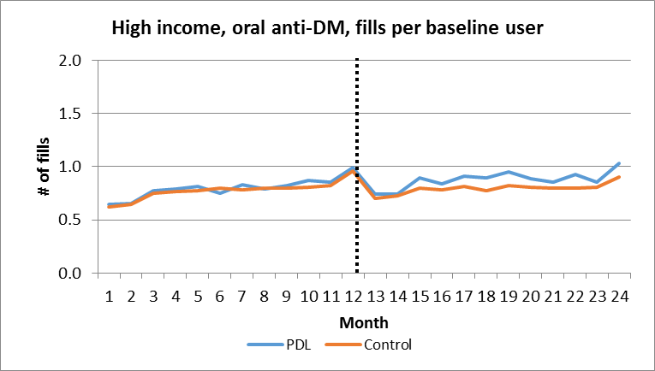 | 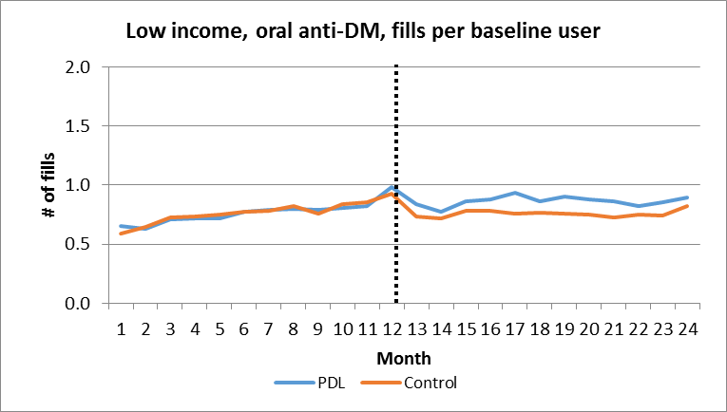
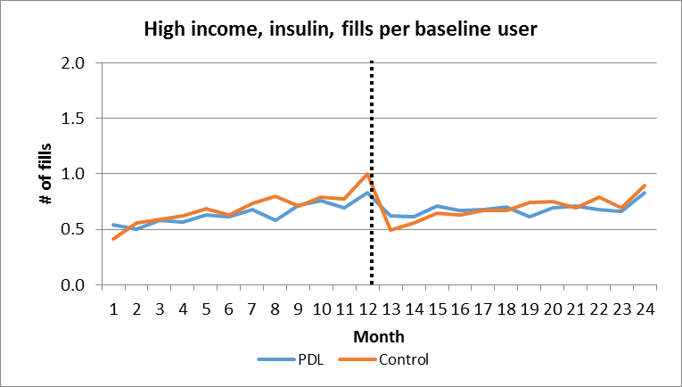 | 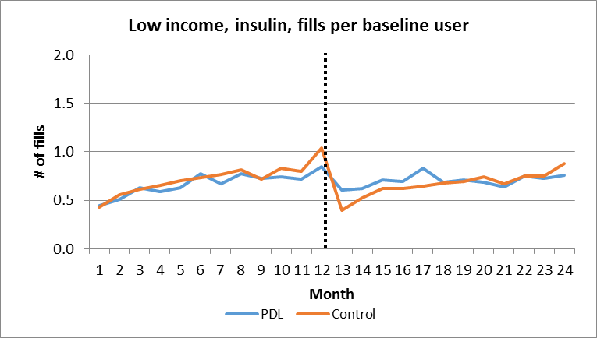
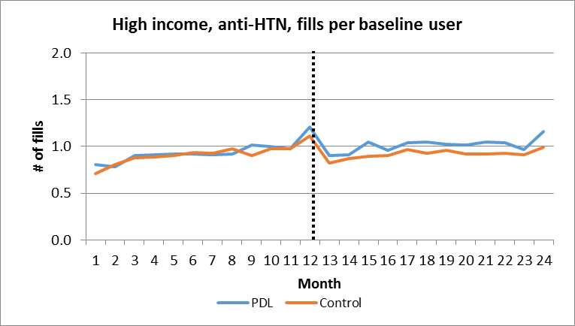 | 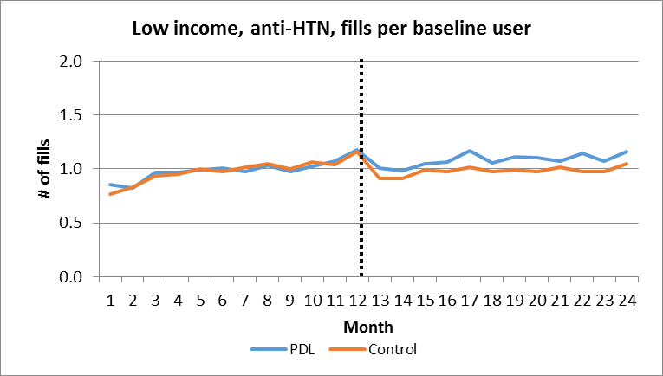
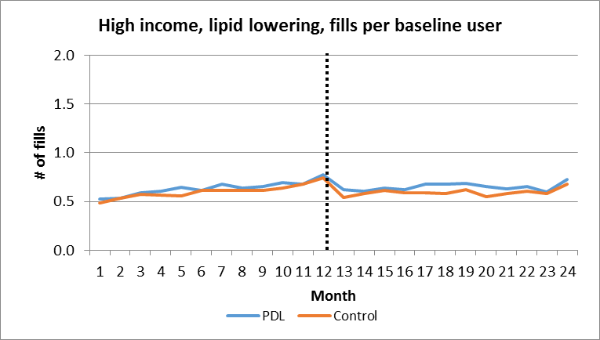 | 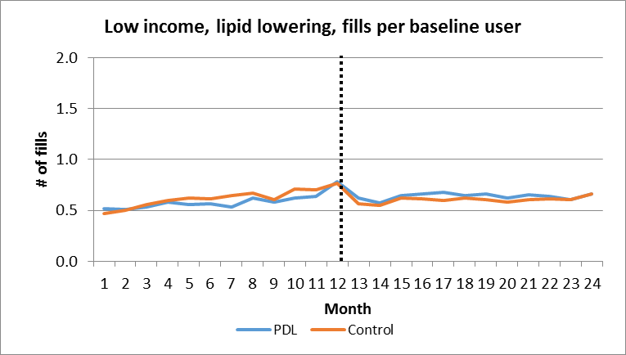

SDC citations
1. Wharam JF, Zhang F, Eggleston EM, Lu CY, Soumerai S, Ross-Degnan D. Diabetes Outpatient Care and Acute Complications Before and After High-Deductible Insurance Enrollment: A Natural Experiment for Translation in Diabetes (NEXT-D) Study. JAMA Intern Med 2017;177(3):358.
2. Wharam JF, Zhang F, Eggleston EM, Lu CY, Soumerai SB, Ross-Degnan D. Effect of High-Deductible Insurance on High-Acuity Outcomes in Diabetes: A Natural Experiment for Translation in Diabetes (NEXT-D) Study. Diabetes Care 2018;dc171183.
3. Wharam JF, Lu CY, Zhang F, et al. High-Deductible Insurance and Delay in Care for the Macrovascular Complications of Diabetes. Ann Intern Med 2018;169(12):845.
4. D’Agostino RB. Propensity score methods for bias reduction in the comparison of a treatment to a non-randomized control group. Stat Med 1998;17(19):2265–81.
5. Austin PC. An Introduction to Propensity Score Methods for Reducing the Effects of Confounding in Observational Studies. Multivar Behav Res 2011;46(3):399–424.
6. Austin PC. Optimal caliper widths for propensity-score matching when estimating differences in means and differences in proportions in observational studies. Pharm Stat 2011;10(2):150–61.
7. Austin PC. A comparison of 12 algorithms for matching on the propensity score. Stat Med 2014;33(6):1057–69.
8. Geronimus AT, Bound J, Neidert LJ. On the Validity of Using Census Geocode Characteristics to Proxy Individual Socioeconomic Characteristics [Internet]. National Bureau of Economic Research; 1995 [cited 2019 May 12]. Available from: http://www.nber.org/papers/t0189
9. Krieger N. Overcoming the absence of socioeconomic data in medical records: validation and application of a census-based methodology. Am J Public Health 1992;82(5):703–10.
10. Krieger N, Chen JT, Waterman PD, Soobader M-J, Subramanian SV, Carson R. Geocoding and monitoring of US socioeconomic inequalities in mortality and cancer incidence: does the choice of area-based measure and geographic level matter?: the Public Health Disparities Geocoding Project. Am J Epidemiol 2002;156(5):471–82.
11. Kwok RK, Yankaskas BC. The use of census data for determining race and education as SES indicators: a validation study. Ann Epidemiol 2001;11(3):171–7.
12. Wharam JF, Graves AJ, Zhang F, Soumerai SB, Ross-Degnan D, Landon BE. Two-year trends in cancer screening among low socioeconomic status women in an HMO-based high-deductible health plan. J Gen Intern Med 2012;27(9):1112–9.
13. Wharam JF, Zhang F, Landon BE, Soumerai SB, Ross-Degnan D. Low-socioeconomic-status enrollees in high-deductible plans reduced high-severity emergency care. Health Aff Proj Hope 2013;32(8):1398–406.
14. Trivedi AN, Leyva B, Lee Y, Panagiotou OA, Dahabreh IJ. Elimination of Cost Sharing for Screening Mammography in Medicare Advantage Plans. N Engl J Med 2018;378(3):262–9.
15. Selby JV, Fireman BH, Swain BE. Effect of a copayment on use of the emergency department in a health maintenance organization. N Engl J Med 1996;334(10):635–41.
16. US Census Bureau. American Community Survey (ACS) [Internet]. [cited 2019 May 12];Available from: https://www.census.gov/programs-surveys/acs
17. Krieger N, Chen JT, Waterman PD, Rehkopf DH, Subramanian SV. Race/ethnicity, gender, and monitoring socioeconomic gradients in health: a comparison of area-based socioeconomic measures—the public health disparities geocoding project. Am J Public Health 2003;93(10):1655–1671.
18. U.S. Department of Health & Human Services. Poverty Guidelines [Internet]. ASPE. 2015 [cited 2019 May 12];Available from: https://aspe.hhs.gov/poverty-guidelines
19. Ethnic Technologies Frequently Asked Questions [Internet]. Ethn. Technol. [cited 2019 Aug 4];Available from: https://www.ethnictechnologies.com/faq
20. Fiscella K, Fremont AM. Use of geocoding and surname analysis to estimate race and ethnicity. Health Serv Res 2006;41(4 Pt 1):1482–500.
21. Elliott MN, Fremont A, Morrison PA, Pantoja P, Lurie N. A new method for estimating race/ethnicity and associated disparities where administrative records lack self-reported race/ethnicity. Health Serv Res 2008;43(5 Pt 1):1722–36.
22. Johns Hopkins ACG® System [Internet]. [cited 2019 May 12];Available from: https://www.hopkinsacg.org/
23. Weiner JP, Starfield BH, Lieberman RN. Johns Hopkins Ambulatory Care Groups (ACGs). A case-mix system for UR, QA and capitation adjustment. HMO Pract HMO Group 1992;6(1):13–9.
24. Reid RJ, Roos NP, MacWilliam L, Frohlich N, Black C. Assessing population health care need using a claims-based ACG morbidity measure: a validation analysis in the Province of Manitoba. Health Serv Res 2002;37(5):1345–64.
25. Weiner JP, Starfield BH, Steinwachs DM, Mumford LM. Development and application of a population-oriented measure of ambulatory care case-mix. Med Care 1991;29(5):452–72.
26. Orueta JF, Lopez-De-Munain J, Báez K, Aiarzaguena JM, Aranguren JI, Pedrero E. Application of the ambulatory care groups in the primary care of a European national health care system: does it work? Med Care 1999;37(3):238–48.
27. Reid R, MacWilliam L, Verhulst L, Roos N, Atkinson M. Performance of the ACG Case-Mix System in Two Canadian Provinces. Med Care 2001;39(1):86–99.

