APPENDIX 2 –Laboratory Calibration Tests
While extensive IMM laboratory calibration testing versus a Hybrid III was previously published and confirmed that kinematic measures fit a linear model versus Reference (Bartsch et al. Mil Med 2020, Bartsch et al. 2014 Stapp, Hedin et al. 2016 IEEE, Bartsch et al. 2019 IEEE, Bartsch et al. RMBS paper), additional testing in the Virginia Tech Sensor STAR Rating protocol was done.
In these tests the IMM was formed to an aluminum dentition that was rigidly attached to a NOCSAE size medium headform. The headform was connected to Hybrid III 50th percentile neck, the base of which was rigidly affixed to a moving trolley. A pendulum was raised to prescribed heights and delivered helmeted head impacts to the forehead, front boss, rear boss and rear with target headform center of gravity (CG) scalar peak linear acceleration (PLA) of 25g, 50g, 75g and 100g occurring over a time duration of about 10-15milliseconds. Each impact type was done twice for both custom-molded and boil-and-bite versions of the IMM, for a total of 64 calibration impacts. The IMM versus Reference scalar peak comparisons were reported for PLA, peak angular acceleration (PAA), peak linear velocity (PLV), peak angular velocity (PAV), kinetic energy transfer (KET) and impact location across all tested impacts and whether the results conform to a linear model. Definitions of ‘peak’ kinematics are given in Bartsch et al. (2014 Stapp).
All Laboratory Reference and IMM data traces are available in the Supplemental Materials.

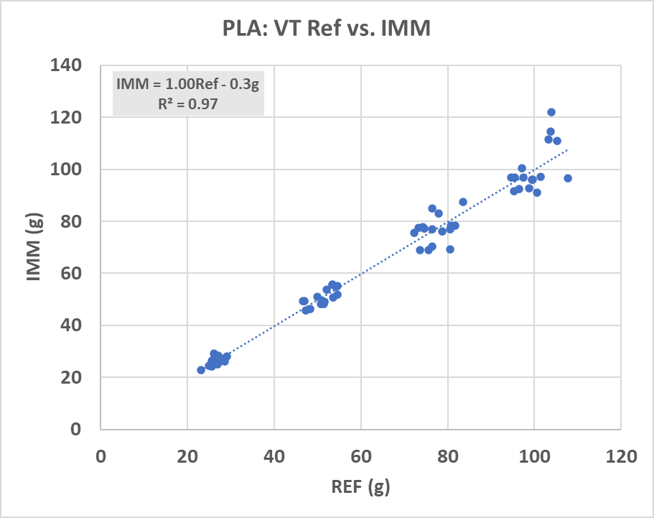
Fig. A1a PLA Results from Virginia Tech Laboratory 5 STAR Sensor Calibration Tests, n=64 tests. The results fit a linear model.

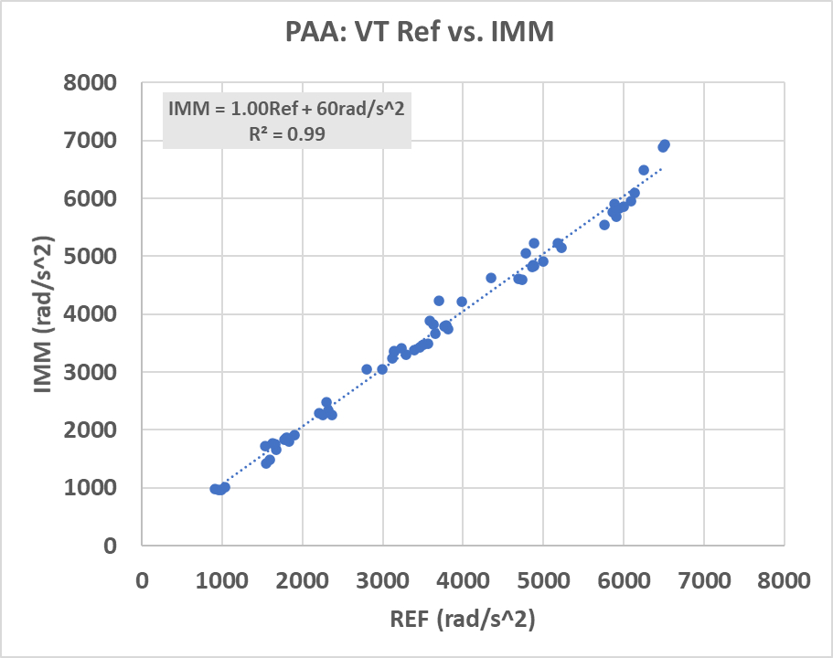
Fig. A1b PAA Results from Virginia Tech Laboratory 5 STAR Sensor Calibration Tests.
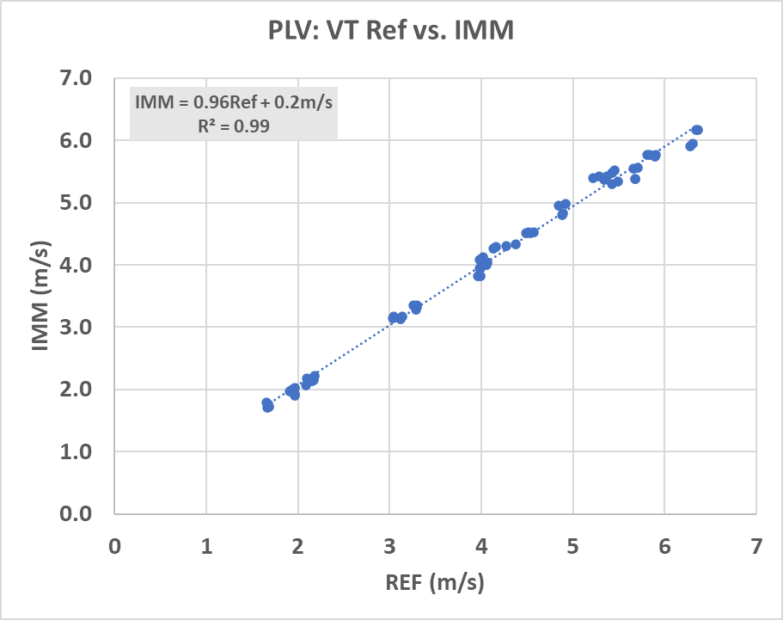
Fig. A1c PLV Results from Virginia Tech Laboratory 5 STAR Sensor Calibration Tests.
Fig. A1d PAV Results from Virginia Tech Laboratory 5 STAR Sensor Calibration Tests.

APPENDIX 3 – Data Acquisition Setup
When data collection was triggered, raw data persists to memory, firmware computations to head CG were done and an iOS application on an iPhone/iPad wirelessly pulled data when within range of ~25-50 meters. The iOS link also set the time on the IMM any time the device was in range. After reaching the iOS device, the data were available for display and in parallel pushed to a secure cloud portal whenever a wireless data connection or Wi-Fi was available. More extensive data viewing and analysis was available in the portal. Up to 475 data records were stored on-board the IMM whenever the athlete was collecting data out of range.
The IMM system was setup with an ultra-low trigger level of 5g and head impact detection algorithms were turned off. This was done to reduce chances of a false negative head impact, e.g. obvious impact on video above ~20g but no IMM triggering.
The sensing elements rested near the first left lateral incisor in their own local coordinate frame. For any movement of the accelerometer axes that exceeded 5g, the sensors collected 3200Hz raw linear acceleration and angular velocity data over a duration of 50 milliseconds – the 5g point was nominally 10 milliseconds into the record – and used textbook transforms to estimate CG kinematics in a head-attached J211 coordinate frame (SAE J211, 2010).
The XYZ and scalar linear and angular accelerations and velocities were computed by the on-board firmware with a 200Hz, 4-pole Butterworth low-pass filter. This filter maximized signal-noise ratio of the first two harmonics by removing environmental and computational noises (Bartsch et al. 2014). The linear velocity was assumed to be zero at the start of data collection; the KET estimate used this computed velocity, the CG-transformed angular velocity, estimated mass (4.5kg) and estimated mass moment of inertia (0.02 kg-m^2) for a midsize male head. The PLV and PAV were computed as the change in velocity from the initial reading at trigger time (PAV) or initial estimate at trigger time (PLV). From the computed CG time traces, PLA, PAA, PLV, PAV, KET and impact location are reported in this paper while full time traces are available in the APPENDIX.
Every head impact kinematics time series with PLA>10g and occurred during time in which the player was on the field was visually checked by an engineer to ensure signal-noise ratios in the time traces and in the peak scalar values made physical sense, in a similar manner to prior studies (Bartsch et al. 2014 Stapp, Bartsch et al. 2019 IEEE, Shah et al. 2019 IRCOBI, Zhao et al. 2019 IRCOBI, Bartsch et al. 2019 BioMedSciInstr, Bartsch et al. 2020 MilMed). Minor inertial motion/head impacts with PLA<10g were not reviewed for signal-noise ratio.

APPENDIX (4)
Video Description | Reviewer #1, after play | Reviewer #1, description | Reviewer #1 | Reviewer #2, after play | Reviewer #2, description | Reviewer #2 | Clinician Review | Position | PLA | PAA | PLV | PAV | KET | RWE | Direction
Head to turf jumping on to make catch. Looks okay. Nothing Obvious. | Continues to play | No visual signs of impairment | No OPD | Continues to Play | No visual signs of impairment | No OPD | No OPD | RB/LB | 35 | 1626 | 4.0 | 13 | 37 | 0.00 | FRONT
Nothing obvious. Either trips over teammate after play, or stumbles. | Continues to Play | No visual signs of impairment | No OPD | Altered Balance and/or Coordination of movement | stumbles | OPD | No OPD | RB/LB | 39 | 1743 | 3.5 | 21 | 32 | 0.00 | FRONT
Continued to play after impact. | Continues to play | No visual signs of impairment | No OPD | Continues to Play | No visual signs of impairment | No OPD | No OPD | OL/DL | 41 | 3846 | 3.5 | 12 | 29 | 0.01 | SIDE
Nothing obvious, blocks LB in hole, big impact to front, looks fine. | Continues to play | No visual signs of impairment | No OPD | Continues to Play | No visual signs of impairment | No OPD | No OPD | TE | 42 | 2296 | 3.9 | 20 | 38 | 0.00 | FRONT
Impact and nothing obvious. | Continues to Play | No visual signs of impairment | No OPD | Continues to Play | No visual signs of impairment | No OPD | No OPD | LB | 43 | 1157 | 4.2 | 9 | 40 | 0.00 | FRONT
Blocks LB in hole, front of head, looks fine. Nothing Obvious. | Continues to play | No visual signs of impairment | No OPD | Continues to Play | No visual signs of impairment | No OPD | No OPD | WR | 43 | 1729 | 3.8 | 14 | 35 | 0.00 | REAR
Nothing obvious, glancing blow, continues during play. Looks fine. | Continues to play | No visual signs of impairment | No OPD | Continues to Play | No visual signs of impairment | No OPD | No OPD | TE | 47 | 1930 | 4.1 | 17 | 42 | 0.00 | FRONT
Head to head at 5 yard line. Continued to play. No visual signs of being affected. | Continues to play | No visual signs of impairment | No OPD | Continues to Play | No visual signs of impairment | No OPD | No OPD | DB (S) | 47 | 1916 | 3.8 | 22 | 38 | 0.00 | FRONT
Head into pile. Likely caused by knee or thigh of opponent. Nothing Obvious. | Continues to play | No visual signs of impairment | No OPD | Continues to Play | No visual signs of impairment | No OPD | No OPD | TE | 49 | 2082 | 3.7 | 12 | 32 | 0.00 | FRONT
Big impact. Looks fine, nothing obvious. | Continues to play | No visual signs of impairment | No OPD | Continues to Play | No visual signs of impairment | No OPD | No OPD | DB (S) | 49 | 2635 | 3.7 | 17 | 33 | 0.00 | FRONT
Makes tackle on punt coverage, large hit to front of head - looks fine. Nothing Obvious. | Continues to play | No visual signs of impairment | No OPD | Continues to Play | No visual signs of impairment | No OPD | No OPD | TE | 50 | 1820 | 4.1 | 8 | 38 | 0.00 | FRONT
Continued to play, no visual signs of being affected. | Continues to play | No visual signs of impairment | No OPD | Continues to Play | No visual signs of impairment | No OPD | No OPD | OL/DL | 53 | 2638 | 4.1 | 13 | 40 | 0.00 | FRONT
Continued to play after head-to-head on pass breakup near 41 yard line. No visual signs of being affected. Opponent is hurt. | Continues to play | No visual signs of impairment | No OPD | Continues to Play | No visual signs of impairment | No OPD | No OPD | DB | 56 | 2106 | 5.1 | 20 | 63 | 0.00 | SIDE
Continued to play after impact near 31 yard line. | Continues to play | No visual signs of impairment | No OPD | Continues to Play | No visual signs of impairment | No OPD | No OPD | LB | 59 | 3921 | 4.8 | 22 | 58 | 0.01 | SIDE
Continued to play. Doesn't seem dazed at all after impact near 49 yard line. | Continues to play | No visual signs of impairment | No OPD | Continues to Play | No visual signs of impairment | No OPD | No OPD | RB/LB | 60 | 2328 | 5.2 | 16 | 64 | 0.00 | FRONT
Nothing obvious after blocking LB in hole, big impact to front seen and he might be clutching head. | Continues to Play | No visual signs of impairment | No OPD | Atypical post-impact behavior | Clutching head | OPD | Questionable OPD | LB | 50 | 1748 | 4.1 | 8 | 39 | 0.00 | SIDE
Might be goofing around but lays on field 5 sec after impact. | Altered Balance and/or Coordination of movement | Slow-to-get-up | OPD | Altered Balance and/or Coordination of movement | Slow-to-get-up | OPD | Questionable OPD | LB | 51 | 2718 | 3.0 | 18 | 24 | 0.00 | SIDE
Drops head when tackling after big impact. Teammate later seeks out sideline staff. | Atypical post-impact behavior | Teammate seeks out sideline personnel | OPD | Atypical post-impact behavior | Teammate seeks out sideline personnel | OPD | Likely OPD | SS | 36 | 2684 | 3.3 | 32 | 35 | 0.00 | REAR
Evaluated by sideline staff and returned to play after huge impact. Appears to intentionally avoid contact while playing. | Atypical post-impact behavior, Altered balance and/or movement coordination | Irregular sport-related actions (incorrect playing style), Unstable movement, Teammate seeks out sideline caregivers | OPD | Atypical post-impact behavior, Altered balance and/or movement coordination | Irregular sport-related actions (incorrect playing style), Unstable movement, Teammate seeks out sideline caregivers | OPD | Likely OPD | SS | 51 | 2233 | 3.7 | 22 | 37 | 0.00 | SIDE
Removed from play did not return. Does not get up from hit near 38 yard line. | Altered Balance and/or Coordination of movement | A functional disturbance (can't get up, can't walk straight) | OPD | Altered Balance and/or Coordination of movement | A functional disturbance (can't get up, can't walk straight) | OPD | Likely OPD | LB | 56 | 2503 | 4.0 | 18 | 39 | 0.00 | REAR
Dives into pile, hard to see but is holding head after play. Looks shook up. | Atypical post-impact behavior | Grabs head after play | OPD | Atypical post-impact behavior | Clutching head | OPD | Likely OPD | LB | 58 | 1712 | 4.6 | 8 | 49 | 0.00 | SIDE
Removed from play did not return. Does not get up from hit at 15 yard line | Possible Loss of Consciousness | Fencing response/posture | OPD | Possible Loss of Consciousness | Fencing response/posture | OPD | Likely OPD | RB | 58 | 3670 | 7.0 | 26 | 118 | 0.01 | SIDE
Continued to play. Balance looks off and looks confused after impact near 30 yard line. | Atypical post-impact behavior | Confusion, disorientation, irregular sport-related movement | OPD | Atypical post-impact behavior | Confusion, disorientation, irregular sport-related movement | OPD | Likely OPD | SS | 59 | 2731 | 4.0 | 22 | 40 | 0.00 | SIDE
Grabs head and slowly walks off field after impact near 32 yard line | Atypical post-impact behavior | Grabs head and slowly walks to sideline | OPD | Atypical post-impact behavior | Clutching head | OPD | Likely OPD | OL/DL | 61 | 3290 | 7.0 | 23 | 116 | 0.01 | REAR
Continued to play after impact near 40 yard line. Teammate helps pick him up. | Altered Balance and/or Coordination of movement | Slow-to-get-up | OPD | Altered Balance and/or Coordination of movement | Slow-to-get-up | OPD | Likely OPD | RB | 62 | 2529 | 4.0 | 9 | 38 | 0.00 | FRONT
Continued to play after a big impact. Balance looks off and looks confused after play. On next play intentionally avoids contact with QB. | Altered Balance and/or Coordination of movement | A functional disturbance (can't get up, can't walk straight) | OPD | Continues to Play | No visual signs of impairment | No OPD | Likely OPD | SS | 82 | 3724 | 4.9 | 38 | 68 | 0.02 | SIDE
Teammate signals to staff after huge hit near 40 yard line. Brief evaluation and returned to play. Forgets helmet when returning to play. | Altered Balance and/or Coordination of movement | Slow-to-get-up | OPD | Altered Balance and/or Coordination of movement | Slow-to-get-up | OPD | Likely OPD | WR | 84 | 5047 | 6.6 | 16 | 101 | 0.07 | SIDE
Big impact on kickoff coverage and runs off field instead of following play. Later removed from play. | Altered Balance and/or Coordination of movement | A functional disturbance (can't get up, can't walk straight) | OPD | Altered Balance and/or Coordination of movement | A functional disturbance (can't get up, can't walk straight) | OPD | Likely OPD | LB | 84 | 4408 | 5.2 | 28 | 68 | 0.04 | SIDE
Slow to get off of field after impact. Goes to bench and sits with head down. | Altered Balance and/or Coordination of movement | Has a hard time getting off of the field, last one to sideline | OPD | Altered Balance and/or Coordination of movement | Slow speed of movement | OPD | Likely OPD | LB | 89 | 3732 | 6.7 | 28 | 110 | 0.03 | SIDE
Removed from game. Did not return after impact at 13 yard line. | Possible Loss of Consciousness | Fencing response/posture | OPD | Possible Loss of Consciousness | Fencing response/posture | OPD | Likely OPD | WR | 99 | 4315 | 6.2 | 22 | 92 | 0.07 | REAR
Table A1. Summary of top 30 head impacts by PLV with OPD observations from video

Appendix 5 – GLOSSARY
AE: Athlete-Exposure
KET: Estimated Kinetic Energy Transfer
OPD: Obvious Performance Decrement
IMM: Impact Monitoring Mouthguard
PAA: Peak Scalar Angular Acceleration
PAV: Peak Scalar Angular Velocity
PLA: Peak Scalar Linear Acceleration
PLV: Peak Scalar Linear Velocity
RWE: Risk Weighted Exposure

