**Supplemental material**

**Pulmonary and systemic toxicity in rats following inhalation exposure of 3-D printer emissions from acrylonitrile butadiene styrene (ABS) filament**

Mariana T. Farcasa,b, Walter McKinneya, Chaolong Qic, Kyle W. Mandlera, Lori Battellia, Sherri A. Frienda, Aleksandr B. Stefaniaka, Mark Jacksona, Marlene Orandlea, Ava Winna, MichaelKashona, Ryan F. LeBoufa, Kristen A. Russa, Duane R. Hammondc, Dru Burnsa, Anand Ranparaa, Treye A.Thomasd, Joanna Mathesond, Yong Qiana*

aNational Institute for Occupational Safety and Health, Morgantown, West Virginia

bPharmaceutical and Pharmacological Sciences, School of Pharmacy, West Virginia University, Morgantown, West Virginia

cNational Institute for Occupational Safety and Health, Cincinnati, Ohio

dOffice of Hazard Identification and Reduction, U.S. Consumer Product Safety Commission, Rockville, Maryland

**\*Corresponding Author:** Dr. Yong Qian, Pathology and Physiology Branch, Health Effects Laboratory Division, National Institute for Occupational Safety and Health, 1095 Willowdale Road, Morgantown, WV 26505 USA. Phone: (304) 285-6286. E-mail: [yaq2@cdc.gov](mailto:yaq2@cdc.gov).

**Table S1.** Three-dimensionalprinter settings.

Acrylonitrile butadiene styrene (ABS) is one of the most popular filaments used in FFF 3-D printers. It is a petrochemical material derived by the copolymerization of 1,3-butadiene and styrene. The butadiene units offer good impact strength, the styrene units give the copolymer its rigidity, and the acrylonitrile units allow heat resistance, making it widely used in industry (Jyoti et al. 2015).

|  |  |
| --- | --- |
| **Setting Name** | **Value** |
| Print nozzle temperature | 260 ºC |
| Print bed temperature | 100 ºC |
| Layer Height | 0.25 mm |
| Line Width | 0.5 mm |
| Wall thickness | 3 lines (1.5 mm) |
| Number of solid bottom layers | 4 (1.0 mm) |
| Number of solid top layers | 4 (1.0 mm) |
| Infill density | 25% |
| Print speed (1st layer) | 45 mm/sec |
| Print speed after 1st layer | 120 mm/sec |
| Print bed adhesion | PEI sheet, no glue. |

**Figure S1:** Object printed for each exposure and sample run: A) completed 3-D printed object, and

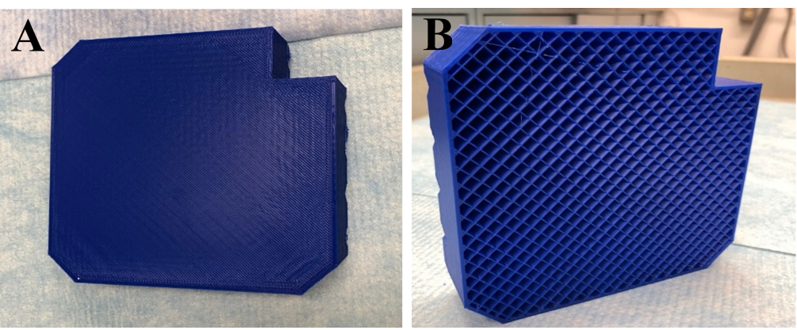B) 3-D printed object stopped before printing the top layers to show infill pattern. The objects printed were 12.7 cm wide by 12.7 cm long, with a height of about 2.54 cm.

**Figure S2:** Experimental design.

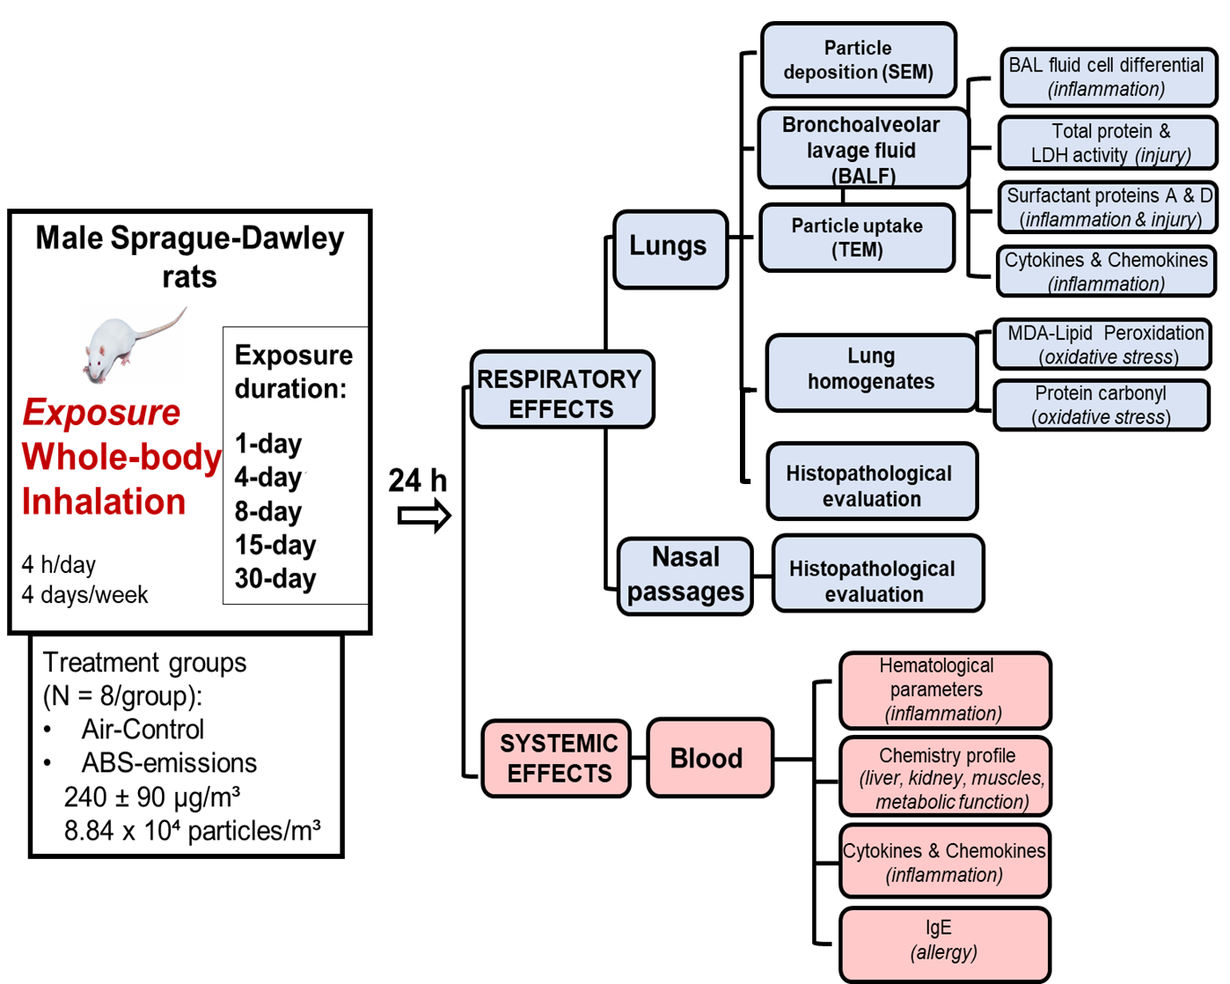

The 4 hours per day exposure duration was selected due to time issues. This was the maximum amount of time that could be allocated to our study by the NIOSH Inhalation Facility staff without impacting other inhalation exposure projects conducted at the same time. Prior to each exposure, the staff had to clean the chambers, remove old printed parts, clean build plates, replace clogged print heads, load / unload animals into the two different exposure chambers (HEPA-filtered air and printer emissions-exposure chamber, respectively), load the filaments into the three printers, ensure proper printing, etc. The 4 days per week exposure schedule was selected to accommodate the schedule of our collaborators who were involved in FFF 3-D printer emission-induced neurotoxicity, hepatotoxicity, microvascular, cardiovascular, and reproductive toxicities studies.

Two identical exposure chambers were used to simultaneously conduct the exposures to HEPA-filtered air and ABS emissions, respectively. The exposures were performed during the daylight portion of the rats’ circadian cycle (from about 9:00 am until 1:00 pm) when they would be mostly inactive/sleeping. Also, during this time, the animals did not have access to food/water or bedding.

Uniformity of exposure from one animal to another was achieved by rotating the rat’s locations daily, throughout the exposure sessions within the animal cage. Furthermore, based on previous tests conducted on the same exposure chambers, we observed less than a 12 % concentration variation across animal cage locations, indicating a spatial uniformity of airborne distribution of printer emissions.

The aerosol mass concentration inside the exposure chamber was continuously monitored with a Data RAM (DR-40000; Thermo Electron Co., Waltham, MA), which was connected to a 1/4 inches (0.64 cm) stainless steel sample tube to sample air from a location near the animals' breathing space. The 240 µg/m³ exposure concentration was the maximum concentration that we could reliably achieve for the repeated exposure runs. Based on our previous experience

(Farcas et al. 2019) and other researcher's reports (Azimi et al. 2016), the inherent variability in the ultrafine particulate (UFP) between the repeated print runs using the same filament is recognized and unavoidable at the moment.

We have not evaluated the particle size or transformations/agglomerations pre-tube (inside printer generation chamber) versus post-tube (inside animal exposure chamber). However, the tubing length was about 6 inches (15 cm) long. Therefore, the particle agglomeration could be affected more by the time spent in the 3-D printer enclosure or time in the exposure chamber. Moreover, the particle size range generated with our system is similar to what has been reported in the literature (Byrley et al. 2019), suggesting that our system does not affect the particle size and is relevant to the indoor environments and occupational settings.

**Figure S3**. Body weight of animals at euthanasia demonstrating that the rats were gaining weight over time, and that there is no significant difference between the air-control and ABS-treated group.

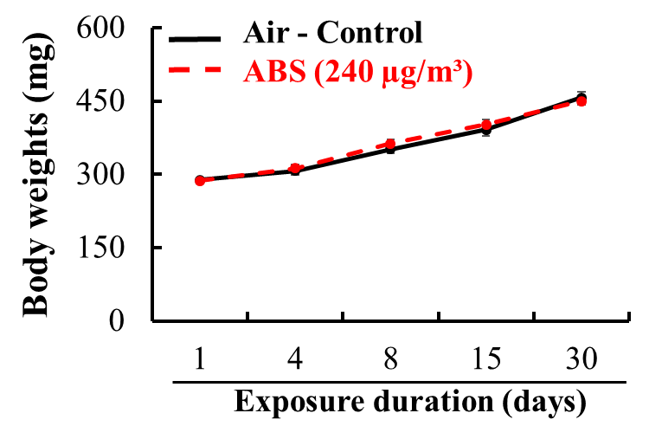

***Estimating equivalent alveolar lung burden in a rat based on previous cell exposures***

For comparison of results in the current study, calculations were made to estimate the equivalent lung burden required for rat lungs to achieve the same dose as that given to the cell culture (Farcas et al. 2019).

The following calculations were made using a custom MATLAB script (MathWorks Inc., Natick, MA). In the cell exposure study, the median particle size in the cell culture medium was found to be 201 nm and ranged in size from about 100 nm to 400 nm. A log-normal distribution curve was generated with a median of 200 nm and to have 95 % of its total area between 100 and 400 nm. This distribution had a bin (data point) every 10 nm ranging from 50 to 600 nm. The total sum of all the bins was set to 1 x 107. This was meant to represent one ml of a solution containing 107 particles. In our previous study, the ABS average particle concentration per ml ranged from 0.45 × 107 to 1.51 × 107. The 107 value was used because it corresponded to one of the doses previously measured and tested in the cell culture media and for easier back-calculation. Assuming all particles are spherical and have a density of 1.04 g/cm3 (density of ABS filament), the mass distribution can be calculated. Each data point in the count distribution was converted to mass using the following equation:

Mass = D x (4/3) × π × r3

Where: D = density, and r = radius of the particle. The sum of mass from every bin in the distribution was then calculated, resulting in 0.626 µg/ml of solution. Each well was given 0.100 ml of solution. Thus, the estimated particle mass per cell well was 0.0626 µg. Each cell well had a surface area of 0.33 cm2. By dividing mass per cell well by area of well, the result was 0.190 µg/cm2. A typical rat lung has an alveolar surface area of approximately 4,000 cm2 (Stone et al. 1992). To achieve the same mass per surface area in a rat lung as what was calculated to be on the wells, a rat would have a lung burden of (0.190 µg/cm2) × (4,000 cm2) = 759 µg.

Summary of MATLAB calculations

mass per ml per 1 × 107 particles in solution = 0.626 µg

each cell well was given 0.100 ml of solution.

mass per well = 0.062606 µg

each cell well area = 0.33 cm2

mass per area on cells = 0.189716 µg/cm2

area of a typical rat lung = 4,000 cm2

equivalent lung burden in a rat for 107 particles = 758.8 µg

Based on MATLAB calculations, the equivalent alveolar lung burden in a rat for 107 ABS particles per ml would be equal to approximately 758 µg in this study.

**Figure S4.** Figure adapted from our previous study (Farcas et al. 2019) displaying the regression analyses performed on the cell viability and LDH activity of small airways epithelial cells using particle number*10-4 as the independent variable. The dotted black line indicates 3.5 × 10⁶ particle/cm² which is approximately equal to 1 × 107 ABS particles per ml, which caused a 10% decrease in viability and 20% increase of LDH over control.

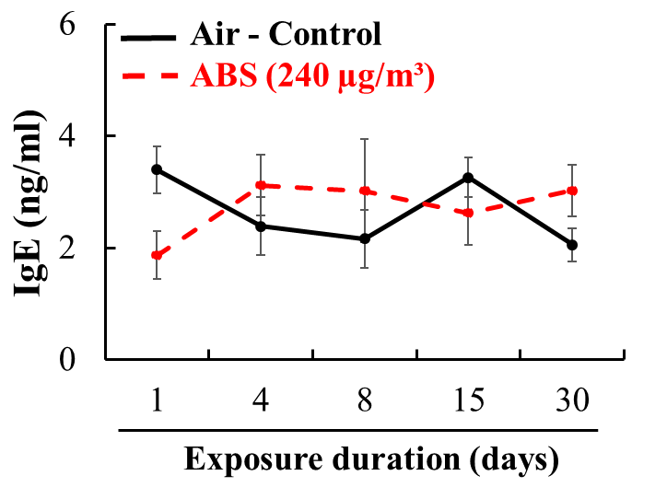**Figure S5**. IgE serum levels. The rats were exposed for 1, 4, 8, 15, and 30 days to air or ABS emissions (240 µg/m³) and euthanized at 24 h post last exposure. Values represents means ± SEMs; N = 8/group/time point.

**Table S2:** Cytokines in rats following exposure to ABS emissions at any time point when compared to air-control rats. The rats were exposed for 1, 4, 8, 15, and 30 days to air or ABS emissions (240 µg/m³) and euthanized at 24 h post last exposure. Values represents means ± SEMs; N = 8/group/time point.

|  |  |  |  |  |  |  |
| --- | --- | --- | --- | --- | --- | --- |
| **Marker**  **(pg/ml ± SEM)** | **Agent** | **Exposure duration (days)** | | | | |
| **1** | **4** | **8** | **15** | **30** |
| **IFN-γ** | **Air** | 14.87 ± 1.50 | 15.59 ± 1.50 | 18.79 ± 1.41 | 16.57 ± 2.71 | 19.41 ± 3.28 |
| **ABS** | 13.92 ± 1.28 | 16.04 ± 1.16 | 15.13 ± 2.03 | 18.30 ± 2.88 | 24.20 ± 3.05 |
| **IL-10** | **Air** | 61.55 ± 3.77 | 71.49 ± 4.77 | 73.26 ± 2.42 | 77.68 ± 6.82 | 80.89 ± 5.55 |
| **ABS** | 61.53 ± 3.273 | 70.68 ± 3.79 | 74.74 ± 4.90 | 80.24 ± 6.57 | 88.32 ± 3.91 |
| **IL-13** | **Air** | 4.28 ± 0.40 | 4.41 ± 0.63 | 4.71 ± 0.40 | 4.47 ± 0.40 | 3.67 ± 0.40 |
| **ABS** | 3.66 ± 0.47 | 3.99 ± 0.70 | 4.45 ± 0.38 | 4.64 ± 0.59 | 4.38 ± 0.79 |
| **IL-1β** | **Air** | 5.10 ± 1.20 | 6.75 ± 2.37 | 12.43 ± 4.15 | 12.61 ± 4.28 | 16.45 ± 4.06 |
| **ABS** | 3.87 ± 0.01 | 8.24 ± 3.56 | 4.48 ± 0.67 | 11.12 ± 3.60 | 20.57 ± 3.50 |
| **IL-4** | **Air** | 8.48 ± 0.53 | 9.75 ± 0.86 | 9.48 ± 0.50 | 10.29 ± 0.85 | 11.14 ± 1.08 |
| **ABS** | 8.98 ± 0.67 | 9.41 ± 0.45 | 9.72 ± 0.47 | 10.25 ± 1.14 | 11.04 ± 0.94 |
| **IL-5** | **Air** | 46.43 ± 7.13 | 51.97 ± 5.87 | 51.98 ± 6.46 | 36.74 ± 5.55 | 43.17 ± 10.22 |
| **ABS** | 44.58 ± 4.30 | 42.76 ± 7.25 | 42.74 ± 5.19 | 37.29 ± 5.42 | 40.27 ± 6.77 |
| **IL-6** | **Air** | 79.59 ± 9.69 | 79.69 ± 10.60 | 86.73 ± 7.58 | 94.47 ± 11.03 | 78.18 ± 13.06 |
| **ABS** | 70.72 ± 11.83 | 82.34 ± 14.25 | 86.90 ± 27.25 | 106.39 ± 17.45 | 92.70 ± 25.44 |
| **KC/GRO** | **Air** | 267.57 ± 28.59 | 181.10 ± 10.08 | 205.37 ± 12.92 | 199.08 ± 14.89 | 232.98 ± 19.94 |
| **ABS** | 258.51 ± 16.41 | 235.71 ± 18.34 | 234.60 ± 26.05 | 237.26 ± 12.76 | 186.87 ± 17.37 |
| **TNF-α** | **Air** | 5.74 ± 0.65 | 5.40 ± 0.49 | 5.30 ± 0.31 | 4.27 ± 0.35 | 4.60 ± 0.29 |
| **ABS** | 5.81 ± 0.55 | 3.78 ± 0.78 | 5.79 ± 1.33 | 4.76 ± 0.47 | 4.88 ± 0.31 |

**References**

Azimi P, Zhao D, Pouzet C, Crain NE, Stephens B. 2016. Emissions of Ultrafine Particles and Volatile Organic Compounds from Commercially Available Desktop Three-Dimensional Printers with Multiple Filaments. Environ Sci Technol. 50(3):1260-1268.

Byrley P, George BJ, Boyes WK, Rogers K. 2019. Particle emissions from fused deposition modeling 3D printers: Evaluation and meta-analysis. Science of The Total Environment. 655:395-407.

Farcas MT, Stefaniak AB, Knepp AK, Bowers L, Mandler WK, Kashon M, Jackson SR, Stueckle TA, Sisler JD, Friend SA et al. 2019. Acrylonitrile butadiene styrene (ABS) and polycarbonate (PC) filaments three-dimensional (3-D) printer emissions-induced cell toxicity. Toxicol Lett. 317:1-12.

Jyoti J, Basu S, Singh BP, Dhakate SR. 2015. Superior mechanical and electrical properties of multiwall carbon nanotube reinforced acrylonitrile butadiene styrene high performance composites. Composites Part B: Engineering. 83:58-65.

Stone KC, Mercer RR, Gehr P, Stockstill B, Crapo JD. 1992. Allometric relationships of cell numbers and size in the mammalian lung. American journal of respiratory cell and molecular biology. 6(2):235-243. eng.