SUPPLEMENTARY FIGURE. Change in antibody signal-to-threshold ratio of pan-Immunoglobulin reactivity to SARS-CoV-2 full length S protein ELISA from a baseline visit (April–June 2020) to a follow-up visit approximately 60 days later (range: 50-91 days) later,*,† overall and by baseline antibody level (156 frontline health care workers) — 13 academic medical centers, United States, April–August, 2020
C. High positive (≥3.0) baseline signal-to-threshold ratio (N = 99)
B. Low positive (1.0–2.9) baseline signal-to-threshold ratio (N = 57)
A. Full population (N = 156)

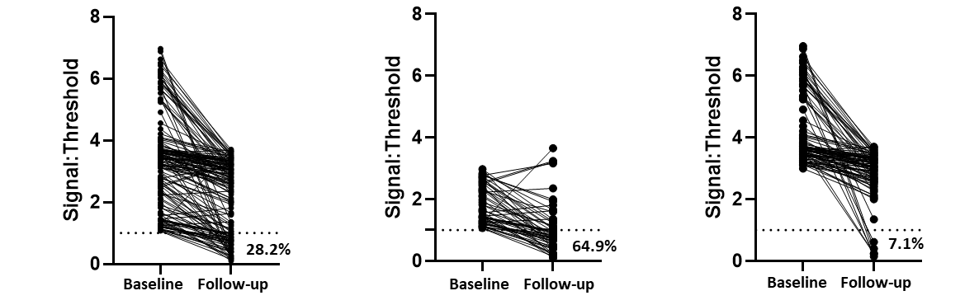
Abbreviation: ELISA = enzyme-linked immunosorbent assay. Plots generated using GraphPad Prism Version 8 (San Diego, CA, USA)
* The population included 156 frontline healthcare personnel in the United States from 13 academic medical centers in 12 states who tested positive for SARS-CoV-2 antibodies (signal-to-threshold >1.0) at the baseline visit and underwent repeat testing at the follow-up visit.
† The dashed horizontal line at a signal-to-threshold value of 1.0 represents the threshold to define a reactive (positive) antibody test; the percentage of participants with antibody decline below the level of positivity (seroreversion) at the follow-up visit is noted in each panel.

