**Urinary Metal Mixtures and Longitudinal Changes in Glucose Homeostasis: The Study of Women’s Health Across the Nation (SWAN)**

Xin Wang, Bhramar Mukherjee, Carrie A. Karvonen-Gutierrez, William H. Herman,

Stuart Batterman, Siobán D. Harlow, Sung Kyun Park

**TABLE OF CONTENTS**

**Table A.1**. Distribution of urinary metal concentrations in SWAN.

**Table A.2.** Selectednon-zero beta coefficients of metals for baseline HOMA insulin resistance (HOMA-IR) and the annualized rate of change in adaptive elastic-net (AENET) models.

**Table A.3.** The association of quartiles of selected metals and environmental risk score (ERS) with HOMA insulin resistance (HOMA-IR) at baseline.

**Table A.4.** Selectednon-zero beta coefficients of metals for baseline HOMA β-cell function (HOMA-β) and the annualized rate of change in adaptive elastic-net (AENET) models.

**Table A.5.** The association of quartiles of selected metals and environmental risk score (ERS) with HOMA insulin resistance (HOMA-β) at baseline.

**Table A.6.** Associations of selected metals with baseline HOMA insulin resistance (HOMA-IR) and its annualized rate of change in adaptive elastic-net (AENET) models after excluding participants with fasting glucose level ≥ 100 mg/dL or HOMA-IR ≥ 4.2 (90th percentile) at baseline (n=1.076).

**Table A.7.** Associations of selected metals with baseline HOMA β-cell function (HOMA-β) and its annualized rate of change in adaptive elastic-net (AENET) models after excluding participants with fasting glucose level ≥ 100 mg/dL or HOMA-IR ≥ 4.2 (90th percentile) at baseline (n=1.076).

**Table A.8.** Associations of urinary arsenic with HOMA β-cell function (HOMA-β) and the annualized rate of change in adaptive elastic-net (AENET) models in a subpopulation with seafood intake < 1 time/week (n=371).

**Table A.9.** Associations of selected metals with baseline HOMA insulin resistance (HOMA-IR) and its annualized rate of change in adaptive elastic-net (AENET) models without adjustment for body mass index at baseline.

**Table A.10.** Associations of selected metals with baseline HOMA β-cell function (HOMA-β) and its annualized rate of change in adaptive elastic-net (AENET) models without adjustment for body mass index at baseline.

**Figure A.1.** Schematic diagram of analytic sample.

**Figure A.2.** A directed acyclic graph (DAG) for evaluation of covariate selection in the analysis of metal effects on HOMA measures.

**Figure A.3.** Spearman correlation matrix of specific gravity adjusted urinary metal concentrations.

**Figure A.4.** Univariate and bivariate exposure-response function for the effects of copper, lead, molybdenum, and zinc on HOMA insulin resistance (HOMA-IR) at baseline estimated from Bayesian Kernel Machine Regression (BKMR).

**Figure A.5.** Univariate and bivariate exposure-response function for the effects of arsenic, cobalt, and zinc on HOMA β-cell function (HOMA-β) at baseline estimated from Bayesian Kernel Machine Regression (BKMR).

**Table A.1**. Distribution of urinary metal concentrations in SWAN.

|  |  |  |  |  |  |  |  |
| --- | --- | --- | --- | --- | --- | --- | --- |
| **Metals (μg/L)** | **LODa** | **% > LODb** | **GM (GSD)c** | **Selected percentiles** | | | |
|  |  |  |  | 25th | 50th | 75th | 90th |
| Arsenic | 0.3 | 100 | 17.43 (3.53) | 7.00 | 15.23 | 40.66 | 95.55 |
| Barium | 0.1 | 99.5 | 1.71 (2.47) | 0.99 | 1.77 | 2.95 | 4.86 |
| Cadmium | 0.06 | 94.6 | 0.41 (2.80) | 0.23 | 0.44 | 0.81 | 1.43 |
| Cobalt | 0.05 | 99.3 | 0.61 (2.27) | 0.38 | 0.62 | 0.96 | 1.70 |
| Cesium | 0.01 | 100 | 4.74 (1.99) | 3.07 | 4.75 | 7.35 | 10.47 |
| Copper | 2.5 | 96.7 | 9.36 (2.03) | 6.03 | 9.42 | 14.26 | 21.39 |
| Mercury | 0.05 | 99.8 | 1.21 (2.50) | 0.67 | 1.23 | 2.37 | 3.68 |
| Manganese | 0.08 | 99.6 | 0.96 (2.20) | 0.59 | 0.90 | 1.47 | 2.50 |
| Molybdenum | 0.3 | 100 | 42.18 (2.28) | 25.19 | 44.20 | 72.69 | 114.78 |
| Nickel | 0.8 | 96.0 | 3.58 (2.09) | 2.37 | 3.79 | 5.83 | 8.40 |
| Lead | 0.1 | 97.6 | 0.76 (2.34) | 0.46 | 0.78 | 1.26 | 2.09 |
| Antimony | 0.04 | 78.9 | 0.08 (2.17) | 0.05 | 0.07 | 0.13 | 0.21 |
| Tin | 0.1 | 96.9 | 0.97 (2.99) | 0.49 | 0.93 | 1.77 | 3.52 |
| Thallium | 0.02 | 92.6 | 0.13 (2.56) | 0.08 | 0.15 | 0.23 | 0.33 |
| Zinc | 2 | 100 | 272.44 (2.43) | 162.81 | 300.43 | 507.32 | 777.14 |

a LOD: limit of detection.

b % > LOD: detection rate

c GM: geometric mean; GSD: geometric standard deviation.

**Table A.2.** Selectednon-zero beta coefficients of metals for baseline HOMA insulin resistance (HOMA-IR) and the annualized rate of change in adaptive elastic-net (AENET) models.

|  |  |  |
| --- | --- | --- |
| Baseline HOMA-IRa | **Selected metals in AENET**b | **β for 1-SD increase in log-transformed urinary metal concentration**c  **(95% CI)** |
| Copper | 0.02 (-0.01, 0.04) |
| Molybdenum | -0.03 (-0.06, -0.01) |
| Lead | 0.01 (-0.02, 0.03) |
| Zinc | 0.06 (0.03, 0.08) |
| Annualized rate of change in HOMA-IR | **Selected metals in AENET** | **β for 1-SD increase in log-transformed urinary metal concentration**  **(95% CI)** |
| Zinc | 0.0006 (-0.0003, 0.0015) |

a HOMA-IR was log-transformed.

b AENET models were adjusted for age, race/ethnicity, study site, education level, annual household income, body mass index, smoking, alcohol drinking, physical activity score, menopausal status, hormone therapy, dietary intake of seafood and rice, total zinc intake from diets and supplements, total energy intake, and urinary specific gravity.

c All urinary metal concentrations were log-transformed and standardized.

**Table A.3.** The association of quartiles of selected metals and environmental risk score (ERS) with HOMA insulin resistance (HOMA-IR) at baseline.

|  |  |  |  |  |  |
| --- | --- | --- | --- | --- | --- |
|  | **Percentage change (95% CI) in HOMA-IRa** | | | |  |
| **Quartiles** | **Quartile 1** | **Quartile 2** | **Quartile 3** | **Quartile 4** | **P for trend** |
| ERS | Ref | 4.02 (-0.96, 9.24) | 6.91 (1.50, 12.60) | 15.70 (9.14, 22.64) | <0.0001 |
| Copper | Ref | -0.18 (-4.90, 4.77) | 2.83 (-2.21, 8.12) | 2.41 (-2.87, 7.97) | 0.22 |
| Molybdenum | Ref | -1.58 (-6.13, 3.19) | -1.10 (-5.74, 3.76) | -4.74 (-9.42, 0.18) | 0.08 |
| Lead | Ref | -0.81 (-5.44, 4.06) | 0.87 (-4.00, 5.99) | -1.02 (-6.13, 4.37) | 0.43 |
| Zinc | Ref | -0.48 (-5.16, 4.44) | 4.35 (-0.73, 9.68) | 8.92 (3.16, 15.00) | 0.0007 |

a Linear regression model was adjusted for age, race/ethnicity, study site, education level, annual household income, body mass index, smoking, alcohol drinking, physical activity score, menopausal status, hormone therapy, dietary intake of seafood and rice, total zinc intake from diets and supplements, total energy intake, and urinary specific gravity.

**Table A.4.** Selectednon-zero beta coefficients of metals for baseline HOMA β-cell function (HOMA-β) and the annualized rate of change in adaptive elastic-net (AENET) models.

|  |  |  |
| --- | --- | --- |
| Baseline HOMA- βa | **Selected metals in AENET**b | **β for 1-SD increase in log-transformed urinary metal concentration**c  **(95% CI)** |
| Arsenic | -0.02 (-0.04, 0.01) |
| Cobalt | 0.02 (-0.01, 0.04) |
| Zinc | -0.03 (-0.05, -0.01) |
| Annualized rate of change in HOMA- β | **Selected metals in AENET** | **β for 1-SD increase in log-transformed urinary metal concentration**  **(95% CI)** |
| Arsenic | -0.0002 (-0.0005, 0) |

a HOMA- β was log-transformed.

b AENET models were adjusted for age, race/ethnicity, study site, education level, annual household income, body mass index, smoking, alcohol drinking, physical activity score, menopausal status, hormone therapy, dietary intake of seafood and rice, total zinc intake from diets and supplements, total energy intake, and urinary specific gravity.

c All urinary metal concentrations were log-transformed and standardized.

**Table A.5.** The association of quartiles of selected metals and environmental risk score (ERS) with HOMA insulin resistance (HOMA-β) at baseline.

|  |  |  |  |  |  |
| --- | --- | --- | --- | --- | --- |
|  | **Percentage change (95% CI) in HOMA-β a** | | | |  |
| **Quartiles** | **Quartile 1** | **Quartile 2** | **Quartile 3** | **Quartile 4** | **P for trend** |
| ERS | -8.96 (-13.89, -3.77) | -5.99 (-10.72, -1.00) | -7.97 (-12.40, -3.31) | Ref | <0.0001 |
| Arsenic | 1.46 (-3.97, 7.21) | 1.77 (-3.28, 7.08) | 3.33 (-1.56, 8.46) | Ref | 0.75 |
| Cobalt | -5.23 (-9.82, -0.42) | -1.39 (-6.03, 3.49) | -3.35 (-7.89, 1.41) | Ref | 0.10 |
| Zinc | 7.11 (1.70, 12.80) | -0.80 (-5.56, 4.20) | 3.31 (-1.60, 8.47) | Ref | 0.06 |

a Linear regression model was adjusted for age, race/ethnicity, study site, education level, annual household income, body mass index, smoking, alcohol drinking, physical activity score, menopausal status, hormone therapy, dietary intake of seafood and rice, total zinc intake from diets and supplements, total energy intake, and urinary specific gravity.

**Table A.6.** Associations of selected metals with baseline HOMA insulin resistance (HOMA-IR) and its annualized rate of change in adaptive elastic-net (AENET) models after excluding participants with fasting glucose level ≥ 100 mg/dL or HOMA-IR ≥ 4.2 (90th percentile) at baseline (n=1.076)

|  |  |  |
| --- | --- | --- |
| Baseline HOMA-IR | **Selected metals in AENETa** | **Percentage change in HOMA-IR**b **at baseline for 1-SD increase in log-transformed urinary metal concentration**c  **(95% CI)** |
| Molybdenum | -3.35% (-5.45%, -1.20%) |
| Zinc | 3.97% (1.59%, 6.40%) |
| Annualized rate of change in HOMA-IR | **Selected metals in AENET** | **Percentage change in annualized rate of change in HOMA-IR for 1-SD increase in log-transformed urinary metal concentration (95% CI)** |
| Zinc | 0.08% (-0.01%, 0.18%) |

a AENET models were adjusted for age, race/ethnicity, study site, education level, annual household income, body mass index, smoking, alcohol drinking, physical activity score, menopausal status, hormone therapy, dietary intake of seafood and rice, total zinc intake from diets and supplements, total energy intake, and urinary specific gravity.

b HOMA-IR was log-transformed.

c All urinary metal concentrations were log-transformed and standardized.

**Table A.7.** Associations of selected metals with baseline HOMA β-cell function (HOMA-β) and its annualized rate of change in adaptive elastic-net (AENET) models after excluding participants with fasting glucose level ≥ 100 mg/dL or HOMA-IR ≥ 4.2 (90th percentile) at baseline (n=1.076).

|  |  |  |
| --- | --- | --- |
| Baseline HOMA-β | **Selected metals in AENETa** | **Percentage change in HOMA-βb at baseline for 1-SD increase in log-transformed urinary metal concentration**c  **(95% CI)** |
| Arsenic | -1.89% (-3.87%, 0.13%) |
| Zinc | -0.94% (-3.17%, 1.34%) |
| Annualized rate of change in HOMA-β | **Selected metals in AENET** | **Percentage change in annualized rate of change in HOMA-IR for 1-SD increase in log-transformed urinary metal concentration (95% CI)** |
| Arsenic | -0.02% (-0.05%, 0.01%) |

a AENET models were adjusted for age, race/ethnicity, study site, education level, annual household income, body mass index, smoking, alcohol drinking, physical activity score, menopausal status, hormone therapy, dietary intake of seafood and rice, total zinc intake from diets and supplements, total energy intake, and urinary specific gravity.

b HOMA-β was log-transformed.

c All urinary metal concentrations were log-transformed and standardized.

**Table A.8.** Associations of urinary arsenic with HOMA β-cell function (HOMA-β) and the annualized rate of change in adaptive elastic-net (AENET) models in a subpopulation with seafood intake < 1 time/week (n=371).

|  |  |
| --- | --- |
| Baseline HOMA- β | **Percentage change in HOMA-β at baseline for 1-SD increase in log-transformed urinary arsenic concentration (95% CI)** |
| -1.09% (-4.69%, 2.43%) |
| Annualized rate of change in HOMA- β | **Percentage change in annualized rate of change in HOMA-β for 1-SD increase in log-transformed urinary arsenic concentration (95% CI)** |
| -0.04% (-0.10%, 0.01%) |

a AENET models were adjusted for age, race/ethnicity, study site, education level, annual household income, body mass index, smoking, alcohol drinking, physical activity score, menopausal status, hormone therapy, dietary intake of rice, total energy intake, and urinary specific gravity.

b HOMA-β was log-transformed.

**Table A.9.** Associations of selected metals with baseline HOMA insulin resistance (HOMA-IR) and its annualized rate of change in adaptive elastic-net (AENET) models without adjustment for body mass index at baseline.

|  |  |  |
| --- | --- | --- |
| Baseline HOMA-IR | **Selected metals in AENETa** | **Percentage change in HOMA-IR**b **at baseline for 1-SD increase in log-transformed urinary metal concentration**c  **(95% CI)** |
| Molybdenum | -1.02% (-3.79%, 1.83%) |
| Zinc | 5.73% (2.58%, 8.97%) |
| Annualized rate of change in HOMA-IR | **Selected metals in AENET** | **Percentage change in annualized rate of change in HOMA-IR for 1-SD increase in log-transformed urinary metal concentration (95% CI)** |
| Zinc | 0.08% (-0.01%, 0.17%) |

a AENET models were adjusted for age, race/ethnicity, study site, education level, annual household income, smoking, alcohol drinking, physical activity score, menopausal status, hormone therapy, dietary intake of seafood and rice, total zinc intake from diets and supplements, total energy intake, and urinary specific gravity.

b HOMA-IR was log-transformed.

c All urinary metal concentrations were log-transformed and standardized.

**Table A.10.** Associations of selected metals with baseline HOMA β-cell function (HOMA-β) and its annualized rate of change in adaptive elastic-net (AENET) models without adjustment for body mass index at baseline.

|  |  |  |
| --- | --- | --- |
| Baseline HOMA-β | **Selected metals in AENETa** | **Percentage change in HOMA-βb at baseline for 1-SD increase in log-transformed urinary metal concentration**c  **(95% CI)** |
| Arsenic | -1.50% (-3.60%, 0.64%) |
| Cobalt | 2.02% (-0.66%, 4.10%) |
| Zinc | -1.98% (-4.09%, 0.91%) |
| Annualized rate of change in HOMA-β | **Selected metals in AENET** | **Percentage change in annualized rate of change in HOMA-IR for 1-SD increase in log-transformed urinary metal concentration (95% CI)** |
| Arsenic | -0.02% (-0.05%, 0.01%) |

a AENET models were adjusted for age, race/ethnicity, study site, education level, annual household income, smoking, alcohol drinking, physical activity score, menopausal status, hormone therapy, dietary intake of seafood and rice, total zinc intake from diets and supplements, total energy intake, and urinary specific gravity.

b HOMA-β was log-transformed.

c All urinary metal concentrations were log-transformed.

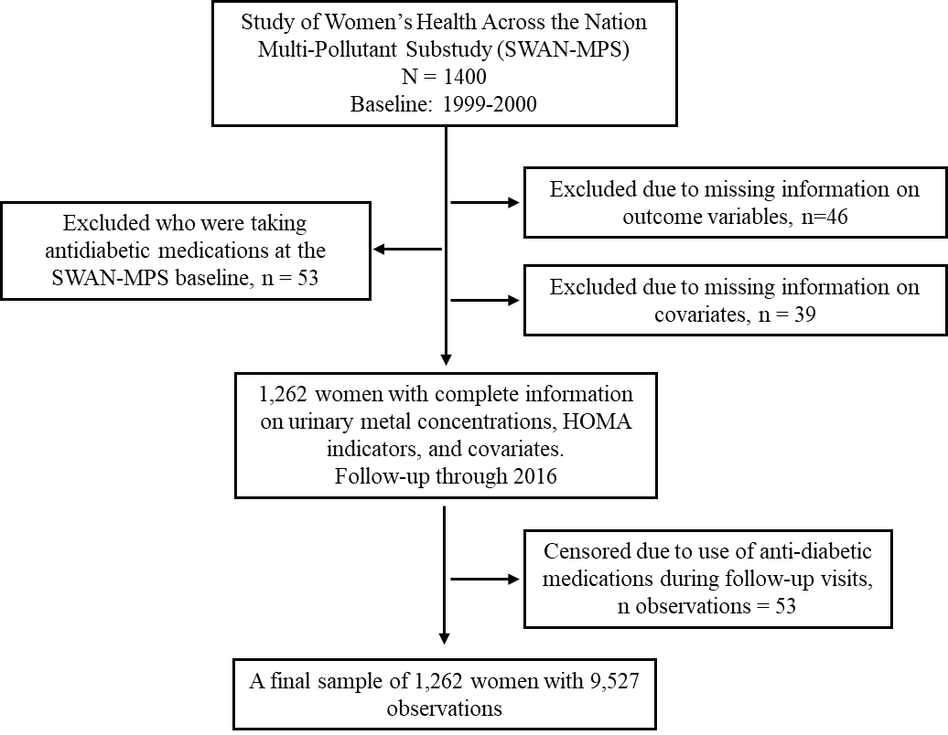

**Figure A.1.** Schematic diagram of analytic sample.

**Figure A.2.** A directed acyclic graph (DAG) for evaluation of covariate selection in the analysis of metal effects on HOMA measures. Exposures are urinary metal concentrations. Outcomes are HOMA insulin resistance and HOMA β-cell function. The minimal and sufficient adjustment set contains all the variables included in the DAG. This figure is constructed through Directed Acyclic Graph (http://www.dagitty.net/dags.html).



**Figure A.3.** Spearman correlation matrix of specific gravity adjusted urinary metal concentrations. As: arsenic, Ba: barium, Cd: cadmium, Co: cobalt, Cs: cesium, Cu: copper, Hg: mercury, Mn: manganese, Mo: molybdenum, Ni: nickel, Pb: lead, Sb: antimony, Sn: tin, Tl: thallium, Zn: zinc.

**Figure A.4.** Univariate and bivariate exposure-response function for the effects of copper, lead, molybdenum, and zinc on HOMA insulin resistance (HOMA-IR) at baseline estimated from Bayesian Kernel Machine Regression (BKMR). This model was adjusted for age, race/ethnicity, study site, education level, annual household income, body mass index, smoking, alcohol drinking, physical activity score, menopausal status, hormone therapy, dietary intake of seafood and rice, total zinc intake from diets and supplements, total energy intake, and urinary specific gravity. All metal concentrations were log-transformed and standardized. **A**. Univariate exposure-response function and 95% confidence interval band for each metal with all the other three metals fixed at their median concentrations. **B**. Bivariate exposure-response function, for example, the bottle left panel characterized copper effect with zinc concentration fixed at its 25th, 50th, and 75th percentiles, respectively, while the other two metals were fixed at their median concentrations.



**Figure A.5.** Univariate and bivariate exposure-response function for the effects of arsenic, cobalt, and zinc on HOMA β-cell function (HOMA-β) at baseline estimated from Bayesian Kernel Machine Regression (BKMR). This model was adjusted for age, race/ethnicity, study site, education level, annual household income, body mass index, smoking, alcohol drinking, physical activity score, menopausal status, hormone therapy, dietary intake of seafood and rice, total zinc intake from diets and supplements, total energy intake, and urinary specific gravity. All metal concentrations were log-transformed and standardized. **A**. Univariate exposure-response function and 95% confidence interval band for each metal with all the other three metals fixed at their median concentrations. **B**. Bivariate exposure-response function, for example, the bottle left panel characterized arsenic effect with zinc concentration fixed at its 25th, 50th, and 75th percentiles, respectively, while cobalt concentration was fixed at its median.