**Supplemental Material: Particulate Matter Exposure, Dietary Inflammatory Index and Preterm Birth in Mexico City, Mexico**

**Tables**

|  |  |  |  |  |  |  |  |  |  |  |
| --- | --- | --- | --- | --- | --- | --- | --- | --- | --- | --- |
|  | **Table S1.** Distribution of PM10 (ug/m3) during pregnancy among 1216 ELEMENT mothers, 1994-2005. | | | | | | | | |  |
|  |  |  |  | **Percentile** | | | | | |  |
|  |  | **Mean ± SD** |  | **5th** | **25th** | **50th** | **75th** | **95th** | **Max** |  |
|  |  |  |  |  |  |  |  |  |  |  |
|  | **1st trimester** | 79.0±29.1 |  | 36.6 | 60.2 | 68.7 | 105.3 | 129.2 | 133.4 |  |
|  | **2nd trimester** | 76.4±26.4 |  | 36.5 | 58.7 | 73.0 | 97.4 | 120.3 | 133.4 |  |
|  | **3rd trimester** | 64.2±17.6 |  | 33.6 | 52.9 | 68.6 | 74.3 | 93.1 | 115.5 |  |
|  | **Overall Pregnancy** | 72.3±19.8 |  | 46.9 | 53.9 | 75.9 | 86.7 | 107.8 | 113.4 |  |
|  | SD: standard deviation |  |  |  |  |  |  |  |  |  |

|  |  |  |  |  |  |  |  |  |  |  |  |
| --- | --- | --- | --- | --- | --- | --- | --- | --- | --- | --- | --- |
|  | **Table S2**. Distribution of E-DII scores during pregnancy among 620 ELEMENT mothers, 1997-2005. | | | | | | | | | |  |
|  |  |  |  |  | **Percentile** | | | | | |  |
|  |  | ***N*** | **Mean ± SD** |  | **5th** | **25th** | **50th** | **75th** | **95th** | **Max** |  |
|  |  |  |  |  |  |  |  |  |  |  |  |
|  | **1st trimester** | **581** | -0.89 ± 1.35 |  | -2.82 | -1.84 | -1.04 | -0.11 | 1.63 | 4.59 |  |
|  | **2nd trimester** | **598** | -0.71 ± 1.35 |  | -2.78 | -1.73 | -0.84 | 0.28 | 1.60 | 3.75 |  |
|  | **3rd trimester** | **558** | -0.58 ± 1.41 |  | -2.47 | -1.68 | -0.76 | 0.28 | 2.21 | 3.87 |  |
|  | **Pregnancy average** | **518** | -0.71 ± 1.06 |  | -2.29 | -1.42 | -0.82 | 0.01 | 1.09 | 2.55 |  |
|  | SD: Standard deviation |  |  |  |  |  |  |  |  |  |  |

|  |  |  |  |
| --- | --- | --- | --- |
| **Table S3. Hazard ratios, 95% confidence intervals for select concentrations of average PM10 vs. PM10 value of 70 ug/m3 and E-DII values of 1, 2 and 3, first trimester. ELEMENT Study, 1994-2005** | | | |
| **PM10** | **DII = 1** | **DII = 2** | **DII = 3** |
| **50** | 0.55 (0.19, 1.58) | 0.48 (0.13, 1.72) | 0.42(0.09, 1.93) |
| **60** | 0.80 (0.45, 1.42) | 0.76 (0.38, 1.54) | 0.72 (0.31, 1.68) |
| **80** | 1.07 (0.48, 2.37) | 1.10 (0.39, 3.08) | 1.14 (0.32, 4.08) |

|  |  |  |  |
| --- | --- | --- | --- |
| **Table S4. Hazard ratios, 95% confidence intervals for select concentrations of average PM10 vs. PM10 value of 70 ug/m3 and E-DII values of 1, 2 and 3, second trimester. ELEMENT Study, 1994-2005** | | | |
| **PM10** | **DII = 1** | **DII = 2** | **DII = 3** |
| **50** | 0.80 (0.31, 2.04) | 0.85 (0.27, 2.66) | 0.91(0.23, 3.58) |
| **60** | 0.94 (0.50, 1.74) | 0.98 (0.45, 2.11) | 1.02 (0.40, 2.59) |
| **80** | 0.99 (0.38, 2.59) | 0.93 (0.27, 3.16) | 0.87 (0.20, 3.90) |



**Figures**

**Figure S1: Adjusted Cox proportional hazard ratios of combinations of PM10 levels and lags, results from distributed lag models using different degree of freedom combinations for exposure and lags compared to no PM10 exposure**

**Figure S2: Adjusted Cox proportional hazard ratios of combinations of PM10 levels and lags, results from distributed lag models using different degree of freedom combinations for exposure and lags** **compared to no PM10 exposure**

**Figure S3: Adjusted Cox proportional hazard ratios of combinations of PM10 levels and lags, results from distributed lag models using different degree of freedom combinations for exposure and lags compared to no PM10 exposure**

**Figure S4: Adjusted Cox proportional hazard ratios of combinations of PM10 levels and lags, results from distributed lag models using different degree of freedom combinations for exposure and lags** **compared to no PM10 exposure**

**Figure S5: Adjusted Cox proportional hazard ratios of combinations of PM10 levels and lags, results from distributed lag models using different degree of freedom combinations for exposure and lags** **compared to no PM10 exposure**

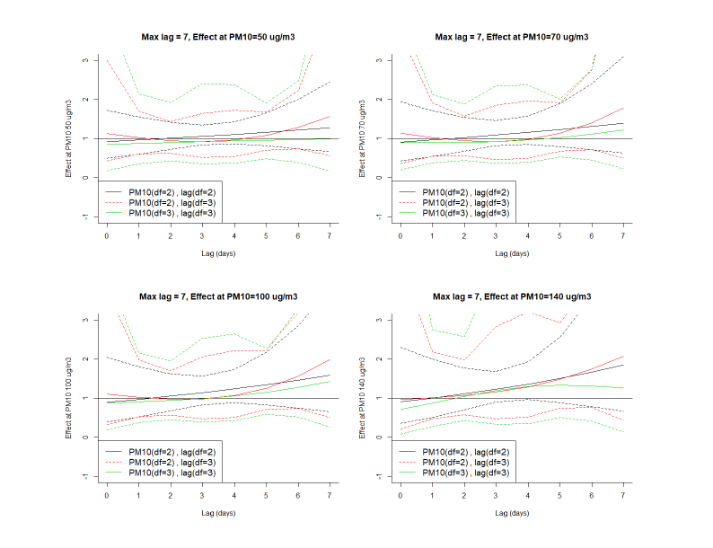

**Figure S1: Adjusted Cox proportional hazard ratios of combinations of PM10 levels and lags, results from distributed lag models using different degree of freedom combinations for exposure and lags compared to no PM10 exposure**

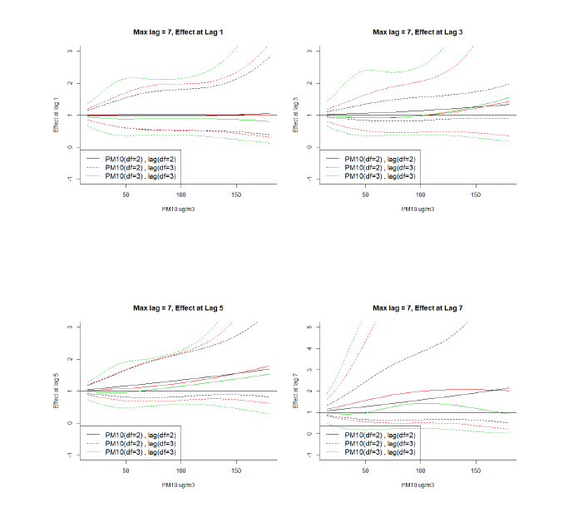

**Figure S2: Adjusted Cox proportional hazard ratios of combinations of PM10 levels and lags, results from distributed lag models using different degree of freedom combinations for exposure and lags** **compared to no PM10 exposure**

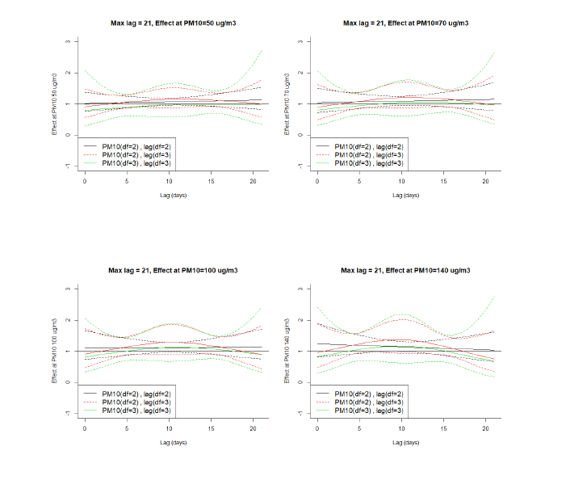

**Figure S3: Adjusted Cox proportional hazard ratios of combinations of PM10 levels and lags, results from distributed lag models using different degree of freedom combinations for exposure and lags compared to no PM10 exposure**

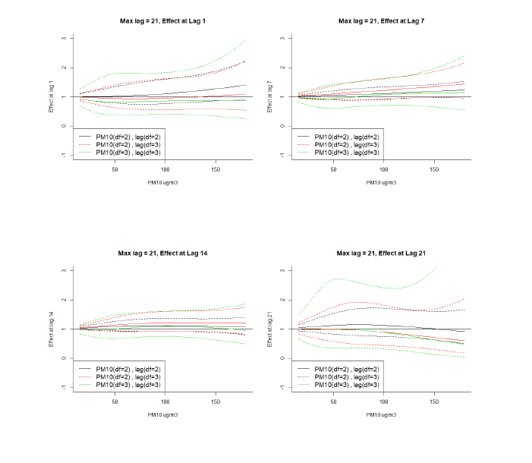

**Figure S4: Adjusted Cox proportional hazard ratios of combinations of PM10 levels and lags, results from distributed lag models using different degree of freedom combinations for exposure and lags** **compared to no PM10 exposure**

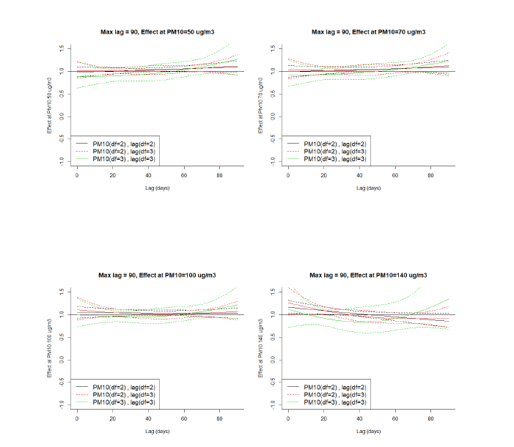

**Figure S5: Adjusted Cox proportional hazard ratios of combinations of PM10 levels and lags, results from distributed lag models using different degree of freedom combinations for exposure and lags** **compared to no PM10 exposure**