**Particulate Matter Exposure, Dietary Inflammatory Index and Preterm Birth in Mexico City, Mexico**

Miatta A. Buxton,1 Wei Perng,2 Martha María Tellez-Rojo,3 Yanelli Rodríguez-Carmona,4 Alejandra Cantoral,3 Brisa N. Sánchez,5 Luis O. Rivera-González,6 Carina J. Gronlund,7 Nitin Shivappa,8,9 James R. Hébert,8,9 Marie S. O’Neill,1,10 Karen E. Peterson4

1 Department of Epidemiology, School of Public Health, University of Michigan, Ann Arbor, MI, USA

2 Department of Epidemiology, School of Public Health, University of Colorado, Aurora, CO, USA

3Center for Research on Nutrition and Health, National Institute of Public Health, Cuernavaca, Morelos, México

4Department of Nutritional Sciences, School of Public Health, University of Michigan, Ann Arbor MI, USA

5Department of Epidemiology and Biostatistics, School of Public Health, Drexel University, Philadelphia, PA, USA

6 Division of Community Health Investigations, Agency for Toxic Substances and Disease Registry, (CDC/ATSDR), Edison, NJ,

7Institute for Social Research, Survey Research Center, University of Michigan, Ann Arbor, MI, USA

8Department of Epidemiology and Biostatistics,School of Public Health, University of South Carolina, Columbia, SC, USA

9Connecting Health Innovations LLC, Columbia, SC, USA

10 Department of Environmental Sciences,School of Public Health, University of Michigan, Ann Arbor, MI, USA

Address correspondence to Miatta Buxton, University of Michigan School of Public Health,

1415 Washington Heights, M5009, Ann Arbor, MI 48109-2029, Phone: 734-763-7862,

Fax: 734-764-3192, Email: mabuxton@umich.edu

The authors declare they have no actual or potential competing financial interests.

**Disclosure:** Dr. James R. Hébert owns controlling interest in Connecting Health Innovations LLC (CHI), a company that has licensed the right to his invention of the dietary inflammatory index (DII®) from the University of South Carolina in order to develop computer and smart phone applications for patient counseling and dietary intervention in clinical settings. Dr. Nitin Shivappa is an employee of CHI.

The subject matter of this paper will not have any direct bearing on that work, nor has that activity exerted any influence on this project.

**Abstract**

**Background**: Particulate matter ≤10 μm in aerodynamic diameter (PM10) and diet quality are risk factors for systemic inflammation, which is associated with preterm birth (PTB). PM10 and a pro-inflammatory diet (assessed by the Dietary Inflammatory Index [DII®]) have been individually evaluated as causes of PTB and differences by offspring sex have been reported for the DII. However, additional studies are needed to evaluate joint effects of these associations to inform intervention efforts.

**Objectives**: To evaluate the independent and joint effects of PM10 and energy-adjusted DII (E-DII) on PTB risks.

**Methods**: PM10 estimates were generated from daily citywide averages for 1216 pregnant women from three subcohorts of the Early Life Exposures in Mexico to Environmental Toxicants study using data from the Mexico City Outdoor Air Monitoring Network. Among a subset of participants (N=620), E-DII scores were calculated using a validated food frequency questionnaire. Cox Proportional Hazards models were run for trimester-specific and entire pregnancy averages for E-DII and PM10. We assessed for potential non-linear associations using natural splines.

**Results**: In adjusted models, PM10 exposure was associated with increased risks of PTB for a range of values (58 – 72 µg/m3) during the second trimester, while negative associations were seen during the second (≥ 74 µg/m3) and third trimesters (55- 65 µg/m3). Analyses conducted using distributed lag models for periods closer to delivery (max lag =90) did not show negative associations between PM10 exposure and preterm birth, and indeed positive significant associations were observed (estimates and figures). E-DII was not associated with PTB and there was no evidence of effect modification by infant sex. There was no evidence of interaction between PM10 and E-DII and the risk of preterm birth.

**Discussion**: Associations between PM10 and PTB in Mexico City varied over time and across levels of PM10. Our findings of negative associations in the second and third trimesters, which are contrary to the hypothesized relationship between PM10 and PTB, may be due to a number of factors, including live birth bias and the exposure period evaluated. Differences in results for the periods evaluatedsuggest that PM10 from shorter exposure windows may play a more proximal role in initiating preterm labor.

**Keywords:** Particulate Matter 10, Dietary Inflammatory Index, Preterm Birth, Cox Proportional Hazards, Mexico City, Intraclass correlation coefficients, Trimester-specific and overall pregnancy estimates

**Introduction**

Preterm birth, along with its complications, is a leading cause of death among infants in the United States [1] and worldwide [2]. It also is associated with substantial immediate emotional and long-term economic costs [3]. The impact of preterm birth extends beyond perinatal outcomes as increased long-term cardiovascular disease risk has been reported among mothers of preterm infants [4]. Systemic inflammation, which may be influenced by factors such as air pollution, is implicated in the pathophysiologic mechanisms leading to preterm birth [3, 5]. One of the postulated mechanisms linking particulate matter, a type of air pollution, to preterm birth involves maternal systemic inflammation that results from pulmonary inflammation after particles are inhaled [6]. Epidemiologic studies evaluating the association between exposure to PM10 and preterm birth have produced inconsistent results that include null, negative or positive associations [7-12]. Nevertheless, a systematic review and meta-analysis published in 2015 reported evidence of adverse effects of PM10 on the length of gestation. Statistically significant pooled odds ratios (CI) from the meta-analysis were reported for the third trimester 1.04, 95% confidence interval (CI): (1.02, 1.06), and over the entire pregnancy 1.23 95% CI: (1.04, 1.41) [13].

Beyond larger-scale environmental risk factors, individual-level factors such as dietary intake may operate through similar pathways as air pollution to affect the length of gestation. Positive associations between inflammatory characteristics of foods consumed based on the Dietary Inflammatory Index (DII®) and systemic inflammation levels have been reported [14, 15]. The DII quantifies the inflammatory potential of foods based on an index generated from a literature review and incorporation of a global consumption dataset[15]. The DII has been validated against the inflammatory marker high-sensitivity C-reactive protein (hs-CRP) obtained from peripheral blood [16], and has been extensively used in studies evaluating the impact of dietary intake on a number of inflammation-related health conditions. To date, the two studies that utilized DII as the primary exposure to evaluate preterm birth risk were US-based. In a Massachusetts cohort, Sen *et al* found no association between the mean of first and second trimester DII and preterm birth before 34 weeks of gestation or between 34-37 weeks of gestation [17]. Similarly, McCullough *et al* also did not find an association between peri-conception (defined as 6 months prior to pregnancy) and prenatal E-DII and gestational age at delivery for participants overall and for male babies. However, the DII was associated with lower gestational age at birth among female babies in this study [18]. Differences by infant sex in the association between the DII and preterm birth as well as other exposures, which are hypothesized to operate through an inflammatory pathway to influence perinatal outcomes, require further investigation. Moreover, the aforementioned studies did not evaluate trimester-specific associations, which may be important for identifying susceptible periods, and this represents a limitation. It is essential to take into account that pregnancy encompasses developmental processes that are associated with varying degrees of inflammatory activity. The first trimester, especially during implantation and placentation, and later at the end of the third trimester, during parturition, are considered pro-inflammatory phases of gestation [19]. Studies of air pollution and preterm birth typically create time-varying exposures at the trimester or finer level in an attempt to identify windows of vulnerability [20]. Although a high correlation between first and second trimester DII scores was reported by Sen et al [17], using trimester-specific DII scores have the potential to identify sensitive exposure periods associated according to the inflammatory potential of the diet.

In addition, the association between diet and preterm birth, particularly in populations exposed to particulate matter (e.g. PM10) that may be higher compared to the United States, needs to be evaluated. Mexico City, Mexico presents a two-fold opportunity to evaluate the associations among PM10, DII and preterm birth. First, Mexico City is outside of the United States, where the previous DII and preterm birth studies took place. This is important because the timing of nutrition transition differs between the United States and other countries, including Mexico [21, 22]; this discordance in timing may reflect differences in diet quality and intake patterns and potential differences in distribution of DII scores and association with preterm birth. Second, Mexico City presents an ideal setting to evaluate the association between the combined effects of air pollution and maternal inflammatory diet on preterm birth. Although air pollution in Mexico City results from sources that are similar to those in other densely populated urban areas, air pollution levels are further influenced by geographical features [23]. The result of this environmental and geographic combination is annual air pollution levels that are higher than the standards established to protect human health [24].

The objectives of this study were: 1) to evaluate sex-specific associations between prenatal PM10 exposure and preterm birth for select points (period-specific) during pregnancy; evaluate sex and period-specific associations between prenatal E-DII scores and preterm birth; and 3) to evaluate the joint effects of PM10 and the E-DII on preterm birth.

**Methods**

Study population

This study utilized data from pregnant participants from three sub-cohorts of the Early Life Exposures in Mexico to Environmental Toxicants (ELEMENT) study. The ELEMENT project is an ongoing longitudinal Mexico City-based study that started in 1994 with the objective of understanding how exposure to environmental toxicants during pregnancy affects offspring health over time [25]. Participants in the current study were enrolled between 1994-2005 and include women from the following cohorts (enrollment years): cohort 1 (1994-1997), cohort 2 (sub cohorts 2a and 2b – 1997-2000) and cohort 3 (2001-2005). Participants were enrolled at delivery (cohorts 1 and 2b) or during pregnancy (cohorts 2a and 3) and provided information on the following: demographic and obstetric information at enrollment, and food frequency and nutrient information during each trimester. Participants were included in this study if data on gestational age at delivery and infant’s date of birth were available. Out of 2098 participants, 1216 (58%) met eligibility requirements and were included in this study.

The study was approved by the study Institutional Review Board of the University of Michigan and the Research, Ethics in Research and Biosafety Committees of the Mexico National Institute of Public Health, the Harvard School of Public Health, the Brigham and Women’s Hospital, the University of California, and participating hospitals. All participants provided written informed consent prior to participating in the study.

**Exposures**

Particulate matter ≤10 in aerodynamic diameter (PM10)

Hourly PM10 data for Mexico City were downloaded from the Mexico City Atmospheric Monitoring System website for the study period (1994-2005). SIMAT, which began monitoring air pollution in 1986, uses 34 monitors to measure daily air pollution levels for gaseous and particulate pollutants.[26] Daily averages were used to calculate citywide averages based on data from 14 monitors that collect PM10 data. However, daily concentrations for PM10 were counted as missing if more than 25% of values were missing for any day [24]. Citywide averages were used to generate trimester-specific and entire pregnancy averages for participants in the study. PM10 averages for all trimesters and entire pregnancy were calculated by first multiplying gestational weeks by 7 to convert gestational weeks to gestational days. The start of gestation was then calculated by subtracting gestational days from the infant’s date of birth. Although we did have home location for many of the ELEMENT participants, our decision to use citywide averages was influenced by concerns about differences in residential address information collected over the course of the study period (1994 -2005). In addition, information was not collected on work location, daily activities (including commuting), or whether participants moved from one residence to another during pregnancy, thus making citywide average a reasonable estimate to use for this particular study. In addition, a previous study conducted in Mexico City showed very high correlations between PM10 concentrations estimated from citywide averages and nearest monitor, inverse distance weighting, and ordinary kriging (Pearson correlation coefficients 0.83, 0.92 and 0.92, respectively) [24].

The Dietary inflammatory Index (DII®)

Among 620 participants enrolled during pregnancy (cohorts 2a and 3), maternal dietary intake was assessed using a food frequency questionnaire (FFQ). The FFQ was interviewer-administered to participants in-clinic for up to three trimester visits by trained interviewers. The FFQ inquired about 104 food items that were selected based on a Mexican national survey conducted in 1983.[27] This semi-qualitative FFQ was validated and reproduced among 134 women in Mexico City [28]. Participants were asked to recall food and nutrient intake for the 3-month period prior to the clinic visit. The frequencies reported by participants, which included a range of timeframe categories such as never, per month, per week, and per day, were subsequently converted to frequency per day. E-DII scores were calculated for each trimester using FFQ data, which included dietary supplements taken during pregnancy. Calculation of DII scores have been previously described in detail by Shivappa et al [29]. To calculate E-DII for the current study, trimester-specific food frequency data from participants were referenced to an energy- adjusted “global” database generated from 11 food consumption datasets from various parts of the world, including Mexico. Z-scores were calculated based on the current study and the global consumption datasets and standardized by 1000 kcal. Centered proportions were multiplied by the overall parameter-specific inflammatory effect score and summed to create a summary E-DII score for each participant. In the original work to develop the DII, scores derived from the global database ranged from -8.87 (highly anti-inflammatory) to + 7.98 (highly pro-inflammatory) [29].

E-DII scores from all three trimesters were used to calculate an average for entire pregnancy for each participant; participants who had one or more E-DII scores missing were not included in the entire pregnancy analysis. The following 26 out of 45 parameters identified in the index were used to calculate E-DII scores: alcohol, beta carotene, caffeine, carbohydrate, cholesterol, fat, fiber, folic acid, iron, magnesium, monounsaturated fatty acids, niacin, omega 3, omega 6, polyunsaturated fatty acids, protein, riboflavin, saturated fat, selenium, thiamin, vitamin A, vitamin B12, vitamin B6, vitamin C, vitamin E and zinc.

Outcome

Preterm birth, the outcome of interest, was calculated by subtracting the date of last menstrual period reported by the mother from the date of infant birth. Preterm birth was defined as delivery of a live infant before 37 completed weeks of gestation.

Covariates

Data on maternal age, marital status, education, parity, and smoking during pregnancy were obtained from questionnaires administered during in-clinic visits. Delivery method (vaginal birth, scheduled and unscheduled Cesarean section) was recorded at birth by the clinical team. Based on the estimated start of pregnancy, a month of conception variable was used to create season of conception; months 10-12 and 1-5 were coded as the dry season while months 6-9 were coded as the rainy season. (<https://weather-and-climate.com/average-monthly-Rainfall-Temperature-Sunshine,mexico-city,Mexico>) Temperature and precipitation data for the study period were obtained from the Global Historical Climatology Network. For bivariate associations, maternal age at enrollment was categorized as 18-24 years, 25-34 years, and 35-44 years and education was categorized as < 10 years, 10-12 years, and ≥ to 13 years. However, each variable was included as a numeric covariate in models evaluating the association between exposures and preterm birth.

Effect measure modifier

Sex of infant was evaluated as a potential effect modifier of the associations between E-DII score and preterm birth, and PM10 and preterm birth.

Statistical analysis

We examined differences in preterm birth prevalence across maternal demographic and obstetric characteristics, such as parity and delivery method, using logistic regression and the Wald test to evaluate for statistical significance. We used bivariate linear regression models to test for differences in PM10 exposure and E-DII scores by categories of maternal demographic and obstetric characteristics. Means and standard deviations, along with select percentiles, were used to generate a summary of PM10 concentrations and E-DII over the course of the study period. Spearman correlation coefficients were used to assess the associations between trimester specific E-DII scores, and PM10. We used paired t-tests to evaluate for mean differences between trimester-specific E-DII scores. We calculated intraclass correlation coefficients (ICC) using a PROC MIXED random-intercept model to estimate the reproducibility of E-DII scores over time.

Trimester-specific and entire pregnancy average Cox proportional hazards models were used to evaluate individual associations between E-DII, PM10 and preterm birth. We assessed for potential non-linear associations between PM10 and preterm birth using natural splines with 2 degrees of freedom. In order to address potential biases associated with using trimester-specific PM10 averages [30], we evaluated the association between PM10 and preterm birth for periods shorter than a trimester. We conducted analyses using distributed lag models (DLM) (DLNM package in R)[31] for max lag days 7, 21, and 90. For PM10, and E-DII models, we ran unadjusted and adjusted models, which included mother’s age at enrollment, parity, years of education, cohort, day of year (using a natural spline with 4 degrees of freedom), temperature and precipitation, each with a natural spline with 3 degrees of freedom, and marital status. Smoking during pregnancy was not included because only 3% of participants reported that they smoked during pregnancy. Although the same covariates were used for the E-DII models, all variables modelled using natural splines were used as linear terms due to the smaller sample size. Plots for PM10 were centered at 70 µg/m3 and E-DII scores were centered at 0. Additionally, separate Cox proportional hazards models were used to evaluate for effect measure modification for each exposure by sex. Statistical significance of effect measure modification was evaluated using non-linear terms for PM10, and linear terms for E-DII scores. These interaction terms were included in fully adjusted models for each trimester and for the entire pregnancy among the 620 participants with E-DII scores.

Analyses were performed using SAS® version 9.4 (SAS Institute Inc., Cary, NC) and R version 3.3.3, (dlnm package, version 2.3.9).

**Results**

The prevalence of preterm birth was 7.4 % (N= 90). 92.5% of participants were younger than 35 years of age (range: 18-44, median age = 25 years). The majority of participants were married (69.2%) and had a high school level of education or less (87.2%). In unadjusted models, there were statistically significant differences in the frequency of preterm birth for delivery method and cohort; the highest prevalence of preterm birth was seen among women who delivered by unscheduled Cesarean section (11.2%) vs. vaginal (6.6 %), p= 0.04 and were enrolled in cohort 2 (12.2%) vs. cohort 1 (5.4%), p= 0.004. (Table 1)

Across pregnancy, PM10 concentrations were highest among participants who were younger, had fewer years of education and were single, except during the third trimester for marital status, where the association was not significant. Additionally, participants who smoked, had not had a prior birth, delivered vaginally, and were enrolled in cohort 1 were exposed to the highest levels of PM10. Mean PM10 concentrations decreased over time across cohorts. (Table 2) Among all pregnancy windows evaluated, PM10 concentrations ranged from 30.7 – 133.4 µg/m3 (minimum not shown in table). Mean PM10 concentrations decreased across trimesters (Supplemental Material, Distribution of PM10 (µg/m3) during Pregnancy). The lowest mean PM10 concentration was in the third trimester, (mean ± SD = 64.2 ± 17.6 µg/m3).

E-DII scores were calculated for a subset of participants from cohorts 2 and 3 (N=620) for whom FFQ data were available. Overall, E-DII scores ranged from -4.10 to +4.59 (minimum not shown in table). First trimester DII scores were positively correlated with second and third trimester DII scores (Spearman correlation coefficients: 0.38 and 0.35, respectively). Second and third trimester E-DII scores also were positively correlated (Spearman correlation coefficient = 0.45). All correlations were significant at p-value < 0.0001. Trimester-specific means and standard deviations for the first, second, third trimesters and average pregnancy E-DII scores were -0.89± 1.35, -0.71 ± 1.35, -0.58 ± 1.41, and -0.71± 1.06, respectively. (See Supplemental Material, Distribution of E-DII scores during Pregnancy) Results from paired t-tests showed mean differences in E-DII scores by trimester. E-DII scores were statistically significant for comparisons between first vs. second trimester, (p = 0.001), and first trimester vs. third trimester (p < 0.0001), but not for second vs. third trimester, (p=0.11). In bivariate analyses, mean E-DII scores across demographic and obstetric characteristics during the first trimester compared to the other trimesters were the most anti-inflammatory. A similar pattern was seen across the two cohorts (2 and 3) used for E-DII analysis (Table 3). ICC for E-DII scores was 0.39, which indicates poor reproducibility across pregnancy [32].

There was no evidence of effect measure modification by sex for PM10 or E-DII; thus the following are results from combined models. In unadjusted models with PM10 centered at 70 µg/m3, PM10 exhibited a non-linear association with preterm birth. Associations in which the 95% confidence intervals did not include the null value were negative at higher levels of PM10 and were seenduring the second trimester and overall pregnancy. In adjusted models, a similar negative association at higher levels of PM10 (significant for PM10 values > 80 µg/m3) was found in the second trimester, but the significant association seen in the unadjusted model for entire pregnancy became non-significant. During the second trimester, a positive association that appeared to be borderline for a narrow range of PM10 values (approximately 58 – 72 µg/m3) in the unadjusted model became statistically significant. In addition, the third trimester exhibited a non-linear pattern that was similar for both unadjusted and adjusted models, but a statistically significant negative association was seen only in the adjusted model for a restricted range of PM10 values (55- 65 µg/m3) (Figures 1 and 2). For DLM results, even though most of the confidence intervals for the hazard ratios for combinations of PM10 levels and lags included the null (HR =1), association patterns were generally positive for maximum lag = 7, particularly at higher levels of PM10. Select estimates using DLM are presented in table 4. The hazard ratios for lag-days 7, 14 and 21 at a PM10 value of 130 µg/m3 were positively associated preterm birth, but lag-day 90 was not. Additional figures showing hazard ratios for combinations of PM10 levels and lags are presented in figure 5 and as supplemental figures 1-5. The figures presented show PM10 and preterm birth associations over the range of exposure at lag day 7, 21, 35 and 90 from the distributed lag models using 90 days of PM10 exposure prior to the birth, using combinations of 2, 3 degrees of freedom in PM10 exposure and lags. For the E-DII centered at 0, none of the associations between E-DII and preterm birth were statistically significant. The plots exhibited a linear pattern in the association for the first trimester (negative), second trimester (slightly positive) and unadjusted models were similar to the adjusted. However, the third trimester was the only point where the association, although null in the unadjusted model, became slightly negative in the adjusted model. (Figures 3 and 4) There was no evidence of interaction at any point during pregnancy between the two exposures and preterm birth. Table 5 shows the associations between average PM10 from overall pregnancy and preterm birth for overall pregnancy E-DII values of 1, 2 and 3. Additional results for other periods in pregnancy are presented in supplemental tables S3 – S5.

**Discussion**

In this study of 1216 mother–infant pairs in Mexico City, we evaluated the relationship of two exposures - PM10, and E-DII - with preterm birth. This study adds to the two previous studies that evaluated the association between the DII and preterm birth [17, 18]. Although we did not find any evidence of interaction between PM10 and E-DII, to our knowledge, the E-DII has not been utilized to evaluate its potential to modify the relationship between exposure to PM10 and preterm birth risk. A number of risk factors for preterm birth, including PM10 and dietary intake, are hypothesized to influence preterm birth via an inflammatory pathway. This rationale served as the basis for evaluating potential interaction between PM10 and E-DII in influencing preterm birth risk. [5] Although not consistent, there is increasing evidence implicating PM10 in adverse pregnancy outcomes [33, 34], and associations have been shown between the DII and systemic inflammatory markers.[14, 16] Findings from these PM10 and DII studies support the hypothesized role of inflammation. However, the lack of evidence in the current study may be due to the small sample size used to evaluate this aim and should be investigated further.

This study found differing associations between PM10 and preterm birth over a study period that shows reduction in PM10 levels over time in Mexico City. These time-associated reductions were additionally influenced by the rainy season, where a review of monthly means of daily citywide averages by year showed considerably lower PM10 values in the rainy season. These differences in PM10, levels coupled with potential vulnerable periods in pregnancy may play a role in differentially affecting preterm birth risk. PM10 exposure was positively associated with preterm birth for a range of values during the second trimester, while negative associations were seen during the second and third trimesters. Our findings of negative associations in the second and third trimesters are contrary to the hypothesized relationship between PM10 and preterm birth. However, these results are in line with a study in Seoul, South Korea wherein Suh *et al* conducted a comparative analysis using a number of statistical models to evaluate the association between PM10 and preterm birth among 374,167 participants. PM10 was negatively associated with preterm birth during the first (OR, 95% CI = 0.91, 0.87, 0.96) and second trimester (0.97, 0.91-1.02), but positively associated with preterm birth in the third trimester (1.09, 1.03, 1.15)[35]. In another study conducted in China, Zhao *et al* evaluated entire and period-specific association between PM10 and a number of preterm birth categories (based on severity type and etiology) among 8,969 participants. The nearest monitor and inverse distance weighting exposure assessment methods were used to estimate participants’ PM10 exposure and PM10 was categorized as a binary variable (defined as less than or greater than or equal to the U.S. National Ambient Air Quality Standard, 150 µg/m3). In this study, investigators found negative as well as positive associations across categories of preterm birth. Exposure to PM10 during the third trimester was negatively associated with preterm birth (OR, 95% CI = 0.75, 0.56–0.99), very preterm birth (0.29, 0.16 – 0.52), and spontaneous preterm birth (0.65, 0.47–0.90) [33]. Additionally, in a systematic review and meta-analysis by Stieb *et al*, the studies included on the review showed that exposure to first and second trimester PM10 wasnegatively associated with preterm birth in most studies although the association was not statistically significant in every study [36]. The pooled estimates resulting from the meta-analysis also were negatively associated with preterm birth in the first and second trimester, but positive for the third trimester and entire pregnancy, similar to the results in our study.

It is not entirely clear why studies show statistically significant findings of a negative association with particulate matterexposure and preterm birth. Interestingly, in the aforementioned studies and similar to our study, these negative associations were found in analyses that used broad trimester-specific exposure periods. Averaging exposure over a period that covers a number of months may lead to cutoffs that do not align with the timing of major fetal developmental processes[30]. This misalignment may lead to assigning of exposure that is significantly different for the period that a major fetal development occurs. This is particularly important if there are major meteorological events and seasonal changes occurring during developmental milestones.[37] Moreover, stronger influences of PM10 on initiating preterm labor may be proximal to the time of the event rather than the wider and distant timeframes considered in trimester-specific models. Our use of distributed lag models addressed both the need to investigate proximal PM10 exposures and the flexibility to explore finer windows of exposure. In our study, unlike the trimester-specific results, using shorter exposure periods showed significant positive associations at higher concentrations of PM10. Negative associations between PM10 and preterm birth in the overall pregnancy and trimester-specific analyses were not seen in the results of the DLM analysis. These findings support the idea that shorter windows that are closer to event may be more influential in initiating preterm labor.

In addition to evaluating shorter exposure windows, other explanations regarding findings of negative associations between particulate matter exposure and preterm birth have been proposed. It has been suggested that live birth bias, a type of selection bias that may result from the deaths of a higher proportion of fetuses susceptible to the exposure under investigation, may be a potential explanation for these findings. In essence, live birth bias results in a lower than expected proportion of highly susceptible fetuses appearing in a study sample and may lead to findings of a protective association, particularly at higher levels of the exposure [38, 39]. We were unable to investigate live birth bias in our study because data on stillbirths were not systematically collected. In addition, residual confounding has been hypothesized as a possible reason for observed negative associations [40]; thus, incorporation of additional information, such as physical activity and daily activity patterns, that might improve exposure assessment methods should be explored in future studies. Potential differences in biological mechanisms between individuals who are constantly exposed to high levels of particulate matter compared to sporadically high or usually lower levels of air pollution should be considered as well. Additionally, the use of air quality alerts along with compliance may play a role in the reduced hazard ratios seen at higher levels of PM10. In Mexico City and surrounding areas, an Air Quality Index (AQI) of 150 is the threshold for issuing level 1 health alerts to warn the public, with particular focus on pregnant women, children, the elderly, and people with respiratory and cardiovascular conditions, of the existing levels of air pollution (<https://www.itf-oecd.org/sites/default/files/docs/air-pollution-mitigation-strategy-mexico-city.pdf>). This level 1 includes an AQI range of 101-150 that corresponds to our lower end break point for PM10 (76 µg/m3 per 24-hour). Further, the conditions associated with adverse air pollution levels, such as smog, might lead to individuals having a tendency to adhere to preventive measures even in the absence of public health messaging.

Our finding that the E-DII was not associated with preterm birth in this population is similar to one of the two previous studies conducted. Similar to the current study, both studies were longitudinal, but the current study used a smaller sample size. In the Sen *et al* study, first and second trimester DII scores were strongly correlated, so the mean was used to evaluate the association between DII and preterm birth [17]. In our study, first and second trimester E-DII scores were weakly correlated, but this difference and time-specific analyses did not change the findings.

This study has some limitations. First, we lacked data on maternal pre-pregnancy body mass index, which is important when evaluating an exposure such as diet, and when evaluating exposures that are hypothesized to act via an inflammatory pathway. Second, the samples used to evaluate the aims, particularly the interaction between PM10 and DII (N=620), were small and therefore limited statistical power. In addition, we were unable to control for physical activity because this information was not available. Although very strong correlations have been reported between citywide averages and other exposure metrics that incorporate distance from monitoring stations for Mexico City [24], the use of citywide averaging based on functioning monitors, a crude measure to estimate PM10 , may have led to exposure misclassification. In the absence of a practical gold standard for estimating PM10, additional information such as activity patterns would have been helpful in improving exposure estimation. Additionally, the estimates for the lowest and highest values of PM10 may be highly uncertain due to very few observations, as demonstrated by the wide confidence intervals.

Strengths of this study include the comprehensive description of trimester-specific E-DII scores over the course of pregnancy. Another strength of this study is the use of trimester-specific E-DII scores to evaluate the association with preterm birth. Our use of trimester-specific E-DII scores allowed us to evaluate for periods during pregnancy that might have a significant impact on preterm birth. Physiologic requirements and dietary intake change during the course of pregnancy; hence, accounting for trimester-specific intake may be important for understanding and identifying potential windows of susceptibility of the effects of inflammation on pregnancy outcomes. In addition, calculation of ICC for the E-DII further confirmed that scores among participants in this study differed over time. Furthermore, assessing the inflammatory potential of the diet from food frequency data, which may be more readily available in existing datasets and cost effective to collect for new studies compared to biomarkers, is an advantage. This is particularly important for studies utilizing secondary data where biological samples may not be available.

In conclusion, associations between PM10 and preterm birth in Mexico City varied over time and across levels of PM10 depending on the exposure period investigated and the statistical models used. These differences may contribute to the range of findings of the association between PM10 and preterm birth.

**Acknowledgements**

This project was supported in part by the following: National Institute of Environmental Health Sciences grants R01 ES016932, R01 ES017022, T32 ES007062, R01 ES007821, P30 ES017885 and R00 ES026198; Environmental Protection Agency grant P01 ES02284401/RD 83543601; National Institute for Occupational Safety and Health grant T42 OH008455-09; and the MCubed Program at the University of Michigan. In addition, we acknowledge the American British Cowdray Hospital, Mexico City for providing the facilities used in this research, the Instituto Nacional de Salud Publica (INSP), Ministry of Health, Mexico for additional resources and financial support, and Mexico City Monitoring Network for the PM10 data. We thank Maritsa Solano for her invaluable assistance regarding follow up questions about ELEMENT Project and data.

Dr. Luis O. Rivera-González, Division of Community Health Investigations, contributed to this article in his personal capacity. The views expressed are his own and do not necessarily represent the views of the Centers for Disease Control and Prevention or the United States government.

**References**

1. Kochanek, K.D., et al., *Deaths: Final Data for 2014.* Natl Vital Stat Rep, 2016. **65**(4): p. 1-122.

2. Lawn, J.E. and M. Kinney, *Preterm Birth: Now the Leading Cause of Child Death Worldwide.* Science Translational Medicine, 2014. **6**(263): p. 263ed21.

3. Behrman, R.E., A.S. Butler, and Institute of Medicine (U.S.). Committee on Understanding Premature Birth and Assuring Healthy Outcomes., *Preterm birth : causes, consequences, and prevention*. 2007, Washington, D.C.: National Academies Press. xvi, 772 p.

4. Perng, W., et al., *Preterm birth and long-term maternal cardiovascular health.* Annals of Epidemiology, 2015. **25**(1): p. 40-45.

5. Kannan, S., et al., *Exposures to airborne particulate matter and adverse perinatal outcomes: a biologically plausible mechanistic framework for exploring potential effect modification by nutrition.* Environmental Health Perspectives, 2006. **114**(11): p. 1636-42.

6. Brook, R.D., et al., *Particulate matter air pollution and cardiovascular disease.* Circulation, 2010. **121**(21): p. 2331-2378.

7. Darrow, L.A., et al., *Ambient air pollution and preterm birth: a time-series analysis.* Epidemiology (Cambridge, Mass.), 2009. **20**(5): p. 689-698.

8. Hannam, K., et al., *Air pollution exposure and adverse pregnancy outcomes in a large UK birth cohort: use of a novel spatio-temporal modelling technique.* Scandinavian Journal of Work, Environment & Health, 2014. **40**(5): p. 518-530.

9. Liu, Y., et al., *The association between air pollution and preterm birth and low birth weight in Guangdong, China.* BMC Public Health, 2019. **19**(1): p. 3-3.

10. Kim, Y.J., et al., *Maternal Exposure to Particulate Matter during Pregnancy and Adverse Birth Outcomes in the Republic of Korea.* International Journal of Environmental Research and Public Health, 2019. **16**(4): p. 633.

11. Hansen, C., et al., *Maternal exposure to low levels of ambient air pollution and preterm birth in Brisbane, Australia.* BJOG, 2006. **113**(8): p. 935-41.

12. Ritz, B., et al., *Effect of air pollution on preterm birth among children born in Southern California between 1989 and 1993.* Epidemiology, 2000. **11**(5): p. 502-11.

13. Lamichhane, D.K., et al., *A meta-analysis of exposure to particulate matter and adverse birth outcomes.* Environmental health and toxicology, 2015. **30**: p. e2015011-e2015011.

14. Shivappa, N., et al., *Association between dietary inflammatory index and inflammatory markers in the HELENA study.* Molecular Nutrition & Food Research, 2016.

15. Shivappa, N., et al., *Designing and developing a literature-derived, population-based dietary inflammatory index.* Public health nutrition, 2014. **17**(8): p. 1689-1696.

16. Shivappa, N., et al., *A population-based dietary inflammatory index predicts levels of C-reactive protein in the Seasonal Variation of Blood Cholesterol Study (SEASONS).* Public Health Nutr, 2014. **17**(8): p. 1825-33.

17. Sen, S., et al., *Dietary Inflammatory Potential during Pregnancy Is Associated with Lower Fetal Growth and Breastfeeding Failure: Results from Project Viva.* The Journal of nutrition, 2016. **146**(4): p. 728-736.

18. McCullough, L.E., et al., *Maternal inflammatory diet and adverse pregnancy outcomes: Circulating cytokines and genomic imprinting as potential regulators?* Epigenetics, 2017: p. 00-00.

19. Mor, G., et al., *Inflammation and pregnancy: the role of the immune system at the implantation site.* Annals of the New York Academy of Sciences, 2011. **1221**(1): p. 80-87.

20. Sanchez, B.N., et al., *Statistical methods to study timing of vulnerability with sparsely sampled data on environmental toxicants.* Environmental Health Perspectives, 2011. **119**(3): p. 409-15.

21. Rivera, J.A., et al., *Nutrition transition in Mexico and in other Latin American countries.* Nutrition Reviews, 2004. **62**(7 Pt 2): p. S149-57.

22. Flegal, K.M., et al., *Overweight and obesity in the United States: prevalence and trends, 1960–1994.* International Journal of Obesity & Related Metabolic Disorders, 1998. **22**(1): p. 39.

23. O'Neill, M.S., D. Loomis, and V.H. Borja-Aburto, *Ozone, area social conditions, and mortality in Mexico City.* Environmental Research, 2004. **94**(3): p. 234-42.

24. Rivera-González, L.O., et al., *An Assessment of Air Pollutant Exposure Methods in Mexico City, Mexico.* Journal of the Air & Waste Management Association (1995), 2015. **65**(5): p. 581-591.

25. Hu, H., et al., *Fetal lead exposure at each stage of pregnancy as a predictor of infant mental development.* Environmental Health Perspectives, 2006. **114**(11): p. 1730-1735.

26. Ministry of the Environment (Federal District, M., *Mexico - Mexico City Automatic Air Quality Monitoring Network Database. Mexico City, Mexico: Ministry of the Environment (Federal District, Mexico).*

27. Hernández M, A.J., Serrano L., *Alimentación de obreros y sus familias, México*. 1983, División de Nutritición de Comunidad INelNSZ.

28. Hernandez-Avila, M., et al., *Validity and reproducibility of a food frequency questionnaire to assess dietary intake of women living in Mexico City.* Salud Publica Mex, 1998. **40**(2): p. 133-40.

29. Shivappa, N., et al., *Designing and developing a literature-derived, population-based dietary inflammatory index.* Public Health Nutr, 2014. **17**(8): p. 1689-96.

30. Wilson, A., et al., *Potential for Bias When Estimating Critical Windows for Air Pollution in Children's Health.* American Journal of Epidemiology, 2017. **186**(11): p. 1281-1289.

31. Gasparrini, A., *Distributed Lag Linear and Non-Linear Models in R: The Package dlnm.* J Stat Softw, 2011. **43**(8): p. 1-20.

32. Rosner, B., *Fundamentals of biostatistics*. 6th ed. 2006, Belmont, CA: Thomson-Brooks/Cole. xix, 868 p.

33. Zhao, N., et al., *Ambient air pollutant PM10 and risk of preterm birth in Lanzhou, China.* Environment International, 2015. **76**: p. 71-77.

34. Sagiv, S.K., et al., *A time-series analysis of air pollution and preterm birth in Pennsylvania, 1997-2001.* Environmental Health Perspectives, 2005. **113**(5): p. 602-6.

35. Suh, Y.J., et al., *Different effects of PM10 exposure on preterm birth by gestational period estimated from time-dependent survival analyses.* International Archives of Occupational and Environmental Health, 2009. **82**(5): p. 613-621.

36. Stieb, D.M., et al., *Ambient air pollution, birth weight and preterm birth: a systematic review and meta-analysis.* Environmental Research, 2012. **117**: p. 100-11.

37. Giorgis-Allemand, L., et al., *The Influence of Meteorological Factors and Atmospheric Pollutants on the Risk of Preterm Birth.* American Journal of Epidemiology, 2017. **185**(4): p. 247-258.

38. Raz, R., M.-A. Kioumourtzoglou, and M.G. Weisskopf, *Live-Birth Bias and Observed Associations Between Air Pollution and Autism.* American Journal of Epidemiology, 2018. **187**(11): p. 2292-2296.

39. Weber, K.A., et al., *Air pollution, maternal hypertensive disorders, and preterm birth.* Environmental Epidemiology, 2019. **3**(5): p. e062.

40. Stieb, D.M., et al., *Associations of Pregnancy Outcomes and PM2.5 in a National Canadian Study.* Environmental Health Perspectives, 2016. **124**(2): p. 243-249.

**Tables**

|  |  |  |  |  |  |
| --- | --- | --- | --- | --- | --- |
|  | **Table 1**. Prevalence of preterm birth (<37 gestational weeks) across characteristics of 1216 ELEMENT mother-child pairs, 1994-2005. | | | |  |
|  | **Maternal characteristics** |  | **Preterm birth** | |  |
|  |  | ***N*** | **% (N)** | ***P*a** |  |
|  | Overall | 1216 | 7.4 (90) |  |  |
|  | Age at enrollment (years) |  |  | 0.03 |  |
|  | 18-24 | 545 | 8.3(45) |  |  |
|  | 25-34 | 578 | 5.7(33) |  |  |
|  | 35-44 | 91 | 13.2(12) |  |  |
|  | Marital status |  |  | 0.68 |  |
|  | Married | 840 | 7.6(64) |  |  |
|  | Single | 374 | 7.0(26) |  |  |
|  | Maternal education (years) |  |  | 0.11 |  |
|  | < 10 | 592 | 8.8(52) |  |  |
|  | 10 - 12 | 460 | 7.0(32) |  |  |
|  | ≥ 13 | 154 | 3.9(6) |  |  |
|  | Parity |  |  | 0.66 |  |
|  | 0 | 445 | 7.2(32) |  |  |
|  | 1 to 2 | 415 | 6.8(28) |  |  |
|  | ≥ 3 | 356 | 8.4(30) |  |  |
|  | Smoking during pregnancy | |  | 0.95 |  |
|  | Yes | 39 | 7.7(3) |  |  |
|  | No | 1175 | 7.4(87) |  |  |
|  | Delivery method |  |  | 0.04 |  |
|  | Vaginal | 799 | 6.6(53) |  |  |
|  | C-section (unscheduled) | 268 | 11.2(30) |  |  |
|  | C-section (scheduled) | 127 | 5.5(7) |  |  |
|  | Cohort |  |  | 0.004 |  |
|  | Cohort 1 | 596 | 5.4(32) |  |  |
|  | Cohort 2 | 247 | 12.2(30) |  |  |
|  | Cohort 3 | 373 | 7.5(28) |  |  |
|  | a Wald test | | | |  |

|  |  |  |  |  |  |  |  |  |  |  |  |
| --- | --- | --- | --- | --- | --- | --- | --- | --- | --- | --- | --- |
|  | **Table 2.** Distribution of PM10 (µg/m3) exposure across characteristics of 1216 ELEMENT mothers, 1994-2005. | | | | | | | | | |  |
|  |  |  | **Mean ± SD PM10** | | | | | |  |  |  |
|  |  | ***N*** | **First trimester** | ***P*a** | **Second trimester** | ***P*a** | **Third trimester** | ***P*a** | **Entire Pregnancy** | ***P*a** |  |
|  | Age at enrollment (years) |  |  | 0.0002 |  | <0.0001 |  | 0.02 |  | <0.0001 |  |
|  | 15-24 | 545 | 82.7 ± 29.5 |  | 80.3 ± 26.5 |  | 65.5 ± 17.7 |  | 75.2 ± 20.2 |  |  |
|  | 25-34 | 578 | 76.6 ± 28.6 |  | 74.1 ± 26.1 |  | 63.5 ± 17.5 |  | 70.6 ± 19.2 |  |  |
|  | 35-44 | 91 | 72.9 ± 27.3 |  | 67.8 ± 24.0 |  | 60.6 ± 17.5 |  | 66.5 ± 18.6 |  |  |
|  | Marital status |  |  | 0.0001 |  | 0.003 |  | 0.26 |  | 0.0001 |  |
|  | Married | 840 | 76.9 ± 28.1 |  | 74.9 ± 25.5 |  | 63.8 ± 17.6 |  | 70.9 ± 18.8 |  |  |
|  | Single | 374 | 83.8 ± 30.7 |  | 80.0 ± 28.0 |  | 65.1 ± 17.7 |  | 75.6 ± 21.6 |  |  |
|  | Maternal education (years) |  |  | <0.0001 |  | <0.0001 |  | <0.0001 |  | <0.0001 |  |
|  | < 10 | 592 | 83.4 ± 30.7 |  | 81.5 ± 25.9 |  | 67.0 ± 16.6 |  | 76.3 ± 20.1 |  |  |
|  | 10 - 12 | 460 | 74.5 ± 26.6 |  | 71.2 ± 25.6 |  | 61.5 ± 18.3 |  | 68.4 ± 18.6 |  |  |
|  | ≥ 13 | 154 | 74.6 ± 27.3 |  | 71.3 ± 26.3 |  | 61.0 ± 18.1 |  | 68.1 ± 18.8 |  |  |
|  | Parity |  |  | 0.01 |  | 0.34 |  | 0.99 |  | 0.13 |  |
|  | 0 | 445 | 82.1 ± 29.5 |  | 77.9 ± 26.3 |  | 64.1 ± 17.6 |  | 73.8 ± 20.0 |  |  |
|  | 1 to 2 | 415 | 76.4 ± 28.1 |  | 75.5 ± 26.6 |  | 64.3 ± 17.0 |  | 71.2 ± 19.4 |  |  |
|  | ≥ 3 | 356 | 78.1 ± 29.4 |  | 75.7 ± 26.2 |  | 64.2 ± 18.4 |  | 71.9 ± 20.0 |  |  |
|  | Smoking during pregnancy | |  | 0.02 |  | 0.13 |  | 0.06 |  | 0.03 |  |
|  | Yes | 39 | 89.7 ± 27.6 |  | 82.8 ± 25.8 |  | 69.4 ± 15.1 |  | 79.3 ± 17.6 |  |  |
|  | No | 1175 | 78.6 ± 29.1 |  | 76.2 ± 26.4 |  | 64.0 ± 17.7 |  | 72.1 ± 19.8 |  |  |
|  | Delivery method |  |  | <0.0001 |  | <0.0001 |  | <0.0001 |  | <0.0001 |  |
|  | Vaginal | 799 | 82.7 ± 29.5 |  | 80.4 ± 26.1 |  | 66.1 ± 17.2 |  | 75.4 ± 19.8 |  |  |
|  | C-section (unscheduled) | 268 | 72.0 ± 26.4 |  | 69.1 ± 24.7 |  | 61.0 ± 17.5 |  | 66.7 ± 18.1 |  |  |
|  | C-section (scheduled) | 127 | 69.6 ± 26.6 |  | 65.8 ± 24.8 |  | 58.9 ± 18.6 |  | 64.6 ± 18.3 |  |  |
|  | Cohort |  |  | <0.0001 |  | <0.0001 |  | <0.0001 |  | <0.0001 |  |
|  | Cohort 1 | 596 | 100.7 ± 23.4 |  | 97.6 ± 18.1 |  | 75.3 ± 9.2 |  | 89.4 ± 12.2 |  |  |
|  | Cohort 2 | 247 | 65.3 ± 17.6 |  | 63.0 ± 15.1 |  | 60.7 ± 20.8 |  | 63.0 ± 9.4 |  |  |
|  | Cohort 3 | 373 | 53.4 ± 12.1 |  | 51.5 ± 11.6 |  | 48.7 ± 12.2 |  | 51.3 ± 4.2 |  |  |
|  | a P-value from ANOVA; variation in N by category is due to missing data | | | | | | | | | |  |

|  |  |  |  |  |  |  |  |  |  |  |  |
| --- | --- | --- | --- | --- | --- | --- | --- | --- | --- | --- | --- |
|  | **Table 3.** Distribution of E-Dietary Inflammatory Index (E-DII) across characteristics of 620 ELEMENT participants, 1997-2005. | | | | | | | | | |  |
|  |  |  | **Mean ± SD DII** | | | | | |  |  |  |
|  |  | ***N*** | **First trimester** | ***P*a** | **Second trimester** | ***P*a** | **Third trimester** | ***P*a** | **Entire pregnancy** | ***P*a** |  |
|  | Age at enrollment (years) |  |  | 0.04 |  | 0.48 |  | 0.20 |  | 0.17 |  |
|  | 18-24 | 223 | -0.72 ± 1.31 |  | -0.65 ± 1.33 |  | -0.46 ± 1.39 |  | -0.60 ± 1.01 |  |  |
|  | 25-34 | 301 | -1.02 ± 1.35 |  | -0.72 ± 1.37 |  | -0.68 ± 1.41 |  | -0.78 ± 1.08 |  |  |
|  | 35-44 | 57 | -0.82 ± 1.47 |  | -0.84 ± 1.34 |  | -0.52 ± 1.43 |  | -0.77 ± 1.06 |  |  |
|  | Marital status |  |  | 0.08 |  | 0.01 |  | 0.21 |  | 0.03 |  |
|  | Married | 424 | -0.94 ± 1.31 |  | -0.79 ± 1.34 |  | -0.63 ± 1.35 |  | -0.77 ± 1.02 |  |  |
|  | Single | 157 | -0.73 ± 1.45 |  | -0.48 ± 1.36 |  | -0.46 ± 1.56 |  | -0.55 ± 1.14 |  |  |
|  | Maternal education (years) |  |  | 0.06 |  | 0.55 |  | 0.67 |  | 0.57 |  |
|  | < 10 | 226 | -0.72 ± 1.39 |  | -0.67 ± 1.41 |  | -0.52 ± 1.38 |  | -0.65 ± 1.07 |  |  |
|  | 10 - 12 | 264 | -0.98 ± 1.37 |  | -0.69 ± 1.33 |  | -0.63 ± 1.43 |  | -0.74 ± 1.07 |  |  |
|  | ≥ 13 | 90 | -1.02 ± 1.18 |  | -0.85 ± 1.28 |  | -0.59 ± 1.43 |  | -0.78 ± 0.10 |  |  |
|  | Parity |  |  | 0.20 |  | 1.00 |  | 0.64 |  | 0.56 |  |
|  | 0 | 189 | -0.74 ± 1.34 |  | -0.71 ± 1.37 |  | -0.52 ± 1.48 |  | -0.65 ± 1.06 |  |  |
|  | 1 to 2 | 211 | -0.97 ± 1.30 |  | -0.71 ± 1.38 |  | -0.57 ± 1.37 |  | -0.72 ± 1.04 |  |  |
|  | ≥ 3 | 181 | -0.94 ± 1.42 |  | -0.70 ± 1.31 |  | -0.67 ± 1.38 |  | -0.77 ± 1.06 |  |  |
|  | Smoking during pregnancy | |  | 0.46 |  | 0.08 |  | 0.33 |  | 0.28 |  |
|  | Yes | 14 | -0.62 ± 1.71 |  | -0.08 ± 1.22 |  | -0.20 ± 1.27 |  | -0.40 ± 1.03 |  |  |
|  | No | 567 | -0.89 ± 1.34 |  | -0.72 ± 1.35 |  | -0.59 ± 1.41 |  | -0.72 ± 1.06 |  |  |
|  | Delivery method |  |  | 0.40 |  | 0.94 |  | 0.78 |  | 0.89 |  |
|  | Vaginal | 320 | -0.92 ± 1.38 |  | -0.70 ± 1.31 |  | -0.62 ± 1.40 |  | -0.73 ± 1.07 |  |  |
|  | C-section (unscheduled) | 161 | -0.77 ± 1.31 |  | -0.75 ± 1.35 |  | -0.52 ± 1.34 |  | -0.68 ± 1.00 |  |  |
|  | C-section (scheduled) | 91 | -0.97 ± 1.34 |  | -0.72 ± 1.47 |  | -0.60 ± 1.49 |  | -0.73 ± 1.10 |  |  |
|  | Cohort |  |  | 0.06 |  | 0.06 |  | 0.03 |  | 0.04 |  |
|  | Cohort 1 |  | N/A |  | N/A |  | N/A |  | N/A |  |  |
|  | Cohort 2 | 208 | -1.03 ± 1.30 |  | -0.84 ± 1.40 |  | -0.75 ± 1.45 |  | -0.85 ± 1.07 |  |  |
|  | Cohort 3 | 373 | -0.81 ± 1.37 |  | -0.62 ± 1.32 |  | -0.48 ± 1.38 |  | -0.65 ± 1.04 |  |  |
|  | a P-value from ANOVA; variation in N by category is due to missing data | | | | | | | | | |  |

|  |  |  |  |  |
| --- | --- | --- | --- | --- |
| **Table 4. Hazard ratios, 95% confidence intervals for select lags and PM10 (ug/m3) combinations compared to no PM10 exposure (PM10 = 0) from distributed lag models, ELEMENT Study, 1994-2005** | | | | |
| **PM10** | **lag7** | **lag14** | **lag21** | **lag90** |
| **70** | 1.00 (0.90, 1.12) | 1.01 (0.92, 1.11) | 1.02 (0.94, 1.10) | 1.10 (0.96, 1.25) |
| **90** | 1.03 (0.92, 1.14) | 1.03 (0.94, 1.13) | 1.03 (0.95, 1.12) | 1.06 (0.94, 1.19) |
| **130** | 1.11 (1.01, 1.22) | 1.09 (1.00, 1.19) | 1.07 (1.00, 1.15) | 0.90 (0.78, 1.04) |



**Figure captions**

Figure 1: Unadjusted and adjusted Cox proportional hazard ratios of preterm birth for first trimester particulate matter 10 (PM10) (µg/m3) (top row) and second trimester PM10 (µg/m3)(bottom row). Reference PM10 value is 70 (µg/m3)

Figure 2: Unadjusted and adjusted Cox proportional hazard ratios of preterm birth for third trimester particulate matter 10 (PM10) (µg/m3) (top row) and average pregnancy PM10 (µg/m3) (bottom row). Reference PM10 value is 70 (µg/m3)

Figure 3: Unadjusted and adjusted Cox proportional hazard ratios of preterm birth for first trimester E-DII (top row) and second trimester E-DII (bottom row)

Figure 4: Unadjusted and adjusted Cox proportional hazard ratios of preterm birth for third trimester E-DII (top row) and average pregnancy E-DII (bottom row)

Figure 5: Adjusted Cox proportional hazard ratios of combinations of PM10 levels and lags from distributed lag models using different degrees of freedom combinations for exposure and lags compared to no PM10 exposure



**Figure 1**: Unadjusted and adjusted Cox proportional hazard ratios of preterm birth for first trimester particulate matter 10 (PM10) (µg/m3) (top row) and second trimester PM10 (µg/m3)(bottom row). Reference PM10 value is 70 (µg/m3)



**Figure 2**: Unadjusted and adjusted Cox proportional hazard ratios of preterm birth for third trimester particulate matter 10 (PM10) (µg/m3) (top row) and average pregnancy PM10 (µg/m3) (bottom row). Reference PM10 value is 70 (µg/m3)



**Figure 3**: Unadjusted and adjusted Cox proportional hazard ratios of preterm birth for first trimester E-DII (top row) and second trimester E-DII (bottom row)



**Figure 4**: Unadjusted and adjusted Cox proportional hazard ratios of preterm birth for third trimester E-DII (top row) and average pregnancy E-DII (bottom row)

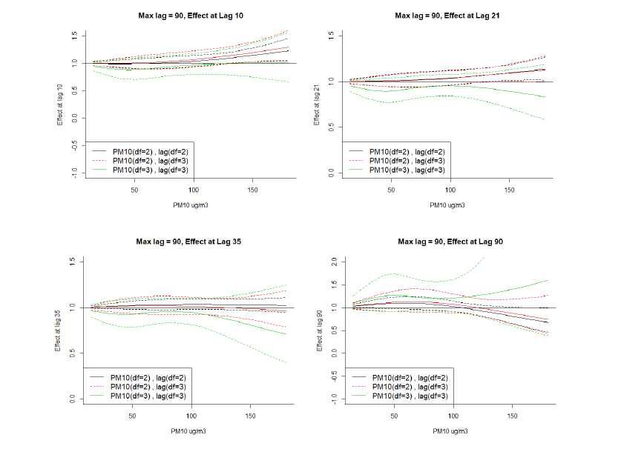

**Figure 5**: Adjusted Cox proportional hazard ratios of combinations of PM10 levels and lags from distributed lag models using different degrees of freedom combinations for exposure and lags compared to no PM10 exposure

**Supplemental Material**

**Figure S1: Adjusted Cox proportional hazard ratios of combinations of PM10 levels and lags, results from distributed lag models using different degree of freedom combinations for exposure and lags compared to no PM10 exposure**

**Figure S2: Adjusted Cox proportional hazard ratios of combinations of PM10 levels and lags, results from distributed lag models using different degree of freedom combinations for exposure and lags** **compared to no PM10 exposure**

**Figure S3: Adjusted Cox proportional hazard ratios of combinations of PM10 levels and lags, results from distributed lag models using different degree of freedom combinations for exposure and lags compared to no PM10 exposure**

**Figure S4: Adjusted Cox proportional hazard ratios of combinations of PM10 levels and lags, results from distributed lag models using different degree of freedom combinations for exposure and lags** **compared to no PM10 exposure**

**Figure S5: Adjusted Cox proportional hazard ratios of combinations of PM10 levels and lags, results from distributed lag models using different degree of freedom combinations for exposure and lags** **compared to no PM10 exposure**

|  |  |  |  |  |  |  |  |  |  |  |
| --- | --- | --- | --- | --- | --- | --- | --- | --- | --- | --- |
|  | **Table S1.** Distribution of PM10 (ug/m3) during pregnancy among 1216 ELEMENT mothers, 1994-2005. | | | | | | | | |  |
|  |  |  |  | **Percentile** | | | | | |  |
|  |  | **Mean ± SD** |  | **5th** | **25th** | **50th** | **75th** | **95th** | **Max** |  |
|  |  |  |  |  |  |  |  |  |  |  |
|  | **1st trimester** | 79.0±29.1 |  | 36.6 | 60.2 | 68.7 | 105.3 | 129.2 | 133.4 |  |
|  | **2nd trimester** | 76.4±26.4 |  | 36.5 | 58.7 | 73.0 | 97.4 | 120.3 | 133.4 |  |
|  | **3rd trimester** | 64.2±17.6 |  | 33.6 | 52.9 | 68.6 | 74.3 | 93.1 | 115.5 |  |
|  | **Overall Pregnancy** | 72.3±19.8 |  | 46.9 | 53.9 | 75.9 | 86.7 | 107.8 | 113.4 |  |
|  | SD: standard deviation |  |  |  |  |  |  |  |  |  |

|  |  |  |  |  |  |  |  |  |  |  |  |
| --- | --- | --- | --- | --- | --- | --- | --- | --- | --- | --- | --- |
|  | **Table S2**. Distribution of E-DII scores during pregnancy among 620 ELEMENT mothers, 1997-2005. | | | | | | | | | |  |
|  |  |  |  |  | **Percentile** | | | | | |  |
|  |  | ***N*** | **Mean ± SD** |  | **5th** | **25th** | **50th** | **75th** | **95th** | **Max** |  |
|  |  |  |  |  |  |  |  |  |  |  |  |
|  | **1st trimester** | **581** | -0.89 ± 1.35 |  | -2.82 | -1.84 | -1.04 | -0.11 | 1.63 | 4.59 |  |
|  | **2nd trimester** | **598** | -0.71 ± 1.35 |  | -2.78 | -1.73 | -0.84 | 0.28 | 1.60 | 3.75 |  |
|  | **3rd trimester** | **558** | -0.58 ± 1.41 |  | -2.47 | -1.68 | -0.76 | 0.28 | 2.21 | 3.87 |  |
|  | **Pregnancy average** | **518** | -0.71 ± 1.06 |  | -2.29 | -1.42 | -0.82 | 0.01 | 1.09 | 2.55 |  |
|  | SD: Standard deviation |  |  |  |  |  |  |  |  |  |  |

|  |  |  |  |
| --- | --- | --- | --- |
| **Table S3. Hazard ratios, 95% confidence intervals for select concentrations of average PM10 vs. PM10 value of 70 ug/m3 and E-DII values of 1, 2 and 3, first trimester. ELEMENT Study, 1994-2005** | | | |
| **PM10** | **DII = 1** | **DII = 2** | **DII = 3** |
| **50** | 0.55 (0.19, 1.58) | 0.48 (0.13, 1.72) | 0.42(0.09, 1.93) |
| **60** | 0.80 (0.45, 1.42) | 0.76 (0.38, 1.54) | 0.72 (0.31, 1.68) |
| **80** | 1.07 (0.48, 2.37) | 1.10 (0.39, 3.08) | 1.14 (0.32, 4.08) |

|  |  |  |  |
| --- | --- | --- | --- |
| **Table S4. Hazard ratios, 95% confidence intervals for select concentrations of average PM10 vs. PM10 value of 70 ug/m3 and E-DII values of 1, 2 and 3, second trimester. ELEMENT Study, 1994-2005** | | | |
| **PM10** | **DII = 1** | **DII = 2** | **DII = 3** |
| **50** | 0.80 (0.31, 2.04) | 0.85 (0.27, 2.66) | 0.91(0.23, 3.58) |
| **60** | 0.94 (0.50, 1.74) | 0.98 (0.45, 2.11) | 1.02 (0.40, 2.59) |
| **80** | 0.99 (0.38, 2.59) | 0.93 (0.27, 3.16) | 0.87 (0.20, 3.90) |



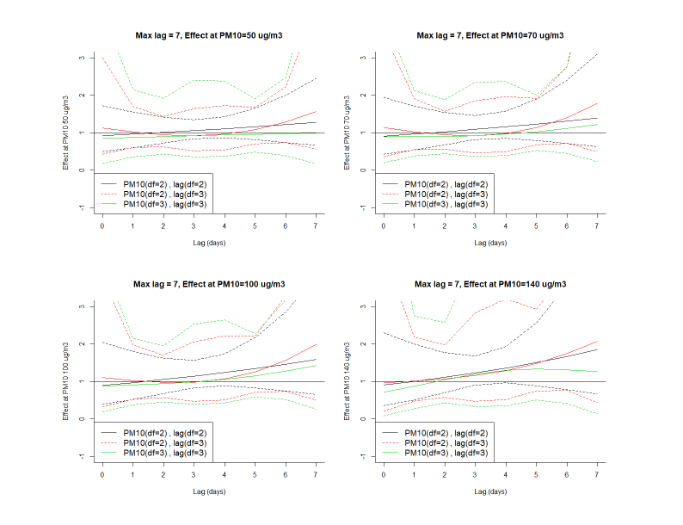

**Figure S1: Adjusted Cox proportional hazard ratios of combinations of PM10 levels and lags, results from distributed lag models using different degree of freedom combinations for exposure and lags compared to no PM10 exposure**

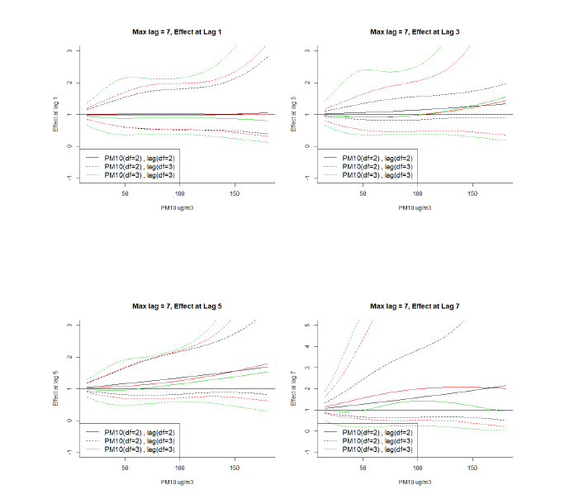

**Figure S2: Adjusted Cox proportional hazard ratios of combinations of PM10 levels and lags, results from distributed lag models using different degree of freedom combinations for exposure and lags** **compared to no PM10 exposure**

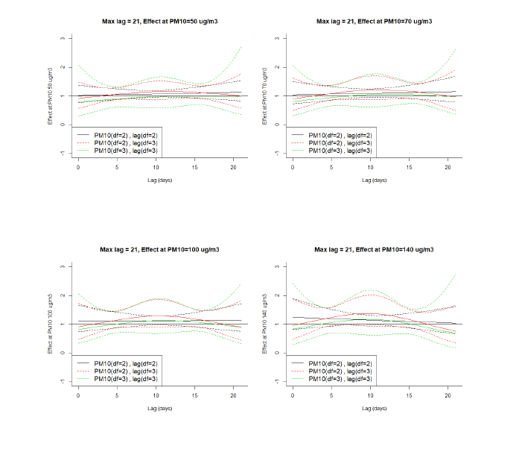

**Figure S3: Adjusted Cox proportional hazard ratios of combinations of PM10 levels and lags, results from distributed lag models using different degree of freedom combinations for exposure and lags compared to no PM10 exposure**

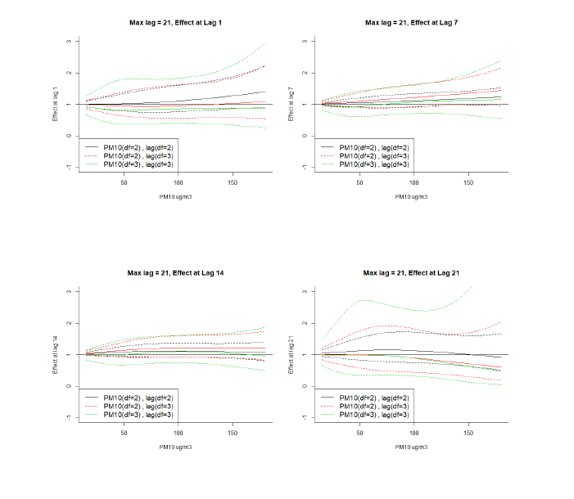

**Figure S4: Adjusted Cox proportional hazard ratios of combinations of PM10 levels and lags, results from distributed lag models using different degree of freedom combinations for exposure and lags** **compared to no PM10 exposure**

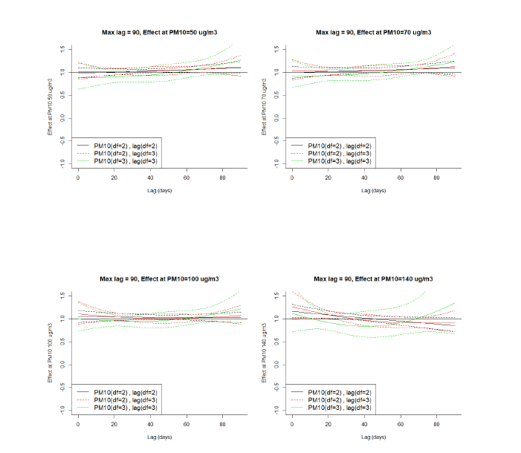

**Figure S5: Adjusted Cox proportional hazard ratios of combinations of PM10 levels and lags, results from distributed lag models using different degree of freedom combinations for exposure and lags** **compared to no PM10 exposure**