**SUPPLEMENTARY FIGURE 1. Weekly COVID-19 incidence in case surveillance data* by age group and U.S. Census Region**† **— United States, May 31–September 5, 2020**

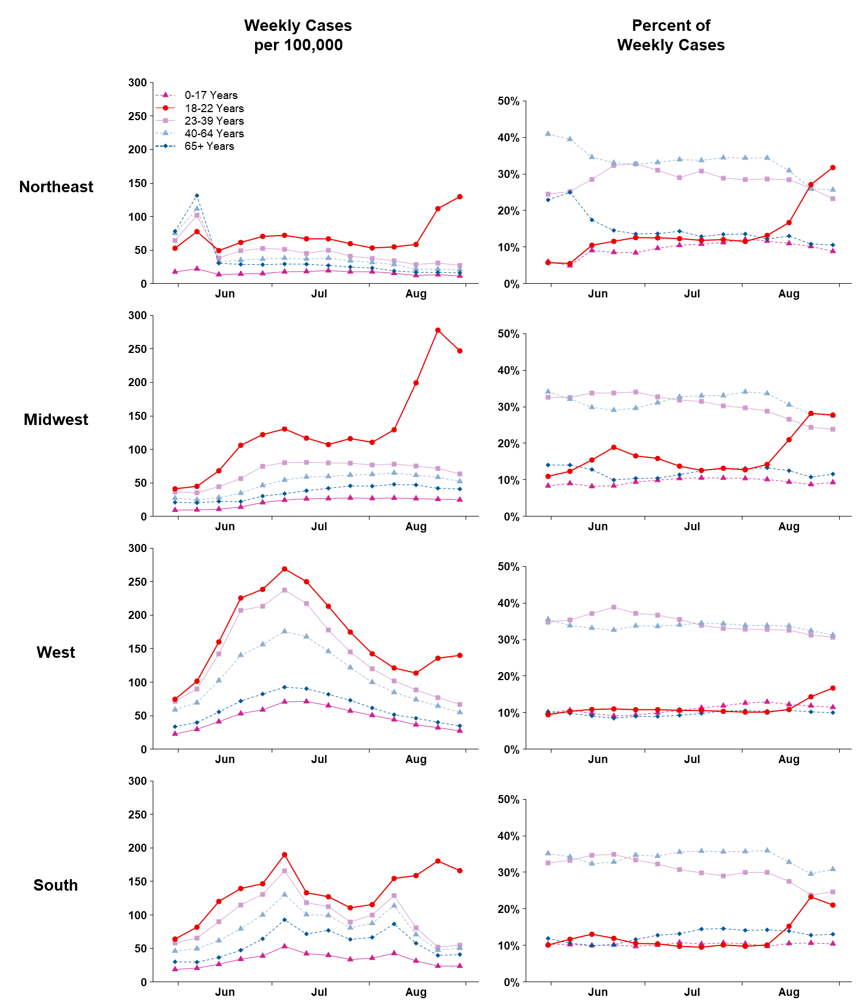* From CDC COVID-19 case report surveillance systems. Case report surveillance systems capture 76% of national aggregate case counts reported to CDC.

† *Northeast:* Connecticut, Maine, Massachusetts, New Hampshire, New Jersey, New York, Pennsylvania, Rhode Island, and Vermont;  *Midwest:* Illinois, Indiana, Iowa, Kansas, Michigan, Minnesota, Missouri, Nebraska, North Dakota, Ohio, South Dakota, and Wisconsin; *West*: Alaska, Arizona, California, Colorado, Hawaii, Idaho, Montana, Nevada, New Mexico, Oregon, Utah, Washington, and Wyoming; *South*: Alabama, Arkansas, Delaware, District of Columbia, Florida, Georgia, Kentucky, Louisiana, Maryland, Mississippi, North Carolina, Oklahoma, South Carolina, Tennessee, Texas, Virginia, and West Virginia.