SUPPLEMENTARY FIGURE 2. Total weekly SARS-CoV-2 RT-PCR test volume and percentage of weekly tests* by age group and U.S. Census Region† — United States, May 31–September 5, 2020
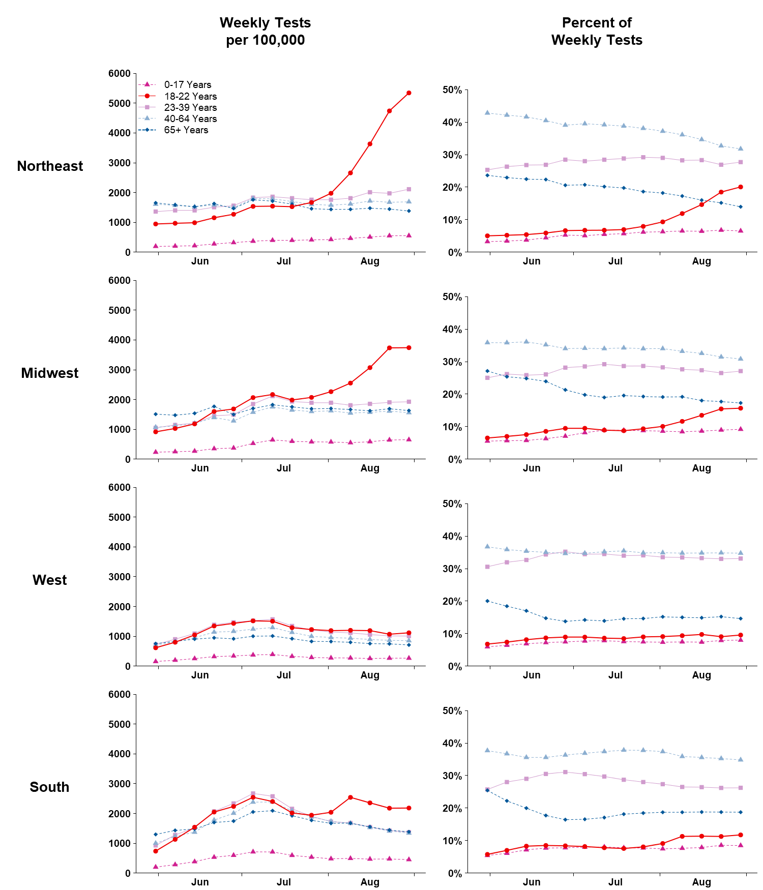
Abbreviations: RT-PCR = reverse transcription–polymerase chain reaction.
* Percentage of weekly tests was calculated as number of tests within each age group divided by number of tests in all age groups; for U.S. Census Region graphs, numerator and denominator data are stratified by US Census region. Specimen collection date or test order date was used for analysis. Tests result were obtained from COVID-19 electronic laboratory reporting data submitted by state health departments for 37 states and, when age was not available in state-submitted data, from data submitted directly by public health, commercial, and reference laboratories for 13 states and the District of Columbia. The data might not include results from all testing sites within a jurisdiction (e.g., point-of-care test sites) and therefore reflect the majority, but not all, SARS-CoV-2 RT-PCR tests in the United States.
† Northeast: Connecticut, Maine, Massachusetts, New Hampshire, New Jersey, New York, Pennsylvania, Rhode Island, and Vermont; Midwest: Illinois, Indiana, Iowa, Kansas, Michigan, Minnesota, Missouri, Nebraska, North Dakota, Ohio, South Dakota, and Wisconsin; West: Alaska, Arizona, California, Colorado, Hawaii, Idaho, Montana, Nevada, New Mexico, Oregon, Utah, Washington, and Wyoming; South: Alabama, Arkansas, Delaware, District of Columbia, Florida, Georgia, Kentucky, Louisiana, Maryland, Mississippi, North Carolina, Oklahoma, South Carolina, Tennessee, Texas, Virginia, and West Virginia.

