SUPPLEMENTARY FIGURE 3. Weekly COVID-19 incidence in case surveillance data* among persons aged 18–22 years, by race and ethnic group† and U.S. Census Region§ — United States, May 31–September 5, 2020
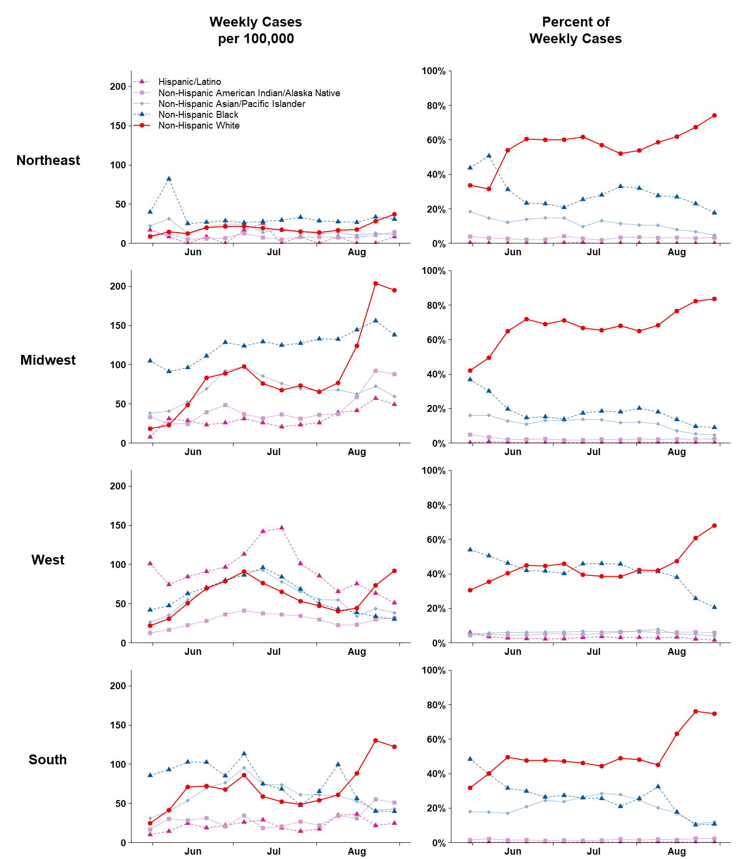
* From CDC COVID-19 case report surveillance systems. Case report surveillance systems capture 76% of national aggregate case counts reported to CDC.
† Race/ethnicity data were not reported for 2,394,772 cases (49.2%) case reports; these cases were excluded from this subgroup analysis.
§ Northeast: Connecticut, Maine, Massachusetts, New Hampshire, New Jersey, New York, Pennsylvania, Rhode Island, and Vermont; Midwest: Illinois, Indiana, Iowa, Kansas, Michigan, Minnesota, Missouri, Nebraska, North Dakota, Ohio, South Dakota, and Wisconsin; West: Alaska, Arizona, California, Colorado, Hawaii, Idaho, Montana, Nevada, New Mexico, Oregon, Utah, Washington, and Wyoming; South: Alabama, Arkansas, Delaware, District of Columbia, Florida, Georgia, Kentucky, Louisiana, Maryland, Mississippi, North Carolina, Oklahoma, South Carolina, Tennessee, Texas, Virginia, and West Virginia.

