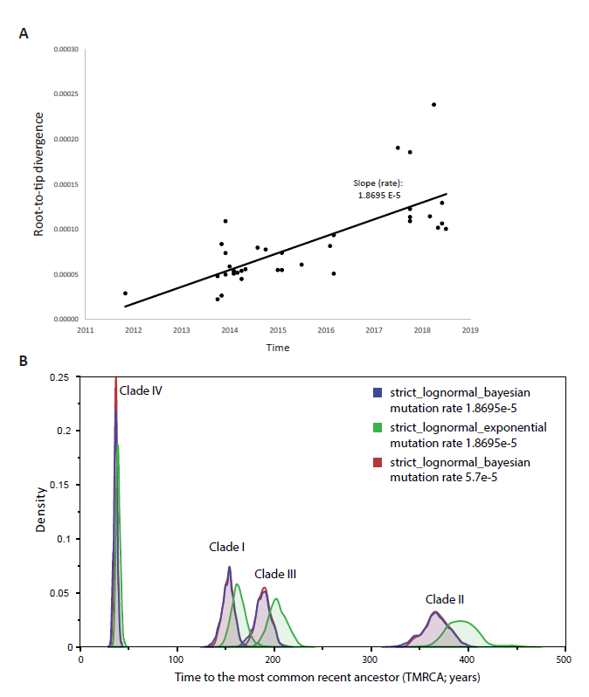
Supplementary Figure 1. (a) Root-to-tip regression analysis performed using a maximum likelihood tree of Candida auris genomes from Kenyan isolates clustering to Clade III. R-squared value = 0.55. (b) Marginal posterior distributions for the date of the most recent common ancestor (TMRCA) of C. auris Clades I, II, III and IV, analysis performed by BEAST under distinct models and mutation rates.

