**Supporting Information**

**Potential antitumor activity of digitoxin and user-designed analog administered to human lung cancer cells**

Reem Eldawuda¥, Alixandra Wagnera¥, Chenbo Donga, Neha Guptaa, Yon Rojanasakulb, George O’Dohertyc, Todd A. Stueckled*, and Cerasela Zoica Dinua*

*a Department of Chemical and Biomedical Engineering, West Virginia University, Morgantown, WV, 26506, USA*

*b Department of Basic Pharmaceutical Sciences, West Virginia University, Morgantown WV, 26506, USA*

*c Department of Chemistry and Chemical Biology, Northeastern University, Boston, MA, 02115, USA*

*d Health Effects Laboratory Division, National Institute for Occupational Safety and Health, Morgantown, WV, 26505, USA*

¥Authors have contributed equally to this work.

*Corresponding authors:

Cerasela Zoica Dinu, Ph.D.

Department of Chemical and Biomedical Engineering

West Virginia University

Benjamin M. Statler College of Engineering and Mineral Resources

PO Box 6102

Morgantown, WV, 26506, USA

E-mail: [cerasela-zoica.dinu@mail.wvu.edu](mailto:cerasela-zoica.dinu@mail.wvu.edu)

Tel.: +1 304 293 9338

Fax: +1 304 293 4139

Todd Stueckle, Ph.D.

Health Effects Laboratory Division

National Institute for Occupational Safety and Health

1095 Willowdale Road

Morgantown, WV, 26505, USA

E-mail: [tstueckle@cdc.gov](mailto:tstueckle@cdc.gov)

Tel.:+1 304 285-6098

Fax: +1 304 285-5398

**Methods**

**Synthesis of D6MA**

***Overview***

D6MA, α-L-rhamnose monosaccharide was synthesized from digitoxin (Sigma; Scheme 1) according to previously described methods.(Wang, Qi, et al., 2011; Wang, Rojanasakul, & O'Doherty, 2011; Wang, Xin, et al., 2011) Briefly, the trisaccharide moiety in digitoxin was cleaved by acid hydrolysis reaction to generate free aglycone moiety, i.e. digitoxigenin. Subsequently, the monosaccharide group was synthesized by a palladium-glycosylation (between digitoxigenin and a a-L-BocO-pyranone 1 to 2),(Bajaj, Farnsworth, & O’Doherty, 2014) Luche reduction (NaBH4/CeCl3, 2 to 3) and Upjohn dihydroxylation (Scheme 2).

***Schemes:***



**Scheme 1:** Digitoxin and its L-sugar synthetic analog D6MA

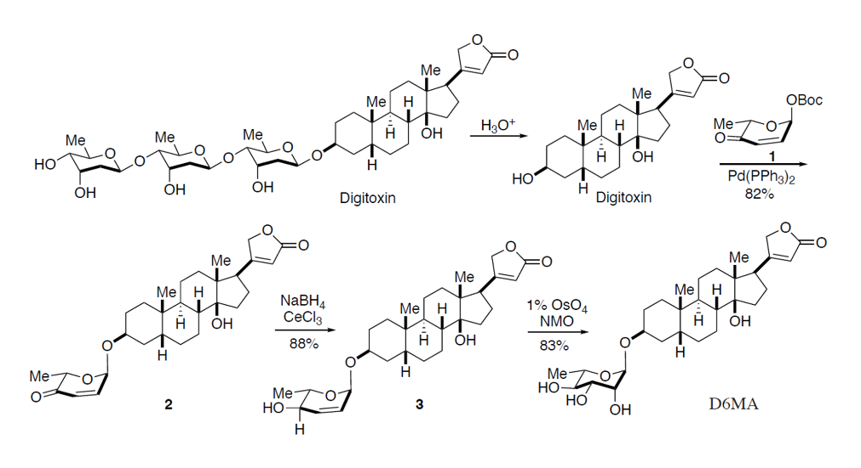

**Scheme 2:** Digitoxin and its L-sugar synthetic analog D6MA.

***General methods***

Air- and/or moisture-sensitive reactions were carried out under an atmosphere of argon or nitrogen using oven-dried glassware and standard syringe/septa techniques. Ether, tetrahydrofuran, methylene chloride and methanol were dried by passing through activated alumina column with argon gas pressure. Hexanes refer to the petroleum fraction bp 40-60 °C. Commercial reagents were used without purification unless otherwise noted. Flash chromatography was performed using the indicated solvent system on silica gel standard grade 60 (230-400 mesh). Rf values are reported for analytical TLC using the specified solvents and 0.25 mm silica gel 60 F254 plates that were visualized by UV irradiation (254 nm) or by staining with KMnO4 stain or anisaldehyde stain (465 mL of 95% EtOH, 17 mL conc. H2SO4, 5 mL acetic acid, and 13 mL anisaldehyde). Optical rotations were obtained using a digital polarimeter at sodium D line (589 nm) and were reported in concentration of g / 100 mL at 21 °C. 1H and 13C NMR spectra were recorded on 600 MHz and 400 MHz spectrometer. Chemical shifts are reported relative to CDCl3 (δ 7.26 ppm) for 1H and CDCl3 (δ 77.0 ppm) for 13C. IR spectra were recorded on a FT-IR spectrometer; thin film was formed in CHCl3 solution. Melting points are uncorrected.

**(2S,6R)-2-Methyl-6-(Digitoxigenoxy)-2*H*-pyran-3(6*H*)-one (2):**



A CH2Cl2/THF solution (7 mL, 4:1 V/V) of Boc pyranone **1** (884 mg, 3.87 mmol) and digitoxigenin (725 mg, 1.94 mmol) was cooled to 0 °C. A CH2Cl2 (2 mL) solution of Pd2(dba)3•CHCl3 (50.1 mg, 2.5 mol%) and PPh3 (50.7 mg, 10 mol%) was added to the reaction mixture via dry cannula at 0 ̊C. The resulting solution was stirred at 0 °C for 6 hours and was directly loaded and purified via silica gel flash chromatography with elution of 35% EtOAc/hexanes to obtain **2** (766 mg, 1.58 mmol, 82%) as a yellow solid; *Rf* (60% EtOAc/hexanes) = 0.58; mp: 121-123 ̊C; [α]25D = + 61.4 (c = 1.0, MeOH); IR (thin film, cm-1) 3481, 2939, 2253, 1738, 1698, 1620, 1448, 1374, 1319, 1237, 1157, 1102, 1079, 1024, 958, 905, 859, 645; 1H NMR (600MHz, CDCl3) δ 6.78 (dd, *J* = 10.4, 1.8 Hz, 1H), 5.99 (dd, *J* = 10.2, 1.2 Hz, 1H), 5.80 (m, 1H), 5.21 (dd, *J* = 2.4, 1.8 Hz, 1H), 4.95 (dd, *J* = 18.0, 1.8 Hz, 1H), 4.50 (dd, *J* = 18.0, 1.8 Hz, 1H), 4.49 (q, *J* = 6.6 Hz, 1H), 4.04 (m, 1H), 2.73 (m, 1H), 2.76 (dd, *J* = 9.6, 6.0 Hz, 1H), 2.20-2.08 (m, 3H), 1.44 (d, *J* = 7.2 Hz, 3H), 1.92-1.16 (m, 18H), 0.93 (s, 3H), 0.86 (s, 3H); 13C NMR (150 MHz, CDCl3) δ 197.2, 174.9, 174.5, 144.4, 126.7, 117.3, 91.7, 85.1, 74.0, 73.4, 70.2, 50.8, 49.5, 41.5, 40.0, 36.3, 35.5, 35.0, 32.8, 30.3, 30.1, 26.8, 26.4, 26.3, 23.5, 21.1, 21.0, 20.8, 15.6; ESIHRMS Calcd for [C29H40O6Na+]: 507.27226, Found: 507.27172.

**(2S,3R,6R)-3,6-Dihydro-2-methyl-6-( Digitoxigenoxy)-2*H*-pyran-4,5-en-3-ol (3):**



A CH2Cl2 (2.8 mL) solution of enone **2** (678 mg, 1.40 mmol) in CeCl3·MeOH solution (0.4 M, 2.8 mL) was cooled to –78 °C. NaBH4 (58.2 mg, 1.54 mmol) was added and the resulting solution was stirred at –78 °C for 1 hour. The reaction mixture was diluted with Et2O (20 mL) and was quenched with 20 mL of saturated aqueous NaHCO3, extracted with Et2O (3 x 20 mL), dried with Na2SO4, and concentrated under reduced pressure. The crude product was purified by silica gel flash chromatography eluting with 55% EtOAc/hexanes to give allylic alcohol **3** (600 mg, 1.23 mmol, 88%) as a white solid; *Rf* (60% EtOAc/hexanes) = 0.22; mp: 155-156 °C; IR (thin film, cm-1) 3448, 2933, 2871, 1780, 1741, 1618, 1446, 1378, 1320, 1180, 1135, 1049, 1024, 1004, 958, 751; 1H NMR (600 MHz, CDCl3): δ 5.90 (ddd, *J* = 10.2, 4.8, 1.2 Hz, 1H), 5.85 (m, 1H), 5.72 (d, *J* = 10.2 Hz, 1H), 5.07 (m, 1H), 4.98 (dd, *J* = 18.0, 1.2 Hz, 1H), 4.80 (dd, *J* = 18.0, 1.8 Hz, 1H), 4.11 (dd, *J* = 4.2, 1.8 Hz, 1H), 3.97 (s, 1H), 3.82 (dq, *J* = 6.6, 2.4Hz, 1H), 3.74 (br, 1H), 2.77 (dd, *J* = 9.6, 6.0 Hz, 1H), 2.25-2.05 (m, 2H), 1.29 (d, *J* = 6.0 Hz, 3H), 1.80-1.05 (m, 20H), 0.92 (s, 3H), 0.86 (s, 3H); 13C NMR (150 MHz, CDCl3): δ 174.6, 132.8, 127.5, 117.6, 93.2, 85.5, 73.6, 73.4, 69.7, 67.9, 64.9, 50.9, 49.5, 41.8, 40.0, 36.4, 35.7, 35.1, 33.1, 30.7, 30.3, 26.7 (2C), 26.5, 23.6, 21.3, 21.1, 17.9, 15.7; HRESIMS Calcd for [C29H42O6Na+]: 509.2879, Found 509.28737.

**(2S,3R,4R,5R,6R)-3,4,5,6-tetrahydro-2-methyl-6-(Digitoxigenoxy)-2*H*-pyran-3,4,5-triol (D6MA):**



To a *t*-BuOH/acetone (7.5 mL, 1:1 (v/v), 0.5M) solution of allylic alcohol **3** (1.80 g, 3.70 mmol) at 0 °C was added a solution of *N*-methylmorpholine-*N*-oxide/water (50% w/v, 3.70mL). Crystalline OsO4 (9.4 mg, 1 mol %) was added and the reaction mixture was stirred for 4 hours. The reaction mixture was quenched with 20mL of saturated Na2S2O3 solution, extracted with EtOAc (3 x 30 ml), dried over Na2SO4, and concentrated under reduced pressure. The crude product was purified via silica gel flash chromatography eluting with 90% EtOAc/Hexane. Pure fraction were combined, concentrated, and crystallized from CH2Cl2/hexanes to afford **D6MA** as white solid (2.07 g, 3.55 mmol, 93%); *Rf* = 0.20 (EtOAc); mp: 160-162 °C; [α]25D = -24 (*c* = 0.7, MeOH); IR (thin film, cm-1) 3371, 2940, 2856, 1739, 1736, 1658; 1449, 1454, 1378, 1160, 1076, 1024, 951, 822; 1H NMR (400MHz, CD3OD) δ 5.90 (m, 1H), 5.04 (dd, *J* = 19.2, 2.0 Hz, 1H), 4.92 (dd, *J* = 19.2, 2.0 Hz, 1H), 4.77 (d, *J* = 2.0 Hz, 1H), 3.95 (br, 1H), 3.76 (dd, *J* = 2.8, 1.6 Hz, 1H), 3.69 (dd, *J* = 9.6, 2.8 Hz, 1H), 3.66 (dq, *J* = 9.6, 6.0 Hz, 1H), 3.37 (dd, *J* = 9.6, 9.6 Hz, 1H), 2.83 (m, 1H), 2.19 (m, 2H), 2.00-1.27 (m, 23H), 1.23 (d, *J* = 6.0 Hz, 3H), 0.96 (s, 3H), 0.89 (s, 3H); 13C NMR (100 MHz, CD3OD) δ 178.46, 177.25, 117.79, 99.85, 86.44, 75.36, 74.07, 73.58, 72.94, 72.51, 70.02, 52.11, 51.07, 42.69, 40.94, 38.18, 36.81, 36.39, 33.38, 31.62, 30.83, 28.06, 27.89, 27.51, 24.35, 22.58, 22.38, 17.98, 16.40; ESIHRMS Calcd. for [C29H44O8Na+]: 543.6446, found: 543.6446.

**Cell culture and treatment**

Human non-small cancer lung cells (NCI-H460) and non-tumorigenic human lung epithelial cells (BEAS-2B) were purchased from American Type Culture Collection (ATCC). NCI-H460 cells were cultured in in Roswell Park Memorial Institute (RPMI; Gibco) 1640 medium supplemented with 10% bovine fetal serum (FBS, Life Technologies), 2 mMl-glutamine and 100-units/ml penicillin/streptomycin (Sigma). BEAS-2B cells were cultured in Dulbecco’s Modified Eagle Medium (DMEM; Sigma) supplemented with 5% bovine fetal serum (FBS), 2 mM l-glutamine and 100-units/ml penicillin/streptomycin. Cells were passaged regularly using 0.25% (w/v) trypsin with 1.5 mM EDTA (Molecular Probes) and maintained in a humidified atmosphere at 37ºC and 5% CO2. Stock concentrations of digitoxin and D6MA were prepared in sterile dimethyl sulfoxide (DMSO) and diluted to 1000x exposure concentrations as previously described. (Elbaz et al., 2012) Digitoxin and D6MA exposures were performed in a medium containing 1% FBS, 2 mM L-glutamine and 100 units/ml penicillin/streptomycin. The concentration of FBS was reduced to 1% upon treatment due to existing concerns regarding the drugs interaction with serum proteins.(Baggot & Davis, 1973)

**Apoptosis assay**

NCI-H460 cells were seeded overnight in 12-well plates (Fisher) at 2×105 cell/mL and exposed to 10, 25, 50, and 100 nM digitoxin or 1, 5, 10, and 25 nM D6MA for 24 and 48 h, respectively. After exposure, the cells were incubated with 10 μg/mL Hoechst-33342 (Molecular Probles) for 30 min. The percentage of cells having intensely condensed chromatin and/or fragmented nuclei was measured using fluorescence microscope (Leica Microsystems). Experiments were performed 3 times, with approximately 1000 nuclei from ten random fields analyzed per sample. The apoptotic percentage was calculated as the percentage of cells with apoptotic nuclei over the total number of cells per field of view.

**Trypan-blue exclusion assay**

NCI-H460 cells were seeded overnight in 12-well plates at a density of 2×105 cell/mL, and exposed to 10, 25, 50, and 100 nM digitoxin or 1, 5, 10, and and 25 nM D6MA for 24 and 48 h. Cells were subsequently washed with phosphate buffered saline (PBS, Invitrogen), trypsinized (0.25%), suspended in 10% media, and stained with 0.4% trypan-blue (Invitrogen) at 1:1 volume ratio and analyzed using Countess automated cell counter (Invitrogen). Experiments were performed in duplicates and repeated 4 times.

### **Western blot analysis**

NCI-H460 cells were seeded overnight in 6-well plates (Fisher) at a density of 5×105 cell/well, and exposed to digitoxin (10, 25, and 50 nM) or D6MA (1, 5, and 10 nM) for 24 h. Following treatment, the cells were lysed for 30 min in a lysis buffer containing 2% Triton X-100 (Sigma), 1% sodium dodecyle sulfate (SDS), 100 mM sodium chloride (NaCl), 10 mM tris-hydrochloric acid (HCl), complete mini cocktail protease inhibitors (all reagents are purchased from Roche) and 1 mM EDTA and centrifuged at 4 °C and 12,500 rpm for 15 min. The amounts of proteins in the supernatant was determined using standard Bicinchoninic Acid Assay (BCA, Thermo Scientific). Briefly, working reagent was prepared according to the manufacturer instructions by mixing 50 parts of reagent A with 1 part of reagent B (reagents included with kit). Two μL of each sample was added to a 96-well plate and incubated with 200 μL of the working reagent at 37 °C for 30 min. Control calibration curves were prepared using serial dilutions of standard bovine serum albumin (BSA). Absorbance at 562 nm was recorded via the FLOUstar OPTIMA plate reader. The supernatant was separated by a 7.5 or 10 % SDS–PAGE gel and transferred to polyvinylidene fluoride (PVDF) membranes using a wet transfer method. Membranes were blocked in 5% milk in distilled water for 2 h at room temperature, and subsequently incubated with the primary antibody at 4 °C overnight. The membranes were washed 3 times in Tris-buffered saline-Tween 20 (TBS-T, 25 mM Tris–HCl, and 125 mM NaCl, Sigma Chemicals, and 1% Tween 20, Fisher Scientific) for 10 min each, incubated with horseradish peroxidase-conjugated secondary antibody (Cell Signaling) for 1 h at room temperature, washed again (3 times for 10 min in TBS-T) and developed by chemiluminescence (Supersignal). Primary antibodies included matrix metalloproteinase-9 (MMP-9) and extracellular signal-regulated kinase (ERK 1/2) (all proteins were purchased from Cell Signaling Technology). Band quantification was performed using ImageJ software, version 10.2. Experiments were performed in duplicates and repeated 3 times. All protein expressions were normalized against β-actin (Sigma).

**Statistical analysis**

Results are represented as mean ± standard deviation, two-way analysis of variance (ANOVA) and unpaired two-tailed Student’s t-test were performed using JMP 8.0 (SAS Institute) and SigmaPlot 10.0 (Systat Software Inc.). Results are considered significant when *p < 0.05.

**Results**

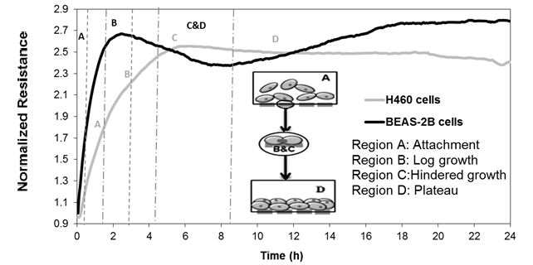

**Figure S1:** Real-time measurements of the attachment and spreading behavior of NCI-H460 and BEAS-2B cells respectively. The normalized resistance curve was analyzed and segmented into different regions that correspond to the cellular behavior from the time of inoculation until the formation of a confluent monolayer.

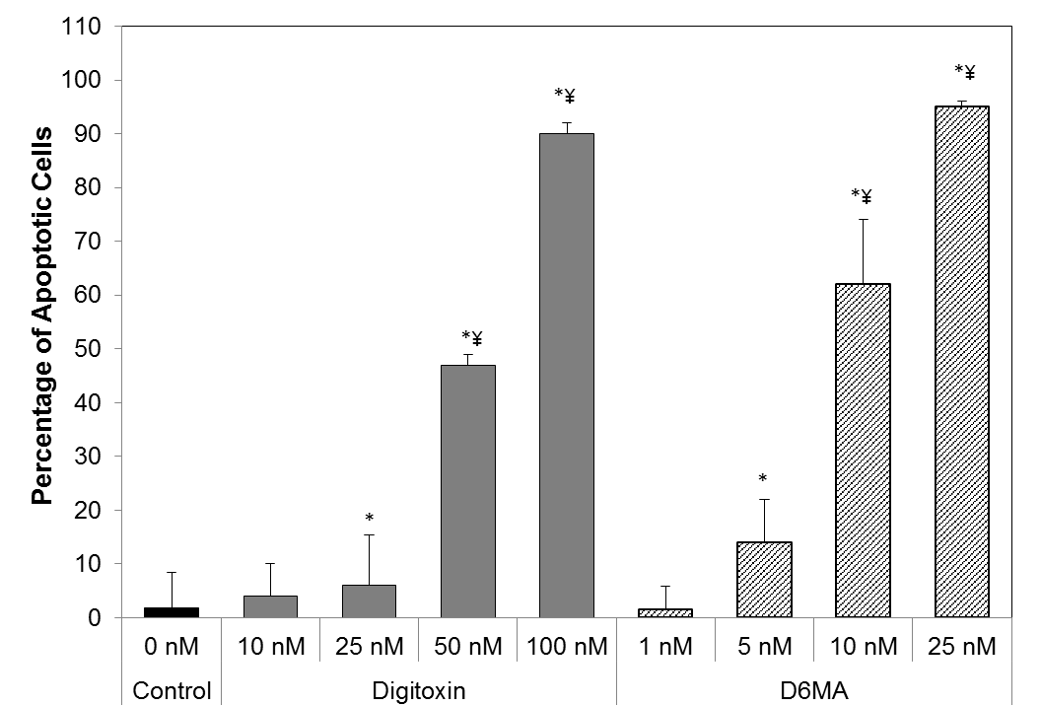

**(a)**

**(b)**

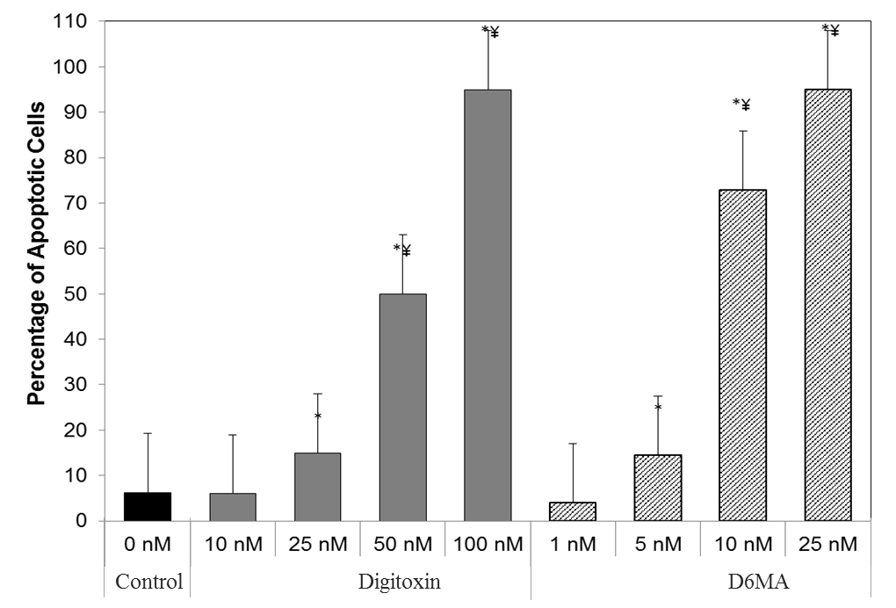

**Figure S2:** Analysis of the cellular apoptotic percentages of NCI-H460 cells after (a) 24 h and (b) 48 h exposure to subtherapeutic, therapeutic, and toxic concentrations of digitoxin and D6MA respectively. The symbol * indicates a significant difference from the control (p < 0.05), and the symbol ¥ indicates a significant difference between doses.

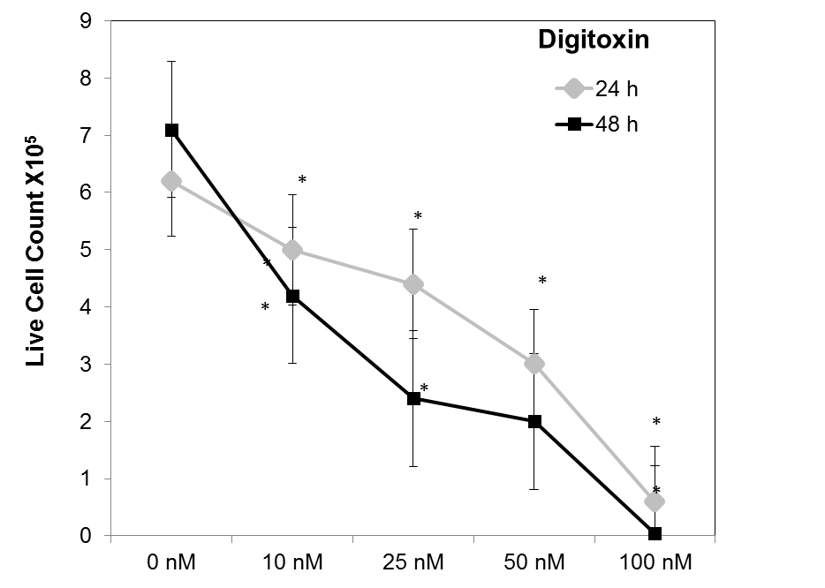

**(b)**

**(a)**

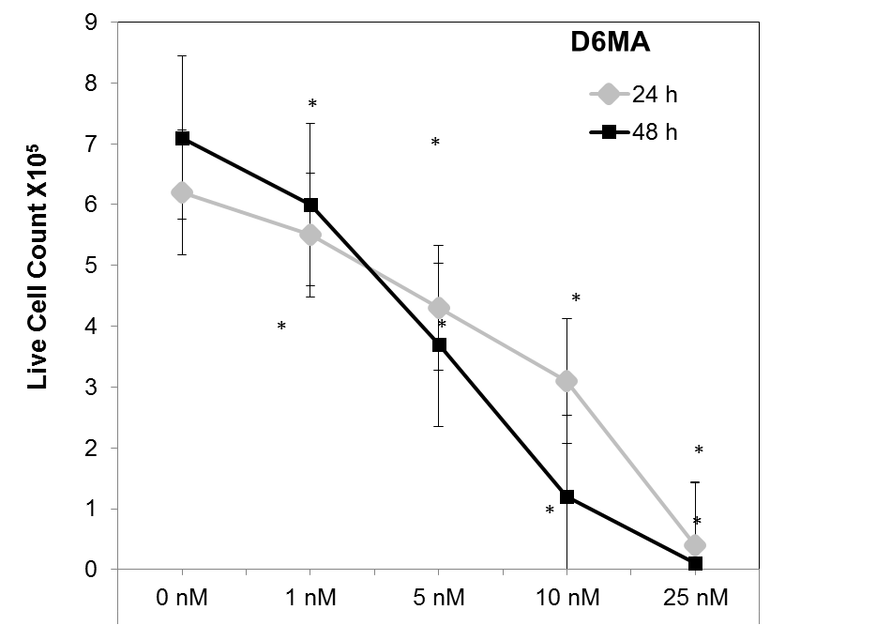

**Figure S3:** Analysis of the cellular viability of NCI-H460 cells by measuring the number of live cells following exposure to subtherapeutic, therapeutic, and toxic concentrations of (a) digitoxin and (b) D6MA after 24 h and 48 h. The symbol * indicates a significant difference from the control cells (p < 0.05).

**(a)**

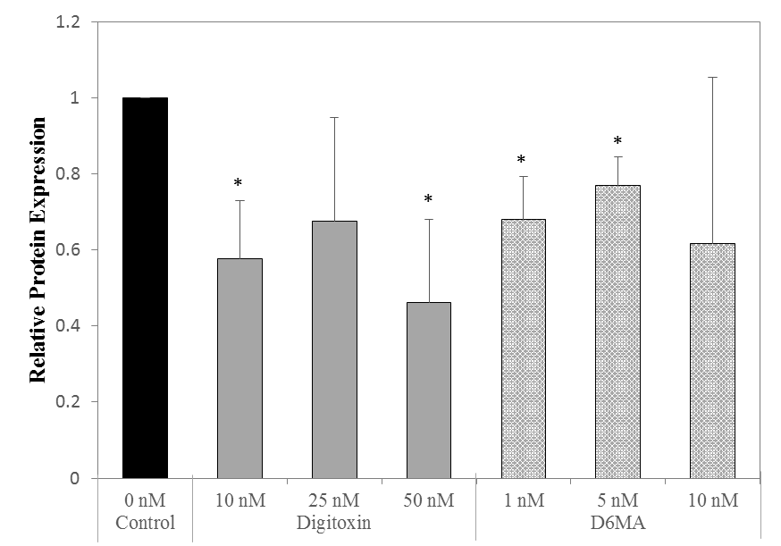

**MMP-9**

**β-actin**

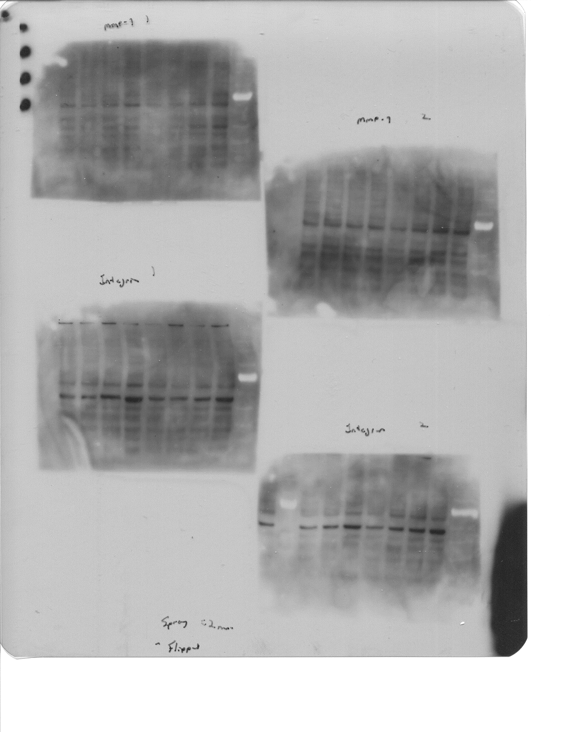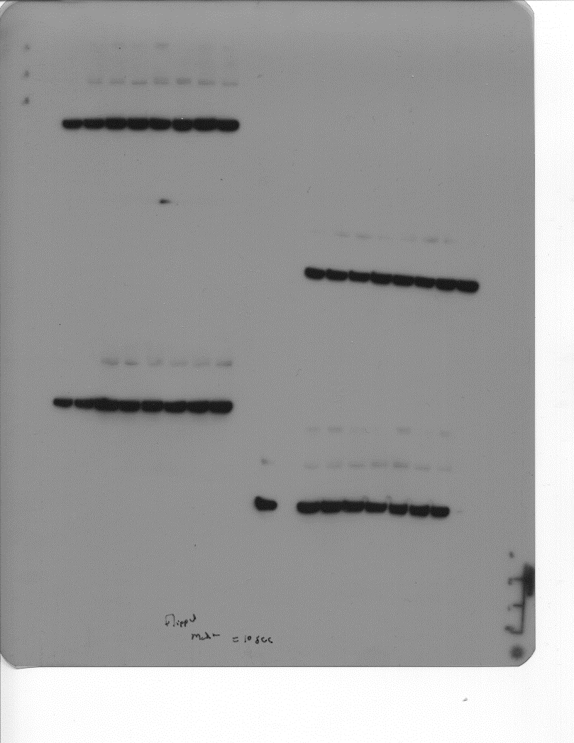

D6MA Digitoxin Control

10 nM 5 nM 1nM 50nM 25nM 10nM 0nM

**(b)**

**Figure S4:** Western blot analyses and quantification of MMP-9 after 24 h exposure to digitoxin and D6MA. The symbol * indicates significant difference from the control (p < 0.05).

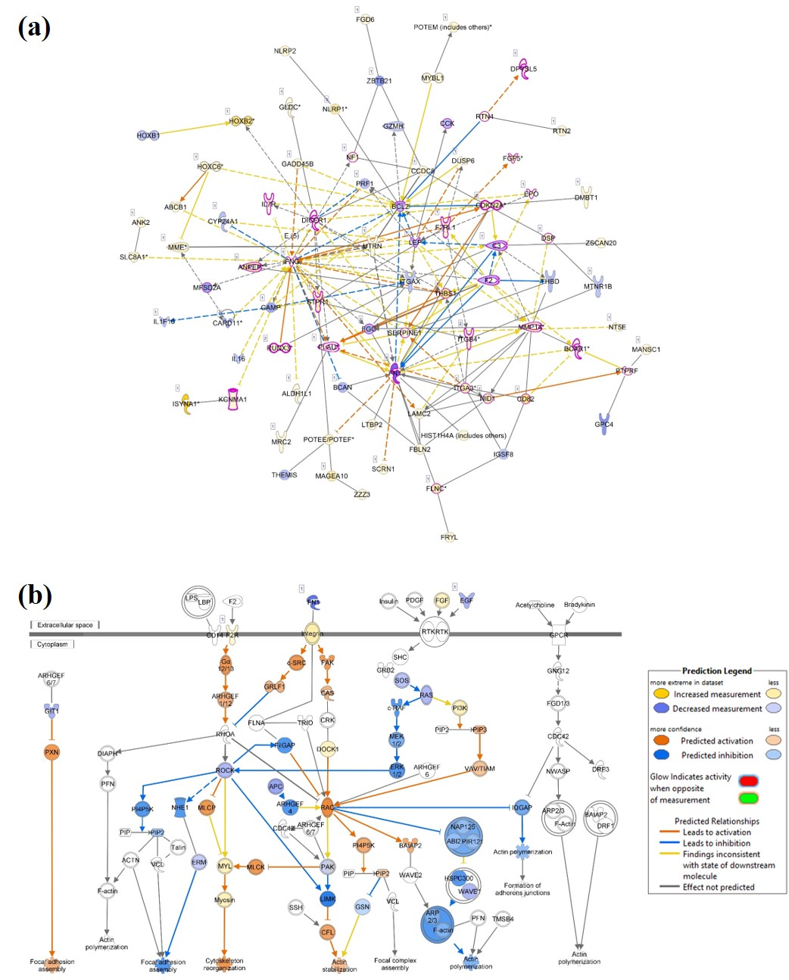

**Figure S5**. Role of cell morphology, cytoskeleton, and adhesion on digitoxin and D6MA anti-cancer effect on NSCLCs. A) Inhibition of lung cancer signaling network in H460 cells following 25 nM DTX exposure for 12 h. B) Actin cytoskeleton canonical pathway signaling in H460 cells following 5 nM D6-MA exposure for 12 h.

**References**

Baggot, J. D., & Davis, L. E. (1973). Plasma protein binding of digitoxin and digoxin in several mammalian species. *Research in veterinary science, 15*(1), 81-87.

Bajaj, S. O., Farnsworth, J. R., & O’Doherty, G. A. (2014). Enantioselective synthesis of a- and b-Boc-protected 6-hydroxy pyranones: carbohydrate building blocks. *Organic Syntheses, 91*, 338-355. doi:10.15227/orgsyn.091/0338

Elbaz, H. A., Stueckle, T. A., Wang, H.-Y. L., O'Doherty, G. A., Lowry, D. T., Sargent, L. M., . . . Rojanasakul, Y. (2012). Digitoxin and a synthetic monosaccharide analog inhibit cell viability in lung cancer cells. *Toxicology and Applied Pharmacology, 258*(1), 51-60. doi:<http://dx.doi.org/10.1016/j.taap.2011.10.007>

Wang, H. Y., Qi, Z., Wu, B., Kang, S. W., Rojanasakul, Y., & O'Doherty, G. A. (2011). C5'-Alkyl Substitution Effects on Digitoxigenin alpha-l-Glycoside Cancer Cytotoxicity. *ACS Med Chem Lett, 2*(4), 259-263. doi:10.1021/ml100291n

Wang, H. Y., Rojanasakul, Y., & O'Doherty, G. A. (2011). Synthesis and Evaluation of the alpha-D-/alpha-L-Rhamnosyl and Amicetosyl Digitoxigenin Oligomers as Anti-tumor Agents. *ACS Med Chem Lett, 2*(4), 264-269. doi:10.1021/ml100290d

Wang, H. Y., Xin, W., Zhou, M., Stueckle, T. A., Rojanasakul, Y., & O'Doherty, G. A. (2011). Stereochemical survey of digitoxin monosaccharides: new anticancer analogues with enhanced apoptotic activity and growth inhibitory effect on human non-small cell lung cancer cell. *ACS Med Chem Lett, 2*(1), 73-78. doi:10.1021/ml100219d