Supplement 1

Sleep disorders: The Athens Insomnia Scale (AIS) is an 8-item instrument that was used to evaluate risk of moderate to severe insomnia (sensitivity 0.93, specificity 0.85), defined in this study as a score of ≥10 on the AIS (Range 0 to 24) (Soldatos et al. 2003). The Berlin Questionnaire consists of three categories related to the risk of having OSA (i.e., snoring; daytime sleepiness; history of hypertension and/or BMI >30 kg/m²). In this study, participants were identified as having a high risk of OSA if they had at least two of the three OSA symptom categories on this tool(sensitivity 0.86, specificity 0.77) (Netzer et al. 1999). The AIS (Jeong et al. 2015) and Berlin Questionnaire (Rajaratnam et al. 2011) have both been used and validated in other studies in emergency personnel. The Restless Legs Syndrome (RLS) Epidemiology, Symptoms and Treatment questionnaire was used to determine presence of RLS (sensitivity 0.82, specificity 0.90) (Allen et al. 2005). The RLS Epidemiology, Symptoms and Treatment questionnaire has 10 items that include diagnostic questions for RLS, questions on the frequency of RLS symptoms, and level of distress associated with these symptoms (Allen et al. 2005). SWD was assessed using a tool previously used in emergency personnel (Rajaratnam et al. 2011) which is based on The International Classification of Sleep Disorders-2 diagnostic criteria(American Academy of Sleep Medicine, 2017. This tool assessed SWD risk by examining excessive sleepiness levels (based on the ESS) and insomnia symptoms (based on AIS) in firefighters during overnight work and during vacation/days off/day work. Using this tool, a positive screening for SWD in this study was defined as having excessive sleepiness and symptoms of insomnia during overnight work but not on vacation/days off/day work. Daytime sleepiness was assessed using the Epworth Sleepiness Scale (ESS; range 0 to 24), which assesses participants likelihood of falling asleep in 8 different situations. In the present study, excessive sleepiness in firefighters was defined as an ESS score ≥11 (sensitivity 93%, specificity 100%) (Johns 2000).

Burnout: The 22-item MBI–Human Services Survey (MBI–HSS) (Maslach et al. 1996) was used to assess burnout across three dimensions including; EE, (9 items), DP (5 items), and PA (8 items). Cronbach’s alpha for these dimensions were between 0.76 to 0.90, aligning with prior studies (Katsavouni et al. 2016; Metlaine et al. 2017). Participants rated the frequency of each item on a 7-point Likert scale (0=never; 6=everyday).

Analysis
An analysis was conducted with sleep disorder and self-reported mental health condition simultaneously in the model to examine their main effects on burnout. An interaction term was also applied to this model to examine whether sleep disorder had an interaction effect with mental health condition on burnout. This analysis revealed Any Sleep Disorder and Any Mental Health Condition had an independent effect on high EE (Any Sleep Disorder P<0.0001; Any Mental Health Condition P<0.0001), DP (Any Sleep Disorder P<0.0001; Any Mental Health Condition P<0.0001) and a High Degree of burnout (Any Sleep Disorder P<0.0001; Any Mental Health Condition P=0.007). Any Sleep Disorder also increased the risk of low PA in this model (P<0.0001), but Any Mental Health Condition was not related to this dimension. Finally, there was no significant interaction effect of the Any Sleep Disorder × Any Mental Health Condition term on EE (P=0.428), DP (P=0.958), PA (P=0.457) or High Degree of burnout (P=0.671; Table S.1).
Table S.1. High burnout associated with Any Sleep Disorder, Any Mental health Condition and an Any Sleep Disorder by Any Mental health Condition interaction term

Burnout  Outcomeª, n^{b} | Included Variables | B (SE) | OR | 95% CI | P Value
EE | Constant | -2.729 (0.069)
 | Any Sleep Disorder^{c} | 1.106 (0.091) | 3.022 | 2.528-3.613 | <0.0001
 | Any Mental Health Condition^{c} | 1.158 (0.206) | 3.183 | 2.125-4.767 | <0.0001
 | Any Sleep Disorder^{c} by Any Mental Health Condition^{c} | -0.193 (0.243) | 0.825 | 0.512-1.328 | 0.428
DP | Constant | -1.911 (0.049)
 | Any Sleep Disorder^{c} | 0.700 (0.072) | 2.013 | 1.747-2.320 | <0.0001
 | Any Mental Health Condition^{c} | 0.662 (0.184) | 1.938 | 1.352-2.779 | <0.0001
 | Any Sleep Disorder^{c} by Any Mental Health Condition^{c} | 0.012 (0.222) | 1.012 | 0.655-1.564 | 0.958
PA | Constant | -0.624 (0.035)
 | Any Sleep Disorder^{c} | 0.300 (0.057) | 1.350 | 1.208-1.509 | <0.0001
 | Any Mental Health Condition^{c} | 0.173 (0.155) | 1.189 | 0.878-1.610 | 0.264
 | Any Sleep Disorder^{c} by Any Mental Health Condition^{c} | 0.145 (0.194) | 1.156 | 0.790-1.691 | 0.457
High Degree | Constant | -3.952 (0.122)
 | Any Sleep Disorder | 1.133 (0.155) | 3.104 | 2.289-4.210 | <0.0001
 | Any Mental Health Condition^{c} | 0.985 (0.363) | 2.677 | 1.315-5.451 | 0.007
 | Any Sleep Disorder^{c} by Any Mental Health Condition^{c} | 0.171 (0.404) | 1.187 | 0.538-2.618 | 0.671
EE, emotional exhaustion; DP, depersonalisation; PA, personal accomplishment; OR, Odds ratio; CI, Confidence interval; ªHigh vs. low to moderate score on burnout dimension. ^{b}high EE, high DP, with low PA. ^{c}Missing or not known outcomes not included.

An analysis was also conducted to examine whether self-reported mental health conditions mediate the effects of sleep duration when working an overnight shift on burnout. The mediator variable in this analysis was Any Mental Health Condition, which was categorical. Therefore, it was not possible to use PROCESS with SPSS. Instead, the method developed by Mackinnon and Dwyer 1993 was applied, which is suitable for examining dichotomous mediator variables. Based on the Sobel tests from this analysis, self-reporting any mental health condition mediated the effect of sleep duration during an overnight shift on EE (Z = -7.7835, P<0.0001), DP (Z = -3.532, p = 0.0004) and PA (Z = 2.2880, P = 0.0221; Table S.2).

Table S.2. Indirect effects of sleep duration when working an overnight shift on EE, DP and PA though self-reporting any mental health condition (i.e., PTSD, Depression, Anxiety).

Predictor | Indirect effect through Any Mental Health Condition
 | Sobel Z | SE | P | % of effect mediated
EE
Sleep duration when working an overnight shift | -7.7835 | 1.5415 | <0.0001 | 0.4401
DP
Sleep duration when working an overnight shift | -3.5321 | 0.1043 | 0.0004 | 0.0702
PA
Sleep duration when working an overnight shift | 2.2880 | 0.0832 | 0.0221 | -0.0988
EE, emotional exhaustion; DP, depersonalisation; PA, personal accomplishment; SE, Standard Error.

To further investigate potential relationships between sleep characteristics and burnout independent of risk of mental health conditions, we conducted a logistic regression analysis when removing those firefighters who reported a mental health condition. This analysis revealed that in firefighters without a mental health condition, short sleep during an overnight shift and when working a day shift was associated with an increased risk of high EE, high DP and a high Degree of burnout (Table S.3). In this sub-sample, short sleep after an overnight shift was also associated with a greater risk of each of the dimensions of burnout (Table S.3.). Finally, in firefighters without a mental health condition, short sleep after more than two days off from work was associated with a greater risk of EE (Table S.3).
Table S.3. High burnout associated with sleep duration in participants who did not report any mental health condition (n=6121)
Burnout Outcomeª | Unadjusted |  |  | Adjusted^{d}
 | OR | 95% CI | P  Value | OR | 95% CI |  |  | P  Value
Sleep when working overnight^{c}
EE | 2.21 | 1.80-2.70 | <0.0001 | 2.08 | 1.68-2.58 |  |  | <0.0001
DP | 2.06 | 1.77-2.40 | <0.0001 | 2.05 | 1.74-2.36 |  |  | <0.0001
PA | 0.96 | 0.86-1.08 | 0.509 | Not sig in final model
High Degree^{b} | 2.34 | 1.68-3.27 | <0.0001 | 2.33 |  | 1.67-3.26 |  |  | <0.0001
Sleep after working overnight^{c}
EE | 2.03 | 1.68-2.45 | <0.0001 | 2.03 | 1.68-2.46 |  |  | <0.0001
DP | 1.35 | 1.16-1.56 | <0.0001 | 1.37 |  | 1.18-1.59 |  |  | <0.0001
PA | 1.17 | 1.04-1.31 | 0.010 | 1.16 |  | 1.02-1.32 |  |  | 0.020
High Degree^{b} | 1.97 | 1.46-2.67 | <0.0001 | 1.97 |  | 1.45-2.66 |  |  | <0.0001
Sleep when working a day shift^{c}
EE | 2.00 | 1.56-2.58 | <0.0001 | 2.14 | 1.64-2.78 |  |  | <0.0001
DP | 1.50 | 1.21-1.85 | <0.0001 | 1.49 |  |  | 1.19-1.86 |  | 0.001
PA | 0.99 | 0.84-1.15 | 0.851 | Not sig in final model
High Degree^{b} | 1.86 | 1.15-3.00 | 0.012 | 1.86 |  | 1.15-3.00 |  |  | 0.012
Sleep following ≥2 days off^{c}
EE | 1.53 | 1.24-1.90 | <0.0001 | 1.50 | 1.21-1.87 |  |  | <0.0001
DP | 1.14 | 0.95-1.37 | 0.158 | Not sig in final model
PA | 1.12 | 0.97-1.29 | 0.127 | Not sig in final model
High Degree^{b} | 1.15 | 0.78-1.69 | 0.471 | Not sig in final model
EE, emotional exhaustion; DP, depersonalisation; PA, personal accomplishment; OR, Odds ratio; CI, Confidence interval; n, number. ªHigh vs. low to moderate score on burnout dimension. ^{b}high EE, high DP, with low PA. ^{c}Missing or not known outcomes not included. ^{d}Adjusted for age, gender, body mass index, cigarette smoking, alcohol consumption, second job and mean weekly work hours. Variables included in each model are in Table S.7.

References for above sleep disorders, burnout and analysis sections
American Academy of Sleep Medicine. International classification of sleep disorders, revised: diagnostic and coding manual. 2nd ed. Westchester, IL: American Academy of Sleep Medicine, 2005.
Allen R. P., Walters A. S., Montplaisir J., et al. Restless legs syndrome prevalence and impact: REST general population study. Arch Intern Med, 2005, 165: 1286-92.
Jeong H. S., Jeon Y., Ma J., et al. Validation of the Athens Insomnia Scale for screening insomnia in South Korean firefighters and rescue workers. Qual Life Res, 2015, 24: 2391-5.
Johns M. W. Sensitivity and specificity of the multiple sleep latency test (MSLT), the maintenance of wakefulness test and the epworth sleepiness scale: failure of the MSLT as a gold standard. J Sleep Res, 2000, 9: 5-11.
Katsavouni F., Bebetsos E., Malliou P., Beneka A. The relationship between burnout, PTSD symptoms and injuries in firefighters. Occup Med, 2016, 66: 32-7.
MacKinnon D. P., Dwyer J. H. Estimating mediated effects in prevention studies. Evaluation Review, 1993, 17: 144-158
Maslach C., Jackson S. E. (1996) Maslach Burnout Inventory - Human Services Survey (MBI-HSS). In: C M, S.e. Jackson, & M.P. Leiter (ed) MBI Manual. 3rd edn. Consulting Psychologists Press, Palo Alto, CA
Metlaine A., Sauvet F., Gomez-Merino D., et al. Association between insomnia symptoms, job strain and burnout syndrome: a cross-sectional survey of 1300 financial workers. BMJ Open, 2017, 7: e012816.
Netzer N. C., Stoohs R. A., Netzer C. M., Clark K., Strohl K. P. Using the Berlin Questionnaire to identify patients at risk for the sleep apnea syndrome. Ann Intern Med, 1999, 131: 485-91.
Rajaratnam S. M., Barger L. K., Lockley S. W., et al. Sleep disorders, health, and safety in police officers. JAMA, 2011, 306: 2567-2578.
Soldatos C. R., Dikeos D. G., Paparrigopoulos T. J. The diagnostic validity of the Athens Insomnia Scale. J Psychosom Res, 2003, 55: 263-7.

Table S.4 Variables included in the models used to examine associations between burnout outcomes and positive sleep disorder screening
Burnout  Outcome | Insomnia | OSA | SWD | RLS | Any Sleep Disorder
EE | Age,  Gender,  Cigarette smoking | Gender,  BMI^{b},  Cigarette smoking | Age,  Gender,  Cigarette smoking,  Second job | Age,  Gender,  Cigarette smoking | Gender
n | 6083 | 6066 | 4706 | 6066 | 6184
DP | Age,  Alcohol consumption | Age,  BMI^{b},  Alcohol consumption | Age,  Alcohol consumption | Age,  Alcohol consumption | Age,  BMI^{b},  Alcohol consumption
n | 6159 | 6107 | 5186 | 6145 | 6204
PA | BMI^{b},  Cigarette smoking | BMI^{b},  Cigarette smoking | BMI^{b},  Cigarette smoking | BMI^{b},  Cigarette  smoking | Cigarette smoking
n | 6120 | 6156 | 5222 | 6194 | 6255
High  Degreeª | Cigarette smoking | Gender, BMI^{b}, Cigarette smoking | Gender, Cigarette smoking | Cigarette smoking | BMI^{b}, Cigarette smoking
n | 6195 | 6026 | 5118 | 6179 | 6240
EE, emotional exhaustion; DP, depersonalisation; PA, personal accomplishment; OSA, obstructive sleep apnea; SWD, shift work disorder; RLS, restless legs syndrome; BMI, body mass index. ªDefined as high EE and high DP, and low PA. ^{b}BMI was a categorical variable.

Table S.5 Variables included in the models used to examine associations between burnout outcomes and mental health conditions.
Burnout Outcome | Depression | PTSD | Anxiety | Any MH condition
EE | Age, Gender, Cigarette smoking | Age, Gender, Cigarette smoking | Age, Gender, Cigarette smoking | Age, Gender
n | 6033 | 6137 | 6140 | 6078
DP | Age, Alcohol consumption, Work hours | Age, Alcohol consumption, Work hours | Age, Alcohol consumption | Age, Alcohol consumption, Mean Work hours
n | 5515 | 5506 | 6104 | 5535
PA | BMI^{b}, Cigarette smoking, Work hours | BMI^{b}, Cigarette smoking, Work hours | BMI^{b}, Cigarette smoking, Work hours | BMI^{b}, Cigarette smoking, Work hours
n | 5549 | 5541 | 5542 | 5570
High  Degreeª | Cigarette smoking | Cigarette smoking | Cigarette smoking | Cigarette smoking
n | 6143 | 6133 | 6137 | 6170
EE, emotional exhaustion; DP, depersonalisation; PA, personal accomplishment; PTSD, post-traumatic stress disorder; BMI, body mass index; MH, mental health.
ªDefined as high EE and high DP, and low PA.
^{b}BMI was a categorical variable.

Table S.6 Variables included in the models used to examine associations between burnout and sleep duration in all participants and participants who did not screen positive for a sleep disorder (i.e., Low-risk sleep disorder participants)
 | All participants |  |  |  | Low-risk sleep disorder participants
Burnout Outcome | Sleep during an overnight shift | Sleep after an overnight shift | Sleep after day shift | Sleep after two days off work | Sleep during an overnight shift | Sleep after an overnight shift | Sleep after day shift | Sleep after two days off work
EE | Age, Gender, Second job | Age, Gender | Age, Gender, BMI^{b} | Age, Gender,  Cigarette smoking | Gender, BMI^{b} | Gender | Age,  Gender | Age, Gender
n | 5201 | 5683 | 2877 | 5453 | 3542 | 3550 | 1170 | 3371
DP | Age, Alcohol consumption | Age, Alcohol consumption | - | Age, Alcohol consumption | Age, Alcohol consumption | Age, Alcohol consumption | Alcohol consumption | Age, Gender, Alcohol consumption
n | 5785 | 5769 | 2936 | 5536 | 3604 | 3575 | 1798 | 3342
PA | BMI^{b} Cigarette smoking, Work hours | BMI^{b}, Cigarette smoking | BMI^{b} | BMI^{b}, Cigarette smoking | BMI^{b}, Cigarette smoking | BMI^{b}, Cigarette smoking | BMI^{b}, Cigarette smoking | BMI^{b}, Cigarette smoking
n | 5237 | 5805 | 2942 | 5574 | 3604 | 3593 | 1804 | 3429
High Degreeª | Cigarette smoking | Cigarette smoking | - | Gender, Cigarette smoking | Gender | Gender | - | Gender
n | 5814 | 5795 | 2935 | 5455 | 3544 | 3533 | 1804 | 3368
EE, emotional exhaustion; DP, depersonalisation; PA, personal accomplishment; BMI, body mass index.
ªDefined as high EE and DP, and low PA.
^{b}BMI was a categorical variable.

Table S.7 Variables included in the models used to examine associations between burnout and sleep duration in participants who did not report a mental health condition
 | participants who did not report a mental health condition
Burnout Outcome | Sleep during an overnight shift | Sleep after an overnight shift | Sleep after day shift | Sleep after two days off work
EE | BMI^{b}, Gender | Age, Gender | BMI^{b}, Age, Gender | BMI^{b}, Age, Gender
n | 4719 | 4892 | 2601 | 4936
DP | Alcohol, Age | Alcohol, Age | Second Job | Alcohol, Age
n | 5238 | 5225 | 2443 | 5012
PA | Work Hours, BMI^{b} | BMI^{b} | Work hours | BMI^{b}
n | 4671 | 4662 | 2364 | 4963
High Degreeª | Smoke | Smoke | - | Smoke
n | 5266 | 5037 | 2655 | 5038
EE, emotional exhaustion; DP, depersonalisation; PA, personal accomplishment; BMI, body mass index.
ªDefined as high EE and DP, and low PA.
^{b}BMI was a categorical variable.
Table S.8 Variables included in the models used to examine associations between burnout and sleep deficit and sleepiness in all participants and participants who did not screen positive for a sleep disorder (i.e., Low-risk sleep disorder participants)
 | All participants |  | Low-risk sleep disorder participants
Burnout Outcome | Sleep after an overnight shift minus sleep required to feel well rested | Daytime sleepiness | Sleep after an overnight shift minus sleep required to feel well rested | Daytime sleepiness
EE | Age, Gender, Second Job | Age, Gender, Cigarette smoking | Gender, BMI^{b} | Age, Gender
n | 5170 | 5987 | 3539 | 3721
DP | Age, Alcohol consumption | Age, Alcohol consumption | Age, Alcohol consumption | Age, Alcohol consumption
n | 5752 | 6062 | 3563 | 3753
PA | BMI^{b}, Cigarette smoking | BMI^{b}, Cigarette smoking | BMI^{b}, Cigarette smoking | BMI^{b}, Cigarette smoking
n | 5787 | 6108 | 3580 | 3780
High degreeª | Cigarette smoking | Cigarette smoking | Gender | Gender
n | 5526 | 6093 | 3522 | 3714
EE, emotional exhaustion; DP, depersonalisation; PA, personal accomplishment; BMI, body mass index.
ªDefined as high EE and high DP, and low PA.
^{b}BMI was a categorical variable.
Table S.9 Direct effect regressions
Variable | EE Scores |  |  | DP Scores |  |  | PA Scores
 | Coefficient (SE) | P  value | St. Beta | Coefficient (SE) | P  value | St. Beta | Coefficient (SE) | P  value | St. Beta
Constant | 10.278 (0.804) | <0.001 | . | 6.824 (0.501) | <0.001 | . | 34.209 (0.881) | <0.001 | -
Any sleep disorder | 5.873 (0.285) | <0.001 | 0.285 | 2.412 (0.177) | <0.001 | 0.195 | -1.472 (0.312) | <0.001 | -0.070
Any mental health condition | 5.711 (0.470) | <0.001 | 0.159 | 2.457 (0.292) | <0.001 | 0.115 | -1.082 (0.514) | 0.035 | -0.029
Cigarette smoking | 0.220 (0.647) | 0.734 | 0.004 | 0.344 (0.401) | 0.391 | 0.012 | -0.829 (0.707) | 0.241 | -0.016
Gender | 3.193 (0.552) | <0.001 | 0.075 | 0.064 (0.344) | 0.852 | 0.012 | 0.412 (0.605) | 0.496 | 0.014
Age | 0.023 (0.015) | 0.111 | 0.029 | -0.045 (0.009) | <0.001 | -0.066 | 0.016 (0.016) | 0.321 | 0.013
BMI | -0.586 (0.172) | 0.001 | -0.047 | -0.177 (0.107) | 0.098 | -0.024 | -0.307 (0.188) | 0.102 | -0.024
Alcohol consumption | -0.117 (0.273) | 0.668 | -0.006 | 0.704 (0.170) | <0.001 | 0.056 | 0.310 (0.298) | 0.300 | 0.014
Work hours per week | -0.003 (0.007) | 0.997 | 0.000 | 0.007 (0.004) | 0.081 | 0.023 | -0.013 (0.007) | 0.085 | -0.024
Second job | 0.788 (0.263) | 0.003 | 0.039 | 0.188 (0.163) | 0.249 | 0.015 | 0.217 (0.287) | 0.449 | 0.010
R-squared | 0.126 |  |  | 0.062 |  |  | 0.009
EE, emotional exhaustion; DP, depersonalisation; PA, personal accomplishment; BMI, body mass index; SE, standard error.

Table S.10 Indirect effects of screening positive for a sleep disorder (i.e., insomnia, OSA, SWD, RLS) on EE, DP and PA through Sleep duration when working an overnight shift.
Predictor | Indirect effect through Sleep duration when working an overnight shift
 | Effect | SE | 95% CI
EE
Any Sleep Disorder | 0.5190 | 0.0727 | 0.3858 to 0.6674
DP
Any Sleep Disorder | 0.2836 | 0.0372 | 0.2154 to 0.3625
PA
Any Sleep Disorder | 0.1383 | 0.0478 | 0.0512 to 0.2382
EE, emotional exhaustion; DP, depersonalisation; PA, personal accomplishment; SE, standard error; CI, confidence interval.

Table S.11 Model coefficients (a, b, c′) and summary information of regression analyses for the single mediator model examining sleep disorder risk and burnout. Analyses performed separately for EE, DP and PA.
Predictor | M1: Sleep duration when working overnight |  |  |  | Y: EE Scores
 |  | Coef | SE | P-value |  | Coef | SE | P-value
EE
X: Any Sleep Disorder | a1 | -0.4223 | 0.0438 | <0.0001 | c′ | 5.9109 | 0.2795 | <0.0001
M1: Sleep duration when working an overnight shift |  |  |  |  | b1 | -1.2289 | 0.0875 | <0.0001
 |  | R² = 0.0242 |  |  |  | R² = 0.1351
Final model controlled for: Gender, BMI, Second job
DP |  |  |  |  | Y: DP Scores
X: Any Sleep Disorder | a1 | -0.4268 | 0.0400 | <0.0001 | c′ | 2.3111 | 0.1593 | <0.0001
M1: Sleep duration when working an overnight shift |  |  |  |  | b1 | -0.6645 | 0.0519 | <0.0001
 |  | R² = 0.0257 |  |  |  | R² = 0.0750
Final model controlled for: Age, Alcohol consumption
PA |  |  |  |  | Y: PA Scores
X: Any Sleep Disorder | a1 | -0.3901 | 0.0405 | <0.0001 | c′ | -1.6772 | 0.2868 | <0.0001
M1: Sleep duration when working an overnight shift |  |  |  |  | b1 | -0.3546 | 0.0920 | <0.0001
 |  | R² = 0.0157 |  |  |  | R² = 0.0075
EE, emotional exhaustion; DP, depersonalisation; PA, personal accomplishment; BMI, body mass index; SE, standard error; M, mediator; X, independent variable; Y, dependent variable; Coef, coefficient.

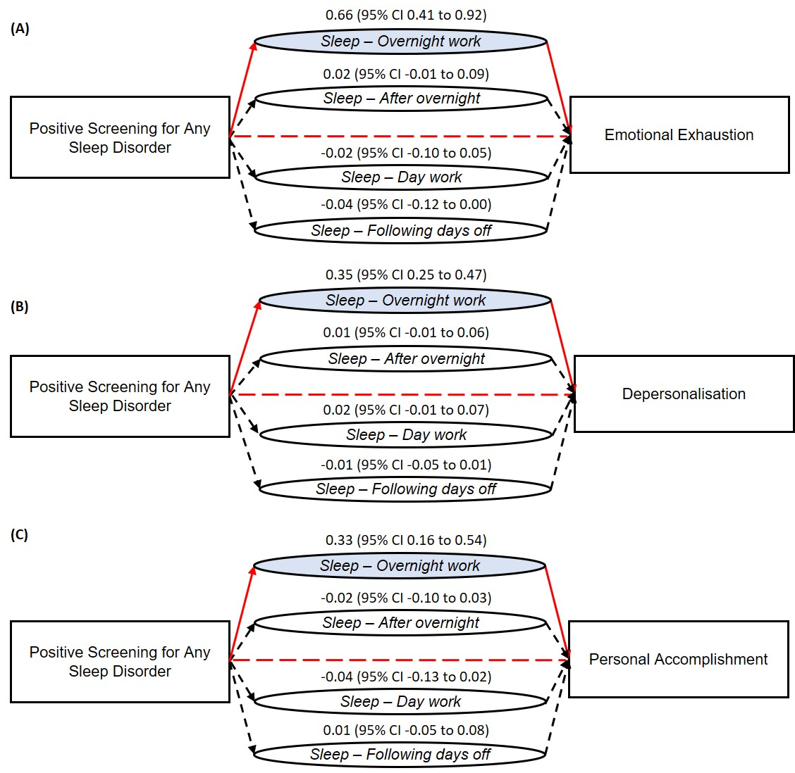
Figure S.1 Simplified models showing indirect effects of positive screening for any sleep disorder on Emotional Exhaustion (A), Depersonilisation (B) and Personal Accomplishment (C) through the mediators Sleep – Overnight work (i.e., sleep duration when working an overnight shift), Sleep – After overnight (i.e., sleep duration after working an overnight shift), Sleep – Day work (i.e., sleep duration when working a day shift) and Sleep – Following days off (i.e., sleep duration following ≥2 days off from work). Path coefficients (95% confidence interval) are shown. Long dashed red lines indicate statistically significant direct effect paths. Solid red lines indicate statistically significant indirect effect paths and dotted black lines indicate non-significant indirect paths. For further indirect effect details see Appendices Table A.8. Adjusted for age, gender, body mass index, cigarette smoking, alcohol consumption, second job and mean work hours per week. For full details of the multiple mediator model and variables included in the multiple mediator model see Appendices Table A.9.
Table S.12 Indirect effects of screening positive for a sleep disorder (i.e., insomnia, OSA, SWD, RLS) on EE, DP and PA through Sleep duration when working an overnight shift, Sleep duration after working an overnight shift, Sleep duration when working a day shift and Sleep duration following ≥2 days off from work (i.e., parallel mediator variables)
Predictor | Indirect effect through Sleep duration when working an overnight shift |  |  | Indirect effect through Sleep duration after working an overnight shift |  |  | Indirect effect through Sleep duration when working a day shift |  |  | Indirect effect through sleep duration following ≥2 days off work
 | Effect | SE | 95% CI | Effect | SE | 95% CI | Effect | SE | 95% CI | Effect | SE | 95% CI
EE
Any Sleep Disorder | 0.6575 | 0.1314 | 0.4113 to 0.9215 ^{a, b, c} | 0.0159 | 0.0221 | -0.0094 to 0.0881 ^{d} | -0.0170 | 0.0381 | -0.0996 to 0.0538 | -0.0387 | 0.0288 | -0.1213 to -0.0004
DP
Any Sleep Disorder | 0.3530 | 0.0565 | 0.2531 to 0.4743 ^{a, b, c} | 0.0148 | 0.0164 | -0.0113 to 0.0565 | 0.0249 | 0.0210 | -0.0101 to 0.0743 | -0.0075 | 0.0144 | -0.0461 to 0.0145
PA
Any Sleep Disorder | 0.3304 | 0.0951 | 0.1591 to 0.5358 ^{a, b, c} | -0.0205 | 0.0318 | -0.0984 to 0.0311 | -0.0409 | 0.0358 | -0.1256 to 0.0183 | 0.0089 | 0.0303 | -0.0465 to 0.0786
EE, emotional exhaustion; DP, depersonalisation; PA, personal accomplishment; SE, standard error; CI, confidence interval.
ªSignificant difference in size of indirect effect through Sleep duration when working an overnight shift compared to Sleep duration after working an overnight shift determined by pairwise contrasts.
^{b}Significant difference in size of indirect effect through Sleep duration when working an overnight shift compared to Sleep duration when working a day shift determined by pairwise contrasts.
^{c}Significant difference in size of indirect effect through Sleep duration when working an overnight shift compared to Sleep duration following ≥2 days off from work determined by pairwise contrasts.
^{d}Significant difference in size of indirect effect through Sleep duration after working an overnight shift compared to Sleep duration following ≥2 days off from work determined by pairwise contrasts.

Table S.13 Model coefficients (a, b, c′) and summary information of regression analyses for the multiple mediator model examining sleep disorder risk and burnout. Analyses performed separately for EE, DP and PA.
Predictors | M1: Sleep when working overnight |  |  |  | M2: Sleep after working overnight |  |  |  | M3: Sleep when working a day shift |  |  |  | M4: Sleep following ≥2 days off work |  |  |  | Y: EE Scores
 |  | Coef | SE | P-value |  | Coef | SE | P-value |  | Coef | SE | P |  | Coef | SE | P-value |  | Coef | SE | P-value
EE
X: Any Sleep Disorder | a1 | -0.5061 | 0.0683 | <0.0001 | a2 | -0.1592 | 0.0953 | 0.0952 | a3 | -0.4269 | 0.1113 | 0.0001 | a4 | -0.1725 | 0.0796 | 0.0304 | c′ | 6.1557 | 0.4214 | <0.0001
M1: Sleep when working overnight |  |  |  |  |  |  |  |  |  |  |  |  |  |  |  |  | b1 | -1.2992 | 0.1307 | <0.0001
M2: Sleep after working overnight |  |  |  |  |  |  |  |  |  |  |  |  |  |  |  |  | b2 | -0.0997 | 0.0952 | <0.0001
M3: Sleep when working a day shift |  |  |  |  |  |  |  |  |  |  |  |  |  |  |  |  | b3 | 0.0398 | 0.0812 | 0.6243
M4: Sleep following ≥2 days off work |  |  |  |  |  |  |  |  |  |  |  |  |  |  |  |  | b4 | 0.2244 | 0.1104 | 0.0421
 |  | R=0.0338 |  |  |  | R² = 0.0158 |  |  |  | R² = 0.0077 |  |  |  | R² = 0.0083 |  |  |  | R=0.1539
Final model controlled for: Gender, BMI, Second job
DP |  |  |  |  |  |  |  |  |  |  |  |  |  |  |  |  | Y: DP Scores
X: Any Sleep Disorder | a1 | -0.5691 | 0.0618 | <0.0001 | a2 | -0.2549 | 0.0877 | 0.0037 | a3 | -0.3954 | 0.1012 | 0.0001 |  | -0.1777 | 0.0729 | 0.0149 | c′ | 2.3680 | 0.2374 | <0.0001
M1: Sleep when working overnight |  |  |  |  |  |  |  |  |  |  |  |  |  |  |  |  | b1 | -0.6202 | 0.0771 | <0.0001
M2: Sleep after working overnight |  |  |  |  |  |  |  |  |  |  |  |  |  |  |  |  | b2 | -0.0579 | 0.0556 | 0.2976
M3: Sleep when working a day shift |  |  |  |  |  |  |  |  |  |  |  |  |  |  |  |  | b3 | -0.0631 | 0.0477 | 0.1865
M4: Sleep following ≥2 days off work |  |  |  |  |  |  |  |  |  |  |  |  |  |  |  |  |  | 0.0424 | 0.0648 | 0.5131
 |  | R² = 0.0385 |  |  |  | R² = 0.0040 |  |  |  | R² = 0.0076 |  |  |  | R=0.0104 |  |  |  | R=0.0816
Final model controlled for: Age, Alcohol consumption

Table S.13 Continued.
Predictors | M1: Sleep when working overnight |  |  |  | M2: Sleep after working overnight |  |  |  | M3: Sleep when working a day shift |  |  |  | M4: Sleep following ≥2 days off work |  |  |  | Y: PA Scores
 |  | Coef | SE | P-value |  | Coef | SE | P-value |  | Coef | SE | P-value |  | Coef | SE | P-value | Coef |  | SE | P-value
PA
X: Any Sleep Disorder | a1 | -0.5054 | 0.0638 | <0.0001 | a2 | -0.2620 | 0.0875 | 0.0028 | a3 | -0.3826 | 0.1002 | 0.0001 | a4 | -0.2037 | 0.0730 | 0.0053 | c′ | -1.0178 | 0.4455 | 0.0224
M1: Sleep duration when working an overnight shift |  |  |  |  |  |  |  |  |  |  |  |  |  |  |  |  | b1 | -0.6537 | 0.1403 | <0.0001
M2: Sleep duration after working an overnight shift |  |  |  |  |  |  |  |  |  |  |  |  |  |  |  |  | b2 | 0.0781 | 0.1048 | 0.4566
M3: Sleep duration when working a day shift |  |  |  |  |  |  |  |  |  |  |  |  |  |  |  |  | b3 | 0.1070 | 0.0904 | 0.2369
M4: Sleep following ≥2 days off work |  |  |  |  |  |  |  |  |  |  |  |  |  |  |  |  | b4 | -0.0439 | 0.1218 | 0.7188
 |  | R² = 0.0234 |  |  |  | R² = 0.0034 |  |  |  | R² = 0.0055 |  |  |  | R²=0.0030 |  |  |  | R²=0.0095
EE, emotional exhaustion; DP, depersonalisation; PA, personal accomplishment; BMI, body mass index; SE, standard error; M, mediator;
X, independent variable; Y, dependent variable; Coef, coefficient.

Table S.14 Indirect effects of self-reporting any mental health condition (i.e., PTSD, Depression, Anxiety) on EE, DP and PA through Sleep duration when working an overnight shift.
Predictor | Indirect effect through Sleep duration when working an overnight shift
 | Effect | SE | 95% CI
EE
Any Mental Health Condition | 0.3124 | 0.0982 | 0.1272 to 0.5152
DP
Any Mental Health Condition | 0.2191 | 0.0502 | 0.1233 to 0.3210
PA
Any Mental Health Condition | 0.0784 | 0.0363 | 0.0216 to 0.1666
EE, emotional exhaustion; DP, depersonalisation; PA, personal accomplishment; SE, standard error; CI, confidence interval.

Table S.15 Model coefficients (a, b, c′) and summary information of regression analyses for the single mediator model examining mental health condition and burnout. Analyses performed separately for EE, DP and PA.
Predictor | M1: Sleep duration when working an overnight shift |  |  |  | Y: EE Scores
 |  | Coef | SE | P-value |  | Coef | SE | P-value
EE
X: Any Mental Health Condition | a1 | -0.2238 | 0.0733 | 0.0023 | c′ | 6.8285 | 0.4684 | <0.0001
M1: Sleep duration when working an overnight shift |  |  |  |  | b1 | -1.3959 | 0.0887 | <0.0001
 |  | R² = 0.0085 |  |  |  | R² = 0.0973
Final model controlled for: Gender, BMI, Second job
DP |  |  |  |  | Y: DP Scores
X: Any Mental Health Condition | a1 | -0.2987 | 0.0703 | <0.0001 | c′ | 2.7712 | 0.2771 | <0.0001
M1: Sleep duration when working an overnight shift |  |  |  |  | b1 | -0.7337 | 0.0520 | <0.0001
 |  | R² = 0.0094 |  |  |  | R² = 0.0575
Final model controlled for: Age, Alcohol consumption
PA |  |  |  |  | Y: PA Scores
X: Any Mental Health Condition | a1 | -0.2669 | 0.0715 | 0.0002 | c′ | -1.3160 | 0.5005 | 0.0086
M1: Sleep duration when working an overnight shift |  |  |  |  | b1 | -0.2936 | 0.0920 | 0.0014
 |  | R² = 0.0024 |  |  |  | R² = 0.0028
EE, emotional exhaustion; DP, depersonalisation; PA, personal accomplishment; BMI, body mass index; SE, standard error; M, mediator; X, independent variable; Y, dependent variable; Coef, coefficient.

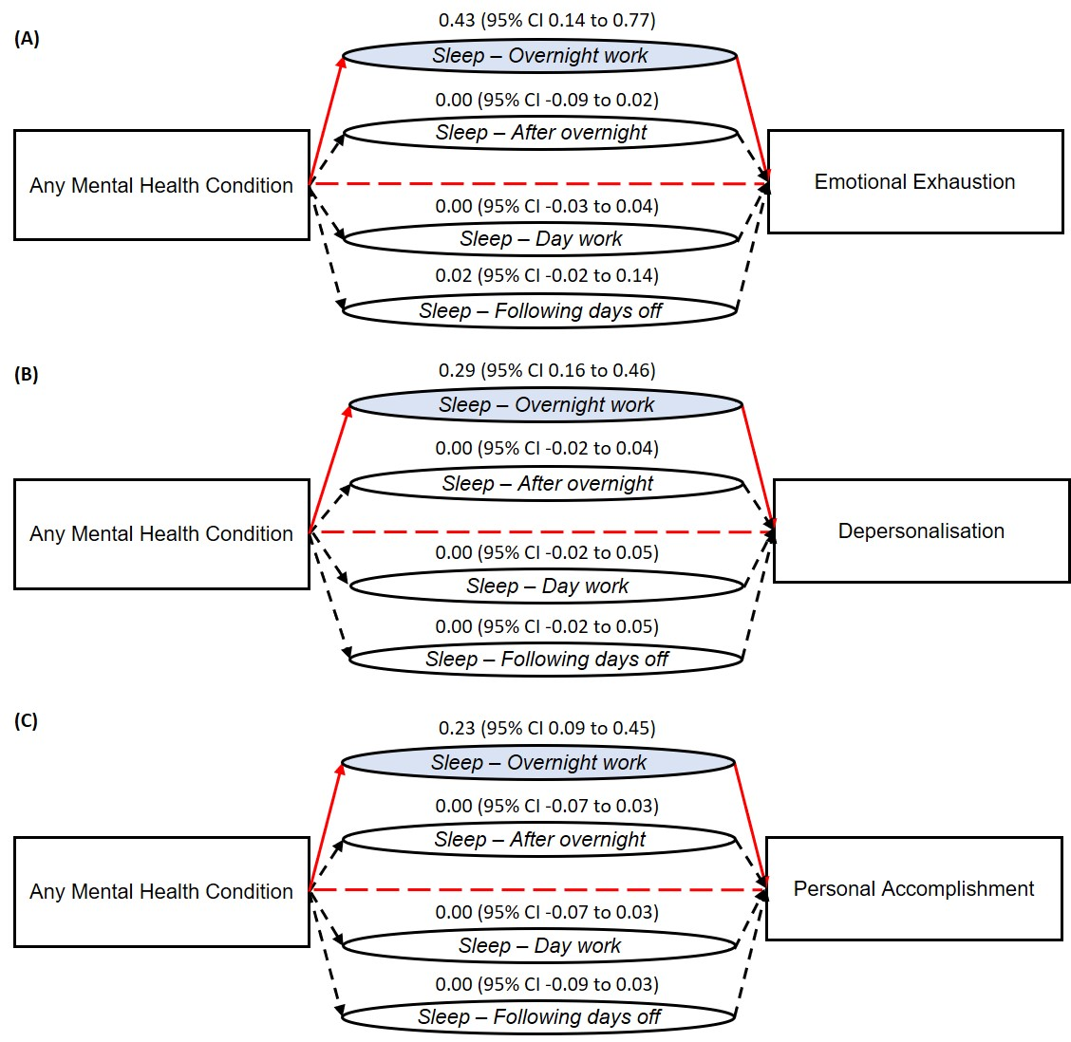
Figure S.2 Simplified models showing indirect effects of self-reporting a current diagnosis of any mental health condition on Emotional Exhaustion (A), Depersonilisation (B) and Personal Accomplishment (C) through the mediators Sleep – Overnight work (i.e., sleep duration when working an overnight shift), Sleep – After overnight (i.e., sleep duration after working an overnight shift), Sleep – Day work (i.e., sleep duration when working a day shift) and Sleep – Following days off (i.e., Sleep duration following ≥2 days off from work). Path coefficients (95% confidence interval) are shown. Long dashed red lines indicate statistically significant direct effect paths. Solid red lines indicate statistically significant indirect effect paths and dotted black lines indicate non-significant indirect paths. For further indirect effect details see Appendices Table A.12. Adjusted for age, gender, body mass index, cigarette smoking, alcohol consumption, second job and mean total work hours per week. For full details of the multiple mediator model and variables included in the model see Appendices Table A.13.

Table S.16 Indirect effects of self-reporting a current diagnosis of any mental health condition (i.e., PTSD, Depression, Anxiety) on EE, DP and PA through Sleep duration when working an overnight shift, Sleep duration after working an overnight shift, Sleep duration when working a day shift and Sleep duration following ≥2 days off from work (i.e., parallel mediator variables).
Predictor | Indirect effect through Sleep duration when working an overnight shift |  |  | Indirect effect through Sleep duration after working an overnight shift |  |  | Indirect effect through Sleep duration when working a day shift |  |  | Indirect effect through sleep following ≥2 days off work
 | Effect | SE | 95% CI | Effect | SE | 95% CI | Effect | SE | 95% CI | Effect | SE | 95% CI
EE
Any Mental Health Condition | 0.4254 | 0.1606 | 0.1373 to 0.7748 ^{a, b, c} | -0.0046 | 0.0231 | -0.0859 to 0.0234 | 0.0001 | 0.0148 | -0.0284 to 0.0354 | 0.0212 | 0.0349 | -0.0175 to 0.1438
DP
Any Mental Health Condition | 0.2930 | 0.0769 | 0.1562 to 0.4600 ^{a, b, c} | 0.0011 | 0.0127 | -0.0199 to 0.0367 | 0.0039 | 0.0156 | -0.0187 to 0.0495 | 0.0030 | 0.0164 | -0.0199 to 0.0540
PA
Any Mental Health Condition | 0.2346 | 0.0912 | 0.0891 to 0.4481 ^{a, b, c} | -0.0019 | 0.0208 | -0.0669 to 0.0283 | -0.0035 | 0.0245 | -0.0704 to 0.0359 | -0.0036 | 0.0268 | -0.0931 to 0.0311
EE, emotional exhaustion; DP, depersonalisation; PA, personal accomplishment; SE, standard error; CI, confidence interval.
ªSignificant difference in size of indirect effect through Sleep duration when working an overnight shift compared to Sleep duration after working an overnight shift determined by pairwise contrasts.
^{b}Significant difference in size of indirect effect through Sleep duration when working an overnight shift compared to Sleep duration when working a day shift determined by pairwise contrasts.
^{c}Significant difference in size of indirect effect through Sleep duration when working an overnight shift compared to Sleep duration following ≥2 days off from work determined by pairwise contrasts.

Table S.17 Model coefficients (a, b, c′) and summary information of regression analyses for the multiple mediator model examining mental health condition and burnout. Analyses performed separately for EE, DP and PA.
Predictors | M1: Sleep duration when working an overnight shift |  |  |  | M2: Sleep duration after working an overnight shift |  |  |  | M3: Sleep duration when working a day shift |  |  |  | M4: Sleep following ≥2 days off work |  |  |  | Y: EE Scores
 |  | Coef | SE | P-value |  | Coef | SE | P-value |  | Coef | SE | P-value |  | Coef | SE | P-value |  | Coef | SE | P-value
EE
X: Any Mental Health | a1 | -0.2904 | 0.1147 | 0.0114 | a2 | 0.0527 | 0.1580 | 0.7386 | a3 | -0.0130 | 0.1856 | 0.9441 | a4 | 0.1337 | 0.1325 | 0.3131 | c′ | 7.2024 | 0.7045 | <0.0001
M1: Sleep when working overnight |  |  |  |  |  |  |  |  |  |  |  |  |  |  |  |  | b1 | -1.4651 | 0.1326 | <0.0001
M2: Sleep after working overnight |  |  |  |  |  |  |  |  |  |  |  |  |  |  |  |  | b2 | -0.0879 | 0.0975 | 0.3677
M3: Sleep when working a day shift |  |  |  |  |  |  |  |  |  |  |  |  |  |  |  |  | b3 | -0.0093 | 0.0829 | 0.9110
M4: Sleep following ≥2 days off work |  |  |  |  |  |  |  |  |  |  |  |  |  |  |  |  | b4 | 0.1589 | 0.1127 | 0.1387
 |  | R² = 0.0142 |  |  |  | R² = 0.0142 |  |  |  | R² = 0.0017 |  |  |  | R²=0.0067 |  |  |  | R²=0.1167
Final model controlled for: Gender, BMI, Second job
DP |  |  |  |  |  |  |  |  |  |  |  |  |  |  |  |  | Y: DP Scores
X: Any Mental Health | a1 | -0.4216 | 0.1107 | 0.0001 | a2 | -0.0188 | 0.1548 | 0.9031 | a3 | -0.0503 | 0.1793 | 0.7789 | a4 | 0.1661 | 0.1291 | 0.1984 | c′ | 2.8244 | 0.4147 | <0.0001
M1: Sleep when working overnight |  |  |  |  |  |  |  |  |  |  |  |  |  |  |  |  | b1 | -0.6951 | 0.0769 | <0.0001
M2: Sleep after working overnight |  |  |  |  |  |  |  |  |  |  |  |  |  |  |  |  | b2 | -0.0571 | 0.0560 | 0.3079
M3: Sleep when working a day shift |  |  |  |  |  |  |  |  |  |  |  |  |  |  |  |  | b3 | -0.0776 | 0.0481 | 0.1066
M4: Sleep following ≥2 days off work |  |  |  |  |  |  |  |  |  |  |  |  |  |  |  |  | b4 | 0.0182 | 0.0652 | 0.7797
 |  | R² = 0.0123 |  |  |  | R² = 0.0008 |  |  |  | R² = 0.0019 |  |  |  | R²=0.0086 |  |  |  | R²=0.0629
Final model controlled for: Age, Alcohol consumption

Table S.17 Continued.
Predictors | M1: Sleep duration when working an overnight shift |  |  |  | M2: Sleep duration after working an overnight shift |  |  |  | M3: Sleep duration when working a day shift |  |  |  | M4: Sleep following ≥2 days off work |  |  |  | Y: PA Scores
 |  | Coef | SE | P-value |  | Coef | SE | P-value |  | Coef | SE | P-value |  | Coef | SE | P-value |  | Coef | SE | P-value
PA
X: Any Mental Health Condition | a1 | -0.3774 | 0.1144 | 0.0010 | a2 | -0.0269 | 0.1551 | 0.8621 | a3 | -0.0299 | 0.1786 | 0.8670 | a4 | 0.1179 | 0.1297 | 0.3636 | c′ | -0.6333 | 0.7828 | 0.4186
M1: Sleep duration when working an overnight shift |  |  |  |  |  |  |  |  |  |  |  |  |  |  |  |  | b1 | -0.6217 | 0.1402 | <0.0001
M2: Sleep duration after working an overnight shift |  |  |  |  |  |  |  |  |  |  |  |  |  |  |  |  | b2 | 0.0713 | 0.1056 | 0.4997
M3: M3: Sleep duration when working a day shift |  |  |  |  |  |  |  |  |  |  |  |  |  |  |  |  | b3 | 0.1159 | 0.0909 | 0.2023
M4: Sleep following ≥2 days off work |  |  |  |  |  |  |  |  |  |  |  |  |  |  |  |  | b4 | -0.0305 | 0.1224 | 0.8035
 |  | R² = 0.0042 |  |  |  | R² = 0.0000 |  |  |  | R² = 0.0000 |  |  |  | R²=0.0003 |  |  |  | R²=0.0078
EE, emotional exhaustion; DP, depersonalisation; PA, personal accomplishment; BMI, body mass index; SE, standard error; M, mediator;
X, independent variable; Y, dependent variable; Coef, coefficient.

Table S.18 Firefighters in Positive OSA Screening Group (n=1830) Reporting Diagnosis and Treatment
Sleep Disorder | Firefighters in positive OSA screening group reporting That they have never been diagnosed with OSA, n (%) | Firefighters in positive OSA screening group reporting that they have been diagnosed with OSA in the past, but do not have it now, n (%) | Firefighters in positive OSA screening group reporting that they have been diagnosed with OSA, but do not regularly take medications or receive treatment, n (%) | Firefighters in positive OSA screening group reporting that they have been diagnosed with OSA and am regularly taking medications or receiving treatment, n (%) | Missing, n (%)
Positive OSA Screening (n=1830) | 1427 (77.98%) | 31 (1.69%) | 142 (7.76%) | 199 (10.87%) | 31 (1.69%)
OSA, Obstructive Sleep Apnoea
Table S.19 Multicollinearity Statistics for Predictor Variables Included in Multiple Logistic Regression Analysis
Predictor variable | Multicollinearity Statistics
 | Tolerance | Variance Inflation Factor
Emotional Exhaustion
Insomnia | 0.882 | 1.133
Obstructive Sleep Apnea | 0.898 | 1.114
Restless Leg Syndrome | 0.986 | 1.015
Shift Work Disorder | 0.941 | 1.063
Depression | 0.809 | 1.236
Post-Traumatic Stress Disorder | 0.886 | 1.128
Anxiety | 0.808 | 1.238
Sleepiness | 0.904 | 1.106
Sleep after overnight work minus sleep required to feel well rested | 0.646 | 1.548
Sleep when working a day shift | 0.685 | 1.460
Sleep after working overnight | 0.468 | 2.139
Sleep when working overnight | 0.921 | 1.086
Sleep following two days off | 0.658 | 1.519
Depersonalisation
Insomnia | 0.882 | 1.134
Obstructive Sleep Apnea | 0.897 | 1.114
Restless Leg Syndrome | 0.986 | 1.015
Shift Work Disorder | 0.940 | 1.064
Depression | 0.809 | 1.235
Post-Traumatic Stress Disorder | 0.886 | 1.128
Anxiety | 0.808 | 1.238
Sleepiness | 0.903 | 1.107
Sleep after overnight work minus sleep required to feel well rested | 0.643 | 1.555
Sleep when working a day shift | 0.687 | 1.456
Sleep after working overnight | 0.467 | 2.140
Sleep when working overnight | 0.921 | 1.086
Sleep following two days off | 0.660 | 1.514
Personal Accomplishment
Insomnia | 0.882 | 1.133
Obstructive Sleep Apnea | 0.897 | 1.115
Restless Leg Syndrome | 0.986 | 1.015
Shift Work Disorder | 0.941 | 1.063
Depression | 0.809 | 1.236
Post-Traumatic Stress Disorder | 0.886 | 1.128
Anxiety | 0.808 | 1.238
Sleepiness | 0.903 | 1.107
Sleep after overnight work minus sleep required to feel well rested | 0.644 | 1.552
Sleep when working a day shift | 0.686 | 1.458
Sleep after working overnight | 0.467 | 2.140
Sleep when working overnight | 0.921 | 1.086
Sleep following two days off | 0.660 | 1.516

