Supplement 1. Comparisons of log-likelihood* (LL), Bayesian Information Criterion (BIC), and entropy between models with fixed numbers of latent profiles (n=1063).
 | Wave 1 |  |  |  | Wave 2
Profiles | 2 | 3 | 4 | 5 | 2 | 3 | 4 | 5
Log-likelihood | 40699 | 40393 | 39133 | 39075 | 32475 | 32393 | 30331 | 29642
LL Difference | - | 306 | 1260 | 58 | - | 82 | 2062 | 689
BIC | 91733 | 91589 | 89340 | 89192 | 75285 | 75489 | 71736 | 70728
Entropy | 0.97 | 0.97 | 0.96 | 0.95 | 0.99 | 0.95 | 0.99 | 0.99
*Significant difference in log likelihood (p<.05) compared to the model with n-1 profiles using the Vu-Lo-Mendel-Rubin adjusted likelihood ratio test bolded.
Models using more than 5 profiles resulted in either failure to fit or no notable improvement in fit.

Supplement 2. Proportions of individual 12-month substance use across latent statuses (n=1063).
 | Marijuana | Inhaled Nitrates | Crack | Cocaine | Heroin | Metham-phetamines | Illicit Prescription Drugs | Other Substance Use
High-Risk Status (A) | 51.6 | 5.5 | 22.0 | 12.3 | 3.8 | 6.1 | 3.8 | 2.5
High-Risk Status (B) | 53.7 | 11.6 | 18.2 | 19.0 | 3.3 | 6.4 | 4.1 | 5.8
High-Risk Status (C) | 56.0 | 12.6 | 16.5 | 14.8 | 2.2 | 6.5 | 5.0 | 7.7
Low-Risk Status | 42.2 | 5.1 | 11.5 | 8.7 | 1.7 | 4.9 | 3.5 | 2.2

Supplement 3. Median syndemic indicators across baseline and 12 month latent profiles (n=1063).
 | Low-Risk Profile |  | High-Risk Profile (A) |  | High-Risk Profile (B) |  | High-Risk Profile (C)
 | Baseline Profile | 6- month Profile | Baseline Profile | 6- month Profile | Baseline Profile | 6- month Profile | Baseline Profile | 6- month Profile
Sexuality-targeted Violence | 0 | 0 | 1 | 1 | 0 | 1 | 0 | 1
Race-targeted Violence | 0 | 0 | 1 | 1 | 0 | 0 | 0 | 0
Trauma | 0 | 0 | 0 | 0 | 0 | 0 | 0 | 0
Internalized Homophobia | 7 | 7 | 9 | 9 | 5 | 6 | 5 | 6
Intimate Partner Violence | 0 | 0 | 0 | 0 | 0 | 0 | 0 | 0
Depression | 12 | 12 | 16 | 18 | 13 | 15 | 12 | 12

Supplement 4. Conceptual diagram of syndemic factors, latent status, social support, and substance use.

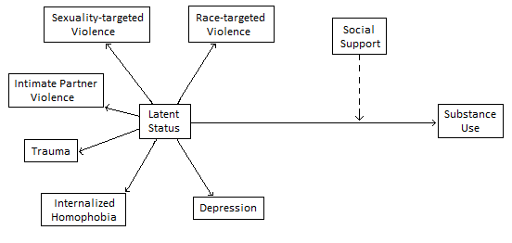
Dotted arrow indicates moderation. All solid lines indicate association.

