Supplementary Materials

Figure S1. The quantile-quantile (Q-Q) plot showing the observed distribution of –log₁₀ (P values), obtained from the GWAS, in black, against the expected distribution under the null hypothesis of no association (diagonal line, in red).
GWAS, genome-wide association study.

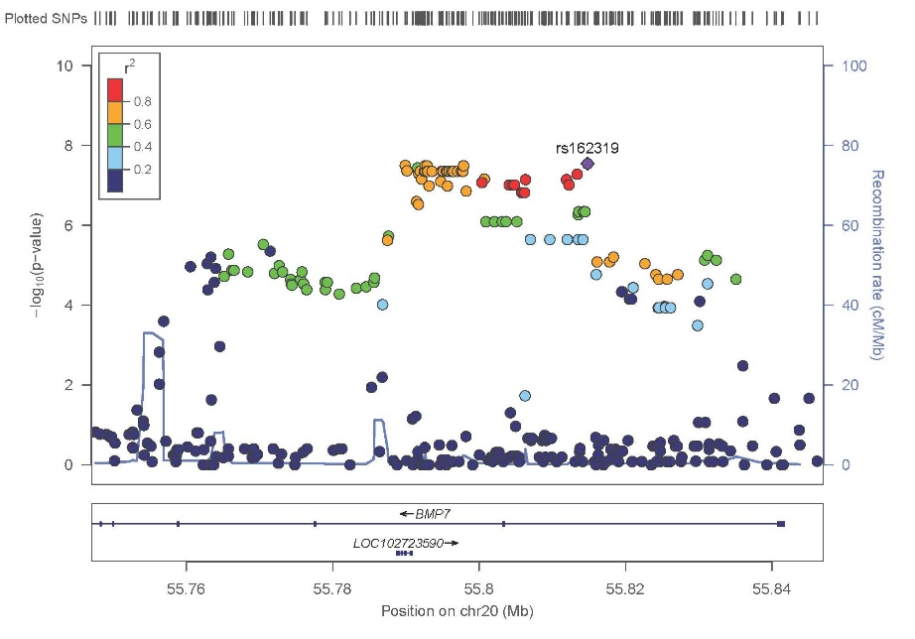
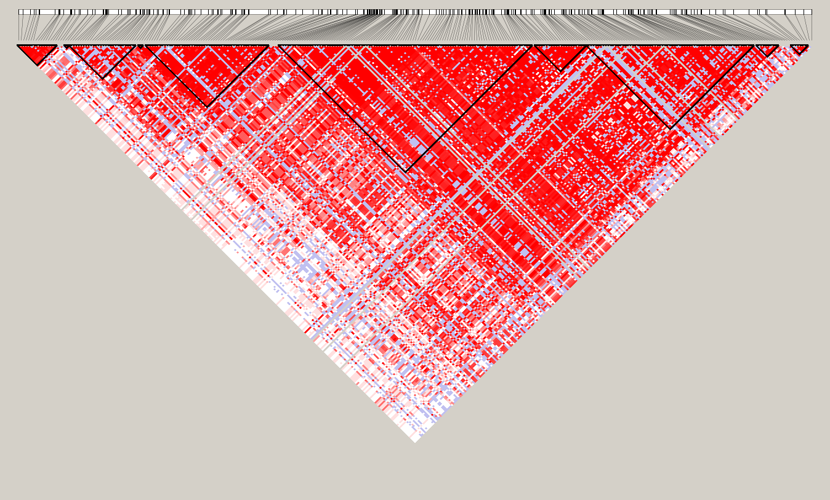
Figure S2. Regional association plot and LD plot for imputed region on chromosome 20 (±50 kb from rs6127972). (a) P-values (-log₁₀) are plotted against the genomic position of each SNP, with the genes in the region depicted below. The LD (r²) between rs6127972 and other SNPs are indicated with different colors. Recombination rate in cM per Mb using HapMap controls. The most significant association was for rs162391 (P = 2.86 x 10⁻⁸). (b) LD plot (r²) based on genotyped and imputed SNPs in this region for 215 NHW case-parent trios.
b.
a.
cM centimorgan; LD, linkage disequilibrium; Mb, megabase; NHW, non-Hispanic White; SNP, single nucleotide polymorph
Table S1. Association results for χ² test for case/control study for 194 (148 males and 46 females) cases and 333 controls (253 males and 80 females). Each sample represents a different set of female controls in the analysis.
CHR | SNP | Sample 1 | Sample 2 | Sample 3 | Sample 4 | Sample 5 | Sample 6 | Sample 7 | Sample 8 | Sample 9 | Sample 10
 |  | P | P | P | P | P | P | P | P | P | P
2 | rs2860732 | 0.1117 | 0.0919 | 0.1228 | 0.12300 | 0.1117 | 0.13500 | 0.0919 | 0.07498 | 0.13480 | 0.24580
5 | rs4976789 | 0.1879 | 0.2131 | 0.2131 | 0.31120 | 0.1879 | 0.55030 | 0.2405 | 0.34600 | 0.55030 | 0.74290
7 | rs1983511 | 0.0606 | 0.0687 | 0.0776 | 0.09819 | 0.0874 | 0.17740 | 0.0982 | 0.09819 | 0.13680 | 0.20610
7 | rs10254116 | 0.0036 | 0.0043 | 0.0050 | 0.00678 | 0.0050 | 0.01010 | 0.0056 | 0.00648 | 0.00648 | 0.02299
7 | rs10262453 | 0.00007 | 0.00009 | 0.00011 | 0.00030 | 0.00011 | 0.00042 | 0.00017 | 0.00028 | 0.00025 | 0.00114
7 | rs4723276 | 0.00008 | 0.00010 | 0.00013 | 0.00023 | 0.00012 | 0.00022 | 0.00019 | 0.00014 | 0.00023 | 0.00098
7 | rs10251775 | 0.1400 | 0.1557 | 0.1725 | 0.21040 | 0.1907 | 0.26560 | 0.1907 | 0.14760 | 0.27730 | 0.30330
8 | rs6992848 | 0.4841 | 0.4346 | 0.4841 | 0.55410 | 0.4346 | 0.46610 | 0.4194 | 0.37410 | 0.62920 | 0.53580
9 | rs55917620 | 0.6892 | 0.6715 | 0.6277 | 0.51860 | 0.6715 | 0.79940 | 0.6715 | 0.79940 | 0.89380 | 0.99130
9 | rs7853336 | 0.5626 | 0.5794 | 0.5794 | 0.73740 | 0.5432 | 0.74160 | 0.5081 | 0.71530 | 0.57940 | 0.60260
10 | rs17476559 | 0.8833 | 0.9310 | 0.8833 | 0.71950 | 0.9310 | 0.49980 | 0.8833 | 0.76660 | 0.82740 | 0.76660
11 | rs936460 | 0.8505 | 0.8097 | 0.8266 | 0.63570 | 0.9086 | 0.44890 | 0.8266 | 0.48190 | 0.47360 | 0.44890
15 | rs1873150 | 0.5298 | 0.5298 | 0.5839 | 0.47800 | 0.6398 | 0.52980 | 0.5839 | 0.52980 | 0.69750 | 0.58390
17 | rs1467288 | 0.2331 | 0.2331 | 0.2331 | 0.10950 | 0.2331 | 0.13490 | 0.2331 | 0.27520 | 0.12690 | 0.21830
17 | rs17688881 | 0.7032 | 0.7395 | 0.7032 | 0.95490 | 0.7120 | 0.97740 | 0.5990 | 0.81380 | 0.92850 | 0.79500
18 | rs12458289 | 0.7534 | 0.7534 | 0.6961 | 0.49000 | 0.7534 | 0.44500 | 0.7534 | 0.64100 | 0.64100 | 0.53780
20 | rs1884302 | 0.0278 | 0.0316 | 0.0278 | 0.02236 | 0.0316 | 0.02236 | 0.0214 | 0.02236 | 0.02667 | 0.03179
20 | rs230191 | 0.0427 | 0.0301 | 0.0478 | 0.04790 | 0.0301 | 0.09093 | 0.0236 | 0.03811 | 0.06664 | 0.05963
20 | rs230217 | 0.0134 | 0.0076 | 0.0117 | 0.00642 | 0.0076 | 0.00463 | 0.0057 | 0.00408 | 0.00968 | 0.00839
20 | rs145473835 | 0.1878 | 0.1878 | 0.1878 | 0.44740 | 0.1878 | 0.44740 | 0.1878 | 0.28240 | 0.18780 | 0.18710
20 | rs6127972 | 0.0088 | 0.0050 | 0.0064 | 0.00416 | 0.0050 | 0.00406 | 0.0037 | 0.00416 | 0.00864 | 0.00561
20 | rs115085047 | 0.6975 | 0.6975 | 0.6975 | 0.19010 | 0.6975 | 0.19010 | 0.6975 | 0.18950 | 0.69750 | 0.18950
20 | rs6014954 | 0.0071 | 0.0039 | 0.0061 | 0.00514 | 0.0039 | 0.00501 | 0.0028 | 0.00430 | 0.00801 | 0.00441
20 | rs230218 | 0.0029 | 0.0015 | 0.0025 | 0.00130 | 0.0015 | 0.00109 | 0.0011 | 0.00109 | 0.00295 | 0.00176
20 | rs17404303 | 0.0410 | 0.0262 | 0.0410 | 0.06010 | 0.0289 | 0.06852 | 0.0325 | 0.05869 | 0.09861 | 0.03584
20 | rs162316 | 0.8284 | 0.6625 | 0.8284 | 0.78570 | 0.7857 | 0.82840 | 0.7026 | 0.74370 | 0.66250 | 0.82840
20 | rs13038779 | 0.1750 | 0.1750 | 0.1750 | 0.19160 | 0.1318 | 0.18150 | 0.1595 | 0.16560 | 0.27920 | 0.18150
20 | rs12480759 | 0.5754 | 0.5862 | 0.6217 | 0.68380 | 0.5862 | 0.56450 | 0.5517 | 0.49730 | 0.46530 | 0.60200
21 | rs9977003 | 0.0733 | 0.0733 | 0.0814 | 0.04716 | 0.0752 | 0.02748 | 0.0658 | 0.07524 | 0.02359 | 0.03022
X | rs4831031 | 0.4896 | 0.5369 | 0.4029 | 0.58660 | 0.4449 | 0.88730 | 0.5369 | 0.63870 | 0.58660 | 0.38640
X | rs6629161 | 0.6822 | 0.5864 | 0.5864 | 0.65670 | 0.6822 | 0.73130 | 0.6087 | 0.70650 | 0.51810 | 0.60870
X | rs7061921 | 0.9989 | 0.9178 | 0.8944 | 0.87160 | 0.8944 | 0.95930 | 0.8419 | 0.65830 | 0.65470 | 0.88790
X | rs5926995 | 0.3336 | 0.3336 | 0.3336 | 0.28140 | 0.3336 | 0.35920 | 0.3336 | 0.25210 | 0.20990 | 0.37540
X | rs7888988 | 0.9929 | 0.9929 | 0.9929 | 0.96930 | 0.9236 | 0.83310 | 0.9929 | 0.91940 | 0.96110 | 0.85190
X | rs5908293 | 0.4753 | 0.4326 | 0.3921 | 0.76730 | 0.4753 | 0.82980 | 0.4326 | 0.87370 | 0.84760 | 0.93600
X | rs66603953 | 0.6716 | 0.7281 | 0.7281 | 0.56550 | 0.6174 | 0.97000 | 0.7281 | 0.72810 | 0.96710 | 0.84080
X | rs56248124 | 0.4890 | 0.6663 | 0.4890 | 0.43710 | 0.5446 | 0.28250 | 0.5446 | 0.52960 | 0.25700 | 0.50000
X | rs41313408 | 0.5409 | 0.6010 | 0.5409 | 0.21860 | 0.6010 | 0.28730 | 0.6010 | 0.37100 | 0.54090 | 0.66460
X | rs5984388 | 0.4872 | 0.5247 | 0.4309 | 0.39710 | 0.5635 | 0.53580 | 0.4872 | 0.45110 | 0.51930 | 0.28370
X | rs34360385 | 0.0542 | 0.0366 | 0.0320 | 0.02422 | 0.0418 | 0.04498 | 0.0477 | 0.05818 | 0.04498 | 0.04837
X | rs2573826 | 0.4346 | 0.4663 | 0.5137 | 0.44830 | 0.5480 | 0.38760 | 0.4483 | 0.33200 | 0.65700 | 0.23850
X | rs7472191 | 0.5868 | 0.5472 | 0.5472 | 0.52440 | 0.5089 | 0.95630 | 0.6275 | 0.90810 | 0.84370 | 0.97600
X | rs67804731 | 0.4608 | 0.4608 | 0.3932 | 0.66750 | 0.4608 | 0.60840 | 0.4261 | 0.43290 | 0.49010 | 0.25800
X | rs17149475 | 0.8271 | 0.8351 | 0.8351 | 0.89310 | 0.8351 | 0.92330 | 0.7506 | 0.92330 | 0.83510 | 0.90710

Table S2. Genotypic transmission disequilibrium test analysis results under an additive, dominant, and recessive models for SNPs with a GWAS allelic transmission disequilibrium test P-value < 5 x 10⁻⁸.
CHR | SNP | BP (hg19) | Allelic |  |  | Additive |  |  | Dominant |  |  | Recessive
 |  |  | OR | P |  | OR | P |  | OR | P |  | OR | P
20 | rs6127972 | 55797057 | 2.17 | 4.41 x 10⁻⁸ |  | 2.17 | 9.38 x 10⁻⁸ |  | 2.25 | 0.0003 |  | 2.57 | 7.10 x 10⁻⁶
25 | rs6259097 | 89022047 | 0.34 | 6.22 x 10⁻⁹ |  | 0.34 | 2.98 x 10⁻⁸ |  | 0.33 | 1.8 x 10⁻⁷ |  | 0.18 | 0.0182
25 | rs2522623 | 91626534 | 0.45 | 1.76 x 10⁻⁸ |  | 0.45 | 4.14 x 10⁻⁸ |  | 0.55 | 0.0008 |  | 0.13 | 2.91 x 10⁻⁶
25 | rs2573826 | 91628577 | 0.45 | 3.31 x 10⁻⁸ |  | 0.45 | 7.36 x 10⁻⁸ |  | 0.56 | 0.0012 |  | 0.14 | 3.22 x 10⁻⁶
25 | rs2754857 | 91632746 | 0.44 | 1.09 x 10⁻⁸ |  | 0.44 | 2.73 x 10⁻⁸ |  | 0.53 | 0.0005 |  | 0.14 | 3.22 x 10⁻⁶
25 | rs781716 | 154994995 | 2.44 | 4.71 x 10⁻⁸ |  | 2.44 | 1.45 x 10⁻⁸ |  | 2.67 | 2.19 x 10⁻⁶ |  | 2.73 | 0.0002
BP, base pair; CHR, chromosome; GWAS, genome-wide association study; OR, odds ratio; SNP, single nucleotide polymorphism.
Table S3. Candidate gene list and number of SNPs
from array found in each gene region.
Geneª | Number of SNPs^{b}
ALPL | 37
ALX3 | 2
ALX4 | 16
BBS9 | 52
BMP2 | 3
BMP4 | 7
BMP7 | 12
BMPER | 42
CDC45 | 5
ESCO2 | 4
FAM20C | 13
FBN1 | 10
FGF9 | 6
FGFR1 | 13
FGFR2 | 39
FREM1 | 79
GLI3 | 48
IFT122 | 1
IFT140 | 7
IFT43 | 9
IGF1R | 104
IL11RA | 4
IMPAD1 | 2
IRX5 | 1
KRAS | 2
MASP1 | 20
MEGF8 | 1
MSX2 | 1
NTRK2 | 79
POR | 16
POSTN | 4
RAB23 | 1
RECQL4 | 1
RUNX2 | 20
SCARF2 | 3
SFRP2 | 3
SKI | 15
SMAD6 | 15
SMO | 4
SMURF1 | 6
SPRY1 | 1
SPRY4 | 3
STAT3 | 12
TCF12 | 16
TGFBR1 | 7
TGFBR2 | 52
WDR19 | 6
WDR35 | 4
SNP, single nucleotide polymorphism
ªtranscript including untranslated regions obtained from
www.genome.ucsc.edu, GRCh37/hg19
^{b}only SNPs with a minor allele frequency>15% and missing in <5 individuals were considered.
Table S4. Discovery study, replication study and meta-analysis results.
CHR | SNPª | BP (hg19) | Location | Alleles^{b} | Discovery |  |  | Replication |  |  |  |  | Meta-analysis
 |  |  |  |  | OR | P | RAF | Cases | Controls | OR | P |  | OR | P | P^{het}
5 | rs4976789 | 177,968,840 | COL23A1 | G/A | 2.83 | 7.56x10⁻⁶ | 0.14 | 193 | 329 | 1.20 | 0.3112 |  | 1.63 | 0.0008 | 0.0046
7 | rs10254116^{c} | 33,237,489 | BBS9 | C/T | 1.71 | 0.0002 | 0.35 | 186 | 331 | 1.44 | 0.0068 |  | 1.56 | 6.53x10⁻⁶ | 0.3722
7 | rs10262453^{c} | 33,256,039 | BBS9 | C/A | 1.79 | 4.48x10⁻⁵ | 0.34 | 184 | 318 | 1.62 | 0.0003 |  | 1.70 | 7.46x10⁻⁸ | 0.6296
7 | rs4723276^{c} | 33,259,793 | BBS9 | C/T | 1.80 | 1.88x10⁻⁵ | 0.34 | 188 | 332 | 1.63 | 0.0002 |  | 1.72 | 2.79x10⁻⁸ | 0.5373
18 | rs12458289 | 60,978,586 | BCL2 | T/G | 3.38 | 5.58x10⁻⁶ | 0.11 | 193 | 330 | 0.86 | 0.4900 |  | 1.40 | 0.0468 | 0.0001
20 | rs230191 | 55,772,683 | BMP7 | C/T* | 1.87 | 9.30x10⁻⁶ | 0.49 | 191 | 324 | 0.77 | 0.0479 |  | 1.15 | 0.1437 | 5.11x10⁻⁶
20 | rs230217 | 55,796,517 | BMP7 | G/C | 2.20 | 4.41x10⁻⁸ | 0.40 | 188 | 324 | 1.43 | 0.0064 |  | 1.72 | 2.24x10⁻⁸ | 0.0315
20 | rs6127972 | 55,797,057 | BMP7 | T/G | 2.17 | 4.41x10⁻⁸ | 0.40 | 189 | 330 | 1.45 | 0.0042 |  | 1.74 | 1.27x10⁻⁸ | 0.0379
20 | rs6014954 | 55,797,585 | BMP7 | T/G | 2.17 | 4.41x10⁻⁸ | 0.39 | 188 | 324 | 1.44 | 0.0051 |  | 1.72 | 2.40x10⁻⁸ | 0.0305
20 | rs230218 | 55,797,797 | BMP7 | A/G | 2.17 | 4.41x10⁻⁸ | 0.40 | 188 | 326 | 1.52 | 0.0013 |  | 1.78 | 2.61x10⁻⁹ | 0.0676
20 | rs17404303 | 55,803,687 | BMP7 | T/C | 0.52 | 2.37x10⁻⁶ | 0.40 | 190 | 328 | 0.78 | 0.0601 |  | 0.64 | 5.42x10⁻⁶ | 0.0375
20 | rs13038779 | 55,809,657 | BMP7 | A/G | 0.49 | 3.05x10⁻⁶ | 0.30 | 191 | 331 | 0.83 | 0.1916 |  | 0.65 | 4.92x10⁻⁵ | 0.0134
X | rs5984388 | 89,000,953 | CPXCR1,TGIF2LX | T/C | 0.46 | 12.71x10⁻⁷ | 0.25 | 186 | 323 | 0.40 | 0.7172 |  | 0.72 | 0.0027 | 3.92x10⁻⁵
X | rs34360385 | 90,407,072 | TGIF2LX,PABPC5 | T/C | 0.44 | 5.81x10⁻⁷ | 0.26 | 191 | 326 | 0.69 | 0.0242 |  | 0.56 | 6.27x10⁻⁷ | 0.0504
X | rs2573826 | 91,628,577 | PCDH11X | G/A | 0.45 | 3.31x10⁻⁸ | 0.32 | 190 | 331 | 1.11 | 0.4483 |  | 0.72 | 0.0014 | 1.06x10⁻⁵
X | rs7472191 | 92,245,578 | PCDH11X,NAP1L3 | A/G | 0.47 | 2.70x10⁻⁶ | 0.26 | 190 | 332 | 1.11 | 0.5244 |  | 0.74 | 0.0069 | 0.0002
X | rs67804731 | 154,995,079 | TMLHE,SPRY3 | G/A | 0.93 | 0.7449 | 0.19 | 188 | 324 | 0.93 | 0.6675 |  | 0.93 | 0.5900 | 0.9978
X | rs17149475 | 154,995,314 | TMLHE,SPRY3 | G/A | 4.26 | 0.0390 | 0.04 | 193 | 331 | 1.04 | 0.8931 |  | 1.36 | 0.2559 | 0.1047
CHR, chromosome; SNP, single nucleotide polymorphism; BP, base pairs; RAF, risk allele frequency calculated from replication study controls; OR, odds ratio; P^{het}, test of homogeneity of the odds ratios
ªSNPs in red font are those that were imputed in the 215 NHW trios discovery sample, and are in linkage disequilibrium to associated SNP
^{b}Minor allele/major allele, * indicates where minor allele differed between discovery and replication samples.
^{c}SNP associated with sNCS

Table S5. GWAS TDT analysis results for the top associations identified in the mNCS and sNCS GWAS, and meta-analysis results.
 | GWAS mNCS |  |  |  |  |  |  | GWAS sNCS |  |  |  |  |  |  | Meta-analysis
SNP | A1 | A2 | T | U | MAF | OR | P | A1 | A2 | T | U | MAF | OR | P | Meta-P | P^{het}
rs6127972 | T | G | 150 | 69 | 0.45 | 2.17 | 4.41x10⁻⁸ | T | G | 62 | 54 | 0.41 | 1.15 | 0.4576 | 1.16 x 10⁻⁶ | 0.0088
rs1884302 | C | T | 86 | 94 | 0.30 | 0.91 | 0.5510 | C | T | 119 | 26 | 0.5 | 4.58 | 1.13x10⁻¹⁴ | 2.42 x 10⁻⁶ | 7.95x10⁻¹⁰
rs10262453 | C | A | 134 | 75 | 0.38 | 1.79 | 4.48x10⁻⁵ | C | A | 15 | 76 | 0.26 | 0.20 | 1.61x10⁻¹⁰ | 0.9081 | 3.32x10⁻¹⁴
GWAS, genome-wide association study; TDT, transmission disequilibrium test; mNCS, metopic nonsyndromic craniosynostosis; sNCS, sagittal nonsyndromic craniosynostosis; SNP, single nucleotide polymorphism; A1, minor allele; A2, major allele; T, transmitted; U, untransmitted; MAF, minor allele frequency; OR, odds ratio; P^{het}, Cochran’s Q test of heterogeneity.

