Supplementary material

Polycaprolactone enabled sealing and carbon composite electrode integration into electrochemical microfluidics

Kevin J. Klunder,*^{a,b} Kaylee, Cynthia,ª Kate berg,ª Shelley D. Minteer,^{b} and Charles S. Henry ª

ªDepartment of Chemistry, Colorado State University, Fort Collins, CO 80523
^{b}Department of Chemistry, University of Utah, Salt Lake City, UT 84112
*Corresponding author

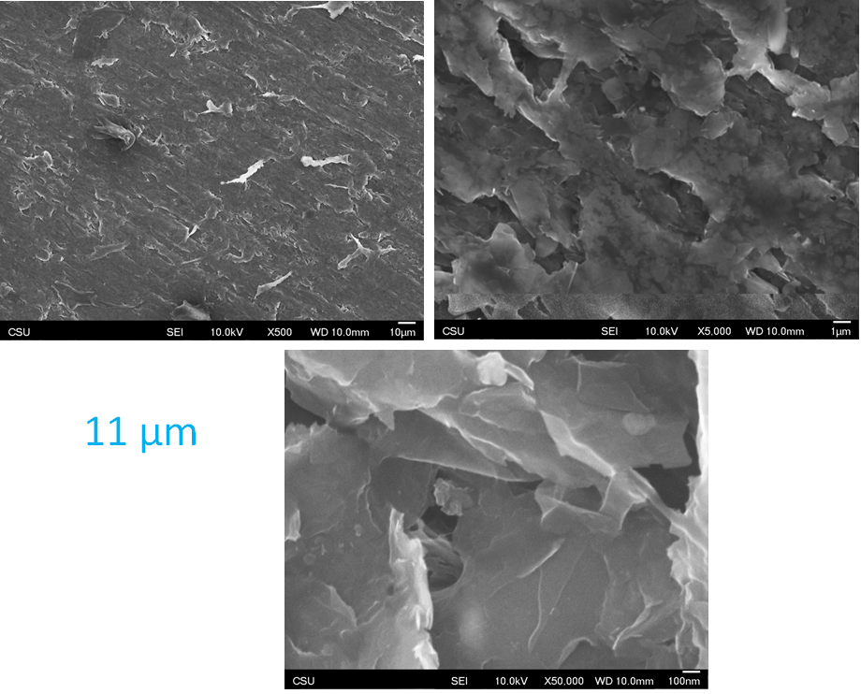
Figure S1 SEM images of a 1:2 11 µm electrode
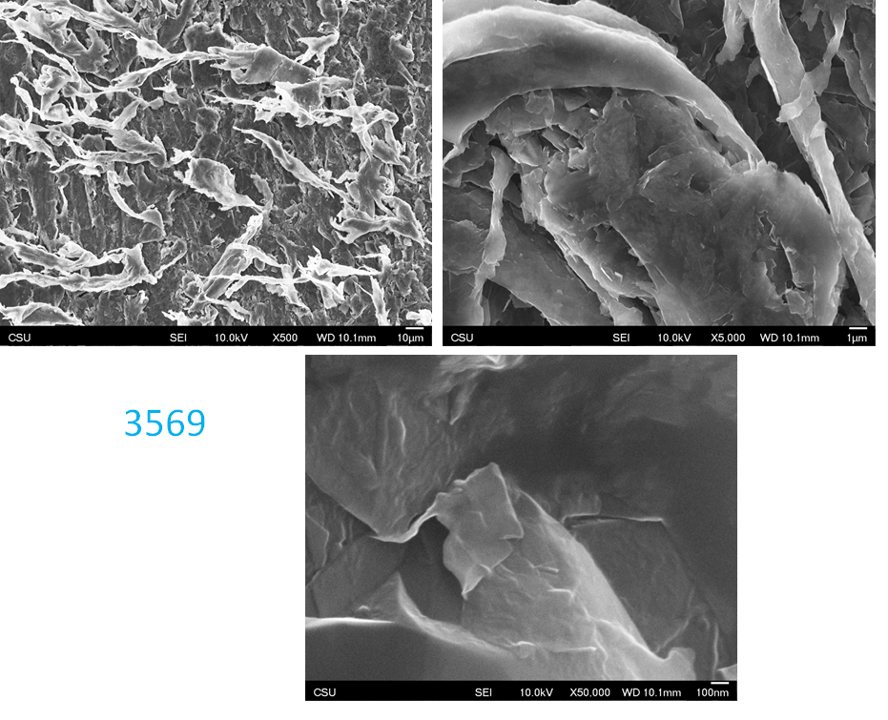
Figure S2 SEM images of a 1:2 3569 electrode
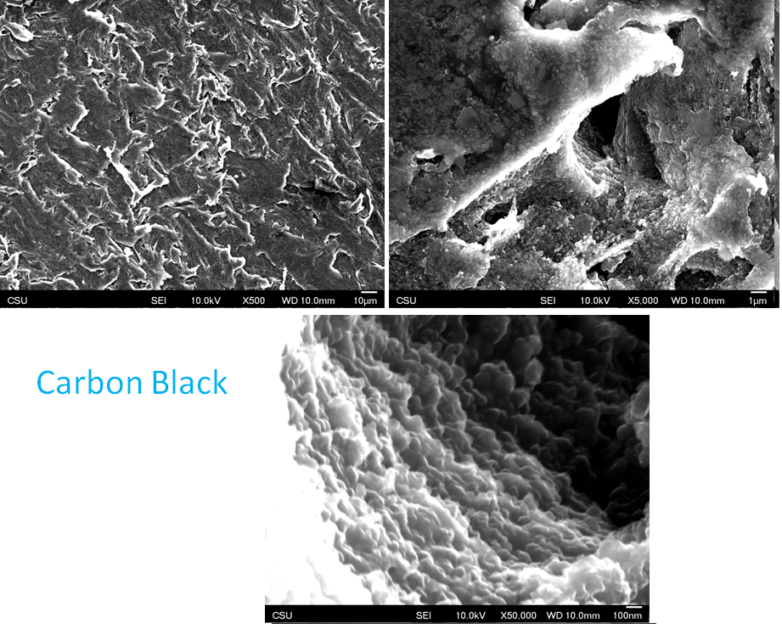
Figure S3 SEM images of a 3:4 Carbon Black electrode

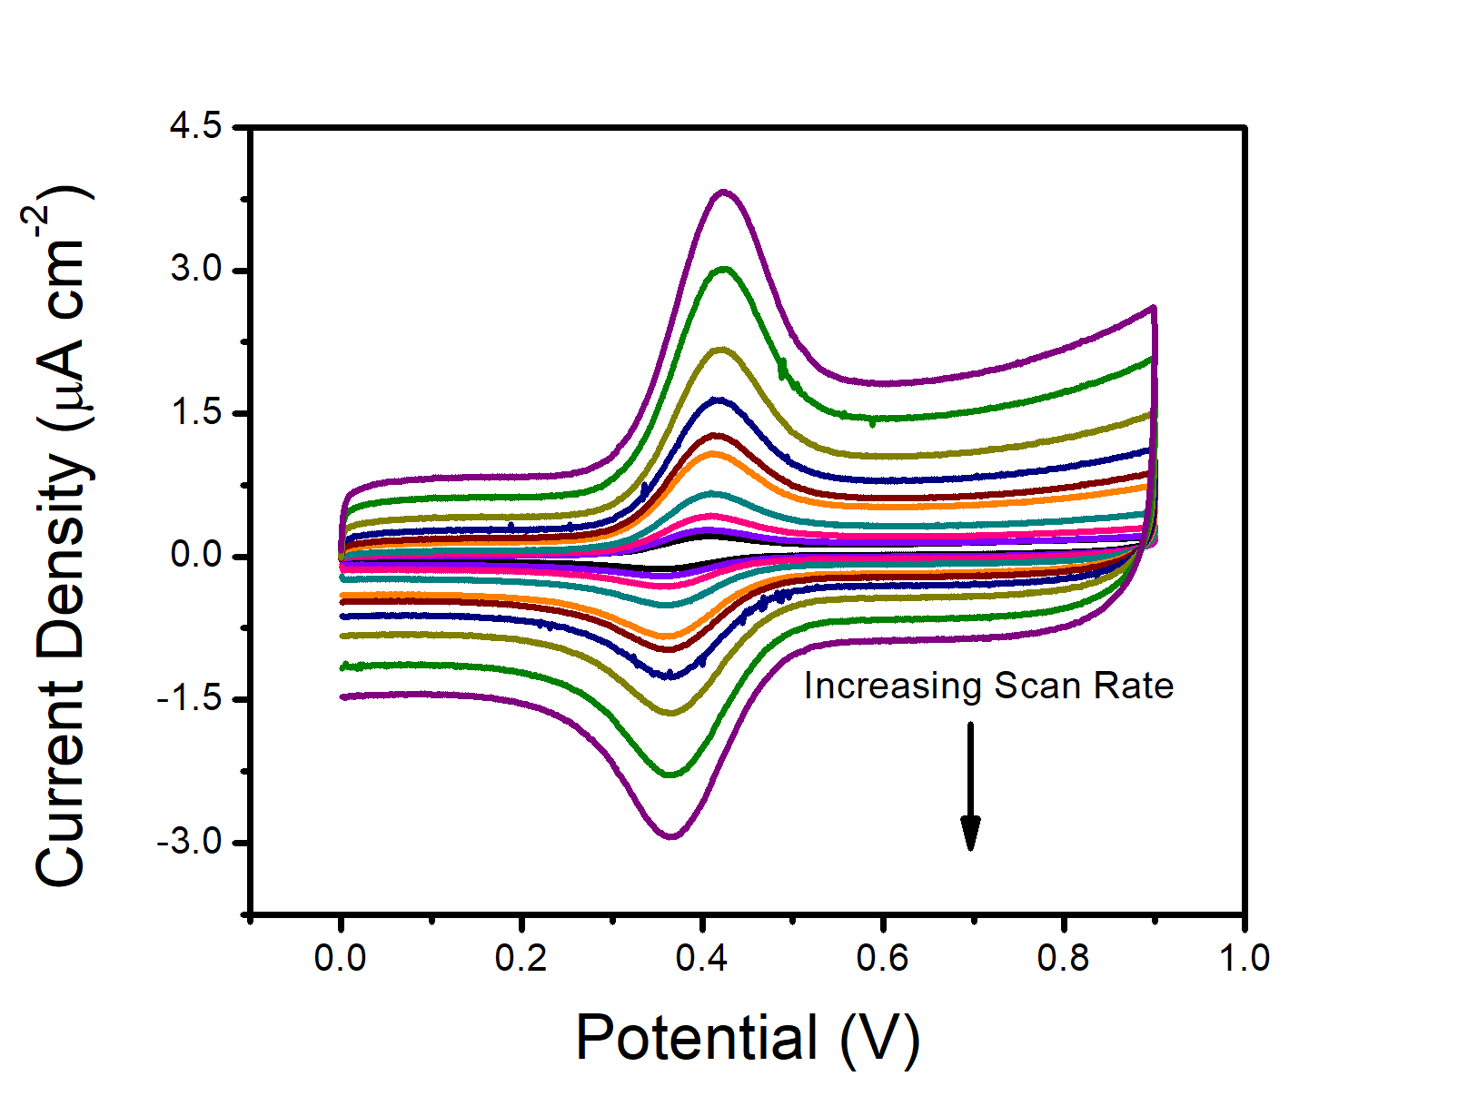
Figure S4 Representative CV’s for scan rate study for 1 mM FcTMA⁺ in 0.5 M KNO3 on 1:2 PCL:MG-1599 electrode (v = 25, 50, 100, 200, 400, 500, 700, 1000, 1500, 2000 mV/s).
Scan Rate (mV/s)V | ΔE (ΔE (mV)mV)
 | 1:2  PCL:11 micron | 1:4  PCL:11 micron | 1:2  PCL:3569 | 1:4  PCL:3569 | 1:2  PCL:MG-1599 | 1:4  PCL:MG-1599
25 | 56 ± 5 | 54 ± 2 | 50 ± 5 | 53 ± 3 | 55 ± 8 | 57 ± 6
50 | 53 ± 4 | 55 ± 0 | 53 ± 8 | 58 ± 8 | 53 ± 5 | 56 ± 4
100 | 56 ± 2 | 52 ± 6 | 53 ± 5 | 56 ± 1 | 46 ± 2 | 51 ± 5
200 | 49 ± 2 | 52 ± 3 | 52 ± 9 | 54 ± 3 | 47 ± 3 | 51 ± 5
400 | 54 ± 5 | 57 ± 4 | 51 ± 10 | 54 ± 4 | 55 ± 5 | 56 ± 2
500 | 55 ± 3 | 58 ± 4 | 54 ± 10 | 59 ± 2 | 56 ± 3 | 59 ± 1
700 | 56 ± 7 | 59 ± 1 | 51 ± 2 | 59 ± 2 | 55 ± 6 | 59 ± 1
1000 | 63 ± 3 | 64 ± 4 | 59 ± 5 | 59 ± 4 | 56 ± 4 | 60 ± 2
1500 | 61 ± 3 | 70 ± 1 | 61 ± 6 | 67 ± 1 | 55 ± 3 | 65 ± 2
2000 | 61 ± 1 | 70 ± 3 | 70 ± 4 | 64 ± 3 | 58 ± 1 | 66 ± 4
Table S1 Scan rate study for 1 mM FcTMA+ in 0.5 M KNO₃, error from standard deviation of 3 different electrodes.
Scan Rate (mV/s) | ΔE (ΔE (mV)mV)
 | 1:2  PCL:11 micron | 1:4  PCL:11 micron | 1:2  PCL:3569 | 1:4  PCL:3569 | 1:2  PCL:MG-1599 | 1:4  PCL:MG-1599
25 | 72 ± 5 | 74 ± 4 | 77 ± 7 | 69 ± 2 | 75 ± 2 | 75 ± 7
50 | 79 ± 7 | 76 ± 6 | 81 ± 8 | 73 ± 2 | 79 ± 3 | 79 ± 5
100 | 85 ± 6 | 81 ± 5 | 88 ± 11 | 77 ± 2 | 84 ± 3 | 88 ± 6
200 | 95 ± 6 | 86 ± 8 | 94 ± 14 | 83 ± 6 | 95 ± 5 | 98 ± 10
400 | 107 ± 10 | 100 ± 8 | 103 ± 13 | 93 ± 6 | 106 ± 7 | 116 ± 10
500 | 115 ± 9 | 103 ± 10 | 107 ± 13 | 97 ± 8 | 111 ± 10 | 119 ± 12
700 | 121 ± 5 | 108 ± 7 | 111 ± 13 | 101 ± 9 | 119 ± 9 | 127 ± 13
1000 | 131 ± 8 | 119 ± 8 | 110 ± 13 | 108 ± 10 | 128 ± 9 | 140 ± 15
1500 | 136 ± 11 | 131 ± 6 | 116 ± 9 | 115 ± 15 | 132 ± 8 | 155 ± 19
2000 | 142 ± 10 | 143 ± 9 | 124 ± 11 | 119 ± 19 | 135 ± 9 | 163 ± 17
Table S2 Scan rate study for 5 mM ferri/ferrocyanide in 0.5 M KNO₃, error from standard deviation of 3 different electrodes.
The heterogeneous electron transfer rate constants (k⁰) were calculated using the Nicholson method.⁴⁰ The following equation was used:
ψ = k⁰[πDnFv/RT]^{-1/2}
The kinetic parameters (ψ) from the average ∆Es of the ferri/ferrocyanide peaks for each scan rate were plotted versus [πDnFv/RT]^{-1/2} where D is the diffusion coefficient, F is Farady’s constant, v is the scan rate, R is the ideal gas constant, and T is temperature. The rate constants were determined from the slopes of the regression lines and the error shown is the standard error of the slope.

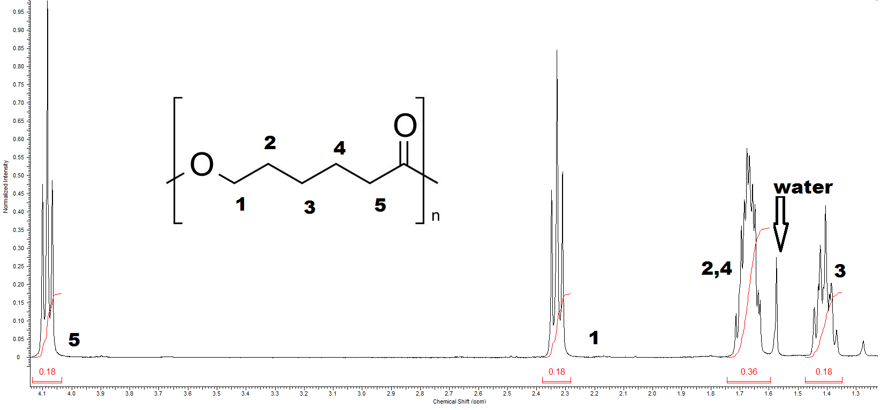
Figure S5 ¹H-NMR spectra of ThermoMorph polymer in CDCl3.

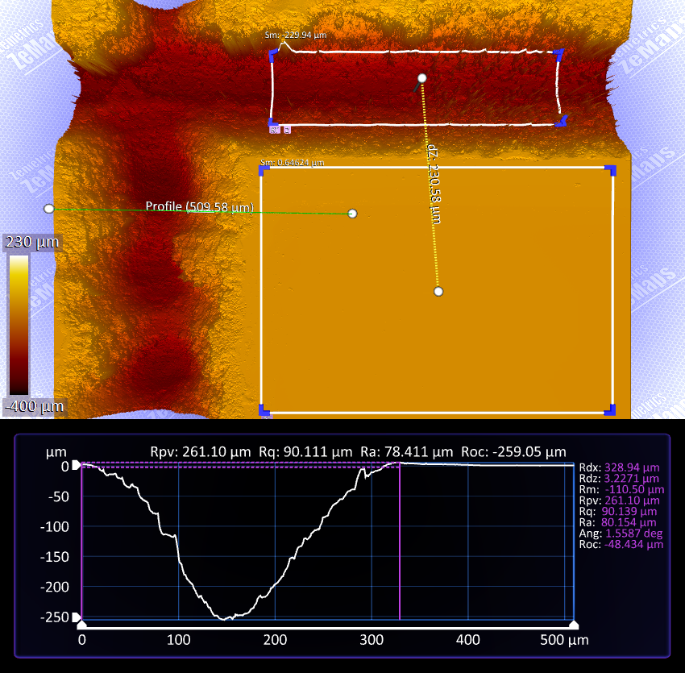
Figure S6 Optical profilometry of a channel cut into a droplet generator of a single pass in the X-axis of the laser cutter.
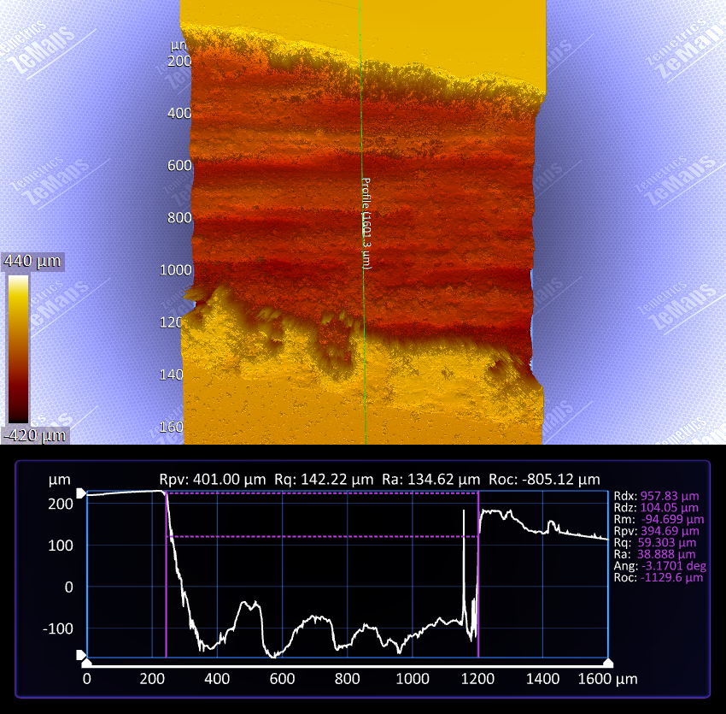
Figure S7 optical profilometry of a channel cut into a droplet generator of a single pass in the Y-axis of the laser cutter. Image is of the waste zone of the droplet generator.

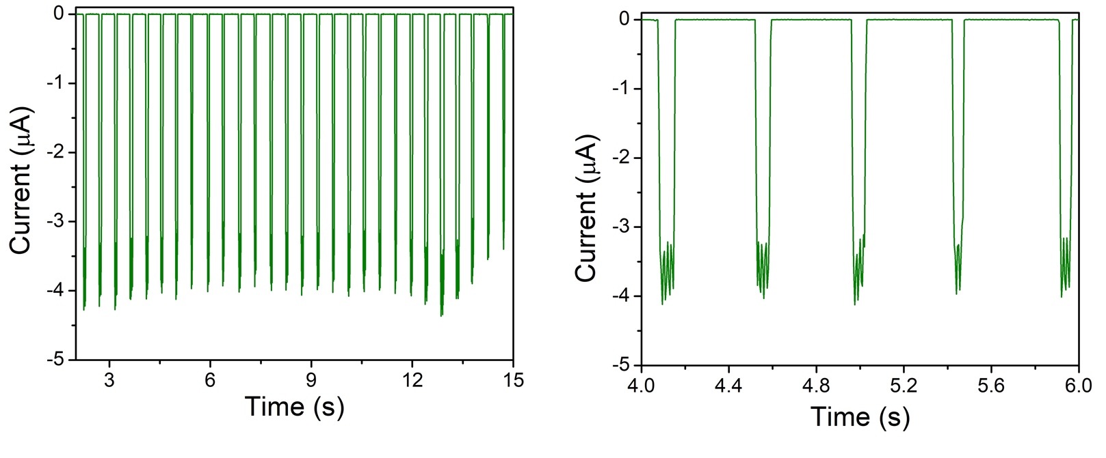
Figure S8 Droplet generation in a salinized microfluidic chip, demonstration of short term stability for the sending of water droplets. Droplets contained 1 mM of ferricyanide in0.5 M KCl..

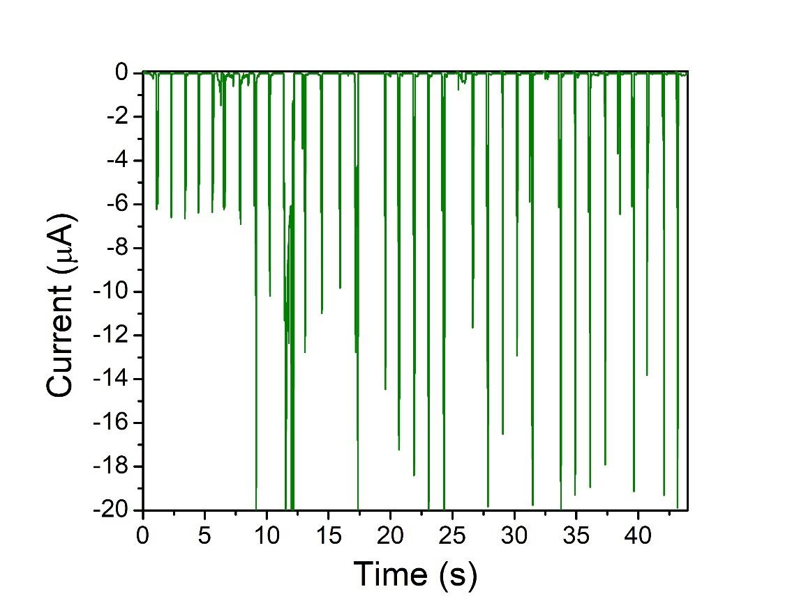
Figure S9 Droplet generation in a salinized microfluidic chip, demonstrating instabilities in droplet sensing in a second run. Droplets contained 1 mM of ferricyanide in 0.5 M KCl.

