Supplementary Information 2

TREXMO plus: an advanced self-learning model for occupational exposure assessment

Authors:
Nenad Savic*, Eun Gyung Lee, Bojan Gasic, David Vernez

Summary
This SI file addressed the established regression trees and the corresponding regression coefficients (i.e. weights) for the total data used. The results in the figures and tables below will be used in the first version TREXMO+ online. Later, when more data becomes available, the given values may be updated.

Fig.S1 Regression tree for volatile liquids obtained for the total data
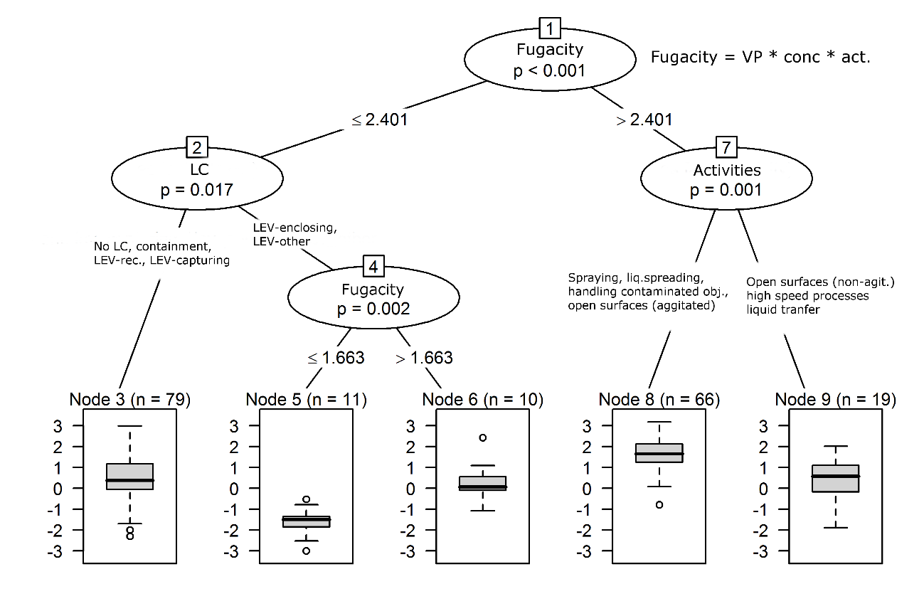

Fig.S2 Regression tree for powders obtained for the total data
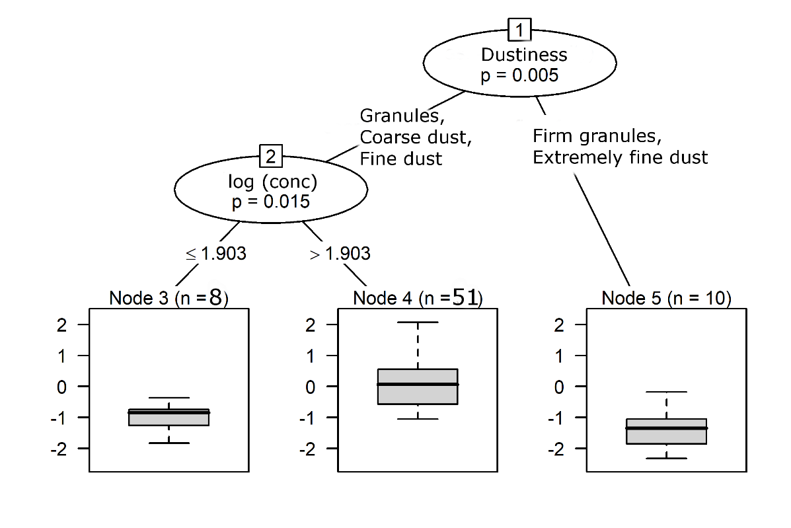

Table S1. The TREXMO+ coefficients for ART, SM, and TRAv3 obtained for the total data. The node numbers correspond to the leaf nodes in Fig.S1-S2
Exposure type | Node | ART | SM | TRA | Error
Liquids | 3 | 0.23 | -0.28 | 0.27 | 1.06
Liquids | 5 | 0.20 | 1.88 | -1.56 | 0.69
Liquids | 6 | 0.25 | -2.23 | 1.47 | 0.67
Liquids | 8 | 0.08 | 0.99 | 0.07 | 0.67
Liquids | 9 | -0.93 | 2.00 | -0.24 | 0.90
Powders | 3 | -0.56 | 1.88 | -0.52 | 1.07
Powders | 4 | 0.27 | 1.13 | -0.08 | 0.68
Powders | 5 | 1.64 | -1.29 | -1.04 | 0.47
Solids | / | -0.05 | 0.10 | 0.42 | 0.54

