Longitudinal Trends in Per- and Polyfluoroalkyl Substances among Multiethnic Midlife Women from 1999 to 2011: the Study of Women’s Health Across the Nation
Ning Ding, Siobán D. Harlow, Stuart Batterman, Bhramar Mukherjee, Sung Kyun Park
TABLE OF CONTENTS
Table A.1 Per- and polyfluoroalkyl substances analyzed in the serum samples.
Table A.2 Comparisons of characteristics between study participants at SWAN V03 (1999/2000) (n=1,400) and those in the PFAS temporal variation sub-study at V03 (n=75).
Table A.3 Comparisons of serum PFAS concentrations between study participants at SWAN V03 (1999/2000) (n=1,400) and those in the PFAS temporal variation sub-study at V03 (n=75).
Table A.4 Summary of PFAS serum concentrations (ng/mL) measured in SWAN PFAS temporal trend sub-study.
Table A.5 Effect estimates (standard errors) from linear mixed regressions on log (serum PFAS concentrations) among 75 women with 300 observations in SWAN 1999-2011.
Table A.6 Baseline characteristics of study participants at SWAN V03 (1999/2000) by race/ethnicity.
Figure A.1 The study designs of the Study of Women’s Health Across the Nation Multi-Pollutant Study (SWAN MPS).
Figure A.2 The study designs of the pilot project to examine temporal variations over time.
Figure A.3 Median (interquartile range) of serum PFAS concentrations (ng/mL) of measured in SWAN among women (n=75) aged 45-56 years at V03(1999-2000), V06 (2002-2003), V09 (2005-2006), and V12 (2009-2010); and in NHANES 1999-2000 (n=91) among women aged 45-56 years, 2003-2004 (n=119) among those aged 48-59 years, 2005-2006 (n=124) among those aged 51-62 years, and 2009-2010 (n=232) among those aged 55-68 years.
Figure A.4 Serum concentrations of selected PFAS with detection rates >70% by study site in women (n=75) across the United States for four SWAN visits.

Table A.1 Per- and polyfluoroalyl substances analyzed in the serum samples.
Analyte (Long Name) | Analyte | Formula
2-(N-ethyl-perfluorooctane sulfonamide) acetate | ET-PFOSA-ACOH | C₁₂H₈F₁₇NO₄S
2-(N-methyl-perfluorooctane sulfonamide) acetate | ME-PFOSA-ACOH2 | C₁₁H₆F₁₇NO₄S
n-perfluorooctanoate | n-PFOA | C₈HF₁₅O₂
branched perfluorooctanoates¹ | sb-PFOA | C₈HF₁₅O₂
perfluorohexane sulfonate | PFHxS | C₆HF₁₃O₃S
perfluorododecanoate | PFDOA | C₁₂HF₂₃O₂
perfluoroundecanoate | PFUA | C₁₁HF₂₁O₂
perfluorodecanoate | PFDeA | C₁₀HF₁₉O₂
branched perfluorooctane sulfonate² | sm-PFOS | C₈HF₁₇O₃S
n-perfluorooctane sulfonate | n-PFOS | C₈HF₁₇O₃S
perfluorononanoate | PFNA | C₉HF₁₇O₂
¹Sb-PFOA include perfluoro-3-methylheptanoic acid, perfluoro-4-methyheptanoic acid, perfluoro-5-methyheptanoic acid, perfluoro-6-methyheptanoic acid, perfluoro-4,4-dimethylhexanoic acid, perfluoro-5,5-dimethylhexanoic acid, perfluoro-3,5-dimethylhexanoic acid, and perfluoro-4,5-dimethylhexanoic acid.
²Sm-PFOS include perfluoro-3-methylheptane sulfonate, perfluoro-4-methylheptane sulfonate, perfluoro-5-methylheptane sulfonate, and perfluoro-6-methylheptane sulfonate.
Table A.2 Comparisons of characteristics between study participants at SWAN V03 (1999/2000) (n=1,400) and those in the PFAS temporal variation sub-study at V03 (n=75).
 | Participants (n=1,400) | Substudy
 |  | Unweighted (n=75) | Weightedª (n=345)
Socio-demographic characteristics | Mean (SD) or N (%) | Mean (SD) or N (%) | Mean (95% CI) or % (95% CI)
Age at interview, years | 49.5 (2.6) | 49.4 (2.4) | 49.4 (48.8-50.0)
Education
High school or less | 252 (18.1%) | 9 (12.0%) | 9.0% (2.0%-16.0%)
Some college | 448 (32.2%) | 20 (26.7%) | 28.8% (17.1%-40.5%)
College degree or higher | 693 (49.7%) | 46 (61.3%) | 62.2% (50.0%-74.4%)
Employed | 1,213 (86.6%) | 70 (93.3%) | 91.7% (84.3%-99.1%)
Difficulty paying for basics (V00)
Very difficult | 89 (6.5%) | 5 (6.9%) | 7.8% (0.7%-14.9%)
Somewhat difficult | 347 (25.2%) | 16 (22.2%) | 20.9% (10.5%-31.2%)
Not at all difficult | 942 (68.3%) | 51 (70.8%) | 71.3% (59.9%-82.7%)
Study sites
Michigan | 257 (18.4%) | 19 (25.3%) | 25.0% (14.2%-35.7%)
Boston | 233 (16.6%) | 23 (30.7%) | 29.0% (17.5%-40.5%)
Oakland | 309 (22.1%) | 33 (44.0%) | 46.0% (33.1%-58.8%)
Los Angeles | 366 (26.1%) | NA | NA
Pittsburgh | 235 (16.8%) | NA | NA
Race/ethnicity
Black | 308 (22.0%) | 19 (25.3%) | 24.9 (14.0%-35.8%)
White | 708 (50.6%) | 37 (49.3%) | 47.0% (34.2%-59.7%)
Japanese | 207 (14.8%) | NA | NA
Chinese | 177 (12.6%) | 19 (25.3%) | 28.1% (16.2%-40.0%)
Physical activity^{b} | 7.8 (1.7) | 7.7 (2.0) | 7.9 (7.5-8.4)
Biomarkers | Mean (SD) or % | Mean (SD) or % | Mean (95% CI) or % (95% CI)
Body mass index, kg/m² | 27.9 (7.3) | 28.0 (7.1) | 27.6 (26.0-29.2)
Percent body fat, % (V06) | 37.3 (7.9) | 37.0 (7.7) | 36.9 (34.9-38.8)
Total body water, kg (V06) | 33.6 (5.5) | 33.7 (5.0) | 34.0 (32.6-35.4)
Estradiol, pg/mL | 65.8 (81.4) | 64.8 (78.6) | 69.2 (48.7-89.7)
Daily dietary intake (V00) | Mean (SD) or % | Mean (SD) or % | Mean (95% CI) or % (95% CI)
Protein, g | 70.1 (26.8) | 71.1 (29.2) | 70.9 (63.4-78.3)
Fiber, g | 12.9 (6.2) | 13.0 (6.2) | 13.4 (11.7-15.1)
Total calorie, kcal | 1816.8 (695.1) | 1841.5 (760.3) | 1851.5 (1643.4-2059.6)
Tuna
Never | 414 (29.9%) | 23 (31.1%) | 31.4% (19.5%-43.3%)
2 times per month | 356 (25.7%) | 18 (24.3%) | 23.1% (12.5%-33.6%)
4 times per month | 324 (23.4%) | 14 (18.9%) | 20.2% (9.8%-30.6%)
12 times per month | 167 (12.1%) | 9 (12.2%) | 13.4% (4.4%-22.4%)
23 times per month | 78 (5.6%) | 6 (8.1%) | 8.3% (1.6%-15.0%)
Once per day | 38 (2.8%) | 4 (5.4%) | 3.6% (0-7.8%)
Twice per day | 6 (0.4%) | NA | NA
30 times per week | NA | NA | NA
Shellfish
Never | 568 (41.1%) | 32 (43.2%) | 42.1% (29.4%-54.8%)
2 times per month | 409 (29.6%) | 21 (28.4%) | 25.8% (14.7%-36.9%)
4 times per month | 263 (19.0%) | 11 (14.9%) | 16.8% (6.9%-26.7%)
12 times per month | 88 (6.4%) | 7 (9.5%) | 10.9% (2.7%-19.0%)
23 times per month | 35 (2.5%) | 1 (1.4%) | 2.2% (0-6.5%)
Once per day | 16 (1.2%) | 2 (2.7%) | 2.3% (0-6.2%)
Twice per day | 2 (0.1%) | NA | NA
30 times per week | 1 (0.1%) | NA | NA
Other fish
Never | 365 (26.4%) | 20 (27.0%) | 29.6% (17.9%-41.4%)
2 times per month | 315 (22.8%) | 12 (16.2%) | 14.4% (6.3%-22.4%)
4 times per month | 332 (24.0%) | 17 (23.0%) | 24.2% (13.0%-35.5%)
12 times per month | 236 (17.1%) | 14 (18.9%) | 16.6% (7.2%-26.1%)
23 times per month | 96 (6.9%) | 9 (12.2%) | 11.3% (3.4%-19.2%)
Once per day | 29 (2.1%) | 2 (2.7%) | 3.9% (0-9.2%)
Twice per day | 4 (0.3%) | NA | NA
30 times per week | 6 (0.4%) | NA | NA
Fried fish or fish sandwich
Never | 715 (51.7%) | 48 (64.9%) | 62.1% (49.8%-74.5%)
2 times per month | 259 (18.7%) | 10 (13.5%) | 16.5% (6.6%-26.4%)
4 times per month | 195 (14.1%) | 8 (10.8%) | 9.5% (2.5%-16.5%)
12 times per month | 138 (10.0%) | 5 (6.8%) | 8.5% (1.0%-16.0%)
23 times per month | 60 (4.3%) | 2 (2.7%) | 1.9% (0-4.7%)
Once per day | 14 (1.0%) | 1 (1.4%) | 1.5% (0-4.5%)
Twice per day | 1 (0.1%) | NA | NA
30 times per week | 1 (0.1%) | NA | NA
Menstruation | % | % | % (95% CI)
Menstrual bleeding since last visit | 1,206 (86.1%) | 67 (89.3%) | 88.6% (80.2%-96.9%)
ª Descriptive statistics were calculated after taking into account sampling weights from stratified random sampling. We created a population of 345 women which were the same as the sampling frame at the selection of study subjects into the pilot project.
^{b} Physical activity was assessed with a modified version of the Kaiser Physical Activity Survey (KPAS) as per Ainsworth et al. 2000 at visit 03. Adapted from the Baecke physical activity questionnaire (Baecke et al. 1982), the KPAS assesses activity levels during the previous 12 months in 3 distinct domains: active living (e.g. frequency of television viewing (reverse coded), active transportation such as walking to work); household/caregiving (e.g. housework, childcare); and sports/exercise (e.g. participation in recreational activity). Domain-specific activity indices were calculated from mostly ordinal Likert scale categorical responses, with higher scores indicating greater activity in that specific domain (range: 1-5).
Table A.3 Comparisons of serum PFAS concentrations between study participants at SWAN V03 (1999/2000) (n=1,400) and those in the PFAS temporal variation sub-study at V03 (n=75).
Serum concentrations, ng/mL | Participants (n=1,400) |  | Substudy  (n=75)
 | Percent detected | GM (GSD) | Percent detected | GM (GSD)
Linear PFOA | 99.9% | 4.08 (1.82) | 100% | 3.46 (1.90)
Branched PFOA | 18.3% | 0.11  (2.46) | 17.3% | 0.10  (2.38)
Linear PFOS | 100% | 17.88  (1.80) | 100% | 17.21  (1.90)
Branched PFOS | 99.9% | 7.18  (2.02) | 100% | 6.55  (2.05)
ET-PFOSA-ACOH | 99.0% | 1.24  (2.53) | 98.7% | 1.21  (2.91)
ME-PFOSA-ACOH2 | 99.6% | 1.45  (2.04) | 100% | 1.45  (1.99)
PFHxS | 99.6% | 1.58  (2.23) | 98.7% | 1.47  (2.30)
PFDeA | 41.1% | 0.13  (2.21) | 42.7% | 0.13  (2.11)
PFUA | 32.0% | 0.12  (2.26) | 36.0% | 0.12  (2.07)
PFDoA | 3.8% | <LOD | 4.0% | <LOD
PFNA | 97.1% | 0.55  (1.82) | 97.3% | 0.54  (1.80)
ª Descriptive statistics were calculated after taking into account sampling weights from stratified random sampling. We created a population of 345 women which were the same as the sampling frame at the selection of study subjects into the pilot project.
^{b} Values below level of detection (LOD) were replaced by LOD/$\sqrt{2}.$
Table A.4 Summary of PFAS serum concentrations (ng/mL) measured in SWAN PFAS temporal trend sub-study.
 | SWAN V03 | SWAN V06 | SWAN V09 | SWAN V12 | ICC
Year of sample collection | 1999-2000 | 20002-2003 | 2005-2006 | 2009-2011
No. of participants | 75 | 75 | 75 | 75
Serum PFAS concentrations, ng/mL
Total PFOA |  |  |  |  | 0.47
GM (GSD) | 3.63 (1.89) | 3.36 (1.92) | 2.88 (1.74) | 2.60 (1.56)
Median (IQR) | 3.57  (2.37, 5.07) | 3.37  (2.37, 4.97) | 2.97  (2.27, 3.87) | 2.67  (1.97, 3.57)
95th percentile | 14.00 | 9.97 | 6.67 | 4.77
99th percentile | 35.87 | 26.77 | 11.27 | 7.07
Min, max | 0.77-35.87 | 0.37-26.77 | 0.47-11.27 | 0.57-7.07
Linear PFOA |  |  |  |  | 0.18
Percent detected | 100% | 100% | 100% | 100%
GM (GSD) | 3.46 (1.90) | 3.27 (1.96) | 2.80 (1.78) | 2.52 (1.59)
Median (IQR) | 3.30  (2.30, 4.80) | 3.30  (2.30, 4.90) | 2.90  (2.20, 3.80) | 2.60  (1.90, 3.50)
95th percentile | 12.30 | 9.90 | 6.60 | 4.70
99th percentile | 35.80 | 26.70 | 11.20 | 7.00
Min, max | 0.7-35.8 | 0.3-26.7 | 0.4-11.2 | 0.5-7.0
Branched PFOA |  |  |  |  | NA^{b}
Percent detected | 17.33% | 0% | 0% | 0%
GM (GSD) | 0.10 (2.38) | <LOD | <LOD | <LOD
Median (IQR) | <LOD | <LOD | <LOD | <LOD
95th percentile | 1.00 | <LOD | <LOD | <LOD
99th percentile | 1.70 | <LOD | <LOD | <LOD
Min, max | <LOD-1.7 | <LOD | <LOD | <LOD
Total PFOS |  |  |  |  | 0.46
GM (GSD) | 24.04 (1.91) | 23.37 (1.89) | 13.81 (1.95) | 10.18 (1.93)
Median (IQR) | 22.80  (16.90, 34.70) | 23.70  (16.10, 33.20) | 15.30  (9.90, 21.10) | 10.40  (7.20, 14.90)
95th percentile | 96.20 | 78.40 | 43.30 | 32.90
99th percentile | 177.80 | 103.60 | 53.70 | 57.00
Min, max | 6.1-177.8 | 6.1-103.6 | 2.7-53.7 | 1.3-57.0
Linear PFOS |  |  |  |  | 0.33
Percent detected | 100% | 100% | 100% | 100%
GM (GSD) | 17.21 (1.90) | 17.17 (1.88) | 10.03 (1.97) | 7.46 (2.03)
Median (IQR) | 17.00  (11.30, 23.40) | 17.60  (11.20, 25.30) | 10.80  (7.30, 15.70) | 7.50  (4.90, 11.00)
95th percentile | 63.50 | 58.80 | 29.80 | 29.40
99th percentile | 141.50 | 67.30 | 48.00 | 53.50
Min, max | 4.3-141.5 | 5.1-67.3 | 1.0-48.0 | 0.8-53.5
Branched PFOS |  |  |  |  | 0.25
Percent detected | 100% | 100% | 100% | 100%
GM (GSD) | 6.55 (2.05) | 5.95 (2.00) | 3.55 (2.00) | 2.50 (1.79)
Median (IQR) | 6.20  (4.30, 9.40) | 6.10  (3.50, 9.50) | 3.50  (2.40, 5.90) | 2.50  (1.80, 3.90)
95th percentile | 32.50 | 23.70 | 9.60 | 6.70
99th percentile | 63.00 | 36.30 | 21.50 | 7.80
Min, max | 1.2-63.0 | 1.0-36.3 | 0.8-21.5 | 0.5-7.8
EtFOSAA |  |  |  |  | NA^{b}
Percent detected | 98.67% | 65.33% | 2.67% | 1.33%
GM (GSD) | 1.21 (2.91) | 0.23 (2.83) | 0.07 (1.23) | 0.07 (1.28)
Median (IQR) | 1.10  (0.60, 2.40) | 0.30  (<LOD, 0.50) | <LOD | <LOD
95th percentile | 7.70 | 1.70 | 0.07 | 0.07
99th percentile | 112.50 | 3.70 | 0.30 | 0.60
Min, max | <LOD-112.5 | <LOD-3.7 | <LOD-0.3 | <LOD-0.6
MeFOSAA |  |  |  |  | 0.48
Percent detected | 100% | 62.67% | 80% | 50.67%
GM (GSD) | 1.42 (1.99) | 0.29 (3.58) | 0.30 (2.43) | 0.18 (2.64)
Median (IQR) | 1.50  (0.80, 2.30) | 0.30  (<LOD, 0.80) | 0.30  (0.20, 0.60) | 0.20  (<LOD, 0.40)
95th percentile | 5.00 | 1.90 | 1.10 | 0.80
99th percentile | 6.60 | 8.40 | 1.60 | 1.10
Min, max | 0.3-6.6 | <LOD-8.4 | <LOD-1.6 | <LOD-1.1
PFHxS |  |  |  |  | 0.40
Percent detected | 98.67% | 98.67% | 93.33% | 97.33%
GM (GSD) | 1.47 (2.30) | 1.31 (2.39) | 1.01 (2.69) | 1.07 (2.25)
Median (IQR) | 1.50  (0.90, 2.50) | 1.50  (0.90, 2.10) | 1.20  (<LOD, 1.70) | 1.20  (<LOD, 1.70)
95th percentile | 6.30 | 5.30 | 3.80 | 4.20
99th percentile | 11.20 | 8.90 | 5.70 | 5.10
Min, max | <LOD-11.2 | <LOD-8.9 | <LOD-5.7 | <LOD-5.1
PFDEA |  |  |  |  | 0.36
Percent detected | 42.67% | 32% | 89.33% | 89.33%
GM (GSD) | 0.13 (2.11) | 0.13 (2.59) | 0.33 (1.99) | 0.37 (2.12)
Median (IQR) | <LOD  (<LOD, 0.30) | <LOD  (<LOD, 0.30) | 0.40  (0.30, 0.50) | 0.40  (0.30, 0.60)
95th percentile | 0.40 | 0.70 | 0.80 | 1.20
99th percentile | 0.70 | 8.40 | 2.00 | 2.30
Min, max | <LOD-0.7 | <LOD-8.4 | <LOD-2.0 | <LOD-2.3
PFUA |  |  |  |  | 0.44
Percent detected | 36% | 26.67% | 46.67% | 66.67%
GM (GSD) | 0.12 (2.07) | 0.11 (2.22) | 0.15 (2.42) | 0.22 (2.43)
Median (IQR) | <LOD  (<LOD, 0.30) | <LOD  (<LOD, 0.20) | <LOD  (<LOD, 0.30) | 0.30  (<LOD, 0.50)
95th percentile | 0.50 | 0.60 | 0.70 | 0.80
99th percentile | 0.50 | 1.10 | 1.00 | 1.00
Min, max | <LOD-0.5 | <LOD-1.1 | <LOD-1.0 | <LOD-1.0
PFDOA |  |  |  |  | NA^{b}
Percent detected | 4% | 2.67% | 0% | 1.33%
GM (GSD) | <LOD | <LOD | <LOD | <LOD
Median (IQR) | <LOD | <LOD | <LOD | <LOD
95th percentile | <LOD | <LOD | <LOD | <LOD
99th percentile | 0.20 | 0.20 | <LOD | 0.20
Min, max | <LOD-0.2 | <LOD-0.2 | <LOD | <LOD-0.2
PFNA |  |  |  |  | 0.16
Percent detected | 97.33% | 77.33% | 100% | 100%
GM (GSD) | 0.54 (1.80) | 0.36 (2.80) | 1.06 (1.51) | 1.22 (1.55)
Median (IQR) | 0.50  (0.40, 0.80) | 0.50  (0.20, 0.70) | 1.10  (0.80, 1.30) | 1.30  (0.90, 1.60)
95th percentile | 1.30 | 1.30 | 2.20 | 2.40
99th percentile | 1.60 | 2.40 | 2.70 | 3.50
Min, max | <LOD-1.6 | <LOD-2.4 | 0.4-2.7 | 0.3-3.5
Abbreviations: GM, geometric mean; GSD, geometric standard deviation; IQR, interquartile range.
P value estimated using Kruskal-Wallis test to assess temporal variations of serum PFAS concentrations.
ª Values below level of detection (LOD) were replaced by LOD/$\sqrt{2}.$
^{b} ICC cannot be estimated because serum congener concentrations can barely be detected in at least one of the follow-up visits.

Table A.5 Effect estimates (standard errors) from linear mixed regressions on log (serum PFAS¹ concentrations) among 75 women with 300 observations in SWAN 1999-2011.
Predictor | n-PFOA | n-PFOS | sm-PFOS | PFHxS | PFNA
Intercept | 1.70 (0.24)*** | 3.63 (0.28)*** | 2.34 (0.28)*** | 0.78 (0.38)* | -0.43 (0.28)
Age at baseline² | 0.02 (0.02) | 0.05 (0.03) | 0.04 (0.03) | 0.06 (0.04) | 0.03 (0.02)
BMI at baseline³ | 0.002 (0.009) | -0.003 (0.01) | 0.01 (0.01) | -0.02 (0.01) | 0.007 (0.009)
Period
1999/2000 | Ref | Ref | Ref | Ref | Ref
2002/2003 | -0.13 (0.18) | -0.16 (0.18) | -0.21 (0.16) | -0.19 (0.24) | -0.51 (0.27)
2005/2006 | -0.59 (0.19)** | -0.72 (0.18)*** | -0.78 (0.16)*** | -0.40 (0.25) | 0.49 (0.27)
2009/2011 | -0.91 (0.19)*** | -1.15 (0.19)*** | -1.30 (0.16)*** | -0.59 (0.25)* | 0.48 (0.28)
Menstruation
No | Ref | Ref | Ref | Ref | Ref
Yes | -0.18 (0.07)** | -0.10 (0.07) | -0.15 (0.06)* | -0.13 (0.09) | -0.20 (0.09)*
Race/ethnicity
Black | Ref | Ref | Ref | Ref | Ref
Chinese | -0.31 (0.24) | 0.05 (0.29) | -0.16 (0.19) | -0.17 (0.39) | 0.56 (0.26)*
White | 0.25 (0.18) | 0.006 (0.21) | 0.29 (0.21) | 0.36 (0.28) | 0.08 (0.20)
Parity
Nulliparous | Ref | Ref | Ref | Ref | Ref
Parous | -0.52 (0.18)** | -0.65 (0.21)** | -0.61 (0.21)** | -0.19 (0.28) | -0.21 (0.20)
Site
Michigan | Ref | Ref | Ref | Ref | Ref
Boston | 0.26 (0.15) | -0.10 (0.18) | 0.16 (0.19) | -0.12 (0.24) | 0.17 (0.14)
Davis | 0.05 (0.19) | -0.21 (0.23) | 0.05 (0.23) | -0.28 (0.31) | -0.15 (0.18)
Period × Race/ethnicity
2002/2003 × Chinese | 0.03 (0.16) | 0.11 (0.15) | 0.11 (0.14) | 0.09 (0.21) | -0.05 (0.23)
2005/2006 × Chinese | 0.26 (0.16) | 0.13 (0.15) | 0.18 (0.14) | 0.41 (0.21)* | -0.17 (0.23)
2009/2011 × Chinese | 0.49 (0.16)** | 0.08 (0.15) | 0.23 (0.14) | 0.59 (0.21)** | -0.08 (0.23)
2002/2003 × White | -0.11 (0.14) | -0.07 (0.14) | -0.04 (0.12) | -0.0003 (0.19) | -0.45 (0.20)*
2005/2006 × White | -0.15 (0.14) | -0.31 (0.14)* | -0.17 (0.12) | -0.16 (0.18) | -0.22 (0.20)
2009/2011 × White | -0.09 (0.14) | -0.43 (0.14)** | -0.14 (0.12) | 0.10 (0.19) | -0.02 (0.20)
Period × Parity
2002/2003 × Parous | 0.08 (0.16) | 0.17 (0.15) | 0.08 (0.14) | 0.02 (0.21) | 0.34 (0.23)
2005/2006 × Parous | 0.34 (0.16)* | 0.29 (0.15) | 0.14 (0.14) | -0.09 (0.21) | 0.25 (0.23)
2009/2011 × Parous | 0.43 (0.16)** | 0.50 (0.15)** | 0.27 (0.14)* | -0.05 (0.21) | 0.23 (0.23)
¹PFAS with serum concentrations above limit of detection more than 70% were included in the analyses.
²Age at baseline was centered at 50 years.
³BMI at baseline was centered at 25 kg/m².
*P<0.05, **P<0.01, ***P<0.001.
Table A.6 Baseline characteristics of study participants at SWAN V03 (1999/2000) by race/ethnicity.
 | Total (n=75) | White (n=37) | Black (n=19) | Chinese (n=19)
 | Mean (SD) or N (%) | Mean (SD) or N (%) | Mean (SD) or N (%) | Mean (SD) or N (%)
Age at interview, years | 49.4 (2.4) | 48.8 (2.4) | 50.1 (2.5) | 49.8 (2.1)
Education
High school or less | 9 (12.0%) | 2 (5.4%) | 2 (10.5%) | 5 (26.3%)
Some college | 20 (26.7%) | 9 (24.3%) | 9 (47.4%) | 2 (10.5%)
College degree or higher | 46 (61.3%) | 26 (70.3%) | 8 (42.1%) | 12 (63.2%)
Employed | 70 (93.3%) | 36 (97.3%) | 17 (89.5%) | 17 (89.5%)
Difficulty paying for basics
Very difficult | 5 (7.0%) | 2 (5.7%) | 3 (16.7%) | 0
Somewhat difficult | 16 (22.2%) | 9 (25.7%) | 4 (22.2%) | 3 (15.8%)
Not at all difficult | 51 (70.8%) | 24 (68.6%) | 11 (61.1%) | 16 (84.2%)
Study sites
Michigan | 19 (25.3%) | 8 (21.6%) | 11 (57.9%) | 0
Boston | 23 (30.7%) | 15 (40.5%) | 8 (42.1%) | 0
Oakland | 33 (44.0%) | 14 (37.8%) | 0 | 19 (100%)
Physical activity | 7.7 (2.0) | 8.2 (1.8) | 7.2 (2.4) | 7.4 (1.7)
Body mass index, kg/m² | 28.0 (7.1) | 27.2 (5.8) | 33.2 (9.1) | 24.3 (4.1)
Menstrual bleeding since last visit | 67 (89.3%) | 33 (89.2%) | 17 (89.5%) | 17 (89.5%)
Daily dietary intake
Protein, g | 71.1 (29.2) | 67.6 (25.4) | 83.1 (37.5) | 66.0 (24.7)
Fiber, g | 13.0 (6.2) | 12.7 (5.7) | 13.1 (6.5) | 13.7 (7.1)
Total calorie, kcal | 1841 (760) | 1722 (624) | 2223 (1024) | 1691 (583)
Fish
<1 per week | 23 (31.1%) | 15 (41.7%) | 6 (31.6%) | 2 (10.5%)
1-2 per week | 24 (32.4%) | 12 (33.3%) | 3 (15.8%) | 9 (47.4%)
>2 per week | 27 (36.5%) | 9 (25.0%) | 10 (52.6%) | 8 (42.1%)
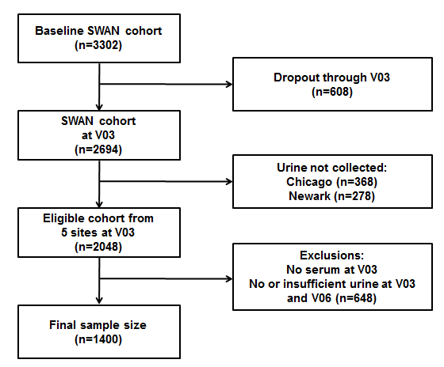

Figure A.1 The study designs of the Study of Women’s Health Across the Nation Multi-Pollutant Study (SWAN MPS).

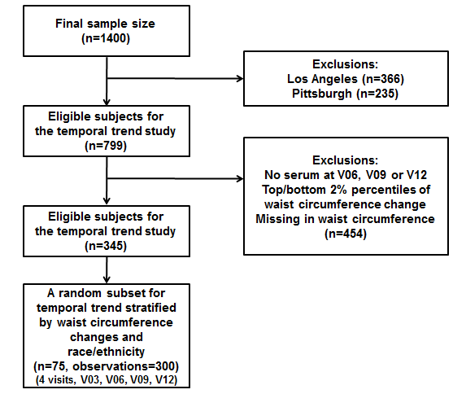

Figure A.2 The study designs of the pilot project to examine temporal variations over time.
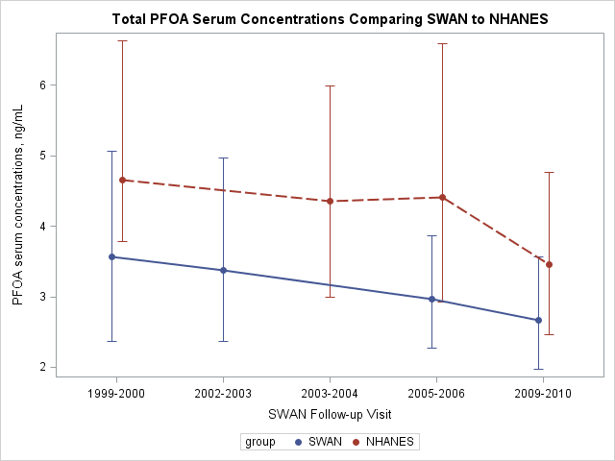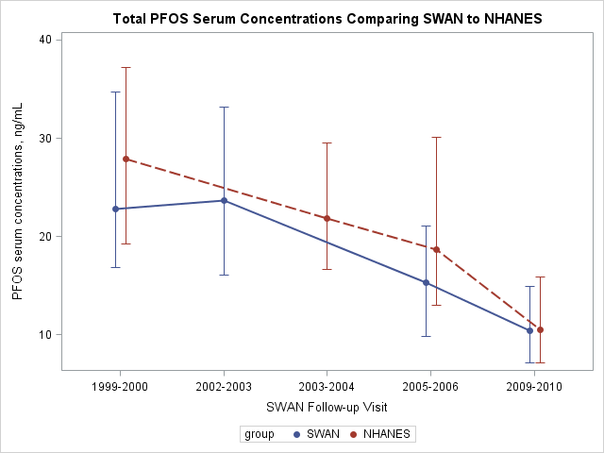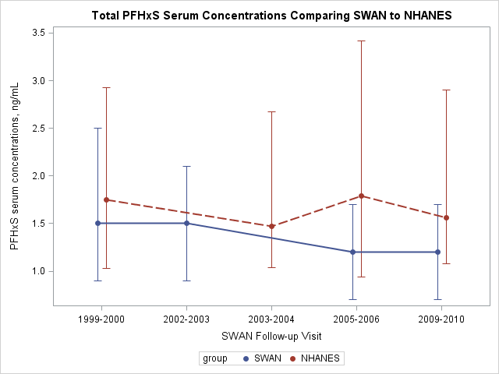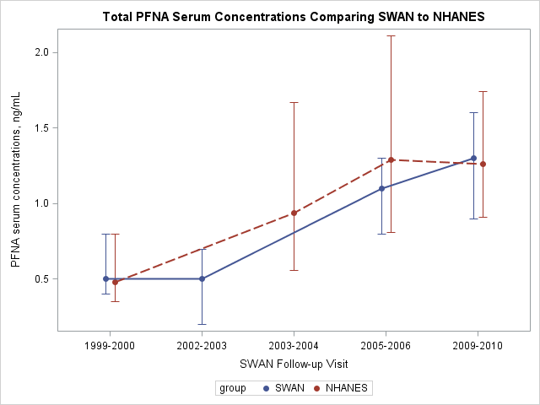

Figure A.3 Median (interquartile range) of serum PFAS concentrations (ng/mL) of measured in SWAN among women (n=75) aged 45-56 years at V03(1999-2000), V06 (2002-2003), V09 (2005-2006), and V12 (2009-2010);and in NHANES 1999-2000 (n=91) among women aged 45-56 years, 2003-2004 (n=119) among those aged 48-59 years, 2005-2006 (n=124) among those aged 51-62 years, and 2009-2010 (n=232) among those aged 55-68 years.
Figure A.4 Serum concentrations of selected PFAS with detection rates >70% by study site in women (n=75) across the United States for four SWAN visits. Boxes represent the 25th-75th percentiles, horizontal lines represent the median, and whiskers indicate 5th and 95th percentiles, respectively. Note that a log scale is used for the Y axis. The limits of detection were 0.1 ng/mL for all PFAS analytes. Abbreviations: n-PFOA, linear-chain perfluorooctanoic acid; PFNA, perfluorononanoic acid; PFHxS, perfluorohexane sulfonic acid; n-PFOS, linear-chain perfluorooctane sulfonic acid; sm-PFOS, sum of branched-chain perfluorooctane sulfonic acid.

