S3 Figure. Phylogenetic tree of serotype III isolates (n = 33)
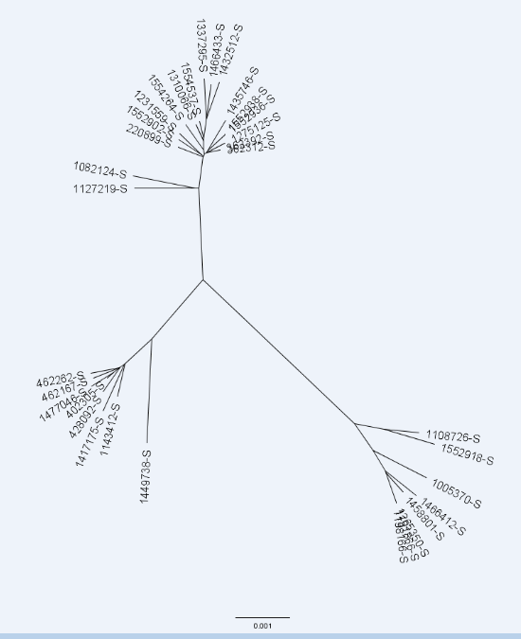
Core genome SNP identification and alignment were carried out using kSNP3.0.
The seven sequence type 109 isolates (circled in red) each differs by 39–74 single nucleotide polymorphisms

