Supplemental Tables and Figures

Supplemental Figure 1. Percent (%) polymorphonuclear neutrophil (PMN) influx comparisons in (A) nasal lavage fluid (NLF) and (B) bronchoalveolar lavage fluid (BALF) of WTC exposed C57BL/6 mice. Reported values are averages of individually measured lavage samples ±SEM with n=5-7. Asterisks (*) indicate a statistically significant difference from control values (p<0.05); (#) indicate a statistically significant difference between treatment group values (p<0.05).
Supplemental Figure 2. Whole lung wet/dry ratios after a single WTC_{PM} treatment 24 hours post-exposure and post-30 days recovery. Values are means ± SEM with n=3/group. Asterisks (*) indicate a statistically significant difference from control values (p<0.05).

Supplemental Figure 3. BALF trypan blue macrophage viability assessment. BALF macrophage evaluation in mice exposed to 1000 µg WTC_{PM} 30 days post-exposure. Values are means ± SEM with n=7/group. Asterisks (*) indicate a statistically significant difference from control values (p<0.05).

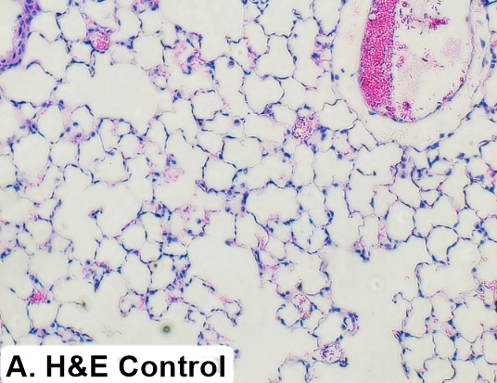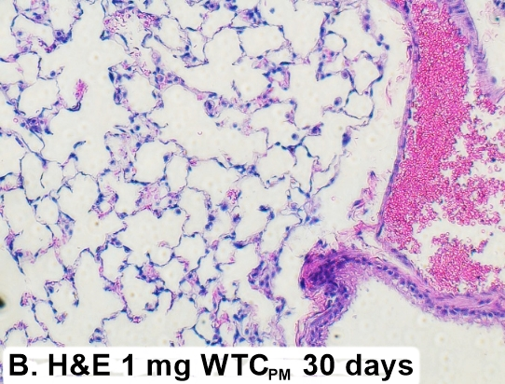
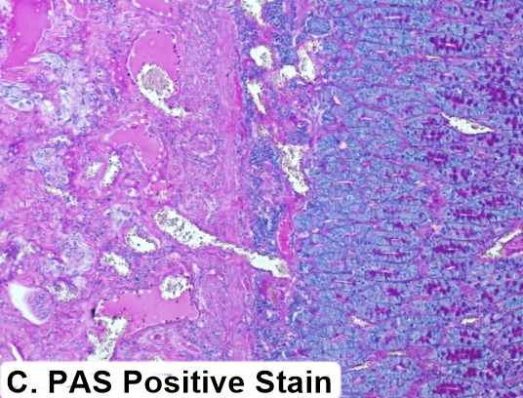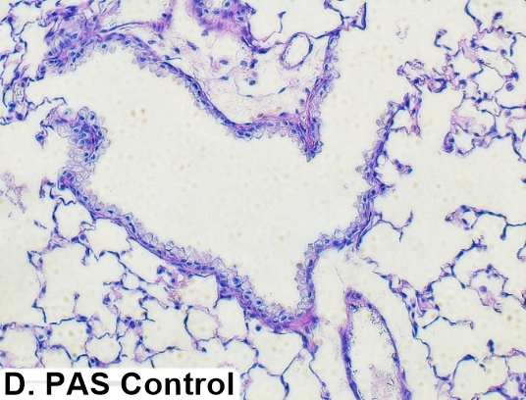
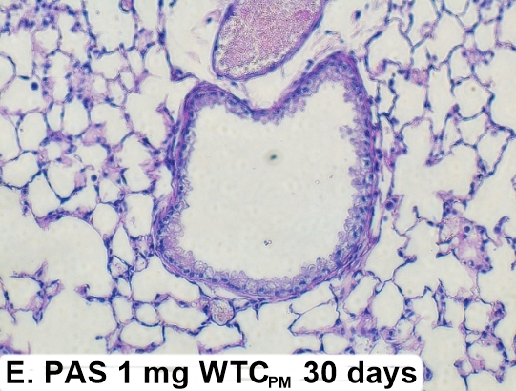

Supplemental Figure 4. Histological stain comparisons in mouse whole lungs 30 days post-exposure. A&B) H&E stain comparisons for inflammation and fibrosis in control and WTCPM exposed mice. C) Periodic acid–Schiff–diastase (PAS) positive control stain for muco-substances. D&E) PAS staining in control and 1 mg WTCPM exposed mice; x100 magnification.

Lung | Stain | Control 30d | Control 30d | Control 30d | 1 mg 30d | 1 mg 30d | 1 mg 30d
Inflammation | H&E | 0 | 1 | 1 | 2 | 1 | 1
Mucus | PAS | 0 | 0 | 0 | 0 | 0 | 0
Fibrosis | H&E | 0 | 0 | 0 | 0 | 0 | 0

Supplemental Table 1. Histopathologic semi-quantitative evaluation of mouse lungs 30 days post-exposure. N/0= Normal; 1= Minimal; 2= Mild; 3= Moderate; 4=Severe

Supplemental Figure 5. ICP-MS insoluble elemental trace analysis evaluation in WTC_{PM} exposed whole heart tissues. Single exposures were evaluated 24 hours and 30 days post-exposure. Reported values are averages of individually measured samples ±SEM with n=3-5. Asterisks (*) indicate a statistically significant difference from control vehicle values (p<0.05).

Supplemental Figure 5 cont. ICP-MS insoluble elemental trace analysis evaluation in WTC_{PM} exposed whole heart tissues. Single exposures were evaluated 24 hours and 30 days post-exposure. Reported values are averages of individually measured samples ±SEM with n=3-5. Asterisks (*) indicate a statistically significant difference from control vehicle values (p<0.05). <LOD indicates below the limit of detection.

Supplemental Figure 6. ICP-MS soluble elemental trace analysis evaluation in WTC_{PM} exposed heart tissues. Single exposures were evaluated 24 hours and 30 days post-exposure. Reported values are averages of individually measured samples ±SEM with n=3-5. Asterisks (*) indicate a statistically significant difference from control vehicle values (p<0.05).

