Additional file 1: Table S1. Enrollment characteristics of GEMS cases included in the present analysis of growth faltering
 |  | Children with complete data  N=6,203 |  | Children with imputed outcomes  N=854 |  | p-value for difference
 |  | n(%) or median (interquartile range) |  | n(%) or median (interquartile range) |  | t-test or chi2
Sociodemographic characteristics
Age, months |  | 11 | (7-16) | 10 | (7-15) | P=0.0051
 | 0-6 months | 1077 | (17.4%) | 156 | (18.3%) | P=0.015
 | >6-12 months | 2361 | (38.1%) | 351 | (41.2%) | P=0.015
 | >12-23 months | 2765 | (44.6%) | 344 | (40.4%) | P=0.015
Site |  |  |  |  |  | P<0.0001
 | the Gambia | 705 | (11.4%) | 125 | (14.7%) | P<0.0001
 | Mali | 1172 | (18.9%) | 207 | (24.3%) | P<0.0001
 | Mozambique | 410 | (6.6%) | 110 | (12.9%) | P<0.0001
 | Kenya | 961 | (15.5%) | 87 | (10.2%) | P<0.0001
 | India | 1195 | (19.3%) | 54 | (6.3%) | P<0.0001
 | Bangladesh | 993 | (16.0%) | 21 | (2.5%) | P<0.0001
 | Pakistan | 767 | (12.4%) | 247 | (29.0%) | P<0.0001
Female |  | 2681 | (43.2%) | 388 | (45.6%) | P=0.157
Access to improved water |  | 2824 | (45.5%) | 283 | (33.3%) | P<0.0001
Access to improved sanitation |  | 1153 | (18.6%) | 183 | (21.5%) | P=0.028
Wealth quintile¹⁴ |  | -0.08 | (-0.71, 0.59) | -0.26 | (-0.87, 0.36) | P<0.0001
Clinical characteristics at presentation
Stunting |  | 1478 | (23.8%) | 292 | (34.5%) | P<0.0001
Wasting |  | 1357 | (21.9%) | 283 | (33.5%) | P<0.0001
Severe acute malnutrition |  | 470 | (7.6%) | 130 | (15.4%) | P<0.0001
MUAC < 12.5 cm among 6-23 mos |  | 863 | (16.8% of 5126 children) | 176 | (28.0% of 640) | P<0.0001
Fever |  | 1788 | (30.3%) | 287 | (35.1%) | P=0.007
Current breastfeeding < 6 mos |  |  |  |  |  | P<0.0001
 | Exclusive | 439 | (30.2%) | 77 | (36.5%) | P<0.0001
 | Partial | 951 | (65.3%) | 118 | (55.9%) | P<0.0001
 | None | 66 | (4.5%) | 16 | (7.6%) | P<0.0001
Hospitalized at presentation |  | 1141 | (19.8%) | 187 | (22.0%) | P=0.0214
Dysentery at presentation |  | 1375 | (21.8%) | 99 | (11.6%)
≥1 IMCI general danger sign |  | 3426 | (59.0%) | 594 | (69.8%) | P<0.0001
Presented with at least 1 co-morbidity |  | 1911 | (33.5%) | 364 | (42.8%) | P<0.0001
 | Pneumonia | 420 | (6.8%) | 83 | (9.8%) | P=0.002
 | Malaria | 1510 | (24.3%) | 219 | (25.7%) | P=0.428
 | Malnutrition | 349 | (5.6%) | 110 | (12.9%) | P<0.0001
 | Other invasive bacterial infection | 82 | (1.3%) | 18 | (2.1%) | P=0.06
 | Upper respiratory tract infection | 8 | (0.1%) | 0 | (0%) | P=0.273

Additional file 1: Figure S1. Distribution of observed vs imputed outcome values
- Change in LAZ b. Prevalence of severe linear growth faltering (loss of ≥1 LAZ)
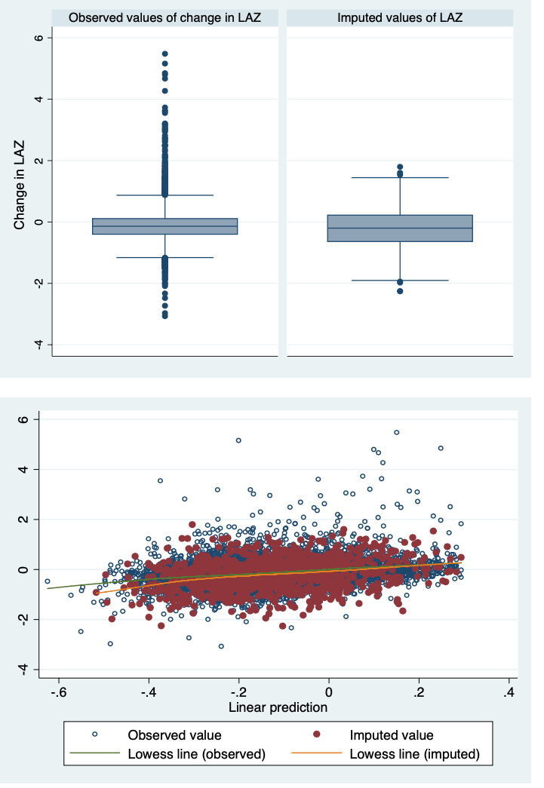

Additional file 1: Table S2. Risk factors for linear growth faltering among children 0-23 months old with MSD including imputed outcome data. Statistically significant results (p <0.05) are bolded.
 |  | Severe linear growth faltering |  |  |  |  | Change in LAZ
 |  | n | % | Crude relative risks |  | Adjusted for age, site, and baseline LAZ |  | mean | SD |  | Crude difference in change in LAZ | Adjusted for age, site, and baseline LAZ
Age
 | 0-6 mo | 431 | 35.0% | 1.58 (1.42, 1.74) | 1.42 (1.20, 1.47) |  | -0.27 |  | 0.70 | -0.08 (-0.11, -0.04) |  | -0.02 (-0.10, -0.05)
 | >6-12 mo | 875 | 32.2% | 1.45 (1.33, 1.58) | 1.33 (1.25, 1.61) |  | -0.31 |  | 0.49 | -0.12 (-0.14, -0.09) |  | -0.07 (-0.06, -0.01)
 | >12-23 mo | 690 | 22.2% | Reference | Reference |  | -0.19 |  | 0.40 | Reference |  | Reference
Sex
 | Male | 1233 | 23.7% | Reference | Reference |  | -0.25 |  | 0.53 | Reference |  | Reference
 | Female | 892 | 22.3% | 0.95 (0.88, 1.02) | 0.94 (0.86, 1.02) |  | -0.24 |  | 0.47 | 0.01 (-0.01, 0.04) |  | 0.02 (-0.0003, 0.05)
Stunting
 | No | 1612 | 30.5% | Reference | Reference |  | -0.29 |  | 0.49 | Reference |  | Reference
 | Yes | 377 | 21.3% | 0.70 (0.63, 0.77) | 0.72 (0.65, 0.81) |  | -0.12 |  | 0.50 | 0.17 (0.14, 0.20) |  | 0.16 (0.13, 0.19)
Wasting
 | No | 1432 | 26.5% | Reference | Reference |  | -0.22 |  | 0.51 | Reference |  | Reference
 | Yes | 554 | 33.8% | 1.27 (1.17, 1.38) | 1.52 (1.37, 1.68) |  | -0.34 |  | 0.47 | -0.12 (-0.15, -0.09) |  | -0.21 (-0.24, -0.18)
MUAC (among >6 mos)
 | ≥12.5 | 1236 | 25.9% | Reference | Reference |  | -0.24 |  | 0.45 | Reference |  | Reference
 | <12.5 cm | 329 | 31.1% | 1.20 (1.06, 1.35) | 1.39 (1.22, 1.60) |  | -0.27 |  | 0.46 | -0.04 (-0.07, -0.004) |  | -0.12 (-0.15, -0.08)
Current breastfeeding (among < 6 mos)
 | Exclusive | 171 | 33.1% | Reference | Reference |  | -0.30 |  | 0.73 | Reference |  | Reference
 | Partial | 356 | 33.2% | 1.00 (0.86, 1.16) | 1.06 (0.87, 1.31) |  | -0.25 |  | 0.68 | 0.04 (-0.04, 0.14) |  | -0.01 (-0.10, 0.09)
 | None | 28 | 34.2% | 1.03 (0.74, 1.43) | 1.20 (0.80, 1.82) |  | -0.28 |  | 0.52 | 0.01 (-0.20, 0.23) |  | -0.11 (-0.32, 0.11)
Diarrhea type
 | Acute | 841 | 26.6% | Reference | Reference |  | -0.23 |  | 0.48 | Reference |  | Reference
 | Prolonged | 579 | 29.8% | 1.12 (1.01, 1.25) | 1.09 (0.98, 1.21 |  | -0.26 |  | 0.50 | -0.03 (-0.06, -0.003) |  | -0.01 (-0.04, 0.01)
 | Persistent | 204 | 30.0% | 1.13 (0.97, 1.32) | 1.12 (0.96, 1.31) |  | -0.26 |  | 0.50 | -0.03 (-0.07, 0.01) |  | -0.003 (-0.04, 0.04)
Hospitalized at enrollment
 | No | 1572 | 21.2% | Reference | Reference |  | -0.23 |  | 0.49 | Reference |  | Reference
 | Yes | 553 | 31.3% | 1.35 (1.24, 1.47) | 1.35 (1.20, 1.52) |  | -0.32 |  | 0.54 | -0.09 (-0.12, -0.06) |  | -0.11 (-0.14, -0.07)
Presentation with fever
 | No | 1194 | 25.7% | Reference | Reference |  | -0.21 |  | 0.51 | Reference |  | Reference
 | Yes | 683 | 32.9% | 1.28 (1.19, 1.39) | 1.20 (1.09, 1.33) |  | -0.31 |  | 0.49 | -0.10 (-0.13, -0.07) |  | -0.09 (-0.12, -0.06)
Presentation with dysentery
 | No | 1630 | 29.1% | Reference | Reference |  | -0.20 |  | 0.49 | Reference |  | Reference
 | Yes | 360 | 25.2% | 0.87 (0.79, 0.96) | 0.82 (0.71, 0.94) |  | -0.26 |  | 0.51 | 0.06 (0.03, 0.079 |  | 0.08 (0.04, 0.11)
Co-morbidities
 | None | 1199 | 26.0% | Reference | Reference |  | -0.23 |  | 0.50 | Reference |  | Reference
 | Any | 797 | 32.6% | 1.26 (1.17, 1.35) | 1.22 (1.08, 1.37) |  | -0.28 |  | 0.51 | -0.06 (-0.08, -0.03) |  | -0.06 (-0.09, -0.03)
 | Pneumonia | 143 | 28.4% | 1.00 (0.87, 1.16) | 0.93 (0.78, 1.10)) |  | -0.25 |  | 0.53 | -0.01 (-0.06, 0.04) |  | -0.0002 (-0.05, 0.05)
 | Malaria | 577 | 33.4% | 1.25 (1.16, 1.36) | 1.15 (1.02, 1.30) |  | -0.29 |  | 0.51 | -0.06 (-0.09, -0.03 |  | -0.03 (-0.07, 0.01)
 | Malnutrition | 156 | 33.9% | 1.22 (1.06, 1.39) | 1.50 (1.26, 1.78) |  | -0.31 |  | 0.47 | -0.07 (-0.12, -0.01) |  | -0.19 (-0.24, -0.13)
 | Other bacterial infection | 49 | 49.0% | 1.75 (1.42, 2.14) | 1.38 (1.03, 1.85) |  | -0.39 |  | 0.57 | -0.15 (-0.26, -0.04) |  | -0.08 (-0.19, 0.02)
 | Upper respiratory tract infection | 2 | 25.0% | 0.88 (0.27, 2.93) | 0.72 (0.18, 2.90) |  | -0.25 |  | 0.69 | -0.0005 (-0.35, 0.35) |  | 0.07 (-0.27, 0.41)
IMCI danger signs
 | None | 639 | 22.8% | Reference | Reference |  | -0.20 |  | 0.49 | Reference |  | Reference
 | At least 1 | 1357 | 31.9% | 1.33 (1.18, 1.50) | 1.33 (1.20, 1.47) |  | -0.28 |  | 0.51 | -0.09 (-0.11, -0.06) |  | -0.07 (-0.09, -0.04)
 | 3 signs present | 26 | 29.2% | 1.28 (0.86, 1.89) | 1.12 (0.74, 1.68) |  | -0.27 |  | 0.58 | -0.08 (-0.11, -0.05) |  | -0.05 (-0.17, 0.07)
 | 2 signs present | 452 | 33.4% | 1.46 (1.29, 1.65) | 1.31 (1.15, 1.49) |  | -0.30 |  | 0.53 | -0.10 (-0.14, -0.07) |  | -0.07 (-0.11, -0.04)
 | 1 sign present | 877 | 31.2% | 1.37 (1.23, 1.51) | 1.34 (1.21, 1.49) |  | -0.28 |  | 0.49 | -0.08 (-0.11, -0.05) |  | -0.07 (-0.10, -0.04)
Access to improved water
 | No | 857 | 23.1% | Reference | Reference |  | -0.25 |  | 0.51 | Reference |  | Reference
 | Yes | 692 | 23.0% | 0.99 (0.97, 1.02) | 1.04 (0.90, 1.21) |  | -0.24 |  | 0.49 | 0.01 (-0.01, 0.04) |  | -0.04 (-0.07, -0.01)
Improved defecation facility
 | No | 1260 | 23.2% | Reference | Reference |  | -0.26 |  | 0.50 | Reference |  | Reference
 | Yes | 289 | 22.5% | 0.96 (0.83, 1.11) | 0.89 (0.74, 1.06) |  | -0.21 |  | 0.49 | 0.05 (0.01, 0.08) |  | 0.07 (0.03, 0.11)
Wealth index
 | Lowest quintile | 403 | 28.1% | Reference | Reference |  | -0.25 |  | 0.49 | Reference |  | Reference
 | Second lowest | 443 | 31.2% | 1.11 (0.99, 1.24) | 1.06 (0.92, 1.21) |  | -0.29 |  | 0.52 | -0.03 (-0.07, 0.01) |  | -0.01 (-0.05, 0.03)
 | Middle | 435 | 28.6% | 1.02 (0.91, 1.14) | 0.96 (0.83, 1.11) |  | -0.24 |  | 0.50 | 0.05 (-0.03, 0.04) |  | 0.03 (-0.01, 0.07)
 | Second highest | 330 | 25.2% | 0.89 (0.79, 1.02) | 0.92 (0.80, 1.06) |  | -0.23 |  | 0.47 | 0.03 (-0.01, 0.07) |  | 0.04 (-0.001, 0.08)
 | Highest quintile | 382 | 28.0% | 0.99 (0.89, 1.12) | 0.93 (0.80, 1.07) |  | -0.22 |  | 0.52 | 0.03 (-0.005, 0.07) |  | 0.0.08 (0.04, 0.12)

Flush toilet, ventilated improved pit latrine with or without water seal, or pour flush toilet not shared with other households
Visible blood in stool observed by study staff or reported by caregiver at presentation; discharge diagnosis of dysentery per managing clinician upon leaving the healthcare facility; or observed in stool sample by laboratory staff
Per discharge diagnoses documented on medical records
Indicates number with severe linear growth faltering
Data on duration of diarrhea for the 7 days before enrollment were ascertained at enrollment (children with diarrhea lasting longer than 7 days were excluded at this point), and data on diarrhea duration for the 14 days following enrollment were ascertained with a memory aid suitable for groups of all literacy levels, which the caregiver returned at the 60-day follow up visit

