Database Search Worksheet

Topic or Question

Stroke
Limits
1/1/2017 - present
Requestor

Informationist

Database: PubMed

Date Searched: 03/02/2018

("mild stroke" OR "minor stroke" OR "mini stroke" OR "transient ischemic stroke") AND ("2017/01/01"[PDAT] : "3000/12/31"[PDAT])
# of Results: 194

Database: PsycINFO – EBSCO

Date Searched: 03/02/2018
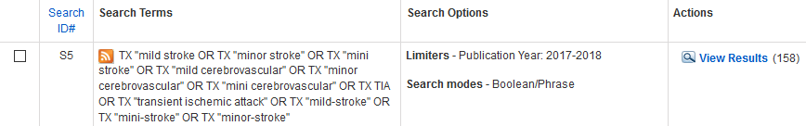
# of Duplicates: 23

Database: CINAHL
Date Searched: 03/05/2018
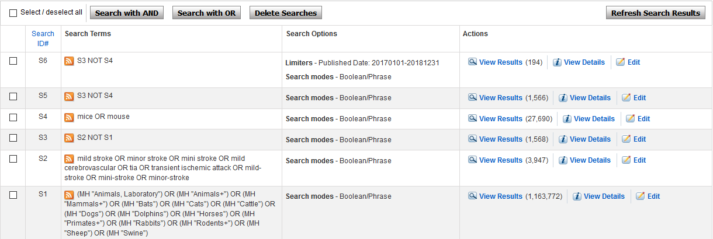
# of Results: 194
# of Duplicates: 36

