Supplemental figure 1. Estimated prevalence of hepatitis C among persons born after 1969, U.S. states and District of Columbia, 2013–2016.

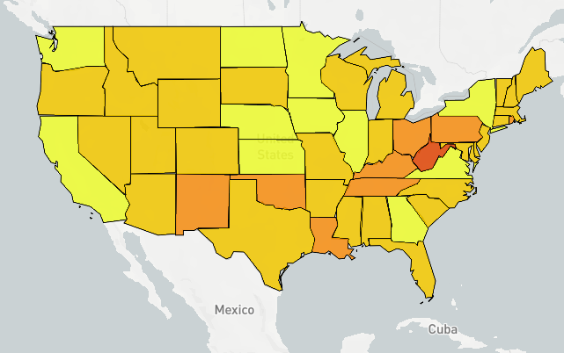

Supplemental figure 2. Estimated prevalence of hepatitis C among persons born during 1945 – 1969, U.S. states and District of Columbia, 2013–2016.
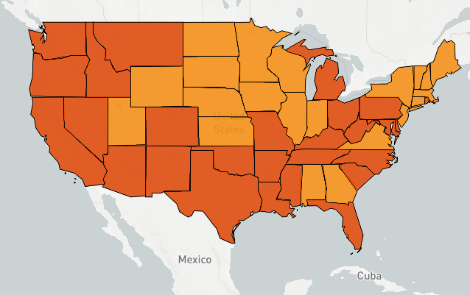
Supplemental figure 3. Estimated prevalence of hepatitis C among persons born before 1945, U.S. states and District of Columbia, 2013–2016.
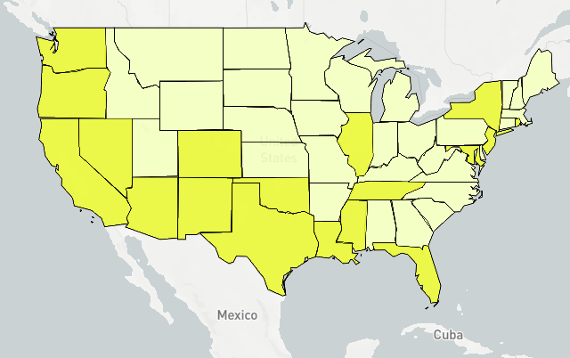

Supplemental figure 4. Estimated prevalence of hepatitis C among males, U.S. states and District of Columbia, 2013–2016.
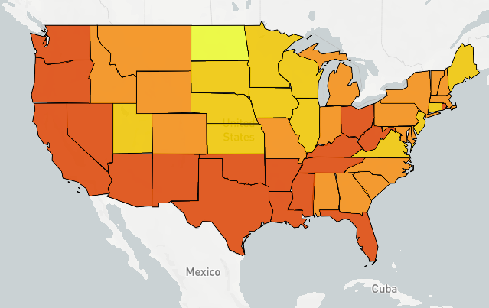

Supplemental figure 5. Estimated prevalence of hepatitis C among females, U.S. states and District of Columbia, 2013–2016.
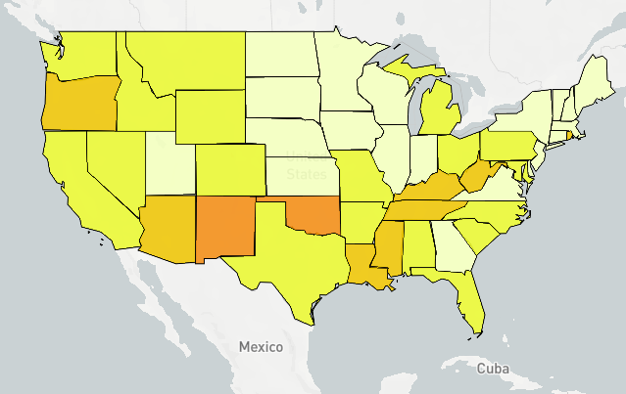

Supplemental figure 6. Estimated prevalence of hepatitis C among non-Hispanic blacks, U.S. states and District of Columbia, 2013–2016.
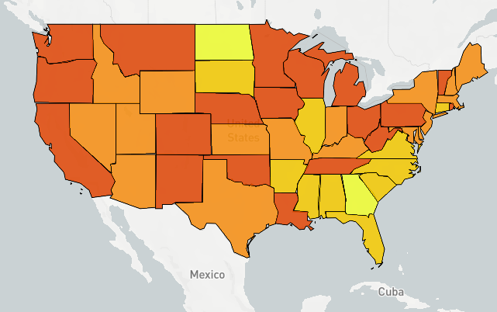
Supplemental figure 7. Estimated prevalence of hepatitis C among non-black persons, U.S. states and District of Columbia, 2013–2016.
