Supplementary Methods: Defining seropositivity across surveys performed in differing malaria transmission levels
Median fluorescence intensity (MFI) measurements were corrected for background reactivity and log10-transformed (MFI-bkg). Density distribution plots showed that the lower Gaussian distribution of the MFI-bkg data from each of the three surveys were not aligned (example for MSP-1₁₉ shown in Figure 1; top). In order to compare surveys directly, antibody distributions were aligned according to the mean of the lower distribution. This was done by adding a constant value to all MFI-bkg measurements per survey to adjust for the difference in the means of the lower distributions, using the EAG-Grand’Anse survey as the reference (Figure 1; bottom). Hereafter, a two-Gaussian distribution was fit to the combined MFI-bkg data (i.e., across all three surveys) and the threshold for seropositivity was set at five standard deviations from the mean of the lower Gaussian distribution (Figure 1; bottom).
This approach was applied to each of the antigens in the panel separately. Resulting thresholds for seropositivity are shown in Table 1.

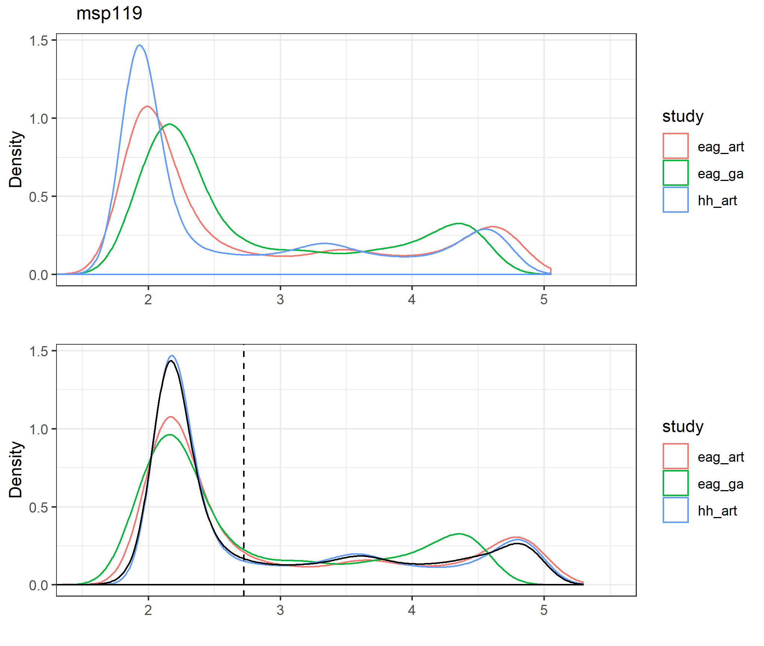
Supplementary Methods Figure 1: MSP-1₁₉ antibody density distributions per survey (top) and aligning antibody distributions resulting in a combined antibody density distribution across all three surveys (bottom; in black). The threshold for seropositivity (dashed vertical line in bottom plot) was determined at five standard deviations from the mean of the lower Gaussian distribution using the combined antibody density distribution across all three surveys (black solid line). MSP-1₁₉/msp119: 19 kDa fragment of Merozoite Surface Protein 1.

Supplementary Methods Table 1: Overview of thresholds for seropositivity by applying a two-Gaussian mixture model per antigen using the combined IgG data across all three surveys. Thresholds are presented in log10-transformed median fluorescence intensity (MFI).
Antigen | Antigen acronym | Alias | Seropositivity threshold
Circumsporozoite surface protein | rCSP | rcsp | 2.654
Liver surface antigen 1 | LSA-1 | lsa1 | 2.394
Plasmodium exported protein | Hyp 2 | hyp2 | 2.697
Heat shock protein 40 | HSP40 Ag1 | hsp40 | 2.606
Schizont egress antigen | SEA-1 | sea | 2.758
Skeleton-binding protein; Maurer's cleft | SBP1 | sbp1 | 2.815
Histidine rich protein 2 | HRP2 | hrp2 | 2.739
Early transcribed membrane antigen | Etramp 4 ag2 | etr42 | 2.883
Early transcribed membrane antigen | Etramp 5 ag1 | etr51 | 2.566
Glutamate rich protein R0 | PfGLURP R0 | glurp0 | 2.418
Glutamate rich protein R2 | PfGLURP R2 | glurp2 | 2.236
19kDa fragment of MSP1 molecule | PfMSP1-₁₉ | msp119 | 2.724
H103/merozoite surface protein 11 | H103/MSP11 | h103 | 2.631
Erythrocyte binding antigen-175 Region III-V | EBA-175 RIII-V | e175 | 2.279
Erythrocyte binding antigen-181 Region III-V | EBA-181 RIII-V | e181 | 2.509
Apical membrane antigen 1 | PfAMA1 | ama1 | 2.461
Reticulocyte binding protein homologue 5 | Rh5.1 | rh5 | 2.792

