Table S1. Principal components factor analysis of household environment variables, Coatepeque and Génova, Guatemala, 2017 (n=508)
Characteristic | Factor pattern
Electricity | 0.31
Running water | 0.71
Television | 0.43
Landline telephone | 0.35
No pit latrine | 0.41
Cable television | 0.65
Garbage service | 0.72
No water well | 0.60
Sewer system | 0.72
Number of rooms in house | 0.43
Eigenvalue | 3.16

Table S2. Full model outputª of adjusted^{b} associations between geographical distances to paved roads and immature mosquito abundance, Poisson regression, Coatepeque and Génova, Guatemala, 2017.
 | Total number of larvae per household |  |  | Total number of pupae per household |  |  | Number of positive containers per household
Variable | β | SE | P-value | β | SE | P-value | β | SE | P-value
Distance from nearest paved road (10-m increase) | -0.04 | 0.01 | <0.01 | -0.07 | 0.03 | <0.01 | -0.04 | 0.01 | <0.01
Environmental capital (ref: middle) |  |  | 0.50 |  |  | 0.82 |  |  | 0.25
Low | -0.03 | 0.11 |  | -0.10 | 0.24 |  | -0.06 | 0.11
High | -0.13 | 0.11 |  | -0.14 | 0.34 |  | -0.18 | 0.11
Survey period (ref: February-March) | 0.40 | 0.15 | 0.06 | 0.37 | 0.21 | 0.08 | 0.42 | 0.18 | 0.06
Urban residence (ref: rural) | 0.18 | 0.11 | 0.11 | 0.01 | 0.24 | 0.99 | 0.24 | 0.11 | 0.03
Number of people / household | -0.01 | 0.02 | 0.81 | 0.04 | 0.03 | 0.26 | -0.01 | 0.02 | 0.36
Cleaned containers (ref: no) | -0.09 | 0.09 | 0.34 | 0.01 | 0.21 | 0.99 | -0.07 | 0.08 | 0.43
Fumigation (ref: no) | -0.10 | 0.11 | 0.39 | -0.40 | 0.28 | 0.16 | -0.18 | 0.10 | 0.07
Total number of containers | 0.13 | 0.02 | <0.01 | 0.23 | 0.04 | <0.01 | 0.22 | 0.02 | <0.01
ªThese estimates should be interpreted with caution, because the relationships between the covariates and outcomes are not adjusted for confounders. Westreich D, Greenland S. The table 2 fallacy: presenting and interpreting confounder and modifier coefficients. American Journal of Epidemiology. 2013;177(4):292-8.
^{b}Adjusted for the other variables listed in the model. Environmental capital was derived from principal components factor analysis and included: number of rooms in the household; presence of electricity, running water, a television, a landline telephone, cable, trash disposal, and sewer system; and absence of a water well and pit latrine.

Table S3. Full model outputª of adjusted^{b} associations between geographical distances to highways and immature mosquito abundance, Poisson regression, Coatepeque and Génova, Guatemala, 2017.
 | Total number of larvae per household |  |  | Total number of pupae per household |  |  | Number of positive containers per household
Variable | β | SE | P-value | β | SE | P-value | β | SE | P-value
Distance from nearest highway (100-m increase) | 0.01 | 0.01 | 0.55 | 0.01 | 0.01 | 0.35 | 0.01 | 0.01 | 0.47
Environmental capital (ref: middle) |  |  | 0.38 |  |  | 0.12 |  |  | 0.32
Low | -0.17 | 0.18 |  | -0.05 | 0.19 |  | -0.19 | 0.16
High | -0.12 | 0.10 |  | -0.12 | 0.09 |  | -0.17 | 0.17
Survey period (ref: February-March) | 0.28 | 0.12 | 0.10 | 0.23 | 0.10 | 0.17 | 0.25 | 0.15 | 0.20
Urban residence (ref: rural) | 0.17 | 0.02 | <0.01 | -0.02 | 0.04 | 0.67 | -0.02 | 0.04 | 0.67
Number of people / household | 0.01 | 0.01 | 0.02 | 0.02 | 0.02 | 0.30 | 0.02 | 0.02 | 0.18
Cleaned containers (ref: no) | -0.07 | 0.06 | 0.22 | 0.03 | 0.03 | 0.41 | 0.03 | 0.03 | 0.41
Fumigation (ref: no) | -0.08 | 0.06 | 0.18 | -0.28 | 0.11 | 0.15 | -0.22 | 0.09 | 0.06
Total number of containers | 0.13 | 0.02 | <0.01 | 0.20 | 0.03 | <0.01 | 0.18 | 0.03 | <0.01
ªThese estimates should be interpreted with caution, because the relationships between the covariates and outcomes are not adjusted for confounders. Westreich D, Greenland S. The table 2 fallacy: presenting and interpreting confounder and modifier coefficients. American Journal of Epidemiology. 2013;177(4):292-8.
^{b}Adjusted for the other variables listed in the model. Environmental capital was derived from principal components factor analysis and included: number of rooms in the household; presence of electricity, running water, a television, a landline telephone, cable, trash disposal, and sewer system; and absence of a water well and pit latrine.

Table S4. Full model outputª of adjusted^{b} associations between geographical distances to houses or structures and immature mosquito abundance, Poisson regression, Coatepeque and Génova, Guatemala, 2017.
 | Total number of larvae per household |  |  | Total number of pupae per household |  |  | Number of positive containers per household
Variable | β | SE | P-value | β | SE | P-value | β | SE | P-value
Distance from nearest structure (1-m increase) | -0.03 | 0.01 | <0.01 | -0.05 | 0.02 | 0.02 | -0.03 | 0.01 | <0.01
Environmental capital (ref: middle) |  |  | 0.50 |  |  | 0.83 |  |  | 0.25
Low | -0.07 | 0.12 |  | -0.11 | 0.25 |  | -0.09 | 0.12
High | -0.13 | 0.11 |  | -0.13 | 0.35 |  | -0.18 | 0.11
Survey period (ref: February-March) | 0.41 | 0.12 | 0.06 | 0.34 | 0.22 | 0.09 | 0.38 | 0.20 | 0.08
Urban residence (ref: rural) | 0.15 | 0.11 | 0.18 | -0.03 | 0.25 | 0.90 | 0.22 | 0.11 | 0.06
Number of people / household | -0.01 | 0.02 | 0.68 | 0.03 | 0.03 | 0.33 | -0.02 | 0.02 | 0.29
Cleaned containers (ref: no) | -0.07 | 0.09 | 0.49 | 0.04 | 0.22 | 0.87 | -0.05 | 0.08 | 0.59
Fumigation (ref: no) | -0.09 | 0.11 | 0.42 | -0.39 | 0.28 | 0.17 | -0.18 | 0.10 | 0.08
Total number of containers | 0.14 | 0.02 | <0.01 | 0.24 | 0.03 | <0.01 | 0.23 | 0.02 | <0.01
ªThese estimates should be interpreted with caution, because the relationships between the covariates and outcomes are not adjusted for confounders. Westreich D, Greenland S. The table 2 fallacy: presenting and interpreting confounder and modifier coefficients. American Journal of Epidemiology. 2013;177(4):292-8.
^{b}Adjusted for the other variables listed in the model. Environmental capital was derived from principal components factor analysis and included: number of rooms in the household; presence of electricity, running water, a television, a landline telephone, cable, trash disposal, and sewer system; and absence of a water well and pit latrine.

Table S5. Associations between geographical distances to roads/structures and immature mosquito abundance, negative binomial regression, Coatepeque and Génova, Guatemala, 2017.
 | Total number of larvae per household |  |  | Total number of pupae per household |  |  | Number of positive containers per household
Variable | β | SE | P-value | β | SE | P-value | β | SE | P-value
Distance from nearest paved road (10-m increase)
Unadjusted | -0.04 | 0.01 | <0.01 | -0.06 | 0.02 | <0.01 | -0.04 | 0.01 | <0.01
Adjustedª | -0.04 | 0.01 | <0.01 | -0.08 | 0.02 | <0.01 | -0.04 | 0.01 | <0.01
Distance from nearest highway (100-m increase)
Unadjusted | 0.01 | 0.01 | 0.49 | 0.01 | 0.02 | 0.27 | 0.02 | 0.01 | 0.41
Adjustedª | -0.01 | 0.01 | 0.73 | 0.02 | 0.02 | 0.64 | 0.01 | 0.01 | 0.78
Distance from nearest structure (1-m increase)
Unadjusted | -0.02 | 0.01 | <0.01 | -0.06 | 0.01 | <0.01 | -0.04 | 0.01 | <0.01
Adjustedª | -0.02 | 0.01 | <0.01 | -0.06 | 0.02 | <0.01 | -0.03 | 0.01 | <0.01
ªAdjusted for environmental capital, survey period, urban/rural residence, the number of people in a household, cleaned containers, fumigated inside or outside the house, and the total number of containers. Environmental capital was derived from principal components factor analysis and included: number of rooms in the household; presence of electricity, running water, a television, a landline telephone, cable, trash disposal, and sewer system; and absence of a water well and pit latrine.

Table S6. Mediation of distances to roads/structures and mosquito prevention measures on the association between environmental capital and the number of containers with any mosquito larvae or pupae per household, Coatepeque and Génova, Guatemala, 2017
 | Controlled direct effect |  | Natural indirect effect |  |  | Total effect
Characteristic | Estimate | 95% CI |  | Estimate | 95% CI |  | Estimate | 95% CI |  | Proportion mediated
Fumigated house | 0.08* | 0.05, 0.11 |  | -0.01 | -0.02, 0.01 |  | 0.08* | 0.04, 0.11 |  | -0.08
Cleaned containers | 0.08* | 0.05, 0.11 |  | -0.01 | -0.02, 0.01 |  | 0.07* | 0.04, 0.11 |  | -0.04
Distance to paved road (m) | 0.01 | -0.02, 0.04 |  | 0.22* | 0.16, 0.29 |  | 0.24* | 0.18, 0.28 |  | 0.94
Distance to highway (m) | 0.08* | 0.04, 0.10 |  | -0.01 | -0.03, 0.01 |  | 0.07* | 0.04, 0.10 |  | -0.02
Distance to nearest structure (m) | 0.03 | 0.03, -0.01 |  | 0.12* | 0.06, 0.18 |  | 0.15* | 0.10, 0.19 |  | 0.80
*p-value<0.05

Figure S1. Aerial view of communities in Coatepeque and Génova, Guatemala, 2017. The study sites are enclosed in red. Source: Quetzaltenango department location map; by user Edouno; licensed under CC BY 3.0 via Wikimedia Commons, https://commons.wikimedia.org/wiki/File:Quetzaltenango_department_location_map.svg.
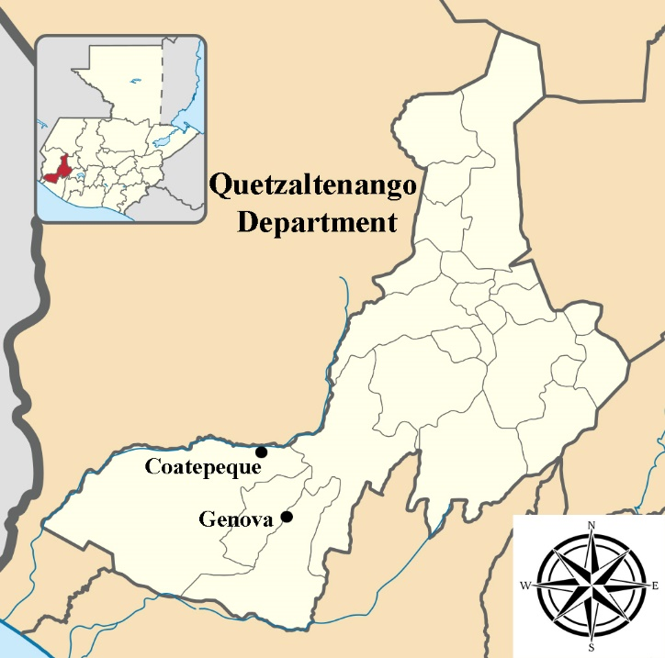
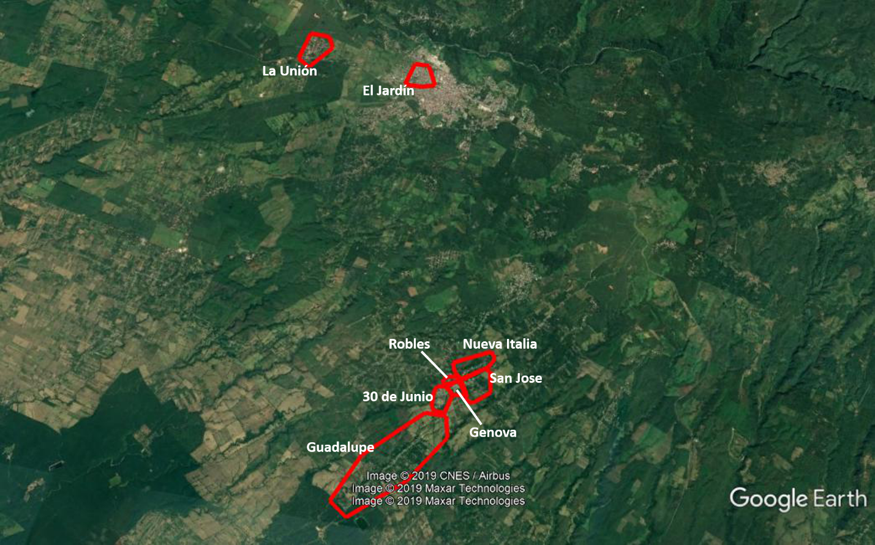

Figure S2. Directed acyclic graphs of associations between geographical distances to roads and houses/structures and immature mosquito abundance. Panel A: distance to paved roads; Panel B: distance to highways; Panel C: distance to nearest house.
Panel A | Panel B
Panel C
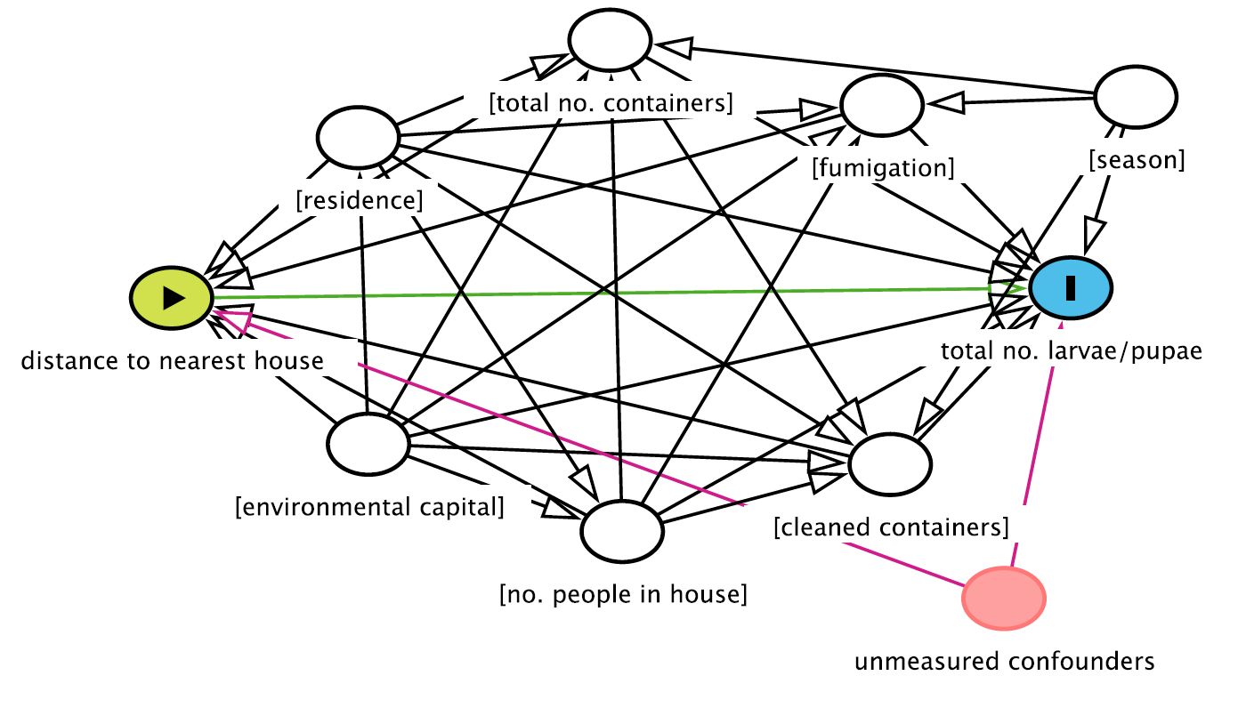

Figure S3. Cubic splines of associations between environmental capital and the number of containers with any mosquito larvae or pupae per household, Coatepeque and Génova, Guatemala, 2017. Panel A shows results from the first survey in February-March, 2017. Panel B shows results from the second survey in November-December, 2017. The bands represent 95% confidence intervals.
Panel A  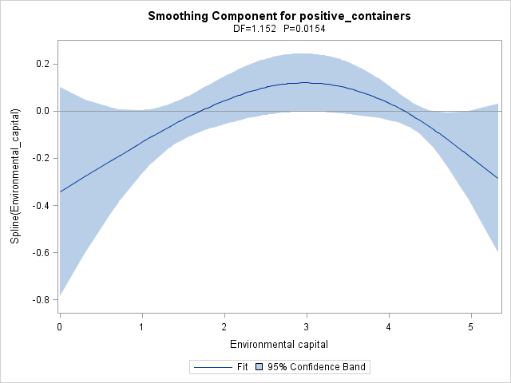 | Panel B  