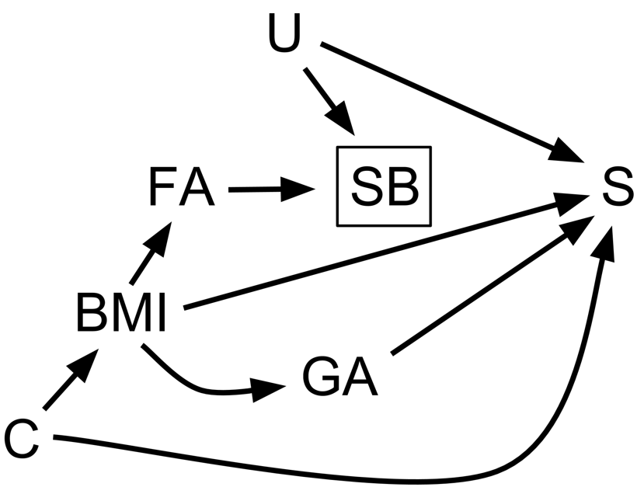

Figure S1. Directed Acyclic Graph (DAG) for the Effect of Maternal Pre-pregnancy BMI on Infant Survival.
This DAG represents a potential causal relation between maternal pre-pregnancy body mass index and infant survival among babies born with spina bifida. A box is placed around spina bifida to indicate that inclusion in this study is conditional upon the presence of spina bifida in a liveborn infant.
Acronym key
BMI: maternal pre-pregnancy body mass index; C: confounders (maternal age, education, race/ethnicity, smoking, alcohol consumption); FA: maternal periconceptional folic acid consumption; GA: infant gestational age; S: infant survival; SB: spina bifida; U: potential unmeasured confounder

