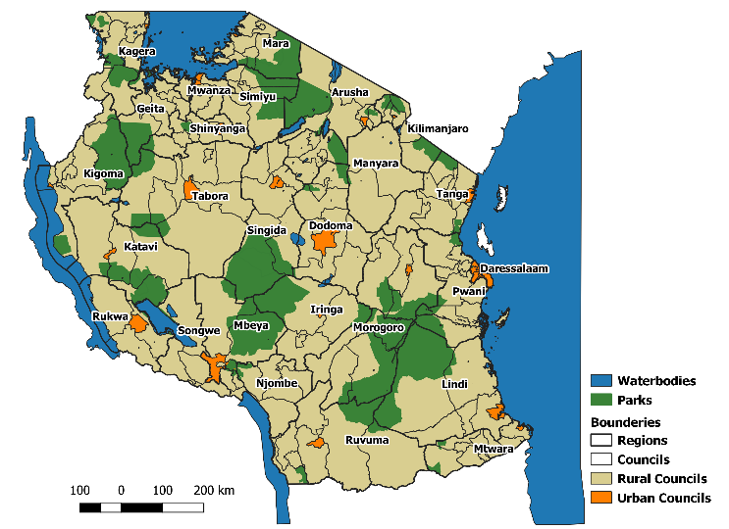
Figure S1: Administrative boundaries and distribution of urban and rural councils in mainland Tanzania. Within the urban councils, town authorities were considered rural due to presence of high numbers of mixed and rural wards within the council thereby resulting in a total of 25 urban councils

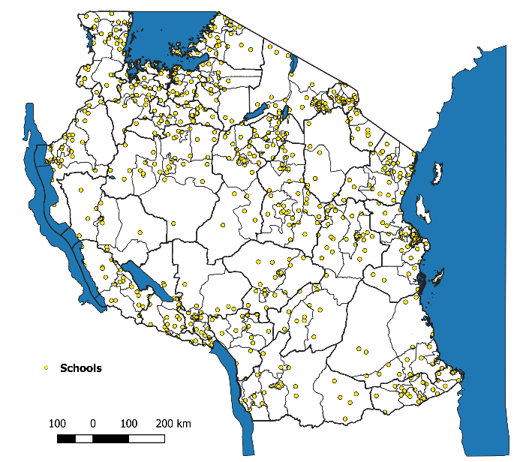
Figure S2: Locations of sampled schools for SMPS in 2015 & 2017 (N=711)

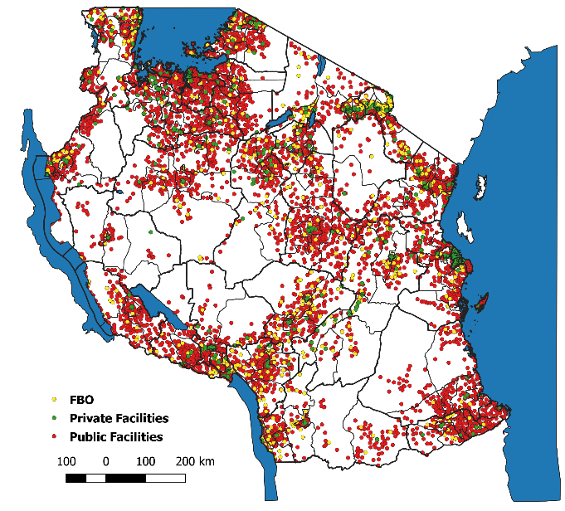
Figure S3: Location of operational health facilities by ownership in mainland Tanzania (N=7620) (Source: HFR Portal, www.moh.go.tz/hfrportal/)
Table S1: Excel file – The maximum of the annual mean values per indicator and resulting overall risk strata assigned per council
Table S2: The cumulative proportion of health facilities submitting between 3 – 12 monthly facility reports from OPD, ANC and laboratory in 2015 – 2017 (N = Total number of facilities)
# of monthly reports submitted | Laboratory |  | OPD |  |  | ANC
 | 2016  (N=6297) | 2017  (N=7078) | 2015  (N=7004) | 2016  (N=7215) | 2017  (N=7425) | 2015  (N=5981) | 2016  (N=6170) | 2017  (N=6362)
3 | 85.7% | 95.8% | 98.4% | 98.0% | 98.7% | 99.0% | 98.8% | 99.3%
6 | 57.9% | 89.9% | 95.5% | 95.4% | 95.9% | 97.5% | 97.7% | 97.7%
9 | 19.3% | 78.9% | 87.7% | 91.5% | 92.4% | 95.3% | 95.7% | 96.0%
12 | 3.0% | 38.9% | 59.0% | 63.0% | 69.3% | 76.8% | 80.3% | 81.7%

Strata | No. councils | No. urban councils (municipal/city councils)* | Percent population
Very Low | 31 | 3 | 36%
Low | 32 | 10 | 26%
Moderate | 50 | 8 | 24%
High | 71 | 4 | 14%
Total | 184 | 25 | 100%

Figure S4: Malaria risk stratification using health facilities with >50% reporting rates

