Supplementary material

Contents
1 Health facilities included in the study 2
2 Additional information describing intervention coverage in Zanzibar 4
3 Seasonality of confirmed malaria in Zanzibar from 2000-2015 5
4 Interrupted time series model development 6
4.1 Specifications of the ITS model presented in the paper to describe impact of ACTs and ACTs plus vector control on malaria incidence 6
Step 1 - Specify the ITS design and impact model 6
Step 2 - Descriptive analysis 7
Step 3 - Specify model structure 7
Step 4 - Build ITS model 8
Step 5 - The final ITS model 9
Step 6 - Generating model prediction confidence intervals 9
4.2 Sensitivity analysis 11
Cross validation of final model 11
Alternative model - Poisson model with case-count outcome 12
5 Generating counterfactuals to estimate cases averted 16
5.1 Counterfactual strategy 1: use an ITS model with level change only 16
5.2 Counterfactual strategy 2: use an ITS model with both level and trend change 20
6 References 24

Health facilities included in the study

All primary health care units (PHCUs) were eligible to be included in the study. A total of 158 unique PCHUs reported data to the health management information system (HMIS) at any point during the period January 2000 to December 2015. PCHUs in Wete and North B district (18 and 11 PCHUs, respectively) were excluded, since none of the PCHUs in these two districts had access to parasitological diagnosis during the pre-intervention period (January 2000 to August 2003), preventing the development of district-level models with confirmed malaria incidence as the primary outcome. As a consequence, analysis presented in the manuscript includes a total of 129 PCHUs from eight districts.

Figure 1 – Flowchart describing health facilities in Zanzibar excluded from analysis
PCHUs retained for interrupted time series and cases averted analysis
N=129
All PCHUs in Wete excluded because parasitological diagnosis of malaria only introduced in 2006
N=18
All PCHUs in North B excluded because parasitological diagnosis of malaria only introduced in 2007
N=11
Primary health care units (PCHUs) reporting any HMIS malaria indicators during the period January 2000 to December 2015
N=158

87 the 129 PCHUs included in the study were operating at the start of the study period (January 2000. The remaining 42 PCHUs opened and began reporting data during the study period. Only 80 PCHUs were open throughout the full study period, from January 2000 to December 2015. District-level aggregate data that was used to estimate monthly incidence of confirmed malaria for each district included all PCHUs reporting data for the month of interest.

Table 1 - Detailed description of the number of facilities operational at different periods of the study, the actual number and proportion of expected monthly reports available in HMIS data, and the number and proportion of expected months with all-cause OPD data available.

Date range | Number facilities operating | Expected facility-months of data | Facility months of data reported  (% of expected) | Facility-months with all-cause OPD data reported  (% of expected)
Jan-00 to Dec-00 | 87 | 1044 | 1041 (99.7) | 1041 (99.7)
Jan-01 to Dec-01 | 89 | 1068 | 1056 (98.9) | 1056 (98.9)
Jan-02 to Dec-02 | 93 | 1116 | 1092 (97.8) | 1092 (97.8)
Jan-03 to Dec-03 | 94 | 1128 | 1116 (98.9) | 1116 (98.9)
Jan-04 to Dec-04 | 95 | 1140 | 1140 (100) | 1140 (100)
Jan-05 to Dec-05 | 98 | 1176 | 1152 (98) | 1152 (98)
Jan-06 to Mar-06 | 102 | 306 | 301 (98.4) | 301 (98.4)
Apr-06 to Jun-06 | 103 | 309 | 306 (99.0) | 306 (99.0)
Jul-06 to Dec-06 | 104 | 624 | 611 (97.9) | 611 (97.9)
Jan-07 to Dec-07 | 105 | 1260 | 1248 (99.0) | 1248 (99.0)
Jan-08 to Dec-08 | 106 | 1272 | 1272 (100) | 1272 (100)
Jan-09 to Oct-09 | 113 | 1130 | 1105 (97.8) | 1105 (97.8)
Nov-09 to Jun-10 | 112 | 896 | 855 (95.4) | 854 (95.3)
Jul-10 to Dec-10 | 113 | 678 | 653 (96.3) | 648 (95.6)
Jan-11 to Aug-11 | 110 | 880 | 871 (99.0) | 871 (99.0)
Sep-11 to Dec-11 | 111 | 444 | 439 (98.9) | 439 (98.9)
Jan-12 to Dec-12 | 110 | 1320 | 1310 (99.2) | 1307 (99.0)
Jan-13 to Apr-13 | 111 | 444 | 432 (97.3) | 431 (97.1)
May-13 to Dec-13 | 112 | 896 | 884 (98.7) | 882 (98.4)
Jan-14 to May-14 | 115 | 575 | 565 (98.3) | 564 (98.1)
Jun-14 to Feb-15 | 114 | 1026 | 1013 (98.7) | 1012 (98.6)
Mar-15 to Dec-15 | 115 | 1150 | 1093 (95.0) | 1091 (94.9)
Full study period |  | 19882 | 19555 (98.4) | 19539 (98.3)

Table 2 - Detailed description of the number of facilities operational at different periods of the study, the actual number and proportion of expected monthly reports available in HMIS data, and the number and proportion of expected months with complete all-cause OPD data available.

Date range | Number facilities with confirmatory diagnostic capacity | Expected facility-months of data on confirmed malaria | Actual facility months of data on number tested  (% of expected) | Actual facility months of data on number confirmed malaria cases  (% of expected)
Jan-00 to Dec-00 | 13 | 156 | 156 (100) | 156 (100)
Jan-01 to Dec-01 | 14 | 168 | 156 (92.9) | 155 (92.3)
Jan-02 to Dec-02 | 15 | 180 | 157 (87.2) | 156 (86.7)
Jan-03 to Jul-03 | 16 | 112 | 98 (87.5) | 98 (87.5)
Aug-03 to Dec-05 | 17 | 493 | 411 (83.4) | 442 (89.7)
Jan-06 to Dec-06 | 41 | 492 | 439 (89.2) | 438 (89.0)
Jan-07 to Dec-07 | 105 | 1260 | 1248 (99.0) | 1248 (99.0)
Jan-08 to Dec-08 | 106 | 1272 | 1272 (100) | 1272 (100)
Jan-09 to Mar-09 | 110 | 330 | 322 (97.6) | 323 (97.9)
Apr-09 to Apr-09 | 111 | 111 | 109 (98.2) | 109 (98.2)
May-09 to Jun-10 | 112 | 1568 | 1508 (96.2) | 1510 (96.3)
Jul-10 to Dec-10 | 113 | 678 | 647 (95.4) | 648 (95.6)
Jan-11 to Jan-11 | 106 | 106 | 49 (46.2) | 105 (99.1)
Feb-11 to Dec-11 | 107 | 1177 | 441 (37.5) | 1161 (98.6)
Jan-12 to Dec-12 | 110 | 1320 | 1305 (98.9) | 1310 (99.2)
Jan-13 to Apr-13 | 111 | 444 | 430 (96.8) | 430 (96.8)
May-13 to Dec-13 | 112 | 896 | 882 (98.4) | 882 (98.4)
Jan-14 to May-14 | 115 | 575 | 562 (97.7) | 562 (97.7)
Jun-14 to Apr-15 | 114 | 1254 | 1225 (97.7) | 1224 (97.6)
May-15 to Dec-15 | 115 | 920 | 871 (94.7) | 874 (95.0)
Full study period |  | 13512 | 12288 (90.9) | 13103 (97.0)

Completeness of confirmed malaria data (proportion of expected facility-months where confirmed malaria count was reported) was moderate (>85%) during the early phase of the study from 2000-2003, completeness was high (>95%) from 2004 onwards. Completeness of data on number tested by microscopy or RDT followed a similar pattern, with the exception of 2011, which had completeness substantially lower than in other years. Data on number tested were available for only 38.1% of expected facility-months in 2011. All districts except Central and West had large amounts of missing data on number tested in 2011. This finding may have resulted in poorer ITS model fit in 2011.

Additional information describing intervention coverage in Zanzibar

Detailed information describing intervention coverage at district and month resolution was not available for the study. To provide further contextual information on the changes in malaria intervention coverage over the study period from 20000-2015, summary statistics were extracted from large-scale cross-sectional surveys: Demographic and Health Surveys (DHS) and Malaria & AIDS Information Surveys (MIS).

Data were downloaded from The DHS Program (https://dhsprogram.com/data), and indicator estimates generated for Zanzibar (Unguja and Pemba islands) using appropriate sampling weighs for each survey.¹⁻⁵

Note that the number of febrile children under five who received any antimalarial becomes substantially smaller over time, from 275 in 2004-5 DHS, to 77 in 2007-8 MIS, 42 in 2010 DHS, to only 5 children in 2011-12 MIS and 6 children in 2015-16 DHS.

Table 3 - Summary of intervention coverage in Zanzibar, extracted from Demographic and Health Surveys (DHS) and Malaria & AIDS Information Surveys (MIS).
 | 2004-05  DHS | 2007-08  MIS | 2010  DHS | 2011-12  MIS | 2015-16  DHS/MIS
Households with at least one ITN | 28.0 | 71.9 | 75.8 | 73.8 | 73.8
Households with at least one ITN for every 2 persons who stayed in the household the previous night | 10.3 | 34.5 | 38.7 | 45.8 | 39.7
Households with IRS in last 12 months | - | 93.6 | - | 87.4 | -
Households with at least one ITN and/or IRS in the past 12 months | - | 98.0 | - | 94.0 | -
Population who slept under an ITN last night | 14.7 | 40.5 | 45.4 | 44.4 | 42.2
Population who slept under an ITN last night or in a dwelling sprayed with IRS in the past 12 months | - | 96.5 | - | 94.7 | -
U5s who slept under an ITN last night | 21.7 | 58.5 | 54.6 | 50.7 | 56.4
U5s who slept under an ITN last night or in a dwelling sprayed with IRS in the last 12 months | - | 97.3 | - | 95.2
U5s who slept under an ITN last night of those living in a household with at least one ITN | 29.3 | 63.9 | 56.9 | 75.8 | 71.3
U5s with fever for whom advice or treatment was sought | 77.4 | 70.3 | 73.3 | 68.6 | 72.7
Among febrile U5s who sought treatment, % receiving ACT | 38.1 | 14.6 | 0.42 | 0.36 | 0.78
Among febrile U5s who received an antimalarial, % receiving ACT | 54.6 | 26.9 | 1.9 | 14.4 | 32.5
Among febrile U5s who sought treatment, % attending private hospitals, private health centers or private dispensaries | 17.5 | 16.8 | 17.1 | 27.7 | 25.5
ITN = Insecticide-treated net. Defined as either i) a factory-treated net that does not require any further treatment, or ii) a net that has been soaked with insecticide within the past 12 months
IRS = Indoor residual spray.
U5 = Child aged less than five years

Seasonality of confirmed malaria in Zanzibar from 2000-2015
To further describe changes in the seasonality of confirmed malaria during the study period, a seasonality index was created by dividing the number of confirmed malaria cases reported each month in the district by the total number of confirmed malaria cases reported in the district during the calendar year (from January to December).

In all districts, an amplification in seasonality can be seen over the study period. During 2000-2004, seasonal peaks can be observed, but from approximately 2010, transmission appears to be much more seasonal, with up to 40% all cases for the year occurring in a single month.

Figure 2 – Line plot of proportion of annual total (January-December) confirmed malaria cases occurring in specified calendar month, by district
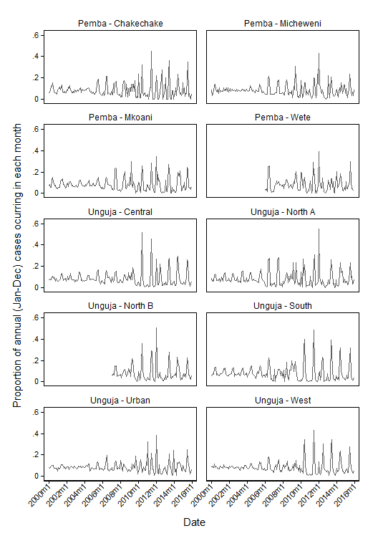

Interrupted time series model development

Specifications of the ITS model presented in the paper to describe impact of ACTs and ACTs plus vector control on malaria incidence

Step 1 - Specify the ITS design and impact model
The ITS design and impact model must be hypothesized a priori, based on the nature of the intervention and estimated impact of the intervention on outcome, according to existing data.

For the Zanzibar study, we split our time series into three: a period prior to introduction of our interventions of interest (pre-intervention period); a period after introduction of artemisinin-based combination therapy (ACT) as the first-line treatment for uncomplicated malaria (ACT-only period); and a period where ACTs continued to be available, and two vector control interventions were introduced; indoor residual spraying and long-lasting insecticide-treated nets (ACT plus vector control period).

We consider each intervention to have been present at a consistent level throughout the specific time period. Our ITS model hypothesizes that each intervention may have had an effect on both the trend of malaria incidence, and on the level of malaria incidence.

The basic regression model for an ITS design with change in level and trend for introduction of two sequential interventions:
$$Y_{t}= β_{0}+ β_{1}T+ β_{2}A_{t}+ β_{3}TA_{t}+ β_{4}V_{t}+ β_{5}TV_{t}$$
Where:
- $Y_{t}$ : Outcome (confirmed malaria case count in district and month)
- $T$ : Time in months elapsed since the start of the study
- $A_{t}$ : Binary variable for the ACT-only intervention (coded 0 from January 2000 to August 2003, and coded 1 from September 2003 to December 2015)
- $V_{t}$ : Binary variable for the ACT plus vector control intervention (coded 0 from January 2000 to December 2005, and coded 1 from January 2006 to December 2015).
- $β_{0}$ : Intercept at T=0
- $β_{1}$ : Baseline trend during the pre-intervention period (January 2000 to August 2003)
- $β_{2}$ : Intercept change immediately after introduction of the ACT-only intervention (compared to the preceding monthly value immediately before the ACT-only intervention)
- $β_{3}$ : Change in trend after introduction of the ACT-only intervention, compared to the pre-intervention period
- $β_{4}$ : Intercept change immediately after introduction of the ACT plus vector control intervention (compared to the preceding monthly value immediately before the ACT-only intervention)
- $β_{5}$ : Change in trend after introduction of the ACT plus vector control intervention, compared to the ACT-only intervention period

An alternative to using binary intervention and time interaction terms ($β_{3}TA_{t}$ and $β_{5}TV_{t}$) is to generate an intervention time variable, which shows the number of months since the intervention was introduced, and is equal to 0 before the intervention is introduced. An illustrative example (with shortened time series) of this data structure is shown below for ITS models estimating change in level and change in trend.

Observation | Malaria case count | Time in months | Intervention 1 | Time after intervention 1 | Intervention 2 | Time after intervention 2
1 | 235 | 1 | 0 | 0 | 0 | 0
2 | 281 | 2 | 0 | 0 | 0 | 0
3 | 210 | 3 | 0 | 0 | 0 | 0
4 | 221 | 4 | 1 | 1 | 0 | 0
5 | 190 | 5 | 1 | 2 | 0 | 0
6 | 182 | 6 | 1 | 3 | 0 | 0
7 | 123 | 7 | 1 | 4 | 0 | 0
8 | 156 | 8 | 1 | 5 | 0 | 0
9 | 132 | 9 | 1 | 6 | 0 | 0
10 | 182 | 10 | 1 | 7 | 1 | 1
11 | 146 | 11 | 1 | 8 | 1 | 2
12 | 138 | 12 | 1 | 9 | 1 | 3
The same ITS model allowing level and trend changes after two different interventions can be specified differently if the output required is the estimate of trend within each period (e.g. pre-intervention period trend, trend during intervention 1 period, trend during intervention 2 period), rather than the change in trend compared to the previous period. The data structure for a model estimating trend within each period would be:

Observation | Malaria case count | Time in pre-intervention period | Intervention 1 | Time in intervention 1 period | Intervention 2 | Time in intervention 2 period
1 | 235 | 1 | 0 | 0 | 0 | 0
2 | 281 | 2 | 0 | 0 | 0 | 0
3 | 210 | 3 | 0 | 0 | 0 | 0
4 | 221 | 3 | 1 | 1 | 0 | 0
5 | 190 | 3 | 1 | 2 | 0 | 0
6 | 182 | 3 | 1 | 3 | 0 | 0
7 | 123 | 3 | 1 | 4 | 0 | 0
8 | 156 | 3 | 1 | 5 | 0 | 0
9 | 132 | 3 | 1 | 6 | 0 | 0
10 | 182 | 3 | 1 | 6 | 1 | 1
11 | 146 | 3 | 1 | 6 | 1 | 2
12 | 138 | 3 | 1 | 6 | 1 | 3

Additional example data tables are shown in Wagner et al.⁶. Detailed worked examples of ITS models and relevant code for R and Stata have been published by Lopez Bernal et al.⁷

Alternative ITS model specifications
The ITS model in the previous section could be adapted to allow change in trend only, by removing the intercept change terms:
$$Y_{t}= β_{0}+ β_{1}T+β_{3}TA_{t}+β_{5}TV_{t}$$

Or to allow only change in level, with consistent trend:
$$Y_{t}= β_{0}+ β_{1}T+ β_{2}A_{t}+ β_{4}V_{t}$$

The ITS can be adapted to various other scenarios. For example, an intervention with limited effect time could be specified by re-setting the binary intervention variable to 0 after the hypothesized effect period. If there is expected to be a lag between the intervention being introduced and an effect observed, the time at which the binary intervention variable changes from 0 to 1 should be lagged by the appropriate time. Further discussion of ITS designs and examples are available elsewhere.^{7,8}

Step 2 - Descriptive analysis
Simple descriptive analysis was conducted to describe the completeness of the data, and major trends in specific variables, such as use of parasitological diagnosis and all cause outpatient attendance (see Figure 2 in main paper). Plotting the main outcome indicator, monthly incidence of confirmed malaria, over time and by district helped to begin identifying seasonal trends and outliers, as well as potential underlying trends (see Figure 3 in main paper).

Due to lack of parasitological confirmation in health facilities in Wete and North B districts, they started reporting confirmed malaria in January 2006 and January 2007, respectively. Since the ITS method requires adequate data to be available from the pre-intervention period (before ACTs were introduced in September 2003), Wete and North B were excluded from ITS models.

Step 3 - Specify model structure
Confirmed malaria count was the primary outcome variable. Over dispersion in the outcome variable, meaning that the variance exceeded the mean, led to selection of a negative binomial model. If the outcome variable had equal variance and mean, a Poisson model would have been appropriate. Negative binomial models differ from Poisson models by inclusion of an additional parameter $δ_{i}$ to model the over-dispersion.

The data were panel-set in Stata, defining the data to have the structure $x_{it}$, where $x_{it}$ is a vector of observations for location $i$ and time $t$. The location unit was district, and time unit was calendar month. The time unit ranged from 1 (January 2000) to 192 (December 2015). The log of district population estimates for each month were included in models with coefficient constrained to 1.

A maximum-likelihood random-effects negative binomial model was selected, where random effects refers to the dispersion parameter. The dispersion is the same for all elements in the same group, but varies randomly by group (district), such that $1/\left(1+δ_{i}\right) \sim Beta(r,s)$.

Standard regression models assume that observations are independent. However this assumption is not appropriate when using time series data, since observations that are close in time are often more similar than those that are far apart⁷. To account for this positive autocorrelation, we initially included a one-month lag of the outcome variable (confirmed malaria count during the previous month) in the model as a fixed effect. Alternative transformations of the lagged count variable can be tested in the model to improve fit.

Step 4 - Build ITS model
Three variables were chosen to include a priori in all models, to account for potential biases in outcome variable, which was sourced from routine health information system data.

- Total all-cause outpatient attendance. This variable is included to account for potential changes in population access to health facilities during the study period.
- Number of facilities reporting any data for the month. This variable was included to account for fluctuations in data reporting by facilities to the HMIS.
- Proportion of all outpatient who received a malaria confirmatory test. This variable was included to account for variation in access to malaria testing by microscopy or rapid diagnostic test.

Satellite-derived environmental data considered for potential inclusion in the model included:
- District-month mean of daily rainfall in mm
- District mean of monthly enhanced vegetation index (EVI)
- District-month minimum of the daily average daytime land surface temperature
- District-month maximum of the daily average daytime land surface temperature
- District-month mean of the daily average daytime land surface temperature
- District-month standard deviation of the daily average daytime land surface temperature
- District-month minimum of the daily average night-time land surface temperature
- District-month maximum of the daily average night-time land surface temperature
- District-month mean of the daily average night-time land surface temperature
- District-month standard deviation of the daily average night-time land surface temperature

For each of the variables listed above, another variable was created of standardized district-month means, where mean was 0 and standard deviation 1. In addition, monthly anomaly variables were calculated for each series listed above, by subtracting the district-month mean from the long-term (2000-2015) mean for the calendar month and district.

Additional variables available for potential inclusion in the model were:
- Calendar month, a categorical variable from 1-12.
- Zone (Pemba or Unguja)
- Individual district dummy variables
- Interaction between calendar month and zone
- Interaction between calendar month and district
- Number of individuals tested for malaria
- Malaria test positivity (total confirmed malaria cases divided by the reported number of malaria tests conducted)

Lag periods of one or two months were considered to be biologically plausible as the time for a change in environment (temperature, rainfall etc.) to impact vector population and thus malaria transmission. Consequently, all environmental variables were considered for inclusion in the model with a lag of one or two months.

Environmental data were tested for colinearity, by calculating pairwise correlation between combinations of environmental variables. If two variables were collinear (r > 0.7), then both would not be included in the model at the same time.

A large number of models were prepared with different biologically plausible combinations of the covariates listed above. For each model, district-level plots of observed and model-predicted confirmed malaria incidence were visually inspected, and models with large differences between observed and predicted data were excluded. For shortlisted models, residual plots, mean square error and Akaike’s Information Criterion were used to identify the most appropriate model. Examples of alternative models’ output and fit statistics can be seen in section 3.2, describing the sensitivity analysis.

Step 5 - The final ITS model
The final model included the following covariates:
- A one-month lag of the square root of number of confirmed malaria cases
- Total all-cause outpatient attendance
- Number of facilities reporting data to HMIS
- Proportion of all outpatients who received a parasitological test
- Two month lag of anomaly in rainfall from the long-term mean
- One month lag of anomaly in EVI
- One month lag of the anomaly in minimum daytime temperature
- Two month lag of the anomaly in minimum night-time temperature
- Categorical variable for calendar month
- Dummy variable indicating Urban and West districts (urban and peri-urban area)
- Dummy variable indicating South district

The AIC for the final model was 12,391 and mean square error 883. Figure 3 shows a plot of standardized model residuals ([residual value - mean residual] / standard deviation of residuals) against time, and demonstrates that residuals varied by district. The final model tended to under-predict in Micheweni during the 2000-2005 period, and showed some under-prediction during seasonal peaks in Micheweni, Central and South districts. Figure 4 shows standardized model residuals against model-predicted value, illustrating the under-prediction for months with >250 cases. A full listing of model coefficient values and 95% confidence intervals for coefficients is presented in Table 4.

Step 6 - Generating model prediction confidence intervals
95% confidence intervals of the model prediction were generated using the nlcom command in stata, which computes confidence intervals for nonlinear combination of parameter estimates using the delta method.

Figure 3 – Scatter plot of standardized model residuals against time (month), with y=0 reference line. Residuals are color-coded according to district.
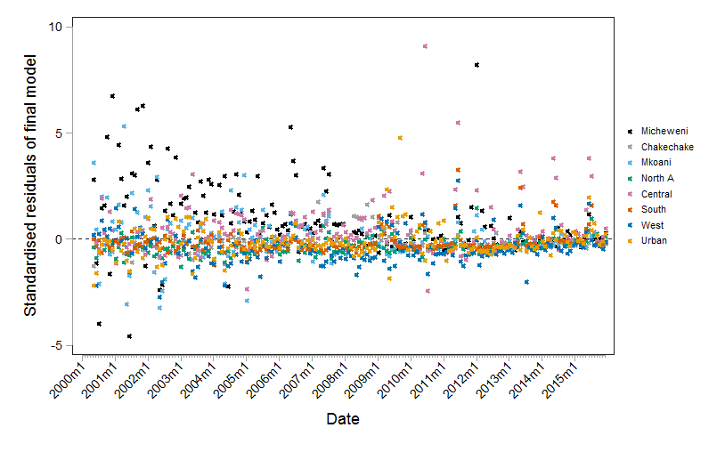

Figure 4 – Scatter plot of standardized model residuals against model prediction value, with lowess smoothed trend line (solid) and y=0 reference line (dashed)
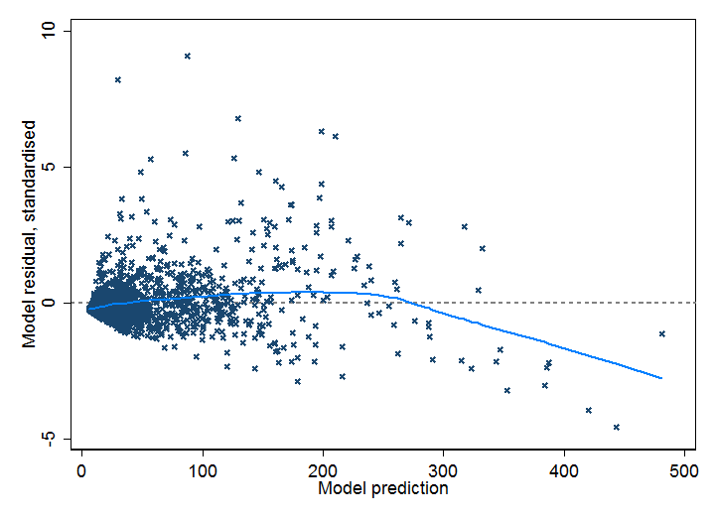

Table 4: Regression coefficients, 95% confidence intervals and z-statistic P value from best-fitting ITS model for confirmed malaria case count in Zanzibar from 2000 to 2015, with introduction of ACT in September 2003 and vector control in January 2006.
Variable | Coefficient | 95% CI | P value
Square root transformation of previous month’s confirmed malaria case count | 0.1289 | 0.1195, 0.1382 | <0.001
Number of health facilities reporting data | 0.0464 | 0.0297, 0.0631 | <0.001
All-cause OPD attendance | 0.00003 | 0.00001, 0.00005 | 0.004
Proportion of all OPD attendees receiving malaria parasitological test | 0.9101 | 0.5963,1.2239 | <0.001
Month
January (base) | - | - | -
February | -0.0631 | -0.1852, 0.0591 | 0.312
March | -0.1145 | -0.2338, -0.0047 | 0.060
April | -0.0707 | -0.0447, 0.1861 | 0.230
May | 0.4743 | 0.3721, 0.5766 | <0.001
June | 0.3385 | 0.2361, 0.4409 | <0.001
July | 0.1514 | 0.0447, 0.2582 | 0.005
August | -0.2528 | -0.3674, 0.1381 | <0.001
September | -0.0233 | -0.1372, 0.0906 | 0.688
October | -0.0787 | -0.1936,0.0362 | 0.179
November | -0.0046 | -0.1192, 0.1099 | 0.937
December | -0.0191 | -0.0944, 0.1326 | 0.742
Monthly rainfall anomaly compared to long-term mean (two month lag) | 0.0002 | -0.0005, 0.0010 | 0.500
Monthly anomaly in enhanced vegetation index compared to long-term mean, (one month lag) | 0.8855 | 0.0750, 1.6960 | 0.032
Anomaly in the month-mean of night-time minimum land surface temperature LST, compared to long-term mean (two month lag) | -0.0095 | -0.0301, 0.0111 | 0.367
Anomaly in the month-mean of daytime minimum land surface temperature LST, compared to long-term mean (one month lag) | -0.0220 | -0.0395, -0.0045 | 0.014
Dummy variable for Urban & West districts | -0.7471 | -0.9139, -0.5675 | <0.001
Dummy variable for South district | 1.1016 | 0.8775, 1.3256 | <0.001
Trend in confirmed malaria incidence (2000-2015) | -0.0025 | -0.0053, 0.0004 | 0.089
Intercept change at ACT introduction (September 2003) | 0.0779 | -0.0330, 0.1888 | 0.169
Change in trend after ACT | -0.0135 | -0.0201, -0.0069 | <0.001
Intercept change at vector control introduction (January 2006) | -0.3821 | -0.5161, -0.2480 | <0.001
Change in trend after vector control | 0.0087 | 0.0025, 0.0149 | 0.006
Intercept | -11.0355 | -11.2962, -10.7748 | <0.001

Sensitivity analysis

Cross validation of final model
Model fit adequacy of the final ITS model was investigated by running a cross-validation, whereby the model was fitted for N-1 districts, and then predictions generated for the excluded district. Out of sample validation was not possible for South district, due to inclusion of a dummy variable for this district in the model.

Figure 5 – Scatter plot of standardized residuals from cross-validation against time (month), with y=0 reference line. Residuals are color-coded according to district.
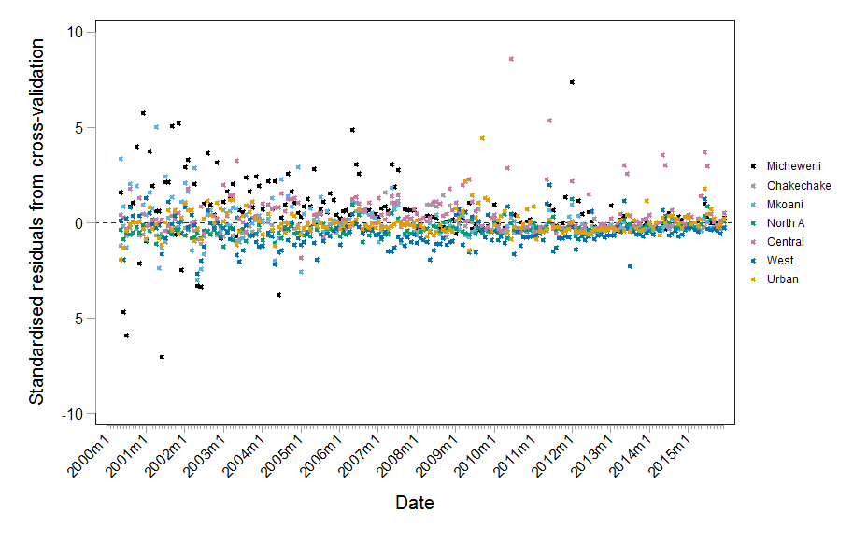

Figure 6 – Scatter plot of standardized residuals for cross-validation against prediction value, with lowess smoothed trend line (solid) and y=0 reference line (dashed)
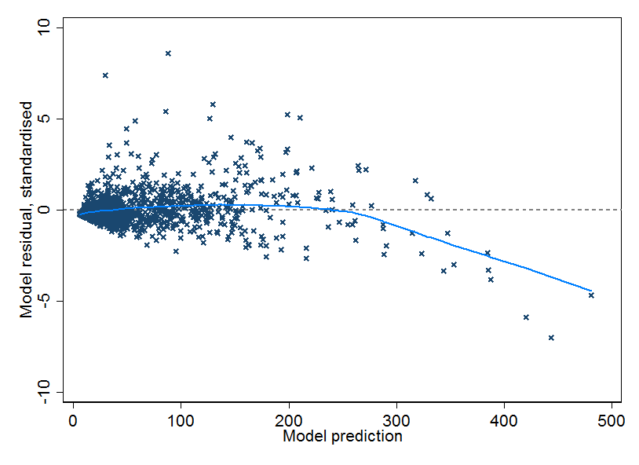

Alternative model - Poisson model with case-count outcome
An alternative model was developed using a Poisson approach, instead of negative binomial. The primary outcome was confirmed malaria case count, and the natural log of district population was included in the model with coefficient constrained to 1. The model included a random effects estimator. A one-month lag of the square root of the primary outcome indicator was included to account for autocorrelation, and all other covariates were included as in the main model as described previously.

The alternative Poisson model had an AIC of 22,413 and mean square error of 818. These can be compared with the final model AIC of 12,391 and mean square error of 883.

Figure 7 – Scatter plot of standardized residuals for alternative Poisson model against time (month), with y=0 reference line. Residuals are color-coded according to district.
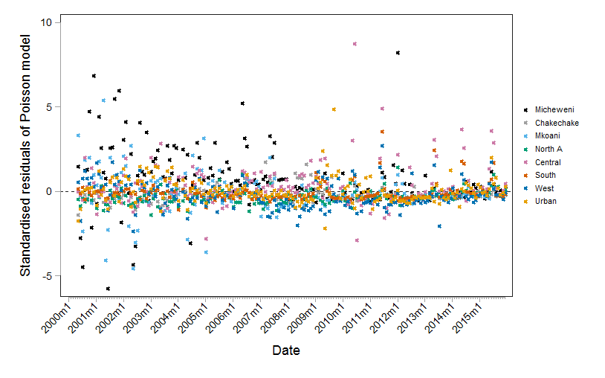

Figure 8 – Scatter plot of standardized residuals for alternative Poisson model against prediction value, with lowess smoothed trend line (solid) and y=0 reference line (dashed)
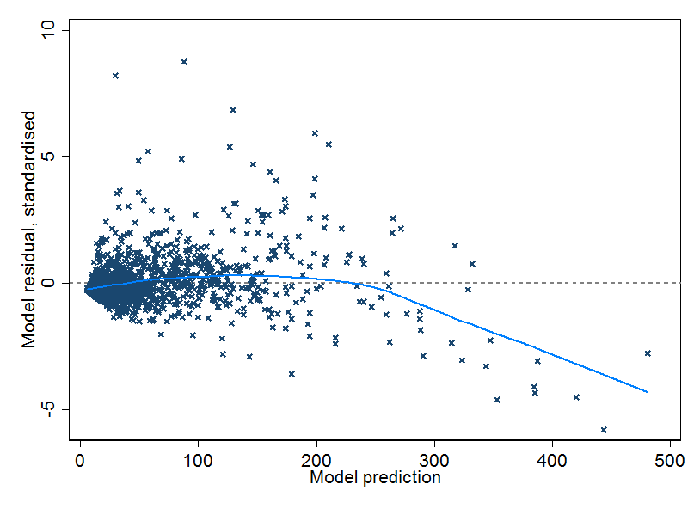

Figure 9 – Line plot of monthly confirmed malaria incidence observed across Zanzibar (gray line), and confirmed malaria incidence predicted by the alternative Poisson model (blue line)
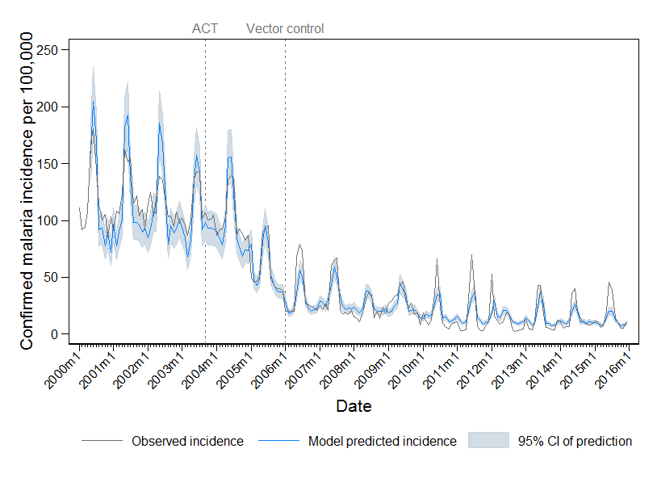

Figures 7 and 8 show the residuals for this model, and indicate that similar to negative binomial model, the Poisson model showed both under- and over-prediction during the pre-intervention period, with particularly large standardized residuals in Micheweni and Mkoani districts. The over-prediction during seasonal peaks in the pre-intervention period and under-prediction during seasonal peaks in the ACT+ VC+ period can be seen in Figure 9.

Table 5: Regression coefficients, 95% confidence intervals and z-statistic P value from alternative Poisson model; using a maximum likelihood random effects Poisson model with confirmed malaria case count as the primary outcome.
Variable | Coefficient | 95% CI | P value
Square root transformation of previous month’s confirmed malaria case count | 0.1315 | 0.1284, 0.1347 | <0.001
Number of health facilities reporting data | 0.0466 | 0.0402, 0.0531 | <0.001
All-cause OPD attendance | 0.00006 | 0.00005, 0.00006 | <0.001
Proportion of all OPD attendees receiving malaria parasitological test | 1.4765 | 1.3701, 1.5829 | <0.001
Month
January (base) | 1.00 | - | -
February | -0.1105 | -0.1497, -0.0712 | <0.001
March | -0.1536 | -0.1919, -0.1154 | <0.001
April | 0.0452 | 0.0083, 0.0820 | 0.016
May | 0.4686 | 0.4365, 0.5007 | <0.001
June | 0.3061 | 0.2737, 0.3386 | <0.001
July | 0.0983 | 0.0643, 0.1324 | <0.001
August | -0.2906 | -0.3275, -0.2537 | <0.001
September | -0.0333 | -0.0696, -0.0030 | 0.072
October | -0.1171 | -0.1541, -0.0800 | <0.001
November | -0.0289 | -0.0657, 0.0078 | 0.123
December | -0.0326 | -0.06936, 0.0041 | 0.081
Monthly rainfall anomaly compared to long-term mean (two month lag) | 0.0004 | 0.0002, 0.0006 | 0.001
Monthly anomaly in enhanced vegetation index compared to long-term mean, (one month lag) | 0.9495 | 0.6872, 1.2119 | <0.001
Anomaly in the month-mean of night-time minimum land surface temperature LST, compared to long-term mean (two month lag) | -0.0031 | -0.0094, 0.0035 | 0.358
Anomaly in the month-mean of daytime minimum land surface temperature LST, compared to long-term mean (one month lag) | -0.0215 | -0.0271, -0.0159 | <0.001
Dummy variable for Urban & West districts | -0.9020 | -1.1240, -0.6800 | <0.001
Dummy variable for South district | 1.0736 | 0.7817, 1.3656 | <0.001
Trend in confirmed malaria incidence (2000-2015) | -0.0033 | -0.0042, -0.0024 | <0.001
Intercept change at ACT introduction (September 2003) | 0.0553 | 0.0200, 0.0906 | 0.002
Change in trend after ACT | -0.0131 | -0.0152, -0.0109 | <0.001
Intercept change at vector control introduction (January 2006) | -0.3495 | -0.3927, -0.3062 | <0.001
Change in trend after vector control | 0.0087 | 0.0067, 0.0107 | <0.001
Intercept | -8.9510 | -9.0970, -8.8051 | <0.001

Generating counterfactuals to estimate cases averted
To estimate counterfactuals representing the expected malaria incidence in the absence of interventions, two approaches were used to adapt the model developed for ITS. Recall that the ITS model includes binary terms for ACT and vector control, and three time variables.

Counterfactual strategy 1: use an ITS model with level change only

To generate counterfactuals and estimate cases averted using strategy 1, the time variables were removed from the model, but binary variables for the interventions (and all other covariates included in the final ITS model) were retained. Therefore this model is the same negative binomial random effects model that was used for ITS, but with the terms $β_{1}T$, $β_{3}TA_{t}$ and $β_{5}TV_{t}$ removed..

The strategy 1 cases averted model therefore had the form:
$$Y_{t}= β_{0}+ β_{1}A_{t}+ β_{2}V_{t}$$
Where:
- $A_{t}$ : Binary variable for the ACT-only intervention (coded 0 from January 2000 to August 2003, and coded 1 from September 2003 to December 2015)
- $V_{t}$ : Binary variable for the ACT plus vector control intervention (coded 0 from January 2000 to December 2005, and coded 1 from January 2006 to December 2015).
- $β_{0}$ : Intercept at T=0
- $β_{1}$ : Intercept change after introduction of the ACT-only intervention
- $β_{2}$ : Intercept change after introduction of the ACT plus vector control intervention

The strategy 1 cases averted model was fitted and predictions generated for the true situation (ACT+ VC+). Coefficients from the fitted cases averted model for the true situation are shown in Table 6.

To generate a counterfactual for a situation where vector control was not introduced (ACT+ VC-), the vector control intervention binary term $V_{t}$ was set to equal 0 throughout the study, the model predictions generated using coefficients generated for the true situation model. To generate a counterfactual for absence of both interventions (ACT- VC-), both $V_{t}$ and $A_{t}$ were set to zero throughout the study, and model predictions generated using coefficients from the ACT+ VC+ model. The number of cases averted was estimated as the difference between the model prediction with both interventions, and the counterfactual model predictions where either vector control was absent, or where both ACTs and vector control were absent.

It should be noted that the adaption of the ITS model in this way removes the variables used to estimate changes in trends between the pre-intervention, ACT+ VC- and ACT+ VC+ periods, and therefore alters the fit of the model to the ACT+ VC+ scenario, compared to the ITS model (Figure 10). A ‘jump’ in count estimate can therefore be seen as a result of the level change in September 2003 and January 2006, particularly when compared to the full ITS model prediction.

Figure 10 – Line plot of monthly total confirmed malaria incidence per 100,000 population observed across Zanzibar (gray line), confirmed malaria incidence predicted by the ITS model (blue line), and confirmed malaria incidence predicted by the level-change only cases averted model (red line)
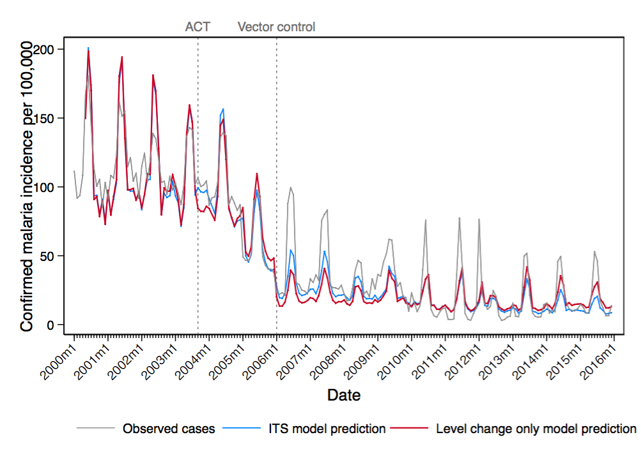

Table 6: Regression coefficients, 95% confidence intervals and z-statistic P value from the level-change only model including binary variables to reflect introduction of ACTs in September 2003 and vector control in January 2006. Cases averted were estimated from this model, by running model predictions using these coefficients for the full model, after setting the vector control binary variable to 0 (a counterfactual of no vector control, but ACT introduced in September 2003), and after setting both the vector control and ACT binary variables to 0 (counterfactual of no ACTs or vector control).
Variable | Coefficient | 95% CI | P value
Square root transformation of previous month’s confirmed malaria case count | 0.1416 | 0.1324, 0.1508 | <0.001
Number of health facilities reporting data | 0.0368 | 0.0204, 0.0533 | <0.001
All-cause OPD attendance | 0.00002 | 0.00000, 0.00004 | 0.049
Proportion of all OPD attendees receiving malaria parasitological test | 0.6952 | 0.3427, 1.0476 | <0.001
Month
January (base) | - | - | -
February | -0.1047 | -0.2326, 0.0232 | 0.109
March | -0.1359 | -0.2608, -0.0110 | 0.033
April | -0.0575 | -0.0635, 0.1785 | 0.352
May | 0.4443 | 0.3368, 0.5517 | <0.001
June | 0.2788 | 0.1721, 0.3855 | <0.001
July | 0.2788 | -0.0507, 0.1720 | 0.286
August | -0.3235 | -0.4427, -0.2044 | 0.011
September | -0.0577 | -0.1770, 0.0618 | 0.344
October | -0.1180 | -0.2386, -0.0026 | 0.055
November | -0.0470 | -0.1673, 0.0733 | 0.444
December | -0.0251 | -0.1439, 0.0937 | 0.679
Monthly rainfall anomaly compared to long-term mean (two month lag) | 0.0002 | -0.0006, 0.0010 | 0.592
Monthly anomaly in enhanced vegetation index compared to long-term mean, (one month lag) | 1.2553 | 0.4210, 2.0897 | 0.003
Anomaly in the month-mean of night-time minimum land surface temperature LST, compared to long-term mean (two month lag) | -0.0108 | -0.0322, 0.0106 | 0.322
Anomaly in the month-mean of daytime minimum land surface temperature LST, compared to long-term mean (one month lag) | -0.0246 | -0.0431, -0.0062 | 0.009
Dummy variable for Urban & West districts | -0.6889 | -0.8689, -0.5089 | <0.001
Dummy variable for South district | 1.1863 | 0.9536, 1.4191 | <0.001
ACT (introduced Sept 2003) | -0.1447 | -0.2114, -0.0780 | <0.001
Vector control (introduced January 2006) | -0.9215 | -1.0272, -0.8158 | <0.001
Intercept | -11.1979 | -11.4456, -10.9503 | <0.001

Figure 11 – Using the level-change only counterfactual model method, model-estimated confirmed malaria cases for the observed scenario of ACT and vector control (green line representing the mean prediction and shaded pale green area the 95% confidence interval), and model-estimated confirmed malaria cases for counterfactual scenario of ACTs but no vector control (blue line representing the mean prediction and shaded pale blue area the 95% confidence interval). Vertical dotted grey lines indicate the timing of introduction of ACT and vector control.
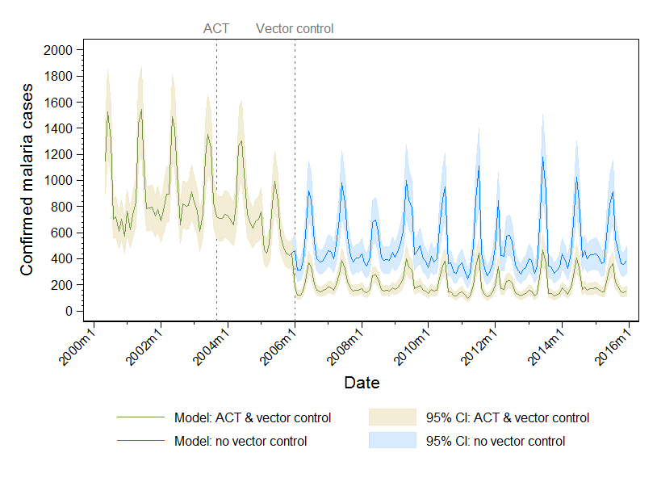

Figure 12 – Using the level-change only counterfactual model method, model-estimated confirmed malaria cases for the observed scenario of ACT and vector control (green line representing the mean prediction and shaded pale green area the 95% confidence interval), and model-estimated confirmed malaria cases for counterfactual scenario of no ACT or vector control (mean prediction indicated by red line and shaded red area the 95% confidence interval). Vertical dotted grey lines indicate the timing of introduction of ACT and vector control.
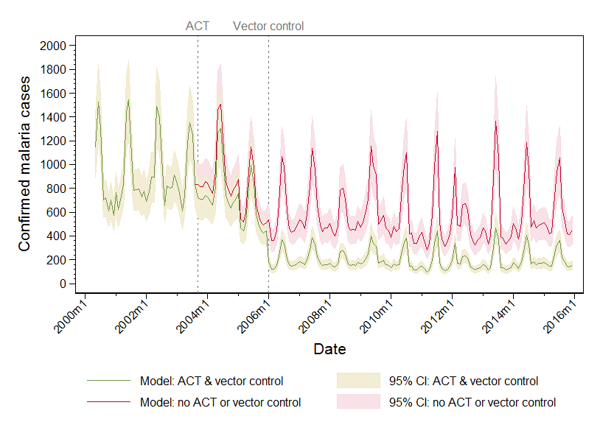

Table 7. Estimated number of confirmed malaria cases averted in eight districts of Zanzibar due to interventions, using counterfactual strategy 1. Data presented include model-predicted confirmed cases count occurring when both ACTs and vector control (ACT+ VC+) were in introduced in September 2003 and January 2006, respectively. Model predictions for alternative scenarios where ACTs were introduced but vector control was not (ACT+ VC-) and where neither intervention were introduced (ACT- VC-) are presented.

Year | Role of ACT & vector control |  |  |  | Role of vector control
 | # Confirmed malaria cases, ACT+ VC+ | Counterfactual: # Confirmed malaria cases, ACT- VC- | Cases averted by ACT & VC |  | # Confirmed malaria cases, ACT+ VC+ | Counterfactual: # Confirmed malaria cases, ACT+ VC- | Cases averted by VC
2000 | 7290 | 7290 | 0 |  | 7290 | 7290 | 0
2001 | 10885 | 10885 | 0 |  | 10885 | 10885 | 0
2002 | 11188 | 11188 | 0 |  | 11188 | 11188 | 0
2003 | 10454 | 10902 | 448 |  | 10454 | 10454 | 0
2004 | 9273 | 10716 | 1443 |  | 9273 | 9273 | 0
2005 | 7208 | 8330 | 1122 |  | 7208 | 7208 | 0
2006 | 2359 | 6850 | 4491 |  | 2359 | 5927 | 3568
2007 | 2593 | 7531 | 4938 |  | 2593 | 6516 | 3923
2008 | 2222 | 6454 | 4232 |  | 2222 | 5584 | 3362
2009 | 2716 | 7888 | 5172 |  | 2716 | 6825 | 4109
2010 | 2238 | 6500 | 4262 |  | 2238 | 5624 | 3386
2011 | 2139 | 6214 | 4075 |  | 2139 | 5377 | 3238
2012 | 2174 | 6315 | 4141 |  | 2174 | 5464 | 3290
2013 | 2342 | 6801 | 4459 |  | 2342 | 5885 | 3543
2014 | 2491 | 7236 | 4745 |  | 2491 | 6261 | 3770
2015 | 2427 | 7049 | 4622 |  | 2427 | 6100 | 3673

Counterfactual strategy 2: use an ITS model with both level and trend change

In this method to generate counterfactuals and estimate cases averted, the time variables were retained in the model, but binary variables for the interventions (and all other covariates included in the final ITS model) were retained.

The model for this second strategy to estimate cases averted had the form:

$$Y_{t}= β_{0}+ β_{1}T+ β_{2}A_{t}+ β_{3}TA_{t}+ β_{4}V_{t}+ β_{5}TV_{t}$$
Where:
- $Y_{t}$ : Outcome (confirmed malaria case count in district and month)
- $T$ : Time in months elapsed since the start of the study
- $A_{t}$ : Binary variable for the ACT-only intervention (coded 0 from January 2000 to August 2003, and coded 1 from September 2003 to December 2015)
- $V_{t}$ : Binary variable for the ACT plus vector control intervention (coded 0 from January 2000 to December 2005, and coded 1 from January 2006 to December 2015).
- $β_{0}$ : Intercept at T=0
- $β_{1}$ : Baseline trend during the pre-intervention period (January 2000 to August 2003)
- $β_{2}$ : Intercept change after introduction of the ACT-only intervention
- $β_{3}$ : Change in trend after introduction of the ACT-only intervention, compared to the pre-intervention period
- $β_{4}$ : Intercept change after introduction of the ACT plus vector control intervention
- $β_{5}$ : Change in trend after introduction of the ACT plus vector control intervention, compared to the ACT-only intervention period

The cases averted model was fitted and predictions generated for the true situation (ACT+ VC+). Coefficients from the fitted cases averted model for the true situation are shown in Table 8.

To generate a counterfactual for a situation where vector control was not introduced (ACT+ VC-), the vector control intervention binary term $V_{t}$ was set to equal 0 throughout the study, the model predictions generated using coefficients generated for the true situation model. To generate a counterfactual for absence of both interventions (ACT- VC-), both $V_{t}$ and $A_{t}$ were set to zero throughout the study, and model predictions generated using coefficients from the ACT+ VC+ model. The number of cases averted was estimated as the difference between the model prediction with both interventions, and the counterfactual model predictions where either vector control was absent, or where both ACTs and vector control were absent.

It should be noted that generation of counterfactuals from this ITS model will assume that trends for the previous period will continue indefinitely. For example, to estimate the counterfactual for no vector control, the trend during the ACT-only period will be projected forward for the rest of the time period. This assumption may not be appropriate, since biological systems tend to eventually reach an equilibrium, rather than continuing to increase or decrease in outcome indefinitely.

Table 8: Regression coefficients, 95% confidence intervals and z-statistic P value from the full ITS model (level- and trend-change) including binary variables to reflect introduction of ACTs in September 2003 and vector control in January 2006. Cases averted were estimated from this model, by running model predictions using these coefficients for the full model, after setting the vector control binary variable to 0 (a counterfactual of no vector control, but ACT introduced in September 2003), and after setting both the vector control and ACT binary variables to 0 (counterfactual of no ACTs or vector control).

Variable | Coefficient | 95% CI | P value
Square root transformation of previous month’s confirmed malaria case count | 0.1289 | 0.1195, 0.1382 | <0.001
Number of health facilities reporting data | 0.0464 | 0.0297, 0.0631 | <0.001
All-cause OPD attendance | 0.00003 | 0.00001, 0.00005 | 0.004
Proportion of all OPD attendees receiving malaria parasitological test | 0.9101 | 0.5963,1.2239 | <0.001
Month
January (base) | - | - | -
February | -0.0631 | -0.1852, 0.0591 | 0.312
March | -0.1145 | -0.2338, -0.0047 | 0.060
April | -0.0707 | -0.0447, 0.1861 | 0.230
May | 0.4743 | 0.3721, 0.5766 | <0.001
June | 0.3385 | 0.2361, 0.4409 | <0.001
July | 0.1514 | 0.0447, 0.2582 | 0.005
August | -0.2528 | -0.3674, 0.1381 | <0.001
September | -0.0233 | -0.1372, 0.0906 | 0.688
October | -0.0787 | -0.1936,0.0362 | 0.179
November | -0.0046 | -0.1192, 0.1099 | 0.937
December | -0.0191 | -0.0944, 0.1326 | 0.742
Monthly rainfall anomaly compared to long-term mean (two month lag) | 0.0002 | -0.0005, 0.0010 | 0.500
Monthly anomaly in enhanced vegetation index compared to long-term mean, (one month lag) | 0.8855 | 0.0750, 1.6960 | 0.032
Anomaly in the month-mean of night-time minimum land surface temperature LST, compared to long-term mean (two month lag) | -0.0095 | -0.0301, 0.0111 | 0.367
Anomaly in the month-mean of daytime minimum land surface temperature LST, compared to long-term mean (one month lag) | -0.0220 | -0.0395, -0.0045 | 0.014
Dummy variable for Urban & West districts | -0.7471 | -0.9139, -0.5675 | <0.001
Dummy variable for South district | 1.1016 | 0.8775, 1.3256 | <0.001
Trend in confirmed malaria incidence (2000-2015) | -0.0025 | -0.0053, 0.0004 | 0.089
Intercept change at ACT introduction (September 2003) | 0.0779 | -0.0330, 0.1888 | 0.169
Change in trend after ACT | -0.0135 | -0.0201, -0.0069 | <0.001
Intercept change at vector control introduction (January 2006) | -0.3821 | -0.5161, -0.2480 | <0.001
Change in trend after vector control | 0.0087 | 0.0025, 0.0149 | 0.006
Intercept | -11.0355 | -11.2962, -10.7748 | <0.001

Figure 13 – Using the level- and trend-change counterfactual model method, model-estimated confirmed malaria cases for the observed scenario of ACT and vector control (green line representing the mean prediction and shaded pale green area the 95% confidence interval), and model-estimated confirmed malaria cases for counterfactual scenario of ACTs but no vector control (blue line representing the mean prediction and shaded pale blue area the 95% confidence interval). Vertical dotted grey lines indicate the timing of introduction of ACT and vector control.
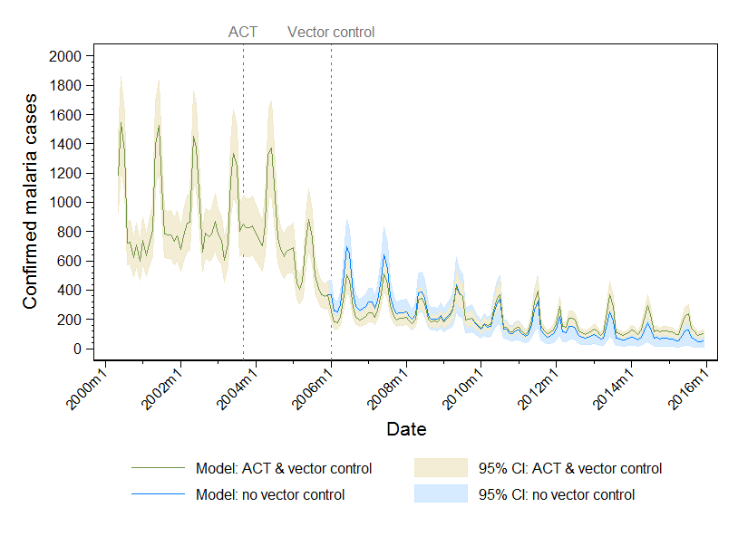

Figure 14 – Using the level- and trend-change counterfactual model method, model-estimated confirmed malaria cases for the observed scenario of ACT and vector control (green line representing the mean prediction and shaded pale green area the 95% confidence interval), and model-estimated confirmed malaria cases for counterfactual scenario of no ACT or vector control (mean prediction indicated by red line and shaded red area the 95% confidence interval). Vertical dotted grey lines indicate the timing of introduction of ACT and vector control.
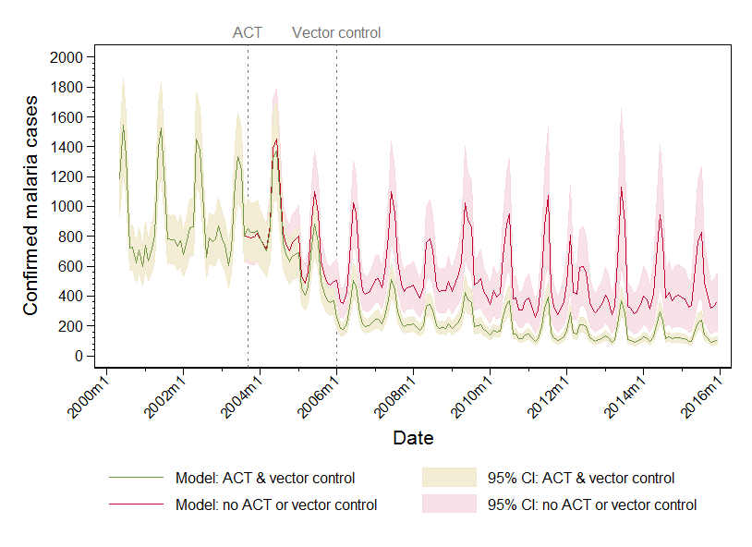

Table 9. Estimated number of confirmed malaria cases averted in Zanzibar due to interventions, using counterfactual strategy 2. Data presented include model-predicted confirmed cases count occurring when both ACTs and vector control (ACT+ VC+) were in introduced in September 2003 and January 2006, respectively. Model predictions for alternative scenarios where ACTs were introduced but vector control was not (ACT+ VC-) and where neither intervention were introduced (ACT- VC-) are presented.

Year | Role of ACT & vector control |  |  |  | Role of vector control
 | # Confirmed malaria cases, ACT+ VC+ | Counterfactual: # Confirmed malaria cases, ACT- VC- | Cases averted by ACT & VC |  | # Confirmed malaria cases, ACT+ VC+ | Counterfactual: # Confirmed malaria cases, ACT+ VC- | Cases averted by VC
2000 | 7456 | 7456 | 0 |  | 7456 | 7456 | 0
2001 | 10793 | 10793 | 0 |  | 10793 | 10793 | 0
2002 | 10947 | 10947 | 0 |  | 10947 | 10947 | 0
2003 | 10725 | 10580 | -145 |  | 10725 | 10725 | 0
2004 | 9578 | 10227 | 649 |  | 9578 | 9578 | 0
2005 | 6391 | 7967 | 1576 |  | 6391 | 6391 | 0
2006 | 3233 | 6595 | 3362 |  | 3233 | 4480 | 1247
2007 | 3406 | 7354 | 3948 |  | 3406 | 4259 | 853
2008 | 2736 | 6260 | 3524 |  | 2736 | 3079 | 343
2009 | 2970 | 7191 | 4221 |  | 2970 | 3016 | 46
2010 | 2278 | 5844 | 3566 |  | 2278 | 2084 | -194
2011 | 2012 | 5473 | 3461 |  | 2012 | 1656 | -356
2012 | 1918 | 5508 | 3590 |  | 1918 | 1432 | -486
2013 | 1875 | 5716 | 3841 |  | 1875 | 1255 | -620
2014 | 1808 | 5843 | 4035 |  | 1808 | 1088 | -720
2015 | 1615 | 5528 | 3913 |  | 1615 | 876 | -739

References

1. National Bureau of Statistics (NBS), ORC Macro. Tanzania Demographic and Health Survey 2004-05. Dar es Salaam, Tanzania: Natinal Bureau of Statistics and ORC Macro, 2005.
2. Tanzania Commission for AIDS, Zanzibar AIDS Commission, National Bureau of Statistics, Office of Chief Government Statistician, Macro International Inc. Tanzania HIV/AIDS and Malaria Indicator Survey 2007-08. Dar es Salaam, Tanzania: TACAIDS, ZAC, NBS, OCGS, and Macro International Inc., 2008.
3. National Bureau of Statistics Tanzania, ICF Macro. Tanzania Demographic and Health Survey 2010. Dar es Salaam, Tanzania: NBS and ICF Macro, 2011.
4. Tanzania Commission for AIDS, Zanzibar AIDS Commission, National Bureau of Statistics, Office of Chief Government Statistician, ICT International. Tanzania HIV/AIDS and Malaria Indicator Survey 2011-12. Dar es Salaam, Tanzania: TACAIDS, ZAC, NBS, OCGS and ICF International, 2013.
5. Ministry of Health CD, Gender, Elderly and Children (MoHCDGEC) [Tanzania Mainland],, Ministry of Health (MoH) [Zanzibar], National Bureau of Statistics (NBS), Office of the Chief Government Statistician (OCGS), ICF International. Tanzania Demographic and Health Survey and Malaria Indicator Survey (TDHS-MIS) 2015-16. Dar es Salaam, Tanzania, and Rockville, Maryland, USA, 2016.
6. Wagner AK, Soumerai SB, Zhang F, Ross-Degnan D. Segmented regression analysis of interrupted time series studies in medication use research. J Clin Pharm Ther 2002; 27(4): 299-309.
7. Lopez Bernal J, Cummins S, Gasparrini A. Interrupted time series regression for the evaluation of public health interventions: a tutorial. Int J Epidemiol 2016.
8. Shadish WR, Cook TD, Campbell DT. Experimental and quasi-experimental designs for generalized causal inference. Belmont, CA: Wadsworth Cengage Learning; 2002.

