Additional file 1: Fixed methods model distribution of two compartments for calculation of cut off values
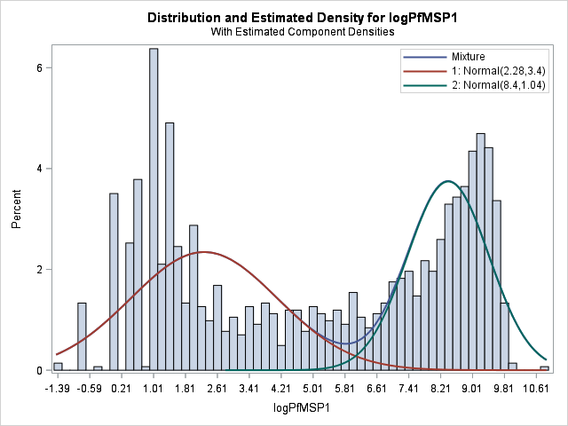 | 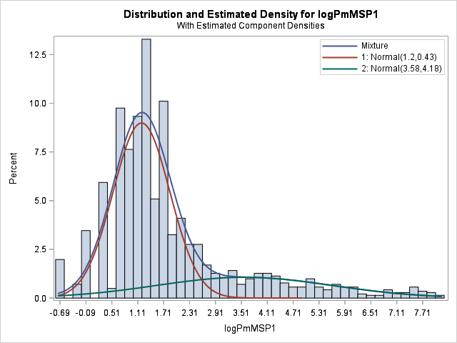
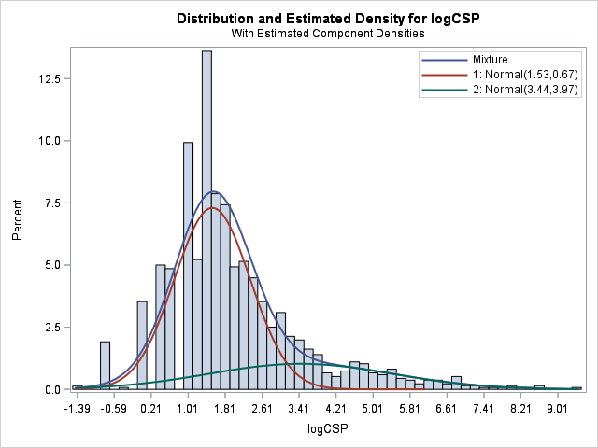 | 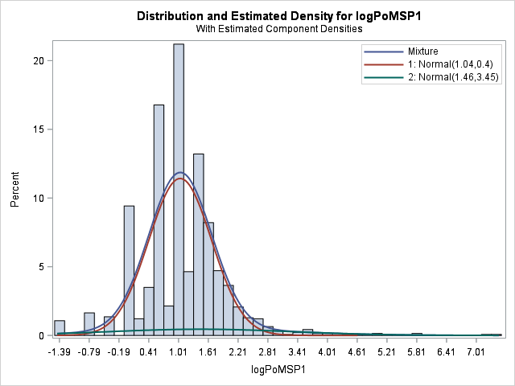
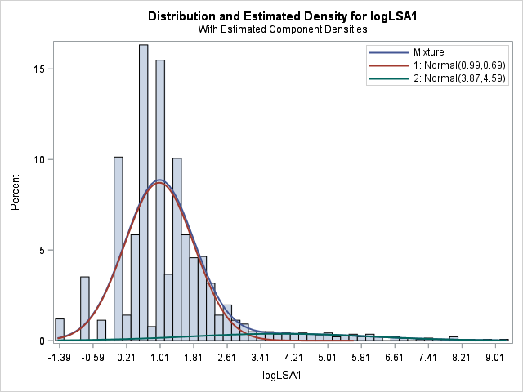 | 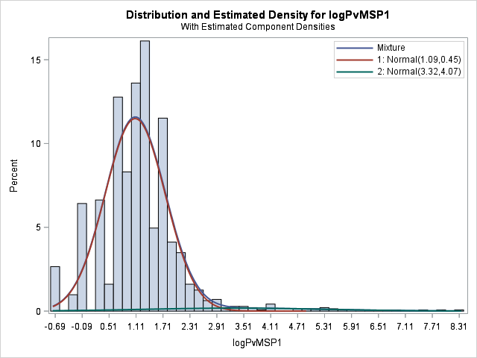

 | Mean | Standard deviation | Mean + 3SD | Cut-off
PfMSP1 | 2.28 | 1.84 | 6.2* | 493
PmMSP1 | 1.20 | 0.66 | 3.17 | 24
PoMSP1 | 1.04 | 0.63 | 2.94 | 19
PvMSP1 | 1.09 | 0.67 | 3.10 | 22
LSA1 | 0.99 | 0.83 | 3.47 | 32
CSP | 1.53 | 0.82 | 3.99 | 54
*Cut off determined visually
‘Mean’ is for log-transformed MFI-bg values
‘cutoff ‘ as exponentiated back to linear scale

