**Quantitative Bias Analysis**

**Methods**

Using an Excel spreadsheet (available at <https://sites.google.com/site/biasanalysis/>), we conducted a multidimensional quantitative bias analysis (Lash et al., 2009). We selected the crude comparison of daily periconceptional folic acid supplementation versus no supplementation among the high risk group with a neural tube defect family history as the application. We conducted the analysis for differential misclassification (recall bias) under three scenarios:

Scenario 1: Control mothers reported daily folic acid supplementation status less accurately than the case mothers. We assumed these were random errors with an equal degree of misclassification among supplementers and non-supplementers. In other words, sensitivity and specificity were equal within each outcome group, but the controls were consistently worse.

Scenario 2: The control mothers who used supplements daily reported their supplement use correctly but some of the control mothers who did not use supplements reported that they did (a plausible scenario if the mother is aware that folic acid supplements are recommended before and during pregnancy); case mothers accurately reported their supplementation status. Specificity is <100% only among the control mothers.

Scenario 3: The case mothers who used supplements daily reported their supplement use correctly but some of the case mothers who did not use supplements reported that they did; controls accurately reported their supplementation status. Specificity is <100% only among the cases.

For the scenarios that had imperfect specificity among the controls, our first scenario used a specificity of 80% among the controls and then reduced it further in the other simulations. For the scenarios with imperfect specificity among the cases we started with 95% and then reduced it further in the other simulations. For all scenarios, we reduced specificity by 5% in each simulation until we encountered an implausible ‘corrected’ scenario with zero individuals in one of the cells of the contingency table.

**Results**

Scenario 1: The results of this bias analysis showed that a correction of this bias, were it to exist in our data, resulted in estimates that suggested stronger associations than observed in the original analysis.

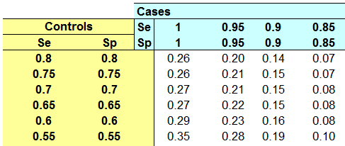

Scenario 2: Here, all ‘corrected’ estimates were attenuated compared to those observed in the original analysis. However, we found that at least 30% of the control mothers who did not actually supplement with folic acid would need to misreport as daily supplementers for the attenuation to be substantial.

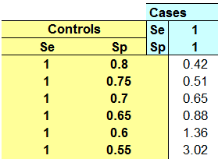

Scenario 3: All ‘corrected’ estimates suggested stronger associations than observed in the original analysis.

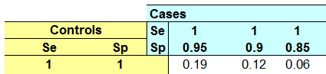

**Reference**

Lash, T.L., Fox, M.P., Fink, A.K. (2009) Applying Quantitative Bias Analysis to Epidemiologic Data. Verlag, New York: Springer.