Sfigure1
Fig. 1A. qRT-PCR results on detecting the knockdown efficiency of the pre-designed siRNA pool (1x = 30 pmol totally per 6-cm dish); mock-siRNA represents the si-Scrambled; Error bars represent ± SD for triplicate experiments. *: p <0.05; ***: p < 0.001
Fig. 1B. Quantification of EdU-positive cell numbers after 12-hour EdU incubation with indicated treatments. siRNA treatment concentration is 90 pmol per 6-cm dish. Student’s t test was performed on indicated treatment groups. Error bars represent ± SD for triplicate experiments.
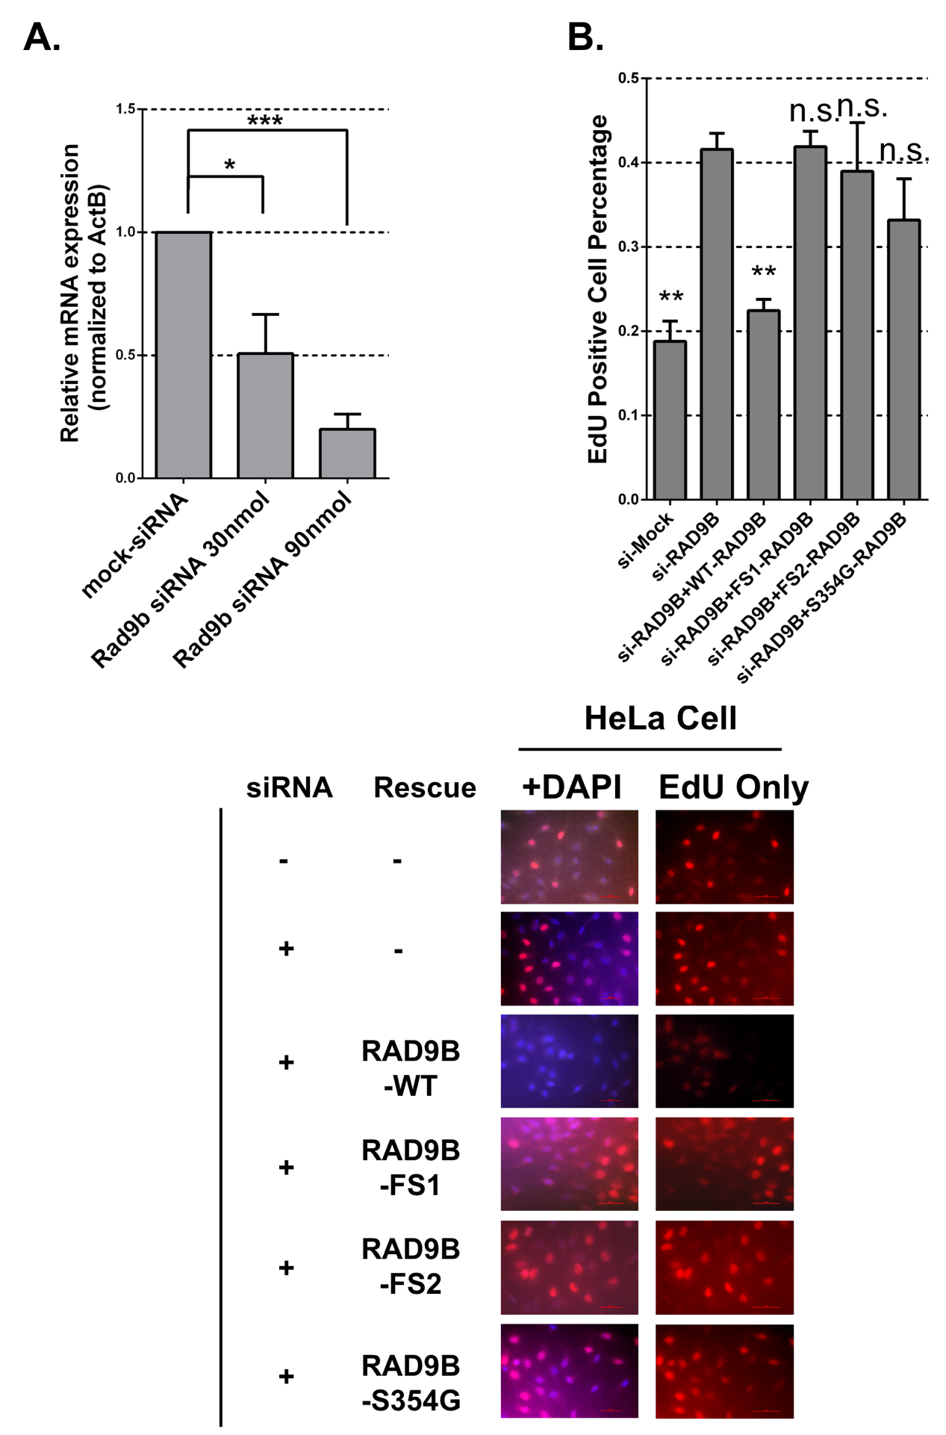
Sfigure2:
Fig. 2A. Rad9B siRNA knockdown efficiency in hESC cells. 1X = 15 pmol per 6-well dish.
Fig. 2B, C. Loss of Rad9B and abnormally accelerated neuroectoderm differentiation. Flow data for siRad9B treated ES cells, displaying TUBB3 positive and Peripherin positive cell population. TUBB3: anti-TUBB3; Peripherin: anti-Peripherin. *: p < 0.05. Chi-square test on si-Scrambled versus si-3X for two markers all show significant difference: two-tailed p < 0.0001.

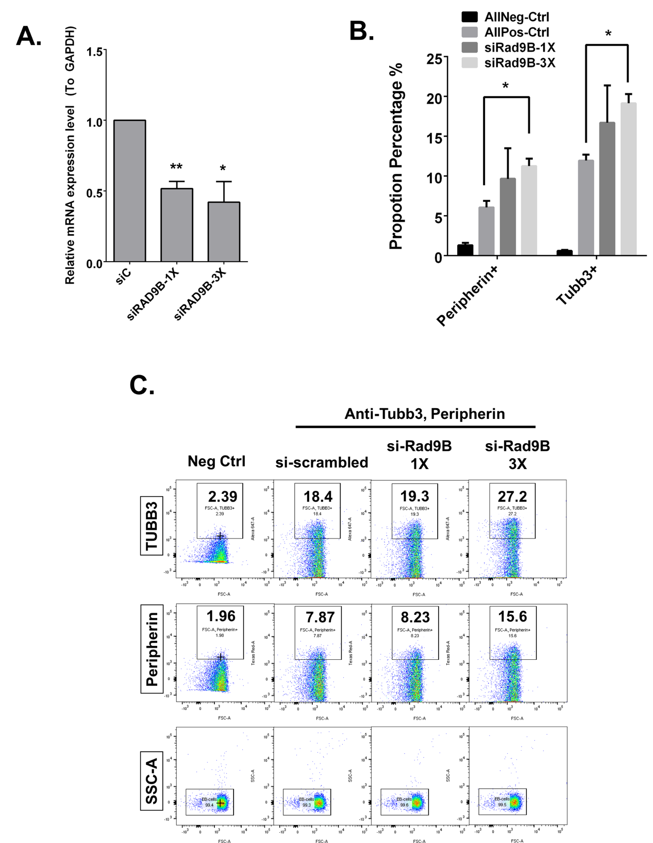
Sfigure3
Fig. 3A. Loss of Rad9B impairs neural stem cell population establishment. Scheme for neural cell and neural stem cell culture and staining experiments.

Fig. 3B. Day 21 Pax mRNA qPCR results. ** p < 0.01
Fig. 3C. Immunofluorescent assay showed siRad9B treatment impaired ‘axon-like’ structure formation. Scale bar = 50 µm; Tuj1: marker for neuron-specific Class III β-tubulin. DAPI: nuclei marker. siRad9B treatment amount = 45 pmol per 6-well dish culture. Two parallel experiments are performed; each experiment has triplicate wells for staining.

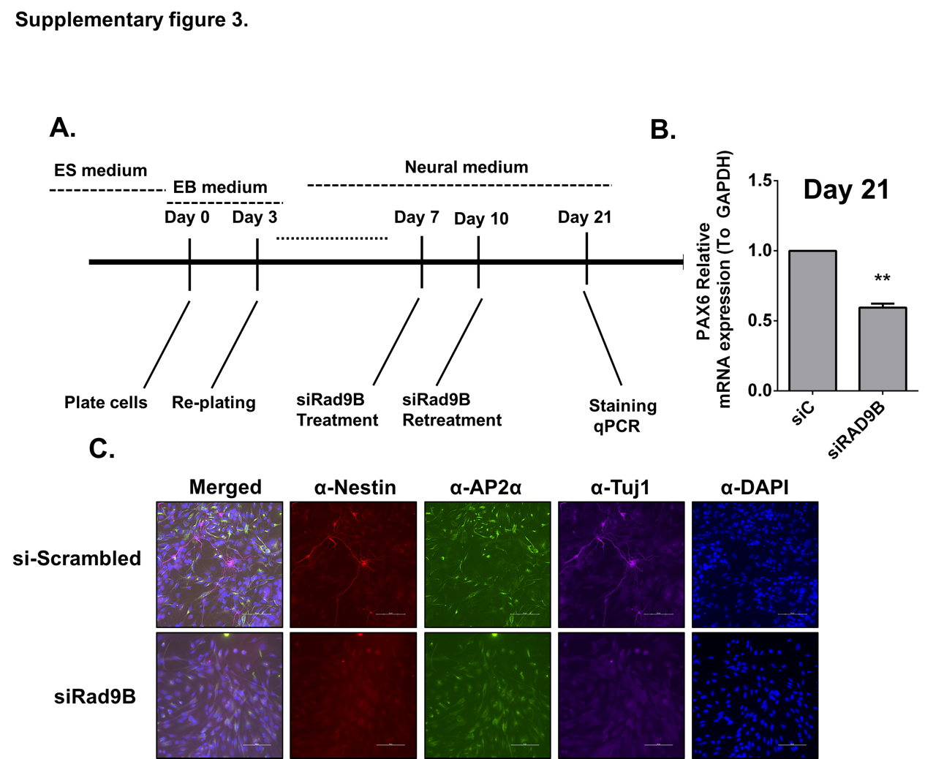
Sfigure4
Fig. 4A. RAD9B mRNA level detected in RNA-seq.
Fig. 4B. Gene set enrichment analysis for mostly enriched gene sets plotted by enrichment of gene expression in siRAD9B transfected cells compared with si-Control-treated cells.
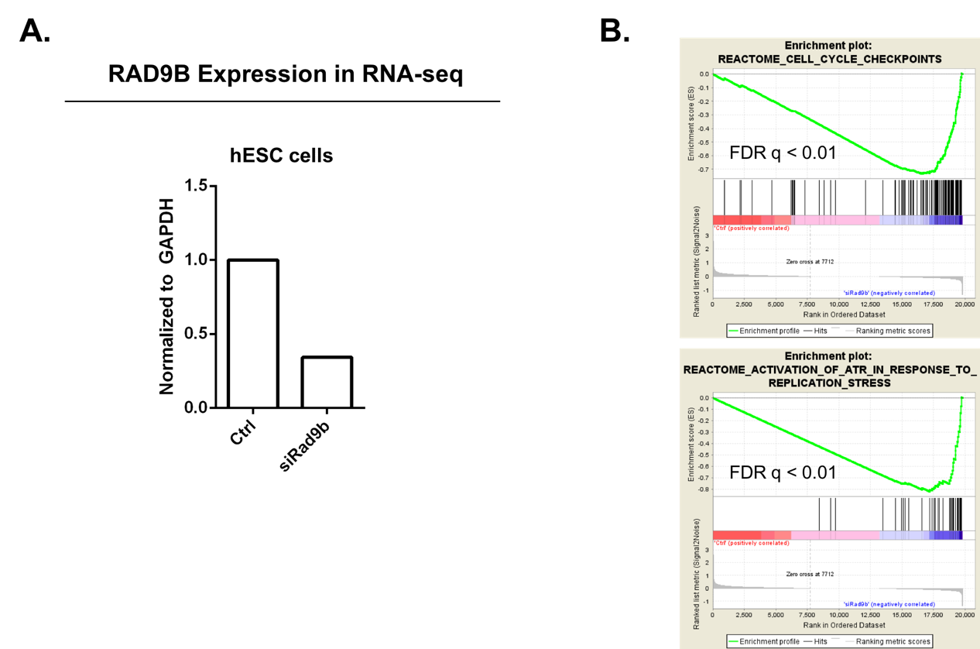
Stable1 RAD9B PCR and Sequencing Primer list
Sequence Name | Bases | Sequence
rad9b-exon1-f | 21 | GAG GGA GAC AGA AAT TGC CGT
rad9b-exon1-r | 20 | CCG CTC CAC CTT TCA CCT GA
rad9b-exon3-f | 20 | GGC TTC CAT CCA TCC TCC TG
rad9b-exon3-r | 33 | GCC ATT TAA ACT ATT AAG TAT AGA ATA CAG GTT
rad9b-exon4-f | 31 | TCA ACC ATG TTA AGT ATG TGC TTA ATA TGT A
rad9b-exon4-r | 32 | GTA ACG AGA AAT CTT GAC ATG AAA TAT CAA TG
rad9b-exon5-f | 34 | TAT TAC TTT AAT TTG GCT GTG AAA CTT AAA GAC T
rad9b-exon5-r | 25 | GAA AAG CTC TAG GGC ATT GAT TCT T
rad9b-exon6-f | 29 | TTG AGT CCC AGT TAA TAA GGT ATG TCT TT
rad9b-exon6-r | 31 | TTA TGT CAC TAA TAT TTG CAG TAT GGT TAG T
rad9b-exon78-f | 21 | GGA AAT GGG ATG GGA TTT GGG
rad9b-exon78-r | 30 | AGG TAT TCC TGA GGT GTT AAT TAA TTT CAA
rad9b-exon9-f | 25 | CAT CAG AAA ATG AGT GTC ACT GTT G
rad9b-exon9-r | 26 | GGT GAT GTT TCT ATG CTA CAG GTA AG
rad9b-exon10-f | 32 | CCA TGT ATT TCA ATA TAT TCC CTA ATC CAG TG
rad9b-exon10-r | 20 | GGA TTG GGG AGG AAG ACT GC
rad9b-exon11-f | 23 | TTG GAA TCA ACA ATG CAG TTC CT
rad9b-exon11-r | 30 | CAT AAT GGA TTT AAA GCA AGT TAC ATA CAC
rad9b-exon12-f | 28 | CCT CAA ATT GTT CTG ATT TTC AGA TGT G
rad9b-exon12-r | 25 | CTC ATT ACT AAG CTA CAA GAG CCA A
rad9B-exon2-f | 27 | GGG AAA GAA TAT AAG CAT CAC CTT TCT
rad9B-exon2-r | 28 | CCA TGC TCT AAG TGT ATT CAG ATA TGT A

Stable2 Summary table of submission on ClinVar
Submission ID | Submission name | Accession | Status | Submitter name | Reports | Release date | Created date | Action
SUB6475355 | SUB6475355 |  | Queued | XUANYE CAO | No summary yet |  | Oct 28, 2019
SUB6475345 | SUB6475345 |  | Queued | XUANYE CAO | No summary yet |  | Oct 28, 2019
SUB6475323 | SUB6475323 |  | Queued | XUANYE CAO | No summary yet |  | Oct 28, 2019
SUB6475184 | SUB6475184 |  | Queued | XUANYE CAO | No summary yet |  | Oct 28, 2019
SUB6475104 | SUB6475104 |  | Queued | XUANYE CAO | No summary yet |  | Oct 28, 2019
SUB6475102 | SUB6475102 |  | Queued | XUANYE CAO | No summary yet |  | Oct 28, 2019
SUB6475098 | SUB6475098 |  | Queued | XUANYE CAO | No summary yet |  | Oct 28, 2019
SUB6475089 | SUB6475089 |  | Queued | XUANYE CAO | No summary yet |  | Oct 28, 2019

