Supplemental Table 1. Description of biomarkers used in TruCulture assay. Bold indicates biomarker showed sufficient response after stimulation to include in modeling analysis.
Biomarker name | Abbreviation | Biomarker description
Alpha-1-antitrypsin | AAT | Liver protein that blocks the destructive effects of certain enzymes
Alpha-2-macroglobulin | A2Macro | Major plasma protein; functions include ion transport, carrier protein, and proteinase inhibition
Beta-2-microglobulin | B2M | Protein found on surface of all nucleated cells, shed into blood particularly by tumor cells and lymphocytes
Brain-derived neurotrophic factor | BDNF | Protein found in neurons, helping support their survival & genesis
C-reactive protein | CRP | Acute phase protein related to inflammatory diseases, infections, and neoplastic diseases
Complement C3 | C3 | Immune system protein involved in activating complement system
Eotaxin-1 | Eotaxin | Protein produced by epithelial & endothelial cells and eosinophils, whose expression is enhanced in allergic inflammation
Factor VII | FactorVII | Protein involved in blood coagulation cascade
Ferratin | FRTN | Protein reflecting iron stores in body or elevated in inflammation
Fibrinogen | Fibrinogen | Plasma glycoprotein involved in coagulation; high levels associated with cardiovascular disease (CVD) and stroke.
Granulocyte-macrophage colony-stimulating factor | GM_CSF | Cytokine that controls granulocytes & macrophages in hematopoiesis
Haptoglobin | Haptoglobin | Acute phase protein that binds free hemoglobin in blood
Intercellular adhesion molecule 1 | ICAM1 | Cell surface receptor involved in inflammation, CVD, & diabetes
Interferon gamma | IFNγ | Cytokine involved in delayed type hypersensitivity & inflammation
Interleukin-1 alpha | IL1α | Immuno-modulator that mediates a wide range of inflammatory responses
Interleukin-1 beta | IL1β | Immuno-modulator that mediates a wide range of inflammatory responses
Interleukin-1 receptor agonist | IL1ra | Protein that acts as an IL-1 inhibitor; balance plays role in inflammation
Interleukin-2 | IL2 | Central regulator of immune response; role in anti-inflammatory reactions
Interleukin-3 | IL3 | Protein produced by T-cells following activation by antigens or leukocytes
Interleukin-4 | IL4 | Produced by T-cells and most biologically active helper cells for B-cells
Interleukin-5 | IL5 | Growth factor responsible for growth & differentiation of eosinophils
Interleukin-6 | IL6 | Cytokine released in response to stimuli & in inflammation or infection
Interleukin-7 | IL7 | Stimulates proliferation of B cells; supports megakaryocyte maturation
Interleukin-8 | IL8 | Chemokine produced by macrophages that attracts other leukocytes
Interleukin-10 | IL10 | Produced by Th1 & Th2 cells; antagonist of IFNγ
Interleukin-12 subunit p40 | IL12p40 | Produced by B-cells in response to bacteria & parasites; also show tumor-inhibitory properties
Interleukin-12 subunit p70 | IL12p70
Interleukin-15 | IL15 | Stimulates T-cell proliferation; similar to IL2
Interleukin-17 | IL17 | Recruits monocytes & neutrophils to inflammation sites
Interleukin-18 | IL18 | Pro-inflammatory cytokine produced by macrophages & other leukocytes
Interleukin-23 | IL23 | Produced by dendritic cells & macrophages; important in inflammation
Macrophage inflammatory protein-1 alpha | MIP1α | Produced by macrophages in response to bacterial endotoxins; involved in activation of granulocytes; induce synthesis of cytokines IL1, IL6 & TNF
Macrophage inflammatory protein-1 beta | MIP1β
Matrix metalloproteinase-3 | MMP3 | Degrades extracellular matrix substrates & inactivates proteinase inhibitors
Matrix metalloproteinase-9 | MMP9 | Degrades proteins in extracellular matrix & activates growth factors
Monocyte chemotactic protein 1 | MCP1 | Helps recruit monocytes to sites of injury & infection
Stem cell factor | SCF | Induces differentiation in lymphoid & erythroid progenitor cells & mast cells
T-cell-specific protein RANTES | RANTES | Chemotactic protein for T-cells & granulocytes; recruits leukocytes
Tissue inhibitor of metalloproteinases 1 | TIMP1 | Involved in biosynthesis of connective tissue; complexes with MMPs
Tumor necrosis factor alpha | TNFα | Secreted by macrophages; can induce cell death of some tumor cell lines
Tumor necrosis factor beta | TNFβ | Produced by T-lymphocytes, cytotoxic for a wide range of tumor cells
Tumor necrosis factor receptor 2 | TNFR2 | Neutralizes the biological activity of TNFα and TNFβ
Vascular cell adhesion molecule-1 | VCAM1 | Supports adhesion of leukocytes; has role in inflammatory immune response
Vascular endothelial growth factor | VEGF | Induces endothelial cells; inhibits apoptosis; induces permeability of vessels
Vitamin D-binding protein | VDBP | Protein in plasma & other tissues that carries vitamin D sterols
von Willebrand factor | vWF | Acute phase reactant; promotes adhesion of platelets to vascular injury sites

*Description source: https://myriadrbm.com/products-services/humanmap-services/humanmap/

Supplemental Table 2. Model parameter estimates for Box-Cox transformed biomarker ratios with demographic, occupational, and carbon nanotube or nanofiber (CNT/F) metrics
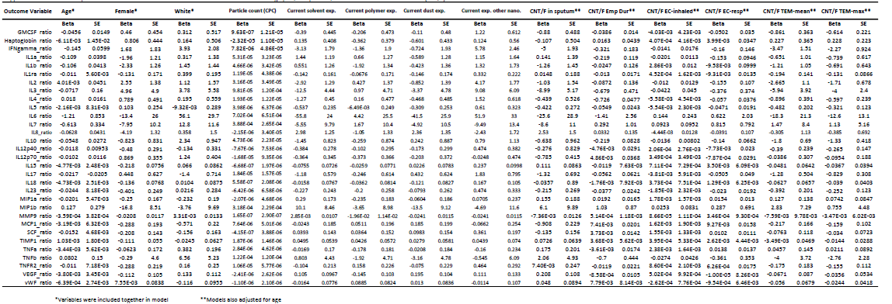
Supplemental Fig. 1. Most significant canonical pathway of effects related to TEM-max. The pathway, role of cytokines in mediating communication between immune cells, illustrates a general suppression of cytokine production (green color indicates reduced levels with increasing TEM-max) of circulating leukocytes following a secondary challenge. Of note, the effects appear to be generalized and not related to any specific cell population.

