Supplemental Table 1 Plasma and red blood cell (RBC) folate concentrations and correlation coefficients for the intervention group (by baseline and 6 months), stratified by folic acid dosage, genotype and BMI¹
 | Baseline (Month 0) |  |  |  |  |  |  |  | Month 6
 | n |  | Plasma folate concentration (nmol/L)^{2,3} |  | RBC folate concentration (nmol/L)^{2,3} |  | Correlation coefficient⁴ |  | n | Plasma folate concentration (nmol/L)^{2,3} | RBC folate concentration (nmol/L)^{2,3} | Correlation coefficient⁴
All | 1108 |  | 9.7  (4.7, 24.1) |  | 600  (272, 1272) |  | 0.46 |  | 977 | 29.4  (8.0, 107.5) | 968  (388, 2585) | 0.67
Folic acid dosage
100 μg/day | 368 |  | 9.6  (4.6, 24.3) |  | 589  (249, 1208) |  | 0.39 |  | 330 | 20.3  (7.4, 51.8) | 755  (355, 1998) | 0.44
400 μg/day | 371 |  | 9.7  (4.9, 25.3) |  | 609  (279, 1275) |  | 0.49 |  | 332 | 34.5  (8.0, 88.0) | 1047.3  (405, 2295) | 0.70
4000 μg/day | 183 |  | 9.7  (4.8, 22.8) |  | 594  (244, 1175) |  | 0.52 |  | 162 | 54.4  (10.2, 511.9) | 1442  (556, 2952) | 0.60
4000 μg/week | 186 |  | 9.8  (4.6, 22.6) |  | 613  (293, 1298) |  | 0.51 |  | 153 | 24.1  (6.8, 63.9) | 912  (371, 1957) | 0.50
MTHFR 677 genotype
CC | 163 |  | 10.3  (5.1, 26.2) |  | 667  (300, 1567) |  | 0.45 |  | 159 | 33.9  (11.7, 102.0) | 1044  (439, 2495) | 0.60
CT | 448 |  | 9.9  (5.0, 22.8) |  | 617  (289, 1350) |  | 0.43 |  | 434 | 32.2  (8.9, 131.6) | 1005  (405, 2593) | 0.67
TT | 330 |  | 9.1  (4.6, 25.0) |  | 554  (252, 1028) |  | 0.49 |  | 316 | 24.8  (5.9, 99.5) | 900.4  (367, 2752) | 0.66
BMI (kg/m²)
<25 | 670 |  | 9.7  (4.6, 23.7) |  | 591  (277, 1076) |  | 0.48 |  | 584 | 30.0  (8.0, 106.6) | 955  (388, 2166) | 0.68
25−<30 | 287 |  | 9.9  (4.7, 24.9) |  | 619  (261, 1124) |  | 0.44 |  | 260 | 28.8  (7.1, 101.6) | 999  (414, 2263) | 0.68
≥30 | 69 |  | 9.2  (4.6, 24.3) |  | 652  (318, 1251) |  | 0.41 |  | 60 | 27.2  (5.7, 131.6) | 988  (351, 2306) | 0.59
¹ Includes data of intervention group at baseline and 6 months (n = 2085). BMI, body mass index; MTHFR, methylenetetrahydrofolate reductase; RBC, red blood cell.
² Measured by Molloy method (microbiologic assay with chloramphenicol-resistant strain and folic acid calibrator) (Molley AM et al, 1997).
³ All values are geometric means and 2.5th and 97.5th percentiles in parentheses.
⁴ Correlation coefficients between natural logarithm of RBC folate concentrations and natural logarithm of plasma folate concentrations.

Supplemental Table 2 Plasma and red blood cell (RBC) folate concentrations and correlation coefficients for all women at baseline (n = 1673), stratified by genotype, BMI, vitamin B12 and hemoglobin¹
 | Plasma folate concentration (nmol/L)^{2, 3} |  | RBC folate concentration (nmol/L)^{2, 3} |  | Correlation coefficient⁴
Subgroup
Intervention (n = 1108) | 9.7 | (4.7, 24.1) | 600 | (272, 1272) | 0.46
Non-intervention (n = 565) | 8.7 | (4.2, 22.8) | 543 | (253, 1244) | 0.41
MTHFR 677 genotype
CC (n = 196) | 10.4 | (5.1, 27.9) | 648 | (253, 1567) | 0.46
CT (n = 559) | 9.8 | (4.9, 24.1) | 599 | (275, 1298) | 0.43
TT (n = 439) | 8.9 | (4.3, 25.1) | 529 | (229, 1208) | 0.53
BMI (kg/m²)
<25 (n = 1020) | 9.3 | (4.6, 22.1) | 575 | (270, 1240) | 0.45
25−<30 (n = 427) | 9.5 | (4.7, 25.1) | 595 | (261, 1356) | 0.46
≥30 (n = 109) | 9.0 | (4.2, 24.3) | 610 | (254, 1631) | 0.36
Vitamin B12 (pmol/L)
<148 (n = 358) | 8.8 | (4.1, 25.1) | 496 | (239, 1177) | 0.49
148–221 (n = 498) | 8.8 | (4.6, 20.0) | 553 | (253, 1143) | 0.41
>221 (n = 817) | 9.9 | (4.7, 24.9) | 640 | (292, 134) | 0.42
Hemoglobin (g/L)
<120 (n = 259) | 8.7 | (3.7, 22.8) | 627 | (296, 1391) | 0.35
≥120 (n = 1413) | 9.4 | (4.6, 24.1) | 572 | (255, 1244) | 0.48
¹ Includes data of intervention group and non-intervention group at baseline. BMI, body mass index; MTHFR, methylenetetrahydrofolate reductase; RBC, red blood cell.
² Measure by Molloy method (microbiologic assay with chloramphenicol-resistant strain and folic acid calibrator) (Molley AM et al, 1997).
³ All values are geometric means and 2.5th and 97.5th percentiles in parentheses.
⁴ Correlation coefficients between natural logarithm of RBC folate concentrations and natural logarithm of plasma folate concentrations.

Supplemental Table 3 Estimated plasma folate concentrations corresponding to the red blood cell folate concentration of 906 nmol/L, stratified by subgroups and different follow-up time¹
 | Baseline and month 6 (n = 2085) |  | Baseline (n = 1108) |  | Month 6 (n = 977)
 | Median plasma folate concentration in nmol/L (95% CI) | Median difference (95% CI) | Median plasma folate concentration in nmol/L (95% CI) | Median difference (95% CI) | Median plasma folate concentration in nmol/L (95% CI) | Median difference (95% CI)
Folic acid dosage
100 μg/day | 38.4 (33.3, 45.8) | 13.9 (8.7, 21.5) | 33.1 (25.8, 49.5) | 9.8 (0.6, 26.4) | 36.7 (31.4, 45.9) | 11.3 (-5.4, 50.6)
400 μg/day | 24.4 (23.1, 25.9) | Reference | 23.2 (19.9, 28.9) | Reference | 25.5 (23.2, 27.7) | Reference
4000 μg/day | 22.0 (20.5, 23.6) | -2.4 (-4.4, -0.4) | 22.8 (18.7, 31.5) | -0.4 (-7.4, 8.8) | 13.2 (9.2, 17.3) | -12.2 (-16.8, -7.7)
4000 μg/week | 25.6 (23.0, 28.8) | 1.0 (-1.8, 4.5) | 23.4 (18.9, 33.6) | 0.2 (-7.0, 10.5) | 23.6 (19.6, 28.1) | -1.9 (-6.5, 3.2)
MTHFR 677 genotype
CC | 23.2 (21.2, 25.5) | Reference | 21.5 (17.5, 30.3) | Reference | 24.9 (21.2, 28.3) | Reference
CT | 25.1 (23.8, 26.6) | 1.9 (-0.7, 4.4) | 26.4 (22.0, 34.5) | 4.7 (-4.9, 13.8) | 25.2 (23.1, 27.4) | 0.4 (-3.8, 4.6)
TT | 26.3 (24.6, 28.2) | 3.1 (0.2, 5.9) | 27.7 (22.7, 37.2) | 6.1 (-4.0, 16.3) | 25.2 (22.9, 27.8) | 0.4 (-3.7, 4.8)
BMI (kg/m²)
<25 | 26.7 (25.5, 28.1) | Reference | 25.6 (22.3, 30.6) | Reference | 26.5 (24.7, 28.3) | Reference
25−<30 | 23.3 (21.9, 25.0) | -3.3 (-5.3, -1.4) | 27.8 (22.2, 39.7) | 2.3 (-5.5, 14.6) | 23.4 (21.2, 25.8) | -3.1 (-6.0, -0.1)
≥30 | 21.9 (19.0, 26.1) | -4.5 (-8.0, -0.5) | 19.1 (14.4, 37.7) | -6.4 (-13.5, 12.2) | 21.7 (16.1, 27.7) | -4.8 (-10.6, 1.4)
¹ Includes data of intervention group at baseline and 6 months (n = 2085). BMI, body mass index; CI, credible interval, MTHFR, methylenetetrahydrofolate reductase.
Supplemental Table 4 Estimated plasma folate concentrations corresponding to the red blood cell folate concentration of 906 nmol/L for the intervention group (includes baseline and 6 months), using Bayesian unadjusted and adjusted linear models¹
 | Median plasma folate concentration in nmol/L (95% CI)
 | Unadjusted | Adjusted without missing values imputed | Adjusted with missing values imputed²
All | 25.5 (24.6, 26.4) | 25.2 (24.3, 26.3) | 25.5 (24.6, 26.5)
MTHFR 677 genotype
CC | 23.2 (21.2, 25.5) | 22.9 (21.1, 24.9) | 22.8 (21.2, 24.7)
CT | 25.1 (23.8, 26.6) | 24.8 (23.5, 26.1) | 25.0 (23.8, 26.2)
TT | 26.3 (24.6, 28.2) | 27.0 (25.4, 28.9) | 27.7 (26.1, 29.5)
BMI (kg/m²)
<25 | 26.7 (25.5, 28.1) | 26.5 (25.3, 27.8) | 26.7 (25.5, 27.9)
25-<30 | 23.3 (21.9, 25.0) | 23.4 (21.8, 25.0) | 24.0 (22.6, 25.5)
≥30 | 21.9 (19.0, 26.1) | 21.4 (18.8, 24.5) | 21.5 (19.1, 24.4)
¹ Includes data of intervention group at baseline and 6 months (n = 2085). Adjusted for age, BMI, and genotype. BMI, body mass index; CI, Bayesian credible interval; MTHFR, methylenetetrahydrofolate reductase.
² Missing data on MTHFR genotype and BMI were replaced with imputed values.
Supplemental Table 5 Estimated plasma folate concentrations corresponding to the red blood cell folate concentration of 906 nmol/L for all women at baseline, using Bayesian unadjusted and adjusted linear models¹
 | Median plasma folate concentration in nmol/L (95% CI)
 | Unadjusted | Adjusted model A² | Adjusted model B³
All | 27.2 (24.6, 30.9) | 27.0 (24.0, 31.2) | 28.8 (25.2, 33.8)
MTHFR 677 genotype
CC | 22.2 (18.4, 29.9) | 23.1 (20.1, 27.2) | 24.3 (20.9, 28.9)
CT | 28.3 (23.8, 36.2) | 25.3 (22.6, 29.7) | 27.2 (23.8, 32.0)
TT | 26.5 (22.6, 32.8) | 31.0 (26.7, 37.1) | 33.4 (28.3, 40.9)
BMI (kg/m²)
<25 | 27.5 (24.1, 32.3) | 27.9 (24.7, 32.6) | 29.9 (25.9, 35.4)
25-<30 | 27.0 (22.5, 35.1) | 26.0 (22.4, 30.3) | 27.3 (23.7, 32.6)
≥30 | 26.5 (18.4, 64.2) | 24.1 (19.7, 30.0) | 25.5 (20.7, 32.4)
Vitamin B12 (pmol/L)
<148 | 34.6 (27.6, 48.2) | - | 38.3 (31.6, 48.4)
148–221 | 29.8 (24.1, 40.8) |  | 31.0 (26.4, 37.9)
>221 | 25.6 (22.3, 30.7) |  | 24.5 (21.8, 28.3)
Hemoglobin (g/L)
<120 | 28.5 (20.9, 50.1) | - | 25.8 (19.3, 35.1)
≥120 | 26.4 (23.8, 29.8) | - | 28.9 (25.3, 34.0)
¹ Includes data of intervention group and non-intervention group at baseline (n = 1673). Missing data were excluded from the models. BMI, body mass index; CI, credible interval; MTHFR, methylenetetrahydrofolate reductase.
² Adjusted for age, BMI, and genotype.
³ Adjusted for age, BMI, genotype, vitamin B12, hemoglobin (anemia).

Contacted
n = 2084

Ineligible for folic acid intervention
- Anemia only: n= 207
- Vitamin B12 deficiency only: n = 305
- Both anemia and vitamin B12 deficiency: n = 53

Enrolled with blood sampling
n = 1673

Randomized
n = 1108

100 µg
1 time/day
n = 182
25 µg
4 times/day
n =186
100 µg
4 times/day
n = 185
400 µg
1 time/day
n = 186
4000 µg
1 time/day
n = 183
4000 µg
1 time/week
n = 186

(100 µg/day)
n = 368
(400 µg/day)
n = 371

Supplemental Figure 1 Selection of women for the folic acid supplement randomized trial. Anemia: hemoglobin (Hb) <120 g/L. Vitamin B12 deficiency: <148 pmol/L.

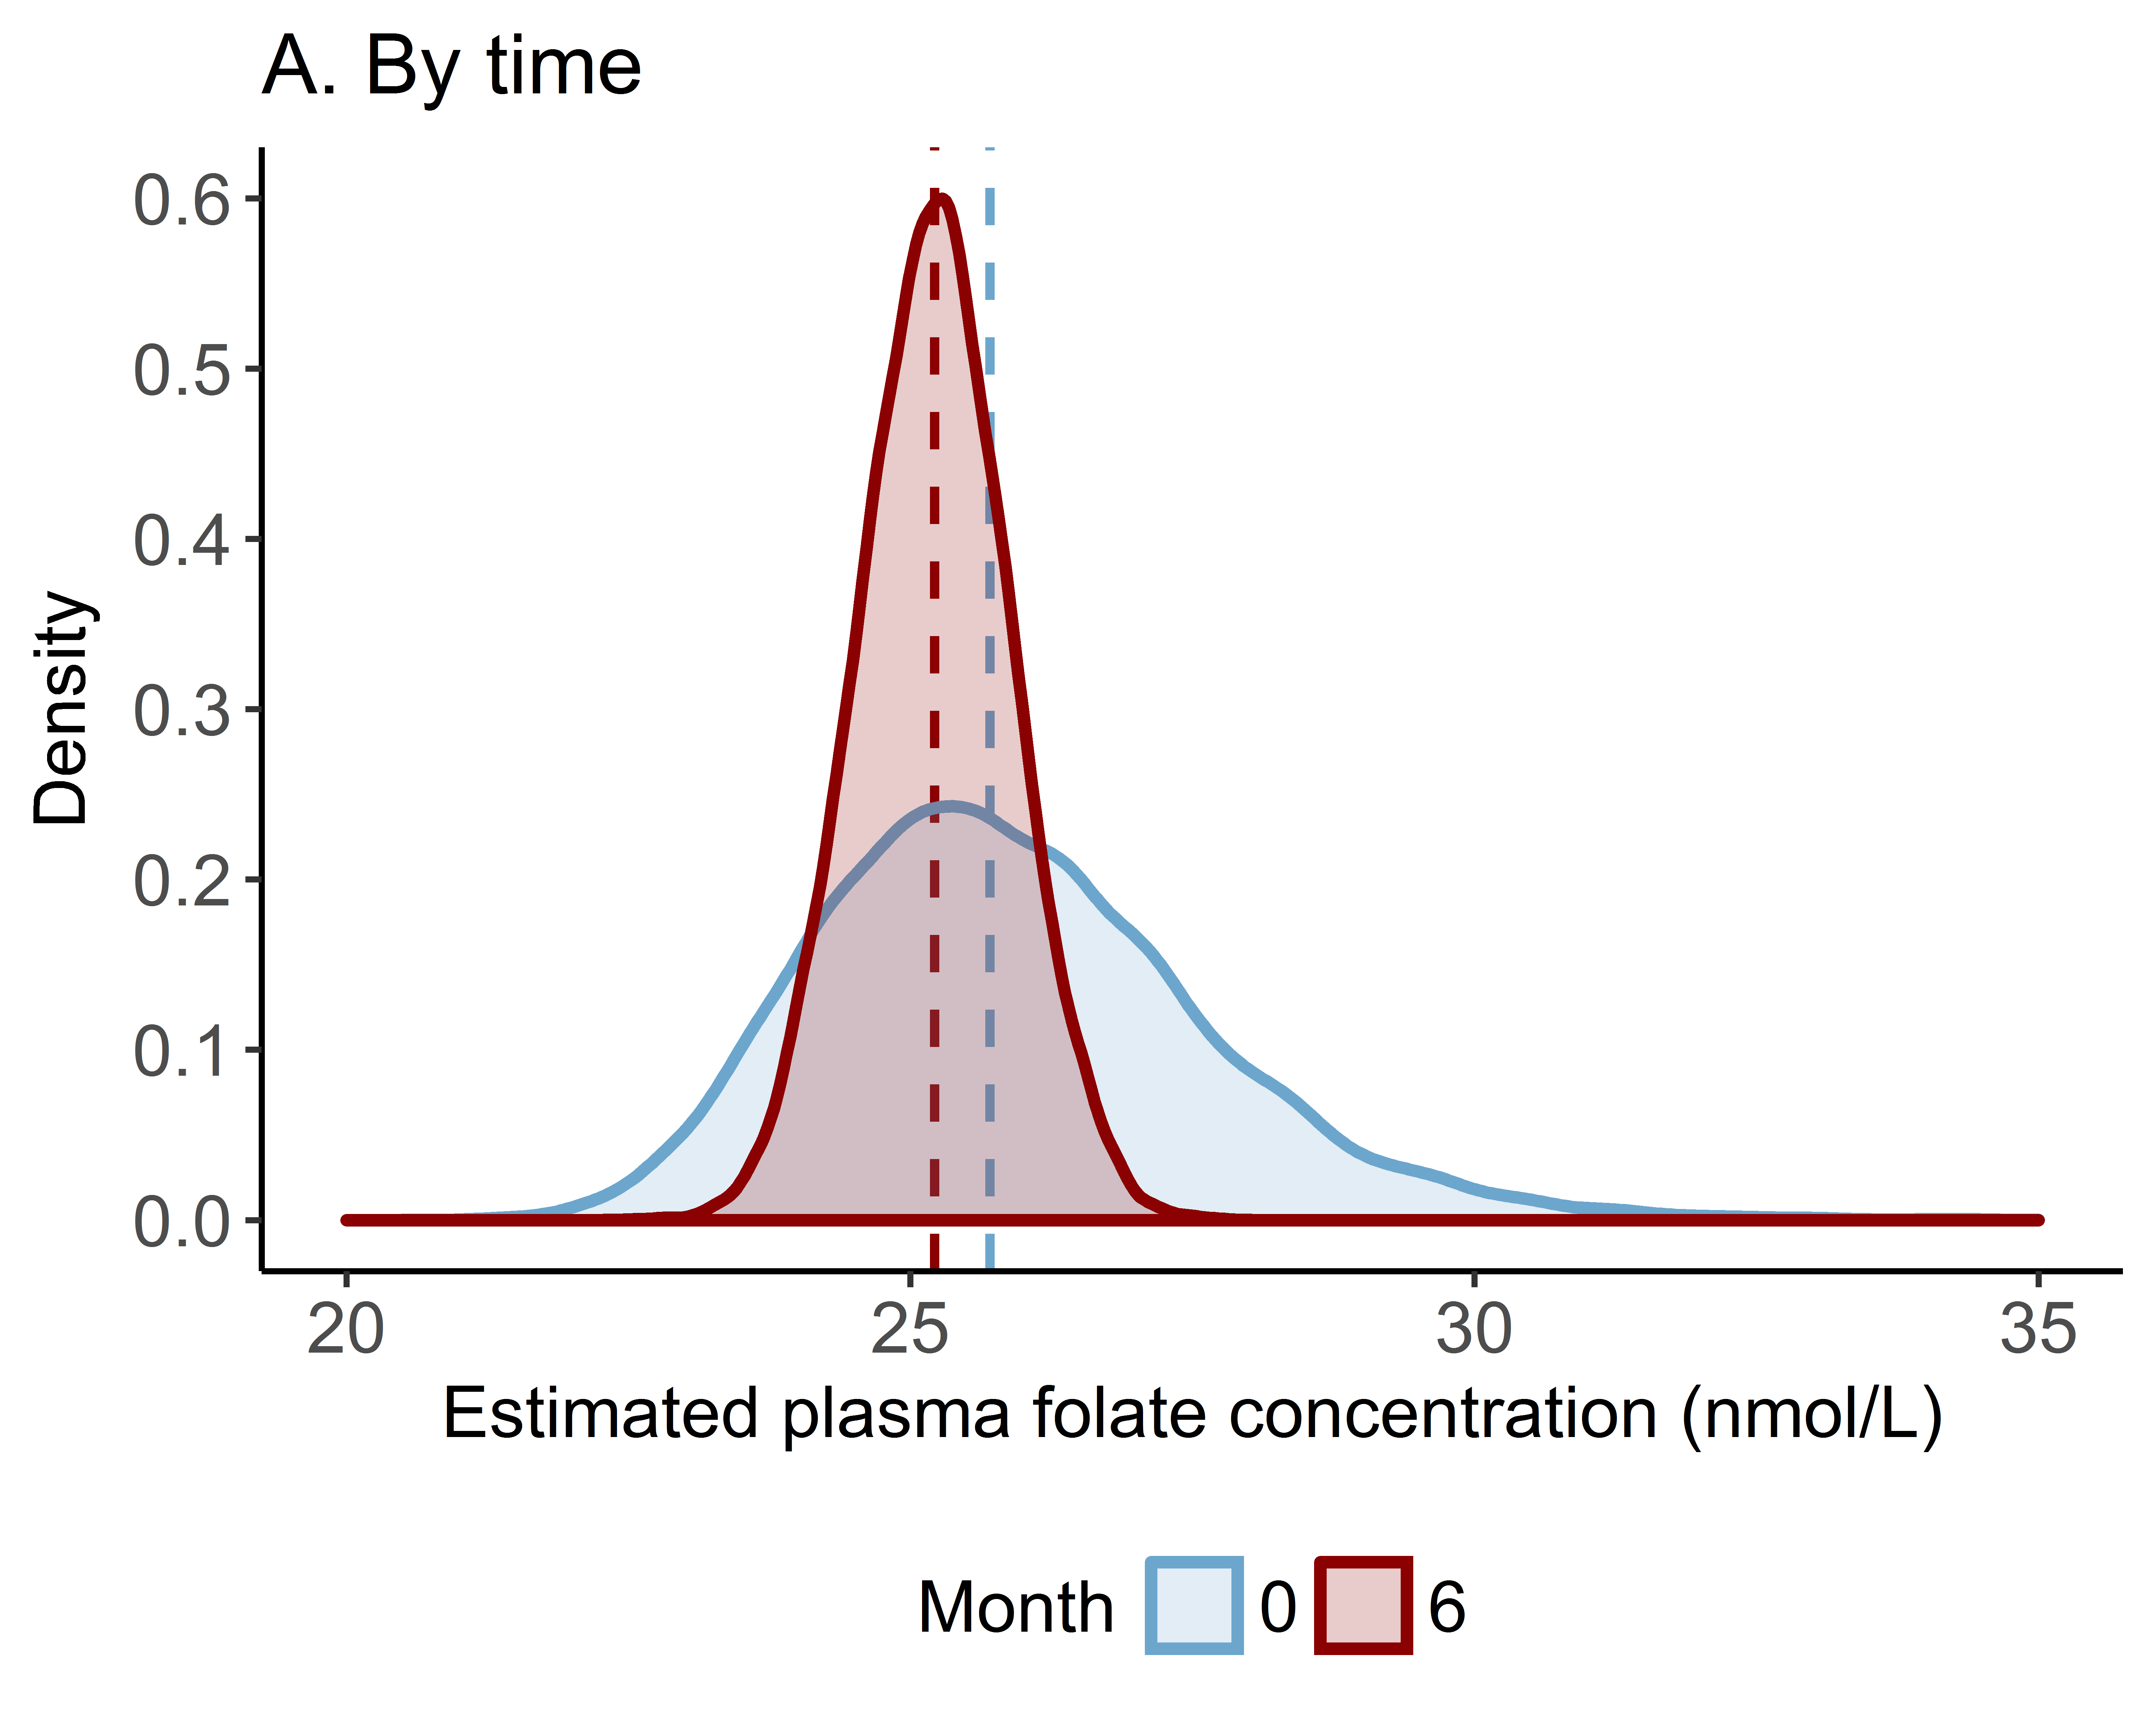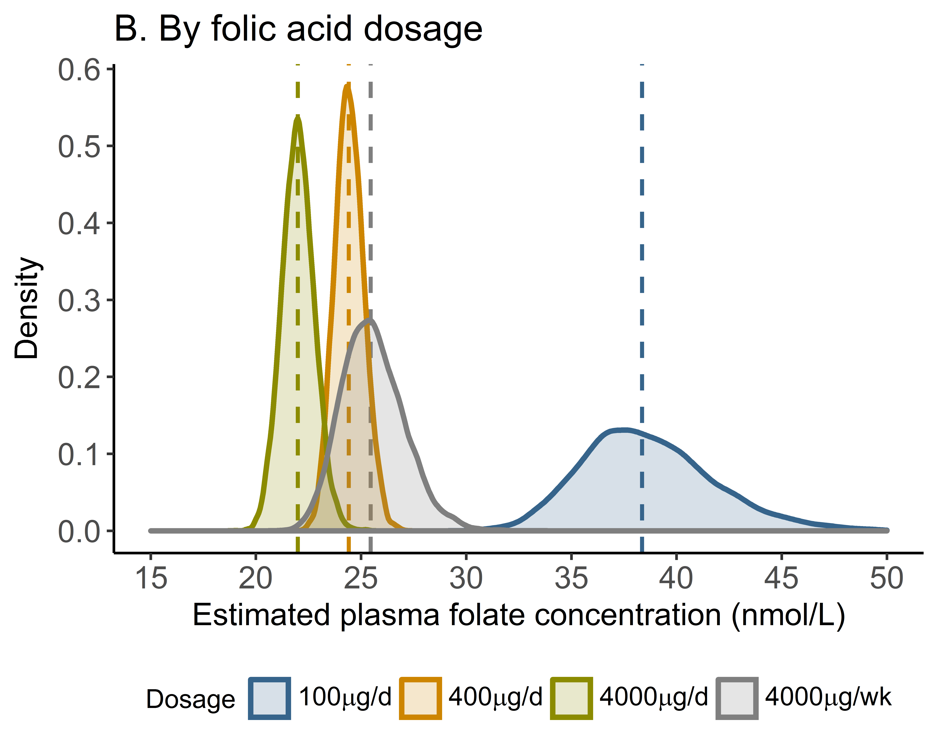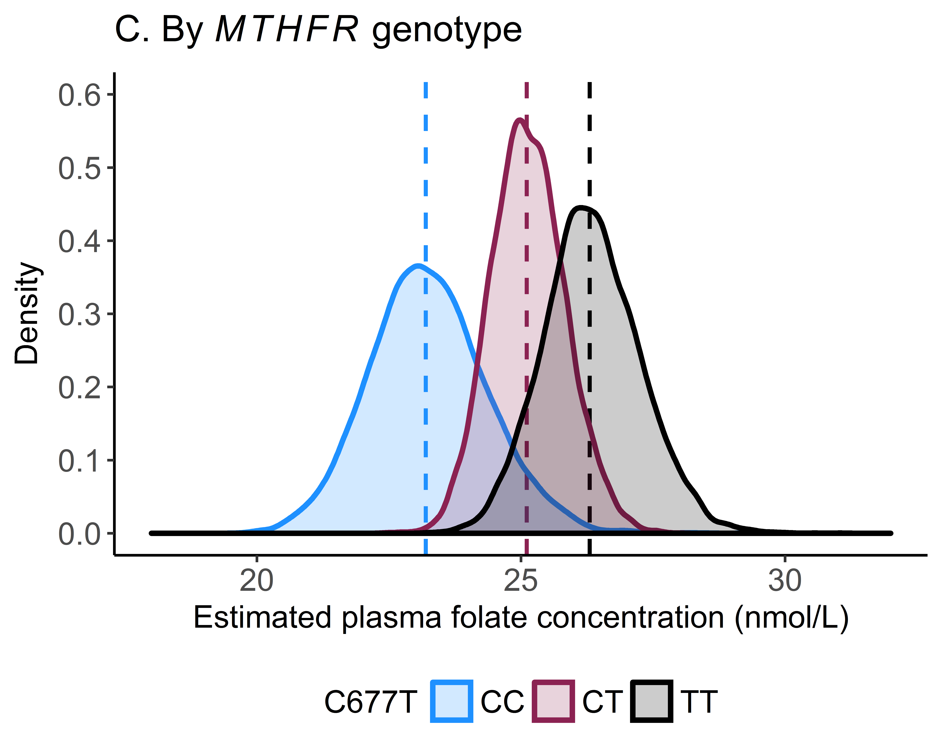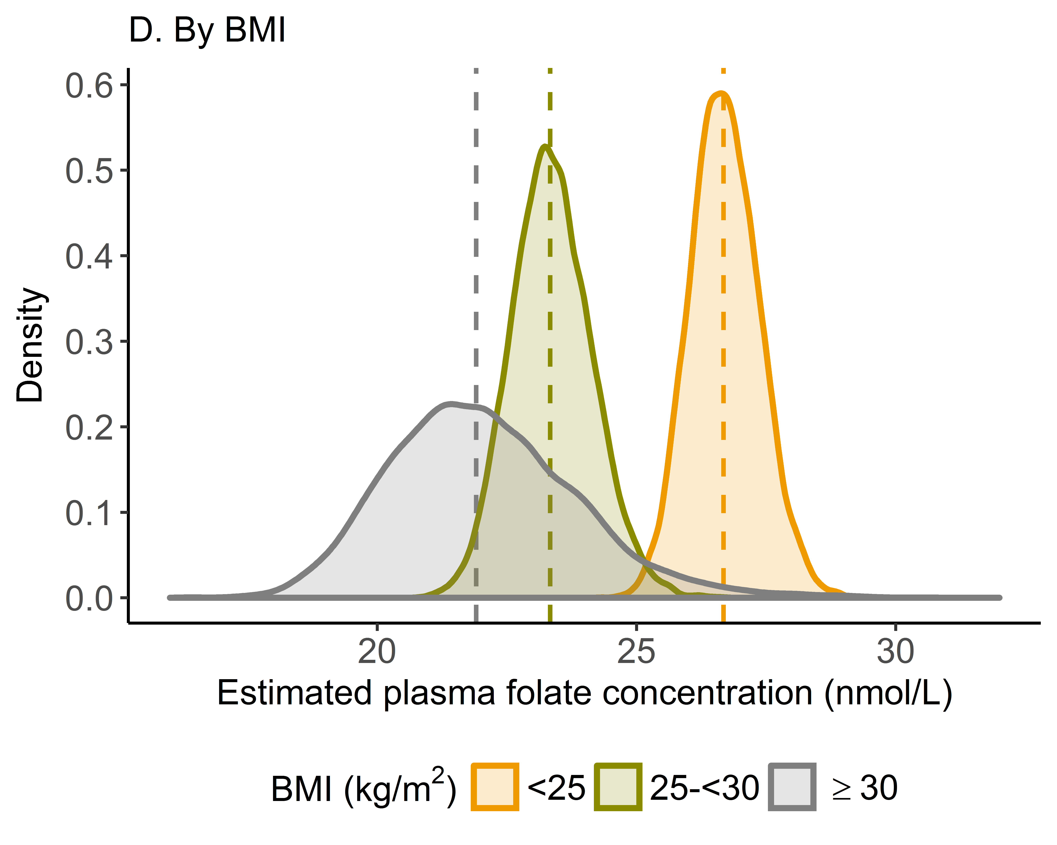
Supplemental Figure 2 Estimated plasma folate concentration corresponding to the red blood cell folate concentration of 906 nmol/L using data from the intervention group, stratified by (A) baseline and 6 months after supplementation, (B) folic acid dosage (100 µg/day, 400 µg/day, 4000 µg/day, or 4000 µg/week), (C) MTHFR C677T genotype (CC, CT, or TT), and (D) BMI (<25, 25–<30, or ≥30 kg/m²). Dashed lines represent the medians of the distributions. BMI, body mass index; MTHFR, methylenetetrahydrofolate reductase.

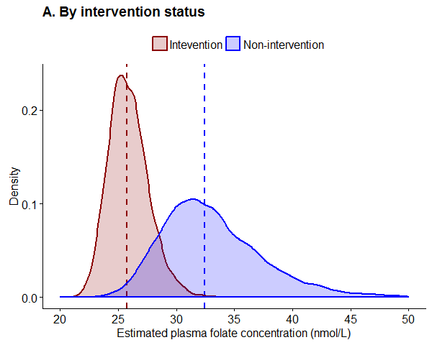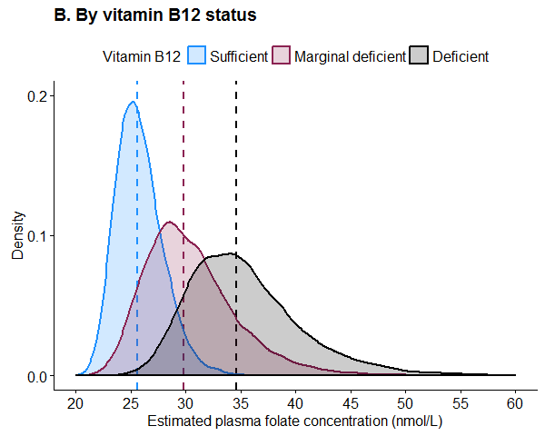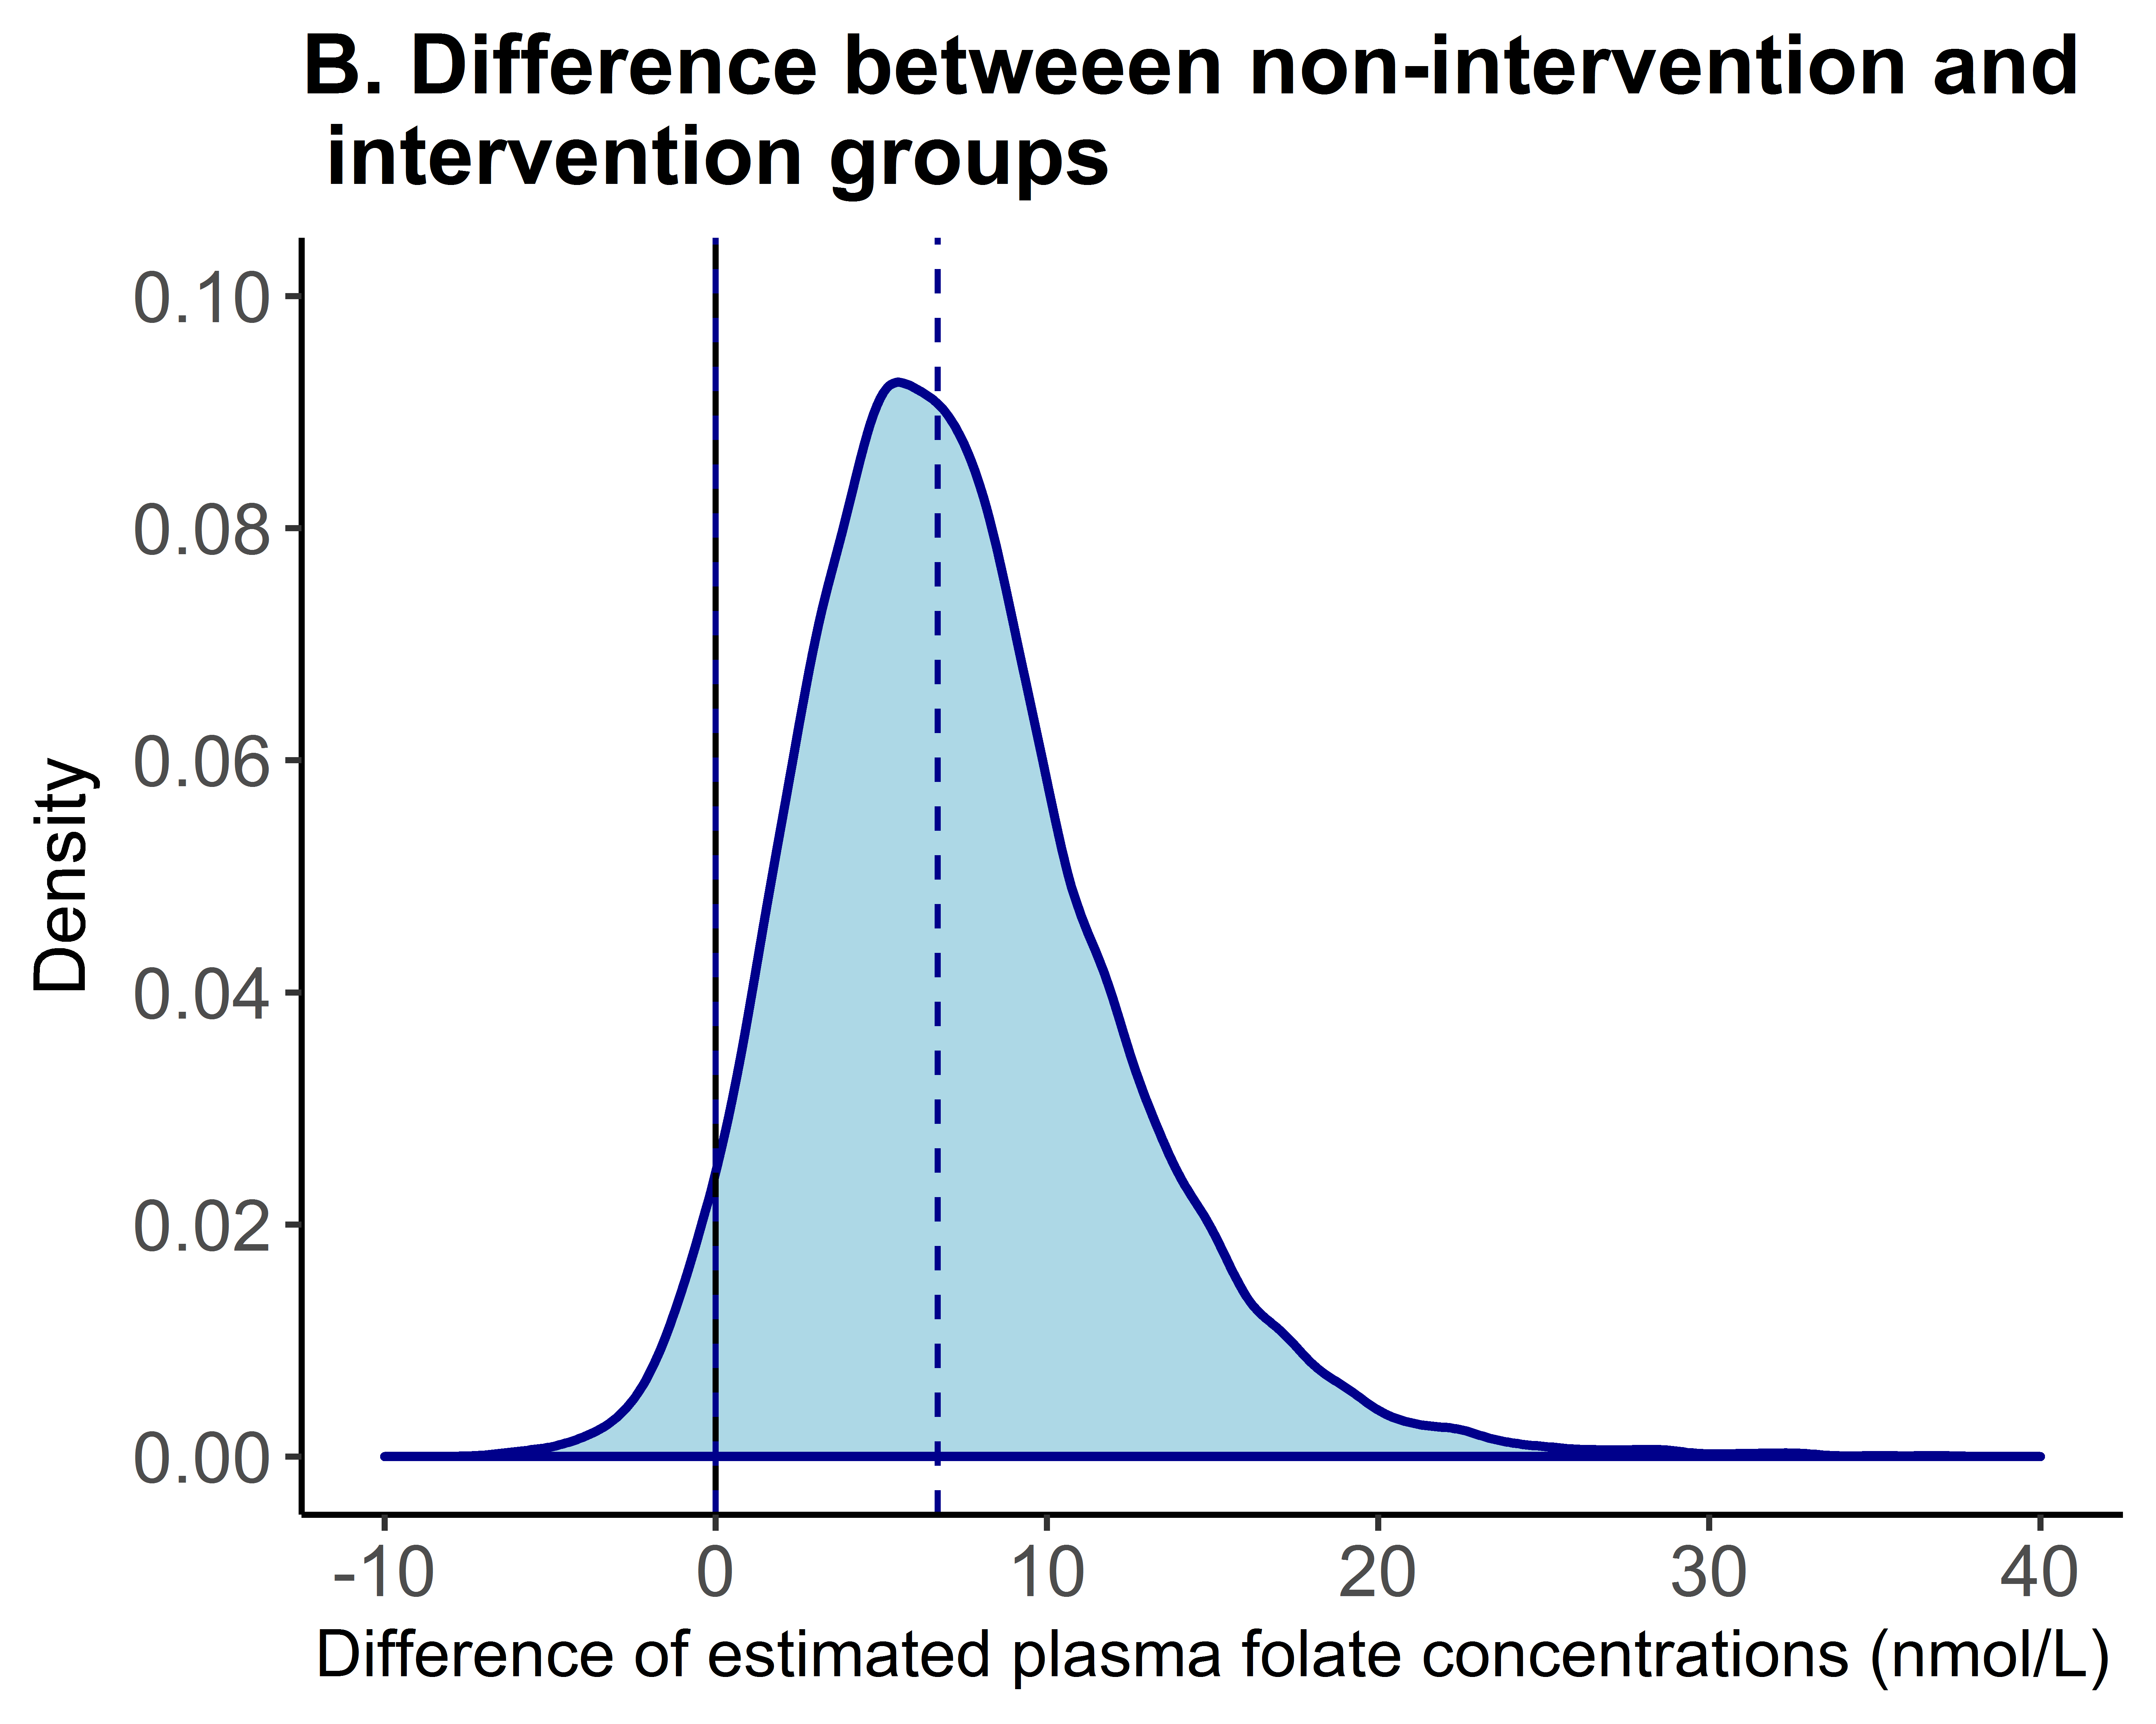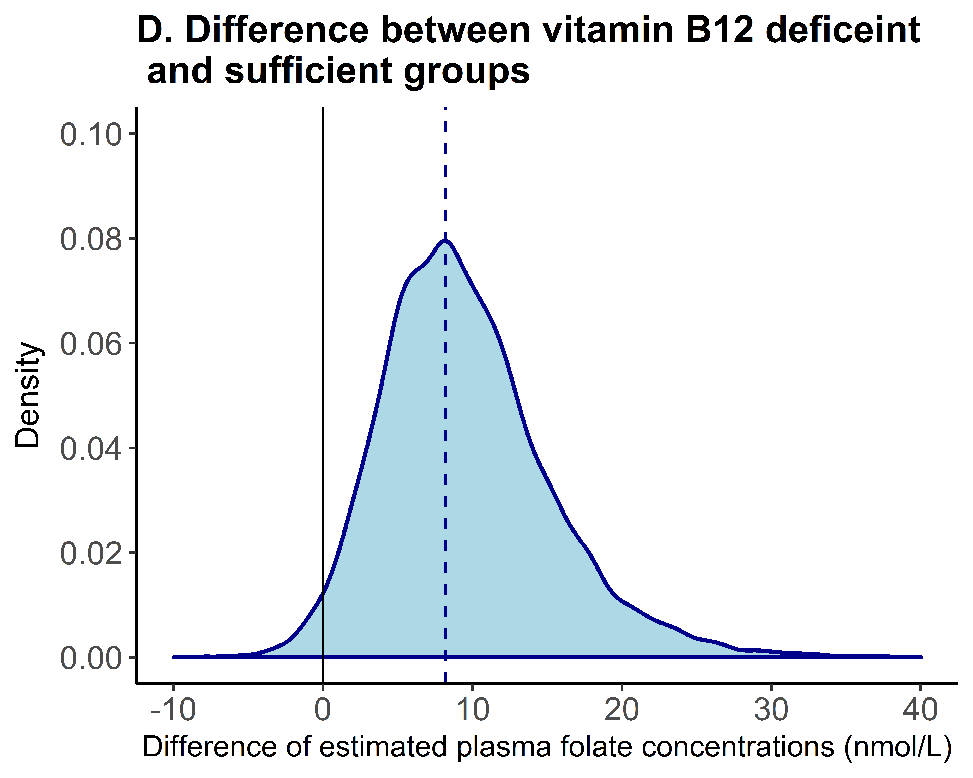
C

Supplemental Figure 3 Estimated plasma folate concentrations corresponding to the red blood cell folate concentration of 906 nmol/L using data from all women at baseline, stratified by (A) the intervention and non-intervention groups, and (B) the vitamin B12 deficient (<148 pmol/L), marginal deficient (148–221 pmol/L) and sufficient (>221 nmol/L) groups. Additional panels show differences between (C) the non-intervention and intervention group, and (D) the vitamin B12 deficiency and sufficiency. Dashed lines represent the medians of the distributions. Solid lines represent the mean difference of zero (C, D).

