Table S1. Cumulative incidence (%) of switch to second-line ART by 1, 2, and 3 years after start of ART: by initial regimen and region
% switched to second-line | USA | Latin America | Europe | Asia | Southern Africa | Rest of sub-Saharan Africa | Total
Overall:  1 year  2 years  3 years | 9.9 (6.2, 14.7)  19.0 (13.8, 24.9)  26.1 (20.0, 32.7) | 1.1 (0.6, 1.9)  3.1 (2.1, 4.4)  6.5 (4.9, 8.3) | 4.8 (3.9, 5.8)  9.5 (8.2, 10.8)  12.2 (10.8, 13.7) | 0.6 (0.5, 0.9)  3.2 (2.8, 3.7)  6.6 (5.9, 7.3) | 0.9 (0.7, 1.0)  3.1 (2.8, 3.7)  5.4 (5.1, 5.9) | 0.3 (0.3, 0.3)  0.8 (0.7, 0.8)  1.5 (1.4, 1.6) | 0.6 (0.5, 0.6)  1.7 (1.6, 1.8)  3.1 (3.0, 3.2)
NNRTI-based ART:  1 year  2 years  3 years | 15.9 (9.9, 23.2)  28.5 (20.5, 37.0)  37.0 (28.1, 45.9) | 1.2 (0.6, 2.2)  3.3 (2.2, 4.7)  6.6 (5.0, 8.5) | 6.7 (5.3, 8.2)  12.5 (10.7, 14.5)  16.1 (14.0, 18.4) | 0.6 (0.4, 0.8)  3.3 (2.8, 3.8)  6.6 (5.9, 7.4) | 1.0 (0.8, 1.2)  4.0 (3.6, 4.4)  7.0 (6.4, 7.6) | 0.3 (0.2, 0.3)  0.7 (0.6, 0.8)  1.4 (1.3, 1.5) | 0.5 (0.5, 0.6)  1.6 (1.5, 1.7)  3.0 (2.9, 3.2)
PI-based ART:  1 year  2 years  3 years | 1.3 (0.1, 6.2)  0.5 (0.2, 11.8)  10.1 (4.4, 18.5) | -  1.1 (0.9, 5.4)  5.1 (1.6, 11.6) | 2.4 (1.6, 3.6)  5.4 (4.1, 7.1)  7.0 (5.4, 8.8) | 1.7 (0.6, 4.0)  2.2 (0.8, 4.8)  3.6 (1.6, 7.1) | 0.7 (0.5, 0.9)  1.8 (1.5, 2.1)  3.2 (2.7, 3.7) | 2.0 (1.3, 2.9)  3.8 (2.8, 5.1)  4.3 (3.2, 5.7) | 1.0 (0.9, 1.3)  2.5 (2.1, 2.8)  3.9 (3.4, 4.3)
NNRTI-based ART, routine CD4/VL monitoring:  1 year  2 years  3 years | - | - | - | - | - | 1.2 (0.8, 1.9)  3.4 (2.6, 4.4)  5.9 (4.7, 7.2)
NNRTI-based ART, routine CD4, targeted VL monitoring:  1 year  2 years  3 years | - | - | - | - | - | 0.3 (0.3, 0.5)  1.0 (0.8, 1.1)  2.1 (1.8, 2.4)
NNRTI-based ART, routine CD4 monitoring only:  1 year  2 years  3 years | - | - | - | - | - | 0.2 (0.2, 0.5)  0.5 (0.4, 0.6)  1.1 (0.9, 1.2)
NNRTI-based ART, clinical monitoring only:  1 year  2 years  3 years | - | - | - | - | - | 0.2 (0.1, 0.3)  0.3 (0.2, 0.5)  0.7 (0.6, 1.0)
PI-based ART, routine CD4/VL monitoring:  1 year  2 years  3 years | - | - | - | - | - | 2.5 (0.7, 6.7)  9.7 (4.4, 17.5)  9.7 (4.4, 17.5)
PI-based ART, other monitoring strategy:  1 year  2 years  3 years | - | - | - | - | - | 1.9 (1.3, 2.8)  3.4 (2.4, 4.6)  3.8 (2.7, 5.2)
ART=antiretroviral therapy; PI=protease inhibitor; NNRTI=non-nucleoside reverse transcriptase inhibitor; VL=viral load.

Table S2. Cumulative incidence (%) of switch to second-line ART by 1, 2, and 3 years after start of ART among patients who initiated ART in 2011-2014: by monitoring strategy
 | Percent (95% CI) switched to second-line
Year after ART start | 1 year | 2 years | 3 years
Monitoring strategy, among those starting ART ≥2011
Routine VL, routine CD4 | 0.9 (0.7, 1.3) | 2.8 (2.2, 3.5) | 4.1 (3.3, 5.2)
Targeted VL, routine CD4 | 0.4 (0.2, 0.6) | 0.9 (0.6, 1.3) | 1.6 (1.1, 2.2)
Routine CD4 only | 0.3 (0.2, 0.4) | 0.6 (0.4, 0.8) | 1.2 (0.8, 1.6)
Clinical monitoring | 0.3 (0.1, 0.5) | 0.3 (0.2, 0.6) | 0.8 (0.4, 1.5)
Total | 0.4 (0.3, 0.5) | 1.0 (0.9, 1.2) | 1.8 (1.5, 2.2)
Table S3: Sensitivity analyses with alternative definition of switch (without requirement for change in ≥NRTI)
Global p-value
sHR (95% CI)
 | Complete case (n=93,351) |  | Sub-group of cohorts with routine CD4 monitoring and children with immune/WAZ ascertainment (n=32,989)
 | Univariate | Multivariate | Univariate | Multivariate
Characteristics at start of ART
Sex | P<0.0001 | P<0.0001 | P<0.0001 | P<0.0001
Female vs male | 0.80 (0.75, 0.85) | 0.79 (0.74, 0.84) | 0.81 (0.76, 0.87) | 0.82 (0.76, 0.89)
Age (years) | p<0.0001 | p<0.0001 | p<0.0001 | p<0.0001
<3 | 0.62 (0.57, 0.67) | 0.64 (0.59, 0.69) | 0.59 (0.55, 0.64) | 0.63 (0.57, 0.71)
3-5 | 0.77 (0.71, 0.84) | 0.72 (0.67, 0.78) | 0.78 (0.71, 0.84) | 0.71 (0.64, 0.79)
6-9 | 1.00 | 1.00 | 1.00 | 1.00
≥10 | 1.29 (1.11, 1.50) | 1.14 (0.97, 1.33) | 1.16 (1.00, 1.36) | 1.25 (1.04, 1.50)
Known AIDS diagnosis | p=0.028 | p=0.029 | p=0.60 | p=0.64
Yes vs no | 0.93 (0.88, 0.99) | 0.93 (0.87, 0.99) | 1.02 (0.95, 1.09) | 0.98 (0.90, 1.07)
WHO immunodeficiency for age |  |  | p<0.0001 | p<0.0001
None |  |  | 1.08 (0.91, 1.28) | 0.92 (0.77, 1.11)
Mild |  |  | 1.24 (1.03, 1.49) | 1.19 (0.97, 1.45)
Advanced |  |  | 1.00 | 1.00
Severe |  |  | 1.38 (1.22, 1.57) | 1.41 (1.22, 1.63)
Weight for age z-score |  |  | p=0.16 | p=0.26
<-2 |  |  | 0.93 (0.86, 1.01) | 1.06 (0.97, 1.16)
-2 to <0 |  |  | 1.00 | 1.00
≥0 |  |  | 1.02 (0.89, 1.18) | 0.94 (0.81, 1.10)
Regimen | p=0.0017 | p<0.0001 | p<0.0001 | p<0.0001
PI vs NNRTI | 1.15 (1.05, 1.26) | 0.70 (0.63, 0.78) | 0.69 (0.62, 0.76) | 0.58 (0.50, 0.68)
Calendar year | p<0.0001 | p<0.0001 | p<0.0001 | p<0.0001
≤2004 | 2.98 (2.72, 3.25) | 1.33 (1.21, 1.47) | 2.30 (2.10, 2.52) | 1.35 (1.18, 1.53)
2005-2007 | 1.45 (1.35, 1.56) | 1.25 (1.16, 1.35) | 1.27 (1.17, 1.37) | 1.18 (1.07, 1.30)
2008-2010 | 1.00 | 1.00 | 1.00 | 1.00
≥2011 | 0.54 (0.47, 0.62) | 0.61 (0.53, 0.70) | 0.48 (0.41, 0.57) | 0.59 (0.48, 0.72)
Cohort level factors
Monitoring strategy | p<0.0001 | p<0.0001 | p<0.0001 | p<0.0001
Routine CD4 & VL | 4.79 (4.38, 5.23) | 2.69 (2.25, 3.21) | 2.95 (2.67, 3.25) | 2.33 (1.91, 2.84)
Routine CD4 & targeted VL | 2.16 (1.94, 2.40) | 1.94 (1.74, 2.17) | 1.27 (1.13, 1.43) | 1.42 (1.23, 1.64)
Routine CD4 only | 1.00 | 1.00 | 1.00 | 1.00
Clinical only | 0.74 (0.61. 0.89) | 0.67 (0.55, 0.82) | - | -
Country income group | p<0.0001 | p<0.0001 | p<0.0001 | P=0.70
Low | 1.00 | 1.00 | 1.00 | 1.00
Lower middle | 1.02 (0.93, 1.12) | 1.08 (0.97, 1.20) | 0.99 (0.89, 1.11) | 1.00 (0.87, 1.14)
High/upper middle | 3.38 (3.13, 3.64) | 1.57 (1.35, 1.84) | 2.39 (2.20, 2.59) | 1.09 (0.89, 1.33)
Region | p<0.0001 | p<0.0001 | p<0.0001 | p<0.0001
USA | 4.15 (3.19, 5.39) | 4.05 (3.09, 5.32) | 3.05 (1.87, 4.97) | 4.40 (2.30, 8.40)
Europe | 2.46 (2.22, 2.74) | 2.41 (2.15, 2.70) | 2.18 (1.96, 2.44) | 2.46 (2.09, 2.91)
Latin America | 1.36 (1.14, 1.63) | 2.14 (1.74, 2.62) | 1.43 (1.19, 1.73) | 2.35 (1.85, 2.99)
Asia | 1.47 (1.34, 1.61) | 1.70 (1.53, 1.90) | 1.38 (1.25, 1.52) | 1.11 (0.96, 1.28)
Southern Africa | 1.00 | 1.00 | 1.00 | 1.00
Rest of SSA | 0.35 (0.32, 0.38) | 1.05 (0.88, 1.26) | 0.47 (0.43, 0.51) | 0.81 (0.65, 1.02)

ART=antiretroviral therapy; sHR=Sub-distribution hazard ratio; CI=confidence interval; PI=protease inhibitor; NNRTI=non-nucleoside reverse transcriptase inhibitor; NRTI= nucleoside reverse transcriptase inhibitor; WAZ=weight-for-age z-score; VL=viral load; SSA=sub-Saharan Africa.

Table S4. Characteristics at time of switch among children switched to second-line ART
 | USA | Latin America | Europe | Asia | Southern Africa | Rest of sub-Saharan Africa | Total
N | 72 | 123 | 464 | 587 | 1255 | 1382 | 3883
Median time from ART start to switch, months [IQR] | 24 [12, 42] | 42 [26, 72] | 35 [14, 66] | 35 [22, 52] | 33 [19, 55] | 38 [23, 57] | 35 [20, 57]
Male sex | 33 (45.8) | 61 (49.6) | 223 (48.1) | 359 (61.2) | 702 (55.9) | 816 (59.1) | 2194 (56.5)
Median age, years [IQR] | 4.1 [1.9, 7.5] | 10.3 [6.7, 13.8] | 8.2 [4.2, 12.0] | 7.7 [5.5, 10.0] | 8.3 [5.3, 11.2] | 9.4 [6.3, 12.0] | 8.6 [5.5, 11.5]
Drug class of switch  NNRTI to PI  PI to NNRTI  Other | 56 (77.8)  8 (11.1)  8 (11.1) | 117 (95.1)  4 (3.3)  2 (1.6) | 330 (71.1)  78 (16.8)  56 (12.1) | 573 (97.6)  5 (0.1)  9 (1.5) | 940 (74.9)  277 (22.1)  38 (3.0) | 1313 (95.0)  47 (3.4)  22 (1.6) | 3329 (85.7)  419 (10.8)  135 (3.5)
WHO immunodeficiency for age  N with measurement available  None  Mild  Advanced  Severe | 56 (77.8*)  25 (44.6)  18 (32.1)  6 (10.7)  7 (12.5) | 106 (86.2*)  31 (29.3)  9 (8.5)  8 (7.6)  58 (54.7) | 394 (84.9*)  183 (46.5)  55 (14.0)  50 (12.7)  106 (26.9) | 525 (89.4*)  129 (24.6)  58 (11.1)  68 (13.0)  270 (51.4) | 984 (78.4*)  496 (50.4)  137 (13.9)  95 (9.7)  256 (26.0) | 951 (68.8*)  174 (18.3)  77 (8.1)  132 (13.9)  568 (59.7) | 3016 (77.7*)  1038 (34.4)  354 (11.7)  359 (11.9)  1265 (41.9)
Viral load  N with measurement available  ≤1000 copies/mL  >1000 copies/mL | 53 (73.6*)  9 (17.0)  44 (83.0) | 56 (45.5*)  9 (16.1)  47 (83.9) | 414 (89.2*)  124 (30.0)  290 (70.1) | 433 (73.8*)  28 (6.5)  405 (93.5) | 1034 (82.4*)  226 (21.9)  808 (78.1) | 429 (31.0*)  10 (2.3)  419 (97.7) | 2419 (62.3*)  406 (16.8)  2013 (83.2)
Tuberculosis diagnosis | 0 (0.0) | 0 (0.0) | 1 (0.2) | 38 (6.5) | 49 (3.9) | 115 (8.3) | 203 (5%)
NOTE. Data are no. (%) of patients, unless otherwise indicated. IQR: interquartile range; ART=antiretroviral therapy; PI=protease inhibitor; NNRTI=non-nucleoside reverse transcriptase inhibitor; NRTI= nucleoside reverse transcriptase inhibitor; WAZ=weight-for-age z-score; VL=viral load

Figure S1. Flowchart of children included in the analysis

Total children in dataset
N=182,747
Perinatally infected and started ART between 1993-2014
N=106,529
Started ≥3 ARVs
N= 97,606
Started NNRTI / boosted PI-based ART
N=94,194

≥1 day follow-up after ART start
N=93,351

ART: antiretroviral therapy; ARVs=antiretroviral drugs; NNRTI=non-nucleoside reverse transcriptase inhibitor; PI=protease inhibitor.

Figure S2. Drug class used in first-line ART regimen, by region
(a) Amongst all children initiating ART
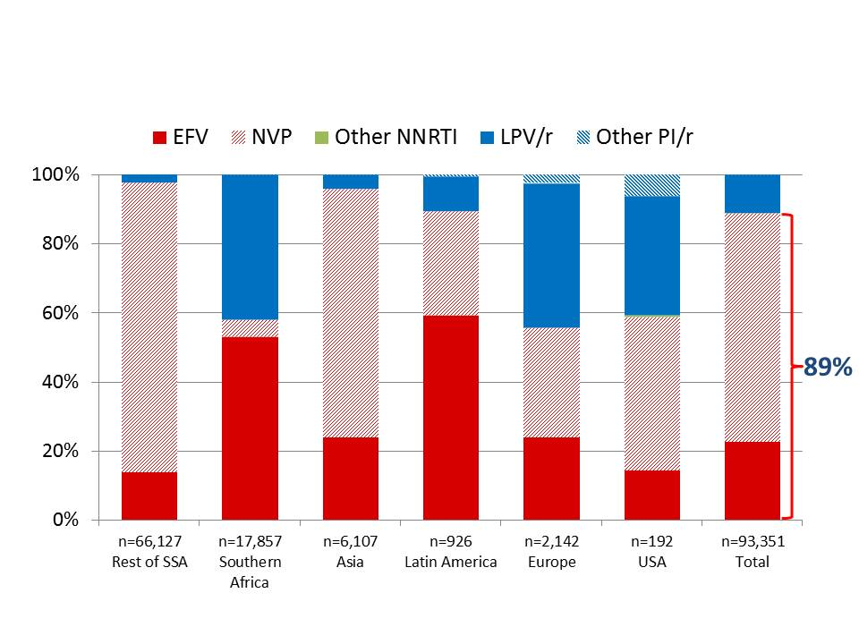

- Amongst children aged <3 years at ART initiation
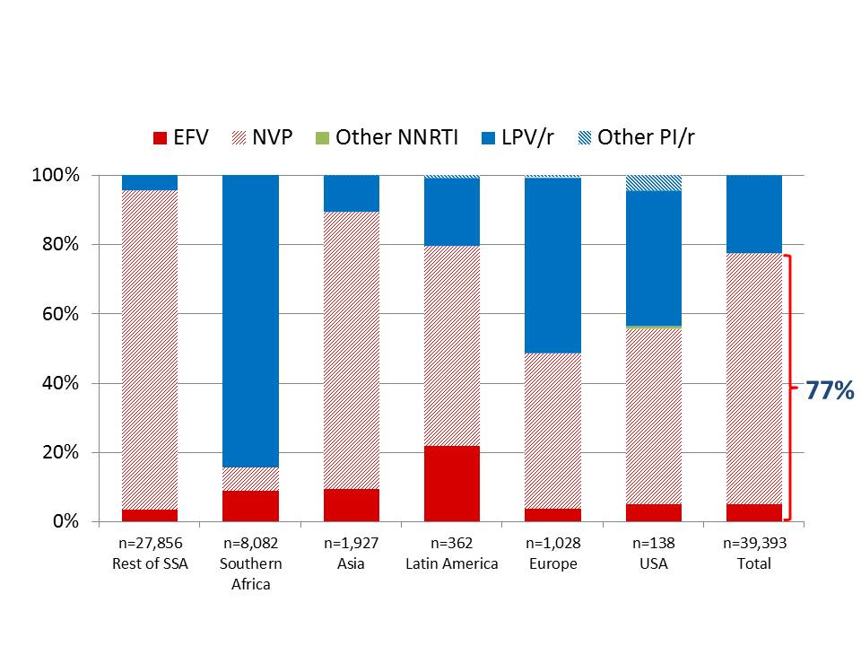

ART: antiretroviral therapy; NNRTI=non-nucleoside reverse transcriptase inhibitor; PI=protease inhibitor; NVP=nevirapine; EFV=efavirenz; LPV=lopinavir; SSA=sub-Saharan Africa.

