Supplementary appendix

Per protocol analysis will be restricted to participants who have:

- Not withdrawn consent for receipt of vaccines and follow-up evaluations since enrollment.
- Adequate blood specimen for serological analysis collected at enrollment (i.e., 6 weeks of age), 22, 23, and 26 weeks of age, within 3 days of the scheduled visit date.
- Received all scheduled vaccines within 3 days of scheduled visit date.

Table S1: Per Protocol Analysis Criteria

Baseline Characteristics | Arm A |  | Arm B |  | Arm C |  | Arm D
 | IPV14+IPV booster |  | IPV14+fIPV booster |  | IPV6+fIPV booster |  | fIPV6/14+fIPV booster
 | (n=262) |  | (n=253) |  | (n=253) |  | (n=260)
Age (days) | 44 (43-47) |  | 44 (42-47) |  | 44 (42-47) |  | 44 (43-47)
Male | 130 | 50% | 123 | 49% | 129 | 51% | 122 | 47%
Mother's education
No formal school | 46 | 18% | 45 | 18% | 43 | 17% | 42 | 16%
Primary | 94 | 36% | 102 | 40% | 103 | 41% | 89 | 34%
Middle | 62 | 24% | 66 | 26% | 59 | 23% | 73 | 28%
High | 43 | 16% | 30 | 12% | 38 | 15% | 41 | 16%
Graduate | 17 | 6% | 10 | 4% | 10 | 4% | 15 | 6%
Exclusive breastfeeding | 62 | 24% | 61 | 24% | 63 | 25% | 81 | 31%
Wasting present | 16 | 6% | 18 | 7% | 16 | 6% | 17 | 7%
Stunting present | 26 | 10% | 41 | 16% | 35 | 14% | 30 | 12%
Type 1 poliovirus
Seropositive | 145 | 55% | 128 | 51% | 134 | 53% | 135 | 52%
Reciprocal titers | 28 | (14-91) | 28 | (14-114) | 28 | (11-114) | 36 | (14-144)
Type 2 poliovirus
Seropositive | 158 | 60% | 130 | 51% | 130 | 51% | 142 | 55%
Reciprocal titers | 18 | (11-36) | 18 | (11-36) | 18 | (11-45) | 18 | (11-36)
Type 3 poliovirus
Seropositive | 86 | 33% | 87 | 34% | 94 | 37% | 78 | 30%
Reciprocal titers | 18 | (11-45) | 23 | (11-72) | 23 | (11-57) | 18 | (11-45)
Data are n (%), median (range) for age in days, or median (interquartile range) for reciprocal antibody titers among seropositive participants. Baseline measurements for participants were obtained at 6 weeks of age.

Table S2: Baseline characteristics of the per-protocol population

Vaccine response | Arm A/B |  | Arm D |  | Fisher's Exact Test/ Kruskal-Wallis Test
 | IPV14 |  | fIPV6/14
 | (n=515) |  | (n=260)
Type 1
Vaccine response to primary series | 297 | 58% (53-62%) | 205 | 79% (73-83%) | p < 0.0001
Reciprocal antibody titers among responders | 297 | 23 (14-57) | 205 | 144 (45-455) | p < 0.0001
Type 2
Vaccine response to primary series | 241 | 47% (43-51%) | 167 | 64% (58-70%) | p < 0.0001
Reciprocal antibody titers among responders | 241 | 14 (11-23) | 167 | 57 (18-144) | p < 0.0001
Type 3
Vaccine response to primary series | 189 | 37% (33-41%) | 188 | 72% (67-77%) | p < 0.0001
Reciprocal antibody titers among responders | 189 | 18 (11-57) | 188 | 114 (45-455) | p < 0.0001
Data are the number of vaccine responders (n), percentage of participants with vaccine response expressed as n/N, and percentage including 95% confidence interval (CI). Fisher’s Exact test was used to test for inequality of proportions between study arms. Median (interquartile range) of reciprocal antibody titers among vaccine responders. Kruskal-Wallis Test was used to test for inequality of antibody titer distributions between study arms. Vaccine response defined as seroconversion from seronegative (<1:8) to seropositive (>1:8) after vaccination, or a four-fold rise in antibody titers after vaccination adjusted maternal antibody decay. IPV=inactivated poliovirus vaccines. fIPV=fractional inactivated poliovirus vaccine.

Table S3: Summary of vaccine response to primary series and reciprocal antibody titers for poliovirus types 1, 2, and 3 among those who received one dose of IPV and two doses of fIPV

Vaccine response | Arm A |  | Arm B |  | Arm C |  | Arm D |  | Fisher's Exact Test
 | IPV14+IPV booster |  | IPV14+fIPV booster |  | IPV6+fIPV booster |  | fIPV6/14+fIPV booster
 | (n=262) |  | (n=253) |  | (n=253) |  | (n=260)
Type 1
Vaccine response to primary series | 160/262 | 61% (55-67%) | 137/253 | 54% (48-60%) | 96/253 | 38% (32-44%) | 205/260 | 79% (73-83%) | B v A: p = 0.13  D v A, D v B: p < 0.0001  C v B: p = 0.0004
Priming response | 102/102 | 100% (96-100%) | 114/116 | 98% (94-100%) | 145/157 | 92% (87-96%) | - | - | B v A: p = 0.50  C v B: p = 0.0482
Cumulative vaccine response | 262/262 | 100% (99-100%) | 251/253 | 99% (97-100%) | 241/253 | 95% (92-97%) | - | - | B v A: p = 0.24  C v B: p = 0.0118
Vaccine response to booster | 262/262 | 100% (99-100%) | 250/253 | 99% (97-100%) | 241/253 | 95% (92-97%) | 255/260 | 98% (96-99%) | D v A: p = 0.0301  D v B: p = 0.72
Type 2
Vaccine response to primary series | 124/262 | 47% (41-53%) | 117/253 | 46% (40-52%) | 68/253 | 27% (22-33%) | 167/260 | 64% (58-70%) | B v A: p = 0.86  D v A: p= 0.0001  D v B, C v B: p < 0.0001
Priming response | 136/138 | 99% (95-100%) | 131/136 | 96% (92-98%) | 158/185 | 85% (80-90%) | - | - | B v A: p = 0.28  C v B: p = 0.0011
Cumulative vaccine response | 260/262 | 99% (97-100%) | 248/253 | 98% (95-99%) | 226/253 | 89% (85-93%) | - | - | B v A: p = 0.28  C v B: p < 0.0001
Vaccine response to booster | 258/262 | 98% (96-99%) | 248/253 | 98% (95-99%) | 226/253 | 89% (85-93%) | 251/260 | 97 (94-98%) | D v A: p = 0.17  D v B: p = 0.42
Type 3
Vaccine response to primary series | 97/262 | 37% (31-43%) | 92/253 | 36% (31-42%) | 88/253 | 35% (29-41%) | 188/260 | 72% (67-77%) | B v A: p = 0.93  D v A, D v B: p < 0.0001  C v B: p = 0.78
Priming response | 164/165 | 99% (97-100%) | 157/161 | 98% (94-99%) | 159/165 | 96% (92-98%) | - | - | B v A: p = 0.21  C v B: p = 0.75
Cumulative vaccine response | 261/262 | 100% (98-100%) | 249/253 | 98% (96-99%) | 247/253 | 98% (95-99%) | - | - | B v A: p = 0.21  C v B: p = 0.75
Vaccine response to booster | 260/262 | 99% (97-100%) | 247/253 | 98% (95-99%) | 243/253 | 96% (93-98%) | 256/260 | 98% (96-99%) | D v A: p = 0.45  D v B: p = 0.54
Data are the percentage of participants with vaccine response expressed as n/N including 95% confidence interval (CI). Vaccine response defined as seroconversion from seronegative (<1:8) to seropositive (>1:8) after vaccination, or a four-fold rise in antibody titers after vaccination adjusted for maternal antibody decay. Priming defined as absence of vaccine response at 22 weeks with subsequent evidence of response at 23 weeks. Cumulative vaccine response defined as vaccine response at 22 weeks or priming response at 23 weeks. IPV=inactivated poliovirus vaccines. fIPV=fractional inactivated poliovirus vaccine. Fisher’s Exact test was used to test for inequality of proportions between study arms.

Table S4A. Summary of vaccine response for poliovirus types 1, 2, and 3 by study arms
Vaccine response | Arm A |  | Arm B |  | Arm C |  | Arm D |  | Kruskal-Wallis Test
 | IPV14+IPV booster |  | IPV14+fIPV booster |  | IPV6+fIPV booster |  | fIPV6/14+fIPV booster
 | (n=262) |  | (n=253) |  | (n=253) |  | (n=260)
Type 1
Vaccine response to primary series | 160 | 223 (13-57) | 137 | 28 (14-57) | 96 | 28 (14-144) | 205 | 144 (45-455) | B v A: p = 0.50  D v A, D v B: p < 0.0001  C v B: p = 0.21
Priming response | 102 | >1448 (1152->1448) | 114 | 576 (288-1152) | 145 | 1152 (362->1448) | - | - | B v A: p < 0.0001  C v B: p = 0.0047
Cumulative vaccine response | 262 | >1448 (1152->1448) | 251 | 910 (455->1448) | 241 | >1448 (576->1448) | - | - | B v A: p < 0.0001  C v B: p = 0.0028
Vaccine response to booster | 262 | >1448 (910->1448) | 250 | 576 (228-1152) | 241 | >1448 (576->1448) | 255 | 288 (114-910) | B v A, D v A, D v B,  C v B: p < 0.0001
Type 2
Vaccine response to primary series | 124 | 14 (9-23) | 117 | 14 (11-23) | 68 | 14 (11-28) | 167 | 57 (18-144) | B v A: p = 0.12  D v A, D v B: p < 0.0001  C v B: p = 0.58
Priming response | 136 | >1448 (1152->1448) | 131 | 576 (228-910) | 158 | 576 (114->1448) | - | - | B v A: p < 0.0001  C v B: p = 0.84
Cumulative vaccine response | 260 | >1448 (1152->1448) | 248 | 817 (362-1152) | 226 | 910 (181->1448) | - | - | B v A: p < 0.0001  C v B: p = 0.49
Vaccine response to booster | 258 | 1152 (576->1448) | 248 | 362 (144-724) | 226 | 724 (228->1448) | 251 | 181 (72-576) | B v A, D v A, D v B:  p < 0.0001  C v B: p = 0.0001
Type 3
Vaccine response to primary series | 97 | 28 (14-91) | 92 | 16 (11-41) | 88 | 20 (11-117) | 188 | 114 (45-455) | B v A: p = 0.0175  D v A, D v B: p < 0.0001  C v B: p = 0.49
Priming response | 164 | >1448 (>1448->1448) | 157 | >1448 (910->1448) | 159 | >1448 (724->1448) | - | - | B v A: p < 0.0001  C v B: p = 0.58
Cumulative vaccine response | 261 | >1448 (>1448->1448) | 249 | >1448 (1152->1448) | 247 | >1448 (910->1448) | - | - | B v A: p < 0.0001  C v B: p = 0.91
Vaccine response to booster | 260 | >1448 (1152->1448) | 247 | 1152 (455->1448) | 243 | >1448 (576->1448) | 256 | 455 (144-1152) | B v A, D v A, D v B:  p < 0.0001  C v B: p = 0.0031
Data are the number of vaccine responders (n) and the median (interquartile range) of reciprocal antibody titers among vaccine responders. Vaccine response defined as seroconversion from seronegative (<1:8) to seropositive (>1:8) after vaccination, or a four-fold rise in antibody titers after vaccination adjusted for maternal antibody decay. Priming defined as absence of vaccine response at 22 weeks with subsequent evidence of response at 23 weeks. Cumulative vaccine response defined as vaccine response at 22 weeks or priming response at 23 weeks. IPV=inactivated poliovirus vaccines. fIPV=fractional inactivated poliovirus vaccine. Kruskal-Wallis Test was used to test for inequality of antibody titer distributions between study arms.

Table S4B. Summary of reciprocal antibody titers to vaccination for poliovirus types 1, 2, and 3 by study arms

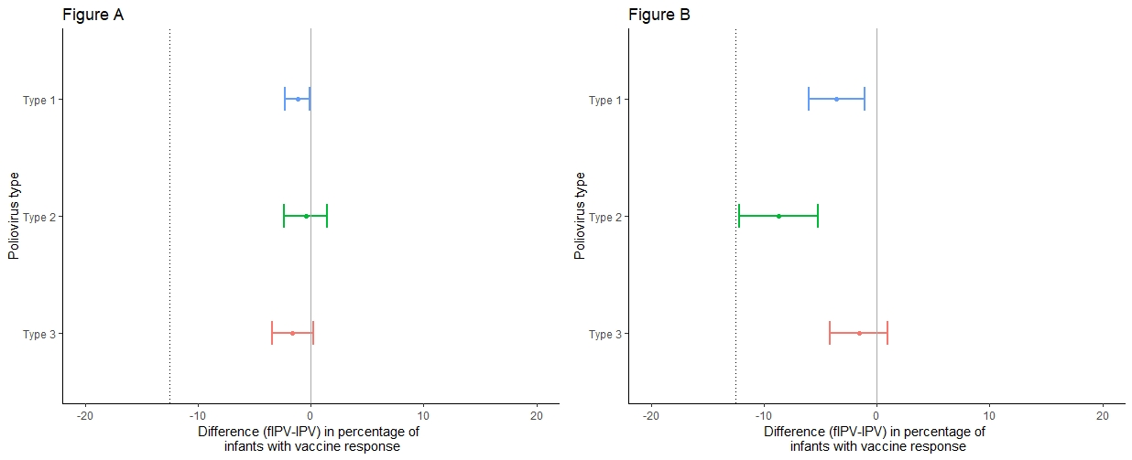
-8·70% (-12·20% - -5·19%)
-1·58% (-4·14% - 0·98%)
-3·56% (-6·02% - -1·09%)
-1·61% (-3·41% - 0·20%)
-0·45% (-2·35% - 1·45%)
-1·19% (-2·31% - -0·07%)

Figure S1. Non-inferiority assessment of vaccine response to poliovirus types 1, 2, and 3, four weeks after booster vaccination
Differences in vaccine response are presented along with 90% confidence intervals around the estimated difference. The hashed line represents the non-inferiority margin defined at -12.5%. Non-inferiority is concluded if the lower bound of the 90% confidence interval falls to the right of the non-inferiority margin. (S1A) IPV at 14 weeks and fIPV booster (Arm B) in comparison with IPV at 14 weeks and IPV booster (Arm A). (S1B) IPV at 6 weeks and fIPV booster (Arm C) in comparison with IPV at 14 weeks and fIPV booster (Arm B).

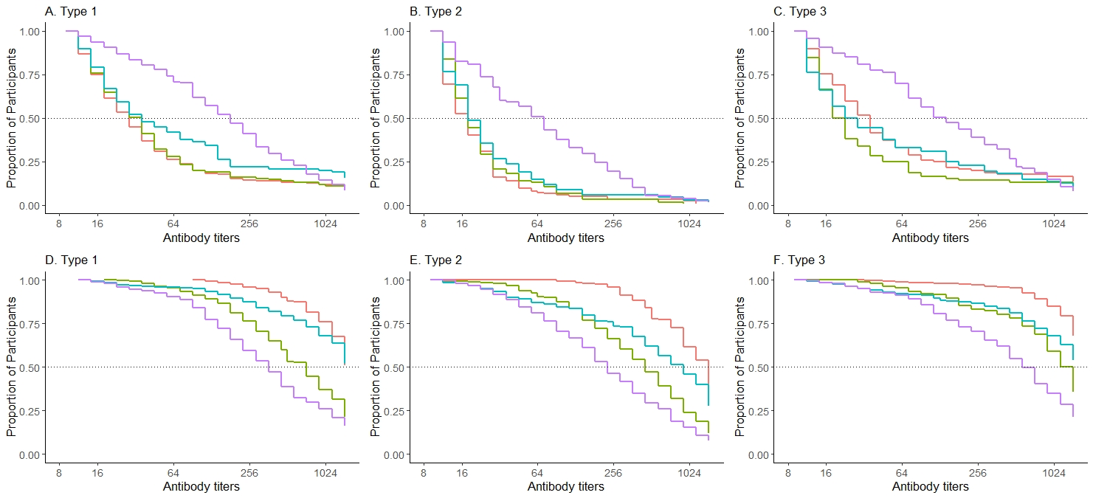

Figure S2. Reverse cumulative distribution function curves of reciprocal antibody titers to poliovirus types 1, 2, and 3 by study arm
(S2A-S2C) Proportion of participants (y-axis) with measured reciprocal antibody titers and all greater titers (x-axis) among vaccine responders at 22 weeks of age by poliovirus type (prior to booster vaccination). (S2D-S2F) Proportion of participants with measured reciprocal antibody titers and all greater titers among vaccine responders at 26 weeks of age by poliovirus type (four weeks after booster vaccination).

