Supplementary

Figure 1: Summary of study procedures

Figure 2. Participant Flow

Table 4. Agreement in testing results read by two conductors and over two time-points in 3 study sites

Table 5. Acceptability of dual RDTs among pregnant women in 3 study sites by baseline characteristics in Lusaka

Table 6. Operational feasibility of dual HIV-Syphilis rapid diagnostic test (RDT) by Test type

SDC 6 Dual HIV/Syphilis Testing Study : Patient Questionnaire

SDC 7 Operational Characteristics of Dual RDTs

SDC1: Figure 1. Summary of study procedures

Routine ANC testing includes, finger stick whole blood for HIV and syphilis testing according to national algorithms: Determine (Alere Medical Company Limited, Japan) confirmation with Uni-gold (Trinity Biotech, USA) and RPR syphilis tests depending on availability

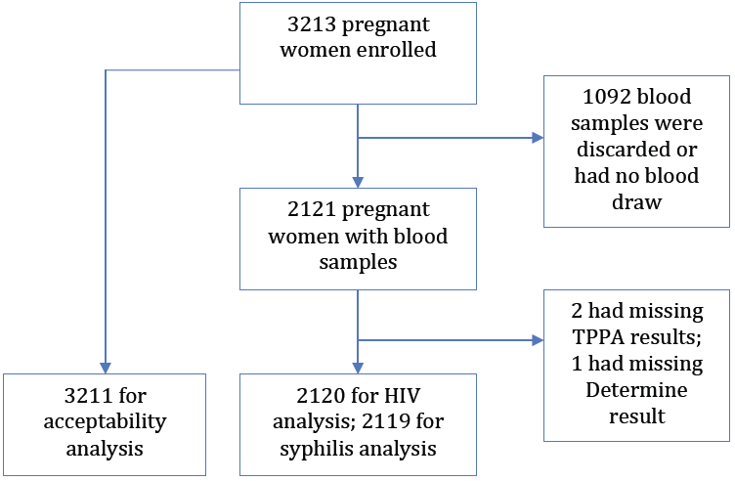

SDC 2: Figure 2: Participant Flow

SDC 3: Table 4. Agreement in testing results read by two conductors and over two time-points in 3 study sites
RDT by manufacturer | HIV component in RDTª |  |  | Syphilis component in RDTª
 | No. | Agreement | Kappa | No. | Agreement | Kappa
 |  | % |  |  | %
Chembio | 2109 | 99.6 | 0.99 | 2109 | 99.6 | 0.97
SD Bioline | 2091 | 99 | 0.96 | 2090 | 99 | 0.94
ª RDT = rapid diagnostic test.
^{b} Concordance was assessed using agreement of testing results read by clinic nurse 1 and 2 independently.
.

SDC 4: Table 5: Acceptability of dual RDTs among pregnant women in 3 urban health centres by baseline characteristics in Lusaka
Characteristics | Number (%) of test preference: |  |  |  | Number (%) willing to wait for results | % of those willing to wait for:
 | N | Dual | Single | Don’t know/ don’t care |  | 30mins | 1 hr | 2hrs
Age (Years)
18-19 | 455 | 453 (99.6) | 2 (0.4) | 0 | 455 (100) | 32.8 | 62.6 | 4.6
20-24 | 1145 | 1140 (99.6) | 3 (0.3) | 2 (0.2) | 1145 (100) | 28.8 | 65 | 6.2
25-29 | 790 | 788 (99.7) | 2 (0.3) | 0 | 790 (100) | 29.9 | 61.7 | 8.4
30-34 | 527 | 526 (99.8) | 0 | 1 (0.2) | 524 (99.6) | 29.6 | 64.7 | 5.7
35-45 | 289 | 289 (100) | 0 | 0 | 289 (100) | 26 | 70.6 | 3.5
Gestational age (Weeks)
<20 | 906 | 902 (99.6) | 3 (0.3) | 1 (0.1) | 905 (99.9) | 29.3 | 65.6 | 5.1
20+ | 2291 | 2285 (99.7) | 4 (0.2) | 2 (0.1) | 2290 (99.9) | 29.6 | 63.8 | 6.6
Travel time (mins)
<30mins | 1581 | 1578 (99.8) | 3 (0.2) | 0 | 1578 (99.8) | 32.1 | 61.5 | 6.4
30mins+ | 1615 | 1607 (99.5) | 5 (0.3) | 3 (0.2) | 1615 (100) | 27.1 | 66.9 | 6
Total | 3211 | 3201(99.7) | 7 (0.2) | 3 (0.1) | 3209 (99.9) | 29.5 | 64.3 | 6.2

SDC 5: Table 6. Operational feasibility of dual HIV-Syphilis rapid diagnostic test (RDT) by manufacturer
Operational characteristics | Chembio | SD Bioline | Variance ratio test, P-value
 | n=318 | n=316
 | Mean Score (SD) | Mean Score (SD)
Clarity of kit instruction (MOS =4) | 3.1(0.67) | 3.2(0.69) | 0.63
Ease of use (MOS =4) | 3.1(0.69) | 3.1(0.63) | 0.13
Ease of control of reading window time (MOS =3) | 2.7(0.44) | 2.8(0.42) | 0.38
Ease of interpretation of results (MOS =4) | 2.9(0.46) | 2.9(0.46) | 0.95
Rapidity of test results (MOS =3) | 2.6(0.52) | 2.5(0.58) | 0.07
Hands-on time (MOS =3) | 2.5(0.52) | 2.5(0.52) | 0.88
Training time required (MOS =4) | 3.2(0.93) | 3.2(0.96) | 0.66
Total (MOS =25) | 20.0(3.24) | 20.1(3.16) | 0.69
MOS=Maximum Obtainable Score

SDC 6

Dual HIV/Syphilis Testing Study

Patient Questionnaire

- Name of clinic:_________________________________________

- Study number _________________________________________

- Date (day/month/year): _______/______/____________

- Age or Date of birth (day/month/year): ______/______/________ ( _____ Years)

- Duration of gestation: _______________ weeks

- How long did it take for you to get to the clinic from home? __________ hours

(Please make an “X” on the number of the chosen answer)

- If we had a rapid test kit that could test for HIV and syphilis at the same time (dual test) and two single tests to separately test HIV and syphilis, which one would you prefer?
Dual (Jump to Question 8) Single Don’t know/don’t care

  - If you prefer single test, why?
Don’t want be tested for HIV Don’t want to be tested for syphilis
Other (please describe):__________________

- If a rapid test is available at this clinic, would you be willing to wait for the results:
Yes No

  - If yes, how long would you be willing to wait?
30 min. 1 hour 2 hours

SDC 7

Operational Characteristics of Dual RDTs

Name of test: __________________________
Manufacturer: __________________________
Survey date (day/month/year):______/_____/__________
Name of staff:________________________________________
 | Choice | Score
- Clarity of kit instructions
- Difficult to follow |  | 0
- Fairly clear |  | 1
- Very clear |  | 2
- Excellent |  | 3
- Ease of use
- Complicated |  | 0
- Fairly easy |  | 1
- Very easy |  | 2
- Excellent |  | 3
- Ease of control of reading window time
- Difficult |  | 0
- Fairly easy |  | 1
- Very easy |  | 2
- Ease of interpretation of results
- Difficult |  | 0
- Fairly easy |  | 1
- Very easy |  | 2
- Unambiguous |  | 3
- Rapidity of test results
- >30 minutes |  | 0
- 20-30 minutes |  | 1
- <20 minutes |  | 2
- Hands-on time
- >10 minutes |  | 0
- 5-10 minutes |  | 1
- <5 minutes |  | 2
- Training time required
- >2 hour |  | 0
- 1-2 hours |  | 1
- 30-59 minutes |  | 2
- <30 minutes |  | 3

