Supplemental Figure 1
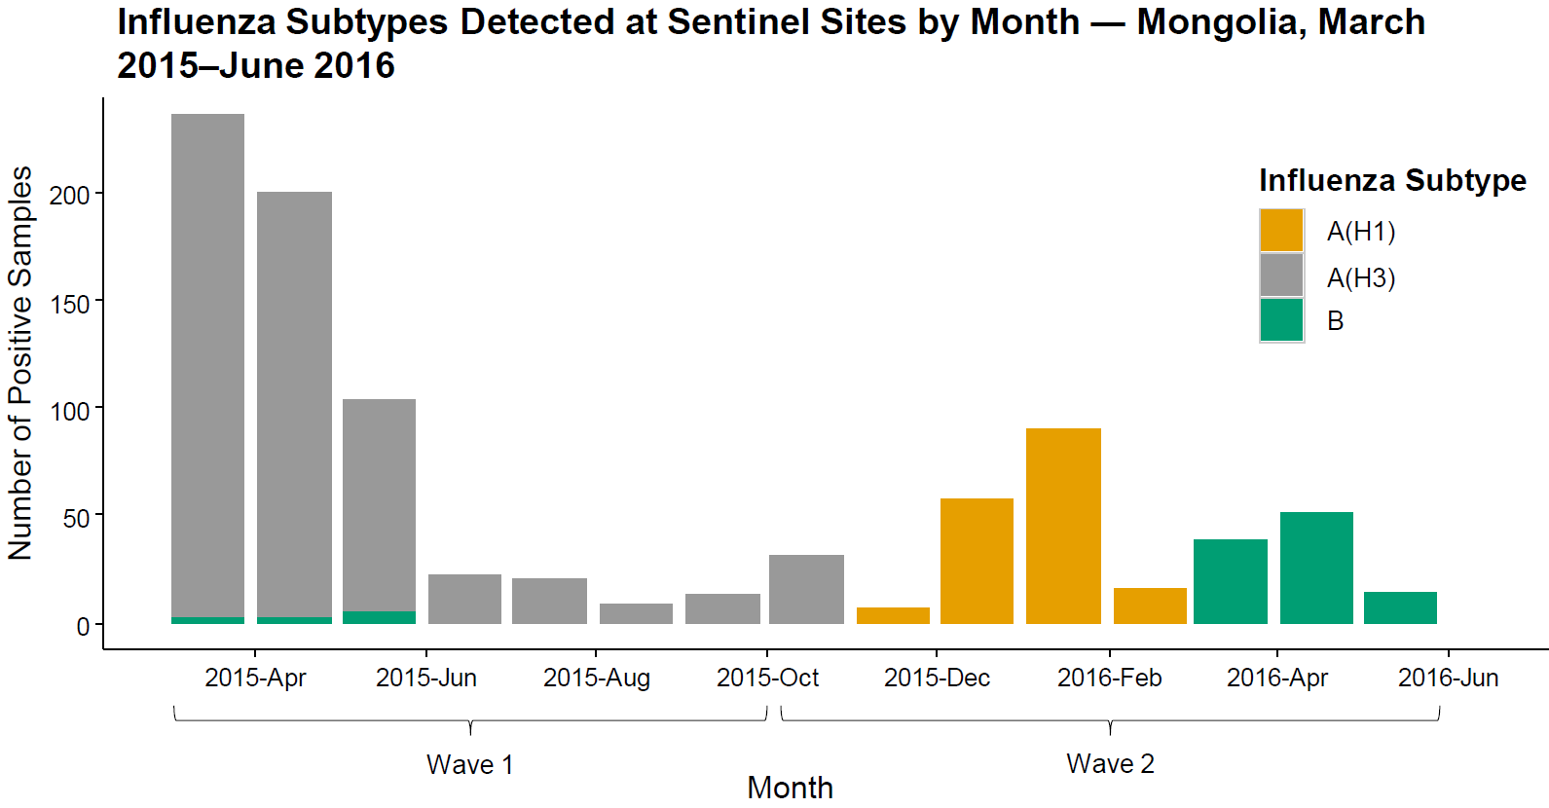
Figure S1: Laboratory-confirmed influenza detected by sentinel surveillance sites in Mongolia. During wave 1 (March–September, 2015), influenza A(H3) was the predominant circulating strain, although there were fewer hospitalizations for influenza-like illness observed than during wave 2 (October 2015–June 2016). Influenza A(H1) circulated in early 2016. Influenza B was exclusively detected during March–May, 2016, during which time infant influenza-like illnesses increased.

