0.08
Mary E. Ingle ª, Deborah Watkins ª, Zaira Rosario ^{b}, Carmen M. Vélez-Vega ^{b}, Antonia M. Calafat ^{c}, Maria Ospina ^{c}, Kelly K. Ferguson ^{d}, José F Cordero ^{e}, Akram Alshawabkeh ^{f}, John D. Meeker ^{a, *}
Supplemental Information

Supplemental Table 1. Demographic characteristics for 48 pregnant women in Puerto Rico
providing up to 3 urine measurements during pregnancy (n=141)
Characteristics | Median or n | (IQR or %)
Demographic characteristics
Age (years) | 27 | (23, 30)
Race/ ethnicity  White  Mestiza  Other | 28  17  3 | (58.3)  (35.4)  (6.3)
Body mass index (kg/m²) | 25.8 | (22.4, 29.0)
Ever smoker | 6 | (12.5)
Education ª  ≤ High school diploma or GED  Some college/technical school/ 2 yr. degree  Bachelor degree  Graduate or doctoral degree | 5  21  14  8 | (10.4)  (43.8)  (29.2)  (16.6)
Household Income  ≤ 19,999  20,000-39,999  ≥ 40,000 | 16  20  12 | (33.3)  (41.7)  (25.0)
Characteristics by visit
Gestational age at urine collection (weeks)  Visit 1 ^{b}  Visit 2 ^{c}  Visit 3 ^{d} | 17  24  26 | (16, 20)  (22, 25)  (26, 29)
ª n=9 missing; ^{b} n=3 missing; ^{c} n=8 missing; ^{d} n=9 missing

Supplemental Figure 1: Correlation matrix (Spearman) for 8-isoprostane, 8-hydroxydeoxyguanosine (OHdG), and urinary OPE metabolites among pregnant women in Puerto Rico

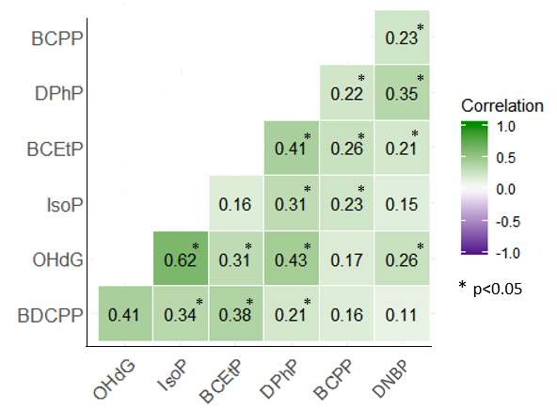

Supplemental Table 2. Regression coefficients (95 %CI) for the association of reported urinary 8-Isoprostane, 8-hydroxydeoxyguanosine and urinary PFR samples among 48 pregnant women (n=141 samples) in the PROTECT cohort
 | PFR ª
 | BCEtP |  |  |  | BCPP |  |  | BDCPP |  |  | DNBP ^{b} |  |  | DPHP
Biomarkers ª | β |  | (95%CI) | p | β | (95%CI) | p | β | (95%CI) | p | β | (95%CI) | p | β | (95%CI) | p
8-isoprostane | 0.06 | (-0.05, 0.18) |  | 0.26 | 0.10 | (-0.01, 0.22) | 0.08 | 0.17 | (0.05, 0.28) | 0.004 | -0.16 | (-0.39, 0.06) | 0.16 | 0.08 | (0.005, 0.16) | 0.04
OHdG | 0.07 | (-0.02, 0.15) |  | 0.13 | -0.01 | (-0.10, 0.09) | 0.89 | 0.15 | (0.06, 0.24) | 0.002 | -0.22 | (-0.39, -0.04) | 0.02 | 0.12 | (0.06, 0.18) | 0.0001
ª natural log transformation; ^{b} DNBP modeled as detect/non-detect; p: p-Value; OHdG: 8-hydroxydeoxyguanosine; Models adjusted for SG, age, BMI, gestational age, and income

Supplemental Table 3. Regression coefficients (95 %CI) for the association of reported urinary 8-Isoprostane, 8-hydroxydeoxyguanosine and urinary PFR samples among 48 pregnant women in the PROTECT cohort stratified by visit
 | 8-Isoprostane
 |  | Visit 1 |  |  | Visit 2 |  |  | Visit 3
 | β | (95%CI) | p | β | (95%CI) | p | β | (95%CI) | p
BCEtP | 0.14 | (-0.10, 0.28) | 0.24 | -0.10 | (-0.27, 0.08) | 0.27 | 0.05 | (-0.14, 0.24) | 0.60
BCPP | 0.02 | (-0.18, 0.23) | 0.82 | 0.07 | (-0.12, 0.27) | 0.44 | 0.10 | (-0.11, 0.30) | 0.34
BDCPP | 0.23 | (0.07, 0.39) | 0.01 | 0.01 | (-0.22, 0.24) | 0.92 | 0.11 | (-0.13, 0.36) | 0.35
DPHP | 0.09 | (-0.05, 0.24) | 0.18 | -0.004 | (-0.14, 0.13) | 0.95 | 0.19 | (0.07, 0.32) | 0.003
 | 8-hydroxydeoxyguanosine
 | Visit 1 |  |  | Visit 2 |  |  | Visit 3
 | β | (95%CI) | p | β | (95%CI) | p | β | (95%CI) | p
BCEtP | 0.08 | (-0.08, 0.24) | 0.29 | -0.01 | (-0.17, 0.16) | 0.94 | 0.15 | (-0.002, 0.29) | 0.05
BCPP | -0.03 | (-0.16, 0.11) | 0.71 | -0.01 | (-0.27, 0.10) | 0.34 | 0.09 | (-0.08, 0.26) | 0.28
BDCPP | 0.21 | (0.11, 0.31) | <0.0001 | 0.02 | (-0.20, 0.24) | 0.86 | 0.18 | (-0.02, 0.28) | 0.07
DPHP | 0.11 | (0.03, 0.20) | 0.01 | 0.03 | (-0.11, 0.16) | 0.70 | 0.21 | (0.02, 0.30) | <0.0001
Visit 1: n=48 observations, Visit 2: n=46 observations, Visit 3: n=47 observations

