Supplement to MI-Environment: Geospatial Patterns for Relative Heat Stress Vulnerability in Michigan

Table of Tables
Table S- 1: Comparison of level of spatial resolution by HVI factor 4
Table S- 2: Inequality curve analysis significance tests of heat exposure for individual and cumulative indicators of vulnerability within Michigan that excludes the Detroit metropolitan area to remove any bias from the state’s largest metropolitan area (Michigan, n=2813 census tracts) 5
Table S- 3: Inequality curve significance tests of heat exposure for individual and cumulative indicators of vulnerability within the Detroit metropolitan area (Michigan, n=2813 census tracts) 6
Table S- 4 Inequality curve significance tests of heat vulnerability exposure for individual and cumulative indicators of vulnerability comparing Michigan’s urban and rural areas (Michigan, n=2813 census tracts) 7
Table S- 5: Descriptive statistics for Analtyic HVI, Place, Temperature, People indices and social vulnerability factors for all Michigan census tracts, all Michigan census tracts excluding the Detroit metropolitan area (rest of Michigan), and only those census tracts within the Detroit metropolitan area (n = 2813) 8
Table S- 6: Pairwise comparisons of descriptive statistics for heat stress, people, place, temperature, and social vulnerabilities between all Michigan census tracts, all Michigan census tracts excluding the Detroit metropolitan area, and only those census tracts within the Detroit metropolitan area (n=2813) 9

Table of Figures
Fig. S- 1: Inequality curve showing the relative distribution of inequality between the Analytic HVI and the Place Index for all Michigan geographies excluding the Detroit metropolitan area 10
Fig. S- 2: Inequality curve showing the relative distribution of inequality between the Analytic HVI and the Analytic People Index for all Michigan geographies excluding the Detroit metropolitan area 10
Fig. S- 3: Inequality curve showing the relative distribution of inequality between the Place Index and the Analytic People Index for all Michigan geographies excluding the Detroit metropolitan area 11
Fig. S- 4: Inequality curve showing the relative distribution of inequality between the Analytic HVI and race for all Michigan geographies excluding the Detroit metropolitan area 11
Fig. S- 5: Inequality curve showing the relative distribution of inequality between the Analytic HVI and renter populations for all Michigan geographies excluding the Detroit metropolitan area 12
Fig. S- 6: Inequality curve showing the relative distribution of inequality between the Analytic HVI and median home value for all Michigan geographies excluding the Detroit metropolitan area 12
Fig. S- 7: Inequality curve showing the relative distribution of inequality between the Analytic HVI and poverty for all Michigan geographies excluding the Detroit metropolitan area 13
Fig. S- 8: Inequality curve showing the relative distribution of inequality between the Analytic HVI and severe poverty for all Michigan geographies excluding the Detroit metropolitan area 13
Fig. S- 9: Inequality curve showing the relative distribution of inequality between the Analytic HVI and education for all Michigan geographies excluding the Detroit metropolitan area 14
Fig. S- 10: Inequality curve showing the relative distribution of inequality between the Analytic HVI and linguistic isolation for all Michigan geographies excluding the Detroit metropolitan area 14
Fig. S- 11 Inequality curve showing the relative distribution of inequality between the Analytic HVI and the Place Index for the Detroit metropolitan area only 15
Fig. S- 12 Inequality curve showing the relative distribution of inequality between the Analytic HVI and the Analytic People Index for the Detroit metropolitan area only 15
Fig. S- 13 Inequality curve showing the relative distribution of inequality between the Place Index and the Analytic People Index for the Detroit metropolitan area only 16
Fig. S- 14 Inequality curve showing the relative distribution of inequality between the Analytic HVI and race for the Detroit metropolitan area only 16
Fig. S- 15 Inequality curve showing the relative distribution of inequality between the Analytic HVI and renter population for the Detroit metropolitan area only 17
Fig. S- 16 Inequality curve showing the relative distribution of inequality between the Analytic HVI and median home value for the Detroit metropolitan area only 17
Fig. S- 17 Inequality curve showing the relative distribution of inequality between the Analytic HVI and poverty for the Detroit metropolitan area only 18
Fig. S- 18 Inequality curve showing the relative distribution of inequality between the Analytic HVI and severe poverty for the Detroit metropolitan area only 18
Fig. S- 19 Inequality curve showing the relative distribution of inequality between the Analytic HVI and education for the Detroit metropolitan area only 19
Fig. S- 20 Inequality curve showing the relative distribution of inequality between the Analytic HVI and linguistic isolation for the Detroit metropolitan area only 19
Fig. S- 21 Inequality curve showing the relative distribution of inequality between the Analytic HVI and the Place Index for Michigan’s urban geographies only 20
Fig. S- 22 Inequality curve showing the relative distribution of inequality between the Analytic HVI and the Analytic People Index for Michigan’s urban geographies only 20
Fig. S- 23 Inequality curve showing the relative distribution of inequality between the Place Index and the Analytic People Index for Michigan’s urban geographies only 21
Fig. S- 24 Inequality curve showing the relative distribution of inequality between the Analytic HVI and race for Michigan’s urban geographies only 21
Fig. S- 25 Inequality curve showing the relative distribution of inequality between the Analytic HVI and renter population for Michigan’s urban geographies only 22
Fig. S- 26 Inequality curve showing the relative distribution of inequality between the Analytic HVI and median home value for Michigan’s urban geographies only 22
Fig. S- 27 Inequality curve showing the relative distribution of inequality between the Analytic HVI and poverty for Michigan’s urban geographies only 23
Fig. S- 28 Inequality curve showing the relative distribution of inequality between the Analytic HVI and severe poverty for Michigan’s urban geographies only 23
Fig. S- 29 Inequality curve showing the relative distribution of inequality between the Analytic HVI and education for Michigan’s urban geographies only 24
Fig. S- 30 Inequality curve showing the relative distribution of inequality between the Analytic HVI and linguistic isolation for Michigan’s urban geographies only 24
Fig. S- 31 Inequality curve showing the relative distribution of inequality between the Analytic HVI and the Place Index for Michigan’s rural geographies only 25
Fig. S- 32 Inequality curve showing the relative distribution of inequality between the Analytic HVI and the Analytic People Index for Michigan’s rural geographies only 25
Fig. S- 33 Inequality curve showing the relative distribution of inequality between the Place Index and the Analytic People Index for Michigan’s rural geographies only 26
Fig. S- 34 Inequality curve showing the relative distribution of inequality between the Analytic HVI and race for Michigan’s rural geographies only 26
Fig. S- 35 Inequality curve showing the relative distribution of inequality between the Analytic HVI and renter population for Michigan’s rural geographies only 27
Fig. S- 36 Inequality curve showing the relative distribution of inequality between the Analytic HVI and median home value for Michigan’s rural geographies only 27
Fig. S- 37 Inequality curve showing the relative distribution of inequality between the Analytic HVI and poverty for Michigan’s rural geographies only 28
Fig. S- 38 Inequality curve showing the relative distribution of inequality between the Analytic HVI and severe poverty for Michigan’s rural geographies only 28
Fig. S- 39 Inequality curve showing the relative distribution of inequality between the Analytic HVI and education for Michigan’s rural geographies only 29
Fig. S- 40 Inequality curve showing the relative distribution of inequality between the Analytic HVI and linguistic isolation for Michigan’s rural geographies only 29

Category | Original Spatial Unit converted to Census Tract Level | Factor | Data Source
Place | Continuous raster 30 m | % Lack of tree canopy coverage | Homer, C.G., Dewitz, J.A., Yang, L., et al., 2015
 | Continuous raster | % Impervious surface
Temper-ature | 10 Climatic regions | Change in projected average seasonal temperature (2041-2070) – (1981-2010) | Great Lakes Integrated Sciences Assessment, Coupled Model Intercomparison Project Phase 3, 2016
 |  | Number of projected hot days over 90 degrees Fahrenheit or 32.2 degrees Celsius (2041-2070)
 |  | Projected average seasonal temperature (2041-2070)
People | Block Group | % of the population over 65 and living alone | U.S. Census Bureau, 2012
 |  | % of children under 5 years
 |  | % of households with no access to a personal vehicle | U.S. Census Bureau, 2013
 | County | % of the population obese BMI > 30kg/m² | Michigan Department of Health and Human Services, 2012
Table S- 1: Comparison of level of spatial resolution by HVI factor

Vulnerability Index | Category of Inequality | Rest of Michigan  (Tri-County Excluded, n=1647)
 |  | Inequality Index | 95% CI
Analytic Heat Stress Vulnerability Index  (Poverty variable excluded) | Proportion people of color | -0.056 | (-0.050,-0.061)***
 | Proportion residents living below poverty | -0.074 | (-0.068,-0.081)***
 | Proportion residents living below twice poverty | -0.081 | (-0.075,-0.087)***
 | Proportion living in rented households | -0.071 | (-0.065,-0.077)***
 | Median house value | -0.102 | (-0.095,-0.109)***
 | Proportion over age 24 without high school completion | -0.068 | (-0.062,-0.074)***
 | Linguistic Isolation | 0.041 | (-0.003,0.087)
Temperature Index | Place Index | -0.082 | (-0.076,-0.088)***
 | People Index (Poverty variable excluded) | -0.018 | (-0.013,-0.023)*
Place Index | People Index (Poverty variable excluded) | -0.060 | (-0.054,-0.066)***
* 0.1<p<0.05, ** 0.05<p<0.001, *** p<0.001
Table S- 2: Inequality curve analysis significance tests of heat exposure for individual and cumulative indicators of vulnerability within Michigan that excludes the Detroit metropolitan area to remove any bias from the state’s largest metropolitan area (Michigan, n=2813 census tracts)

Vulnerability Index | Category of Inequality | Tri-County(n=1166)
 |  | Inequality Index | 95% CI
Analytic Heat Stress Vulnerability Index  (Poverty variable excluded) | Proportion people of color | -0.114 | (-0.107,-0.121)***
 | Proportion residents living below poverty | -0.134 | (-0.126,-0.141)***
 | Proportion residents living below twice poverty | -0.145 | (-0.137,-0.153)***
 | Proportion living in rented households | -0.116 | (-0.109,-0.123)***
 | Median house value | -0.171 | (-0.163,-0.180)***
 | Proportion over age 24 without high school completion | -0.112 | (-0.105,-0.119)***
 | Linguistic Isolation | -0.029 | (-0.024,-0.034)
Temperature Index | Place Index | -0.163 | (-0.155,-0.171)***
 | Analytic People Index (Poverty variable excluded) | -0.190 | (-0.181,-0.199)***
Place index | Analytic People Index (Poverty variable excluded) | -0.193 | (-0.184,-0.202)***
* 0.1<p<0.05, ** 0.05<p<0.001, *** p<0.001
Table S- 3: Inequality curve significance tests of heat exposure for individual and cumulative indicators of vulnerability within the Detroit metropolitan area (Michigan, n=2813 census tracts)

Significance tests of inequality in heat vulnerability exposure for individual and cumulative indicators of vulnerability (Urban vs Rural)
 |  | Urban(n=2347) |  | Rural (n=466)
Vulnerability Index | Category of Inequality | Inequality Index | 95% CI | Inequality Index | 95% CI
Analytic Heat Stress Vulnerability Index  (Poverty variable excluded) | Proportion people of color | -0.120 | (-0.112,-0.127)*** | 0.038 | (-0.170, 0.039)
 | Proportion residents living below poverty | -0.114 | (-0.106,-0.121)*** | -0.026 | (-0.296,0.243)
 | Proportion residents living below twice poverty | -0.122 | (-0.114,-0.129)*** | -0.030 | (-0.303,0.243)
 | Proportion living in rented households | -0.108 | (-0.101,-0.115)*** | 0.011 | (-0.221,0.243)
 | Median house value | -0.156 | (-0.148,-0.164)*** | -0.058 | (-0.362,0.246)
 | Proportion over age 24 without high school completion | -0.113 | (-0.106,-0.12)*** | -0.033 | (-0.309,0.244)
 | Proportion linguistic isolation | 0.090 | (-0.750, 0.929) | 0.025 | (-1.074,1.124)
Temperature Index | Place Index | -0.115 | (-0.108,-0.123)*** | -0.050 | (-0.345,0.245)
 | Analytic People Index (Poverty variable excluded) | -0.056 | (-0.050,-0.062)*** | -0.005 | (-0.253,0.243)
Place Index | Analytic People Index (Poverty variable excluded) | -0.119 | (-0.112,-0.126)*** | -0.034 | (-0.312,0.244)
* 0.1<p<0.05, ** 0.05<p<0.001, *** p<0.001
Table S- 4 Inequality curve significance tests of heat vulnerability exposure for individual and cumulative indicators of vulnerability comparing Michigan’s urban and rural areas (Michigan, n=2813 census tracts)

 | (A) |  | (B) |  | ( C )
 | Michigan (2813 census tracts)  n= (2722-2767) |  | Rest Michigan (1647 census tracts) n= (1577-1604) |  | Tri-County (1166 census tracts) n= (1145-1163)
Variable | Mean (SD) | Min - Max | Mean (SD) | Min - Max | Mean (SD) | Min - Max
Analytic Heat Stress Vulnerability Index | 51.8 (12.1) | 15.0 - 85.0 | 46.1 (10.2) | 15.0 - 79.0 | 59.7 (10.0) | 30.0 - 85.0
Place Index | 46.5 (20.2) | 8.0 - 100.0 | 35.6 (16.0) | 8.0 - 100.0 | 61.5 (15.3) | 21.0 - 100.0
Percent Lack of Tree Canopy | 38.1 (17.1) | 0.0 - 83.5 | 47.1 (14.1) | 0.0 - 83.5 | 25.7 (12.7) | 0.0 - 59.7
Percent Impervious Surface Coverage | 29.1 (23.2) | 0.0 - 93.5 | 17.2 (18.7) | 0.0 - 93.0 | 45.5 (18.5) | 0.7 - 93.4
Temperature Index | 65.2 (15.0) | 2.0 - 100 | 59.1 (16.8) | 2.0 - 100.0 | 73.6 (4.5) | 59.0 - 82.0
Average Heat Index | 92.1 (20.7) | 0.0 - 100.0 | 86.3 (25.8) | 0.0 - 100.0 | 100.0 (0.0) | 100.0 - 100.0
Extreme Heat Index | 56.3 (14.8) | 0.0 - 100.0 | 50.1 (16.2) | 0.0 - 100.0 | 64.9 (6.0) | 44.7 - 76.6
Analytic People index | 43.8 (13.8) | 0.0 - 100.0 | 43.5 (13.1) | 0.0 - 94.0 | 44.2 (14.8) | 5.0 - 100.0
Obesity Prevalence | 52.9 (20.9) | 0.0 - 100.0 | 55.0 (21.6) | 0.0 - 100.0 | 50.0 (19.6) | 19.6 - 63.7
Percent 65+ Living Alone | 25.3 (13.6) | 0.0 - 100.0 | 24.5 (12.5) | 0.0 - 78.1 | 26.3 (15.0) | 0.0 - 100.0
Percent <5 Years Old | 27.3 (12.1) | 0.0 - 100.0 | 27.0 (11.7) | 0.0 - 100.0 | 27.7 (12.7) | 0.0 - 88.4
Percent No Personal Transportation | 8.9 (9.8) | 0.0 - 100.0 | 7.2 (7.7) | 0.0 - 100.0 | 11.2 (11.8) | 0.0 - 69.9
Population Vulnerability Indicator from American Community Survey (2008-2012)
% People of color | 24 (29.7) | 0.0 - 100.0 | 14.1 (19) | 0.0 - 99.5 | 37.7 (35.8) | 0.0 - 100.0
% age 25 and older with < High School | 12.3 (8.8) | 0.0 - 83.3 | 11.2 (7.2) | 0.0 - 83.3 | 13.9 (10.4) | 0.0 - 67.1
% Living in rented households | 28.3 (21.1) | 0.0 - 100.0 | 26.0 (20.4) | 0.0 - 100.0 | 31.4 (21.6) | 0.0 - 100.0
Median house value | 129,083.6 (69,660.3) | 12,500.0 - 674,900.0 | 128,722.0 (56,514.0) | 12,500.0 -639,600.0 | 129,581.6 (84,507.2) | 13,400.0 -674,900.0
% below poverty line | 18.2 (14.9) | 0.0 - 100.0 | 17.3 (13.5) | 0.0 - 100.0 | 19.3 (16.6) | 0.0 - 100.0
% below twice poverty line | 37.1 (19.9) | 0.0 - 100.0 | 37.0 17.6) | 0.0 - 100.0 | 37.3 (22.8) | 0.0 - 100.0
Linguist isolation: 5 years+ living in households where no one age 18 and older speaks English | 0.3 (0.9) | 0.0 - 11.2 | 0.2 (0.7) | 0.0 - 11.2 | 0.4 (1.1) | 0.0 - 10.9
1: Comparisons significant at the 0.05 level are indicated by ***
Table S- 5: Descriptive statistics for Analtyic HVI, Place, Temperature, People indices and social vulnerability factors for all Michigan census tracts, all Michigan census tracts excluding the Detroit metropolitan area (rest of Michigan), and only those census tracts within the Detroit metropolitan area (n = 2813)
 | Pairwise test for comparisons
 | Tukey's Studentized Range (HSD)¹ p-values²
Factor | (A) vs (B) | Area³  (A) vs (C) | (B) vs (C)
Analytic Heat Stress Vulnerability Index | ** | ** | **
Place Index | ** | ** | **
Percent Lack of Tree Canopy | ** | ** | **
Percent Impervious Surface Coverage | ** | ** | **
Temperature Index | ** | ** | **
Average Heat Index | ** | ** | **
Extreme Heat Index | ** | ** | **
Analytic People index
Obesity Prevalence | ** | ** | **
Percent 65+ Living Alone |  |  | **
Percent <5 Years Old
Percent No Personal Transportation | ** | ** | **
Population Vulnerability Indicator from American Community Survey 2008-2012
% People of color |  | ** | **
% age 25 and older with < High School |  | ** | **
% Living in rented households |  | ** | **
Median House value
% below poverty line |  |  | **
% below twice poverty line
Linguist isolation : % 5 and older living in households where no one age 18 and older speaks English | ** | ** | **
¹This test controls the Type I experiment-wise error rate.
²Comparisons significant at the p<0.05 level are indicated by **
³Area (A) Michigan (2813 census tracts), Area (B) Rest Michigan (1647 census tracts), Area (C) Tri-County Detroit (1166 census tracts)

Table S- 6: Pairwise comparisons of descriptive statistics for heat stress, people, place, temperature, and social vulnerabilities between all Michigan census tracts, all Michigan census tracts excluding the Detroit metropolitan area, and only those census tracts within the Detroit metropolitan area (n=2813)
Pairwise t-test using Tukey’s studentized range comparing (A) the whole state of Michigan to (B) the Rest of Michigan or to (C) the Tri-County Detroit Metro area show that there are significant differences at the 95% confidence level of means of the aggregate Analytic Health Stress Vulnerability Index as well as some of its components such as Place and Temperature. The People dimension of the cumulative index had some of its components significantly different when comparing (C) the Tri-County Detroit Metro Area to (B) the Rest of Michigan.
Eigenvalues of the Correlation Matrix using SAS FACTOR procedure
Factor Eigenvalue Difference Proportion Cumulative
1 Place 2.61709993 1.67996582 0.6543 0.6543
2 Temperature 0.93713411 0.49167356 0.2343 0.8886
3 People (poverty excluded) 0.44546055 0.44515514 0.1114 0.9999
4 0.00030541 0.0001 1.0000

Table S- 6: Principal component analyses of Place, Temperature and Analytic People indices

Figures S-1 to S-10: Inequality Curves for the Rest of Michigan, Excluding Metropolitan Detroit

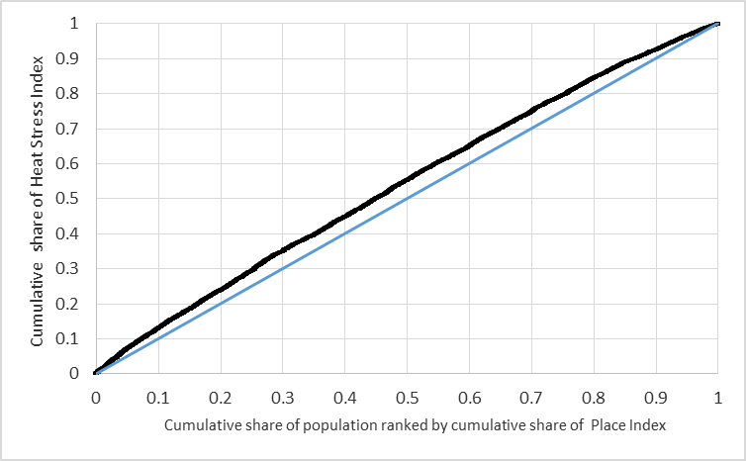
Fig. S- 1: Inequality curve showing the relative distribution of inequality between the Analytic HVI and the Place Index for all Michigan geographies excluding the Detroit metropolitan area

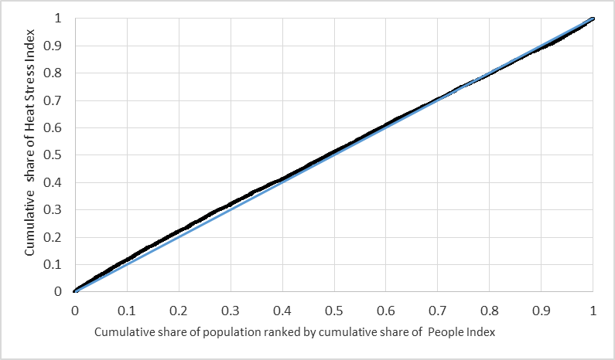
Fig. S- 2: Inequality curve showing the relative distribution of inequality between the Analytic HVI and the Analytic People Index for all Michigan geographies excluding the Detroit metropolitan area

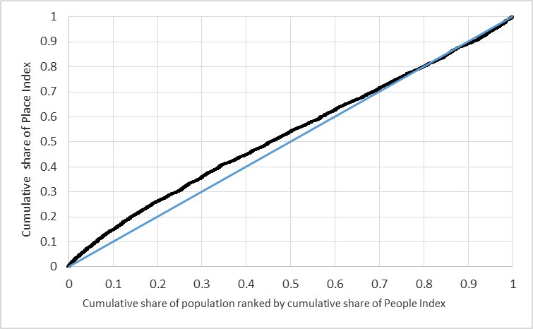
Fig. S- 3: Inequality curve showing the relative distribution of inequality between the Place Index and the Analytic People Index for all Michigan geographies excluding the Detroit metropolitan area

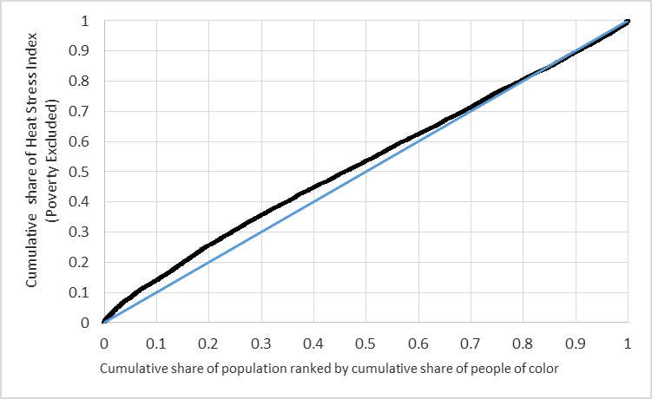
Fig. S- 4: Inequality curve showing the relative distribution of inequality between the Analytic HVI and race for all Michigan geographies excluding the Detroit metropolitan area

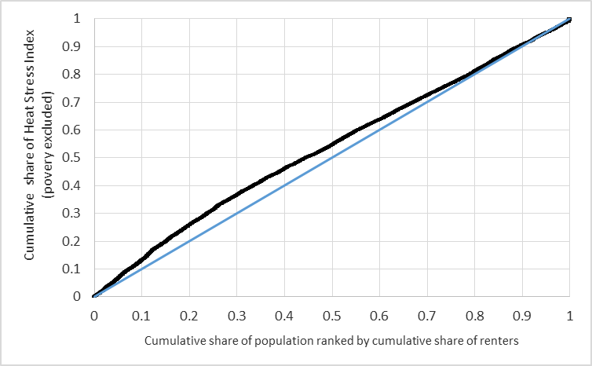
Fig. S- 5: Inequality curve showing the relative distribution of inequality between the Analytic HVI and renter populations for all Michigan geographies excluding the Detroit metropolitan area

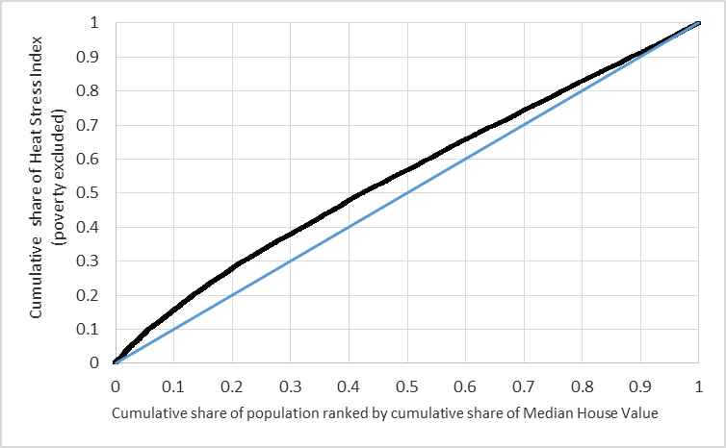
Fig. S- 6: Inequality curve showing the relative distribution of inequality between the Analytic HVI and median home value for all Michigan geographies excluding the Detroit metropolitan area

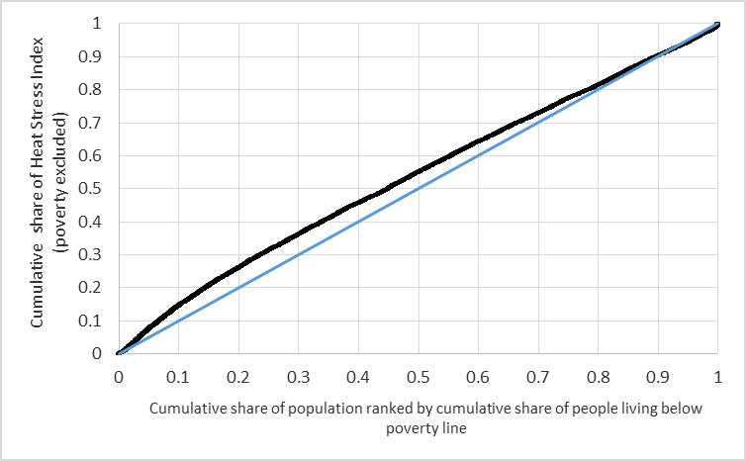
Fig. S- 7: Inequality curve showing the relative distribution of inequality between the Analytic HVI and poverty for all Michigan geographies excluding the Detroit metropolitan area

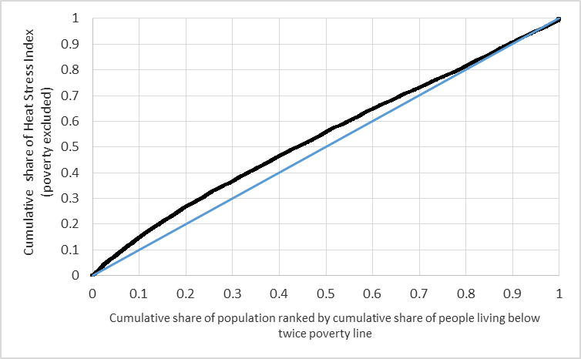
Fig. S- 8: Inequality curve showing the relative distribution of inequality between the Analytic HVI and severe poverty for all Michigan geographies excluding the Detroit metropolitan area

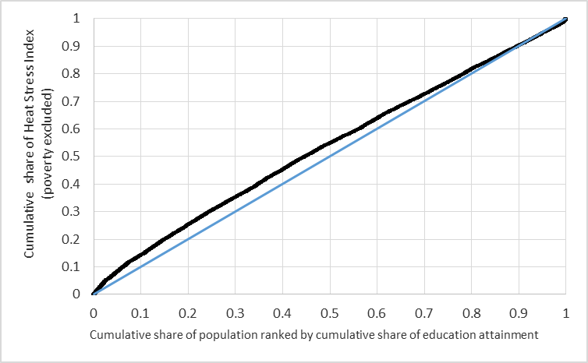
Fig. S- 9: Inequality curve showing the relative distribution of inequality between the Analytic HVI and education for all Michigan geographies excluding the Detroit metropolitan area

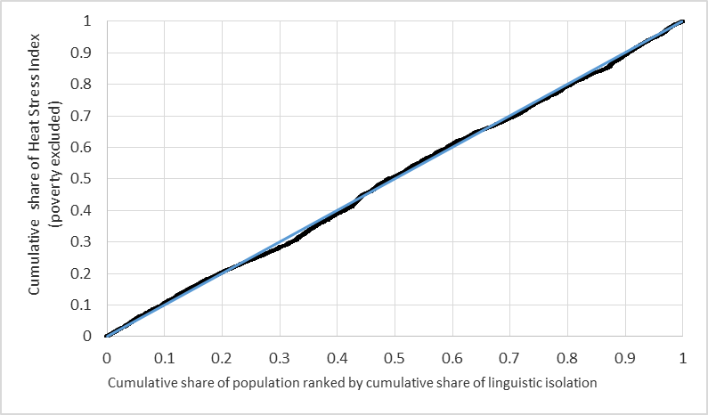
Fig. S- 10: Inequality curve showing the relative distribution of inequality between the Analytic HVI and linguistic isolation for all Michigan geographies excluding the Detroit metropolitan area

Figures S-11 to S-20: Inequity Curves for Tri-County Metropolitan Detroit Only

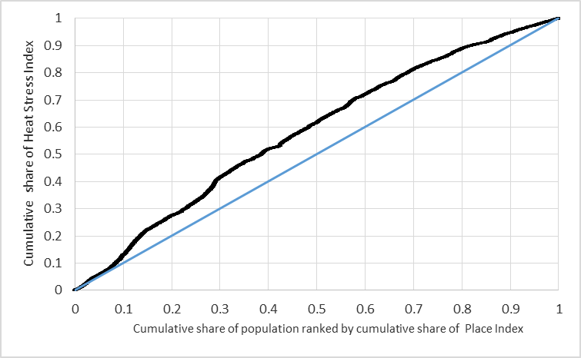
Fig. S- 11 Inequality curve showing the relative distribution of inequality between the Analytic HVI and the Place Index for the Detroit metropolitan area only

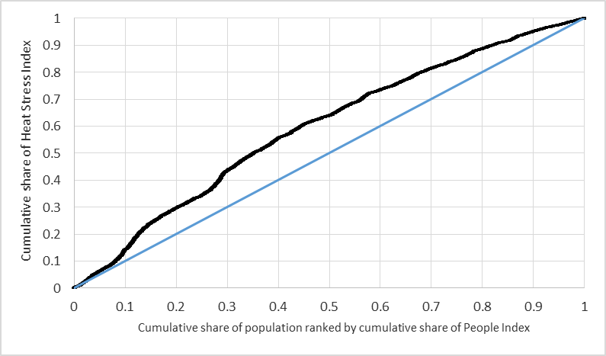
Fig. S- 12 Inequality curve showing the relative distribution of inequality between the Analytic HVI and the Analytic People Index for the Detroit metropolitan area only

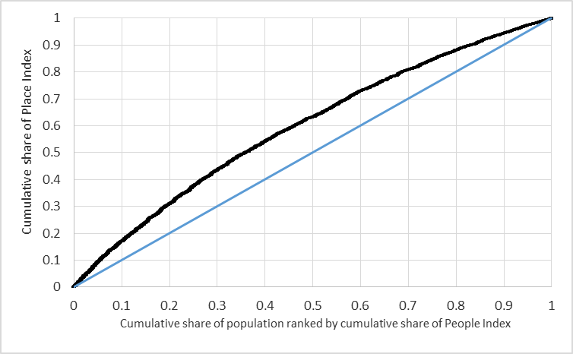
Fig. S- 13 Inequality curve showing the relative distribution of inequality between the Place Index and the Analytic People Index for the Detroit metropolitan area only

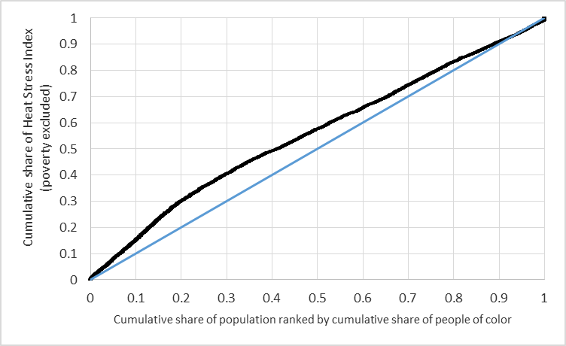
Fig. S- 14 Inequality curve showing the relative distribution of inequality between the Analytic HVI and race for the Detroit metropolitan area only

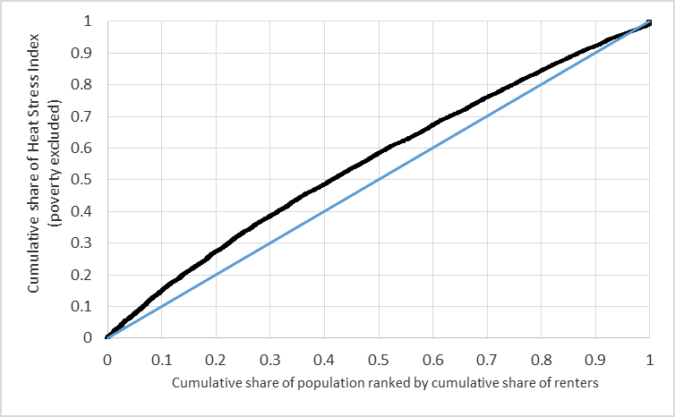
Fig. S- 15 Inequality curve showing the relative distribution of inequality between the Analytic HVI and renter population for the Detroit metropolitan area only

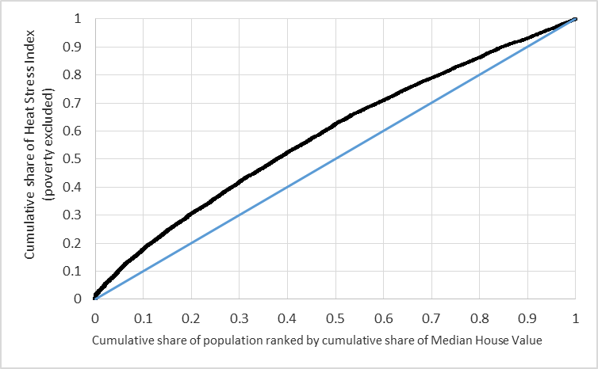
Fig. S- 16 Inequality curve showing the relative distribution of inequality between the Analytic HVI and median home value for the Detroit metropolitan area only

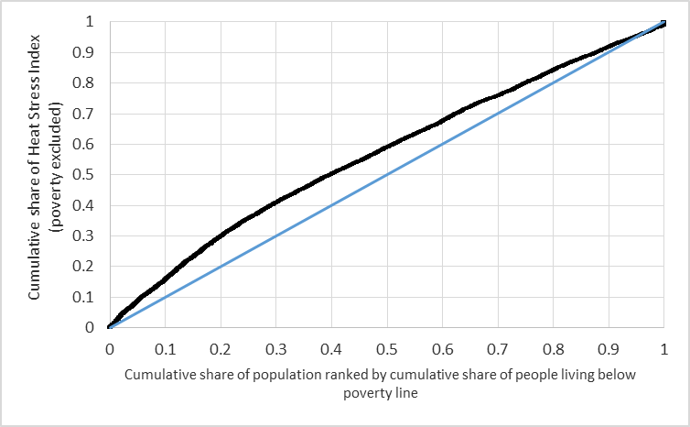
Fig. S- 17 Inequality curve showing the relative distribution of inequality between the Analytic HVI and poverty for the Detroit metropolitan area only

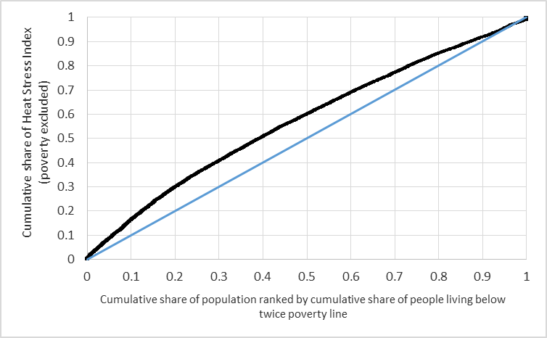
Fig. S- 18 Inequality curve showing the relative distribution of inequality between the Analytic HVI and severe poverty for the Detroit metropolitan area only

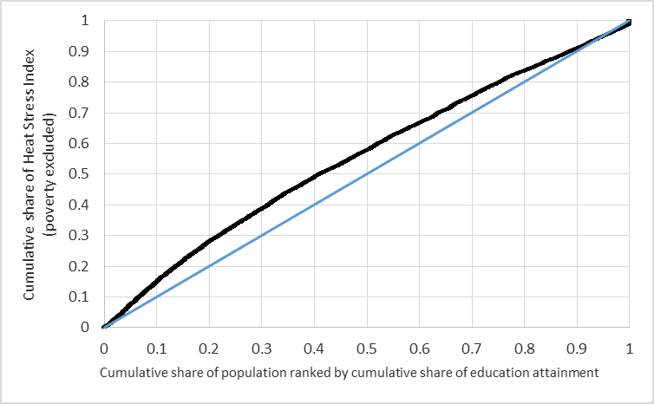
Fig. S- 19 Inequality curve showing the relative distribution of inequality between the Analytic HVI and education for the Detroit metropolitan area only

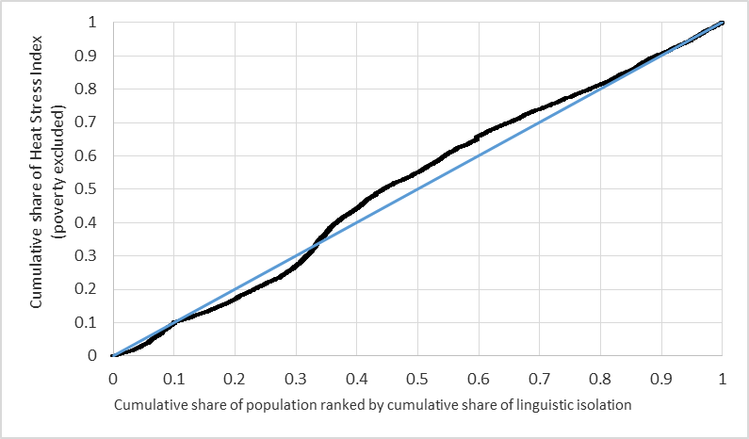
Fig. S- 20 Inequality curve showing the relative distribution of inequality between the Analytic HVI and linguistic isolation for the Detroit metropolitan area only

Figures S-21 to S-30: Inequality Curves for Michigan’s Urban Geographies Only
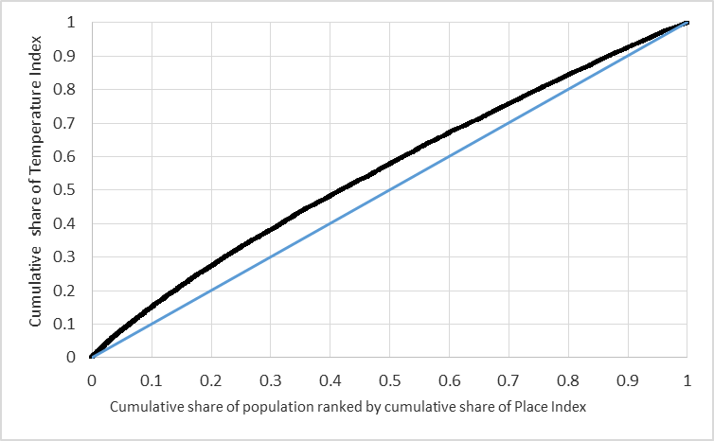
Fig. S- 21 Inequality curve showing the relative distribution of inequality between the Analytic HVI and the Place Index for Michigan’s urban geographies only
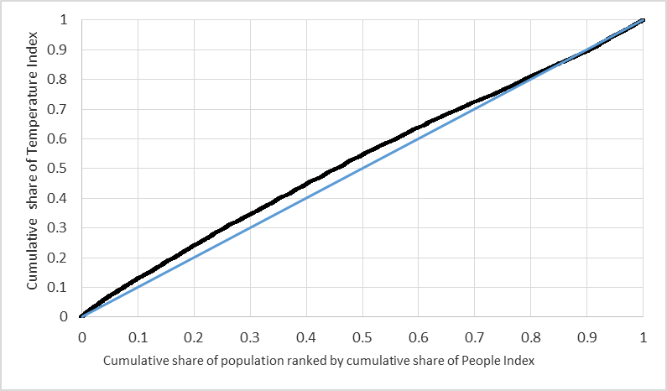
Fig. S- 22 Inequality curve showing the relative distribution of inequality between the Analytic HVI and the Analytic People Index for Michigan’s urban geographies only
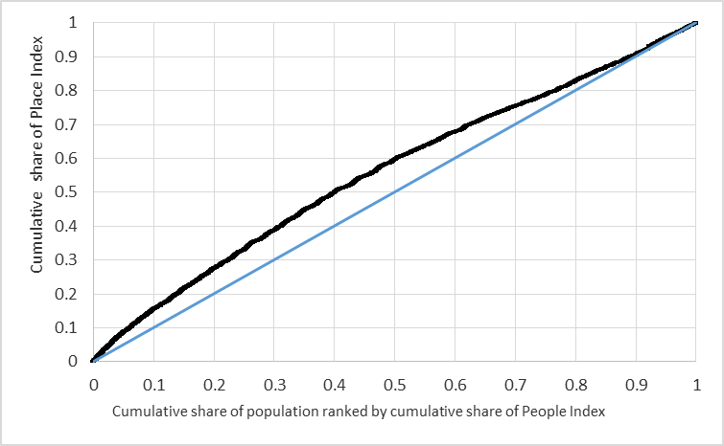
Fig. S- 23 Inequality curve showing the relative distribution of inequality between the Place Index and the Analytic People Index for Michigan’s urban geographies only
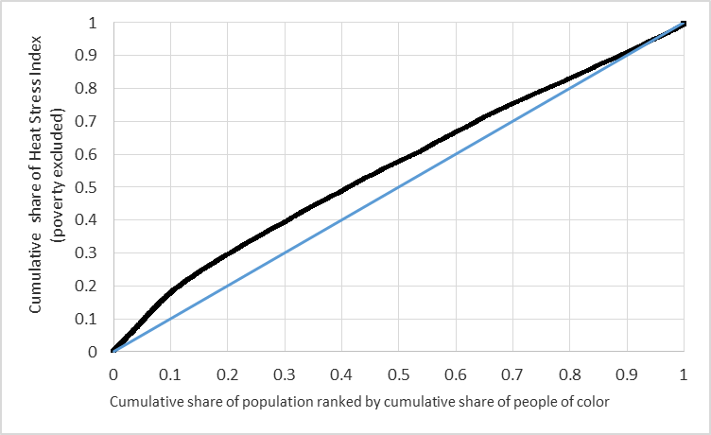
Fig. S- 24 Inequality curve showing the relative distribution of inequality between the Analytic HVI and race for Michigan’s urban geographies only
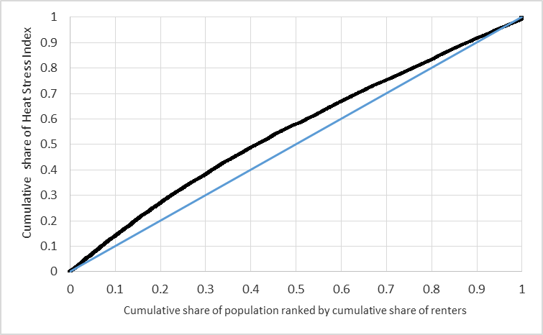
Fig. S- 25 Inequality curve showing the relative distribution of inequality between the Analytic HVI and renter population for Michigan’s urban geographies only
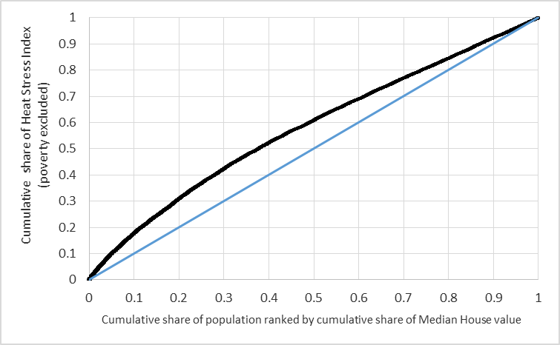
Fig. S- 26 Inequality curve showing the relative distribution of inequality between the Analytic HVI and median home value for Michigan’s urban geographies only
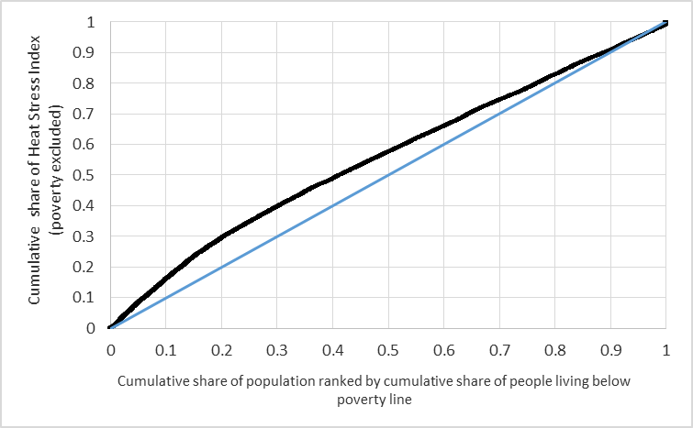
Fig. S- 27 Inequality curve showing the relative distribution of inequality between the Analytic HVI and poverty for Michigan’s urban geographies only
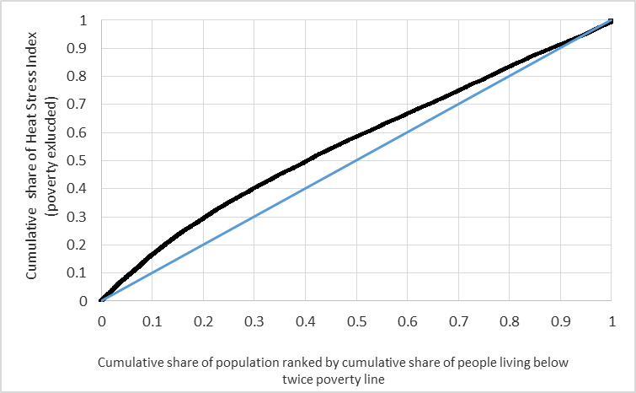
Fig. S- 28 Inequality curve showing the relative distribution of inequality between the Analytic HVI and severe poverty for Michigan’s urban geographies only
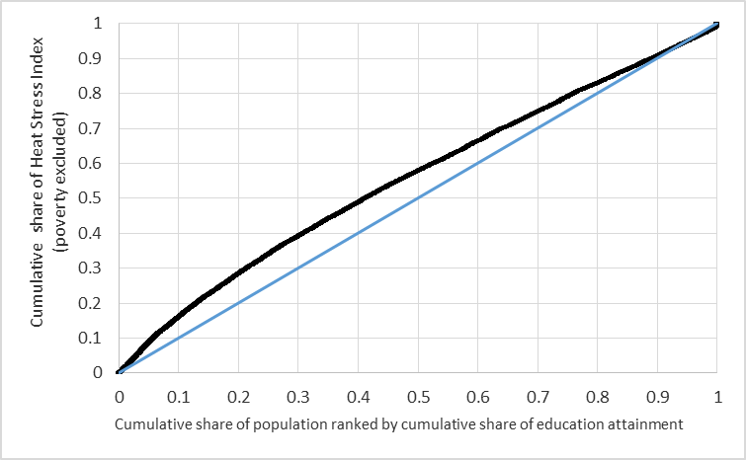
Fig. S- 29 Inequality curve showing the relative distribution of inequality between the Analytic HVI and education for Michigan’s urban geographies only
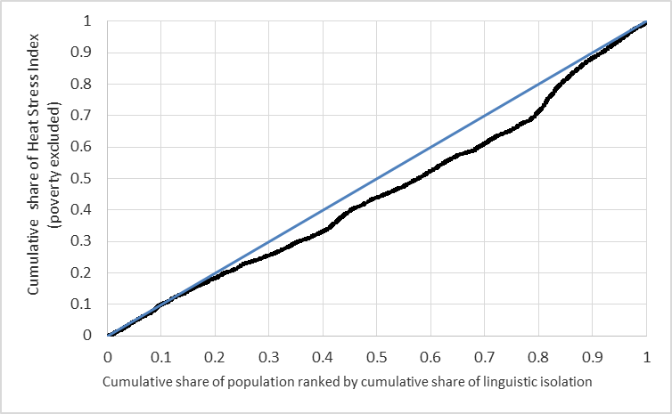
Fig. S- 30 Inequality curve showing the relative distribution of inequality between the Analytic HVI and linguistic isolation for Michigan’s urban geographies only

Figures S-31 to S-40: Inequality Curves for Michigan’s Rural Geographies Only
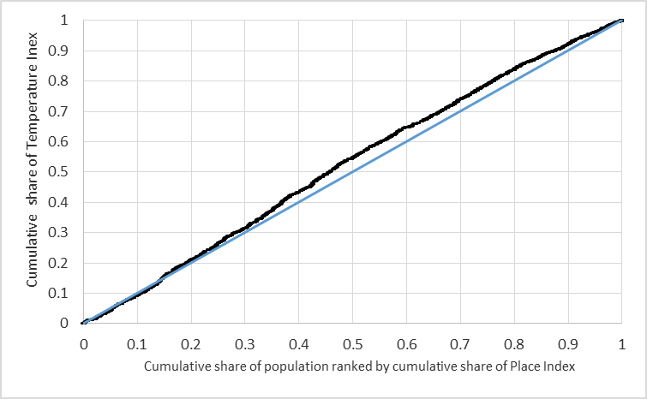
Fig. S- 31 Inequality curve showing the relative distribution of inequality between the Analytic HVI and the Place Index for Michigan’s rural geographies only
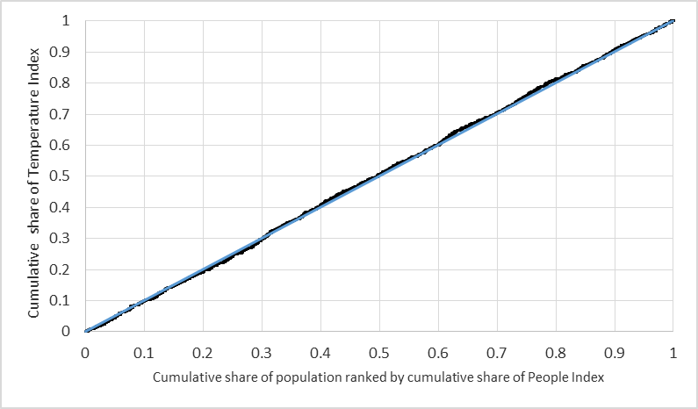
Fig. S- 32 Inequality curve showing the relative distribution of inequality between the Analytic HVI and the Analytic People Index for Michigan’s rural geographies only
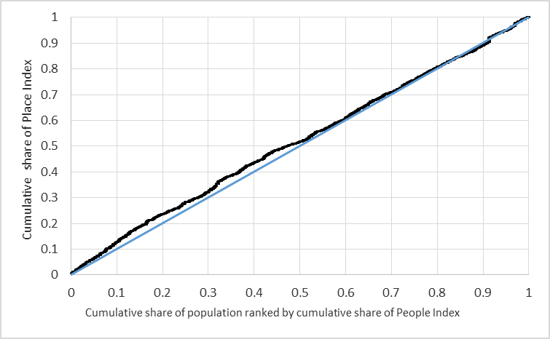
Fig. S- 33 Inequality curve showing the relative distribution of inequality between the Place Index and the Analytic People Index for Michigan’s rural geographies only
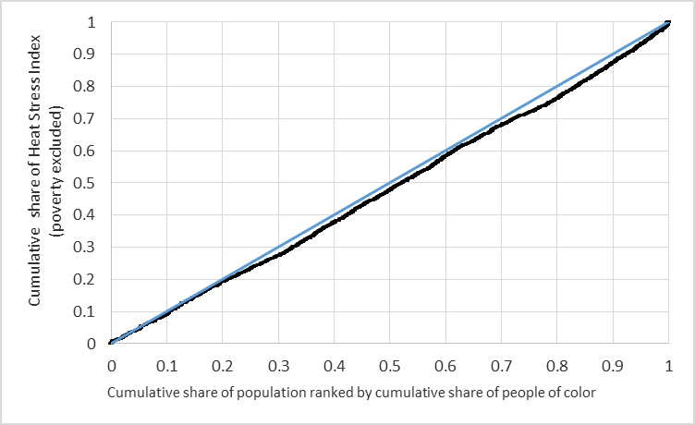
Fig. S- 34 Inequality curve showing the relative distribution of inequality between the Analytic HVI and race for Michigan’s rural geographies only
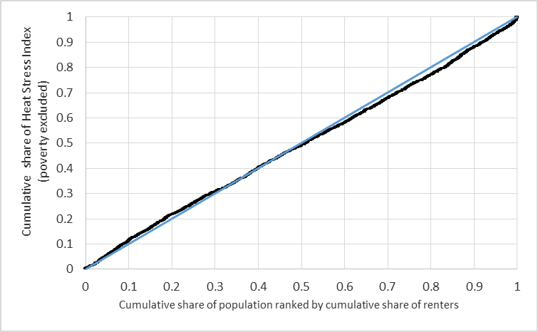
Fig. S- 35 Inequality curve showing the relative distribution of inequality between the Analytic HVI and renter population for Michigan’s rural geographies only
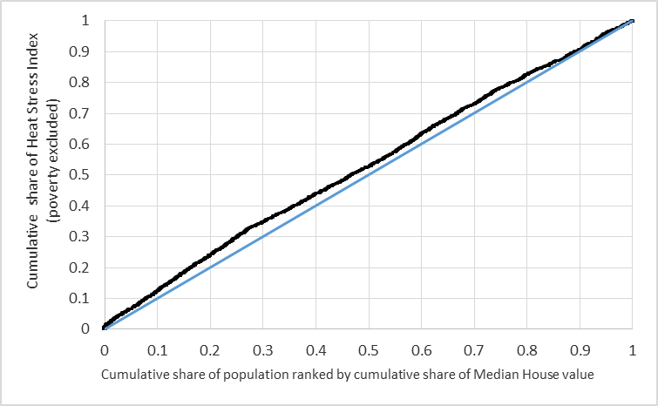
Fig. S- 36 Inequality curve showing the relative distribution of inequality between the Analytic HVI and median home value for Michigan’s rural geographies only
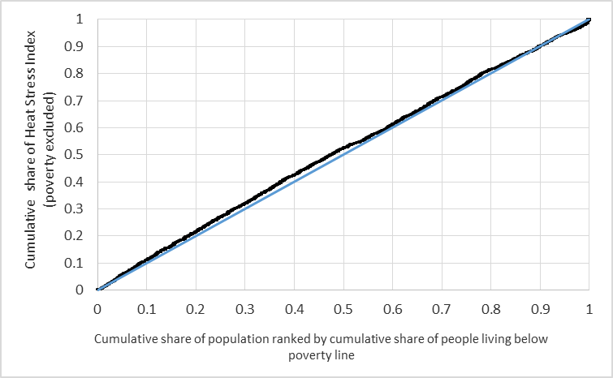
Fig. S- 37 Inequality curve showing the relative distribution of inequality between the Analytic HVI and poverty for Michigan’s rural geographies only
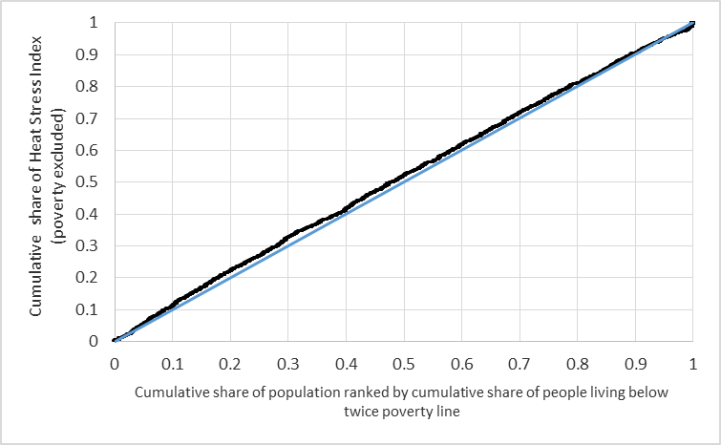
Fig. S- 38 Inequality curve showing the relative distribution of inequality between the Analytic HVI and severe poverty for Michigan’s rural geographies only
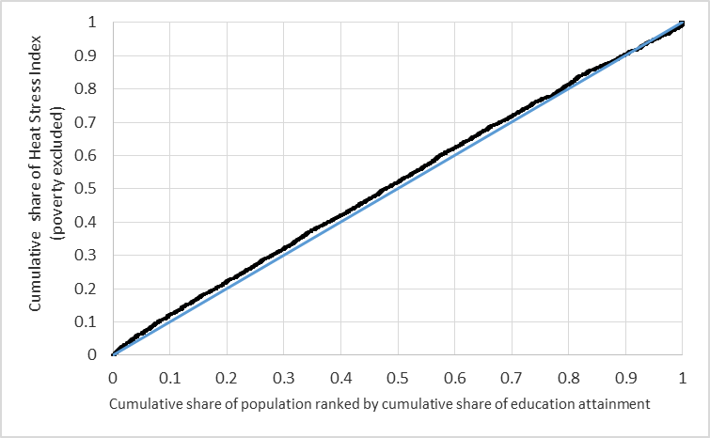
Fig. S- 39 Inequality curve showing the relative distribution of inequality between the Analytic HVI and education for Michigan’s rural geographies only
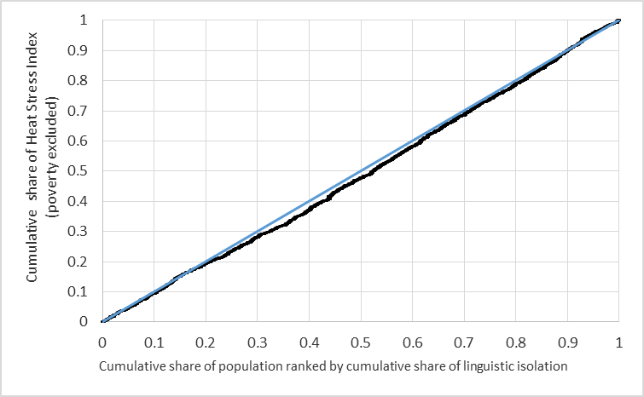
Fig. S- 40 Inequality curve showing the relative distribution of inequality between the Analytic HVI and linguistic isolation for Michigan’s rural geographies only

