Supplemental Material

Longitudinal Association of Biomarkers of Pesticide Exposure with Cardiovascular Disease Risk Factors in Youth with Diabetes
Navdep Kaur,¹ Anne P. Starling,² Antonia M. Calafat,³ Andreas Sjodin,³ Noemie Clouet-Foraison,⁴ Lawrence M. Dolan,⁵ Giuseppina Imperatore,⁶ Elizabeth T. Jensen,⁷ Jean M Lawrence,⁸ Maria Ospina,³ Catherine Pihoker,⁹ Kyla Taylor,¹⁰ Christine Turley,¹¹ Dana Dabelea,² Lindsay M. Jaacks¹
¹Department of Global Health and Population, Harvard T.H. Chan School of Public Health, Boston, MA, USA

²Department of Epidemiology, Colorado School of Public Health, Aurora, CO, USA

³Division of Laboratory Sciences, Centers for Disease Control and Prevention, Atlanta, GA, USA
⁴Northwest Lipid Metabolism and Diabetes Research Laboratory, Division of Metabolism, Endocrinology, and Nutrition, Department of Medicine, University of Washington, Seattle, WA, USA.
⁵Division of Endocrinology, Department of Pediatrics, University of Cincinnati, College of Medicine, Cincinnati, OH, USA
⁶Division of Diabetes Translation, Centers for Disease Control and Prevention (CDC), National Center for Chronic Disease Prevention and Health Promotion, Atlanta, Georgia
⁷Wake Forest School of Medicine, Winston-Salem, NC, USA
⁸Department of Research & Evaluation, Kaiser Permanente Southern California, Pasadena CA, USA
⁹Department of Pediatrics, University of Washington, Seattle, WA, USA
¹⁰Office of Health Assessment and Translation, National Toxicology Program, National Institute of Environmental Health Sciences, Durham, NC, USA
¹¹Department of Pediatrics, University of South Carolina School of Medicine, Columbia, SC, USA
Table S1. Summary of baseline characteristics of selected youth with type 1 and type 2 diabetes from the SEARCH for Diabetes in Youth Study (n=87).
 | N(%) or mean (SD)
Female | 45 (51.7)
Age at Baseline Visit (years) | 14.2 (2.7)
Age at Diagnosis (years) | 13.3 (2.8)
Ethnicity
Hispanic | 13 (14.9)
Non-Hispanic | 74 (85.1)
Race
Non-white | 35 (40.2)
White | 52 (59.8)
Provider-Diagnosed Diabetes Type
Type 1 | 50 (57.5)
Type 2 | 37 (42.5)
Annual Household Income
<$25K | 28 (32.2)
$25-74K | 27 (31.0)
$75K+ | 24 (27.6)
Don’t know/Refuse | 6 (6.9)
Missing | 2 (2.3)
Highest Level of Education of Either Parent
<High School | 7 (8.1)
High School | 25 (28.7)
Some College to Associate’s Degree | 31 (35.6)
Bachelor’s Degree or more | 23 (26.4)
Missing | 1 (1.2)

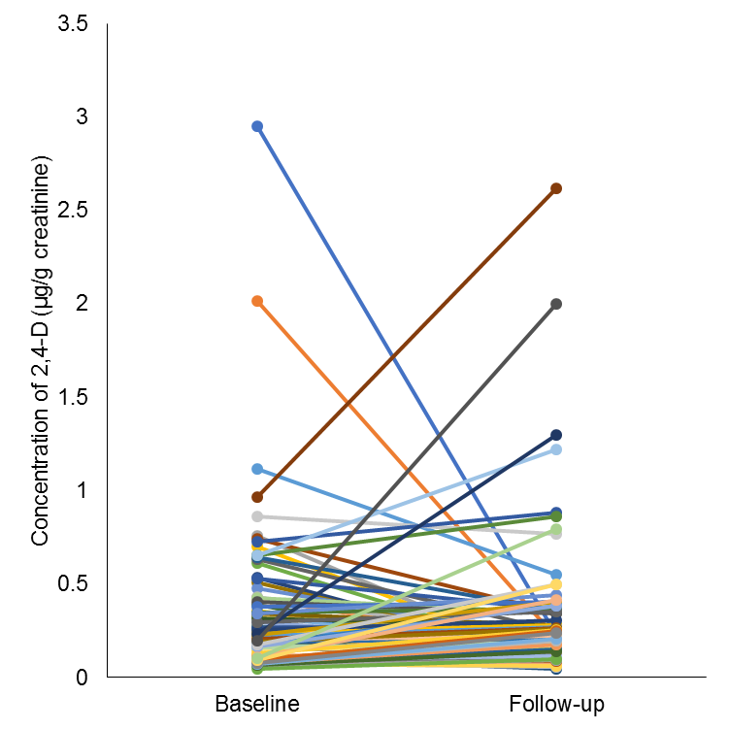
Figure S1. Within-participant change in concentration of 2,4-dichlorophenoxyacetic acid (2,4-D) among participating youth with type 1 and type 2 diabetes in the United States (n=87).

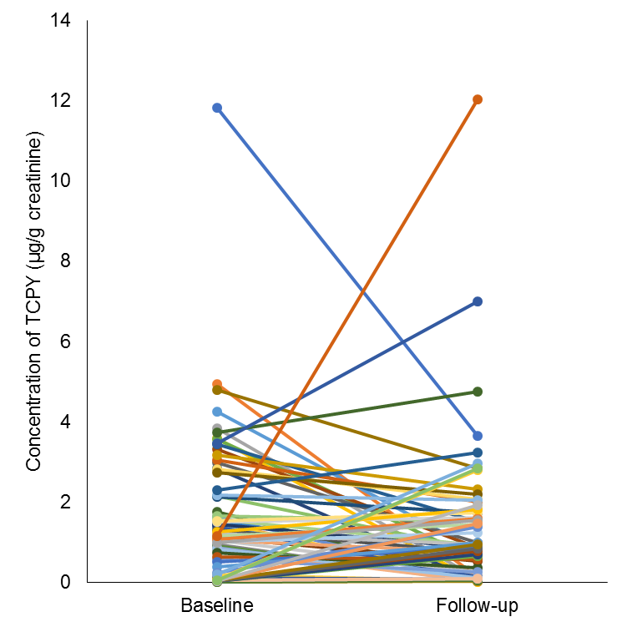
Figure S2. Within-participant change in concentration of 3,5,6-trichloro-2-pyridinol (TCPY) among participating youth with type 1 and type 2 diabetes in the United States (n=74).

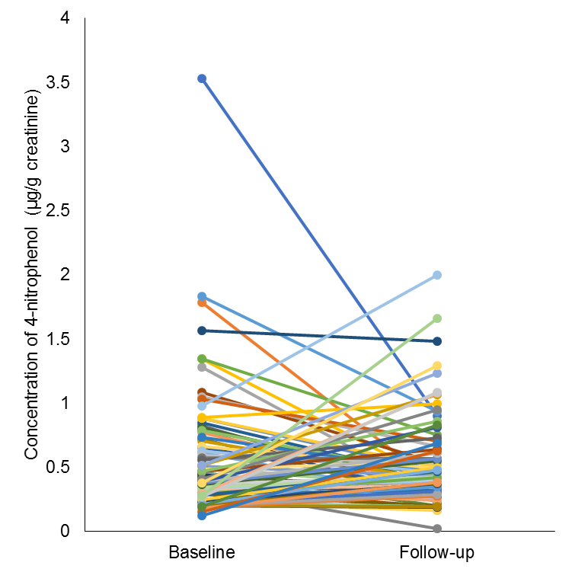
Figure S3. Within-participant change in concentration of 4-nitrophenol among participating youth with type 1 and type 2 diabetes in the United States (n=84).

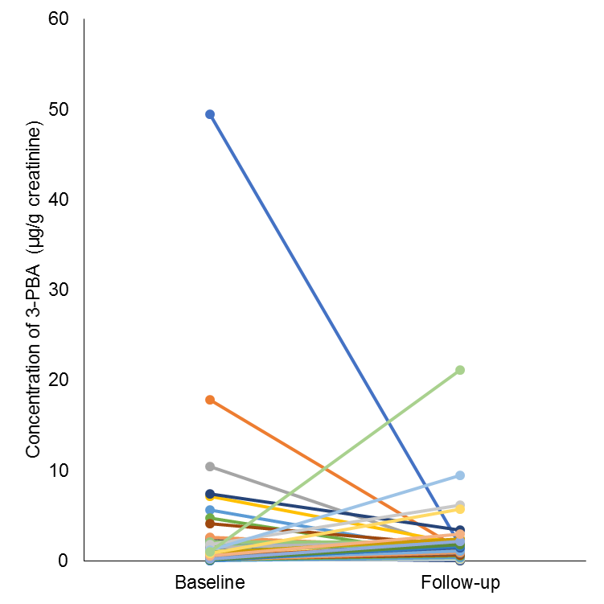
Figure S4. Within-participant change in concentration of 3-phenoxybenzoic acid (3-PBA) among participating youth with type 1 and type 2 diabetes in the United States (n=84).

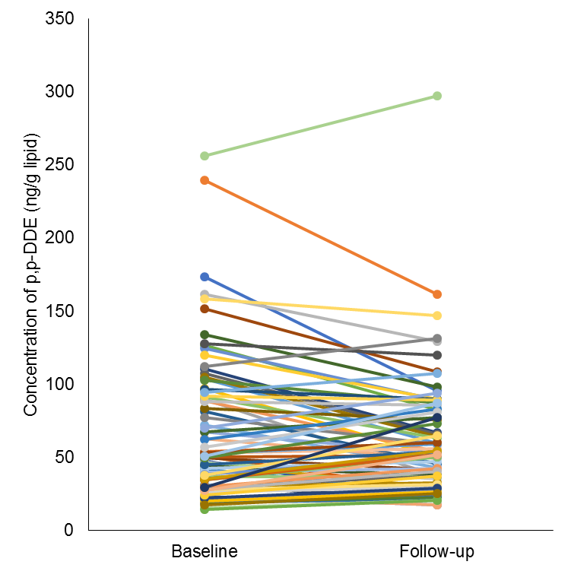
Figure S5. Within-participant change in concentration of 2,2-bis(4-chlorophenyl)-1,1-dichloroethene (p,p-DDE) among participating youth with type 1 and type 2 diabetes in the United States (n=85).

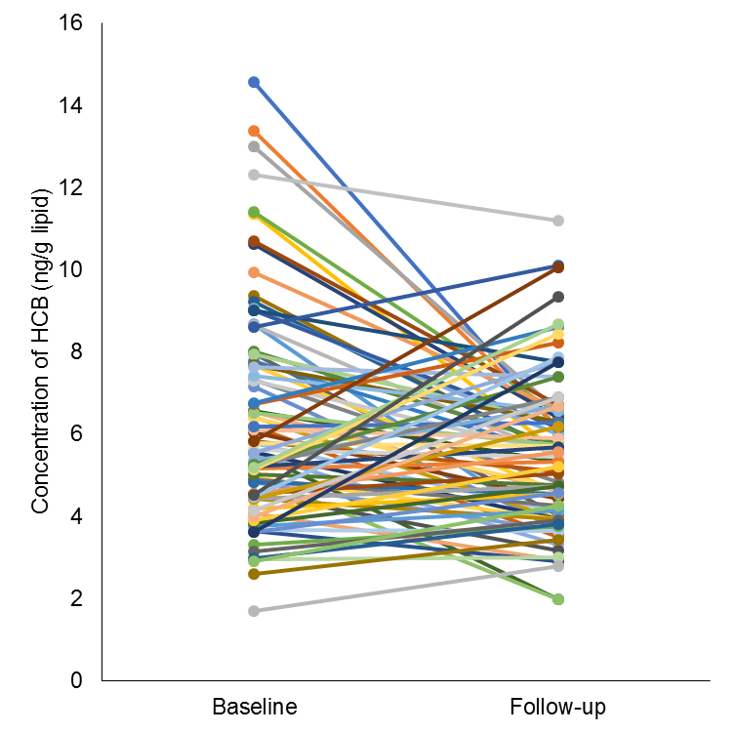
Figure S6. Within-participant change in concentration of hexachlorobenzene (HCB) among participating youth with type 1 and type 2 diabetes in the United States (n=87).

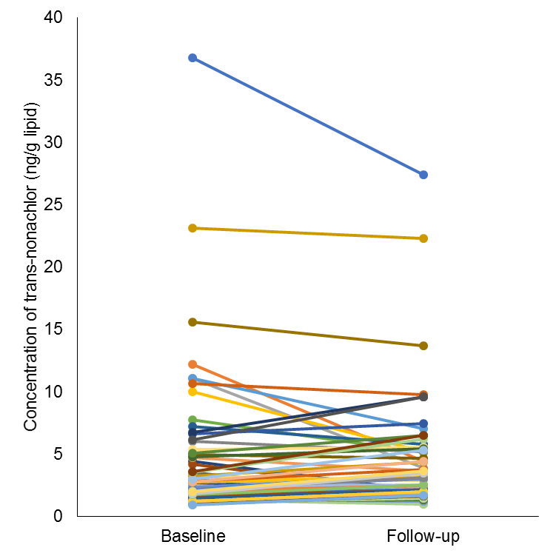
Figure S7. Within-participant change in concentration of trans-nonachlor among participating youth with type 1 and type 2 diabetes in the United States (n=87).

Table S2. Baseline characteristics of participating youth with type 1 and type 2 diabetes in the United States (n=87) according to quartile of 2,4-dichlorophenoxyacetic acid (2,4-D).
 | Baseline 2,4-D Quartile |  |  |  | p-value¹
 | 1 | 2 | 3 | 4
GM (95% CI) (µg/g creatinine) | <LOD | 0.18 (0.17-0.20) | 0.30 (0.28-0.33) | 0.72 (0.57-0.89)
Sex |  |  |  |  | 0.95
Female | 11 (50%) | 11 (50%) | 11 (50%) | 12 (57%)
Male | 11 (50%) | 11 (50%) | 11 (50%) | 9 (43%)
Age (years) | 15.17 (12.63, 17.02) | 12.72 (11.19, 16.11) | 12.86 (11.38, 16.13) | 13.66 (12.21, 15.94) | 0.14
Age at Diagnosis (years) | 13.99 (11.94, 16.43) | 12.53 (10.07, 15.38) | 12.13 (10.51, 15.62) | 13.23 (11.07, 15.20) | 0.26
Ethnicity |  |  |  |  | 0.45
Hispanic | 4 (18%) | 3 (14%) | 5 (23%) | 1 (5%)
Non-Hispanic | 18 (82%) | 19 (86%) | 17 (77%) | 20 (95%)
Race |  |  |  |  | 0.12
Non-white | 11 (50%) | 5 (23%) | 12 (55%) | 7 (33%)
White | 11 (50%) | 17 (77%) | 10 (45%) | 14 (67%)
Provider-Diagnosed Diabetes Type |  |  |  |  | 0.40
Type 1 | 10 (45%) | 12 (55%) | 13 (59%) | 15 (71%)
Type 2 | 12 (55%) | 10 (45%) | 9 (41%) | 6 (29%)
Annual Household Income |  |  |  |  | 0.32
<$25K | 6 (29%) | 10 (45%) | 5 (23%) | 7 (35%)
$25-74K | 7 (33%) | 9 (41%) | 7 (32%) | 4 (20%)
$75K+ | 5 (24%) | 3 (14%) | 9 (41%) | 7 (35%)
Don’t know/Refuse | 3 (14%) | 0 (0%) | 1 (5%) | 2 (10%)
Highest Level of Education of Either Parent |  |  |  |  | 0.56
<High School | 2 (9%) | 2 (9%) | 1 (5%) | 2 (10%)
High School | 9 (41%) | 6 (27%) | 6 (27%) | 4 (20%)
Some College to Associate’s Degree | 7 (32%) | 11 (50%) | 7 (32%) | 6 (30%)
Bachelor’s Degree or more | 4 (18%) | 3 (14%) | 8 (36%) | 8 (40%)
Values are n (%) or median (IQR). Limit of detection (LOD) was 0.15 ng/mL.
¹ Statistical comparisons were made using Fisher’s exact test for categorical comparisons and Kruskal-Wallis non-parametric tests for continuous comparisons.

Table S3. Baseline characteristics of participating youth with type 1 and type 2 diabetes in the United States (n=87) according to quartile of 3,5,6-trichloro-2-pyridinol (TCPY).
 | Baseline TCPY Quartile |  |  |  | p-value¹
 | 1 | 2 | 3 | 4
GM (95% CI) (µg/g creatinine) | <LOD | 0.83 (0.70-0.99) | 1.64 (1.51-1.78) | 3.63 (3.10-4.24)
Sex |  |  |  |  | 0.63
Female | 12 (60%) | 10 (48%) | 9 (43%) | 12 (60%)
Male | 8 (40%) | 11 (52%) | 12 (57%) | 8 (40%)
Age (years) | 16.36 (12.53, 17.50) | 14.97 (12.63, 16.63) | 14.07 (12.12, 16.78) | 11.95 (11.00, 13.00) | <0.01
Age at Diagnosis (years) | 15.44 (11.93, 16.53) | 14.18 (11.55, 15.84) | 13.11 (10.75, 15.71) | 10.73 (10.32, 12.72) | 0.02
Ethnicity |  |  |  |  | 0.19
Hispanic | 2 (10%) | 1 (5%) | 6 (29%) | 2 (10%)
Non-Hispanic | 18 (90%) | 20 (95%) | 15 (71%) | 18 (90%)
Race |  |  |  |  | 0.57
Non-white | 9 (45%) | 8 (38%) | 9 (43%) | 5 (25%)
White | 11 (55%) | 13 (62%) | 12 (57%) | 15 (75%)
Provider-Diagnosed Diabetes Type |  |  |  |  | 0.07
Type 1 | 9 (45%) | 10 (48%) | 14 (67%) | 16 (80%)
Type 2 | 11 (55%) | 11 (52%) | 7 (33%) | 4 (20%)
Annual Household Income |  |  |  |  | 0.08
<$25K | 10 (50%) | 9 (45%) | 3 (14%) | 3 (16%)
$25-74K | 3 (15%) | 5 (25%) | 9 (43%) | 9 (47%)
$75K+ | 6 (30%) | 5 (25%) | 6 (29%) | 7 (37%)
Don’t know/Refuse | 1 (5%) | 1 (5%) | 3 (14%) | 0 (0%)
Highest Level of Education of Either Parent |  |  |  |  | 0.60
<High School | 2 (10%) | 1 (5%) | 3 (14%) | 0 (0%)
High School | 5 (25%) | 6 (29%) | 6 (29%) | 6 (30%)
Some College to Associate’s Degree | 8 (40%) | 10 (48%) | 4 (19%) | 8 (40%)
Bachelor’s Degree or more | 5 (25%) | 4 (19%) | 8 (38%) | 6 (30%)
Values are n (%) or median (IQR). Limit of detection (LOD) was 0.1 ng/mL.
¹ Statistical comparisons were made using Fisher’s exact test for categorical comparisons and Kruskal-Wallis non-parametric tests for continuous comparisons.

Table S4. Baseline characteristics of participating youth with type 1 and type 2 diabetes in the United States (n=87) according to quartile of 4-nitrophenol.
 | Baseline 4-nitrophenol Quartile |  |  |  | p-value¹
 | 1 | 2 | 3 | 4
GM (95% CI) (µg/g creatinine) | <LOD | 0.34 (0.33-0.36) | 0.53 (0.49-0.57) | 1.07 (0.90-1.27)
Sex |  |  |  |  | 0.53
Female | 11 (52%) | 10 (45%) | 9 (43%) | 14 (64%)
Male | 10 (48%) | 12 (55%) | 12 (57%) | 8 (36%)
Age (years) | 14.29 (12.10, 17.19) | 14.52 (12.12, 16.83) | 13.88 (11.96, 15.89) | 12.60 (11.39, 15.11) | 0.33
Age at Diagnosis (years) | 13.31 (10.67, 15.86) | 13.51 (10.75, 16.24) | 12.56 (11.73, 14.67) | 12.13 (10.64, 14.55) | 0.62
Ethnicity |  |  |  |  | 0.67
Hispanic | 3 (14%) | 2 (9%) | 3 (14%) | 5 (23%)
Non-Hispanic | 18 (86%) | 20 (91%) | 18 (86%) | 17 (77%)
Race |  |  |  |  | 0.31
Non-white | 11 (52%) | 9 (41%) | 5 (24%) | 9 (41%)
White | 10 (48%) | 13 (59%) | 16 (76%) | 13 (59%)
Provider-Diagnosed Diabetes Type |  |  |  |  | 0.42
Type 1 | 9 (43%) | 12 (55%) | 14 (67%) | 14 (64%)
Type 2 | 12 (57%) | 10 (45%) | 7 (33%) | 8 (36%)
Annual Household Income |  |  |  |  | 0.71
<$25K | 10 (48%) | 6 (27%) | 5 (25%) | 7 (33%)
$25-74K | 3 (14%) | 9 (41%) | 7 (35%) | 7 (33%)
$75K+ | 7 (33%) | 5 (23%) | 7 (35%) | 5 (24%)
Don’t know/Refuse | 1 (5%) | 2 (9%) | 1 (5%) | 2 (10%)
Highest Level of Education of Either Parent |  |  |  |  | 0.29
<High School | 2 (10%) | 1 (5%) | 2 (10%) | 2 (9%)
High School | 5 (24%) | 5 (23%) | 4 (20%) | 11 (50%)
Some College to Associate’s Degree | 9 (43%) | 8 (36%) | 10 (50%) | 3 (14%)
Bachelor’s Degree or more | 5 (24%) | 8 (36%) | 4 (20%) | 6 (27%)
Values are n (%) or median (IQR). Limit of detection (LOD) was 0.1 ng/mL
¹ Statistical comparisons were made using Fisher’s exact test for categorical comparisons and Kruskal-Wallis non-parametric tests for continuous comparisons.

Table S5. Baseline characteristics of participating youth with type 1 and type 2 diabetes in the United States (n=87) according to quartile of 3-phenoxybenzoic acid (3-PBA).
 | Baseline 3-PBA Quartile |  |  |  | p-value¹
 | 1 | 2 | 3 | 4
GM (95% CI) (µg/g creatinine) | <LOD | 0.44 (0.39-0.49) | 0.97 (0.88-1.06) | 3.54 (2.35-5.33)
Sex |  |  |  |  | 0.83
Female | 11 (52%) | 13 (62%) | 10 (48%) | 11 (50%)
Male | 10 (48%) | 8 (38%) | 11 (52%) | 11 (50%)
Age (years) | 12.97 (12.10, 16.78) | 15.02 (12.12, 17.02) | 14.29 (11.96, 15.62) | 12.84 (11.94, 14.97) | 0.59
Age at Diagnosis (years) | 11.98 (10.67, 16.40) | 13.76 (10.75, 16.34) | 13.31 (11.73, 14.88) | 12.09 (10.82, 14.18) | 0.64
Ethnicity |  |  |  |  | 0.22
Hispanic | 2 (10%) | 6 (29%) | 2 (10%) | 2 (9%)
Non-Hispanic | 19 (90%) | 15 (71%) | 19 (90%) | 20 (91%)
Race |  |  |  |  | 0.13
Non-white | 8 (38%) | 13 (62%) | 6 (29%) | 7 (32%)
White | 13 (62%) | 8 (38%) | 15 (71%) | 15 (68%)
Provider-Diagnosed Diabetes Type |  |  |  |  | 0.47
Type 1 | 11 (52%) | 11 (52%) | 12 (57%) | 16 (73%)
Type 2 | 10 (48%) | 10 (48%) | 9 (43%) | 6 (27%)
Annual Household Income |  |  |  |  | 0.38
<$25K | 8 (38%) | 7 (35%) | 6 (30%) | 7 (32%)
$25-74K | 3 (14%) | 9 (45%) | 5 (25%) | 8 (36%)
$75K+ | 9 (43%) | 2 (10%) | 7 (35%) | 6 (27%)
Don’t know/Refuse | 1 (5%) | 2 (10%) | 2 (10%) | 1 (5%)
Highest Level of Education of Either Parent |  |  |  |  | 0.29
<High School | 1 (5%) | 3 (14%) | 1 (5%) | 2 (9%)
High School | 5 (24%) | 5 (24%) | 4 (20%) | 9 (41%)
Some College to Associate’s Degree | 9 (43%) | 10 (48%) | 9 (45%) | 3 (14%)
Bachelor’s Degree or more | 6 (29%) | 3 (14%) | 6 (30%) | 8 (36%)
Values are n (%) or median (IQR). Limit of detection (LOD) was 0.1 ng/mL
¹ Statistical comparisons were made using Fisher’s exact test for categorical comparisons and Kruskal-Wallis non-parametric tests for continuous comparisons.

Table S6. Baseline characteristics of participating youth with type 1 and type 2 diabetes in the United States (n=87) according to quartile of 2,2-bis(4-chlorophenyl)-1,1-dichloroethene (p,p-DDE).
 | Baseline p,p-DDE Quartile |  |  |  | p-value¹
 | 1 | 2 | 3 | 4
GM (95% CI) (ng/g lipid) | <LOD | 39.23 (36.65-41.99) | 65.44 (59.37-72.14) | 127.32 (111.67-145.17)
Sex |  |  |  |  | <0.01
Female | 16 (73%) | 15 (71%) | 7 (32%) | 7 (33%)
Male | 6 (27%) | 6 (29%) | 15 (68%) | 14 (67%)
Age (years) | 13.55 (12.28, 16.59) | 15.02 (12.29, 16.85) | 12.69 (11.38, 16.11) | 14.46 (12.21, 16.01) | 0.50
Age at Diagnosis (years) | 12.51 (11.55, 15.58) | 13.76 (10.82, 16.11) | 11.86 (10.57, 15.62) | 13.23 (11.81, 15.20) | 0.82
Ethnicity |  |  |  |  | <0.01
Hispanic | 0 (0%) | 2 (10%) | 1 (5%) | 10 (48%)
Non-Hispanic | 22 (100%) | 19 (90%) | 21 (95%) | 11 (52%)
Race |  |  |  |  | 0.59
Non-white | 9 (41%) | 8 (38%) | 7 (32%) | 11 (52%)
White | 13 (59%) | 13 (62%) | 15 (68%) | 10 (48%)
Provider-Diagnosed Diabetes Type |  |  |  |  | 0.02
Type 1 | 7 (32%) | 12 (57%) | 17 (77%) | 13 (62%)
Type 2 | 15 (68%) | 9 (43%) | 5 (23%) | 8 (38%)
Annual Household Income |  |  |  |  | <0.01
<$25K | 10 (45%) | 10 (48%) | 6 (29%) | 2 (10%)
$25-74K | 10 (45%) | 5 (24%) | 5 (24%) | 7 (35%)
$75K+ | 2 (9%) | 4 (19%) | 10 (48%) | 7 (35%)
Don’t know/Refuse | 0 (0%) | 2 (10%) | 0 (0%) | 4 (20%)
Highest Level of Education of Either Parent |  |  |  |  | 0.22
<High School | 2 (9%) | 2 (10%) | 1 (5%) | 2 (10%)
High School | 9 (41%) | 7 (33%) | 3 (14%) | 6 (29%)
Some College to Associate’s Degree | 9 (41%) | 7 (33%) | 10 (48%) | 4 (19%)
Bachelor’s Degree or more | 2 (9%) | 5 (24%) | 7 (33%) | 9 (43%)
Values are n (%) or median (IQR). The LODs for the persistent pesticides were calculated by adding a recovery standard to each sample. To calculate the sample-specific LOD, the instrumental LOD was adjusted for the absolute recovery of this standard and background noise for the sample. The mean LOD for p,p-DDE it was 2.33 ng/ml.
¹ Statistical comparisons were made using Fisher’s exact test for categorical comparisons and Kruskal-Wallis non-parametric tests for continuous comparisons.

Table S7. Baseline characteristics of participating youth with type 1 and type 2 diabetes in the United States (n=87) according to quartile of hexachlorobenzene (HCB).
 | Baseline HCB Quartile |  |  |  | p-value¹
 | 1 | 2 | 3 | 4
GM (95% CI) (ng/g lipid) | <LOD | 5.08 (4.93-5.25) | 6.60 (6.33-6.89) | 9.86 (9.06-10.74)
Sex |  |  |  |  | <0.01
Female | 18 (82%) | 11 (50%) | 12 (55%) | 4 (19%)
Male | 4 (18%) | 11 (50%) | 10 (45%) | 17 (81%)
Age (years) | 14.99 (12.10, 16.77) | 14.79 (12.29, 16.96) | 13.04 (12.21, 16.78) | 12.21 (11.19, 14.78) | 0.11
Age at Diagnosis (years) | 13.83 (11.98, 15.59) | 13.89 (11.07, 16.34) | 12.39 (11.39, 15.58) | 10.86 (10.51, 14.18) | 0.18
Ethnicity |  |  |  |  | 0.18
Hispanic | 2 (9%) | 4 (18%) | 6 (27%) | 1 (5%)
Non-Hispanic | 20 (91%) | 18 (82%) | 16 (73%) | 20 (95%)
Race |  |  |  |  | 0.25
Non-white | 12 (55%) | 9 (41%) | 9 (41%) | 5 (24%)
White | 10 (45%) | 13 (59%) | 13 (59%) | 16 (76%)
Provider-Diagnosed Diabetes Type |  |  |  |  | <0.01
Type 1 | 8 (36%) | 12 (55%) | 11 (50%) | 19 (90%)
Type 2 | 14 (64%) | 10 (45%) | 11 (50%) | 2 (10%)
Annual Household Income |  |  |  |  | 0.16
<$25K | 8 (36%) | 9 (45%) | 4 (18%) | 7 (33%)
$25-74K | 9 (41%) | 4 (20%) | 9 (41%) | 5 (24%)
$75K+ | 5 (23%) | 4 (20%) | 6 (27%) | 9 (43%)
Don’t know/Refuse | 0 (0%) | 3 (15%) | 3 (14%) | 0 (0%)
Highest Level of Education of Either Parent |  |  |  |  | 0.36
<High School | 3 (14%) | 2 (9%) | 1 (5%) | 1 (5%)
High School | 6 (27%) | 9 (41%) | 8 (36%) | 2 (10%)
Some College to Associate’s Degree | 7 (32%) | 8 (36%) | 8 (36%) | 8 (40%)
Bachelor’s Degree or more | 6 (27%) | 3 (14%) | 5 (23%) | 9 (45%)
Values are n (%) or median (IQR). The LODs for the persistent pesticides were calculated by adding a recovery standard to each sample. To calculate the sample-specific LOD, the instrumental LOD was adjusted for the absolute recovery of this standard and background noise for the sample. The mean LOD for HCB was 2.34 ng/ml.
¹ Statistical comparisons were made using Fisher’s exact test for categorical comparisons and Kruskal-Wallis non-parametric tests for continuous comparisons.

Table S8. Baseline characteristics of participating youth with type 1 and type 2 diabetes in the United States (n=87) according to quartile of trans-nonachlor.
 | Baseline trans-nonachlor Quartile |  |  |  | p-value¹
 | 1 | 2 | 3 | 4
GM (95% CI) (ng/g lipid) | <LOD | 1.96 (1.88-2.04) | 2.82 (2.63-3.02) | 7.78 (6.00-10.08)
Sex |  |  |  |  | 0.32
Female | 15 (65%) | 10 (43%) | 11 (58%) | 9 (41%)
Male | 8 (35%) | 13 (57%) | 8 (42%) | 13 (59%)
Age (years) | 16.01 (12.32, 17.19) | 14.07 (12.21, 16.78) | 12.56 (11.39, 14.97) | 12.69 (11.38, 15.11) | 0.02
Age at Diagnosis (years) | 15.56 (11.92, 16.40) | 13.23 (11.73, 15.58) | 11.55 (10.49, 13.90) | 12.03 (10.51, 14.55) | 0.04
Ethnicity |  |  |  |  | 0.21
Hispanic | 6 (26%) | 4 (17%) | 2 (11%) | 1 (5%)
Non-Hispanic | 17 (74%) | 19 (83%) | 17 (89%) | 21 (95%)
Race |  |  |  |  | <0.01
Non-white | 14 (61%) | 14 (61%) | 3 (16%) | 4 (18%)
White | 9 (39%) | 9 (39%) | 16 (84%) | 18 (82%)
Provider-Diagnosed Diabetes Type |  |  |  |  | <0.01
Type 1 | 7 (30%) | 12 (52%) | 14 (74%) | 17 (77%)
Type 2 | 16 (70%) | 11 (48%) | 5 (26%) | 5 (23%)
Annual Household Income |  |  |  |  | 0.17
<$25K | 10 (43%) | 9 (41%) | 4 (21%) | 5 (24%)
$25-74K | 8 (35%) | 3 (14%) | 7 (37%) | 9 (43%)
$75K+ | 3 (13%) | 7 (32%) | 8 (42%) | 6 (29%)
Don’t know/Refuse | 2 (9%) | 3 (14%) | 0 (0%) | 1 (5%)
Highest Level of Education of Either Parent |  |  |  |  | 0.47
<High School | 3 (13%) | 1 (5%) | 2 (11%) | 1 (5%)
High School | 8 (35%) | 8 (36%) | 4 (21%) | 5 (23%)
Some College to Associate’s Degree | 9 (39%) | 5 (23%) | 6 (32%) | 11 (50%)
Bachelor’s Degree or more | 3 (13%) | 8 (36%) | 7 (37%) | 5 (23%)
Values are n (%) or median (IQR). The LODs for the persistent pesticides were calculated by adding a recovery standard to each sample. To calculate the sample-specific LOD, the instrumental LOD was adjusted for the absolute recovery of this standard and background noise for the sample. The mean LOD across all samples for trans-nonachlor was 2.34 ng/ml.
¹ Statistical comparisons were made using Fisher’s exact test for categorical comparisons and Kruskal-Wallis non-parametric tests for continuous comparisons.

