Data S4. Supplemental Figures and Tables.

Figure S1. Observed and fetal growth curve (linear mixed model)-imputed ultrasound measurements vs. gestational age at visit 2, 3, and 4. Black dots are observed data.
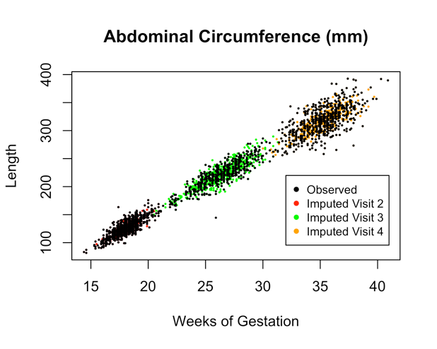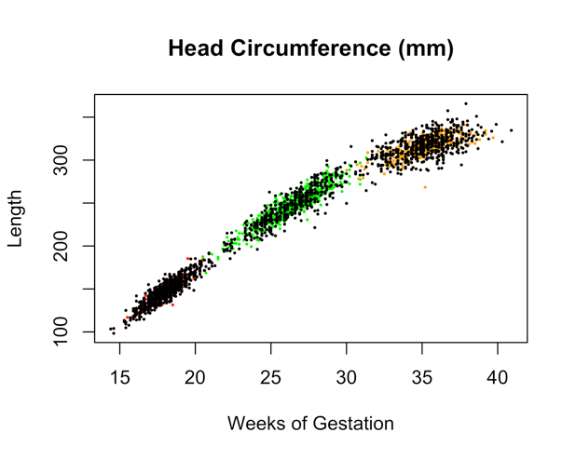
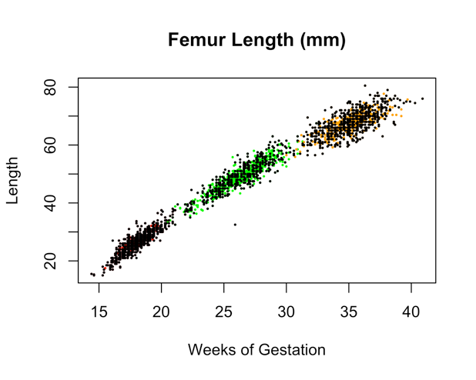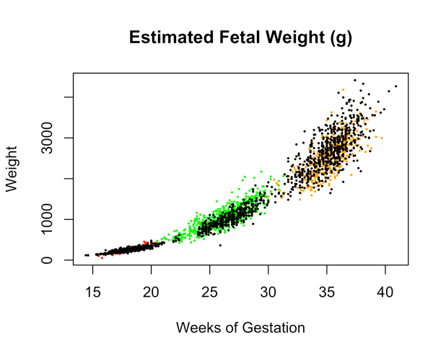

Figure S2. Observed and MICE-imputed ultrasound measurements vs. gestational age at visit 2, 3, and 4.

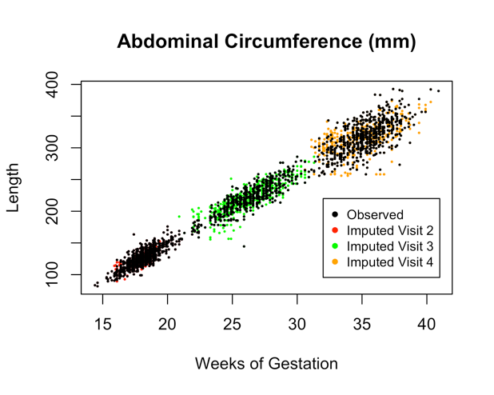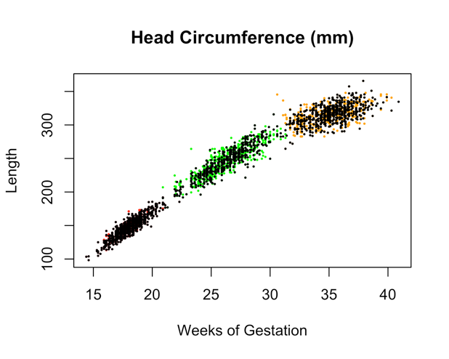
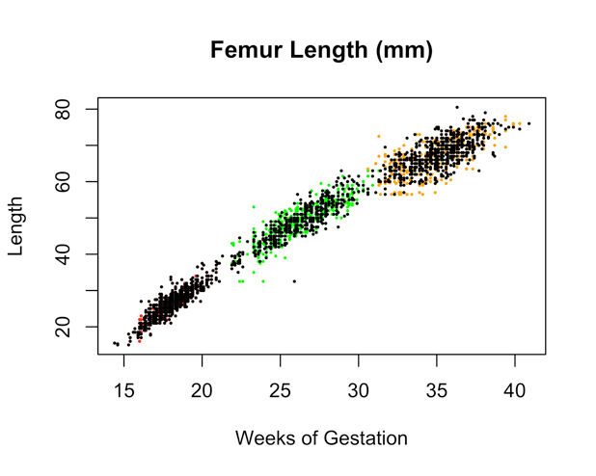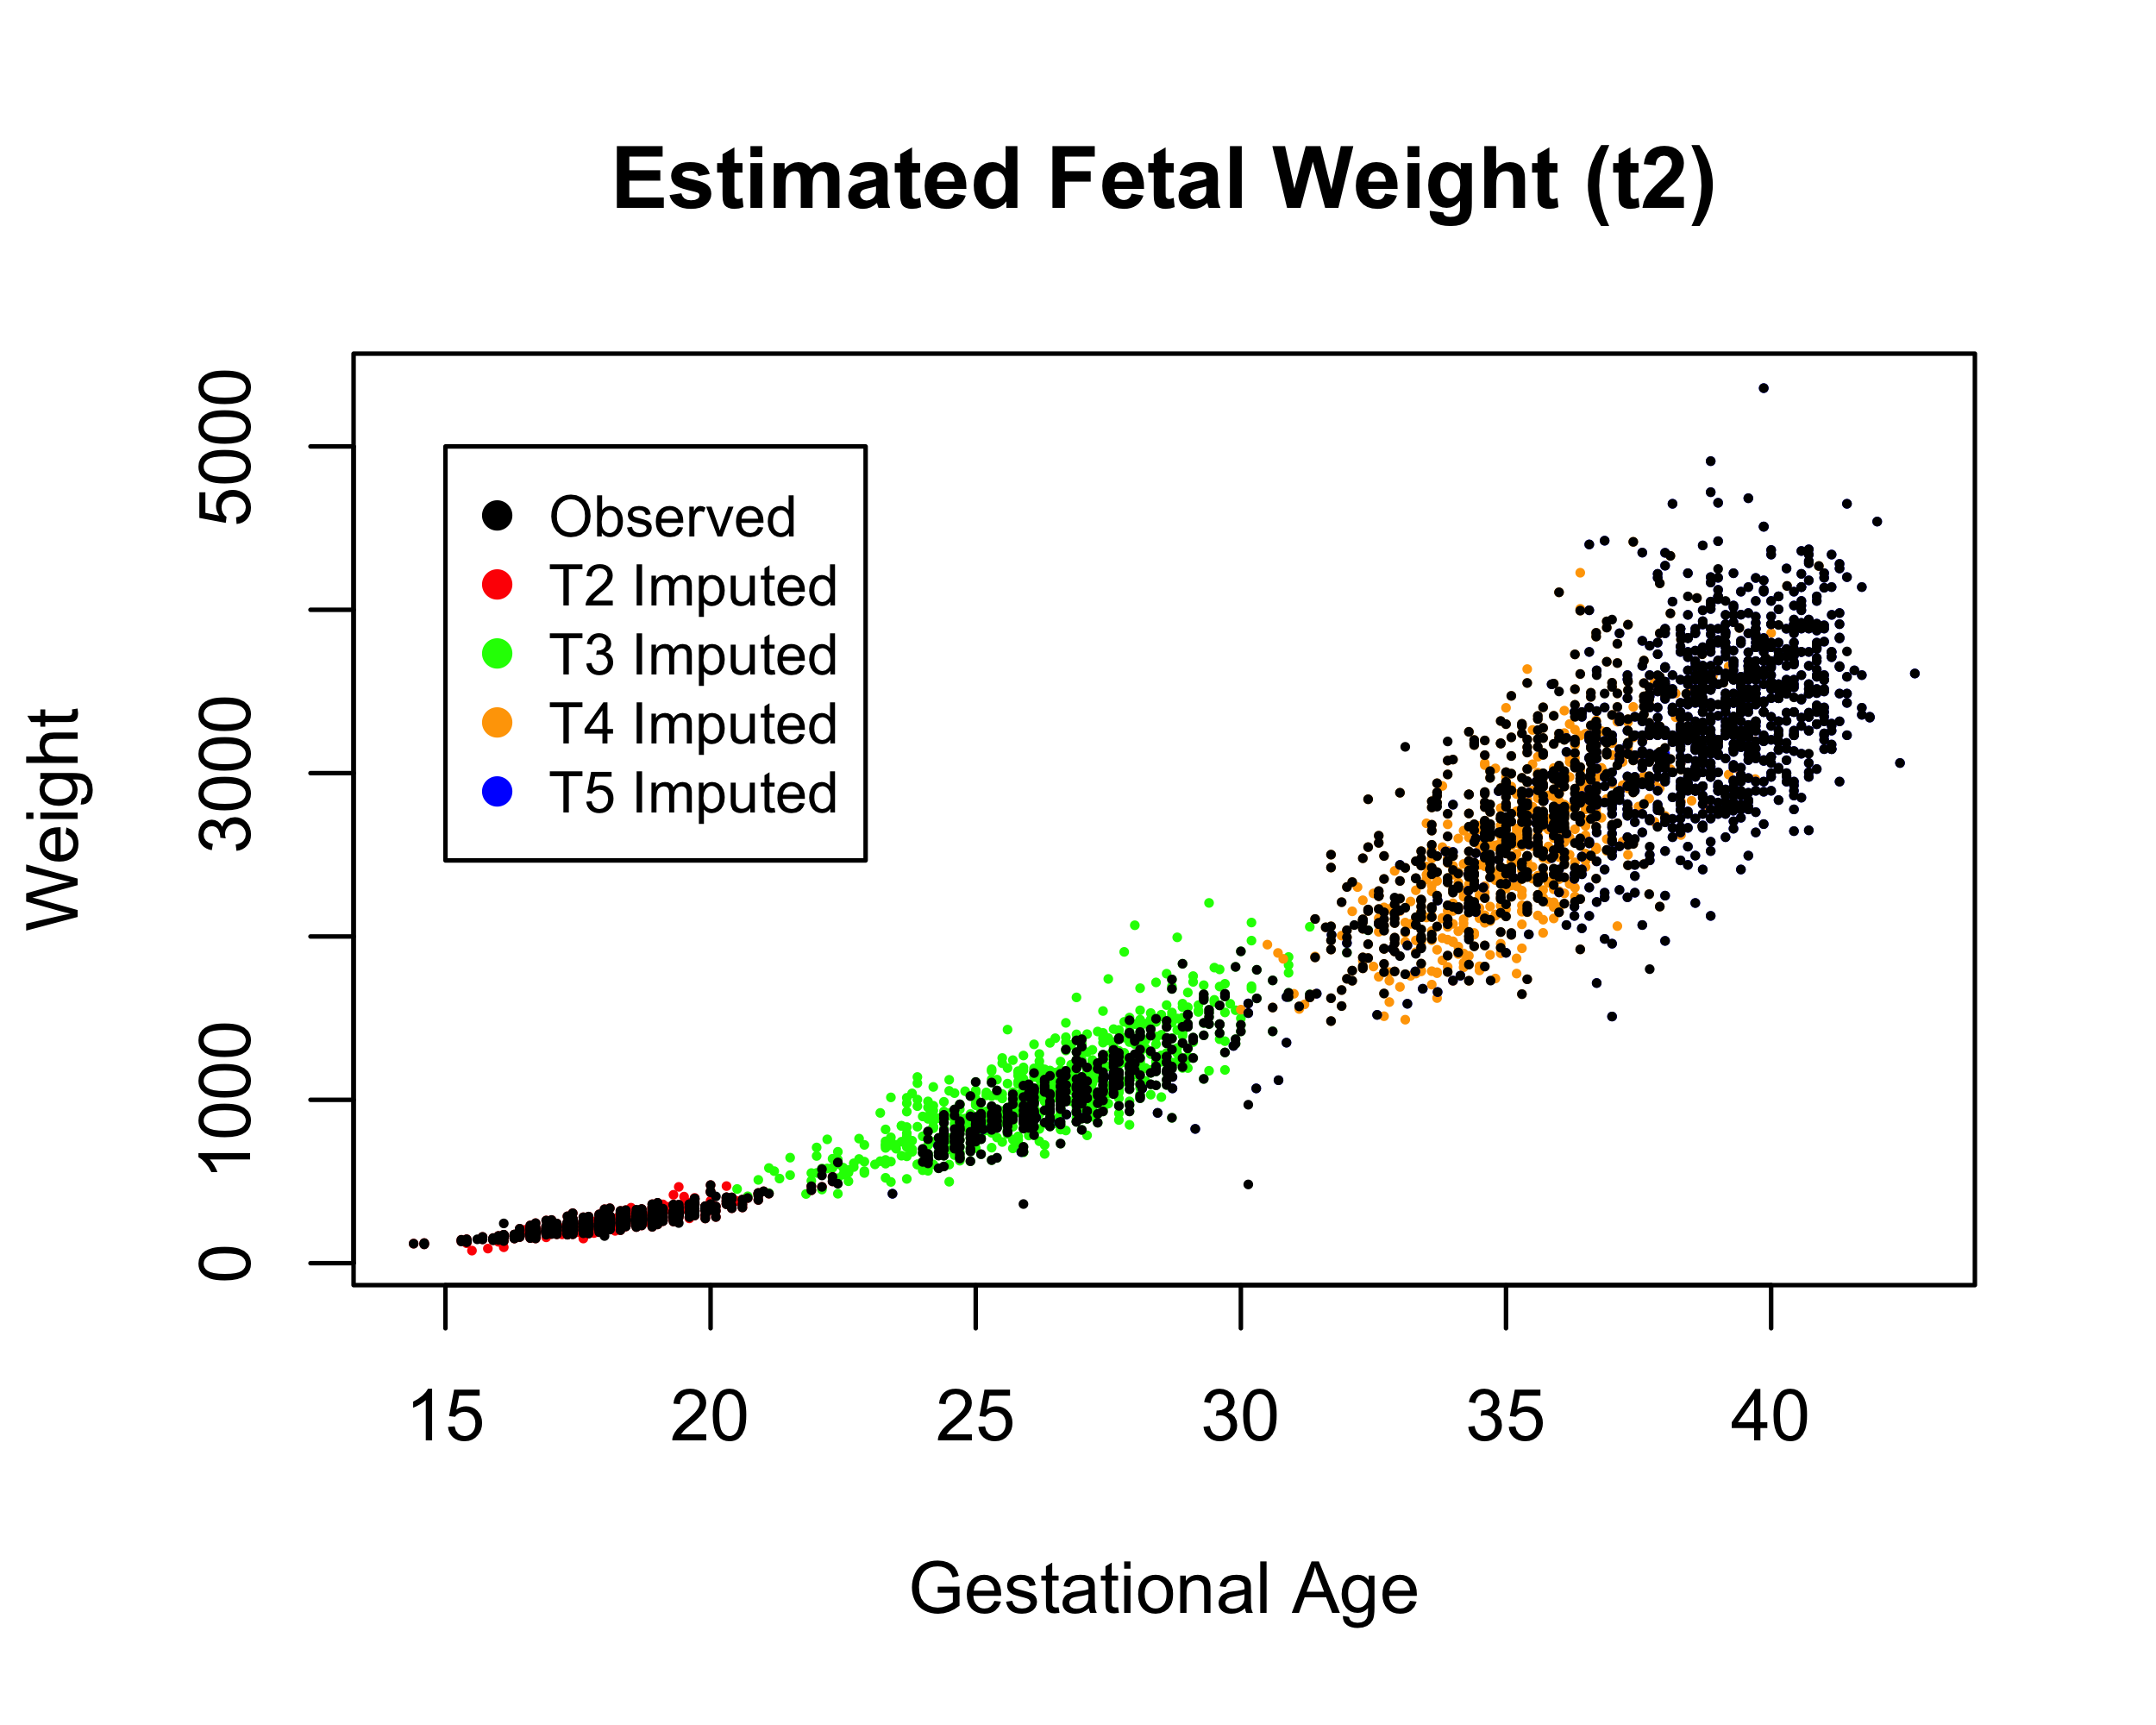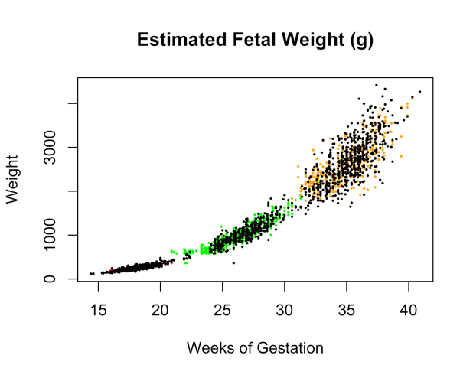

Figure S3. Difference in imputed measurements from MICE compared to LMM methods.

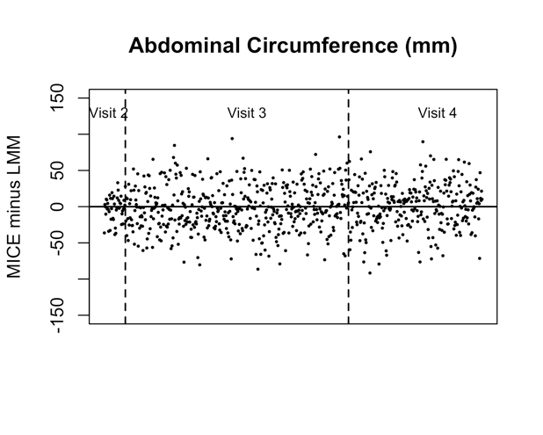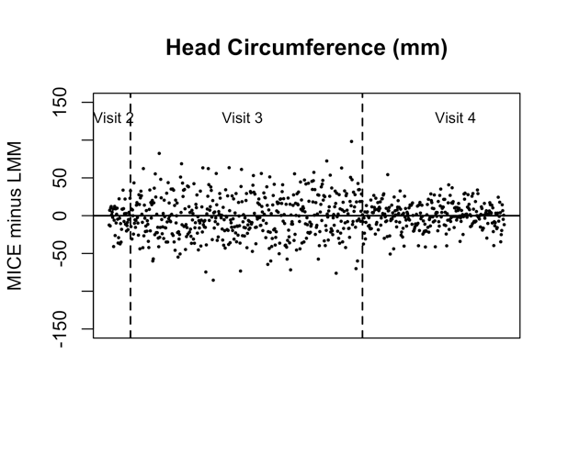
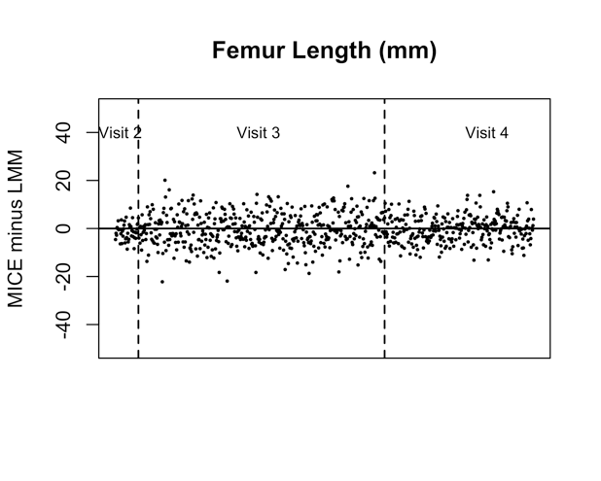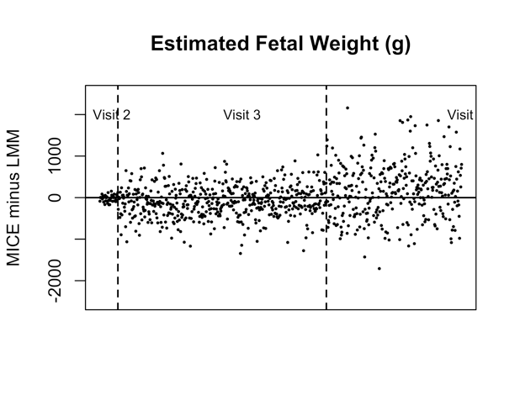

Table S1. Adjusted* cross-sectional associations at visit 2 between characteristics of the mother and pregnancy in relation to fetal growth parameters fitted on: A) original data; B) data imputed using LMM; and C) data imputed using MICE. Abdominal and head circumferences and femur length associations in mm; estimated fetal weight associations in grams.
A) Original data
 | Abdominal circumference  (N=852) | Head Circumference  (N=853) | Femur length  (N=853) | Estimated fetal weight  (N=852)
 | β (95% CI) | β (95% CI) | β (95% CI) | β (95% CI)
Maternal age | -0.07 (-0.18, 0.04) | 0.01 (-0.07, 0.10) | 0.02 (-0.004, 0.04) | 0.12 (-0.24, 0.47)
Maternal BMI | 0.10 (0.004, 0.20) | 0.12 (0.04, 0.19) | 0.05 (0.03, 0.07) | 0.55 (0.24, 0.86)
Infant sex | -2.63 (-3.66, -1.60) | -2.87 (-3.67, -2.07) | -0.12 (-0.34, 0.10) | -7.66 (-10.99, -4.33)
Maternal smoking | 2.39 (0.08, 4.69) | -0.63 (-2.39, 1.14) | -0.21 (-0.69, 0.28) | 4.02 (-3.43, 11.47)
Preeclampsia | 0.36 (-1.65, 2.37) | 0.13 (-1.43, 1.68) | 0.16 (-0.27, 0.59) | 0.61 (-5.89, 7.11)
B) LMM imputed
 | Abdominal circumference  (N=897) | Head Circumference  (N=897) | Femur length  (N=897) | Estimated fetal weight  (N=956)
 | β (95% CI) | β (95% CI) | β (95% CI) | β (95% CI)
Maternal age | -0.06 (-0.17, 0.05) | 0.01 (-0.08, 0.09) | 0.02 (-0.01, 0.04) | 0.03 (-0.36, 0.42)
Maternal BMI | 0.10 (0.01, 0.20) | 0.12 (0.04, 0.19) | 0.05 (0.03, 0.07) | 0.66 (0.33, 0.99)
Infant sex | -2.62 (-3.65, -1.60) | -2.89 (-3.69, -2.10) | -0.12 (-0.34, 0.09) | -9.27 (-12.83, -5.71)
Maternal smoking | 2.38 (0.08, 4.69) | -0.73 (-2.49, 1.05) | -0.23 (-0.71, 0.25) | 2.18 (-5.92, 10.28)
Preeclampsia | 0.39 (-1.65, 2.30) | 0.06 (-1.51, 1.62) | 0.10 (-0.31, 0.54) | -0.22 (-7.29, 6.85)
C) MICE imputed
 | Abdominal circumference  (N=1003) | Head Circumference  (N=1003) | Femur length  (N=1003) | Estimated fetal weight  (N=1003)
 | β (95% CI) | β (95% CI) | β (95% CI) | β (95% CI)
Maternal age | -0.07 (-0.17, 0.04) | 0.02 (-0.07, 0.10) | 0.03 (0.002, 0.05) | 0.15 (-0.20, 0.50)
Maternal BMI | 0.07 (-0.02, 0.17) | 0.09 (0.02, 0.16) | 0.05 (0.03, 0.07) | 0.47 (0.15, 0.80)
Infant sex | -2.75 (-3.75, -1.75) | -2.97 (-3.74, -2.20) | -0.12 (-0.34, 0.09) | -8.40 (-11.73, -5.07)
Maternal smoking | 2.48 (0.30, 4.67) | -0.52 (-2.20, 1.16) | -0.22 (-0.68, 0.25) | 4.17 (-3.08, 11.42)
Preeclampsia | 0.03 (-1.88, 1.94) | -0.28 (-1.79, 1.23) | 0.18 (-0.23, 0.59) | 1.60 (-5.08, 7.71)
* Maternal age (years) and pre-pregnancy body mass index (BMI, kg/m²) modeled continuously. For categorical variables, reference categories are as follows: infant sex (male); maternal smoking in pregnancy (none); diagnosis of preeclampsia (none). Models additionally adjusted for: maternal race, health insurance provider, alcohol use in pregnancy, use of IVF for conception, and gestation age at the time of ultrasound measurement. Note: For visit 2, none of the imputed gestational age was after the date of delivery

Table S2. Adjusted* cross-sectional associations at visit 3 between characteristics of the mother and pregnancy in relation to fetal growth parameters fitted on: A) original data; B) data imputed using LMM; and C) data imputed using MICE. Abdominal and head circumferences and femur length associations in mm; estimated fetal weight associations in grams.
A) Original data
 | Abdominal circumference  (N=425) | Head Circumference  (N=425) |  |  | Femur length  (N=425) |  |  |  |  | Estimated fetal weight  (N=385)
 | β (95% CI) | β (95% CI) |  |  | β (95% CI) |  |  |  |  | β (95% CI)
Maternal age | 0.14 (-0.09, 0.36) | -0.01 (-0.20, 0.17) |  |  | 0.03 (-0.01, 0.08) |  |  |  |  | 1.90 (-0.67, 4.47)
Maternal BMI | 0.26 (0.07, 0.45) | 0.18 (0.02, 0.33) |  |  | 0.08 (0.05, 0.12) |  |  |  |  | 4.67 (2.51, 6.83)
Infant sex | -1.45 (-3.66, 0.77) | -3.67 (-5.49, -1.85) |  |  | 0.53 (0.08, 0.97) |  |  |  |  | -2.54 (-27.3, 22.2)
Maternal smoking | -0.01 (-4.76, 4.74) | -1.40 (-5.30, 2.51) |  |  | -0.48 (-1.43, 0.48) |  |  |  |  | -9.80 (-61.5, 41.9)
Preeclampsia | 0.53 (-3.26, 4.31) | -0.41 (-3.52, 2.70) |  |  | -0.35 (-1.11, 0.42) |  |  |  |  | 3.12 (-38.3, 44.6)
B) LMM imputed
 | Abdominal circumference  (N=999) | Head Circumference  (N=999) |  |  | Femur length  (N=999) |  |  |  |  | Estimated fetal weight  (N=999)
 | β (95% CI) | β (95% CI) |  |  | β (95% CI) |  |  |  |  | β (95% CI)
Maternal age | 0.07 (-0.10, 0.24) | 0.01 (-0.13, 0.13) |  |  | 0.03 (-0.01, 0.06) |  |  |  |  | 2.05 (-0.06, 4.16)
Maternal BMI | 0.30 (0.16, 0.46) | 0.20 (0.09, 0.31) |  |  | 0.08 (0.06, 0.11) |  |  |  |  | 6.09 (4.30, 8.02)
Infant sex | -2.32 (-3.95, -0.81) | -3.42 (-4.63, -2.20) |  |  | 0.29 (-0.03, 0.58) |  |  |  |  | -44.7 (-64.7, -24.7)
Maternal smoking | 1.40 (-2.07, 5.08) | -1.25 (-3.79, 1.56) |  |  | -0.57 (-1.19, 0.14) |  |  |  |  | -35.2 (-80.13, 9.66)
Preeclampsia | 0.04 (-3.01, 3.08) | -0.97 (-3.31, 1.42) |  |  | -0.35 (-0.93, 0.20) |  |  |  |  | -25.7 (-64.17, 12.74)
C) MICE imputed
 | Abdominal circumference  (N=894) | Head Circumference  (N=894) |  |  | Femur length  (N=894) |  |  |  |  | Estimated fetal weight  (N=953)
 | β (95% CI) | β (95% CI) |  |  | β (95% CI) |  |  |  |  | β (95% CI)
Maternal age | 0.13 (-0.06, 0.33) | -0.05 (-0.21, 0.10) |  |  | 0.03 (-0.01, 0.07) |  |  |  |  | 1.23 (-0.62, 3.09)
Maternal BMI | 0.24 (0.08, 0.41) | 0.21 (0.07, 0.34) |  |  | 0.08 (0.04, 0.11) |  |  |  |  | 4.01 (2.40, 5.62)
Infant sex | -1.32 (-0.54, 3.19) | -4.63 (-6.18, -3.09) |  |  | 0.50 (-0.05, 0.97) |  |  |  |  | -9.22 (-27.38, 8.94)
Maternal smoking | 2.72 (-1.46, 6.90) | -1.03 (-4.18, 2.12) |  |  | -0.30 (-1.20, 0.61) |  |  |  |  | 5.85 (-35.05, 46.76)
Preeclampsia | 0.38 (-2.81, 3.57) | -1.01 (-3.82, 1.81) |  |  | -0.26 (-0.94, 0.42) |  |  |  |  | -5.95 (-37.72, 25.81)
* Maternal age (years) and pre-pregnancy body mass index (BMI, kg/m²) modeled continuously. For categorical variables, reference categories are as follows: infant sex (male); maternal smoking in pregnancy (none); diagnosis of preeclampsia (none). Models additionally adjusted for: maternal race, health insurance provider, alcohol use in pregnancy, use of IVF for conception, and gestation age at the time of ultrasound measurement. Note: For LMM and MICE methods the number of observations is based in part on the average number of observations from 50 imputed datasets. For visit 3, if the imputed gestational age was after the date of delivery the observation was treated as missing.
Table S3. Adjusted* cross-sectional associations at visit 4 between characteristics of the mother and pregnancy in relation to fetal growth parameters fitted on: A) original data; B) data imputed using LMM; and C) data imputed using MICE. Abdominal and head circumferences and femur length associations in mm; estimated fetal weight associations in grams.
A) Original data
 | Abdominal circumference  (N=565) |  | Head Circumference  (N=554) |  |  |  | Femur length  (N=565) |  | Estimated fetal weight  (N=565)
 | β (95% CI) |  | β (95% CI) |  |  |  | β (95% CI) |  | β (95% CI)
Maternal age | 0.30 (-0.02, 0.62) |  | 0.14 (-0.05, 0.33) |  |  |  | 0.06 (0.01, 0.11) |  | 7.06 (1.04, 13.08)
Maternal BMI | 0.90 (0.64, 1.15) |  | 0.47 (0.32, 0.62) |  |  |  | 0.15 (0.11, 0.19) |  | 19.63 (14.81, 24.44)
Infant sex | -2.51 (-5.47, 0.45) |  | -4.75 (6.47, 3.02) |  |  |  | 0.36 (-0.12, 0.83) |  | -54.32 (-109.94, 1.31)
Maternal smoking | -0.32 (-7.27, 6.64) |  | -1.81 (-5.92, 2.30) |  |  |  | -1.07 (-2.19, 0.05) |  | -43.73 (-174.38, 86.91)
Preeclampsia | -0.07 (-5.53, 5.40) |  | -3.08 (-6.28, 0.11) |  |  |  | -0.33 (-1.21, 0.55) |  | -30.25 (-132.97, 72.47)
B) LMM imputed
 | Abdominal circumference  (N=848) |  | Head Circumference  (N=848) |  |  |  | Femur length  (N=848) |  | Estimated fetal weight  (N=887)
 | β (95% CI) |  | β (95% CI) |  |  |  | β (95% CI) |  | β (95% CI)
Maternal age | 0.13 (-0.11, 0.37) |  | 0.06 (-0.10, 0.19) |  |  |  | 0.04 (0.002, 0.08) |  | 5.77 (1.16, 10.38)
Maternal BMI | 0.67 (0.47, 0.89) |  | 0.36 (0.22, 0.48) |  |  |  | 0.12 (0.08, 0.15) |  | 16.39 (12.29, 20.49)
Infant sex | -2.63 (-4.84, -0.40) |  | -4.03 (2.72, 5.46) |  |  |  | 0.28 (-0.10, 0.64) |  | -79.09 (-122.57, -35.61)
Maternal smoking | -0.27 (-5.40, 4.85) |  | -1.73 (-4.83, 1.37) |  |  |  | -0.77 (-1.66, 0.07) |  | -44.75 (-147.18, 57.68)
Preeclampsia | -1.27 (-5.81, 3.19) |  | -3.10 (-5.71, -0.49) |  |  |  | -0.42 (-1.15, 0.31) |  | -37.26 (-124.44, 49.92)
C) MICE imputed
 | Abdominal circumference  (N=920) |  | Head Circumference  (N=920) | Femur length  (N=920) |  |  |  | Estimated fetal weight  (N=920)
 | β (95% CI) |  | β (95% CI) | β (95% CI) |  |  |  | β (95% CI)
Maternal age | 0.12 (-0.18, 0.42) |  | 0.04 (-0.15, 0.23) | 0.07 (0.02, 0.13) |  |  |  | 4.14 (-0.89, 9.17)
Maternal BMI | 0.68 (0.43, 0.94) |  | 0.40 (0.26, 0.55) | 0.14 (0.10, 0.19) |  |  |  | 16.07 (11.72, 20.42)
Infant sex | -3.42 (-6.10, -0.74) |  | -4.52 (-6.34, -2.70) | 0.44 (-0.06, 0.94) |  |  |  | -62.71 (-109.33, -16.10)
Maternal smoking | -0.29 (-6.33, 6.91) |  | -1.07 (-4.78, 2.65) | -0.33 (-1.39, 0.74) |  |  |  | -5.81 (-116.39, 104.77)
Preeclampsia | -2.17 (-7.78, 3.45) |  | -3.76 (-6.97, -0.55) | -0.56 (-1.50, 0.38) |  |  |  | -68.22 (-165.24, 28.81)
* Maternal age (years) and pre-pregnancy body mass index (BMI, kg/m²) modeled continuously. For categorical variables, reference categories are as follows: infant sex (male); maternal smoking in pregnancy (none); diagnosis of preeclampsia (none). Models additionally adjusted for: maternal race, health insurance provider, alcohol use in pregnancy, use of IVF for conception, and gestation age at the time of ultrasound measurement. Note: For LMM and MICE methods the number of observations is based in part on the average number of observations from 50 imputed datasets. For visit 4, if the imputed gestational age was after the date of delivery the observation was treated as missing.
Table S4. Adjusted* longitudinal associations between characteristics of the mother and pregnancy in relation to repeated fetal growth parameters fitted on: A) original data; B) data imputed using LMM; and C) data imputed using MICE. Abdominal and head circumferences and femur length associations in mm; estimated fetal weight associations in grams. Samples sizes denote number of subjects and observations, respectively.
A) Original data
 | Abdominal circumference  (N=897, 1842) |  | Head Circumference  (N=897, 1832) |  |  | Femur length  (N=897, 1843) |  |  |  |  | Weight**  (N=956, 2757)
 | β (95% CI) |  | β (95% CI) |  |  | β (95% CI) |  |  |  |  | β (95% CI)
Maternal age | -0.03 (-0.14, 0.08) |  | 0.01 (-0.08, 0.09) |  |  | 0.02 (-0.01, 0.04) |  |  |  |  | 0.57 (-2.10. 3.25)
Maternal BMI | 0.13 (0.03, 0.22) |  | 0.15 (0.07, 0.22) |  |  | 0.06 (0.04, 0.08) |  |  |  |  | 5.39 (3.08, 7.70)
Infant sex | -2.63 (-3.65, -1.62) |  | -3.20 (-4.00, -2.40) |  |  | -0.02 (-0.23, 0.20) |  |  |  |  | -42.7 (-67.81, -17.54)
Maternal smoking | 2.25 (-0.03, 4.53) |  | -0.95 (-2.74, 0.84) |  |  | -0.31 (-0.78, 0.16) |  |  |  |  | -43.7 (-100.18, 12.87)
Preeclampsia | 0.39 (-1.57, 2.36) |  | -0.27 (-1.81, 1.26) |  |  | -0.03 (-0.43, 0.38) |  |  |  |  | -9.85 (-57.72, 38.03)
B) LMM imputed
 | Abdominal circumference  (N=897, 2639) |  | Head Circumference  (N=897, 2639) |  |  | Femur length  (N=897, 2639) |  |  |  |  | Weight**  (N=897, 2639)
 | β (95% CI) |  | β (95% CI) |  |  | β (95% CI) |  |  |  |  | β (95% CI)
Maternal age | -0.03 (-0.13, 0.08) |  | 0.01 (-0.08, 0.09) |  |  | 0.02 (-0.003, 0.04) |  |  |  |  | 0.46 (-2.10, 3.06)
Maternal BMI | 0.14 (0.04, 0.23) |  | 0.15 (0.09, 0.23) |  |  | 0.06 (0.04, 0.08) |  |  |  |  | 4.10 (1.81, 6.34)
Infant sex | -2.60 (1.61, 3.58) |  | -3.23 (-3.99, -2.48) |  |  | 0.002 (-0.20, 0.20) |  |  |  |  | -40.9 (16.20, 64.64)
Maternal smoking | 2.28 (0.06, 4.48) |  | -1.01 (-2.69, 0.69) |  |  | -0.32 (-0.78, 0.13) |  |  |  |  | -34.5 (-89.04, 21.49)
Preeclampsia | 0.29 (-1.60, 2.19) |  | -0.39 (-1.86, 1.09) |  |  | -0.07 (-0.46, 0.33) |  |  |  |  | -8.20 (54.66, 39.55)
C) MICE imputed
 | Abdominal circumference  (N=1003, 2922) |  | Head Circumference  (N=1003, 2922) |  |  | Femur length  (N=1003, 2922) |  |  |  |  | Weight**  (N=1003, 3925)
 | β (95% CI) |  | β (95% CI) |  |  | β (95% CI) |  |  |  |  | β (95% CI)
Maternal age | -0.01 (-0.12, 0.11) |  | -0.01 (-0.10, 0.08) |  |  | 0.03 (0.004, 0.05) |  |  |  |  | 1.16 (-1.11, 3.42)
Maternal BMI | 0.10 (0.003, 0.20) |  | 0.15 (0.07, 0.23) |  |  | 0.06 (0.04, 0.08) |  |  |  |  | 5.07 (3.08, 7.07)
Infant sex | -2.40 (-3.50, -1.29) |  | -3.73 (-4.59, -2.88) |  |  | 0.05 (-0.19, 0.28) |  |  |  |  | -40.7 (-62.03, 19.39)
Maternal smoking | 2.66 (0.18, 5.14) |  | -0.75 (-2.59, 1.08) |  |  | -0.24 (-0.73, 0.25) |  |  |  |  | -26.2 (-74.21, 21.79)
Preeclampsia | 0.25 (-1.77, 2.28) |  | -0.76 (-2.39, 0.87) |  |  | 0.03 (-0.39, 0.45) |  |  |  |  | -13.1 (-54.45, 28.19)
* Maternal age (years) and pre-pregnancy body mass index (BMI, kg/m²) modeled continuously. For categorical variables, reference categories are as follows: infant sex (male); maternal smoking in pregnancy (none); diagnosis of preeclampsia (none). Models additionally adjusted for: maternal race, health insurance provider, alcohol use in pregnancy, use of IVF for conception, and gestation age at the time of ultrasound measurement. **Includes estimated fetal weight from visits 2-4 in combination with birth weight at delivery. Note: For LMM and MICE methods the number of observations is based in part on the average number of observations from 50 imputed datasets. For visits 3 and 4, if the imputed gestational age was after the date of delivery the observation was treated as missing

