Supplemental Information on Exposure Assessment
Methods in Brief:
In a previous publication, the occupational exposures resulting in doses to three of the eight pesticides included in this study are derived and the methods described in detail. The remaining five pesticide doses were calculated following the same methods.
These exposures and doses were calculated following the methods used by the Environmental Protection Agency (EPA) in the risk assessments carried out for pesticide registration, with the addition of variability and uncertainty to build probabilistic estimates. EPA occupational pesticide exposures are calculated based on a set of field studies curated by the Agricultural Handler Exposure Task Force of the dermal and inhalation exposures experienced by occupational applicators performing a variety of tasks. In this study, we examined eight of the most popular pesticides for control of codling moth in apple orchards. These pesticides are diluted from their concentrated form into large tanks which are then applied to trees via airblast, therefore the relevant tasks on which the exposures are based in this study are mixing and loading of liquid concentrates, dry flowables, wettable powders, packaged wettable powders, and emulsifiable concentrates, and open cab airblast applications in tree fruit orchards.
Exposure rates under the EPA methodology are in units of micrograms of exposure to the active ingredient per pound of active ingredient used in the task. Occupational exposures were estimated for one eight-hour day’s worth of work based on a number of assumptions about the size of the area that would be covered in one day of pesticide application, and on the rate of pesticide mass applied to land area for control of the pest of interest.
Variability distributions of the dermal pesticide deposition were developed for each area of the body and for the inhalation filter collections within a scenario. Distributions were also developed for the effect of protective clothing and equipment, the pesticide application rates, the size of area applied, and physiological factors such as breathing rate, skin surface area, body weight, and dermal absorption rates for pesticides in order to estimate the dermal and inhalation exposure and the absorbed internal dose. These factors were combined to adjust the measured pesticide deposition and air filtrate to the dose that an adult pesticide applicator would receive internally, using the following generalized formulae per task:
$${Exposure Rate}_{area}={Deposition Rate}_{area}×Application Rate \left(\frac{lbs}{acre}\right)×Land area/day$$
$$Total Dermal dose =Dermal absorption fraction ×\sum_{\begin{aligned}Body \\ areas\end{aligned}}{ ({Exposure Rate}_{area}× {Surface Area}_{area}×{ Clothing protection}_{area} × {PPE}_{area})}$$
$$Inhalation Dose= \frac{sample mass*inhalation rate}{sampling flow rate*mass active ingredient applied}$$
Details on the values used in each equation are described in the previous publication.
Results:
The estimated dose distributions are summarized in the following table and figure. The table also includes the values used in the EPA human health risk assessments for these pesticides for tree fruit applicators and mixers-loaders. Total doses for handlers of azinphos methyl ranged from 5.27 ng/kg/day to 3.34 mg/kg/day, with a geometric mean of 2.73 µg/kg/day (GSD = 5.8). The dermal dose was an average of 97% of the total dose, ranging from 30% to 100%. Emamectin benzoate doses ranged from 11.31 pg/kg/day to 0.12 mg/kg/day, with a geometric mean of 0.043 µg/kg/day (GSD = 8.0). The dermal dose of emamectin benzoate ranged from 0.01% to 100% of the total dose, and averaged 65% of the total. The doses calculated for acetamiprid handlers ranged from 13.19 ng/kg/day to 3.36 mg/kg/day and had a geometric mean of 5.05 µg/kg/day (GSD 6.2). The acetamiprid dermal dose ranged from 18% to 100%, mean of 87%, of the total dose.

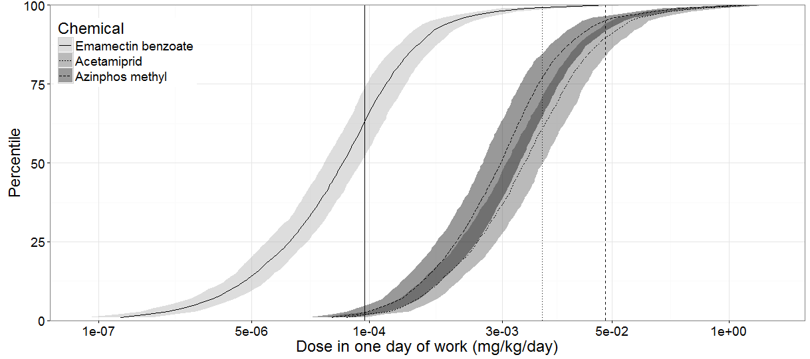
Figure 1: Probabilistic dose estimation for one day’s dose following mixing and loading and application for each pesticide. The vertical lines represent the dose used in the human health risk assessment. The shaded portions represent the 95th percentile of the uncertainty simulations surrounding the median estimate of dose.

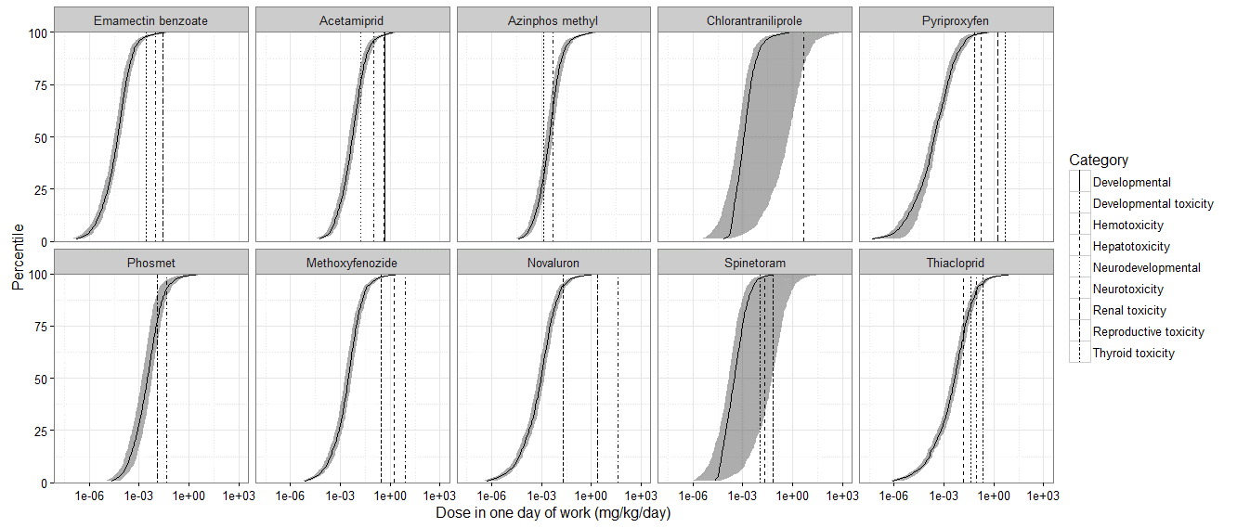

Figure 2: Cumulative distributions of pesticide doses calculated as previously described with associated (100x) safety factor adjusted benchmark doses used to calculate exceedance fractions for pesticide handlers working with each compound, for all associated health impact categories.

Table 1: Exceedance fractions, expressed as population percentages, of probabilistic estimates and summary statistics for EPA Human Health Risk (HHR) deterministic values of dose and margin of exposure (MOE) and level of concern (LOC), and NOAELs identified from relevant studies of neurotoxicity.
 | NOAEL (µg/kg/day) | EPA HHR deterministic dose (µg/kg/day) | EPA HHR estimated MOE | EPA Levels of concern (LOCs) used to evaluate MOE | Mean of probabilistic dose distribution (µg/kg/day) | % (95% C.I.) of probabilistic dose distribution greater than HHR deterministic dose | % (95% C.I.) of probabilistic MOE distribution beyond (less than) LOC‡
AZM | 150 | 8.33† | 18 | 100 | 18.3 | 27(19,38) | 54(42,64)
Dermal | 560 | -- | -- | 100 | 17 | -- | 53(43,64)
Inhalation | 200 | 3.42 | 58 |  | 1.3 | 19(6,43) | 9(3,15)
ACP | 10,000 | 35.43 | 282 | 100 | 2.8 | 14(4,21) | 5(3,8)
Dermal | 10,000 | 31.71 | 315 | 100 | 2.2 | 13(8,18) | 4 (3,8)
Inhalation | 10,000 | 3.72 | 2688 | 1000 | 0.6 | 20(12,28) | 12(6,18)
EB | 75 | 0.09 | 837 | 300 | 0.4 | 36(28,47) | 20(14,26)
Dermal | 75 | 0.04 | 1705 | 300 | 0.3 | 39(5,59) | 15(10,26)
Inhalation | 75 | 0.05 | 1645 | 300 | 0.1 | 14(5,29) | 12(4,20)
†The estimated dose used in the most recent EPA human health risk assessment of open-cab pesticide handlers for azinphos methyl is based on biomonitoring and inhalation data collected from mixer/loader/applicators (MRID 46316406).⁴⁷
‡ The levels of concern (LOC) for margins of exposure for azinphos methyl and dermal exposures to acetamiprid are 100, the typical value for occupational scenarios. Because of a lack of inhalation study for acetamiprid, the occupational inhalation LOC for acetamiprid is 1000.²² The LOC for emamectin benzoate inhalation and dermal occupational exposures is 300 for short term and 1,000 for intermediate exposures. The percent exceedance in this table uses 300 as the LOC MOE. The additional uncertainty factor of 3 was applied in the EPA human health risk assessment due to the severity of the health impact at the LOAEL (neuropathology).²³

