Supplementary material

Monitoring exposure to polycyclic aromatic hydrocarbons in an Australian population using pooled urine samples
Phong K Thai ^{a,b*}, Amy L Heffernan ^{b}, Leisa-Maree L Toms ^{c}, Zheng Li ^{d}, Antonia M Calafat ^{d}, Peter Hobson ^{e}, Sara Broomhall ^{f}, Jochen F Mueller ^{b}

ª International Laboratory for Air Quality and Health, Queensland University of Technology, Brisbane, QLD, Australia;
^{b} National Research Centre for Environmental Toxicology, University of Queensland, Brisbane, QLD, Australia;
^{c} School of Public Health and Social Work and Institute of Health and Biomedical Innovation, Queensland University of Technology, Brisbane, QLD, Australia
^{d} Centers for Disease Control and Prevention, Atlanta, GA, USA;
^{e} Sullivan Nicolaides Pathology, Taringa, QLD, Australia;
^{f} The Department of Environment, Canberra, ACT, Australia

*Corresponding author:
Phong Thai, Queensland University of Technology, Australia
(e) phong.thai@qut.edu.au;

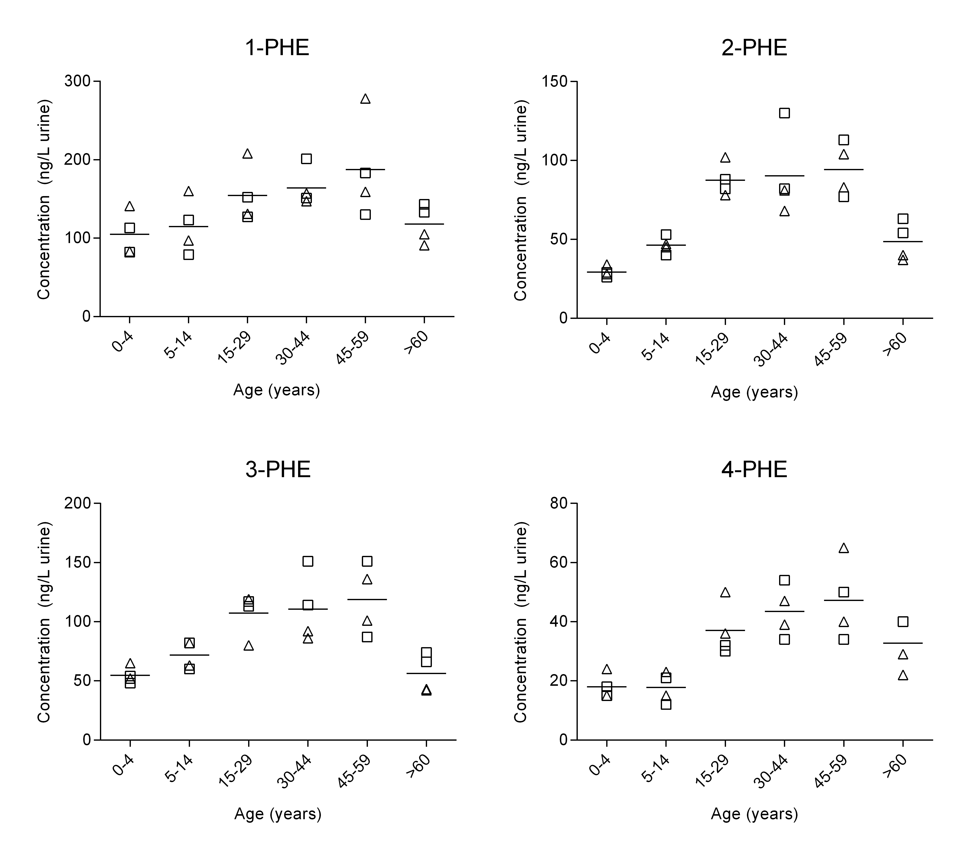

Figure S1: Urinary concentration (ng/L) versus age (years) for all OH-PAHs. Triangles denote female pools, squares denote male pools. Horizontal line indicates mean concentration of four pools in each age strata. Note log axis for 1-NAP.

