**a**

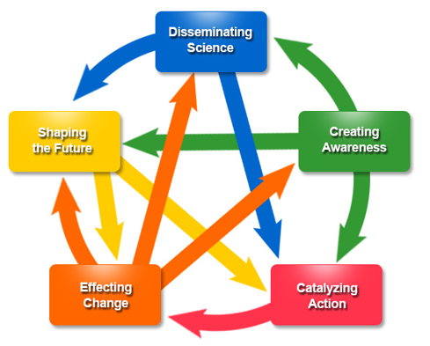

**b.**

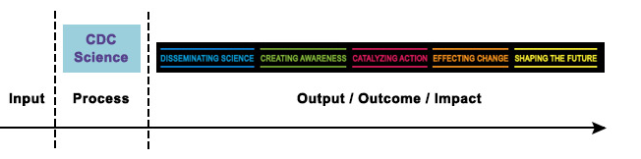

Figure 1. The CDC Science Impact Framework. **a.** inter-relationship of the five key domains. **b** application of the framework in an “input-process-output” logic model (Source: CDC) <https://www.cdc.gov/od/science/impact/framework.html>. Downloaded July 1, 2019.