Figure 2: Households surveyed (N=119) and suspect lead-emitting historical facilities (N=12) in the study area, Philadelphia, 2014*
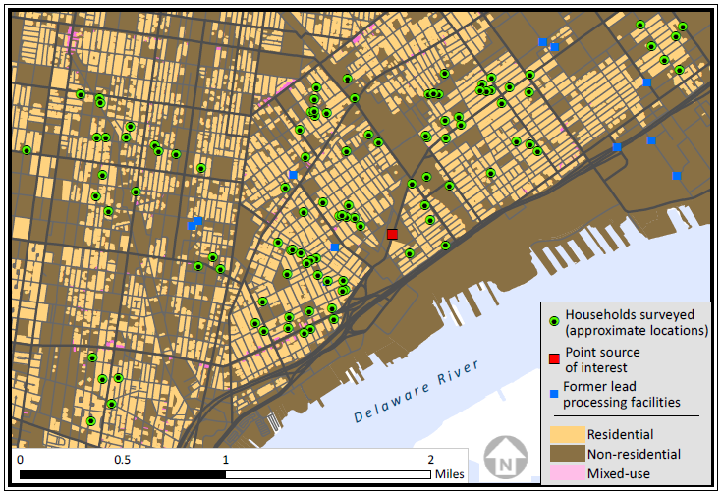
*Households surveyed are not shown in their true locations. The figure was created by offsetting each surveyed home in a random direction and a random distance up to 800 feet. This method retains the general pattern of the actual distribution, while preserving the confidentiality of study participants.

