Supplemental Data
Designing Traceable Opioid Material§ Kits to Improve Laboratory Testing During the U.S. Opioid Overdose Crisis
Mike A. Mojica‡; Melissa D. Carter‡,*; Samantha L. Isenberg‡; James L. Pirkle‡; Elizabeth I. Hamelin‡; Rebecca L. Shaner‡; Craig Seymour‡; Cody I. Sheppard‡; Grant T. Baldwin˚; Rudolph C. Johnson‡
‡Division of Laboratory Sciences, National Center for Environmental Health, CDC, Atlanta, GA, USA
˚Division of Unintentional Injury Prevention, National Center for Injury Prevention and Control, CDC, Atlanta, GA, USA

*Correspondence to: M.D. Carter, Division of Laboratory Sciences, Centers for Disease Control and Prevention, 4770 Buford Hwy NE, MS-F44, Atlanta, GA 30341, USA. Email melissa.carter@cdc.hhs.gov

Supplemental Table 1..........................................................................................................................................2-11
Supplemental Table 2……………………………………………………………………………………………………….………………………………12
Supplemental References…………………………………………………………………………………………………………………………….13-18

§TRACEABLE OPIOID MATERIAL, TOM KITS, and the TOM KITS logo are marks of the U.S. Department of Health and Human Services.
Supplemental Table 1: Names, structures and literature sources for 66 fentanyl analogs, fentanyl precursors/byproducts, fentanyl metabolites, and emerging synthetic, non-pharmaceutical opioids “research compounds” confirmed in analytical laboratory forensic, material seizure, and/or post mortem cases.
Fentanyl Analogs Found in Illicit Cases (Illegal Manufacture, Recreational Use, Suicides, or Homicides)
Name | Structure | Select Literature Sources
Fentanyl | 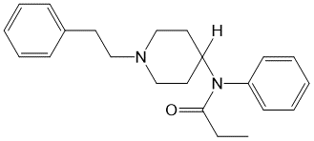 | (Backberg et al., 2015; Baldwin et al., 2018; Bate, 2018; Colon-Berezin et al., 2019; Coopman et al., 2016a; DEA, 2017b, 2018c; Hedegaard et al., 2018a; Hedegaard et al., 2018b; Helander et al., 2016; Helander et al., 2017; Hikin et al., 2018; Kacinko, 2018; Moody et al., 2018; NFLIS, 2015, 2016, 2017a, b, 2018; Papsun et al., 2017b; Pearson et al., 2015; Scholl et al., 2019; Schumann et al., 2008; Shanks and Behonick, 2017; Shoff et al., 2017; Teske et al., 2007; Thompson et al., 2007; Tiscione and Alford, 2018; Tomassoni et al., 2017)
2-Furanyl fentanyl | 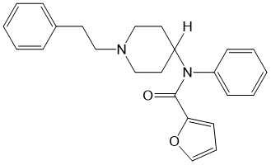 | (Daniulaityte et al., 2017; DEA, 2016, 2017b, 2018c; Guerrieri et al., 2017a; Helander et al., 2016; Hikin et al., 2018; Kacinko, 2018; Klar et al., 2016; Martucci et al., 2018; Mohr et al., 2016; Moody et al., 2018; Nash et al., 2018; NFLIS, 2016, 2017a, 2018; O’Donnell et al., 2017; Papsun et al., 2017a; Papsun et al., 2017b)
Acetyl fentanyl | 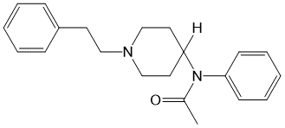 | (Cunningham et al., 2016; Daniulaityte et al., 2017; DEA, 2016, 2017b, 2018c; Dwyer et al., 2018; Fort et al., 2016; Helander et al., 2016; Kacinko, 2018; Lozier et al., 2015; McIntyre et al., 2015; Mochizuki et al., 2019; Moody et al., 2018; Moss et al., 2019; NFLIS, 2015, 2016, 2017a, 2018; O’Donnell et al., 2017; Pearson et al., 2015; Shoff et al., 2017; Yonemitsu et al., 2016)
Carfentanil | 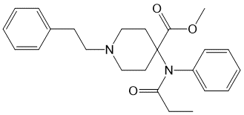 | (Daniulaityte et al., 2017; DEA, 2016, 2017b, 2018c; Hikin et al., 2018; Kacinko, 2018; Moody et al., 2018; Muller et al., 2018; NFLIS, 2017a, 2018; O’Donnell et al., 2017; Papsun et al., 2017b; Riches et al., 2012; Seither and Reidy, 2017; Shanks and Behonick, 2017; Shoff et al., 2017; Swanson et al., 2017; Tiscione and Alford, 2018; Uddayasankar et al., 2018)
4-Fluoro butryryl fentanyl (p-fluoro)* | 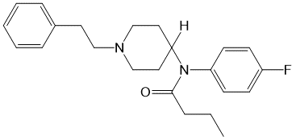 | (Backberg et al., 2015; DEA, 2016, 2017b, 2018c; Helander et al., 2017; Hikin et al., 2018; Moody et al., 2018; NFLIS, 2017a, 2018; O’Donnell et al., 2017; Rojkiewicz et al., 2017; Shoff et al., 2017)
4-Fluoro Isobutyryl fentanyl (p-fluoro)* | 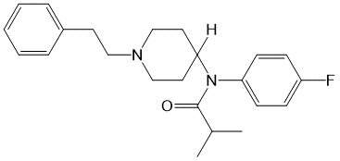
Acryl fentanyl | 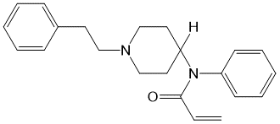 | (Breindahl et al., 2017; Butler et al., 2018; Daniulaityte et al., 2017; DEA, 2016, 2017b, 2018c; Guerrieri et al., 2017b; Helander et al., 2017; Kacinko, 2018; Moody et al., 2018; NFLIS, 2017a, 2018; O’Donnell et al., 2017)
Butyryl Fentanyl (Butyr Fentanyl)* | 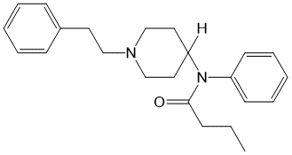 | (Backberg et al., 2015; Cole et al., 2015; Daniulaityte et al., 2017; DEA, 2016, 2017b, 2018c; Hikin et al., 2018; Kacinko, 2018; McIntyre et al., 2016; Moody et al., 2018; NFLIS, 2015, 2018; O’Donnell et al., 2017; Poklis et al., 2016; Shoff et al., 2017; Staeheli et al., 2016)
Isobutyryl fentanyl* | 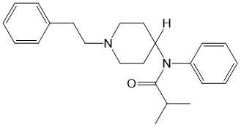
3-Methyl fentanyl | 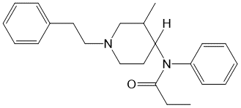 | (DEA, 2016, 2017b, 2018c; Hibbs et al., 1991; Kacinko, 2018; NFLIS, 2016, 2018; O’Donnell et al., 2017; Ojanpera et al., 2008; Ojanpera et al., 2006)
Cyclopropyl fentanyl* | 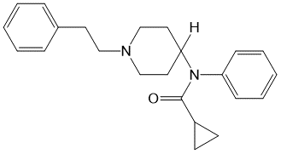 | (Brockbals et al., 2019; DEA, 2017b, 2018c; Fogarty et al., 2018; Kacinko, 2018; Palaty et al., 2018)
Crotonyl fentanyl* | 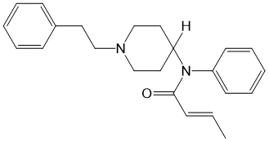
Methoxyacetyl fentanyl | 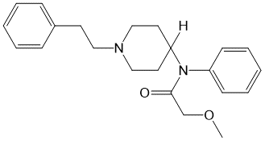 | (DEA, 2017b, 2018c; Fagiola et al., 2018; Fogarty et al., 2018; Kacinko, 2018; Mardal et al., 2018)
4-Fluoro fentanyl  (p-Fluoro)* | 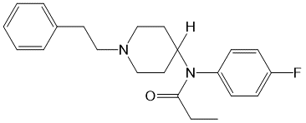 | (DEA, 2016; Helland et al., 2017; Kacinko, 2018; Moody et al., 2018; NFLIS, 2018; O’Donnell et al., 2017)
2-Fluoro fentanyl  (o-Fluoro)* | 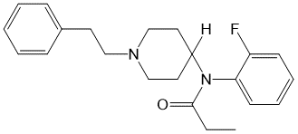
Valeryl fentanyl | 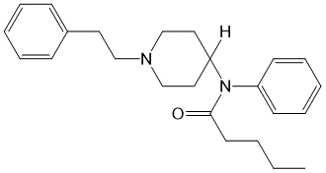 | (DEA, 2016, 2018c; Kacinko, 2018; Moody et al., 2018; NFLIS, 2018)
Tetrahydrofuranyl fentanyl | 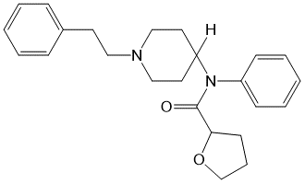 | (DEA, 2016, 2017b; Kacinko, 2018; Krotulski et al., 2018e)
Beta-Hydroxythio fentanyl | 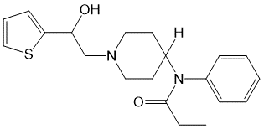 | (NFLIS, 2018; Shoff et al., 2017)
2-Thiofuranyl fentanyl | 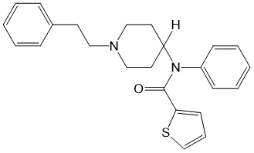 | (DEA, 2016, 2017b)
alpha-methyl fentanyl | 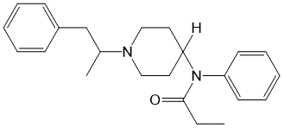 | (Gillespie et al., 1982; NFLIS, 2018)
Acetyl alpha-methyl fentanyl | 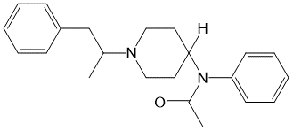 | (NFLIS, 2018)
4'-Methyl acetyl fentanyl | 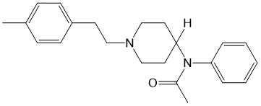 | (DEA, 2018c)
2-Methyl acetyl fentanyl | 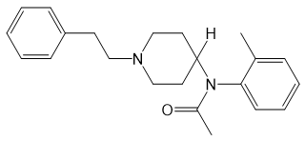 | (DEA, 2018b)
Benzoyl fentanyl | 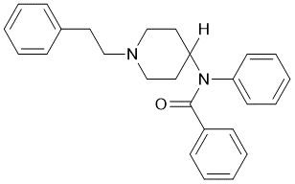 | (Casale et al., 2018)
4-Methoxy butyryl fentanyl (p-methoxy) | 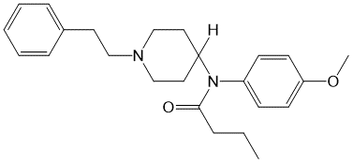 | (Helander et al., 2016; Helander et al., 2017; Moody et al., 2018)
4-Chloro isobutyryl fentanyl (p-Chloro) | 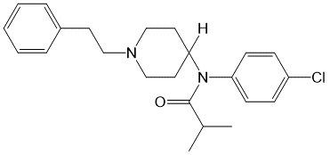 | (Helander et al., 2017)
Cyclopentyl fentanyl | 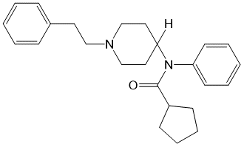 | (Helander et al., 2017)
Ocfentanil | 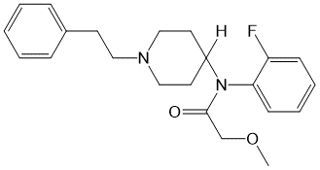 | (Casati et al., 2018; Coopman et al., 2016b; Dussy et al., 2016)
2,2'-Difluoro fentanyl | 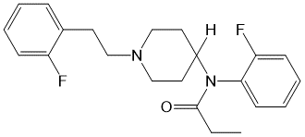 | (Liu et al., 2018)
4-Methoxy furanyl fentanyl (p-methoxy) | 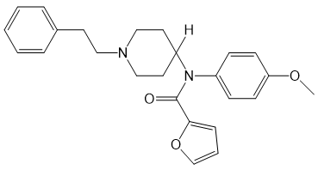 | (DEA, 2018d)
2/3/4-Fluoro furanyl fentanyl | 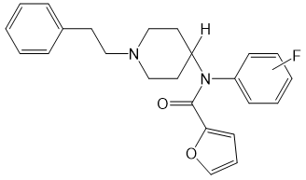 | (Krotulski and Logan, 2019)
4-methyl cyclopropyl fentanyl (p-methyl) | 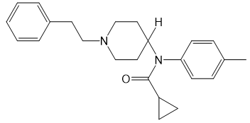 | (DEA, 2018d)
Remifentanil | 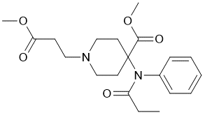 | (Riches et al., 2012)
Sufentanil | 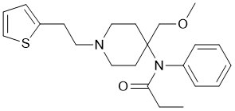 | (Ferslew et al., 1989; Kintz et al., 2005)
Alfentanil | 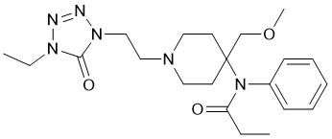 | (Kintz et al., 2014; Kintz et al., 2005)
Fentanyl Metabolite Markers in Analytical Reports
Name | Structure | Select Literature Sources
Norfentanyl | 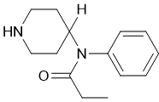 | (Daniulaityte et al., 2017; Papsun et al., 2017b; Poklis and Backer, 2004; Tomassoni et al., 2017)
Furanyl norfentanyl | 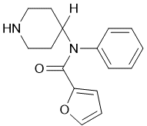 | (Daniulaityte et al., 2017)
Butyryl norfentanyl (Butyr norfentanyl) | 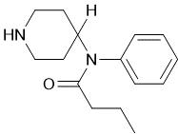 | (Daniulaityte et al., 2017; Staeheli et al., 2016)
Acetyl norfentanyl | 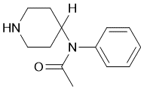 | (DEA, 2016; Watanabe et al., 2017)
Acryl norfentanyl | 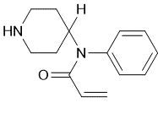 | (Watanabe et al., 2017)
4-fluoro-isobutyryl norfentanyl (p-fluoro) | 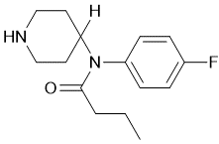 | (Watanabe et al., 2017)
CH2-Ocfentanil | 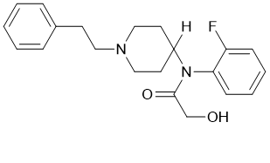 | (Allibe et al., 2018)
Dihydrodiol furanyl fentanyl | 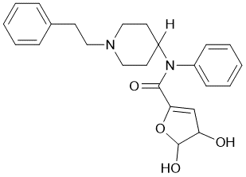 | (Watanabe et al., 2017)
Remifentanil acid | 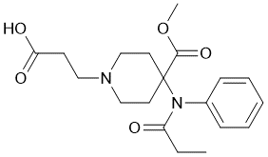 | (Pitsiu et al., 2004)
Fentanyl Synthesis Precursors and Byproducts
Name | Structure | Select Literature Sources
4-ANPP (Despropionyl fentanyl) | 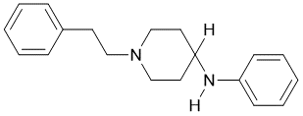 | (Daniulaityte et al., 2017; DEA, 2016, 2017b, 2018c; Martucci et al., 2018; NFLIS, 2018)
Benzyl fentanyl | 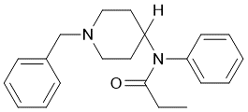 | (DEA, 2016, 2017b, 2018c)
2-Furanyl benzyl fentanyl | 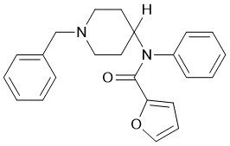 | (DEA, 2018c)
NPP (N-Phenethyl-4-piperidone) | 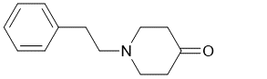 | (DEA, 2018c)
N-Methyl norfentanyl | 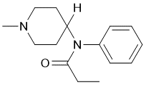 | (DEA, 2018c)
N-Methyl cyclopropyl norfentanyl | 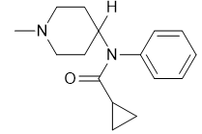 | (DEA, 2018d)
Benzoyl benzyl fentanyl | 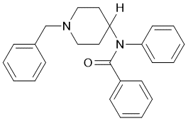 | (Casale et al., 2018; DEA, 2017b)
p-F-ANPP (Despropionyl p-fluoro fentanyl) | 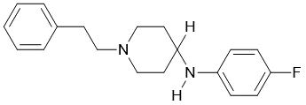 | (Daniulaityte et al., 2017; DEA, 2018d)
Despropionyl para-Fluoro benzyl fentanyl | 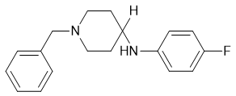 | (DEA, 2018c; Krotulski et al., 2018c)
para-Fluoro cyclopropyl benzyl fentanyl | 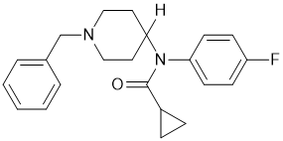 | (Krotulski et al., 2018c)
Despropionyl o-methyl fentanyl | 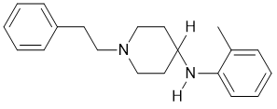 | (Krotulski et al., 2018b)
Despropionyl 3-methyl fentanyl | 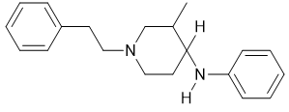 | (Krotulski et al., 2018a)

Emerging Synthetic Non-Pharmaceutical Opioids (“Research Chemicals”) Found in Illicit Cases
Name | Structure | Select Literature Sources
U-47700 | 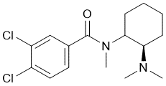 | (Coopman et al., 2016a; DEA, 2016, 2017b, 2018c; Domanski et al., 2017; Dziadosz et al., 2017; Ellefsen et al., 2017; Elliott et al., 2016; Gerace et al., 2018; Jones et al., 2017; Kacinko, 2018; McIntyre et al., 2017; Mohr et al., 2016; Moody et al., 2018; NFLIS, 2016, 2017a; Papsun et al., 2017a; Partridge et al., 2018; Rohrig et al., 2018; Schneir et al., 2017; Shoff et al., 2017; Vogliardi et al., 2018)
U-48800 | 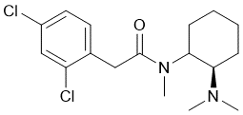 | (DEA, 2017b, 2018c)
U-49900 | 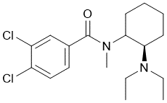 | (DEA, 2017b; Fabregat-Safont et al., 2017; Krotulski et al., 2018e)
Methylenedioxy-U-47700 | 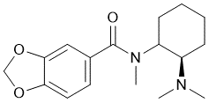 | (Krotulski and Logan, 2018b)
Isopropyl U-47700 | 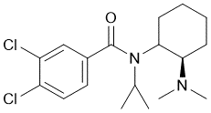 | (DEA, 2018c; Krotulski and Logan, 2018a)
U-47931E | 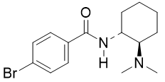 | (Krotulski et al., 2018d)
N-methyl U-47931E | 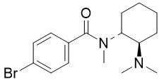 | (DEA, 2018d)
AH-7921 | 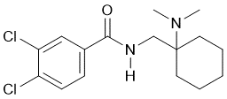 | (Fels et al., 2017; Karinen et al., 2014; Kronstrand et al., 2014; Vorce et al., 2014)
MT-45 | 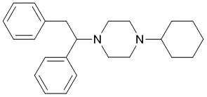 | (Fels et al., 2017; Helander et al., 2014; Papsun et al., 2016; Uchiyama et al., 2014)
2F-MT-45 | 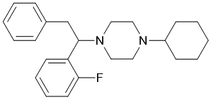 | (McKenzie et al., 2018)
* Isomers are occasionally reported together if analysis cannot differentiate between them.

Supplemental Table 2: The DEA(2017a, 2018a) and NFLIS(NFLIS, 2016, 2017a) reports were used to guide the 2018 design and the 2019 launch of the Opioid CRM Kit.
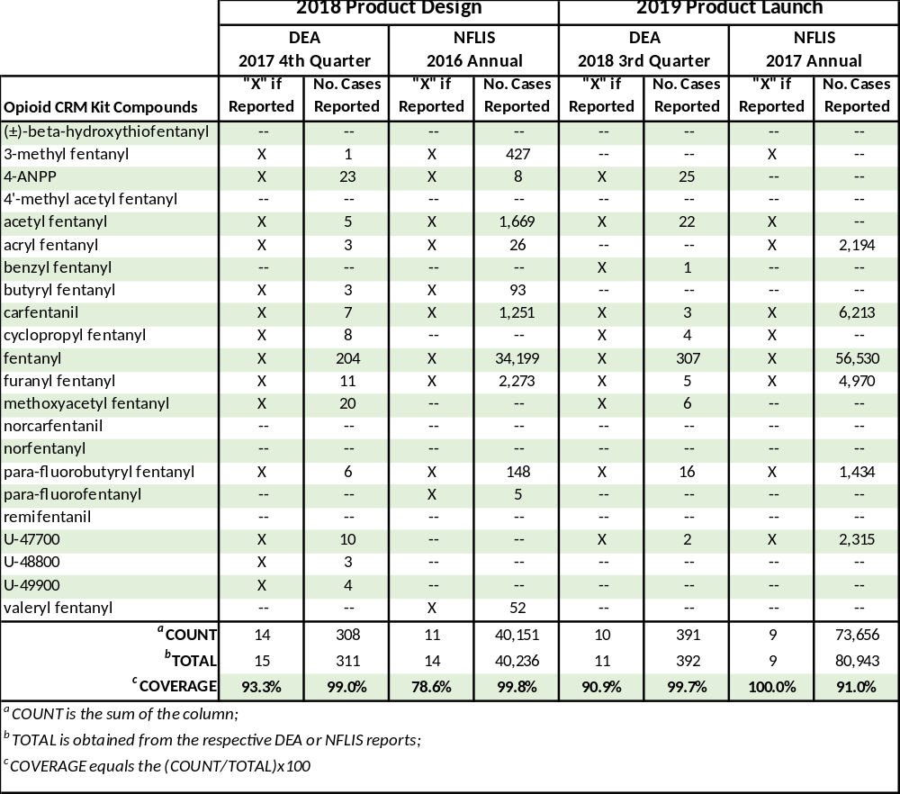
Supplemental References

