SUPPLEMENTAL MATERIAL
Supplemental Table 1. Vaccine introductions in MenAfriNet countries
Country | Vaccine antigen
 | MACV  (mass campaigns) | MACV  (routine) | Hib | PCV*
Burkina Faso | 2010 | 2017  (15–18 months) | 2006  (8, 12, 16 weeks) | 2013  (8, 12, 16 weeks)
Chad | 2011–2012 | 2017  (9–11 months) | 2008  (6, 10, 14 weeks) | Not yet introduced
Mali | 2010–2011 | 2017  (9–11 months) | 2005–2007  (6, 10, 14 weeks) | 2011  (6, 10, 14 weeks)
Niger | 2010–2011 | 2017  (9–11 months) | 2008  (6, 10, 14 weeks) | 2014  (6, 10, 14 weeks)
Togo | 2014 | Planned for 2019 | 2008  (6, 10, 14 weeks) | 2014  (6, 10, 14 weeks)
Source: World Health Organization vaccine introduction database
Abbreviations: Hib, Haemophilus influenzae serotype b conjugate vaccine; MACV, meningococcal serogroup A conjugate vaccine; PCV, pneumococcal conjugate vaccine.
*All 4 countries introduced 13-valent PCV.
Supplemental Table 2. Case counts of laboratory-confirmed meningitis by country, pathogen, age group, and year, MenAfriNet, 2015–2017
 | Burkina Faso |  |  | Chadª | Maliª |  | Niger |  |  | Togo
 | 2015 | 2016 | 2017 | 2017 | 2016 | 2017 | 2015 | 2016 | 2017 | 2015 | 2016 | 2017
NmC
<1 year | 0 | 0 | 0 | 0 | 1 | 0 | 20 | 5 | 7 | 0 | 0 | 0
1–4 years | 0 | 1 | 1 | 0 | 4 | 1 | 74 | 24 | 56 | 0 | 0 | 0
5–9 years | 6 | 5 | 8 | 0 | 2 | 0 | 137 | 58 | 152 | 0 | 0 | 0
10–14 years | 6 | 3 | 2 | 0 | 5 | 0 | 137 | 55 | 157 | 0 | 0 | 0
15–29 years | 0 | 5 | 2 | 0 | 5 | 0 | 119 | 49 | 103 | 0 | 0 | 0
≥30 years | 0 | 0 | 1 | 0 | 0 | 1 | 15 | 8 | 8 | 0 | 0 | 0
NmW
<1 year | 21 | 7 | 5 | 0 | 1 | 0 | 6 | 3 | 0 | 2 | 3 | 1
1–4 years | 69 | 34 | 19 | 0 | 0 | 0 | 31 | 3 | 1 | 7 | 4 | 2
5–9 years | 81 | 41 | 24 | 2 | 0 | 0 | 26 | 2 | 0 | 7 | 13 | 13
10–14 years | 38 | 27 | 26 | 0 | 1 | 0 | 21 | 3 | 0 | 3 | 13 | 7
15–29 years | 25 | 19 | 7 | 0 | 0 | 0 | 7 | 1 | 0 | 1 | 13 | 15
≥30 years | 24 | 8 | 3 | 0 | 0 | 0 | 1 | 0 | 0 | 3 | 17 | 4
NmX
<1 year | 0 | 0 | 1 | 1 | 1 | 1 | 0 | 0 | 3 | 0 | 0 | 5
1–4 years | 1 | 7 | 15 | 5 | 2 | 0 | 0 | 5 | 32 | 0 | 0 | 9
5–9 years | 2 | 16 | 14 | 3 | 0 | 0 | 0 | 5 | 33 | 0 | 1 | 15
10–14 years | 1 | 7 | 22 | 4 | 3 | 0 | 0 | 3 | 35 | 0 | 2 | 18
15–29 years | 2 | 1 | 2 | 4 | 1 | 0 | 0 | 0 | 8 | 0 | 0 | 13
≥30 years | 0 | 0 | 0 | 0 | 0 | 0 | 0 | 0 | 1 | 0 | 0 | 6
S. pneumoniae
<1 year | 45 | 59 | 41 | 8 | 9 | 4 | 21 | 8 | 10 | 1 | 1 | 0
1–4 years | 48 | 66 | 57 | 8 | 8 | 6 | 10 | 6 | 9 | 0 | 0 | 3
5–9 years | 141 | 129 | 76 | 4 | 4 | 3 | 5 | 3 | 5 | 2 | 1 | 1
10–14 years | 124 | 130 | 82 | 3 | 6 | 1 | 12 | 6 | 14 | 3 | 2 | 4
15–29 years | 121 | 90 | 57 | 1 | 10 | 5 | 16 | 7 | 10 | 6 | 0 | 5
≥30 years | 73 | 64 | 39 | 5 | 2 | 0 | 12 | 8 | 10 | 8 | 5 | 6
H. influenzae
<1 year | 13 | 23 | 14 | 4 | 4 | 12 | 2 | 6 | 1 | 0 | 0 | 0
1–4 years | 8 | 14 | 12 | 1 | 5 | 1 | 1 | 1 | 1 | 0 | 1 | 1
≥5 years | 9 | 11 | 7 | 3 | 2 | 4 | 1 | 1 | 14 | 0 | 0 | 0
Note: Cases were confirmed via latex agglutination, culture, or real-time polymerase chain reaction as N. meningitidis, S. pneumoniae, or H. influenzae. Only the predominant meningococcal serogroups are included in this table. Cases were reported from districts participating in MenAfriNet in each country. Cases with an unknown age are not included in this table. Incidences reported in this paper were adjusted for age and the proportion of cases with cerebrospinal fluid tested at a national reference laboratory, as opposed to using only these crude case counts.
ªAs Mali began data collection in 2015 and 2016 was the first complete year of surveillance, only 2016–2017 data are included. Similarly, only 2017 data from Chad are included.

A)
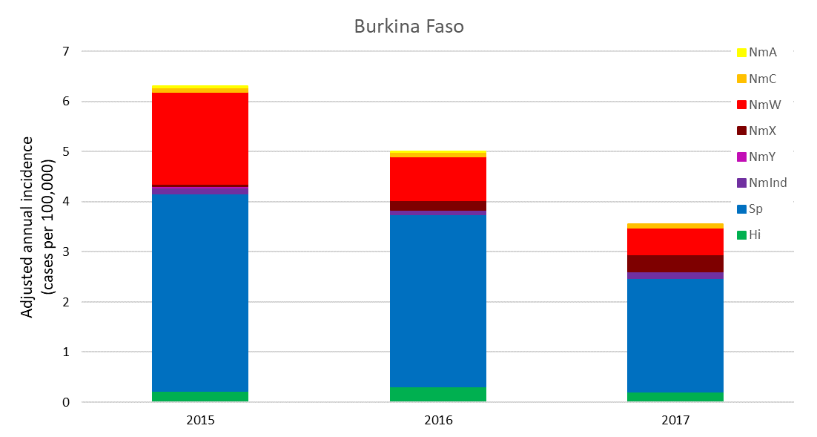
B)
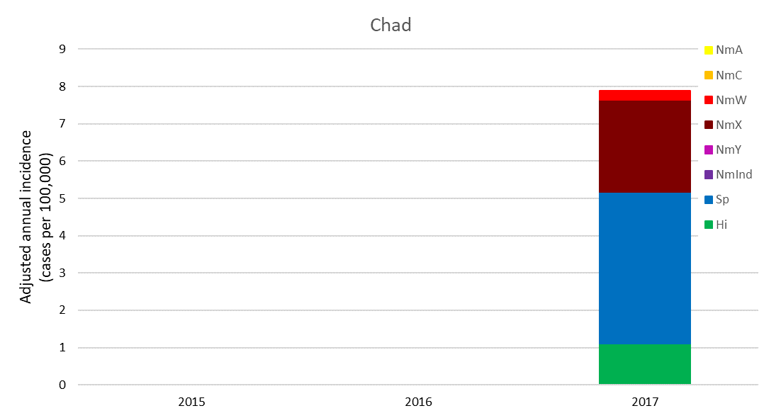
C)
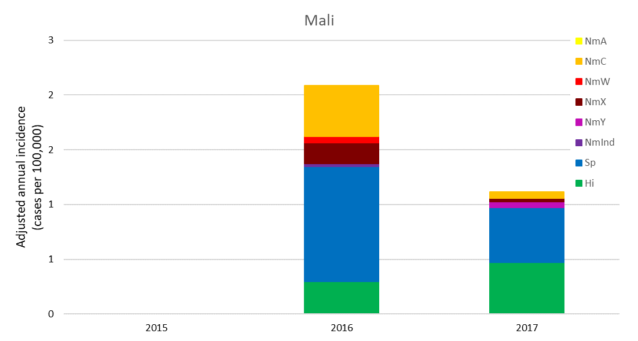

D)
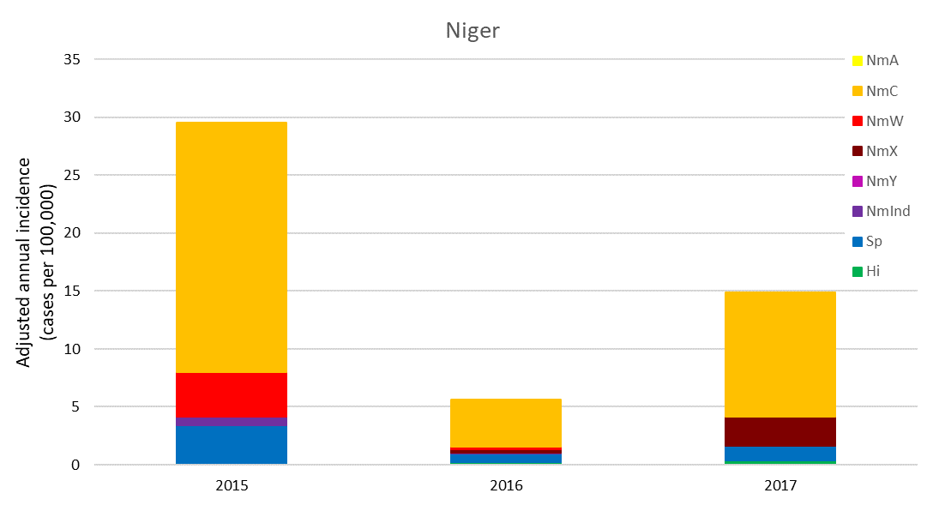
E)
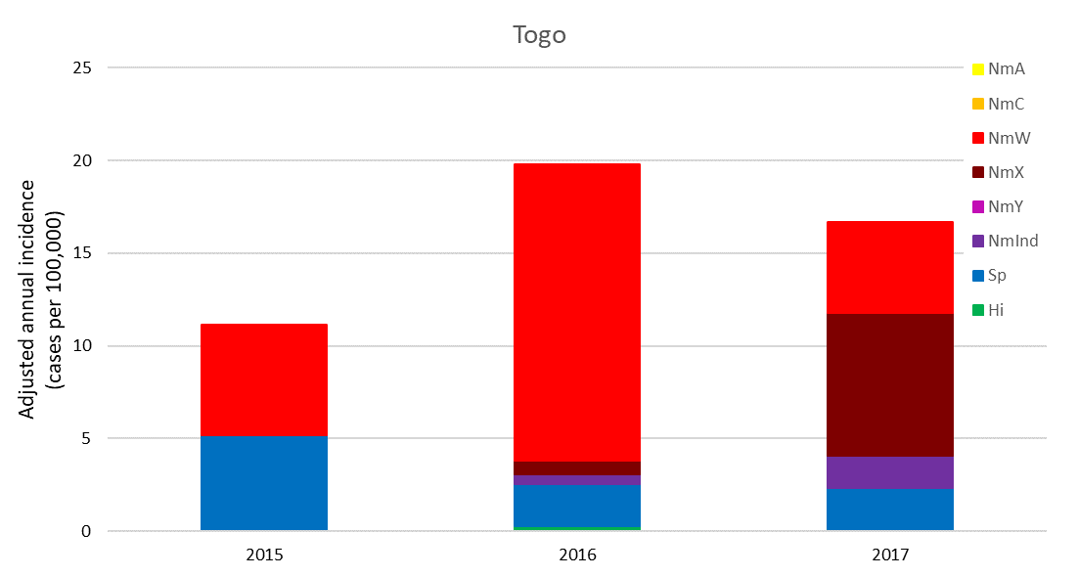
Supplemental Figure. Country-specific adjusted annual incidences of meningococcal meningitis by serogroup, 2015–2017. A) Burkina Faso; B) Chad; C) Mali; D) Niger; E) Togo. Abbreviations: NmA, N. meningitidis serogroup A; NmC, N. meningitidis serogroup C; NmW, N. meningitidis serogroup W; NmX, N. meningitidis serogroup X; NmY, N. meningitidis serogroup Y. As Mali began data collection in 2015 and 2016 was the first complete year of surveillance, only 2016–2017 data are included. Similarly, only 2017 data from Chad are included.

