Cervical cancer risk in women living with HIV across four continents: a multicohort study

The AIDS-defining Cancer Project Working Group of IeDEA and COHERE in EuroCoord

Supplementary material
Figures
- Supplementary Figure S1: Identification of study population for analysis. The flow diagram shows the number of included and excluded patients.
- Supplementary Figure S2: Identification of study population for the European region.
- Supplementary Figure S3: Identification of study population for the North American region.
- Supplementary Figure S4: Identification of study population for the Latin American region.
- Supplementary Figure S5: Identification of study population for the South African region.
- Supplementary Figure S6: ICC incidence rates by time since ART initiation and current CD4 cell count (cells/µl) predicted from the second adjusted model (sensitivity analysis) for women living with HIV who initiated an NNRTI-based first-line ART regimen between 2008-2014 at age 31-50 years.
Tables
- Supplementary Table S1: Characteristics of women with incident ICC.
- Supplementary Table S2: Comparison of ICC rates between different regions and Europe: Crude and adjusted HRs for ICC at 2 years and 5 years after ART initiation in women living with HIV; sensitivity analysis excluding ICC cases diagnosed within the first three months after ART initiation.
- Supplementary Table S3: Sensitivity analysis of regional risk factors for incident ICC in women who have initiated ART, excluding ICC cases diagnosed within the first three months after ART initiation.
- Supplementary Table S4: Sensitivity analysis of regional risk factors for incident ICC in women who have initiated ART, including current CD4 cell count instead of CD4 cell count at ART initation.
Acknowledgements
- Detailed acknowledgements of consortia contributing data to this analysis.

Supplementary Figure S1: Identification of study population for analysis. The flow diagram shows the number of included and excluded women.
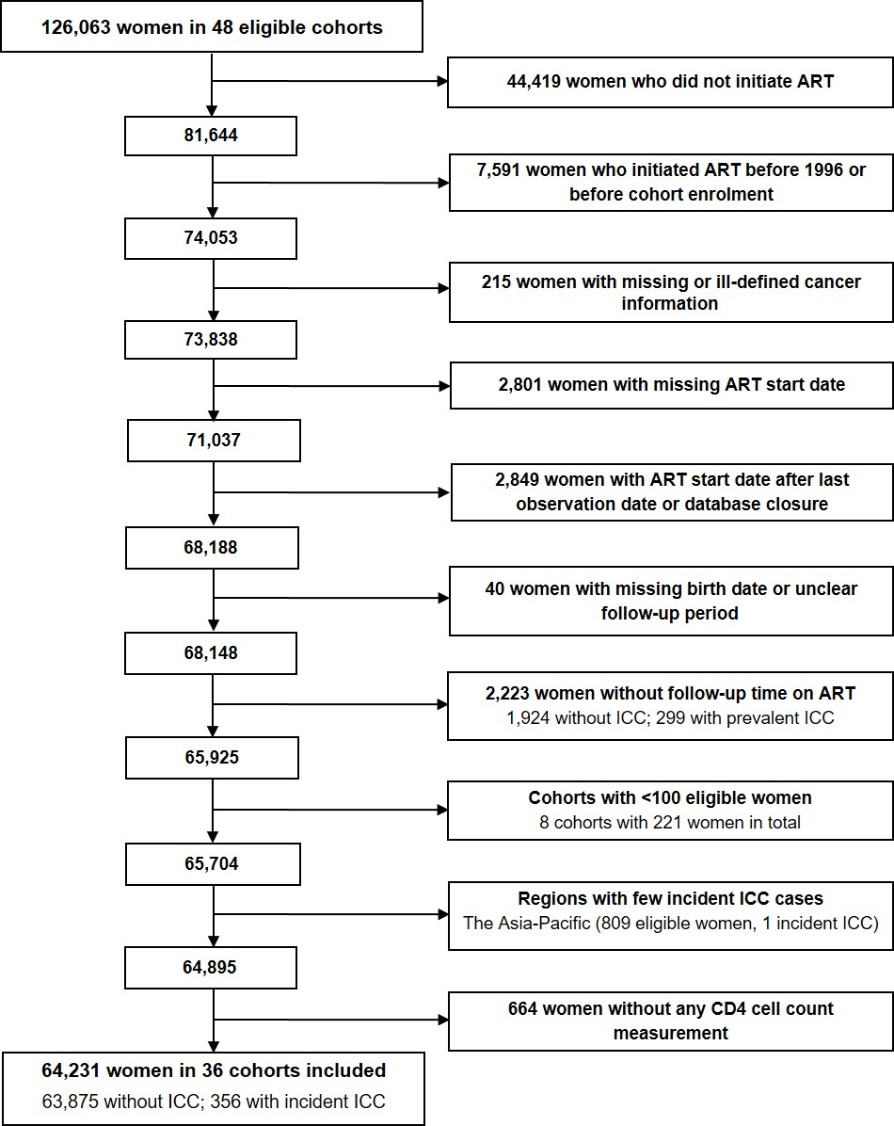

ART, antiretroviral therapy; ICC, invasive cervical cancer.
Supplementary Figure S2: Identification of study population for the European region.
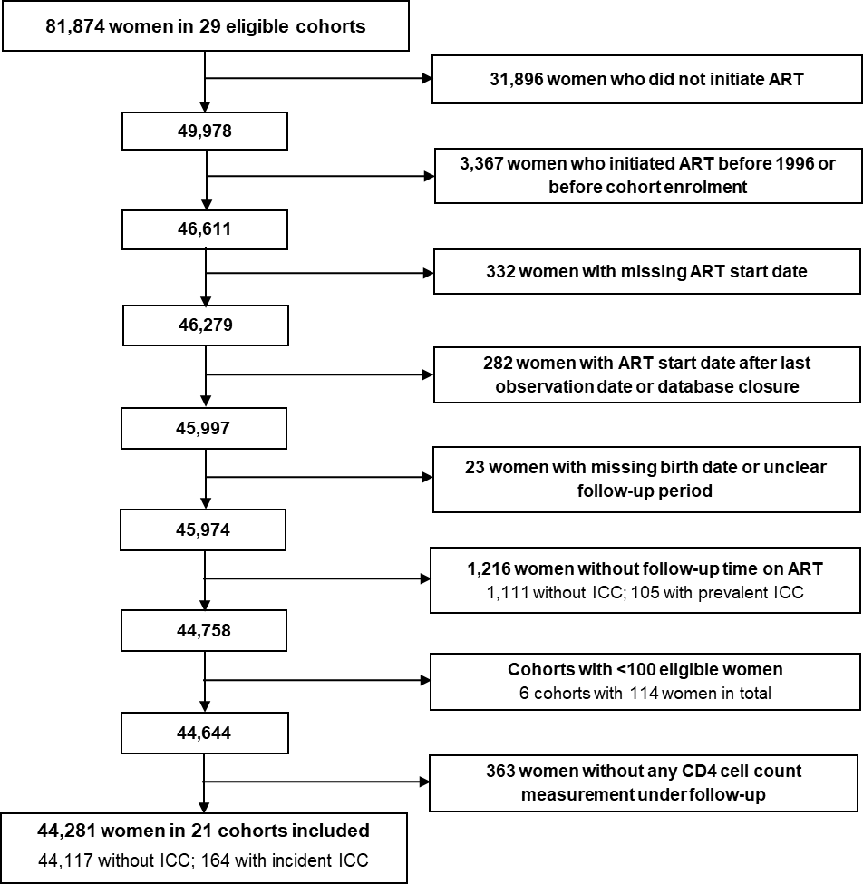

Supplementary Figure S3: Identification of study population for the North American region.
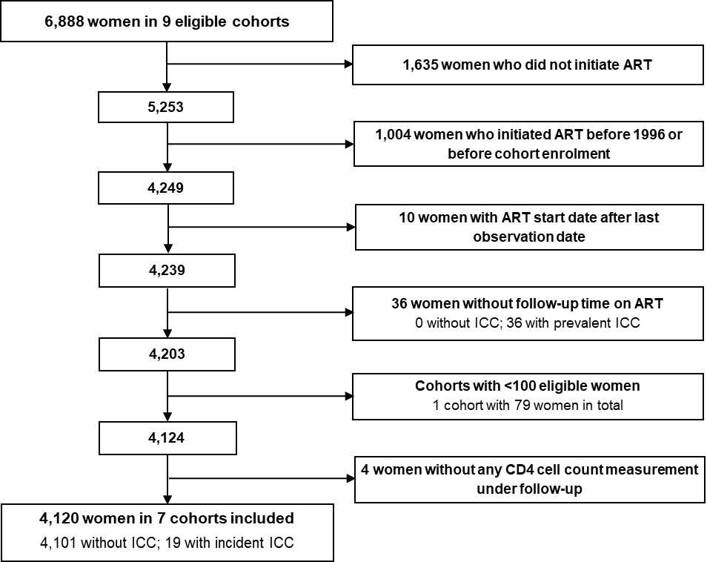

Supplementary Figure S4: Identification of study population for the Latin American region.
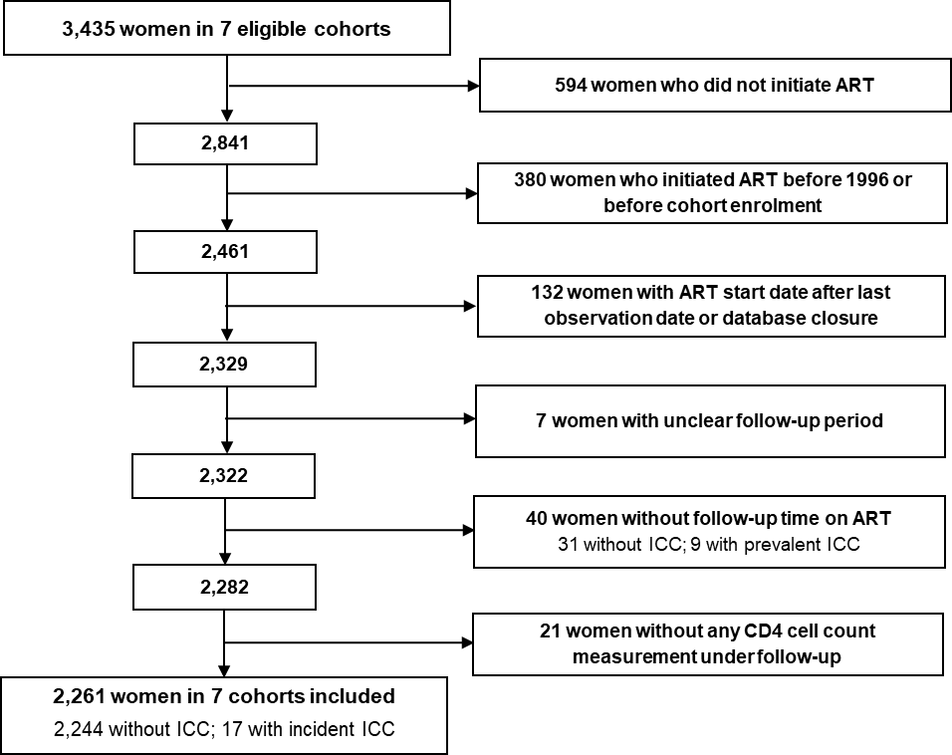

Supplementary Figure S5: Identification of study population for the South African region.
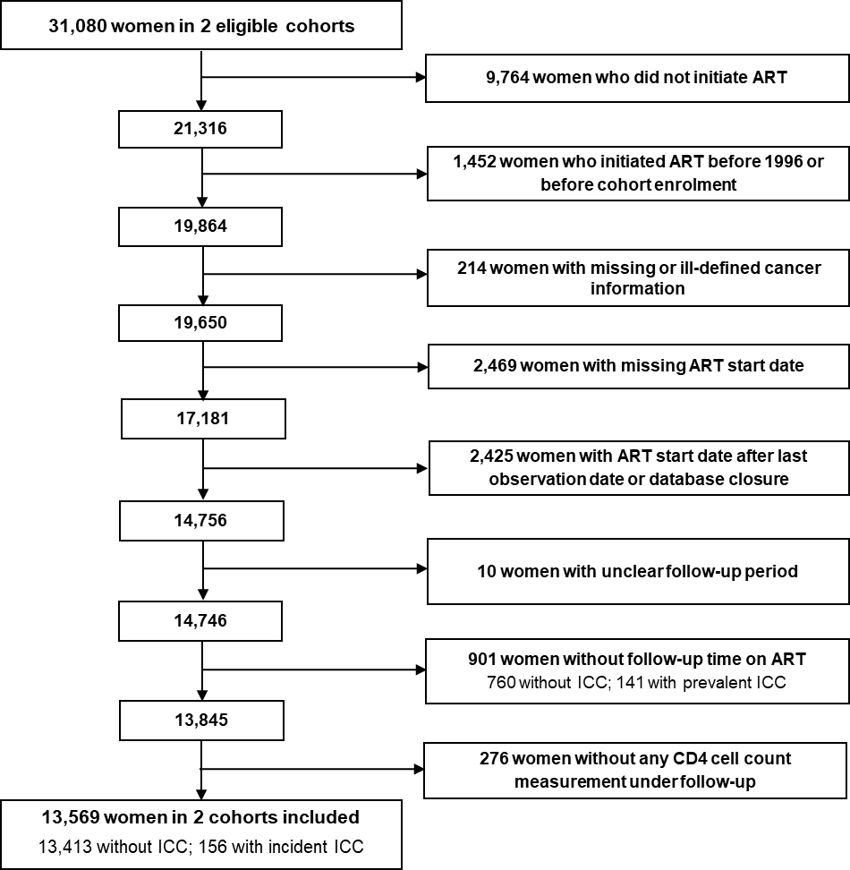

Supplementary Figure S6: ICC incidence rates by time since ART initiation and current CD4 cell count (cells/µl) predicted from the second adjusted model (sensitivity analysis) for women living with HIV who initiated an NNRTI-based first-line ART regimen between 2008-2014 at age 31-50 years.
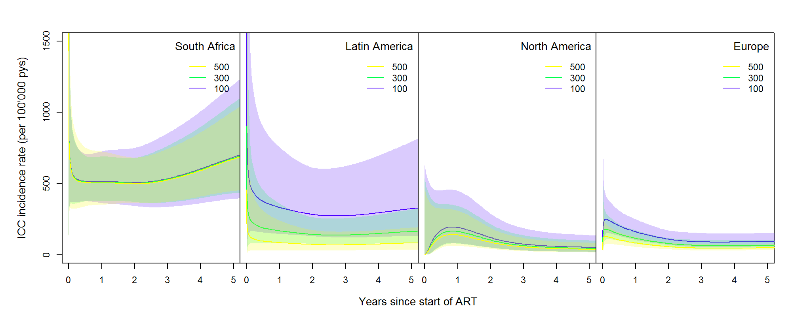
ART, antiretroviral therapy; ICC, invasive cervical cancer; NNRTI, non-nucleoside reverse-transcriptase inhibitor.
Supplementary Table S1: Characteristics of women with incident ICC.
 | South Africa | Latin America | North America | Europe
 | N (%) | N (%) | N (%) | N (%)
All ICC cases | 156 (100%) | 17 (100%) | 19 (100%) | 164 (100%)
Median time to ICC diagnosis (IQR) [years] | 1.7 (0.9-3.2) | 2.6 (0.7-5.6) | 1.7 (1.2-6.0) | 2.2 (0.7-5.3)
Median age at ICC diagnosis (IQR) [years] | 38.3  (33.5; 42.7) | 33.0  (28.8; 43.4) | 39.0  (29.6; 43.1) | 39.7  (33.8; 45.4)
Age at ICC diagnosis [years]
16-30 | 13 (8%) | 5 (29%) | 5 (26%) | 16 (10%)
31-50 | 131 (84%) | 10 (59%) | 13 (68%) | 124 (76%)
>50 | 12 (8%) | 2 (12%) | 1 (5%) | 24 (15%)
First-line ART regimen
NNRTI-based | 150 (96%) | 14 (82%) | 3 (16%) | 55 (34%)
PI-based | 5 (3%) | 3 (18%) | 15 (79%) | 103 (63%)
Other ART | 1 (1%) | 0 (0%) | 1 (5%) | 6 (4%)
Year of ART initiation
1996-1998 | 0 (0%) | 1 (6%) | 10 (53%) | 36 (22%)
1999-2003 | 0 (0%) | 6 (35%) | 6 (32%) | 71 (43%)
2004-2007 | 114 (73%) | 3 (18%) | 3 (16%) | 31 (19%)
2008-2014 | 42 (27%) | 7 (41%) | 0 (0%) | 26 (16%)
Median CD4 cell count at ICC diagnosis (IQR) [cells/µl] | 292 (170-450) | 275 (190-406) | 370 (200-586) | 350 (183-523)
Women with missing CD4 cell count at ICC diagnoisis | 37 (24%) | 6 (35%) | 1 (5%) | 23 (14%)
Median HIV RNA at ICC diagnosis (IQR) [log10 copies/ml] | 1.7 (1.7-1.7) | 1.7 (1.6-3.3) | 2.3 (2.3-2.8) | 2.0 (1.7-3.7)
Women with missing HIV RNA at ICC diagnosis | 51 (33%) | 4 (24%) | 1 (5%) | 31 (19%)
ART, antiretroviral therapy; HIV, human immunodeficiency virus; IQR, interquartile range; NNRTI, non-nucleoside reverse-transcriptase inhibitors; PI, protease-inhibitors; RNA, ribonucleic acid.

Supplementary Table S2: Comparison of ICC rates between different regions and Europe: Crude and adjusted HRs for ICC at 2 years and 5 years after ART initiation in women living with HIV; sensitivity analysis excluding ICC cases diagnosed within the first three months after ART initiation.
 | At 2 years |  | At 5 years
 | Crude HR  (95% CI) | Adjusted HR* (95% CI) | Crude HR  (95% CI) | Adjusted HR*  (95% CI)
Region
Europe | 1.00 | 1.00 | 1.00 | 1.00
North America | 1.31 (0.71 - 2.41) | 1.09 (0.55 - 2.15) | 0.99 (0.49 – 2.01) | 0.80 (0.37 - 1.74)
Latin America | 1.81 (1.02 - 3.24) | 1.94 (0.98 - 3.82) | 2.32 (1.23 - 4.39) | 2.42 (1.22 - 4.78)
South Africa | 7.36 (5.52 - 9.83) | 6.85 (4.60 - 10.19) | 10.53 (7.08 - 15.67) | 9.87 (5.89 - 16.53)
* Adjusted for CD4 cell count at ART initiation, age at ART initiation, first-line ART regimen, and calendar period of ART initiation.
ART, antiretroviral therapy; CI, confidence interval; HR, hazard ratio; ICC, invasive cervical cancer.

Supplementary Table S3: Sensitivity analysis of risk factors for incident ICC in women who have initiated ART, excluding ICC cases diagnosed within the first three months after ART initiation.
 | Hazard ratio*
 | (95% CI)
CD4 cell count at ART initiation
per 100 cells/µl decrease | 1.23 (1.12 - 1.34)
Age at ART initiation [years]
16-30 | 1.00
31-50 | 1.32 (1.00 - 1.76)
>50 | 1.48 (0.94 - 2.33)
First-line ART regimen
NNRTI-based | 1.00
PI-based | 1.07 (0.79 - 1.45)
Other ART | 0.39 (0.16 - 0.97)
Year of ART initiation
1996-1998 | 1.71 (1.01 - 2.90)
1999-2003 | 1.37 (0.88 – 2.13)
2004-2007 | 0.98 (0.69 - 1.39)
2008-2014 | 1.00
* Adjusted for region, CD4 cell count at ART initiation, age, calendar year of ART start, and first-line ART regimen.
** Derived from likelihood ratio test comparing the adjusted model with and without the interaction of a specific variable with region.
ART, antiretroviral therapy; CI, confidence interval; ICC, invasive cervical cancer; NNRTI, non-nucleoside reverse-transcriptase inhibitor; PI, protease-inhibitor

Supplementary Table S4: Sensitivity analysis of risk factors for incident ICC in women who have initiated ART, including current CD4 cell count instead of CD4 cell count at ART initiation.
 | Hazard ratio* | p-value for
 | (95% CI) | interaction**
Current CD4 cell count per 100 cells/µl decrease |  | 0.017
South Africa | 1.00 (0.92 - 1.10)
Latin America | 1.41 (1.07 - 1.86)
North America | 1.08 (0.90 – 1.30)
Europe | 1.18 (1.10 - 1.27)
Age at ART initiation [years] |  | 0.055
16-30 | 1.00
31-50 | 1.39 (1.07 - 1.81)
>50 | 1.54 (1.02 - 2.32)
First-line ART regimen |  | 0.103
NNRTI-based | 1.00
PI-based | 1.01 (0.77 - 1.33)
Other ART | 0.48 (0.23 - 1.00)
Year of ART initiation |  | 0.129
1996-1998 | 1.46 (0.92 - 2.32)
1999-2003 | 1.14 (0.77 - 1.66)
2004-2007 | 0.84 (0.62 - 1.13)
2008-2014 | 1.00
* Adjusted for current CD4 cell count and its interaction with region, age, calendar year of ART start, and first-line ART regimen.
** Derived from likelihood ratio test comparing the adjusted models with and without the interaction of a specific variable with region.
ART, antiretroviral therapy; CI, confidence interval; ICC, invasive cervical cancer; NNRTI, non-nucleoside reverse-transcriptase inhibitor; PI, protease-inhibitor

Acknowledgements
COHERE Steering Committee - Contributing Cohorts: Ali Judd (AALPHI), Robert Zangerle (AHIVCOS), Giota Touloumi (AMACS), Josiane Warszawski (ANRS CO1 EPF/ANRS CO11 OBSERVATOIRE EPF), Laurence Meyer (ANRS CO2 SEROCO), François Dabis (ANRS CO3 AQUITAINE), Murielle Mary Krause (ANRS CO4 FHDH), Jade Ghosn (ANRS CO6 PRIMO), Catherine Leport (ANRS CO8 COPILOTE), Linda Wittkop (ANRS CO13 HEPAVIH), Peter Reiss (ATHENA), Ferdinand Wit (ATHENA), Maria Prins (CASCADE), Heiner Bucher (CASCADE), Diana Gibb (CHIPS), Gerd Fätkenheuer (Cologne-Bonn), Julia Del Amo (CoRIS), Niels Obel (Danish HIV Cohort), Claire Thorne (ECS), Amanda Mocroft (EuroSIDA), Ole Kirk (EuroSIDA), Christoph Stephan (Frankfurt), Santiago Pérez-Hoyos (GEMES-Haemo), Osamah Hamouda (German ClinSurv), Barbara Bartmeyer (German ClinSurv), Nikoloz Chkhartishvili (Georgian National HIV/AIDS), Antoni Noguera-Julian (CORISPE-cat), Andrea Antinori (ICC), Antonella d’Arminio Monforte (ICONA), Norbert Brockmeyer (KOMPNET), Luis Prieto (Madrid PMTCT Cohort), Pablo Rojo Conejo (CORISPES-Madrid), Antoni Soriano-Arandes (NENEXP), Manuel Battegay (SHCS), Roger Kouyos (SHCS), Cristina Mussini (Modena Cohort), Pat Tookey (NSHPC), Jordi Casabona (PISCIS), Jose M. Miró (PISCIS), Antonella Castagna (San Raffaele), Deborah Konopnick (St. Pierre Cohort), Tessa Goetghebuer (St Pierre Paediatric Cohort), Anders Sönnerborg (Swedish InfCare), Eugenia Quiros-Roldan (The Italian Master Cohort), Caroline Sabin (UK CHIC), Ramon Teira (VACH), Myriam Garrido (VACH). David Haerry (European AIDS Treatment Group)
COHERE Executive Committee: Stéphane de Wit (Chair, St. Pierre University Hospital), Jose Mª Miró (PISCIS), Dominique Costagliola (FHDH), Antonella d’Arminio-Monforte (ICONA), Antonella Castagna (San Raffaele), Julia del Amo (CoRIS), Amanda Mocroft (EuroSida), Dorthe Raben (Head, Copenhagen Regional Coordinating Centre), Geneviève Chêne (Head, Bordeaux Regional Coordinating Centre). Paediatric Cohort Representatives: Ali Judd, Pablo Rojo Conejo.
COHERE Regional Coordinating Centres: Bordeaux RCC: Diana Barger, Christine Schwimmer, Monique Termote, Linda Wittkop; Copenhagen RCC: Maria Campbell, Casper M. Frederiksen, Nina Friis-Møller, Jesper Kjaer, Dorthe Raben, Rikke Salbøl Brandt.
COHERE Project Leads and Statisticians: Juan Berenguer, Julia Bohlius, Vincent Bouteloup, Heiner Bucher, Alessandro Cozzi-Lepri, François Dabis, Antonella d’Arminio Monforte, Mary-Anne Davies, Julia del Amo, Maria Dorrucci, David Dunn, Matthias Egger, Hansjakob Furrer, Marguerite Guiguet, Sophie Grabar, Ali Judd, Ole Kirk, Olivier Lambotte, Valériane Leroy, Sara Lodi, Sophie Matheron, Laurence Meyer, Jose M. Miro, Amanda Mocroft, Susana Monge, Fumiyo Nakagawa, Roger Paredes, Andrew Phillips, Massimo Puoti, Eliane Rohner, Michael Schomaker, Colette Smit, Jonathan Sterne, Rodolphe Thiebaut, Claire Thorne, Carlo Torti, Marc van der Valk, Linda Wittkop.
IeDEA-SA site investigators and cohorts: Gary Maartens, Aid for AIDS, South Africa; Michael Vinikoor, Centre for Infectious Disease Research in Zambia (CIDRZ), Zambia; Monique van Lettow, Dignitas, Malawi; Robin Wood, Gugulethu ART Programme, South Africa; Nosisa Sipambo, Harriet Shezi Clinic, South Africa; Frank Tanser, Africa Centre for Health & Population Studies (Hlabisa), South Africa; Andrew Boulle, Khayelitsha ART Programme, South Africa; Geoffrey Fatti, Kheth’Impilo, South Africa; Sam Phiri, Lighthouse Clinic, Malawi; Cleophas Chimbetete, Newlands Clinic, Zimbabwe; Karl Technau, Rahima Moosa Mother and Child Hospital, South Africa; Brian Eley, Red Cross Children's Hospital, South Africa; Josephine Muhairwe, SolidarMed Lesotho; Anna Jores, SolidarMed Mozambique; Cordelia Kunzekwenyika, SolidarMed Zimbabwe, Matthew P Fox, Themba Lethu Clinic, South Africa; Hans Prozesky, Tygerberg Academic Hospital, South Africa.
We also would like to acknowledge colleagues at the National Health Laboratory Service and the National Cancer Registry in South Africa.
IeDEA-SA data centers: Nina Anderegg, Marie Ballif, Lina Bartels, Julia Bohlius, Frédérique Chammartin, Benedikt Christ, Cam Ha Dao Ostinelli, Matthias Egger, Lukas Fenner, Per von Groote, Andreas Haas, Taghavi Katayoun, Eliane Rohner, Lilian Smith, Adrian Spörri, Gilles Wandeler, Elizabeth Zaniewski, Kathrin Zürcher, Institute of Social and Preventive Medicine, University of Bern, Switzerland; Andrew Boulle, Morna Cornell, Mary-Ann Davies, Victoria Iyun, Leigh Johnson, Mmamapudi Kubjane, Nicola Maxwell, Tshabakwane Nembandona, Patience Nyakato, Ernest Mokotoane, Gem Patten, Michael Schomaker, Priscilla Tsondai, Renee de Waal, School of Public Health and Family Medicine, University of Cape Town, South Africa.
NA-ACCORD Collaborating Cohorts and Representatives: AIDS Clinical Trials Group Longitudinal Linked Randomized Trials: Constance A. Benson and Ronald J. Bosch; AIDS Link to the IntraVenous Experience: Gregory D. Kirk; Fenway Health HIV Cohort: Stephen Boswell, Kenneth H. Mayer and Chris Grasso; HAART Observational Medical Evaluation and Research: Robert S. Hogg, P. Richard Harrigan, Julio SG Montaner, Benita Yip, Julia Zhu, Kate Salters and Karyn Gabler; HIV Outpatient Study: Kate Buchacz and John T. Brooks; HIV Research Network: Kelly A. Gebo and Richard D. Moore; Johns Hopkins HIV Clinical Cohort: Richard D. Moore; John T. Carey Special Immunology Unit Patient Care and Research Database, Case Western Reserve University: Benigno Rodriguez; Kaiser Permanente Mid-Atlantic States: Michael A. Horberg; Kaiser Permanente Northern California: Michael J. Silverberg; Longitudinal Study of Ocular Complications of AIDS: Jennifer E. Thorne; Multicenter Hemophilia Cohort Study–II: Charles Rabkin; Multicenter AIDS Cohort Study: Joseph B. Margolick, Lisa P. Jacobson and Gypsyamber D’Souza; Montreal Chest Institute Immunodeficiency Service Cohort: Marina B. Klein; Ontario HIV Treatment Network Cohort Study: Sean B. Rourke, Anita R. Rachlis, and Patrick Cupido; Retrovirus Research Center, Bayamon Puerto Rico: Robert F. Hunter-Mellado and Angel M. Mayor; Southern Alberta Clinic Cohort: M. John Gill; Study of the Consequences of the Protease Inhibitor Era: Steven G. Deeks and Jeffrey N. Martin; Study to Understand the Natural History of HIV/AIDS in the Era of Effective Therapy: Pragna Patel and John T. Brooks; University of Alabama at Birmingham 1917 Clinic Cohort: Michael S. Saag, Michael J. Mugavero and James Willig; University of North Carolina at Chapel Hill HIV Clinic Cohort: Joseph J. Eron and Sonia Napravnik; University of Washington HIV Cohort: Mari M. Kitahata, Heidi M. Crane and Daniel R. Drozd; Vanderbilt Comprehensive Care Clinic HIV Cohort: Timothy R. Sterling, David Haas, Peter Rebeiro, Megan Turner, Sally Bebawy and Ben Rogers; Veterans Aging Cohort Study: Amy C. Justice, Robert Dubrow, and David Fiellin; Women's Interagency HIV Study: Stephen J. Gange and Kathryn Anastos.
NA-ACCORD Study Administration: Executive Committee: Richard D. Moore, Michael S. Saag, Stephen J. Gange, Mari M. Kitahata, Keri N. Althoff, Michael A. Horberg, Marina B. Klein, Rosemary G. McKaig and Aimee M. Freeman; Administrative Core: Richard D. Moore, Aimee M. Freeman and Carol Lent; Data Management Core: Mari M. Kitahata, Stephen E. Van Rompaey, Heidi M. Crane, Daniel R. Drozd, Liz Morton, Justin McReynolds and William B. Lober; Epidemiology and Biostatistics Core: Stephen J. Gange, Keri N. Althoff, Alison G. Abraham, Bryan Lau, Jinbing Zhang, Jerry Jing, Sharada Modur, Cherise Wong, Brenna Hogan, Fidel Desir, Bin Liu and Bin You.
IeDEA Caribbean, Central, and South America (CCASAnet): Fundación Huésped, Argentina: Pedro Cahn, Carina Cesar, Valeria Fink, Omar Sued, Emanuel Dell’Isola, Cleyton Yamamoto; Instituto Nacional de Infectologia-Fiocruz, Brazil: Beatriz Grinsztejn, Valdilea Veloso, Paula Luz, Raquel de Boni, Sandra Cardoso Wagner, Ruth Friedman, Ronaldo Moreira; Universidade Federal de Minas Gerais, Brazil: Jorge Pinto, Flavia Ferreira, Marcelle Maia; Universidade Federal de São Paulo, Brazil: Regina Célia de Menezes Succi, Daisy Maria Machado, Aida de Fátima Barbosa Gouvêa; Fundación Arriarán, Chile: Marcelo Wolff, Claudia Cortes, Maria Fernanda Rodriguez, Gladys Allendes; Les Centres GHESKIO, Haiti: Jean William Pape, Vanessa Rouzier, Adias Marcelin, Christian Perodin; Hospital Escuela Universitario, Honduras: Marco Tulio Luque; Instituto Hondureño de Seguridad Social, Honduras: Denis Padgett; Instituto Nacional de Ciencias Médicas y Nutrición Salvador Zubirán, Mexico: Juan Sierra Madero, Brenda Crabtree Ramirez, Paco Belaunzaran, Yanink Caro Vega; Instituto de Medicina Tropical Alexander von Humboldt, Peru: Eduardo Gotuzzo, Fernando Mejia, Gabriela Carriquiry; Vanderbilt University Medical Center, USA: Catherine C McGowan, Bryan E Shepherd, Timothy Sterling, Karu Jayathilake, Anna K Person, Peter F Rebeiro, Mark Giganti, Jessica Castilho, Stephany N Duda, Fernanda Maruri, Hilary Vansell.
IeDEA Asia-Pacific TAHOD study members: PS Ly* and V Khol, National Center for HIV/AIDS, Dermatology & STDs, Phnom Penh, Cambodia; FJ Zhang* ‡, HX Zhao and N Han, Beijing Ditan Hospital, Capital Medical University, Beijing, China; MP Lee*, PCK Li, W Lam and YT Chan, Queen Elizabeth Hospital, Hong Kong, China; N Kumarasamy*, S Saghayam and C Ezhilarasi, Chennai Antiviral Research and Treatment Clinical Research Site (CARTCRS), YRGCARE Medical Centre, VHS, Chennai, India; S Pujari*, K Joshi , S Gaikwad and A Chitalikar, Institute of Infectious Diseases, Pune, India; TP Merati*, DN Wirawan and F Yuliana, Faculty of Medicine Udayana University & Sanglah Hospital, Bali, Indonesia; E Yunihastuti*, D Imran and A Widhani, Faculty of Medicine Universitas Indonesia - Dr. Cipto Mangunkusumo General Hospital, Jakarta, Indonesia; J Tanuma*, S Oka and T Nishijima, National Center for Global Health and Medicine, Tokyo, Japan; JY Choi*, Na S and JM Kim, Division of Infectious Diseases, Department of Internal Medicine, Yonsei University College of Medicine, Seoul, South Korea; BLH Sim*, YM Gani, and R David, Hospital Sungai Buloh, Sungai Buloh, Malaysia; A Kamarulzaman*, SF Syed Omar, S Ponnampalavanar and I Azwa, University Malaya Medical Centre, Kuala Lumpur, Malaysia; R Ditangco*, E Uy and R Bantique, Research Institute for Tropical Medicine, Manila, Philippines; WW Wong* †, WW Ku and PC Wu, Taipei Veterans General Hospital, Taipei, Taiwan; OT Ng*, PL Lim, LS Lee and PS Ohnmar, Tan Tock Seng Hospital, Singapore; A Avihingsanon*, S Gatechompol, P Phanuphak and C Phadungphon, HIV-NAT/Thai Red Cross AIDS Research Centre, Bangkok, Thailand; S Kiertiburanakul*, S Sungkanuparph, L Chumla and N Sanmeema, Faculty of Medicine Ramathibodi Hospital, Mahidol University, Bangkok, Thailand; R Chaiwarith*, T Sirisanthana, W Kotarathititum and J Praparattanapan, Research Institute for Health Sciences, Chiang Mai, Thailand; P Kantipong* and P Kambua, Chiangrai Prachanukroh Hospital, Chiang Rai, Thailand; KV Nguyen*, HV Bui, DTH Nguyen and DT Nguyen, National Hospital for Tropical Diseases, Hanoi, Vietnam; DD Cuong*, NV An and NT Luan, Bach Mai Hospital, Hanoi, Vietnam; AH Sohn*, JL Ross* and B Petersen, TREAT Asia, amfAR - The Foundation for AIDS Research, Bangkok, Thailand; MG Law*, A Jiamsakul* and DC Boettiger, The Kirby Institute, UNSW Australia, Sydney, Australia.
* TAHOD Steering Committee member; † Steering Committee Chair; ‡ co-Chair.
IeDEA Asia-Pacific AHOD study members: New South Wales: D Ellis, Coffs Harbour Medical Centre, Coffs Harbour; M Bloch, S Agrawal, T Vincent, Holdsworth House Medical Practice, Sydney; D Allen, Holden Street Clinic, Gosford; D Smith, A Rankin, Lismore Sexual Health & AIDS Services, Lismore; D Baker*, East Sydney Doctors, Surry Hills; DJ Templeton*, CC O’Connor, O Thackeray, RPA Sexual Health, Camperdown; E Jackson, K McCallum, Blue Mountains Sexual Health and HIV Clinic, Katoomba; N Ryder, G Sweeney, Clinic 468, HNE Sexual Health, Tamworth; D Cooper, A Carr, K Macrae, K Hesse, St Vincent’s Hospital, Darlinghurst; R Finlayson, S Gupta, Taylor Square Private Clinic, Darlinghurst; J Langton-Lockton, J Shakeshaft, Nepean Sexual Health and HIV Clinic, Penrith; K Brown, S Idle, N Arvela, Illawarra Sexual Health Service, Warrawong; R Varma, H Lu, Sydney Sexual Health Centre, Sydney; D Couldwell, S Eswarappa, Western Sydney Sexual Health Clinic; DE Smith*, V Furner, D Smith, G Cabrera, Albion Street Centre; S Fernando, Clinic 16 – Royal North Shore Hospital; A Cogle*, National Association of People living with HIV/AIDS; C Lawrence*, National Aboriginal Community Controlled Health Organisation; B Mulhall*, Department of Public Health and Community Medicine, University of Sydney; M Boyd*, University of Adelaide; M Law*, K Petoumenos*, R Puhr*, R Huang*, A Han*, The Kirby Institute, University of NSW. Northern Territory: M Gunathilake, R Payne, Communicable Disease Centre, Darwin. Queensland: M O’Sullivan, A Croydon, Gold Coast Sexual Health Clinic, Miami; D Russell, C Cashman, C Roberts, Cairns Sexual Health Service, Cairns; D Sowden, K Taing, P Marshall, Clinic 87, Sunshine Coast-Wide Bay Health Service District, Nambour; D Orth, D Youds, Gladstone Road Medical Centre, Highgate Hill; D Rowling, N Latch, E Warzywoda, Sexual Health and HIV Service in Metro North, Brisbane; B Dickson*, CaraData. South Australia: W Donohue, O’Brien Street General Practice, Adelaide. Victoria: R Moore, S Edwards, S Boyd, Northside Clinic, North Fitzroy; NJ Roth*, H Lau, Prahran Market Clinic, South Yarra; T Read, J Silvers*, W Zeng, Melbourne Sexual Health Centre, Melbourne; J Hoy*, K Watson*, M Bryant, S Price, The Alfred Hospital, Melbourne; I Woolley, M Giles*, T Korman, J Williams*, Monash Medical Centre, Clayton. Western Australia: D Nolan, A Allen, G Guelfi. Department of Clinical Immunology, Royal Perth Hospital, Perth. New Zealand: G Mills, C Wharry, Waikato District Hospital Hamilton; N Raymond, K Bargh, Wellington Hospital, Wellington. CoDe reviewers: D Templeton, M Giles, K Brown and J Hoy.
* AHOD Steering Committee member

